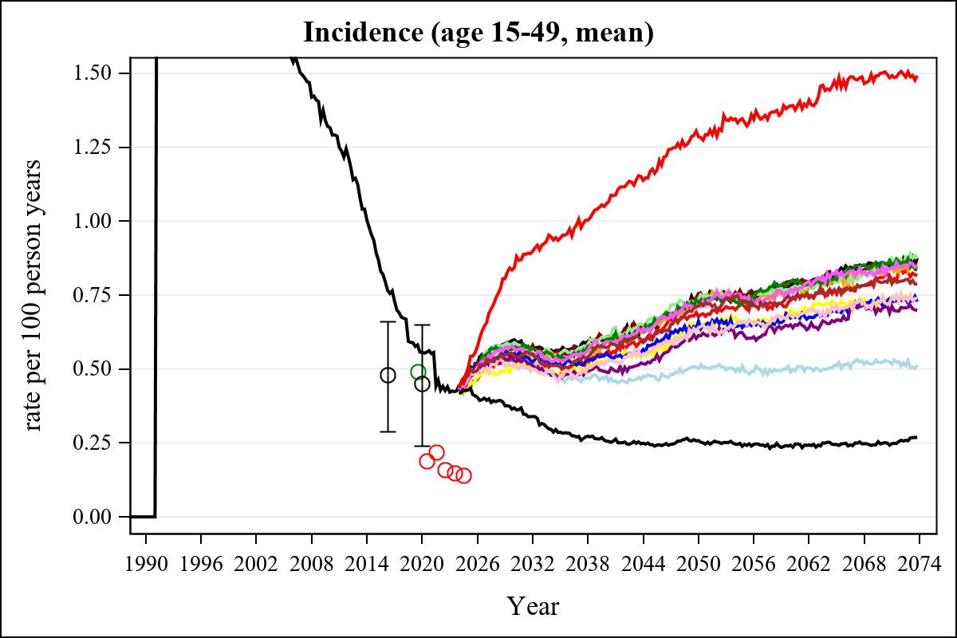

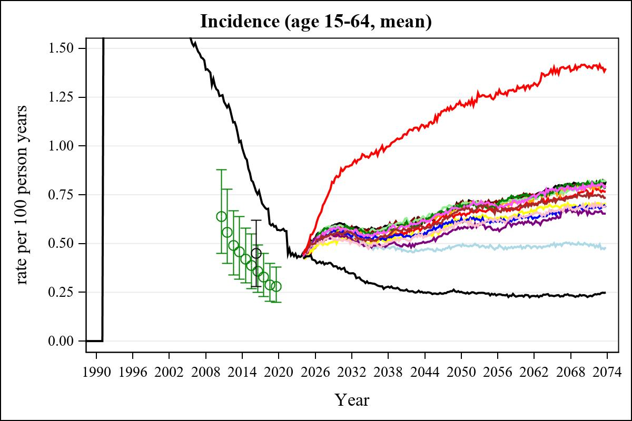

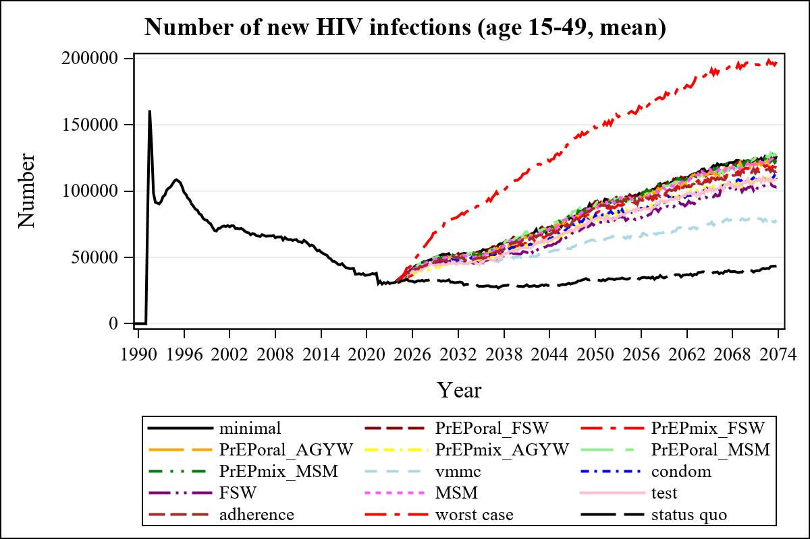

Obs | mean_n_new_inf1549__0 | mean_n_new_inf1549__1 | mean_n_new_inf1549__2 | mean_n_new_inf1549__3
225 | 63422.11 | 64950.38 | 59575.13 | 63737.65

Obs | mean_n_new_inf1549__4 | mean_n_new_inf1549__5 | mean_n_new_inf1549__6 | mean_n_new_inf1549__7
225 | 57302.10 | 65318.87 | 64040.99 | 51319.82

Obs | mean_n_new_inf1549__8 | mean_n_new_inf1549__9 | mean_n_new_inf1549__10 | mean_n_new_inf1549__11
225 | 59297.69 | 52608.37 | 63256.42 | 56479.10

Obs | mean_n_new_inf1549__12 | mean_n_new_inf1549__13 | mean_n_new_inf1549__99
225 | 61410.38 | 109292.89 | 28115.32

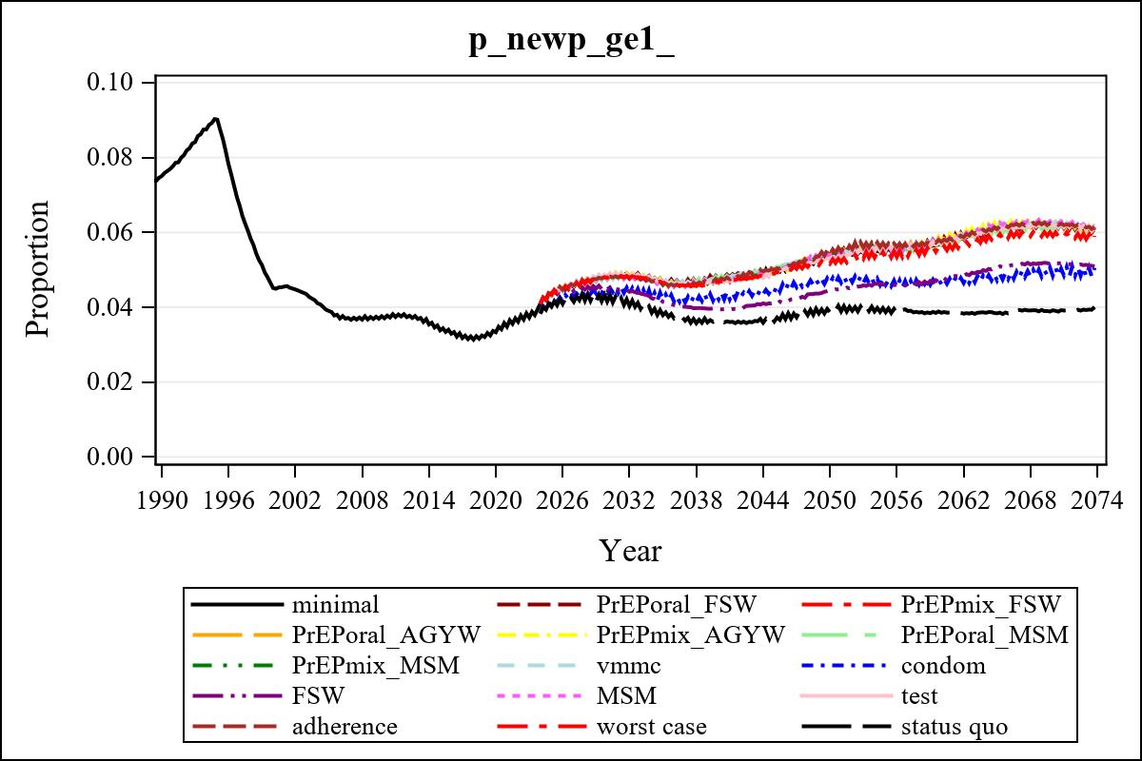

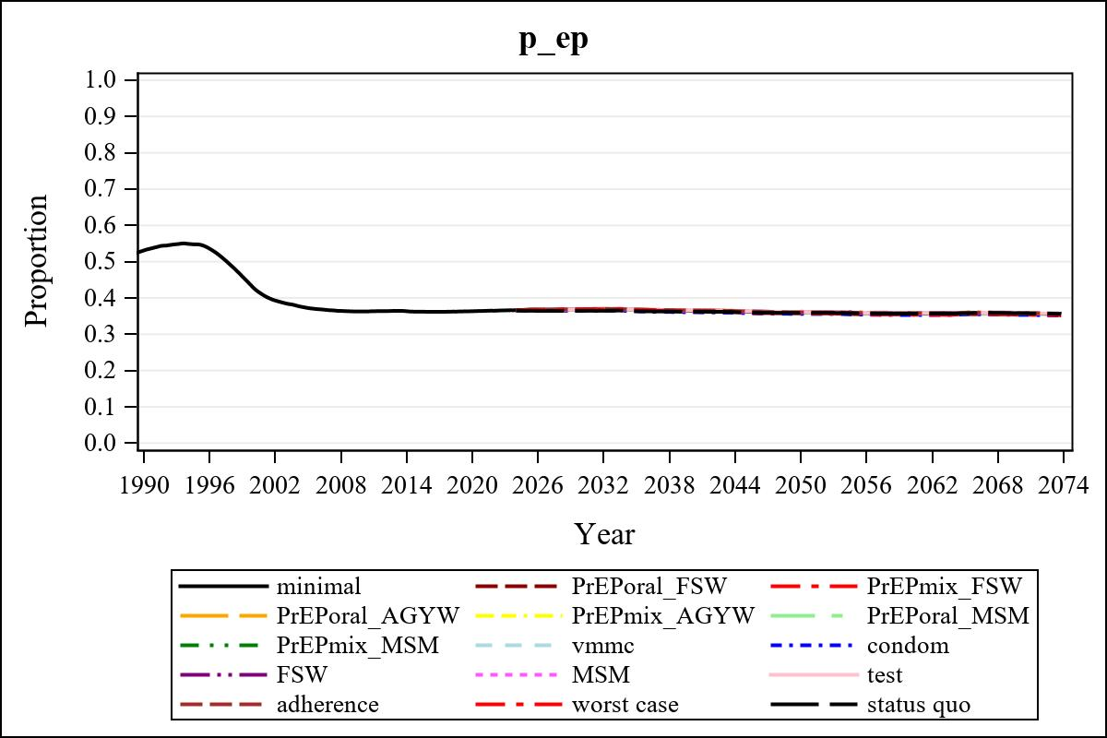

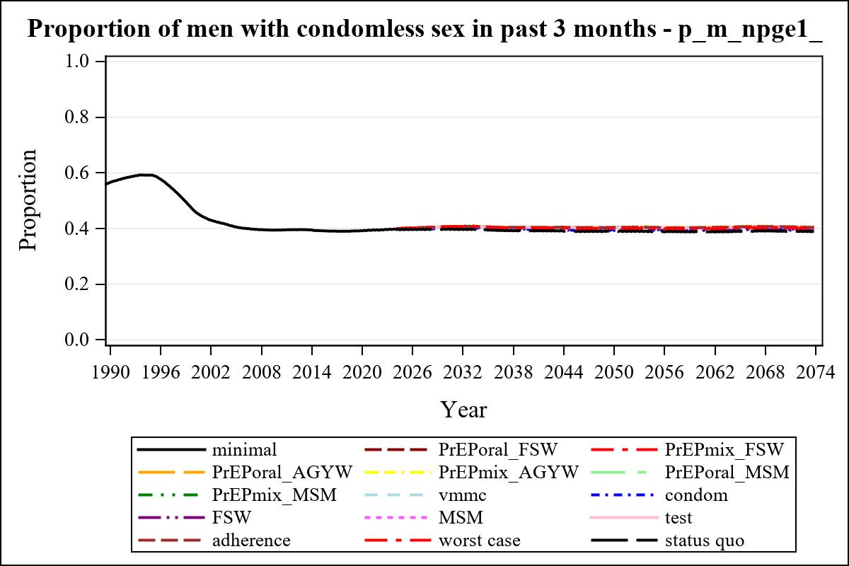

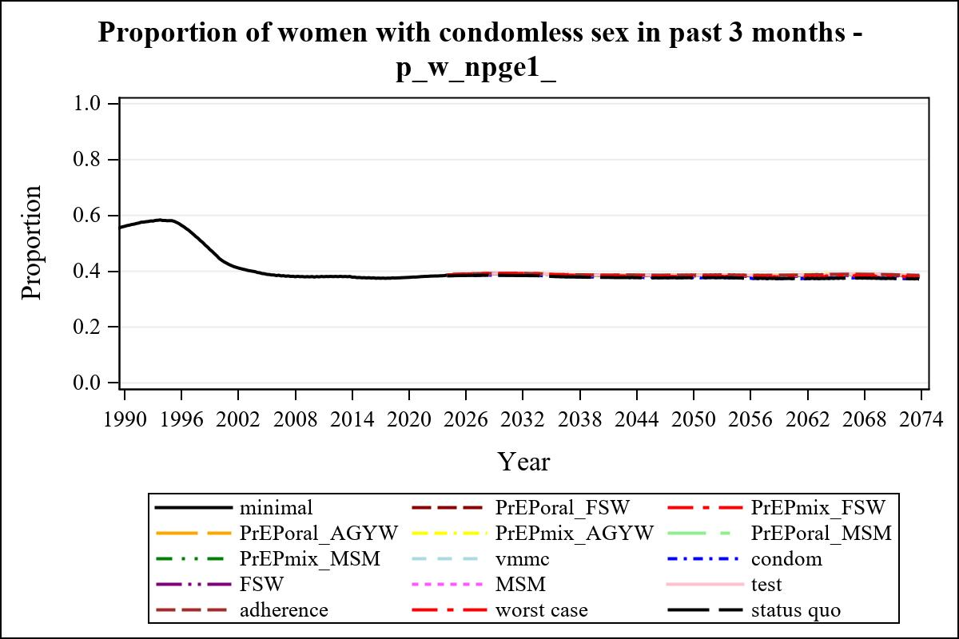

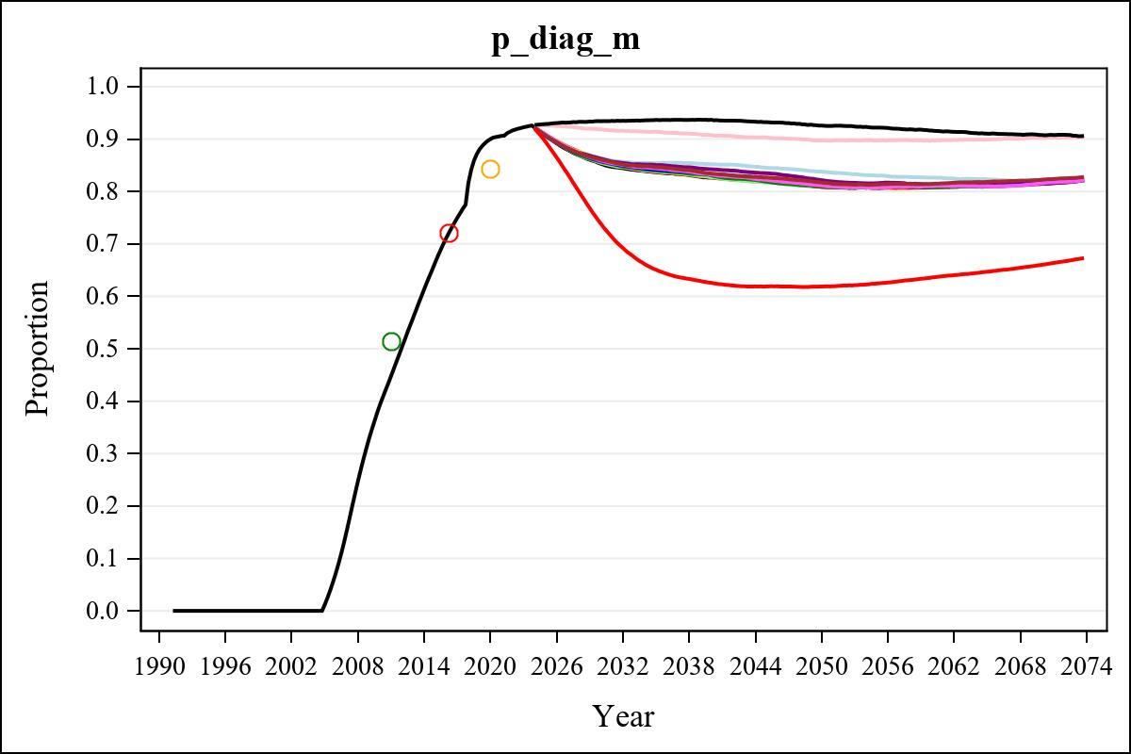

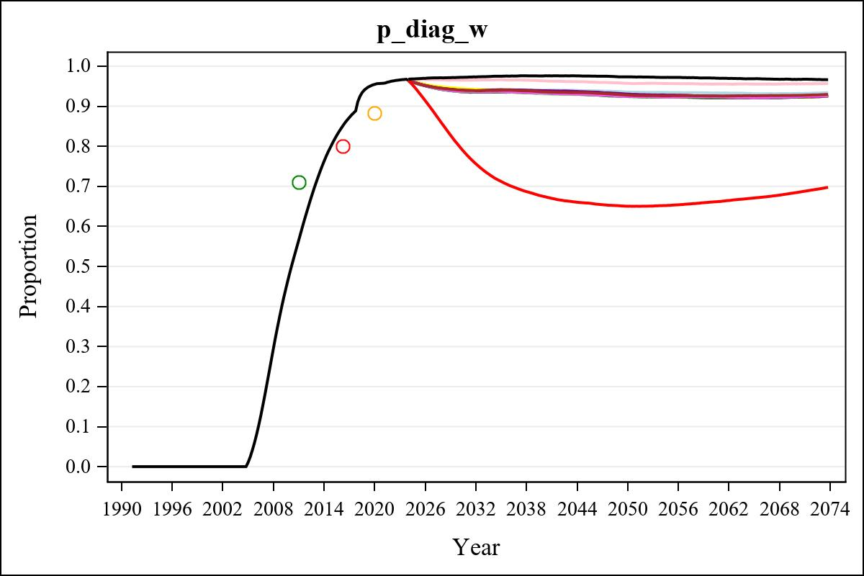

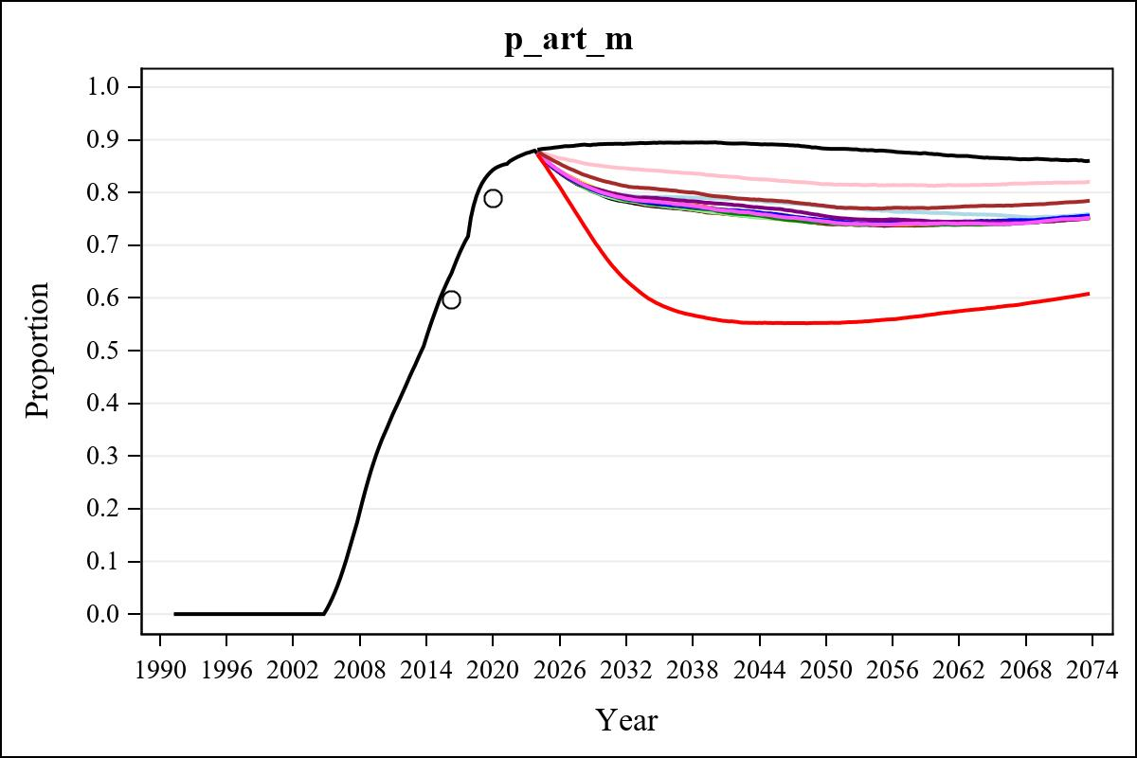

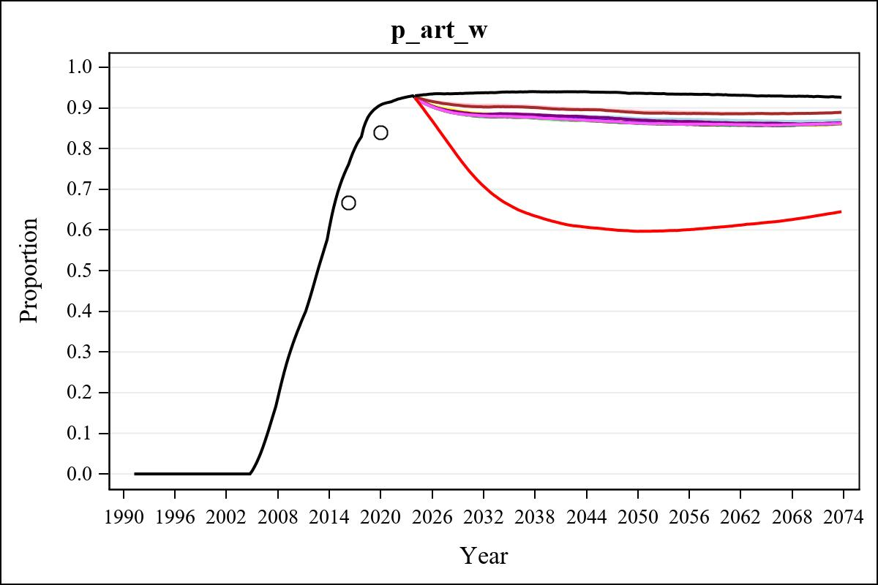

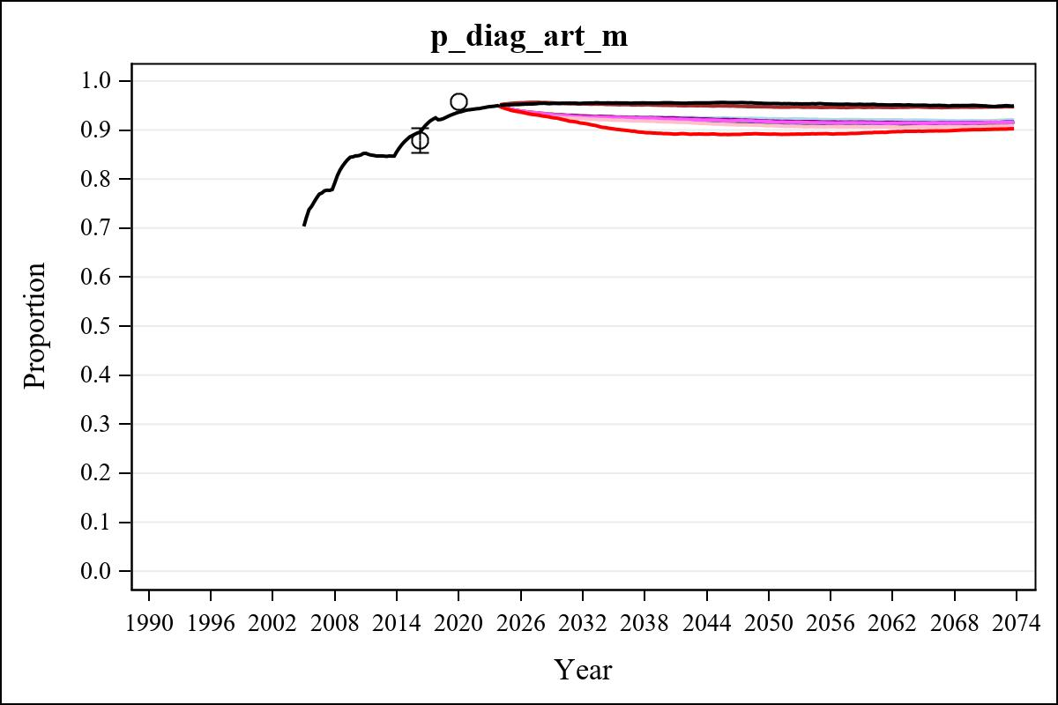

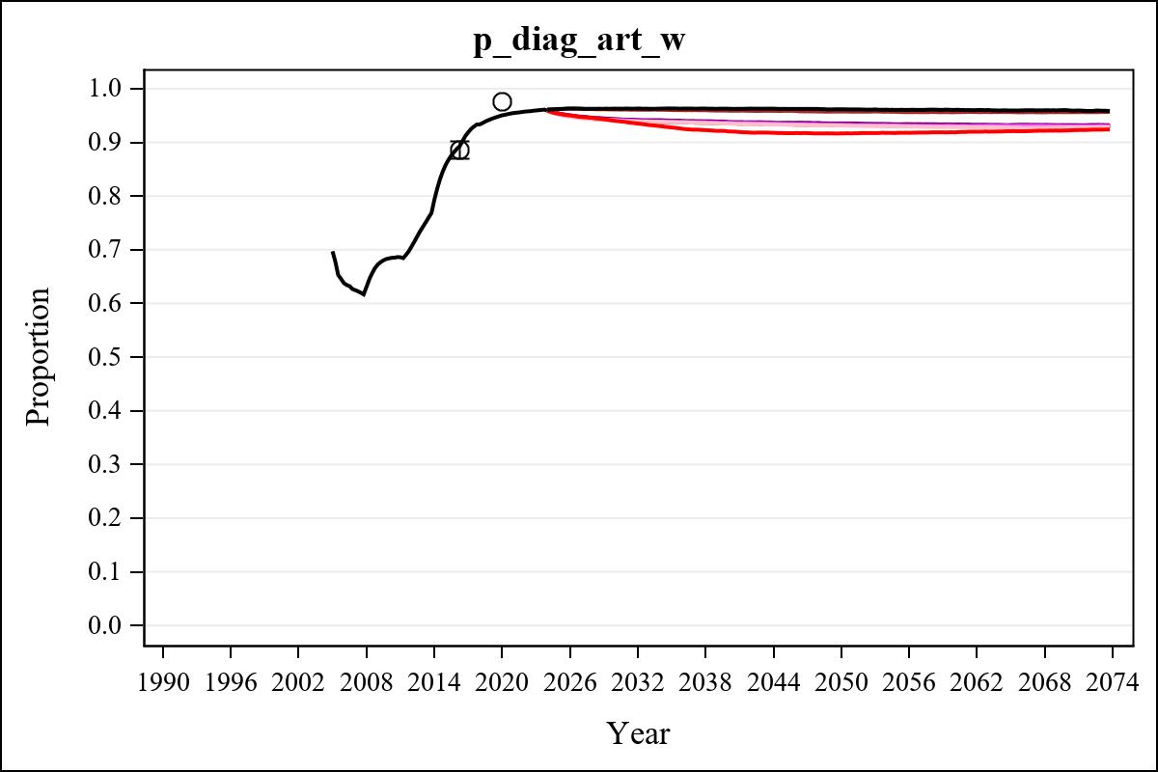

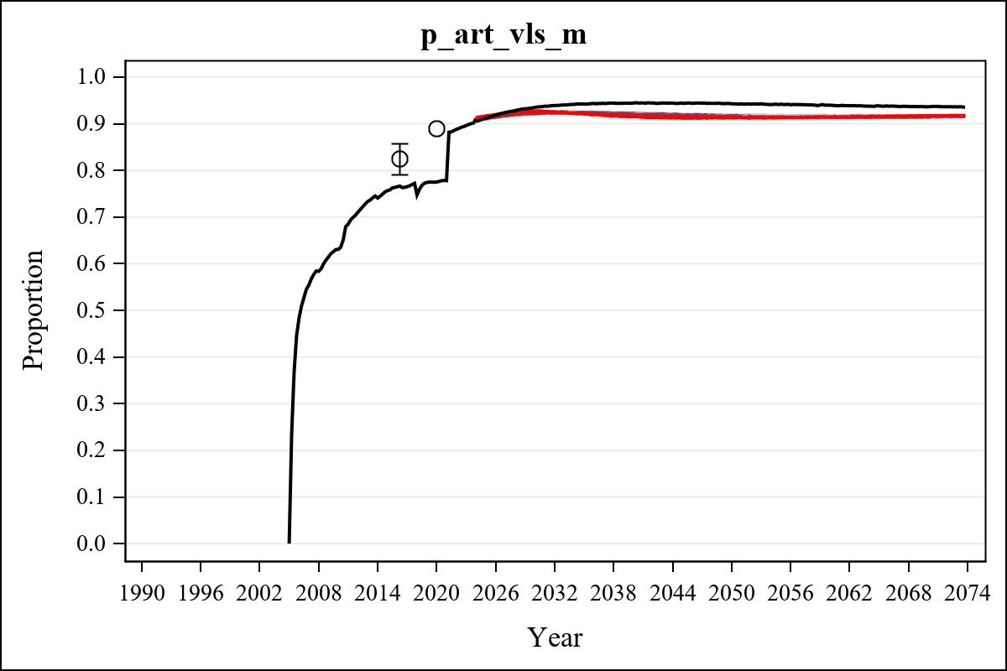

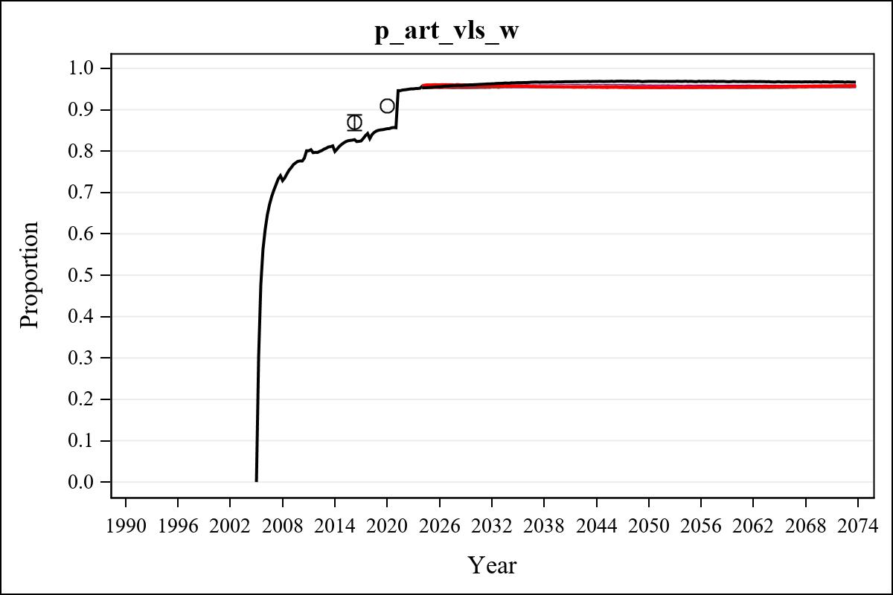

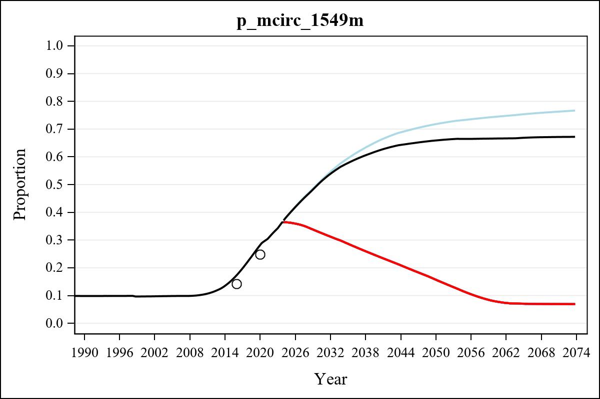

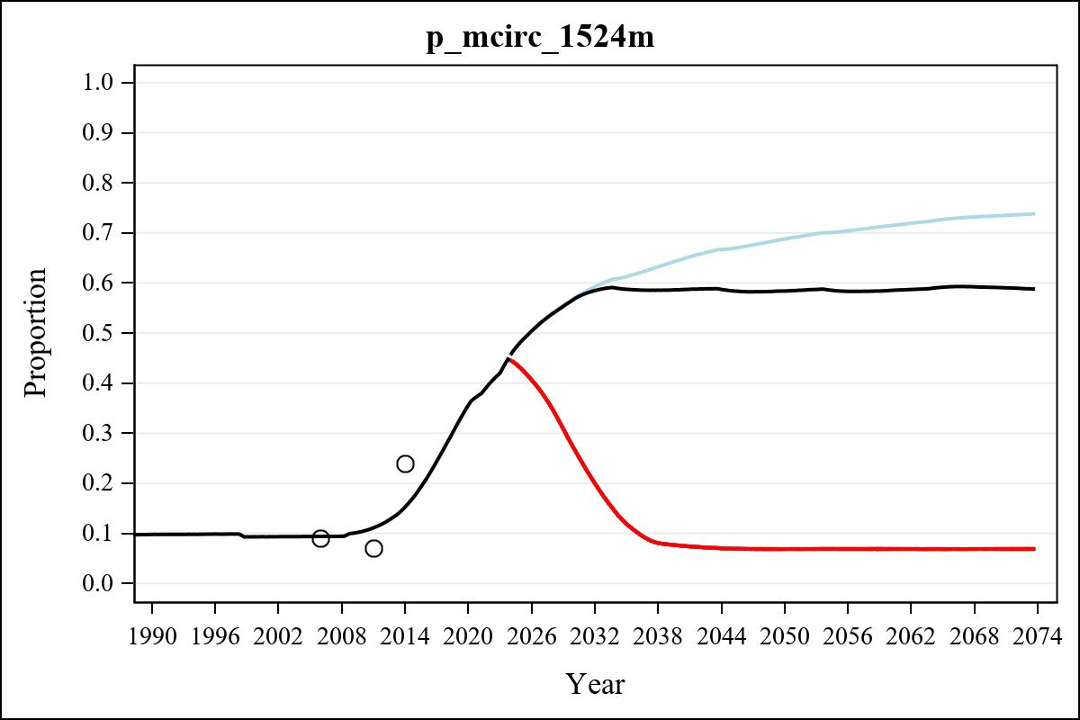

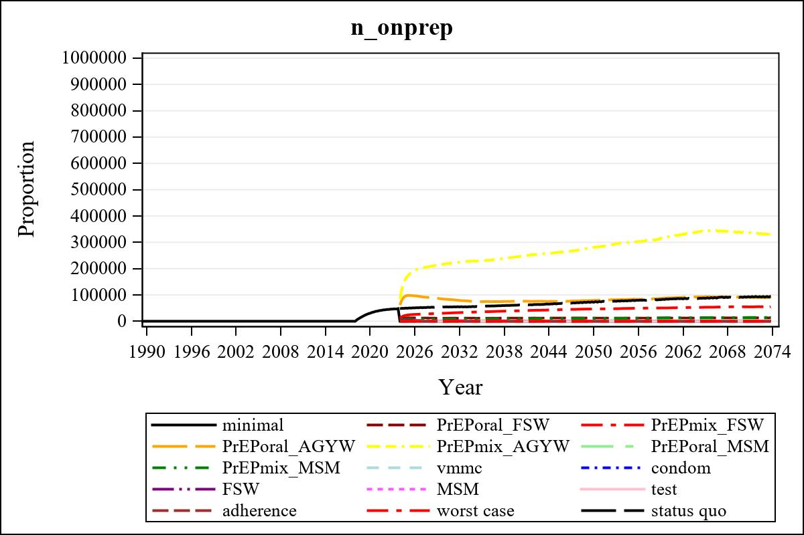

Obs | mean_n_onprep_0 | mean_n_onprep_1 | mean_n_onprep_2 | mean_n_onprep_3
345 | 0 | 12858.61 | 54969.27 | 91709.12

Obs | mean_n_onprep_4 | mean_n_onprep_5 | mean_n_onprep_6 | mean_n_onprep_99
345 | 338922.02 | 2958.63 | 14002.73 | 90939.78

Obs | mean_n_sw_1564__1 | mean_n_undiag_sw_1 | mean_n_elig_prep_1 | mean_n_elig_prep_any_sw_1
185 | 124313.92 | 71791.26 | 72850.23 | 72850.23

Obs | mean_n_onprep_sw_1 | mean_n_onprep_w_1 | mean_n_sw_1564__2 | mean_n_undiag_sw_2
185 | 11564.49 | 11564.49 | 124620.90 | 76021.79

Obs | mean_n_elig_prep_2 | mean_n_elig_prep_any_sw_2 | mean_n_onprep_sw_2 | mean_n_onprep_w_2
185 | 76930.98 | 76930.98 | 30546.13 | 30546.13

Obs | mean_n_onprep_oral_sw_2 | mean_n_onprep_len_sw_2 | mean_n_agyw_pg_3 | mean_n_elig_prep_3
185 | 6029.85 | 24516.28 | 938992.91 | 893550.26

Obs | mean_n_onprep_agyw_pg_3 | mean_n_onprep_w_3 | mean_n_agyw_pg_4 | mean_n_elig_prep_4
185 | 84083.70 | 84083.70 | 941816.23 | 899684.27

Obs | mean_n_onprep_agyw_pg_4 | mean_n_onprep_w_4 | mean_n_onprep_oral_agyw_pg_4
185 | 217930.19 | 217930.19 | 47349.39

Obs | mean_n_onprep_len_agyw_pg_4 | mean_n_alive_msm_5 | mean_n_elig_prep_5 | mean_n_onprep_msm_5
185 | 170580.81 | 64934.37 | 22632.01 | 3205.15

Obs | mean_n_onprep_m_5 | mean_n_alive_msm_6 | mean_n_elig_prep_6 | mean_n_onprep_msm_6
185 | 3205.15 | 64875.83 | 22938.26 | 8456.45

Obs | mean_n_onprep_m_6 | mean_n_onprep_oral_msm_6 | mean_n_onprep_len_msm_6 | mean_pc_elig_onprep_1
185 | 8456.45 | 1850.40 | 6606.04 | 0.15949

Obs | mean_pc_elig_onprep_2 | mean_pc_elig_onprep_3 | mean_pc_elig_onprep_4 | mean_pc_elig_onprep_5
185 | 0.39312 | 0.094720 | 0.23884 | 0.13932

Obs | mean_pc_elig_onprep_6
185 | 0.36856

Obs | mean_n_sw_1564__1 | mean_n_undiag_sw_1 | mean_n_elig_prep_1
185 | 124313.92 | 71791.26 | 72850.23

Obs | mean_n_elig_prep_any_sw_1 | mean_n_onprep_sw_1 | mean_n_onprep_w_1
185 | 72850.23 | 11564.49 | 11564.49

Obs | ratio_oral_len_2 | ratio_oral_len_4 | ratio_oral_len_6
1 | 0.21414 | 0.25811 | 0.20909

