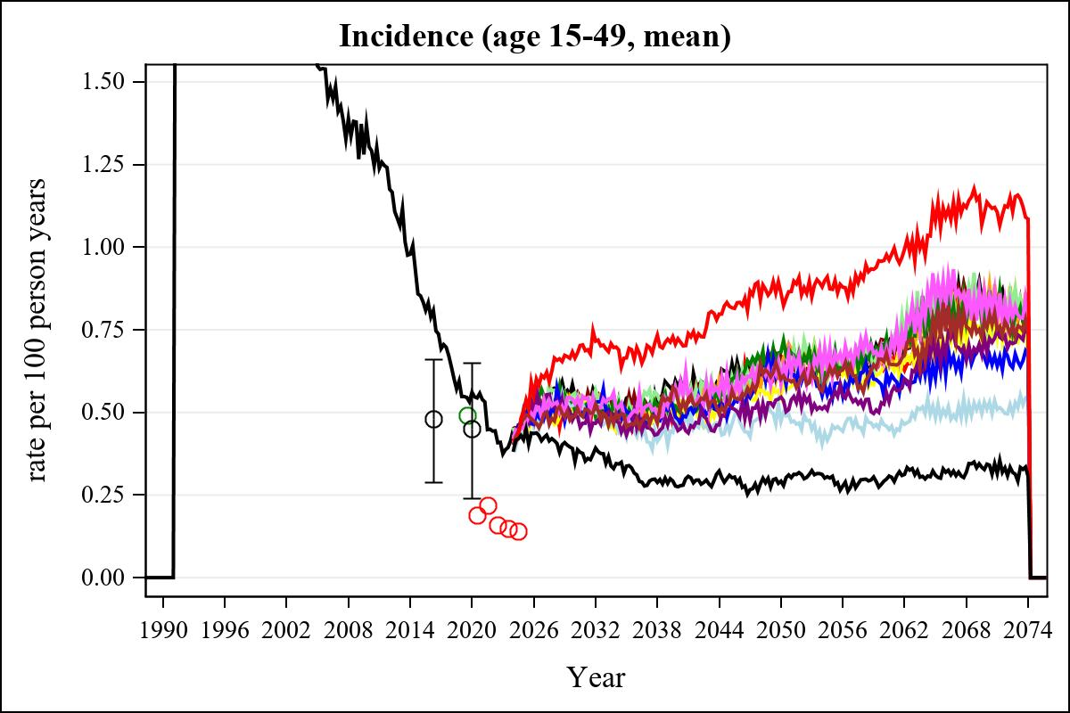

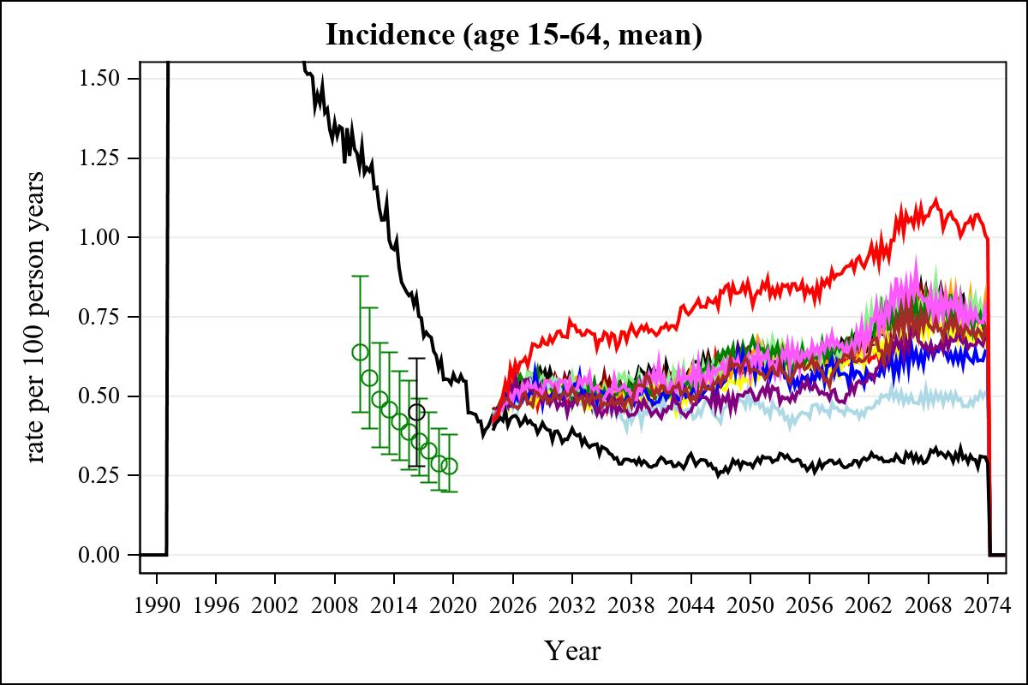

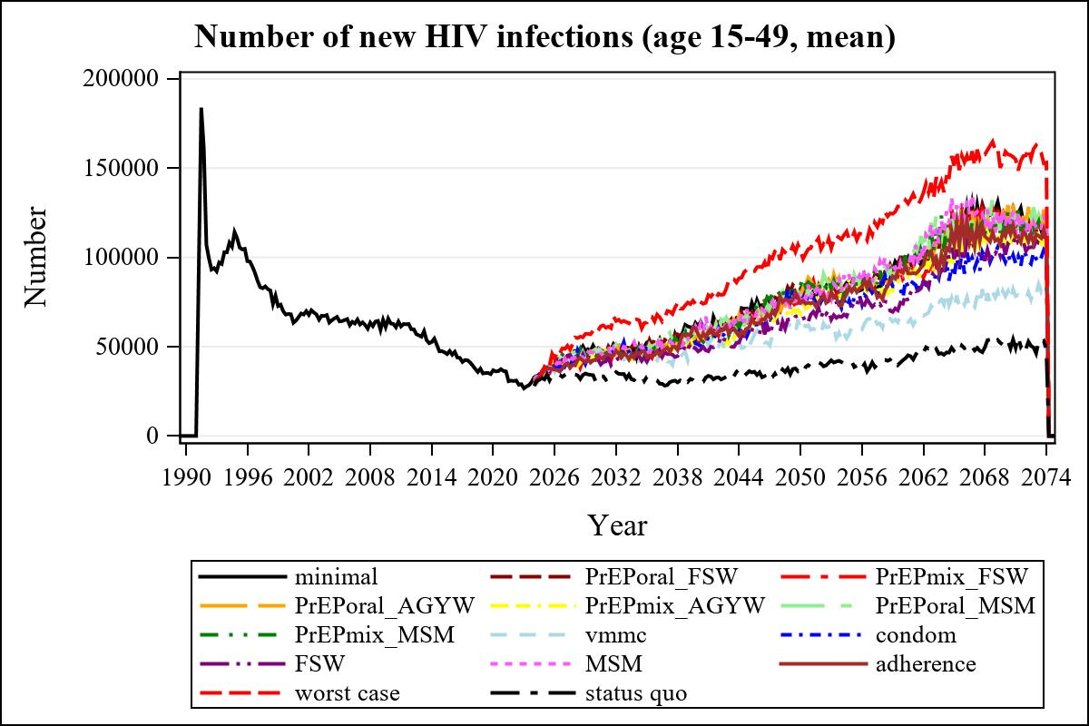

Obs | mean_n_new_inf1549__0 | mean_n_new_inf1549__1 | mean_n_new_inf1549__2 | mean_n_new_inf1549__3
226 | 61530.71 | 49893.68 | 51420.94 | 55965.67

Obs | mean_n_new_inf1549__4 | mean_n_new_inf1549__5 | mean_n_new_inf1549__6 | mean_n_new_inf1549__7
226 | 52149.70 | 57323.24 | 53869.60 | 47718.04

Obs | mean_n_new_inf1549__8 | mean_n_new_inf1549__9 | mean_n_new_inf1549__10 | mean_n_new_inf1549__11
226 | 51314.41 | 47354.86 | 57823.57 | .

Obs | mean_n_new_inf1549__12 | mean_n_new_inf1549__13 | mean_n_new_inf1549__99
226 | 57095.29 | 75947.10 | 29607.04

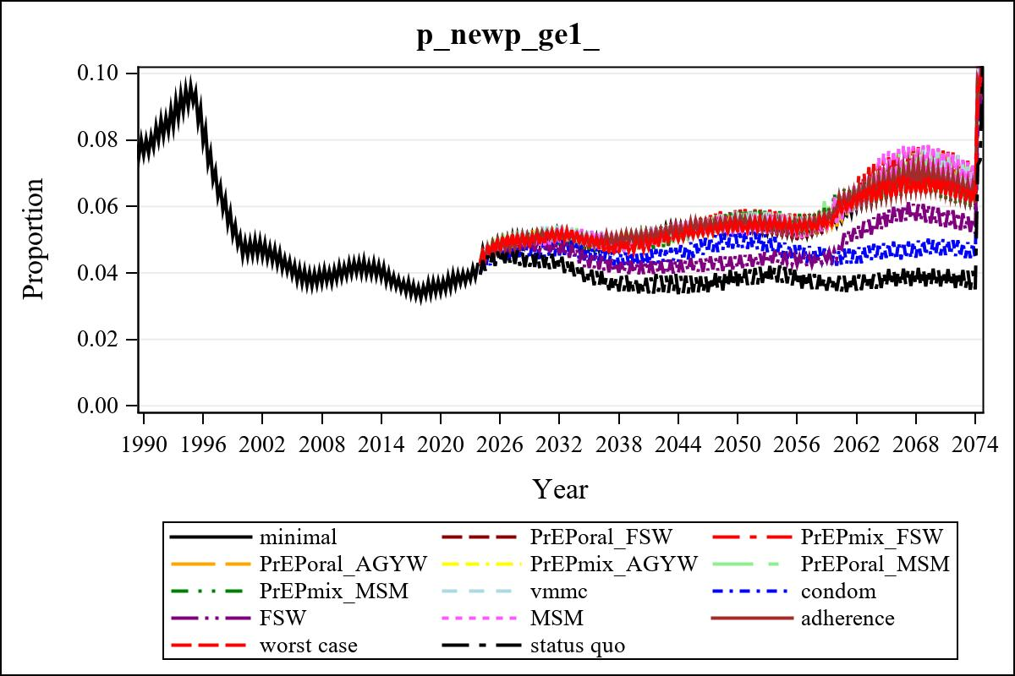

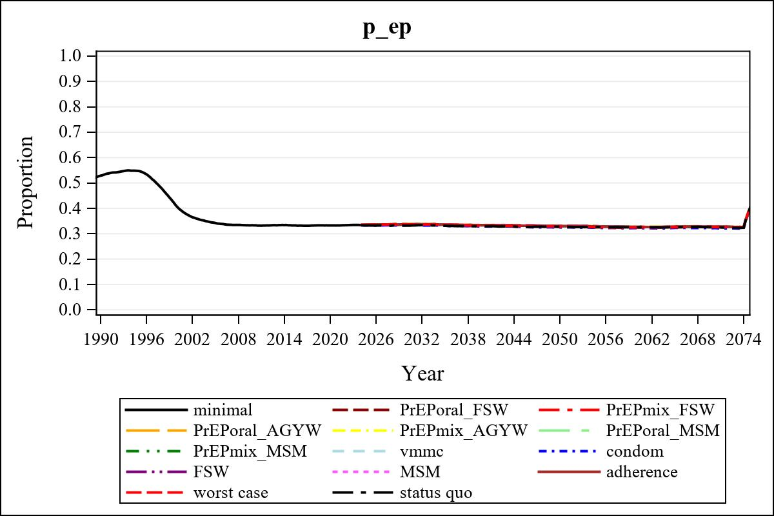

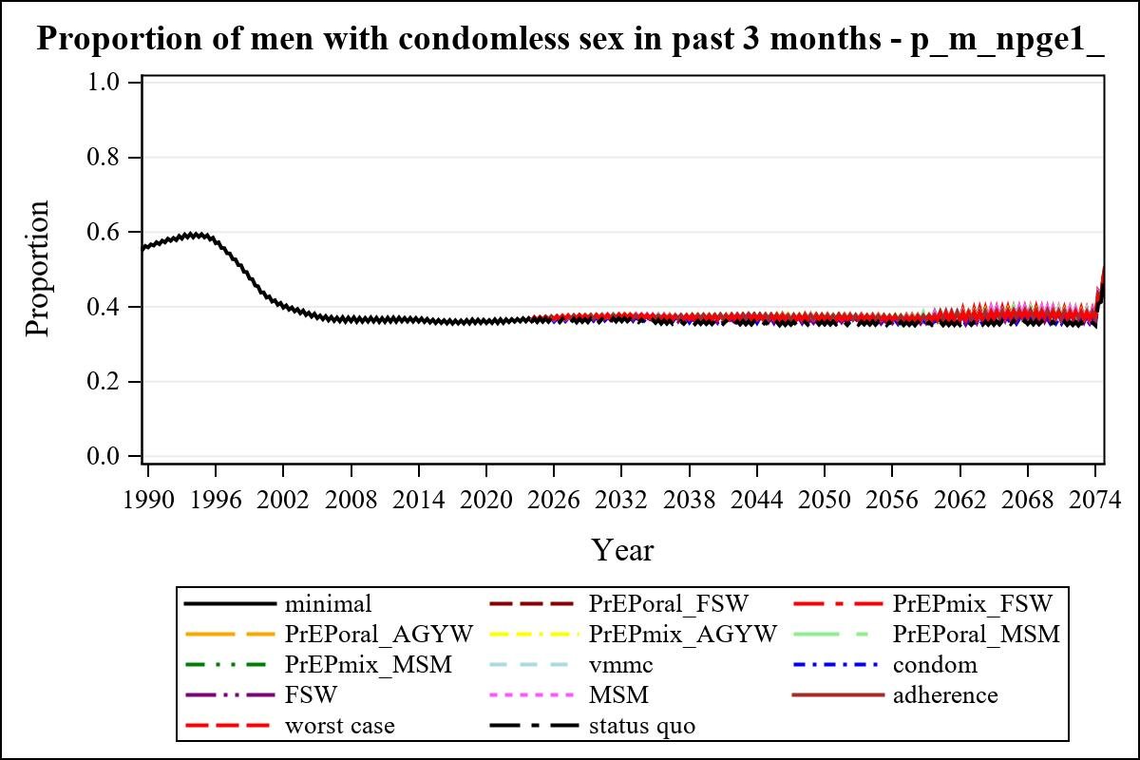

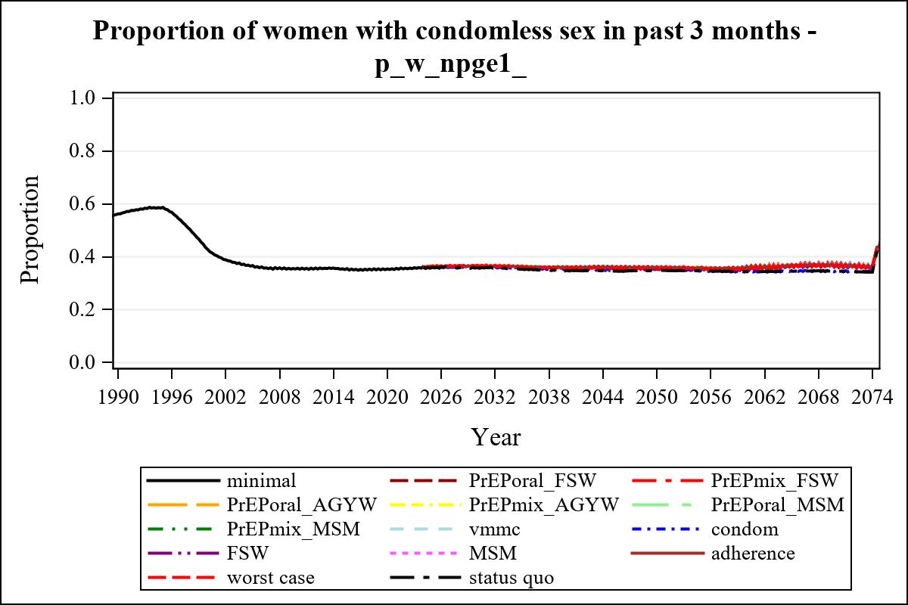

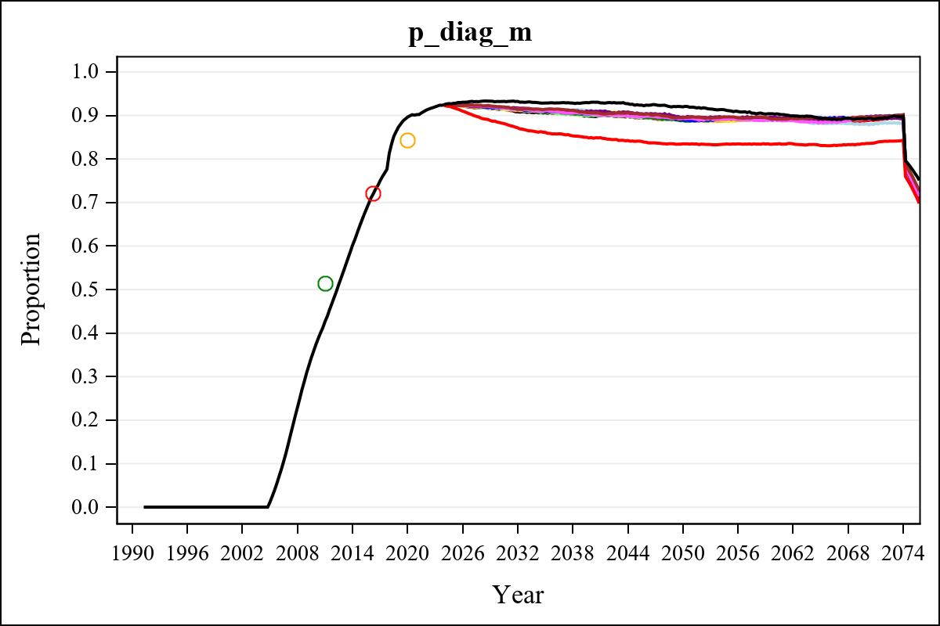

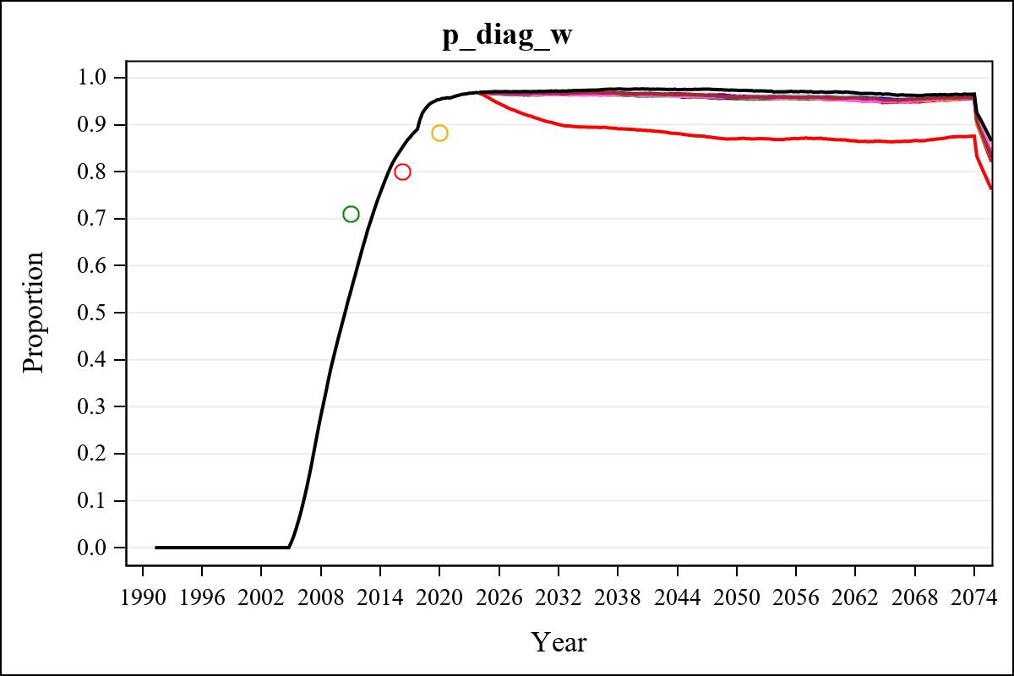

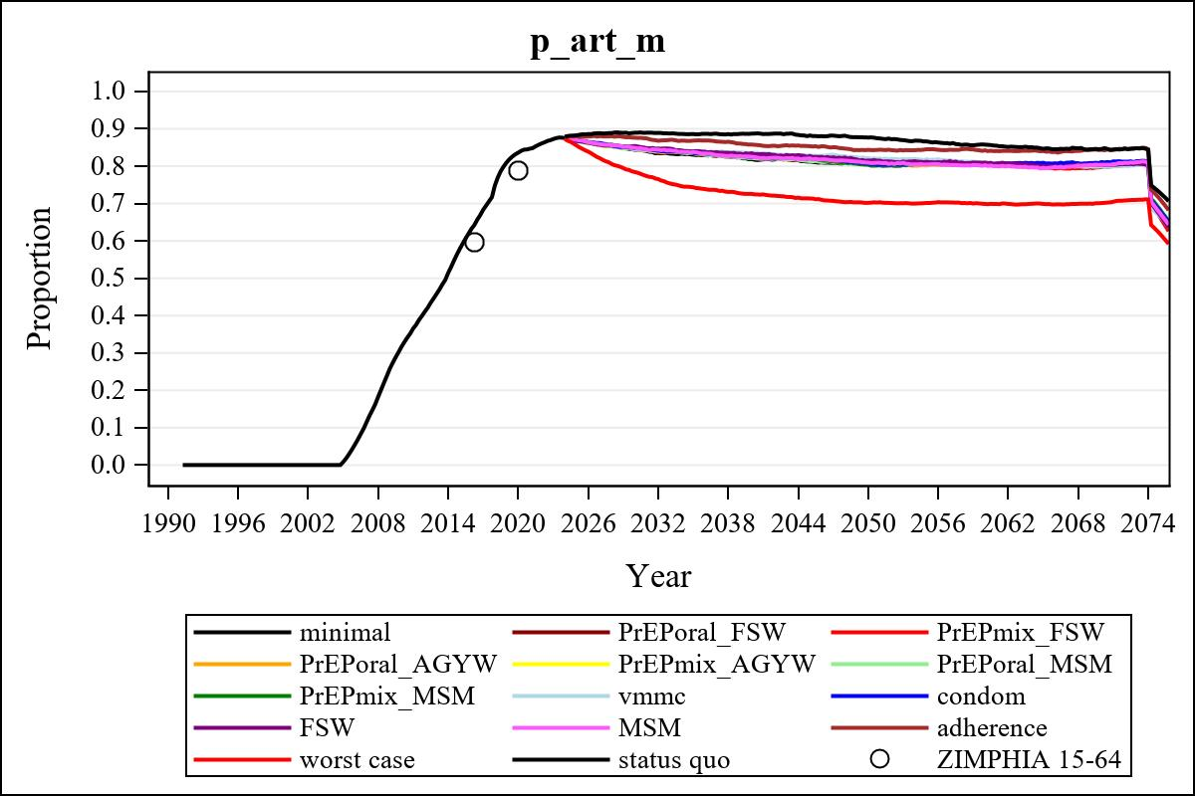

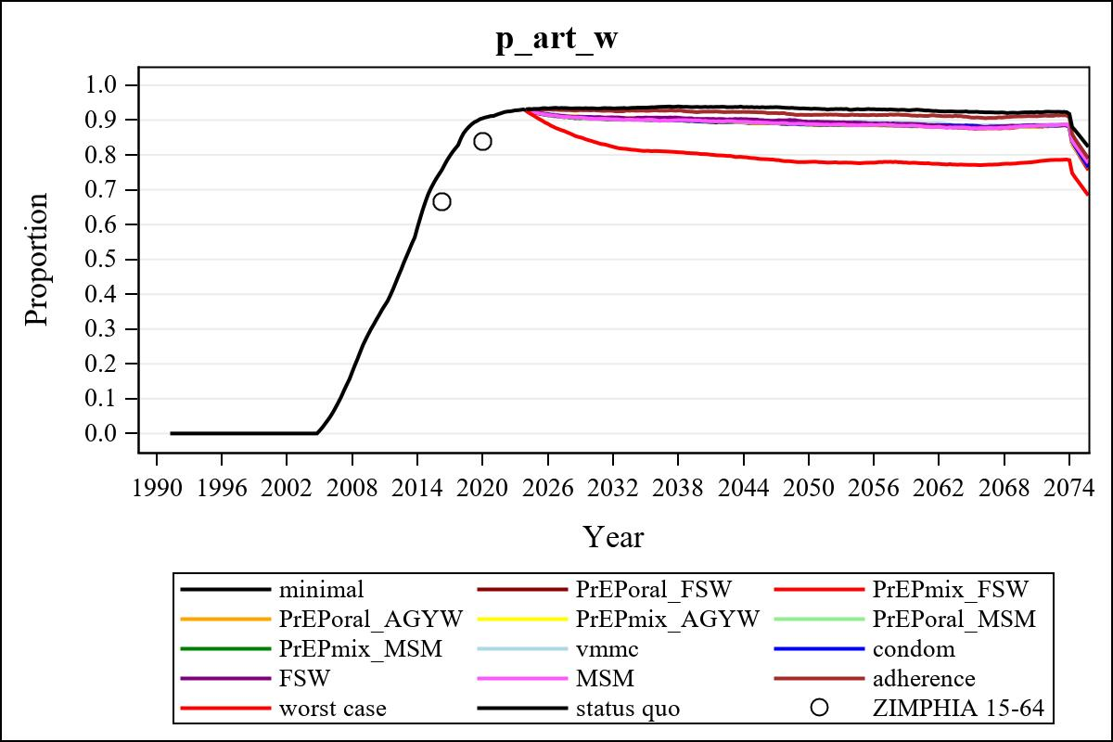

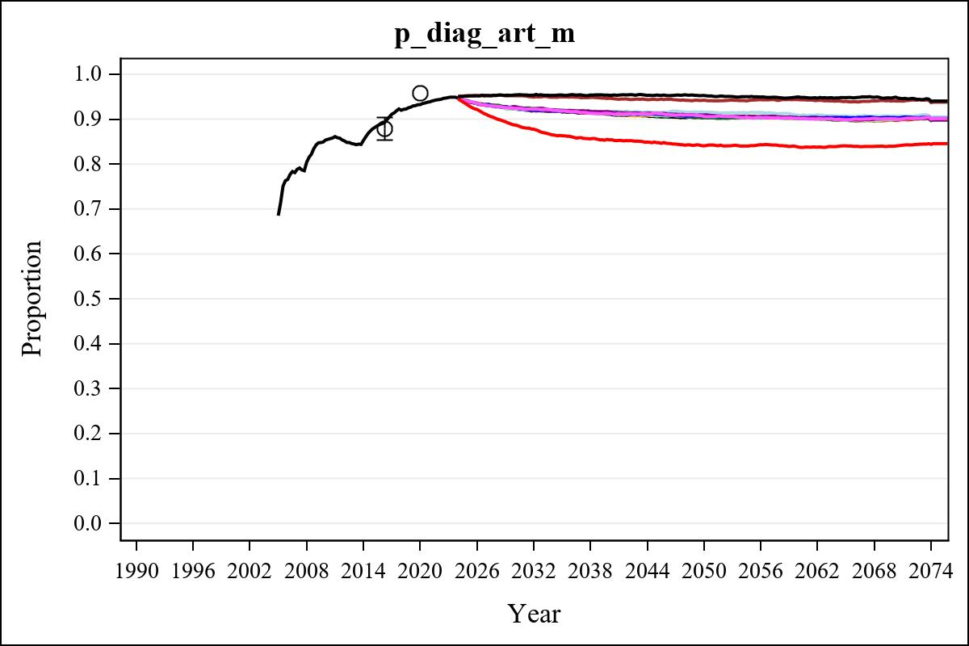

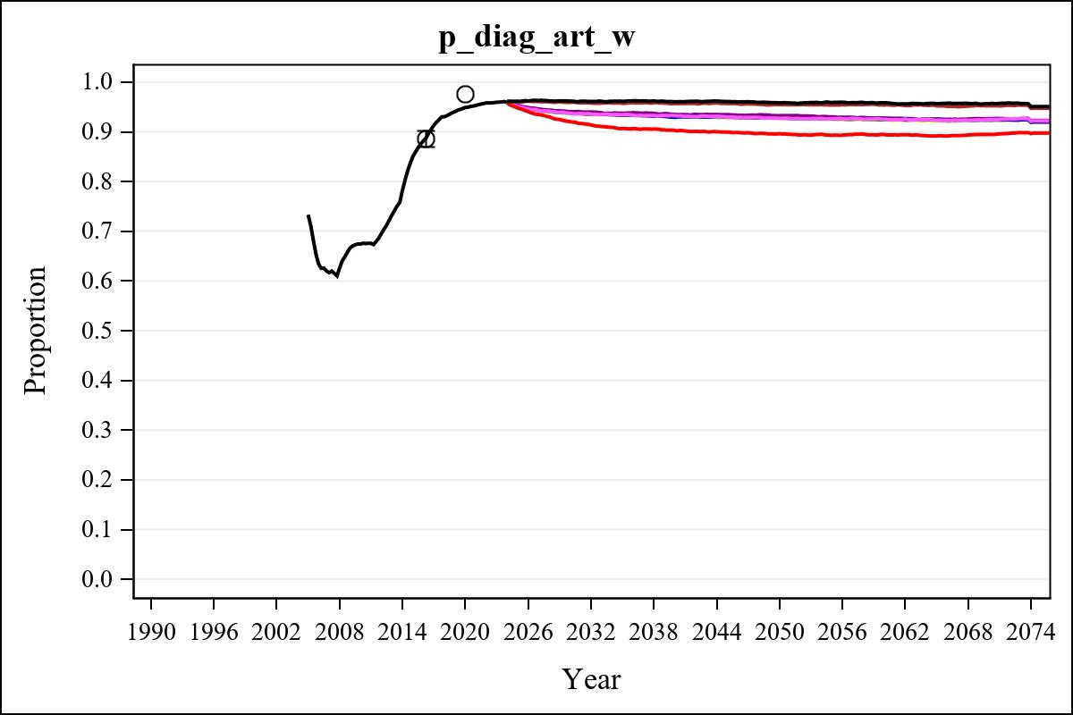

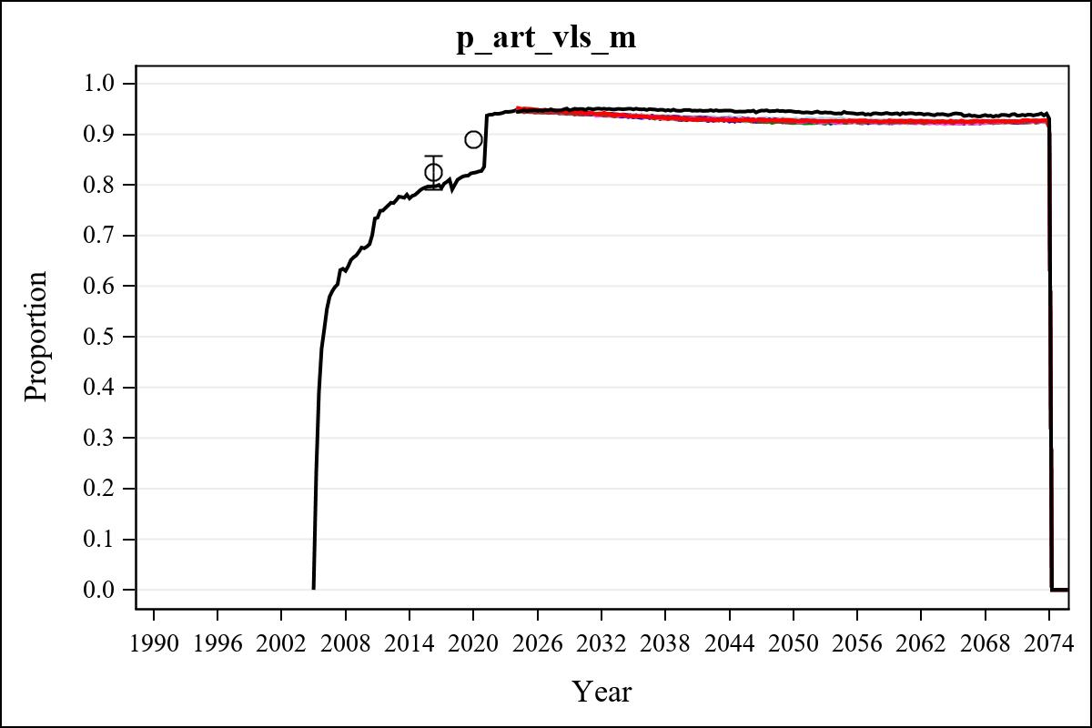

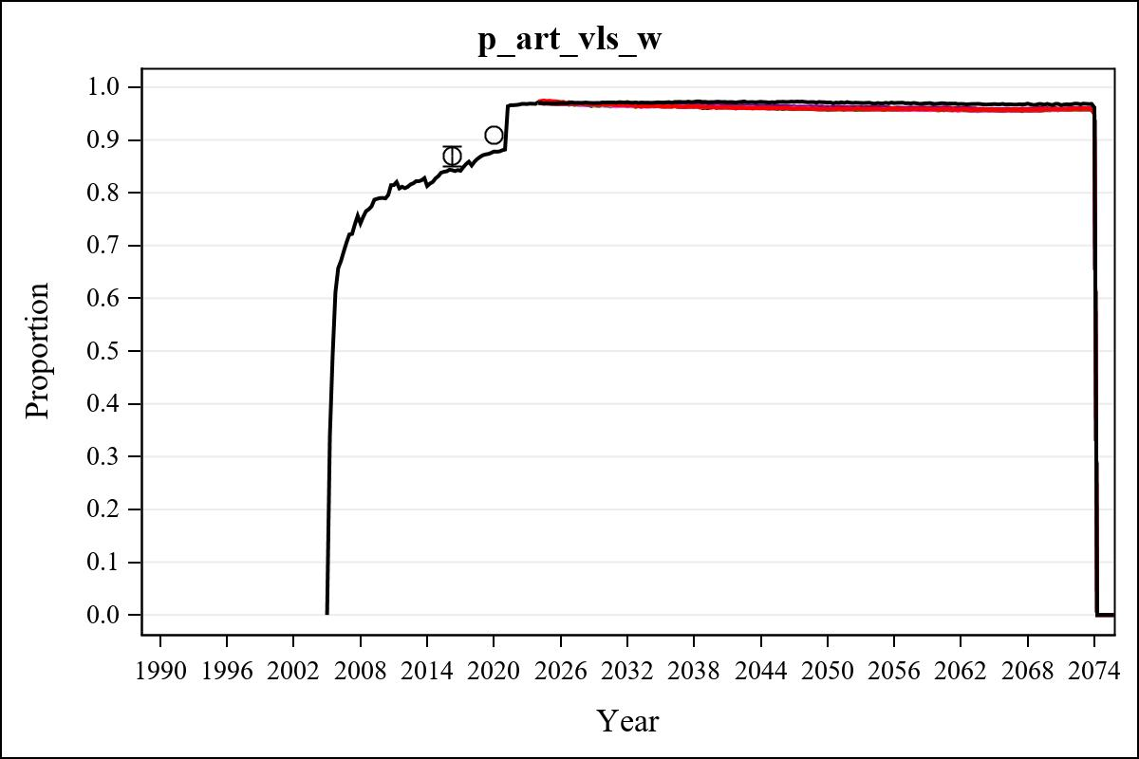

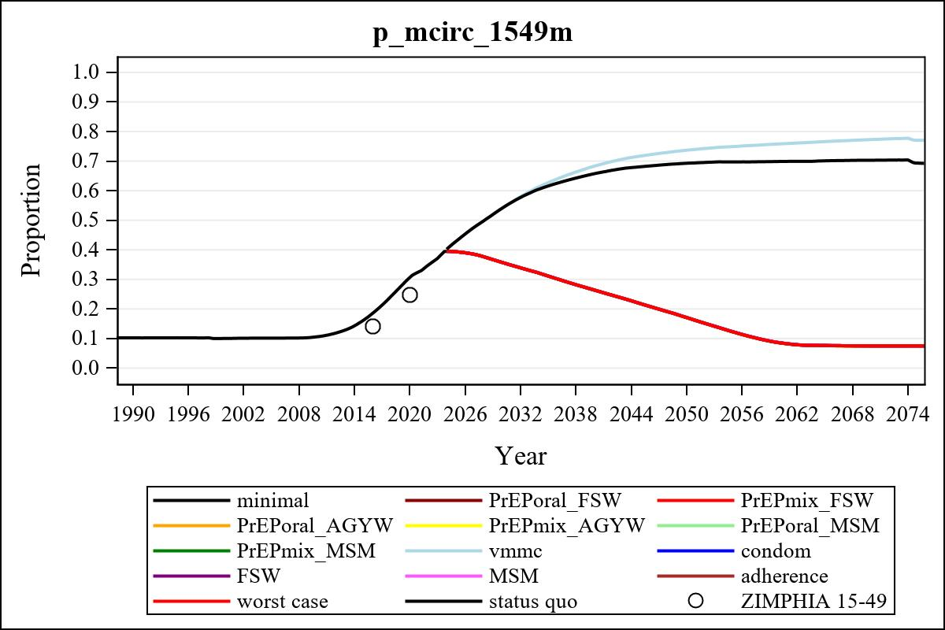

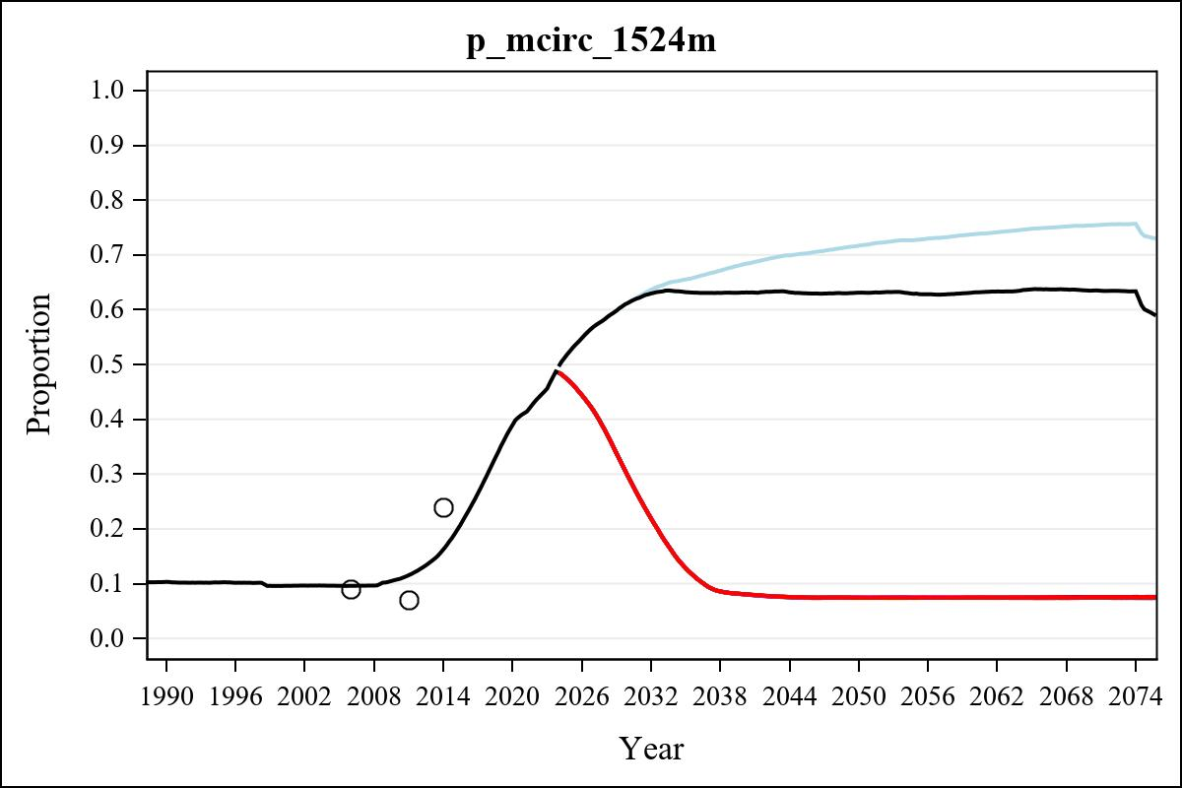

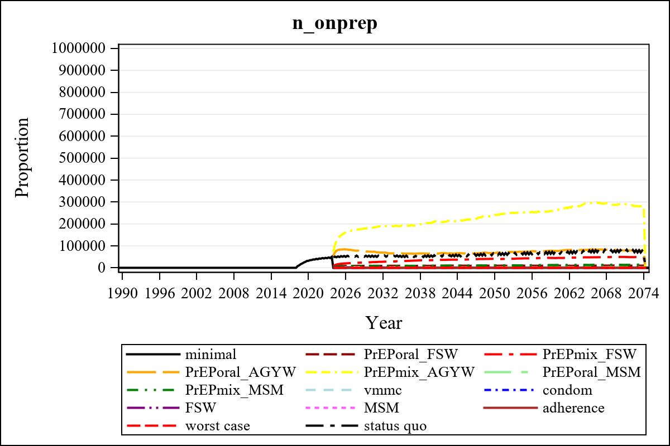

Obs | mean_n_onprep_0 | mean_n_onprep_1 | mean_n_onprep_2 | mean_n_onprep_3
346 | 0 | 9968.55 | 49438.41 | 80182.26

Obs | mean_n_onprep_4 | mean_n_onprep_5 | mean_n_onprep_6 | mean_n_onprep_99
346 | 289960.79 | 2760.62 | 13556.69 | 71633.00

Obs | mean_n_sw_1564__1 | mean_n_undiag_sw_1 | mean_n_elig_prep_1 | mean_n_elig_prep_any_sw_1
186 | 119153.04 | 65255.23 | 66441.05 | 66441.05

Obs | mean_n_onprep_sw_1 | mean_n_onprep_w_1 | mean_n_sw_1564__2 | mean_n_undiag_sw_2
186 | 9271.08 | 9271.08 | 119359.87 | 69087.13

Obs | mean_n_elig_prep_2 | mean_n_elig_prep_any_sw_2 | mean_n_onprep_sw_2 | mean_n_onprep_w_2
186 | 70118.58 | 70118.58 | 25405.53 | 25405.53

Obs | mean_n_onprep_oral_sw_2 | mean_n_onprep_len_sw_2 | mean_n_agyw_pg_3 | mean_n_elig_prep_3
186 | 4837.90 | 20567.63 | 886825.85 | 837621.27

Obs | mean_n_onprep_agyw_pg_3 | mean_n_onprep_w_3 | mean_n_agyw_pg_4 | mean_n_elig_prep_4
186 | 73660.86 | 73660.86 | 884982.32 | 837023.49

Obs | mean_n_onprep_agyw_pg_4 | mean_n_onprep_w_4 | mean_n_onprep_oral_agyw_pg_4
186 | 184746.08 | 184746.08 | 41874.47

Obs | mean_n_onprep_len_agyw_pg_4 | mean_n_alive_msm_5 | mean_n_elig_prep_5 | mean_n_onprep_msm_5
186 | 142871.61 | 68223.13 | 24386.22 | 3109.76

Obs | mean_n_onprep_m_5 | mean_n_alive_msm_6 | mean_n_elig_prep_6 | mean_n_onprep_msm_6
186 | 3109.76 | 68430.92 | 24507.30 | 8158.87

Obs | mean_n_onprep_m_6 | mean_n_onprep_oral_msm_6 | mean_n_onprep_len_msm_6 | mean_pc_elig_onprep_1
186 | 8158.87 | 1657.23 | 6501.64 | 0.15080

Obs | mean_pc_elig_onprep_2 | mean_pc_elig_onprep_3 | mean_pc_elig_onprep_4 | mean_pc_elig_onprep_5
186 | 0.37082 | 0.086140 | 0.21539 | 0.12963

Obs | mean_pc_elig_onprep_6
186 | 0.33171

Obs | mean_n_sw_1564__1 | mean_n_undiag_sw_1 | mean_n_elig_prep_1
186 | 119153.04 | 65255.23 | 66441.05

Obs | mean_n_elig_prep_any_sw_1 | mean_n_onprep_sw_1 | mean_n_onprep_w_1
186 | 66441.05 | 9271.08 | 9271.08

Obs | ratio_oral_len_2 | ratio_oral_len_4 | ratio_oral_len_6
1 | 0.19248 | 0.26993 | 0.20249

