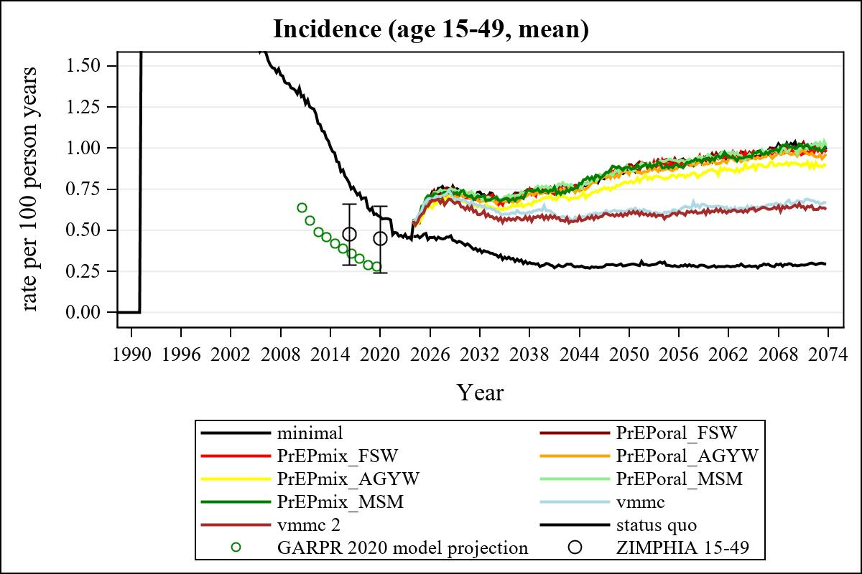

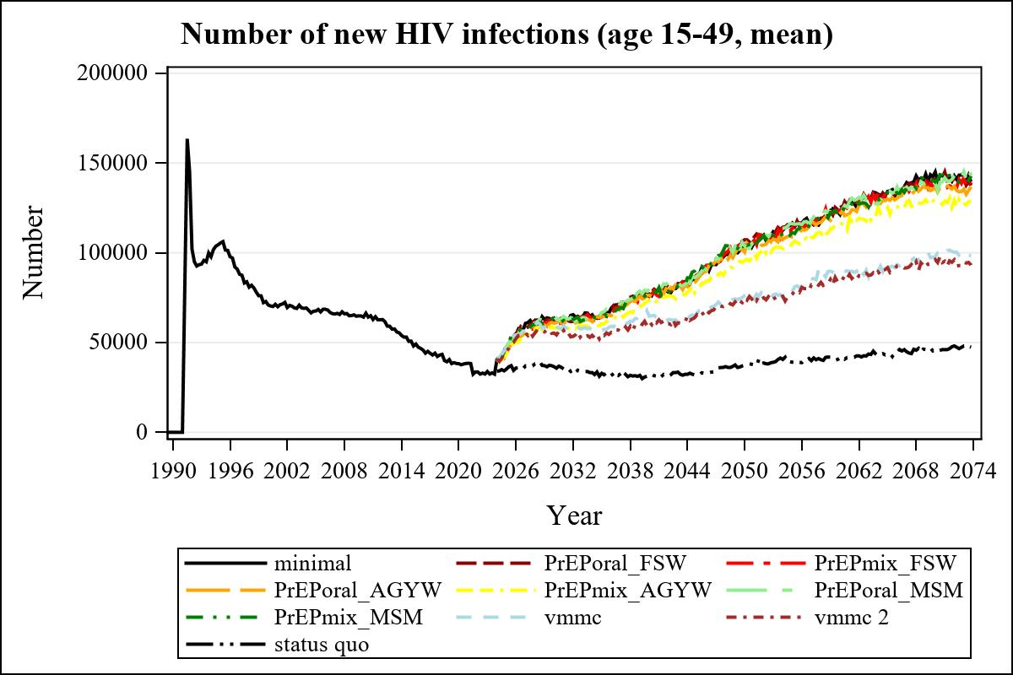

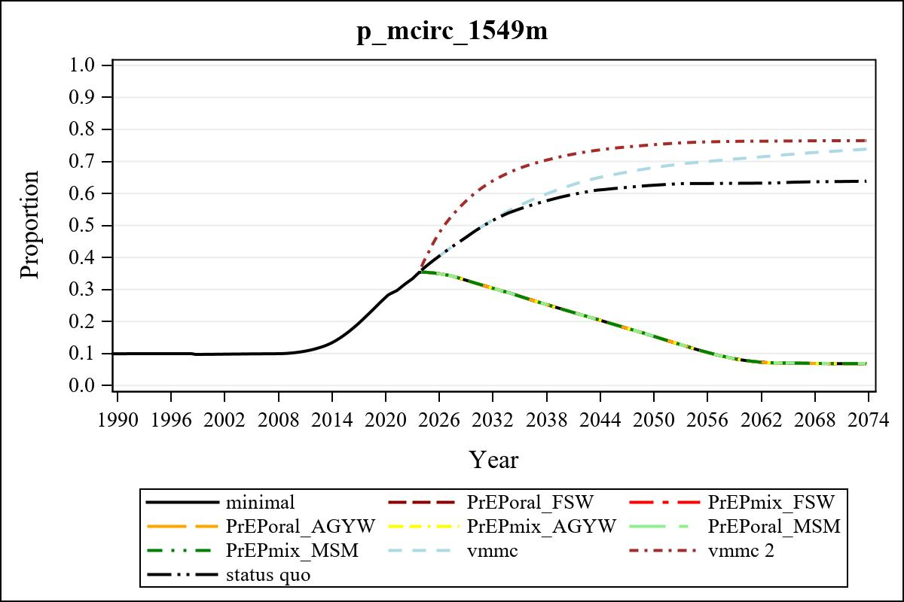

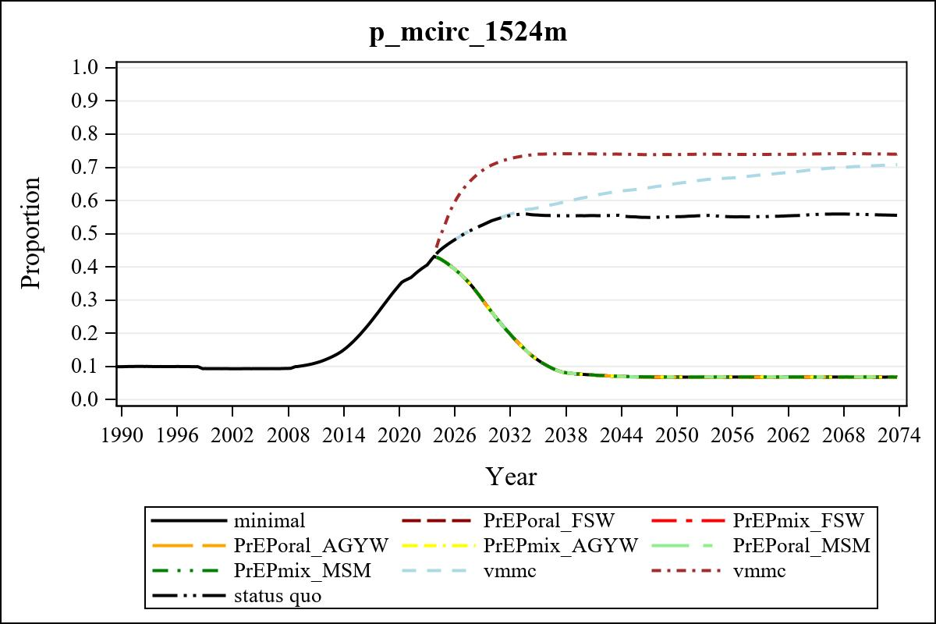

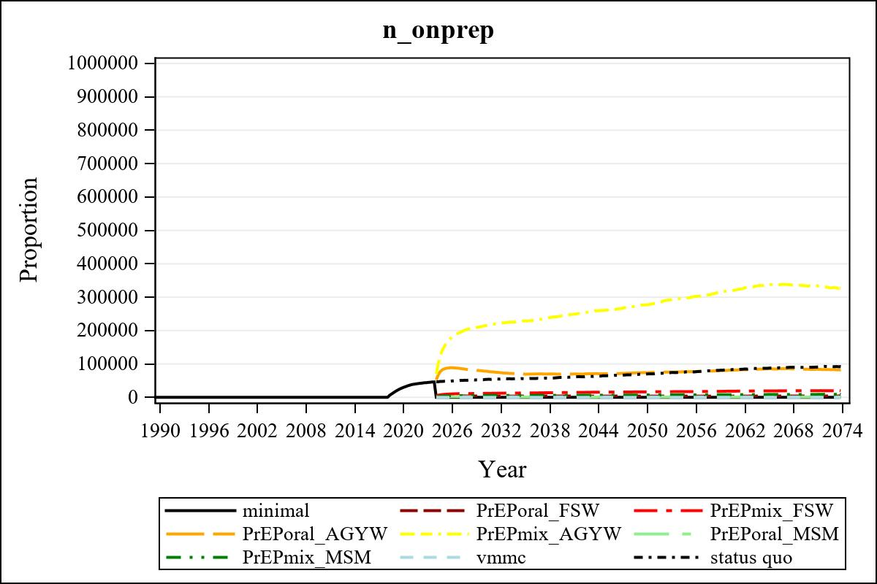

Obs | mean_n_onprep_0
345 | 0

Obs | mean_n_elig_prep_1 | mean_n_sw_1564__1 | mean_n_onprep_sw_1 | mean_n_onprep_w_1
185 | 64161.05 | 122557.92 | 3898.86 | 3898.86

Obs | mean_n_elig_prep_2 | mean_n_sw_1564__2 | mean_n_onprep_sw_2 | mean_n_onprep_w_2
185 | 65746.15 | 123864.76 | 11788.21 | 11788.21

Obs | mean_n_onprep_oral_sw_2 | mean_n_onprep_len_sw_2 | mean_n_elig_prep_3 | mean_n_agyw_pg_3
185 | 1958.18 | 9830.03 | 1001460.93 | 1076538.23

Obs | mean_n_onprep_agyw_pg_3 | mean_n_onprep_w_3 | mean_n_elig_prep_4 | mean_n_agyw_pg_4
185 | 78427.02 | 78427.02 | 1005423.10 | 1077441.09

Obs | mean_n_onprep_agyw_pg_4 | mean_n_onprep_w_4 | mean_n_onprep_oral_agyw_pg_4
185 | 214535.53 | 214535.53 | 42675.39

Obs | mean_n_onprep_len_agyw_pg_4 | mean_n_elig_prep_5 | mean_n_alive_msm_5 | mean_n_onprep_msm_5
185 | 171860.14 | 22443.53 | 65489.48 | 1623.42

Obs | mean_n_onprep_m_5 | mean_n_elig_prep_6 | mean_n_alive_msm_6 | mean_n_onprep_msm_6
185 | 1623.42 | 23030.89 | 65864.06 | 5410.55

Obs | mean_n_onprep_m_6 | mean_n_onprep_oral_msm_6 | mean_n_onprep_len_msm_6 | mean_pc_elig_onprep_1
185 | 5410.55 | 821.762 | 4588.79 | 0.062856

Obs | mean_pc_elig_onprep_2 | mean_pc_elig_onprep_3 | mean_pc_elig_onprep_4 | mean_pc_elig_onprep_5
185 | 0.18357 | 0.078817 | 0.20882 | 0.071915

Obs | mean_pc_elig_onprep_6
185 | 0.22856

Obs | ratio_oral_len_2 | ratio_oral_len_4 | ratio_oral_len_6
1 | 0.18058 | 0.22558 | 0.13262

