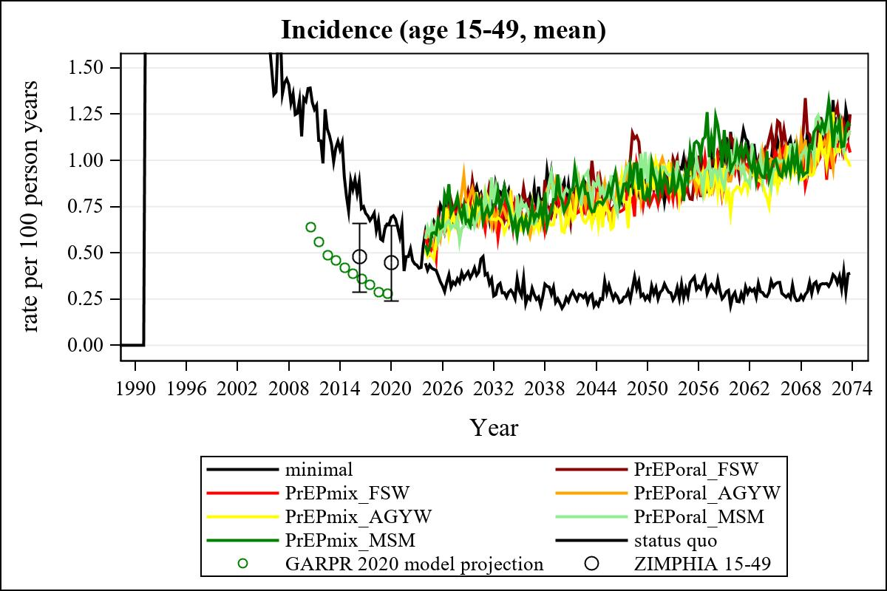

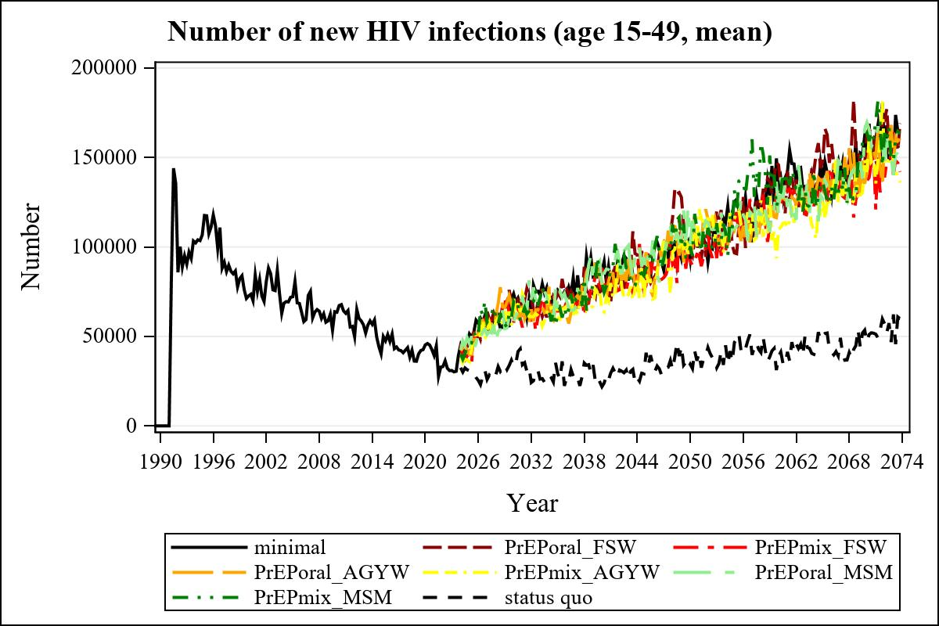

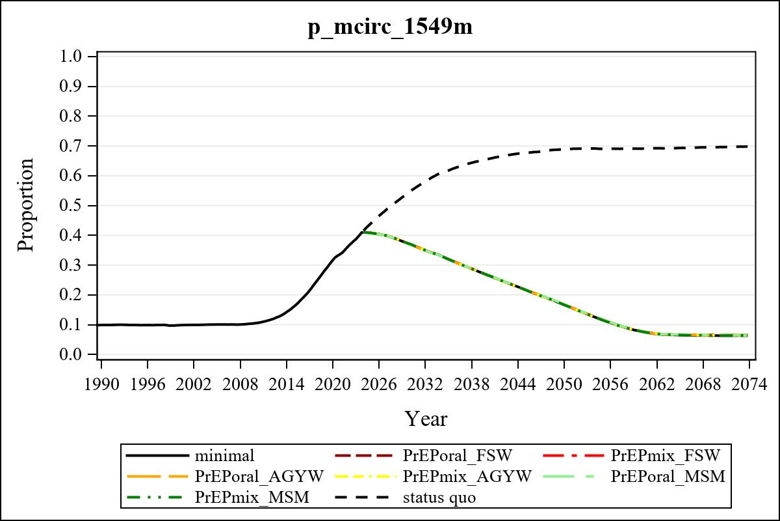

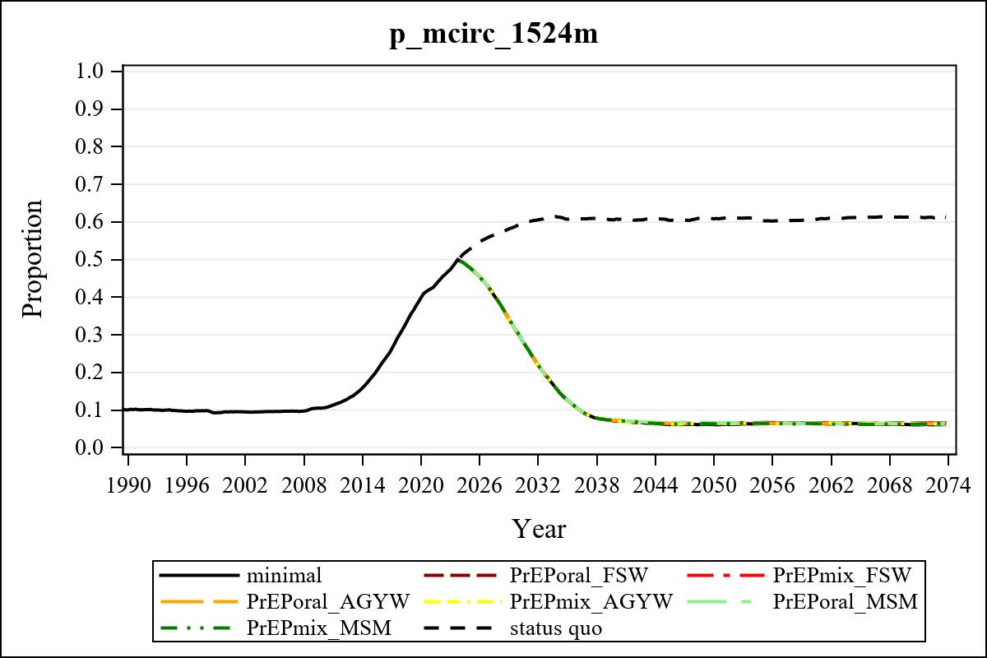

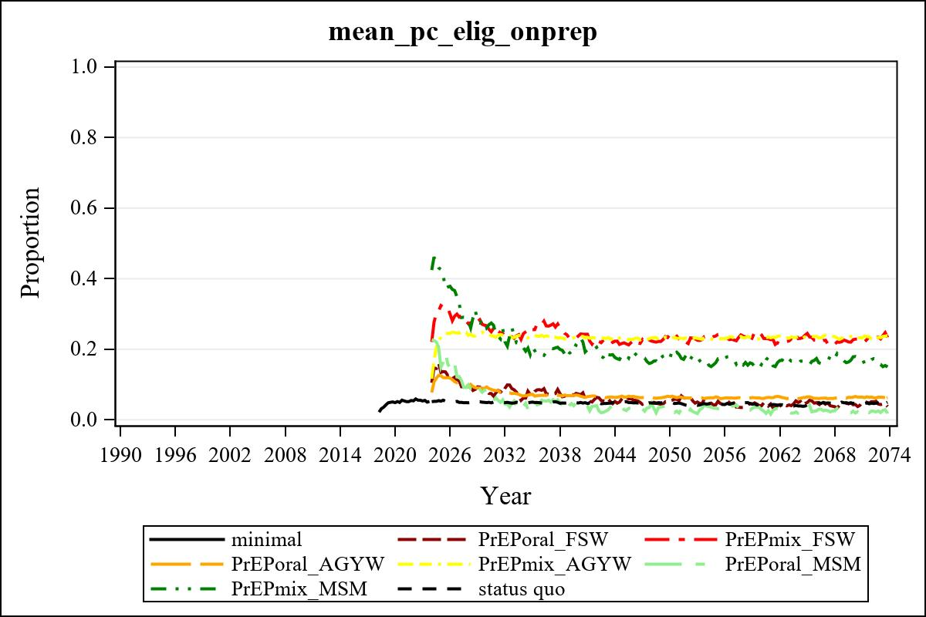

Obs | mean_n_onprep_0
345 | 0

Obs | mean_n_elig_prep_1 | mean_n_sw_1564__1 | mean_n_onprep_sw_1 | mean_n_onprep_w_1
185 | 69927.17 | 121027.53 | 4553.30 | 4553.30

Obs | mean_n_elig_prep_2 | mean_n_sw_1564__2 | mean_n_onprep_sw_2 | mean_n_onprep_w_2
185 | 69971.27 | 120060.75 | 19569.90 | 19569.90

Obs | mean_n_onprep_oral_sw_2 | mean_n_onprep_len_sw_2 | mean_n_elig_prep_3 | mean_n_agyw_pg_3
185 | 2195.71 | 17374.19 | 988998.69 | 1043870.91

Obs | mean_n_onprep_agyw_pg_3 | mean_n_onprep_w_3 | mean_n_elig_prep_4 | mean_n_agyw_pg_4
185 | 83189.19 | 83189.19 | 1006094.72 | 1056048.94

Obs | mean_n_onprep_agyw_pg_4 | mean_n_onprep_w_4 | mean_n_onprep_oral_agyw_pg_4
185 | 241654.30 | 241654.30 | 44865.16

Obs | mean_n_onprep_len_agyw_pg_4 | mean_n_elig_prep_5 | mean_n_alive_msm_5 | mean_n_onprep_msm_5
185 | 196789.14 | 24062.93 | 62847.44 | 1980.22

Obs | mean_n_onprep_m_5 | mean_n_elig_prep_6 | mean_n_alive_msm_6 | mean_n_onprep_msm_6
185 | 1980.22 | 24063.69 | 62929.32 | 6790.52

Obs | mean_n_onprep_m_6 | mean_n_onprep_oral_msm_6 | mean_n_onprep_len_msm_6 | mean_pc_elig_onprep_1
185 | 6790.52 | 951.609 | 5838.91 | 0.082641

Obs | mean_pc_elig_onprep_2 | mean_pc_elig_onprep_3 | mean_pc_elig_onprep_4 | mean_pc_elig_onprep_5
185 | 0.26650 | 0.093159 | 0.24098 | 0.084671

Obs | mean_pc_elig_onprep_6
185 | 0.26100

Obs | mean_n_sw_1564__1 | mean_n_sw_1549__1 | mean_n_elig_prep_1
225 | 167478.12 | 167478.12 | 96142.46

Obs | mean_n_elig_prep_any_sw_1 | mean_n_elig_prep_w_1564__1 | mean_n_elig_prep_w_1549__1
225 | 342261.68 | 96142.46 | 96142.46

Obs | mean_n_sw_1564__2 | mean_n_elig_prep_2 | mean_n_elig_prep_any_sw_2 | mean_n_elig_prep_w_1564__2
225 | 163340.14 | 96556.55 | 354058.04 | 96556.55

Obs | ratio_oral_len_2 | ratio_oral_len_4 | ratio_oral_len_6
1 | 0.11473 | 0.21148 | 0.12326

