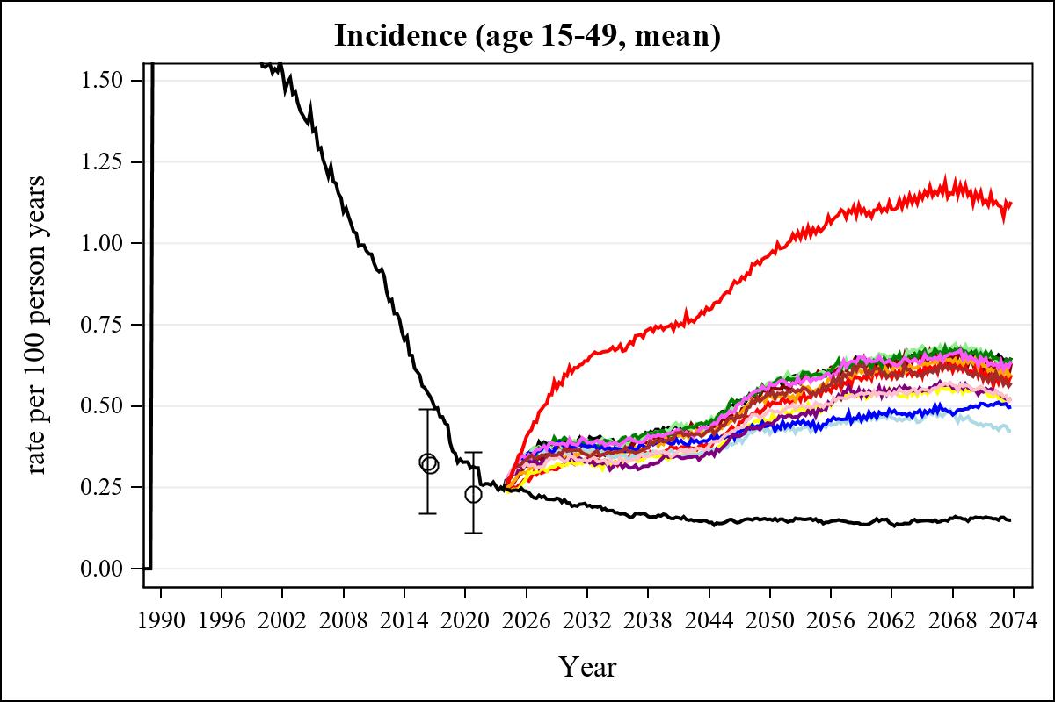

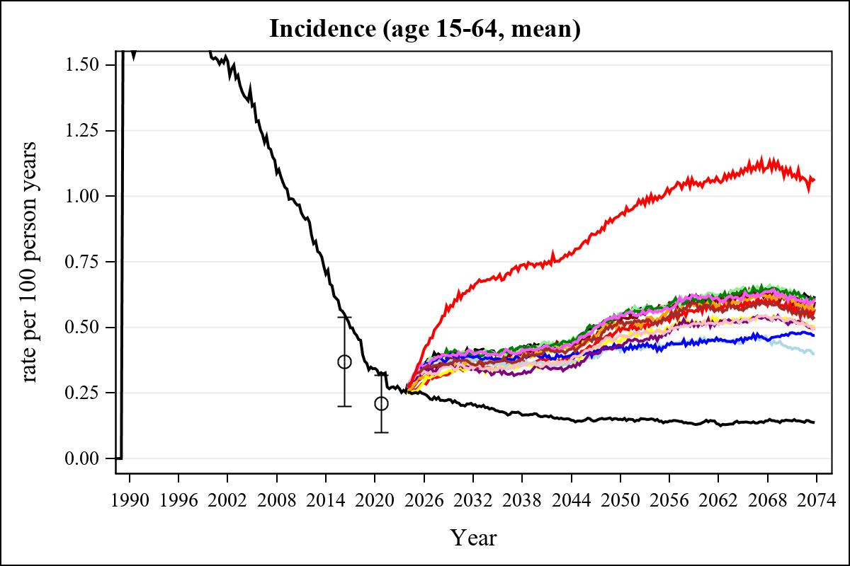

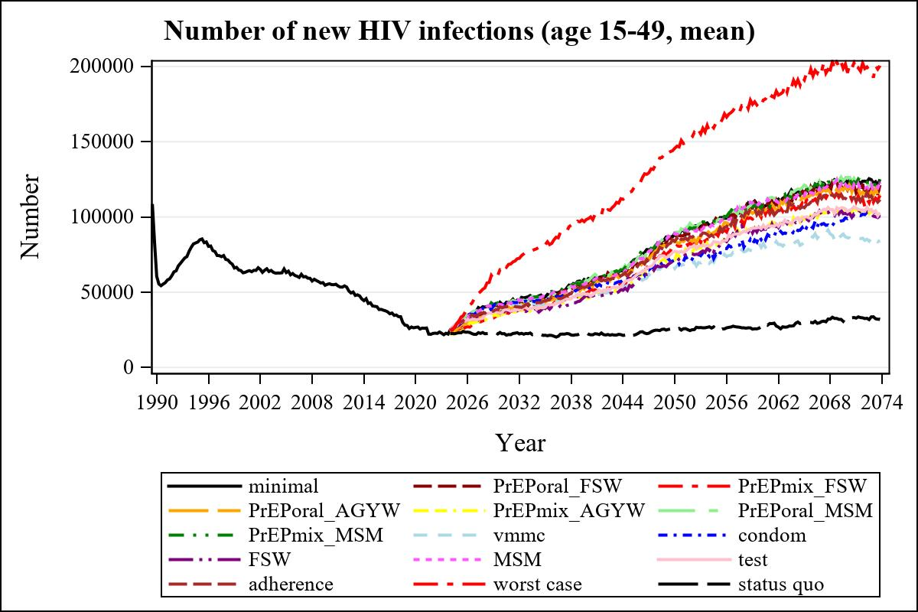

Obs | mean_n_new_inf1549__0 | mean_n_new_inf1549__1 | mean_n_new_inf1549__2 | mean_n_new_inf1549__3
225 | 59170.09 | 55838.37 | 50115.08 | 53540.66

Obs | mean_n_new_inf1549__4 | mean_n_new_inf1549__5 | mean_n_new_inf1549__6 | mean_n_new_inf1549__7
225 | 46147.43 | 57677.98 | 56119.61 | 49095.86

Obs | mean_n_new_inf1549__8 | mean_n_new_inf1549__9 | mean_n_new_inf1549__10 | mean_n_new_inf1549__11
225 | 53104.07 | 47062.18 | 56692.88 | 48659.15

Obs | mean_n_new_inf1549__12 | mean_n_new_inf1549__13 | mean_n_new_inf1549__99
225 | 54404.25 | 98958.09 | 22145.43

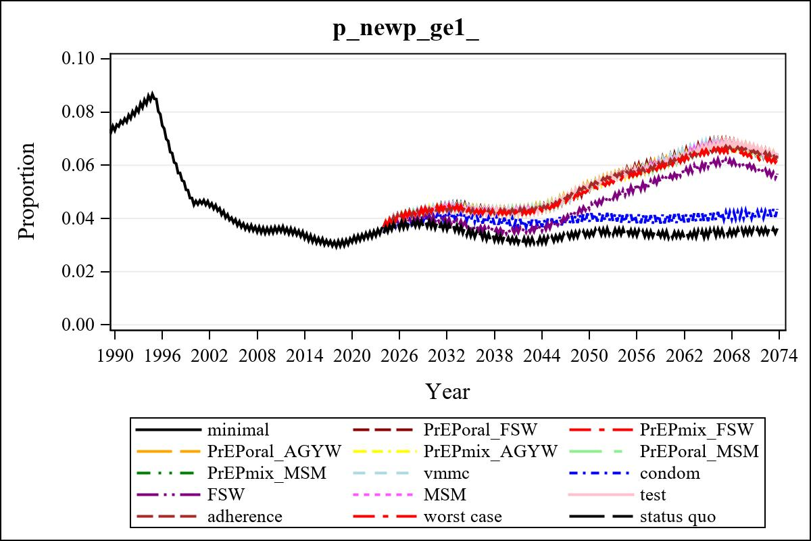

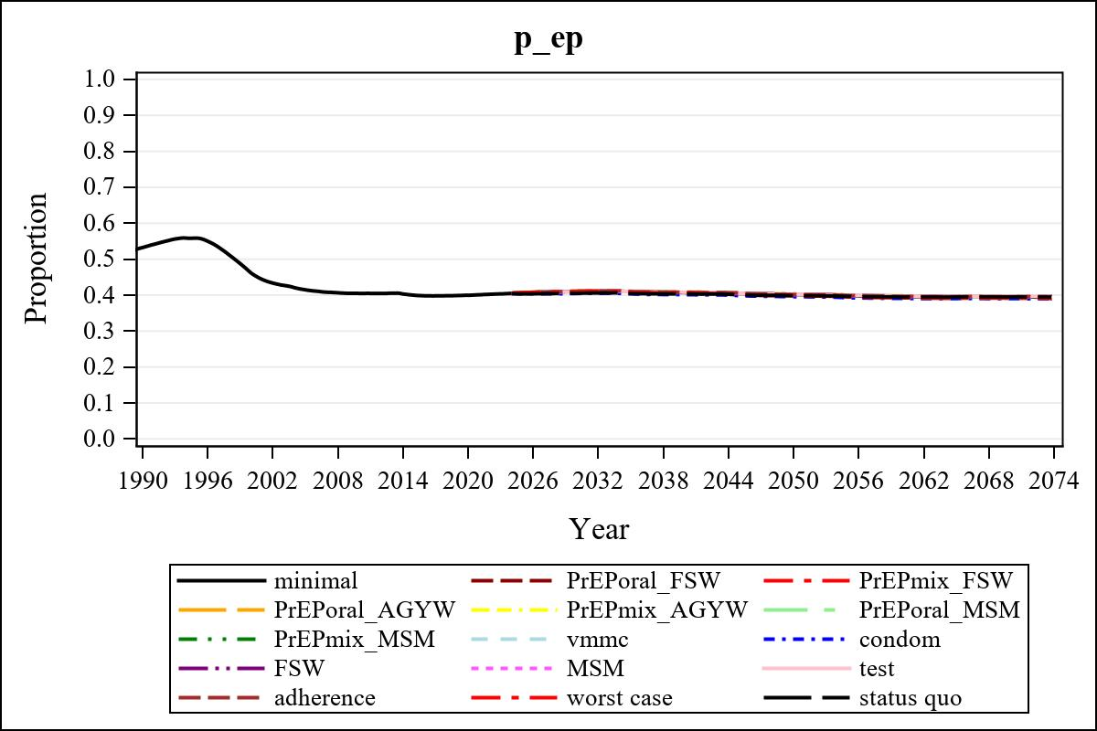

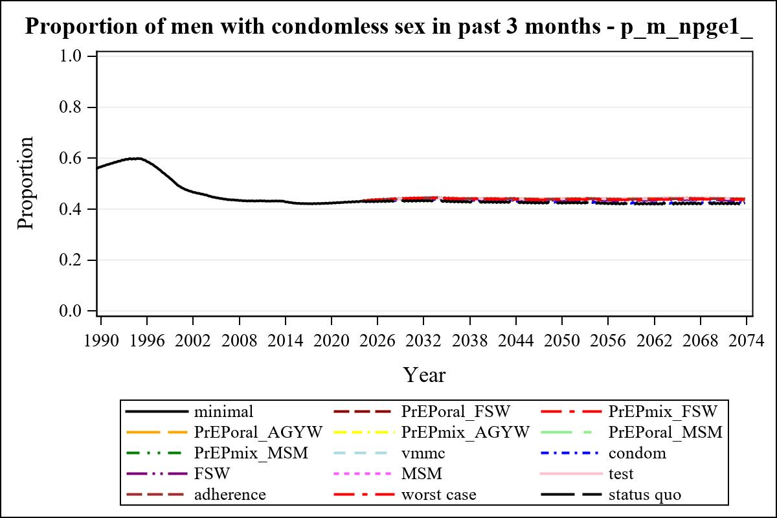

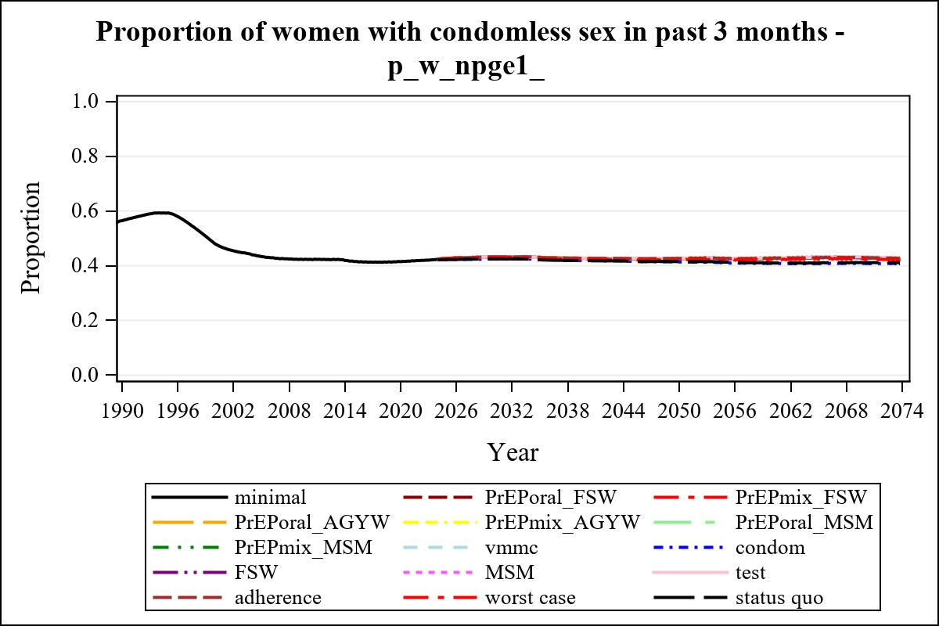

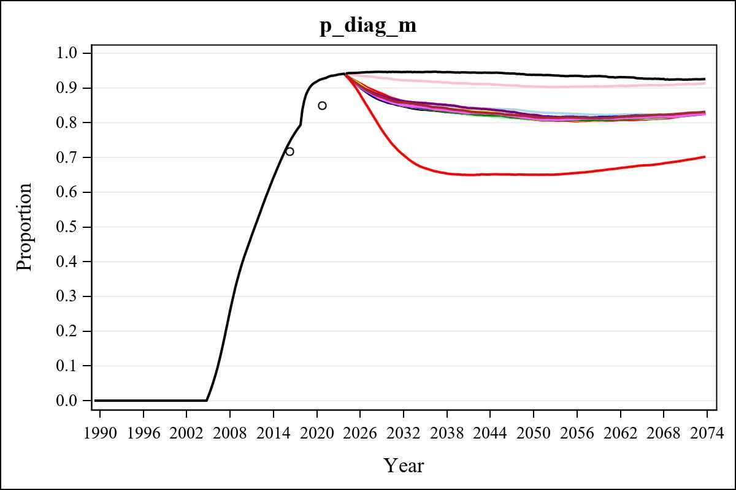

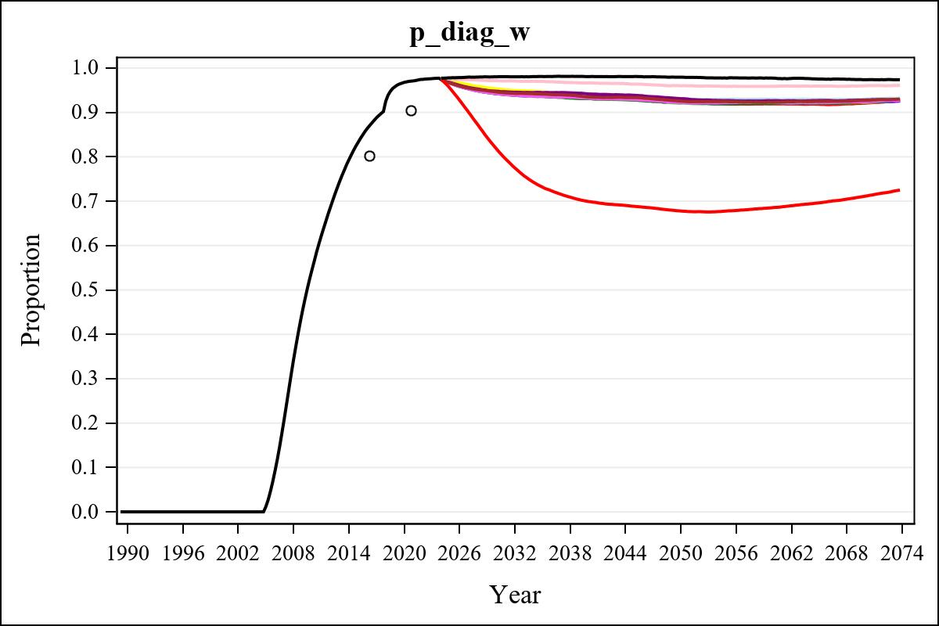

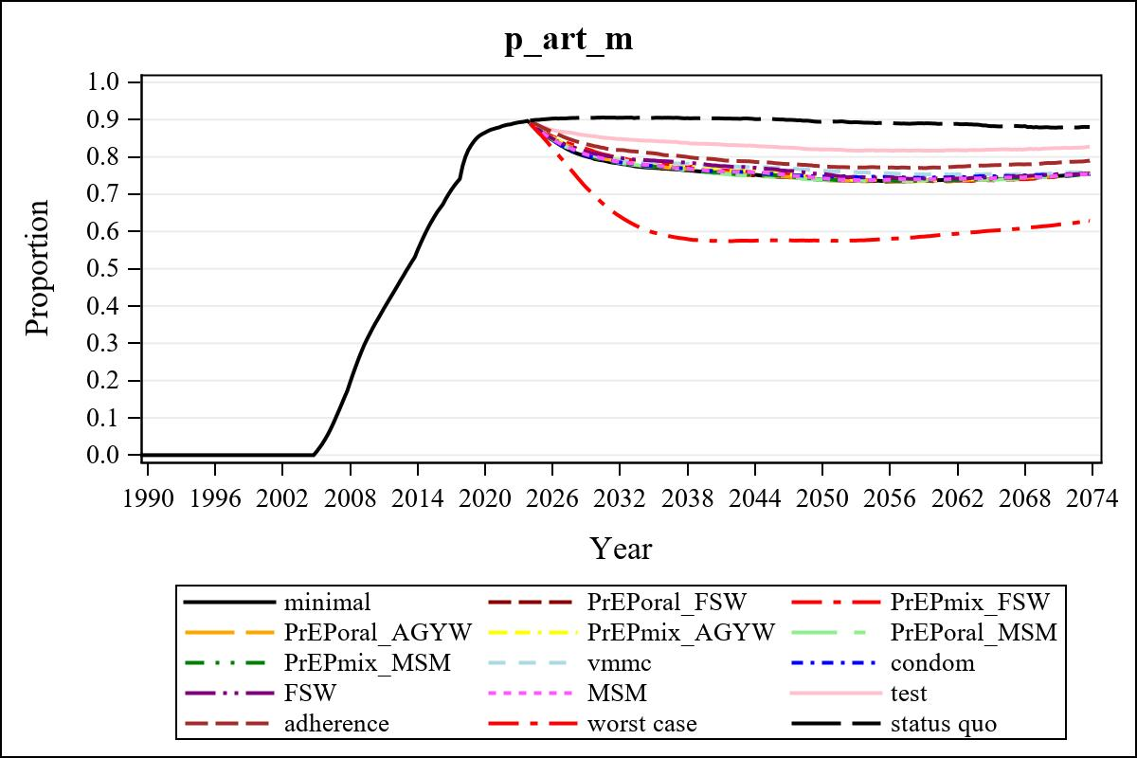

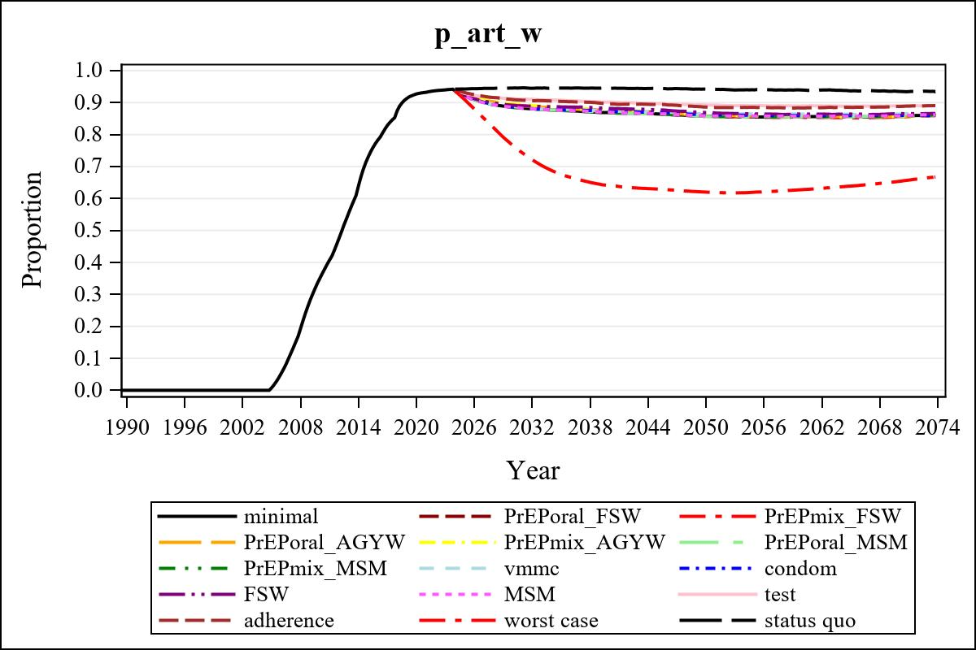

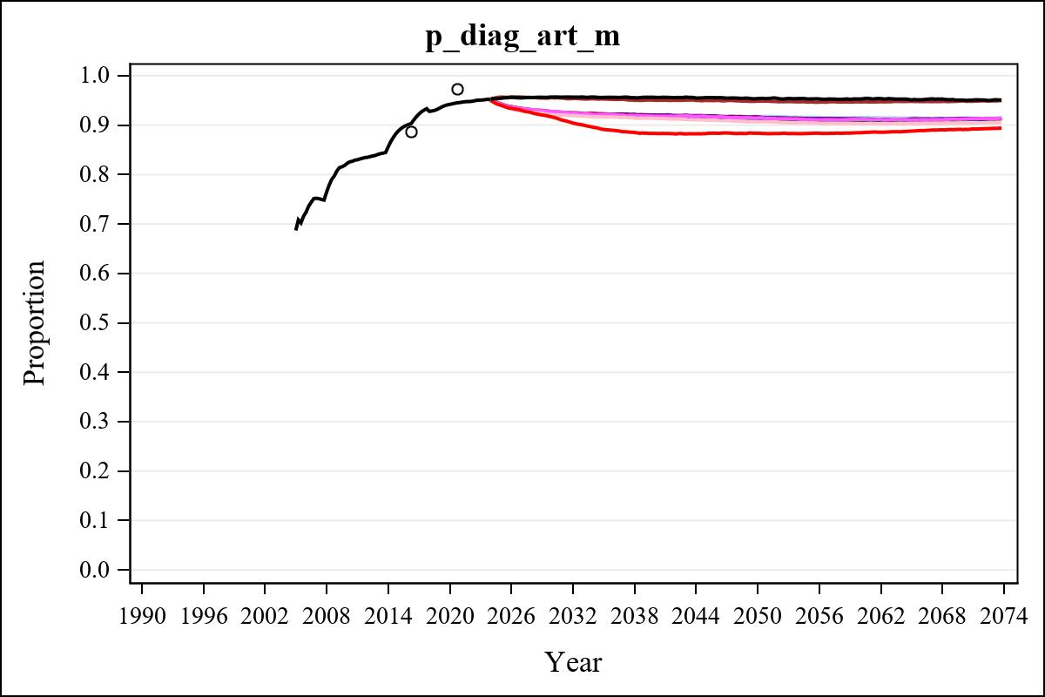

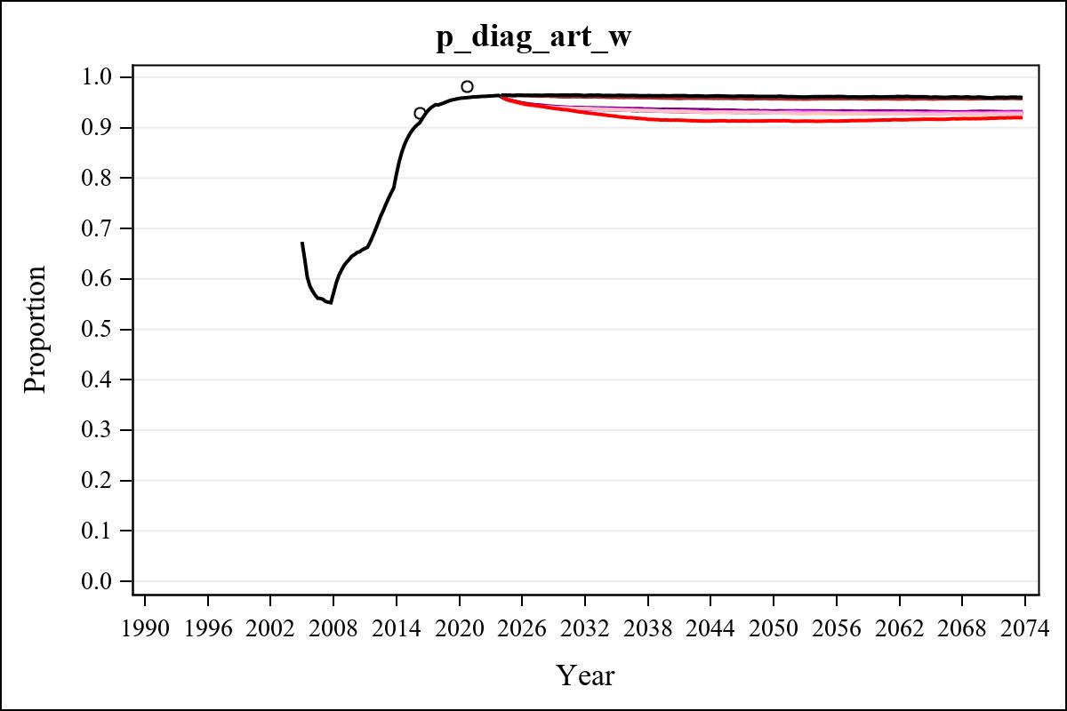

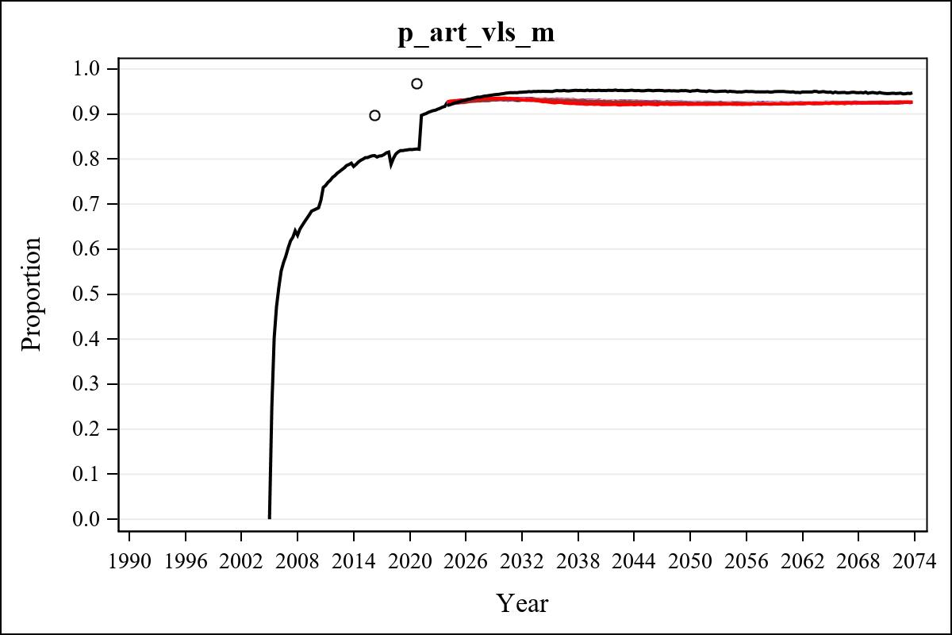

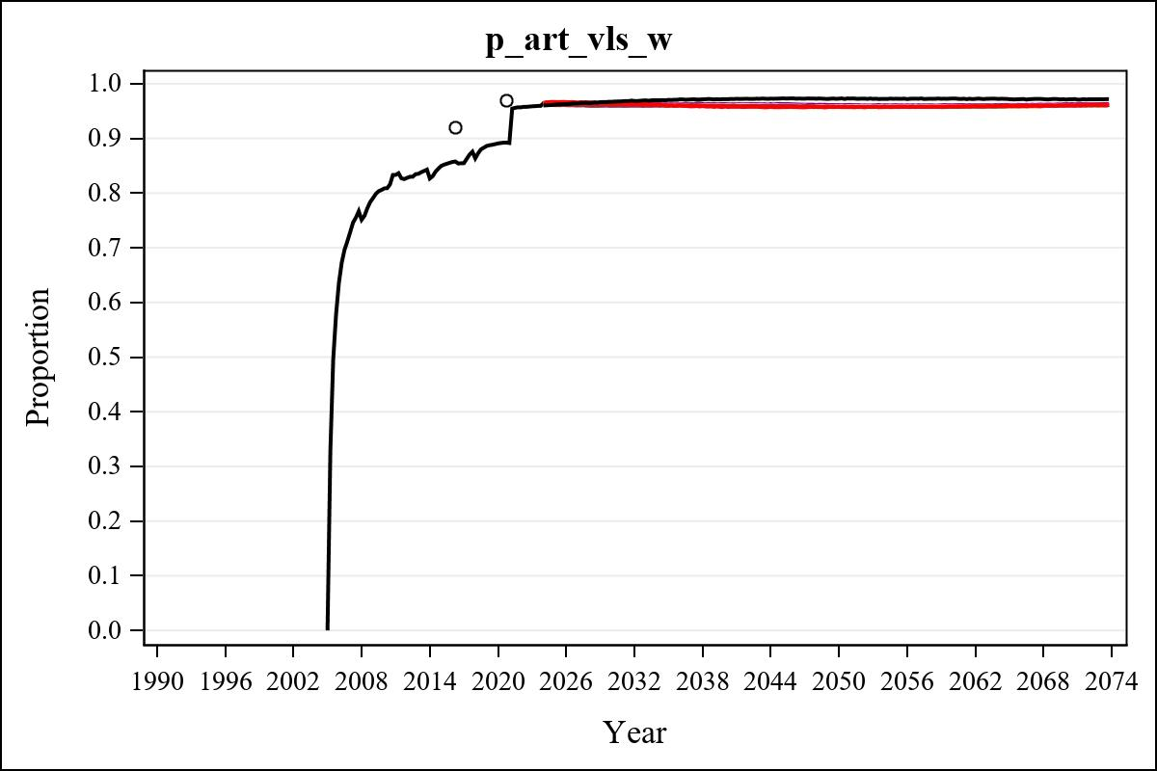

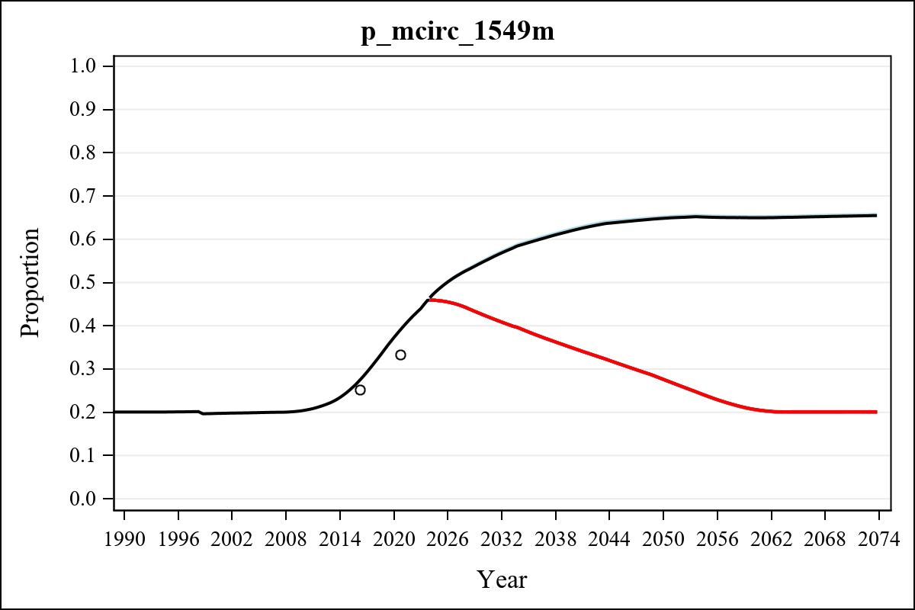

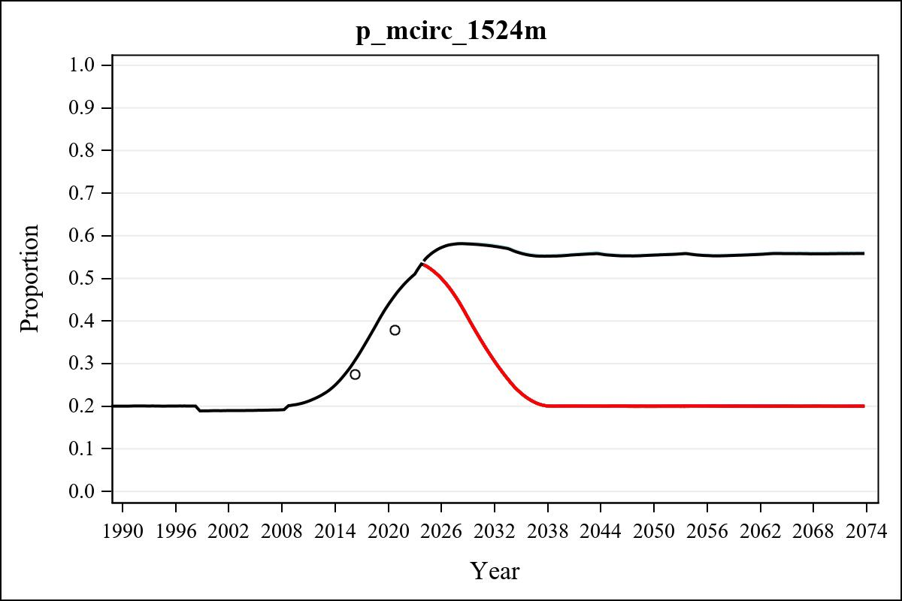

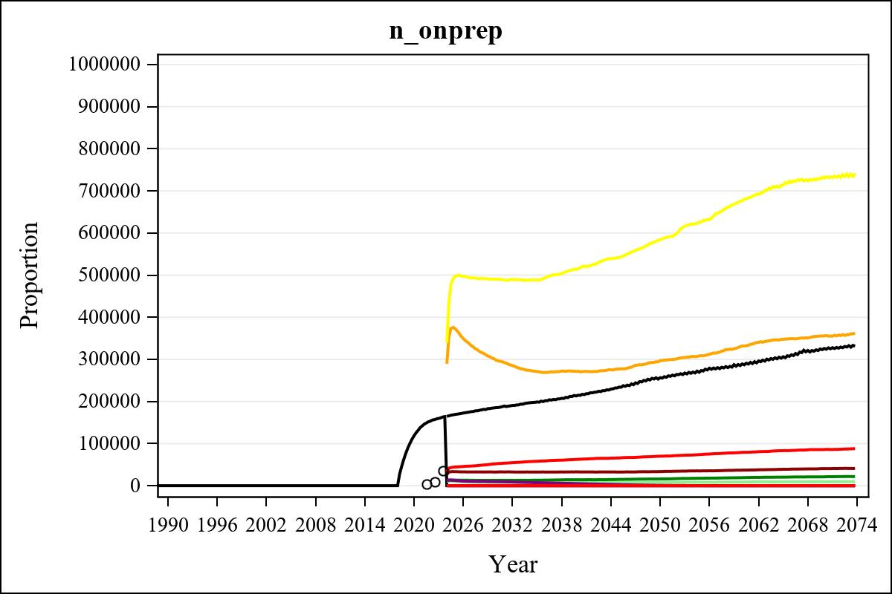

Obs | mean_n_onprep_0 | mean_n_onprep_1 | mean_n_onprep_2 | mean_n_onprep_3
345 | 0 | 40614.95 | 85890.50 | 355521.57

Obs | mean_n_onprep_4 | mean_n_onprep_5 | mean_n_onprep_6 | mean_n_onprep_99
345 | 730371.07 | 9339.72 | 21104.47 | 325839.82

Obs | mean_n_sw_1564__1 | mean_n_undiag_sw_1 | mean_n_elig_prep_1 | mean_n_elig_prep_any_sw_1
185 | 140753.48 | 102494.61 | 103711.68 | 103711.68

Obs | mean_n_onprep_sw_1 | mean_n_onprep_w_1 | mean_n_sw_1564__2 | mean_n_undiag_sw_2
185 | 32562.25 | 32562.25 | 140750.46 | 107746.14

Obs | mean_n_elig_prep_2 | mean_n_elig_prep_any_sw_2 | mean_n_onprep_sw_2 | mean_n_onprep_w_2
185 | 108636.49 | 108636.49 | 52093.16 | 52093.16

Obs | mean_n_onprep_oral_sw_2 | mean_n_onprep_len_sw_2 | mean_n_agyw_pg_3 | mean_n_elig_prep_3
185 | 19107.86 | 32985.30 | 1420269.26 | 1375833.13

Obs | mean_n_onprep_agyw_pg_3 | mean_n_onprep_w_3 | mean_n_agyw_pg_4 | mean_n_elig_prep_4
185 | 298232.27 | 298232.27 | 1419956.33 | 1379140.08

Obs | mean_n_onprep_agyw_pg_4 | mean_n_onprep_w_4 | mean_n_onprep_oral_agyw_pg_4
185 | 489677.11 | 489677.11 | 183406.33

Obs | mean_n_onprep_len_agyw_pg_4 | mean_n_alive_msm_5 | mean_n_elig_prep_5 | mean_n_onprep_msm_5
185 | 306270.78 | 79633.33 | 30280.19 | 7766.73

Obs | mean_n_onprep_m_5 | mean_n_alive_msm_6 | mean_n_elig_prep_6 | mean_n_onprep_msm_6
185 | 7766.73 | 79648.13 | 30422.92 | 12714.08

Obs | mean_n_onprep_m_6 | mean_n_onprep_oral_msm_6 | mean_n_onprep_len_msm_6 | mean_pc_elig_onprep_1
185 | 12714.08 | 4678.69 | 8035.39 | 0.30441

Obs | mean_pc_elig_onprep_2 | mean_pc_elig_onprep_3 | mean_pc_elig_onprep_4 | mean_pc_elig_onprep_5
185 | 0.47326 | 0.22184 | 0.36107 | 0.25368

Obs | mean_pc_elig_onprep_6
185 | 0.41604

Obs | mean_n_sw_1564__1 | mean_n_undiag_sw_1 | mean_n_elig_prep_1
185 | 140753.48 | 102494.61 | 103711.68

Obs | mean_n_elig_prep_any_sw_1 | mean_n_onprep_sw_1 | mean_n_onprep_w_1
185 | 103711.68 | 32562.25 | 32562.25

Obs | ratio_oral_len_2 | ratio_oral_len_4 | ratio_oral_len_6
1 | 0.55515 | 0.57554 | 0.51818

