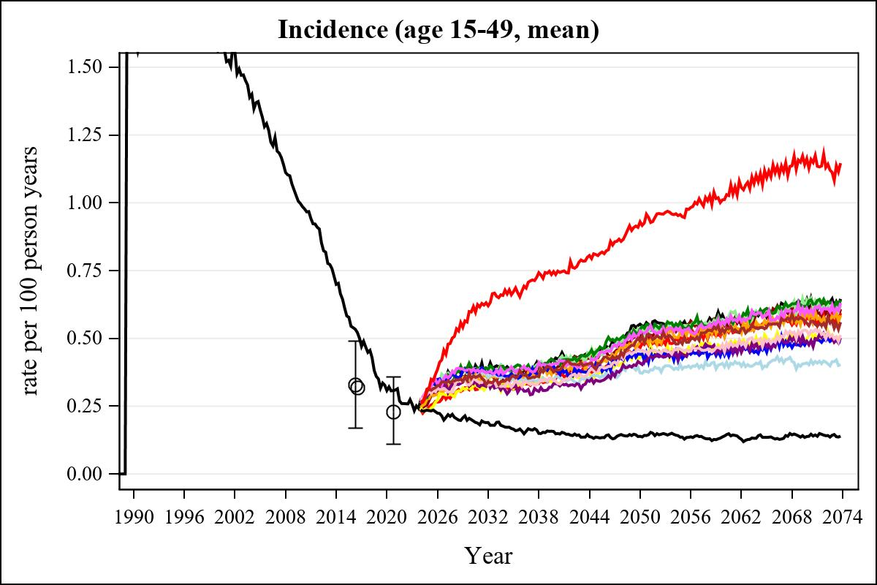

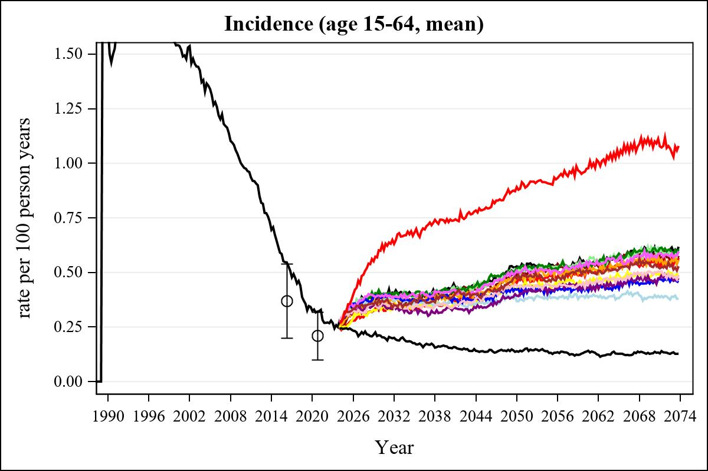

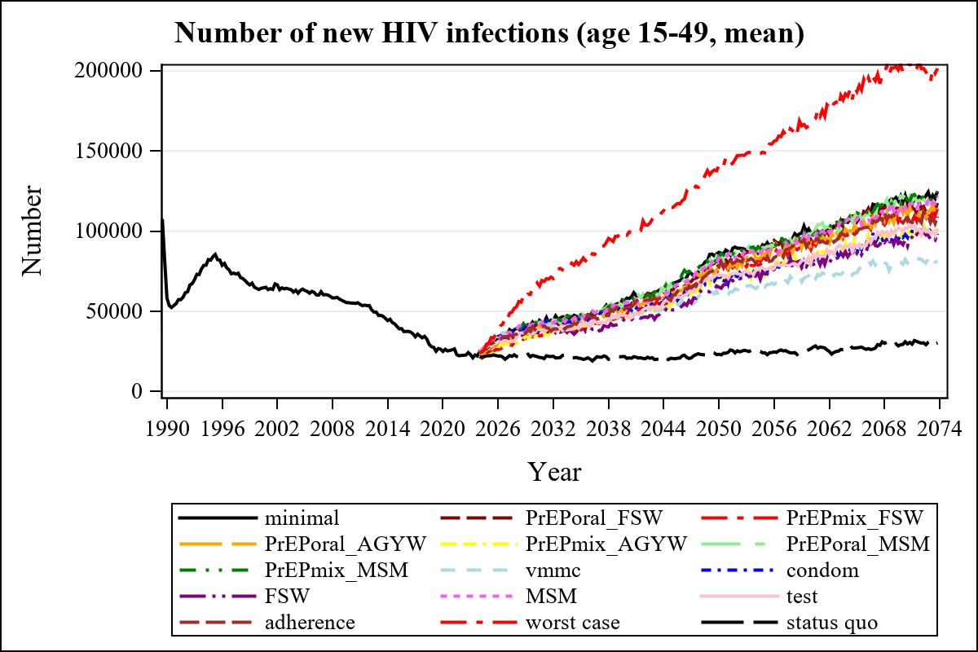

Obs | mean_n_new_inf1549__0 | mean_n_new_inf1549__1 | mean_n_new_inf1549__2 | mean_n_new_inf1549__3
225 | 58277.30 | 52589.07 | 48142.71 | 51130.49

Obs | mean_n_new_inf1549__4 | mean_n_new_inf1549__5 | mean_n_new_inf1549__6 | mean_n_new_inf1549__7
225 | 46047.82 | 56217.90 | 55784.22 | 49099.17

Obs | mean_n_new_inf1549__8 | mean_n_new_inf1549__9 | mean_n_new_inf1549__10 | mean_n_new_inf1549__11
225 | 52131.79 | 45612.31 | 55447.03 | 46977.19

Obs | mean_n_new_inf1549__12 | mean_n_new_inf1549__13 | mean_n_new_inf1549__99
225 | 52594.28 | 97585.98 | 20669.17

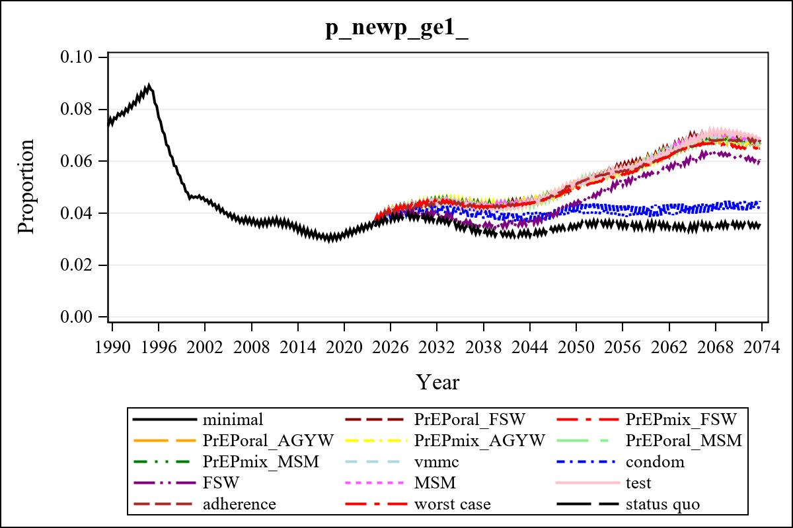

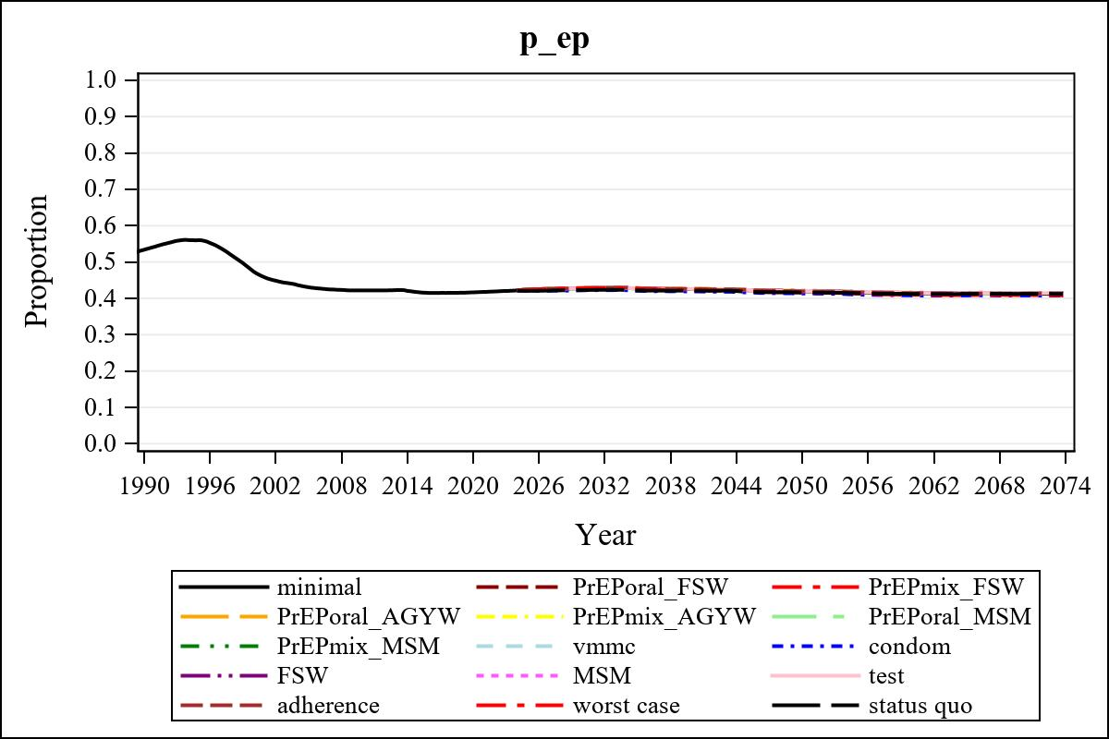

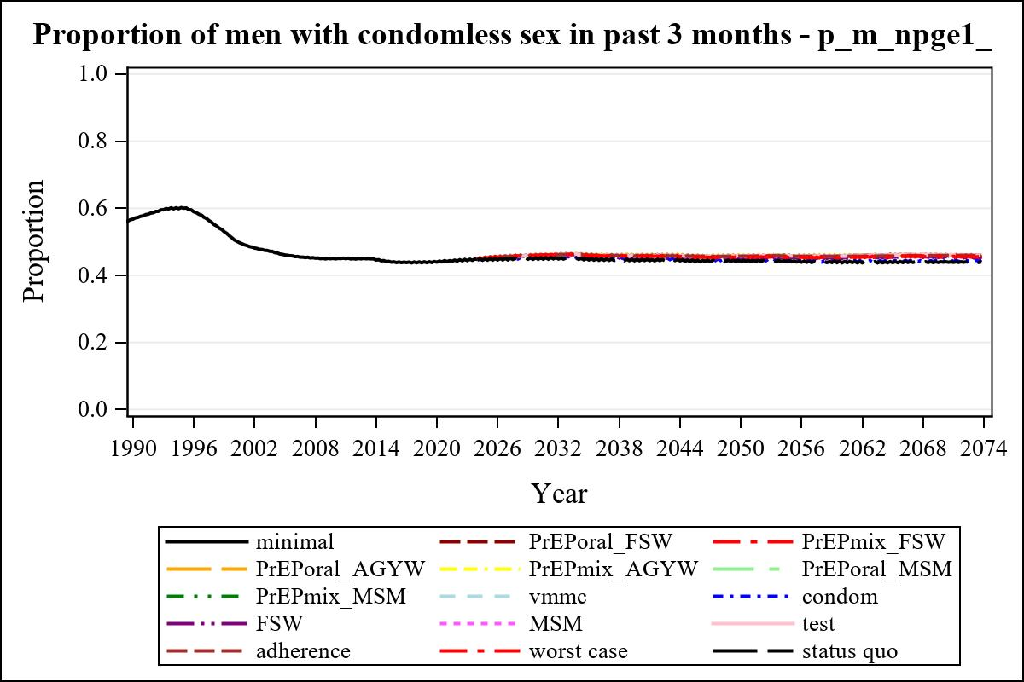

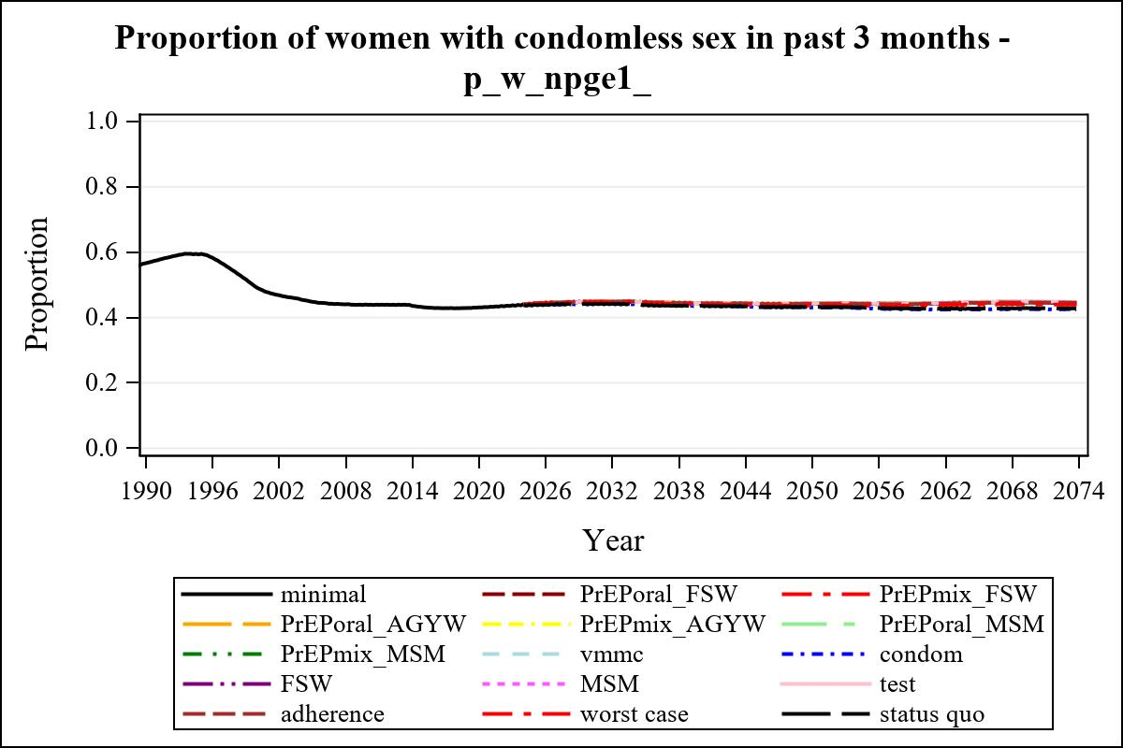

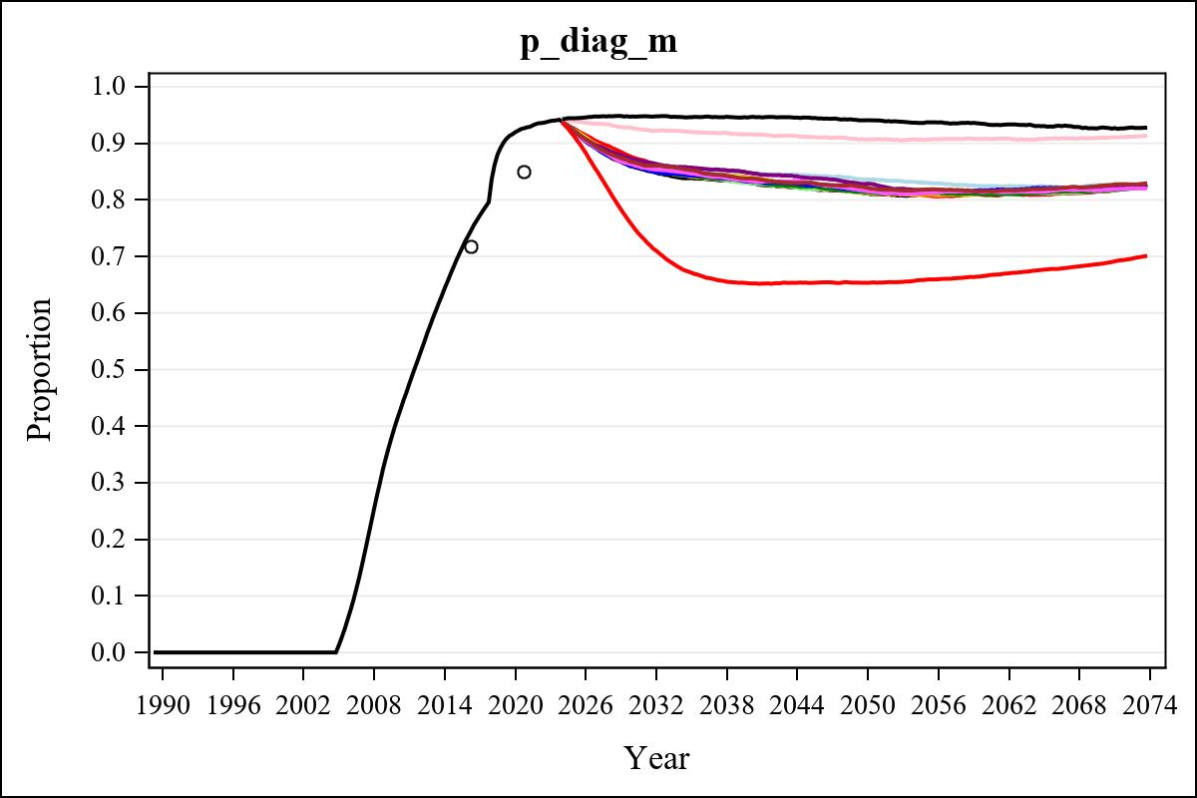

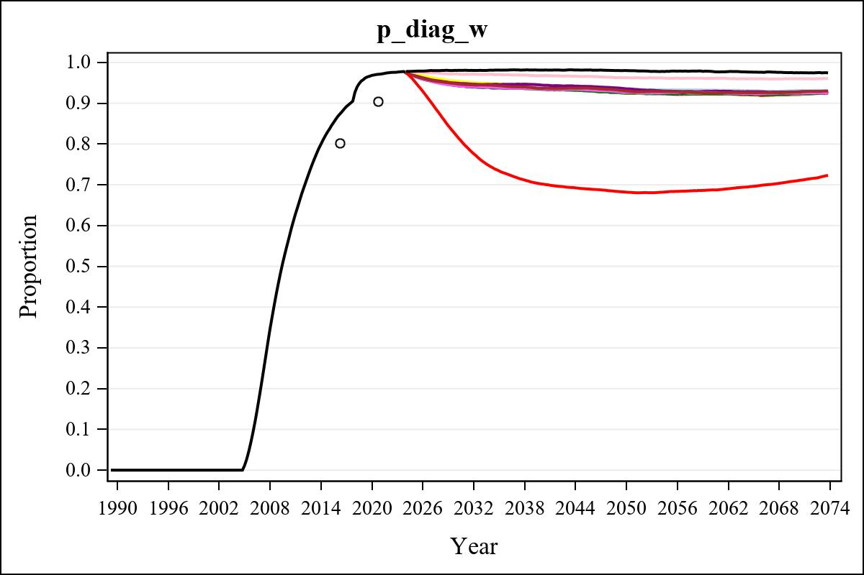

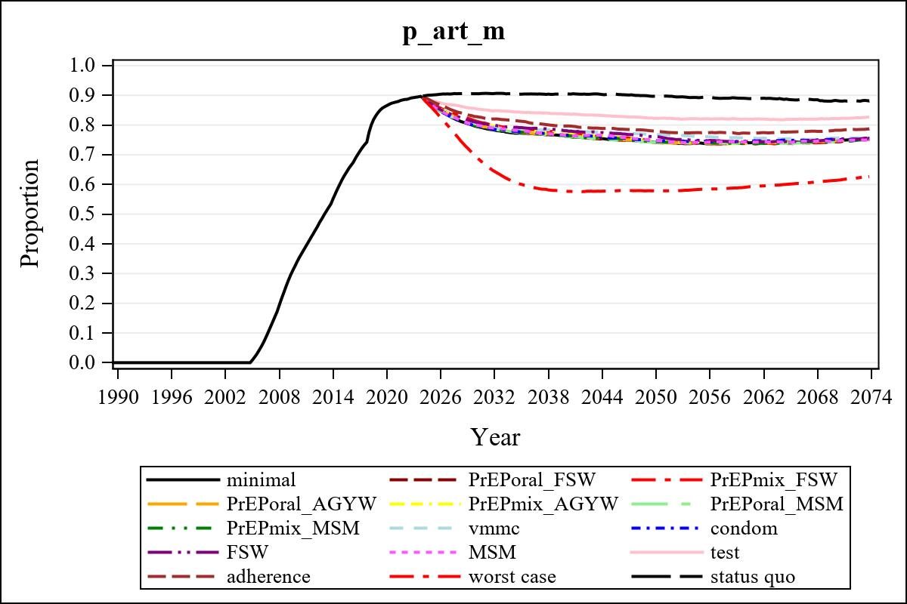

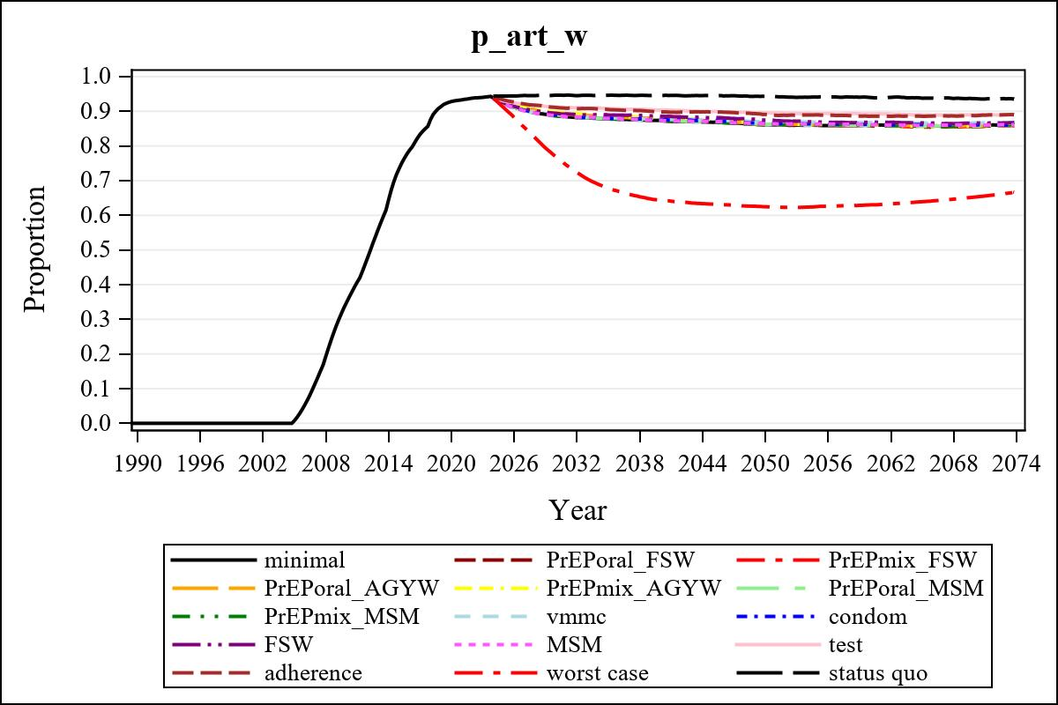

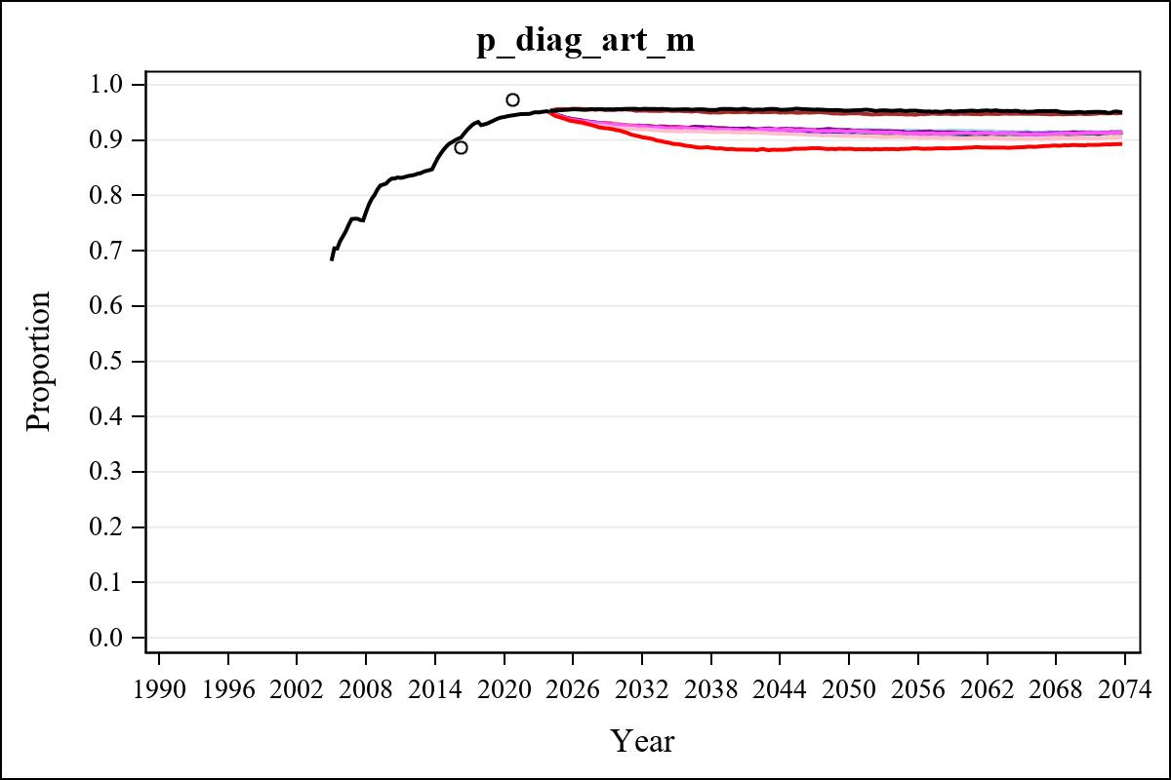

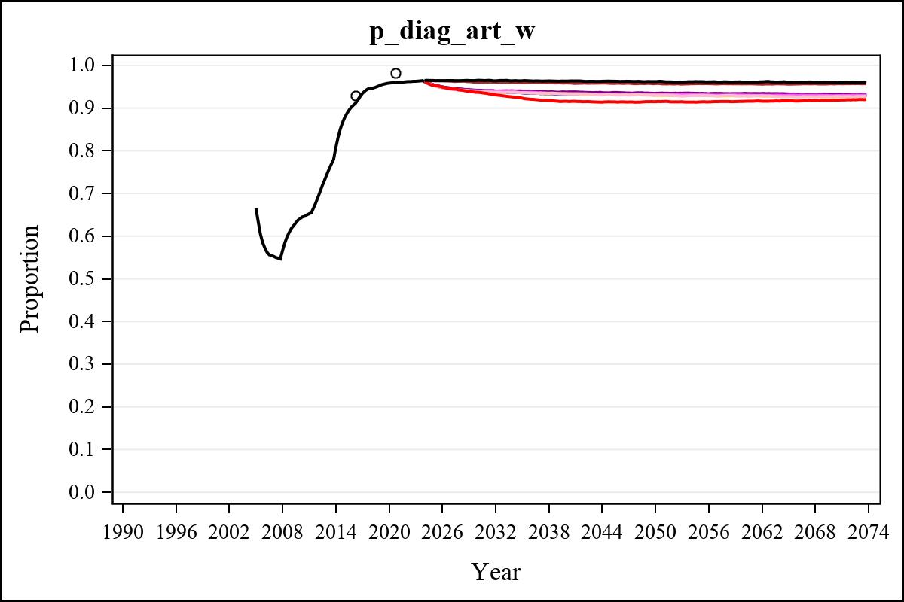

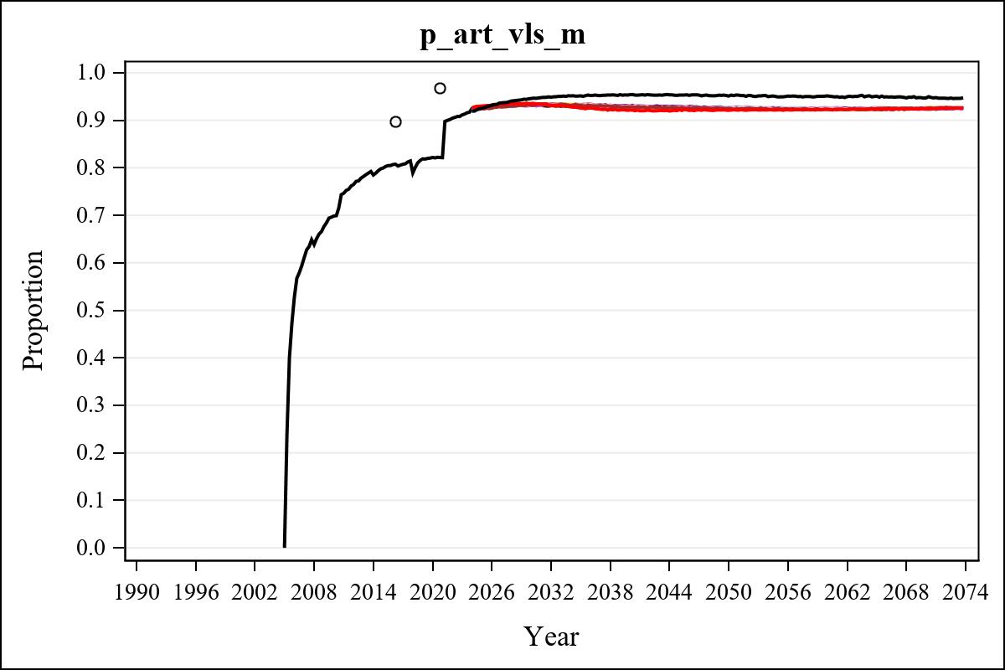

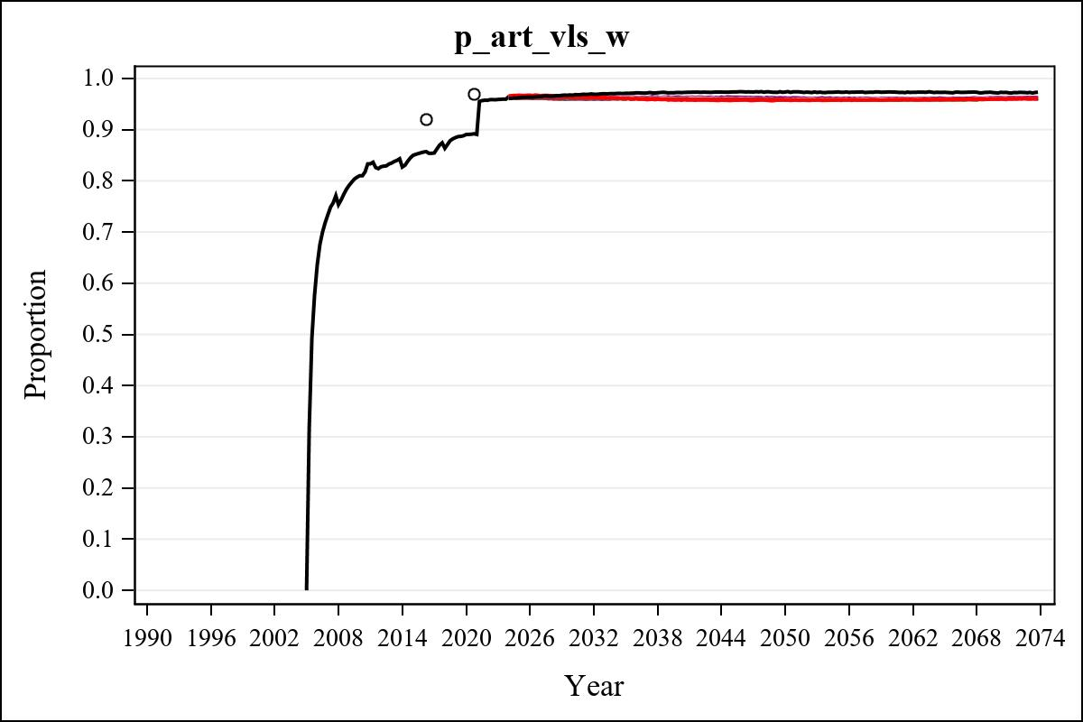

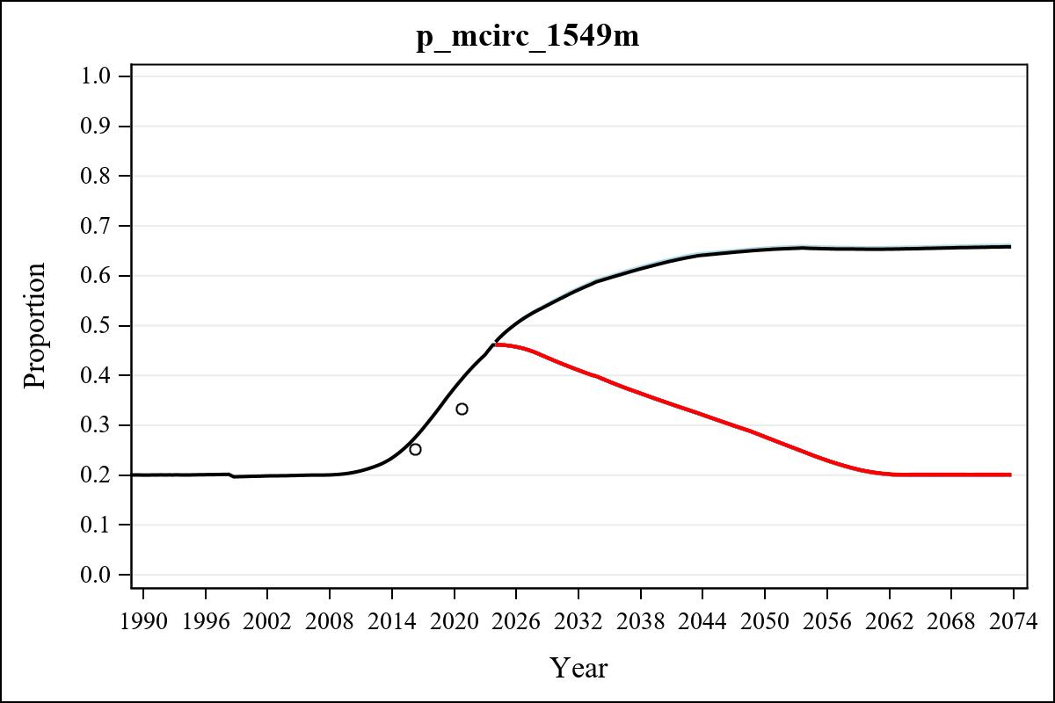

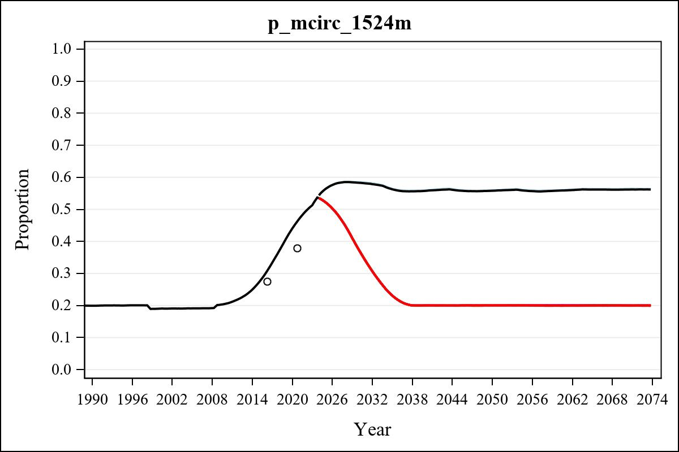

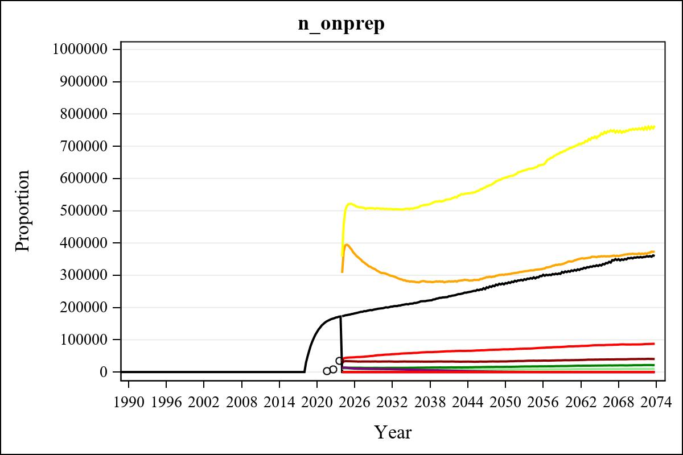

Obs | mean_n_onprep_0 | mean_n_onprep_1 | mean_n_onprep_2 | mean_n_onprep_3
345 | 0 | 40120.64 | 85396.97 | 365894.18

Obs | mean_n_onprep_4 | mean_n_onprep_5 | mean_n_onprep_6 | mean_n_onprep_99
345 | 750438.75 | 9472.87 | 20747.30 | 354143.69

Obs | mean_n_sw_1564__1 | mean_n_undiag_sw_1 | mean_n_elig_prep_1 | mean_n_elig_prep_any_sw_1
185 | 142867.74 | 103544.52 | 104736.45 | 104736.45

Obs | mean_n_onprep_sw_1 | mean_n_onprep_w_1 | mean_n_sw_1564__2 | mean_n_undiag_sw_2
185 | 32375.95 | 32375.95 | 142998.78 | 108913.04

Obs | mean_n_elig_prep_2 | mean_n_elig_prep_any_sw_2 | mean_n_onprep_sw_2 | mean_n_onprep_w_2
185 | 109797.38 | 109797.38 | 52426.41 | 52426.41

Obs | mean_n_onprep_oral_sw_2 | mean_n_onprep_len_sw_2 | mean_n_agyw_pg_3 | mean_n_elig_prep_3
185 | 19281.01 | 33145.40 | 1478875.65 | 1432942.92

Obs | mean_n_onprep_agyw_pg_3 | mean_n_onprep_w_3 | mean_n_agyw_pg_4 | mean_n_elig_prep_4
185 | 309494.23 | 309494.23 | 1480356.28 | 1438523.73

Obs | mean_n_onprep_agyw_pg_4 | mean_n_onprep_w_4 | mean_n_onprep_oral_agyw_pg_4
185 | 506457.25 | 506457.25 | 190761.91

Obs | mean_n_onprep_len_agyw_pg_4 | mean_n_alive_msm_5 | mean_n_elig_prep_5 | mean_n_onprep_msm_5
185 | 315695.34 | 79863.20 | 30683.84 | 7896.55

Obs | mean_n_onprep_m_5 | mean_n_alive_msm_6 | mean_n_elig_prep_6 | mean_n_onprep_msm_6
185 | 7896.55 | 79996.99 | 30778.96 | 12775.55

Obs | mean_n_onprep_m_6 | mean_n_onprep_oral_msm_6 | mean_n_onprep_len_msm_6 | mean_pc_elig_onprep_1
185 | 12775.55 | 4816.20 | 7959.35 | 0.30519

Obs | mean_pc_elig_onprep_2 | mean_pc_elig_onprep_3 | mean_pc_elig_onprep_4 | mean_pc_elig_onprep_5
185 | 0.47456 | 0.21980 | 0.35700 | 0.25354

Obs | mean_pc_elig_onprep_6
185 | 0.41273

Obs | mean_n_sw_1564__1 | mean_n_undiag_sw_1 | mean_n_elig_prep_1
185 | 142867.74 | 103544.52 | 104736.45

Obs | mean_n_elig_prep_any_sw_1 | mean_n_onprep_sw_1 | mean_n_onprep_w_1
185 | 104736.45 | 32375.95 | 32375.95

Obs | ratio_oral_len_2 | ratio_oral_len_4 | ratio_oral_len_6
1 | 0.54881 | 0.57928 | 0.51797

