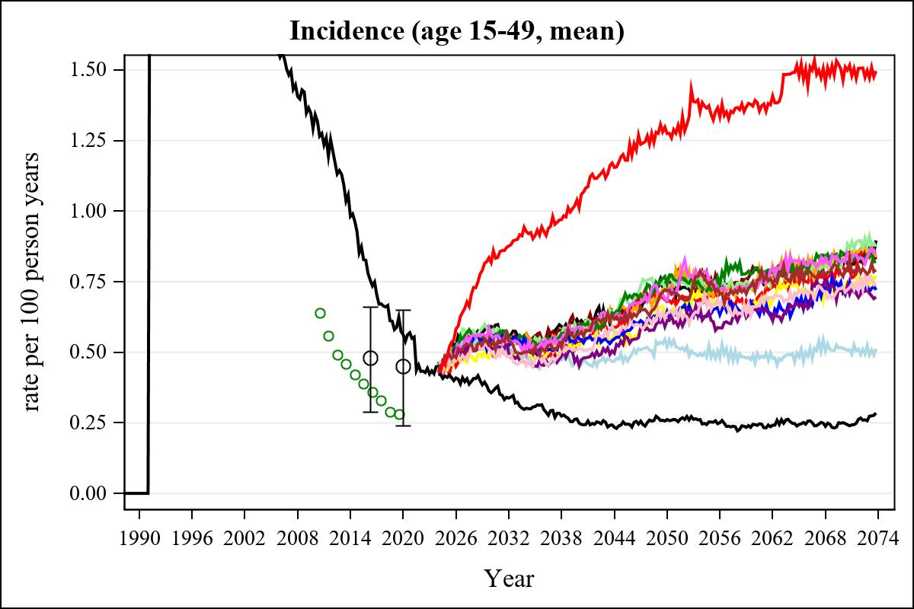

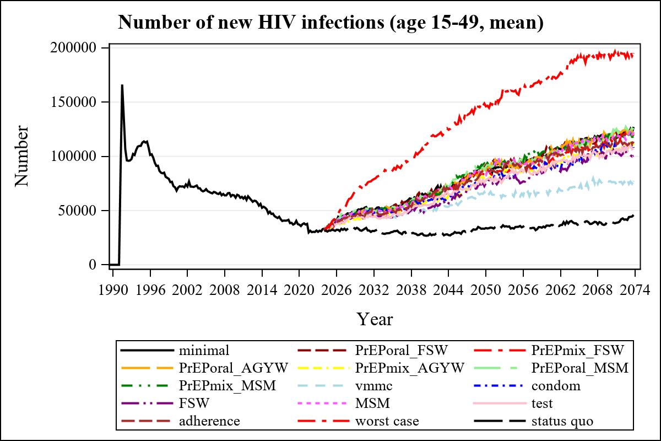

Obs | mean_n_new_inf1549__0 | mean_n_new_inf1549__1 | mean_n_new_inf1549__2 | mean_n_new_inf1549__3
225 | 64215.16 | 64274.71 | 56640.24 | 61590.13

Obs | mean_n_new_inf1549__4 | mean_n_new_inf1549__5 | mean_n_new_inf1549__6 | mean_n_new_inf1549__7
225 | 57082.95 | 63584.97 | 63798.41 | 51224.60

Obs | mean_n_new_inf1549__8 | mean_n_new_inf1549__9 | mean_n_new_inf1549__10 | mean_n_new_inf1549__11
225 | 58459.48 | 48481.95 | 62917.04 | 54933.31

Obs | mean_n_new_inf1549__12 | mean_n_new_inf1549__13 | mean_n_new_inf1549__99
225 | 60423.12 | 104746.41 | 27314.54

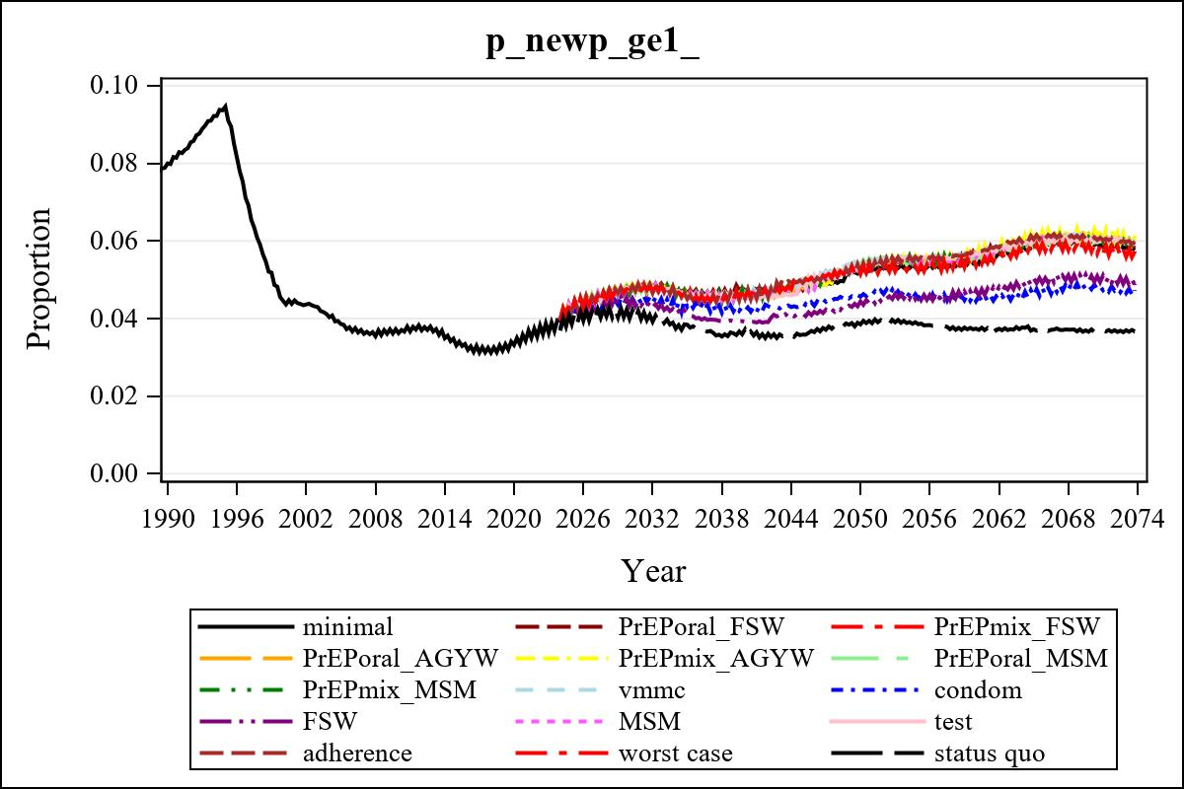

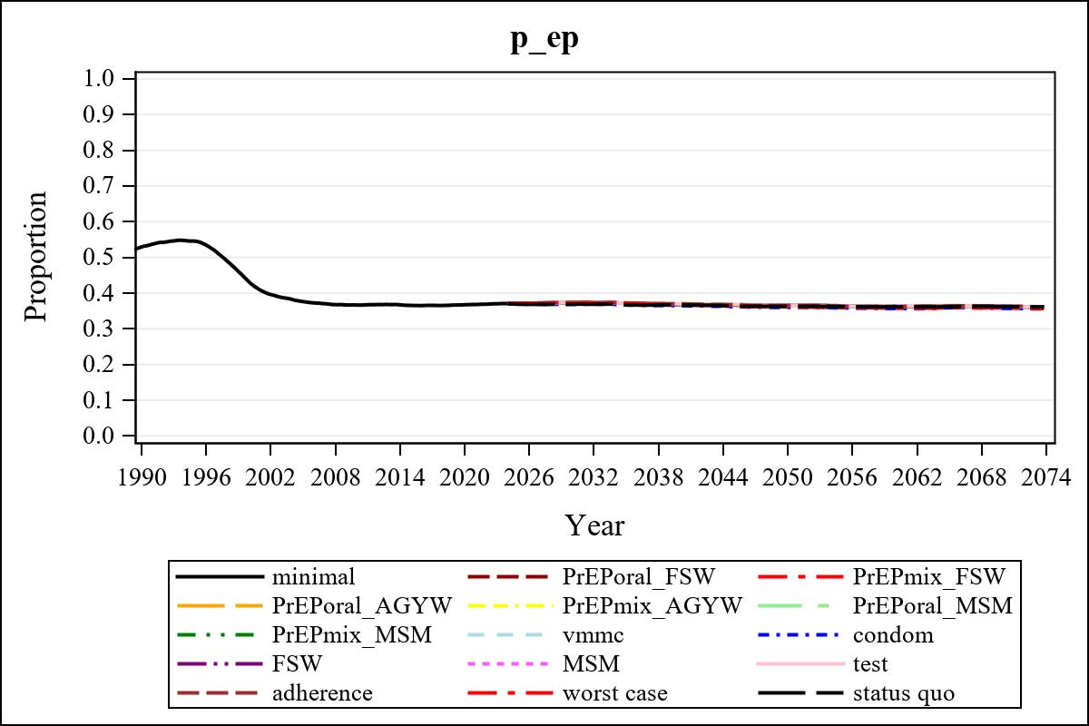

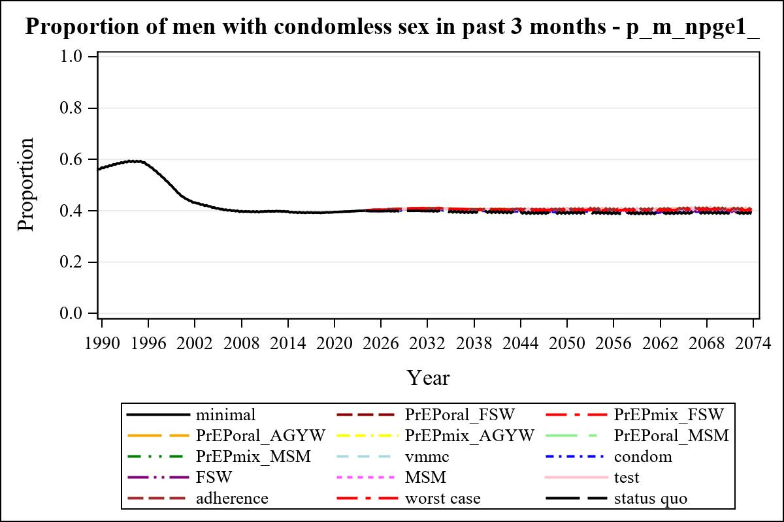

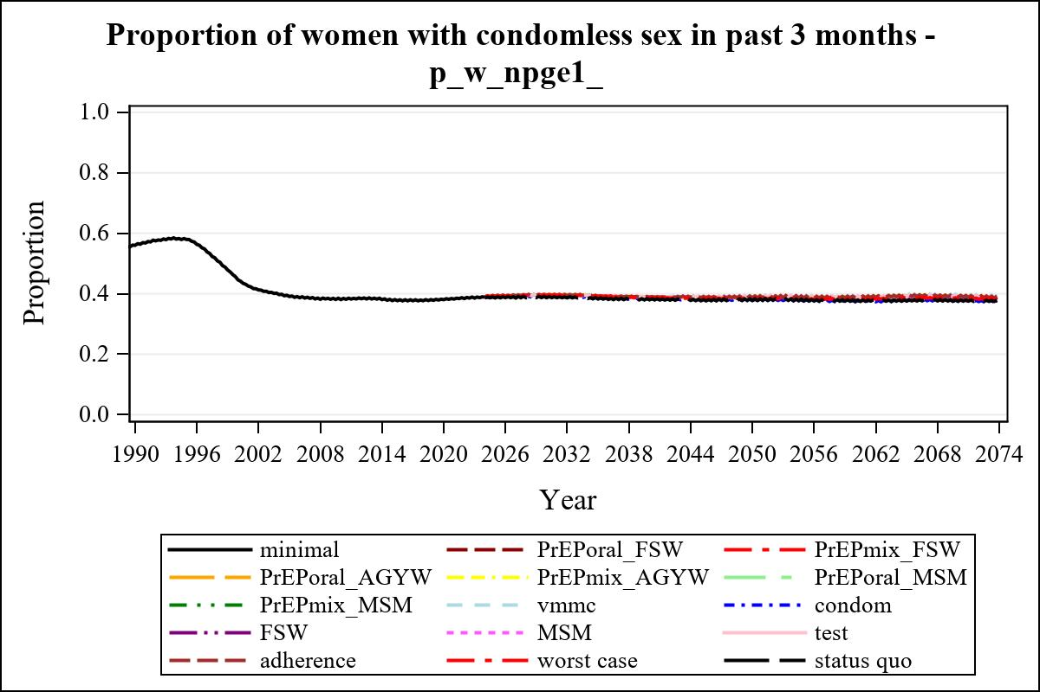

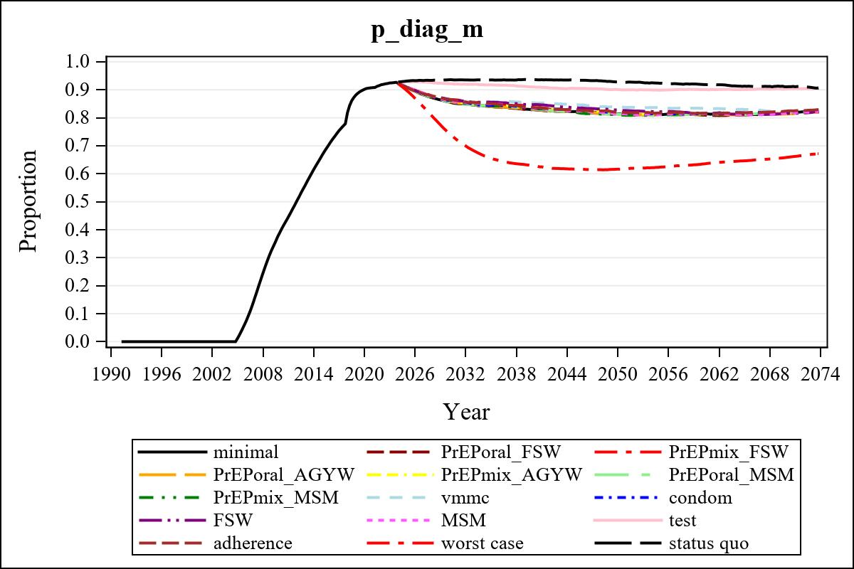

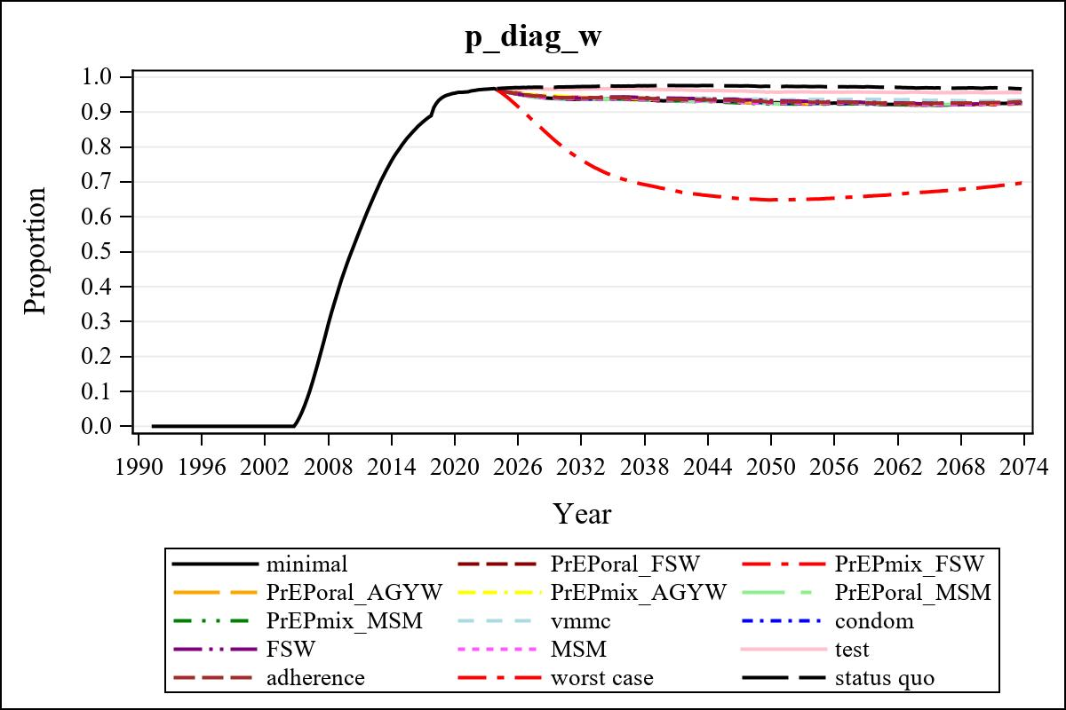

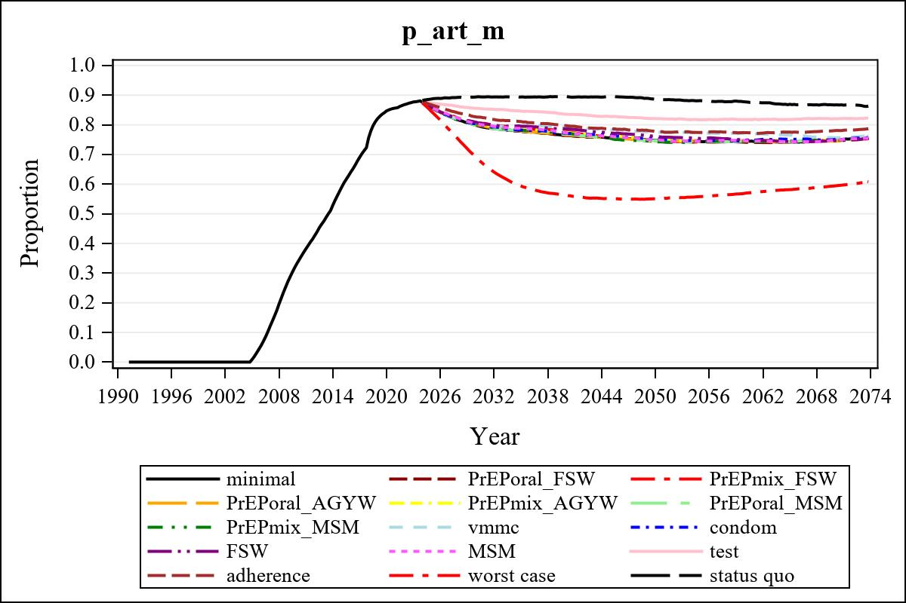

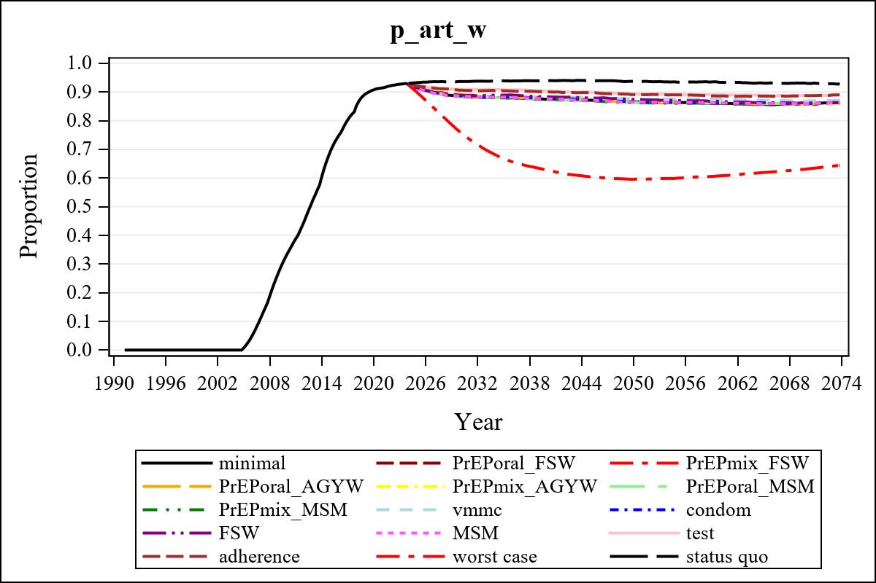

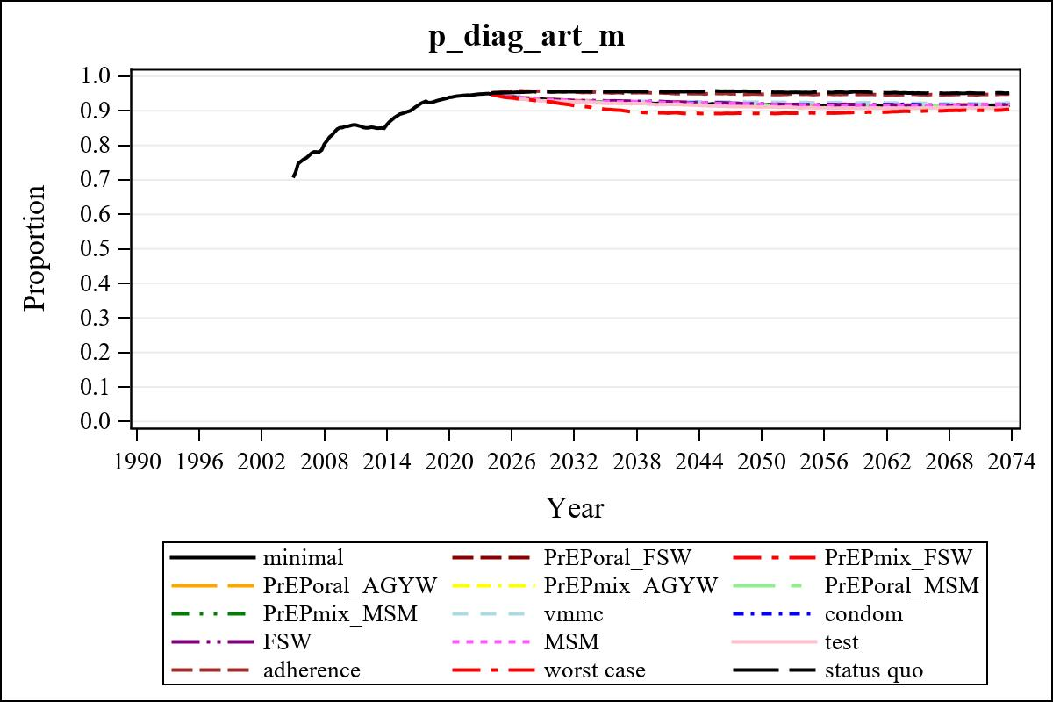

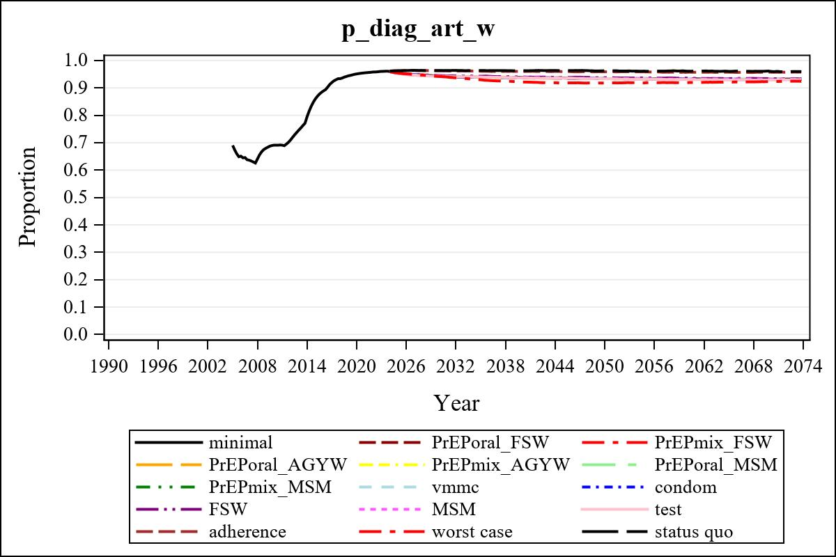

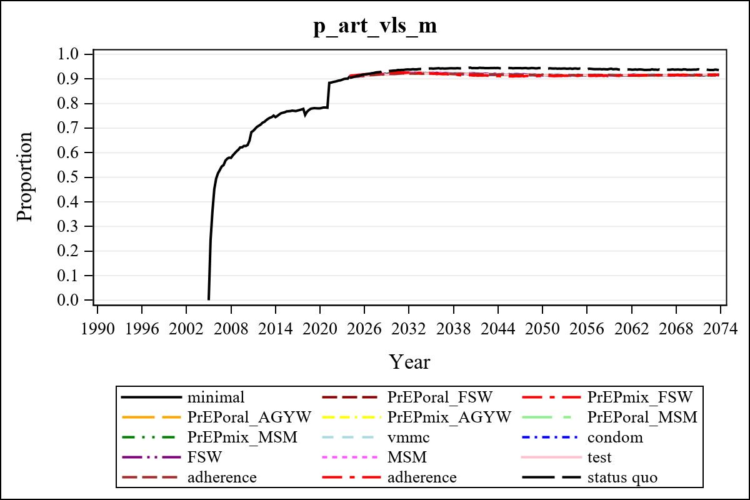

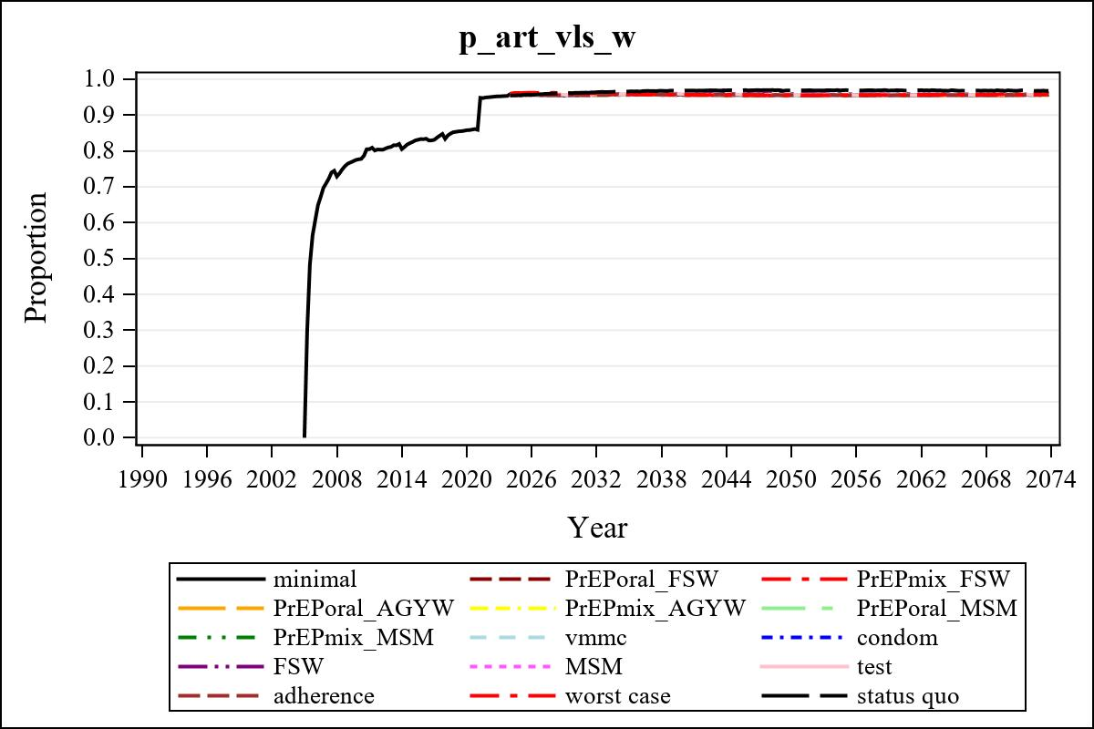

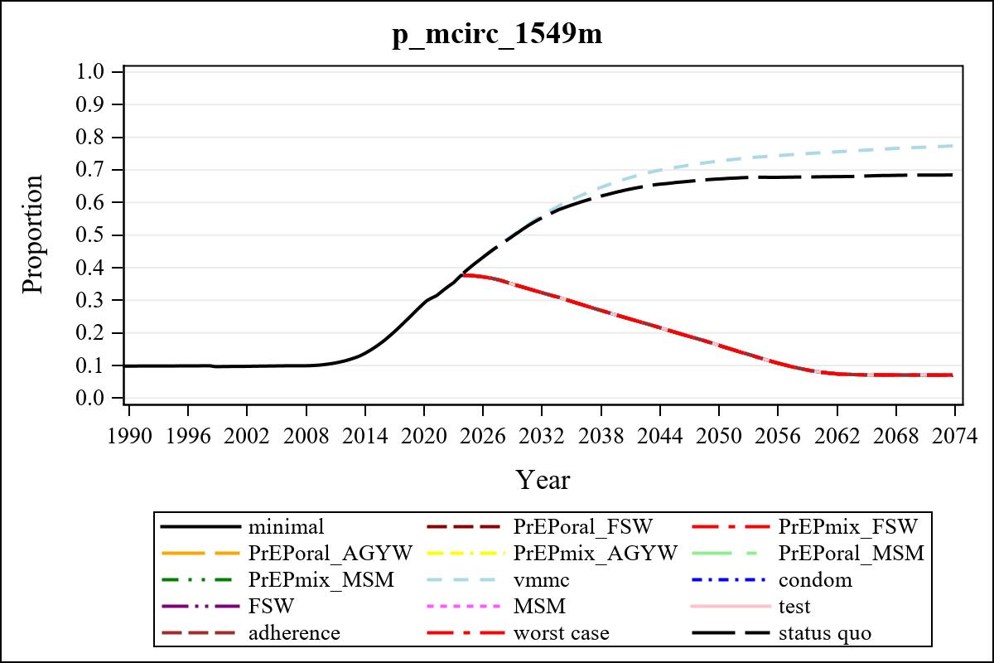

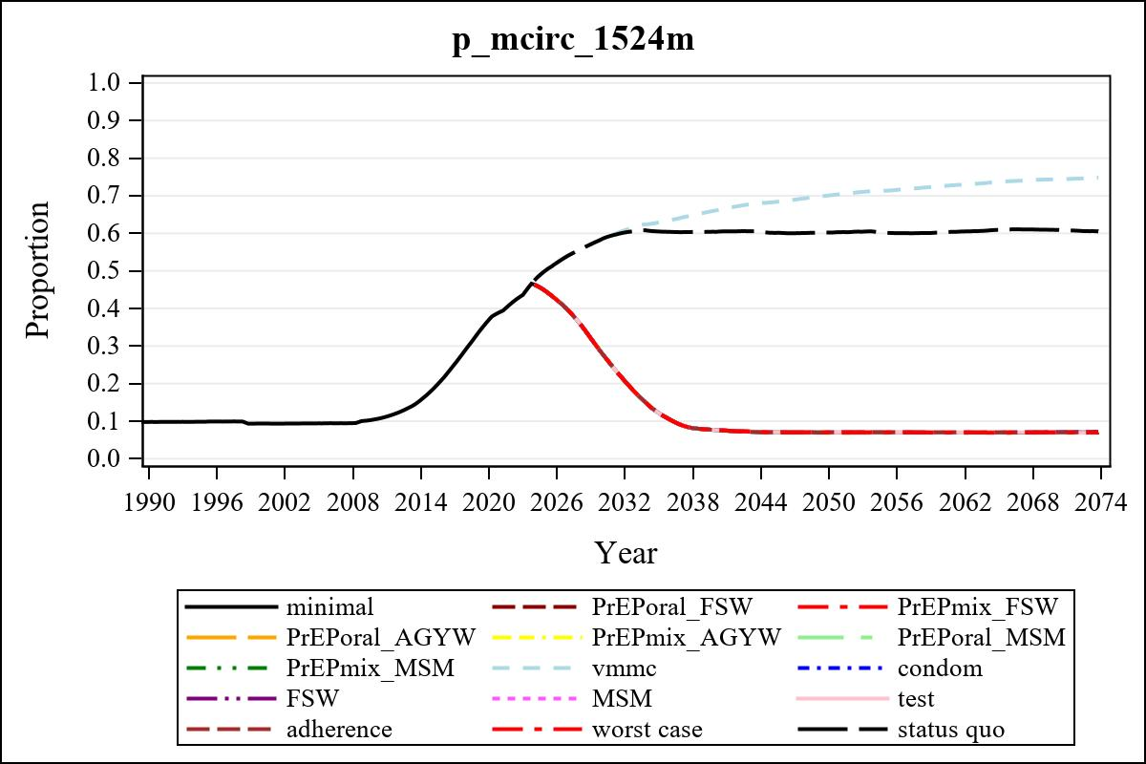

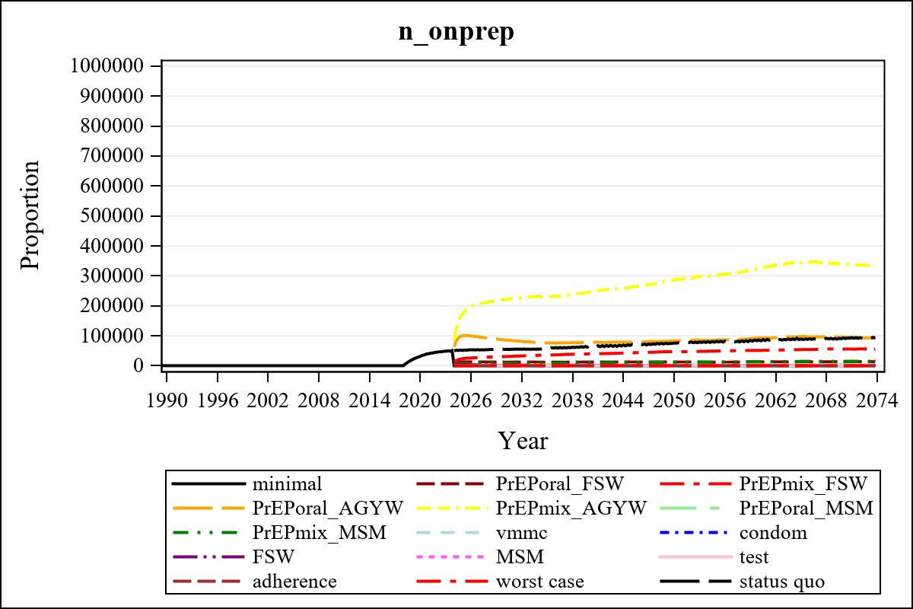

Obs | mean_n_onprep_0 | mean_n_onprep_1 | mean_n_onprep_2 | mean_n_onprep_3
345 | 0 | 13143.31 | 55465.44 | 94528.96

Obs | mean_n_onprep_4 | mean_n_onprep_5 | mean_n_onprep_6 | mean_n_onprep_99
345 | 339813.61 | 3074.42 | 14470.41 | 92851.49

Obs | mean_n_sw_1564__1 | mean_n_undiag_sw_1 | mean_n_elig_prep_1 | mean_n_elig_prep_any_sw_1
185 | 123684.96 | 70694.08 | 71767.91 | 71767.91

Obs | mean_n_onprep_sw_1 | mean_n_onprep_w_1 | mean_n_sw_1564__2 | mean_n_undiag_sw_2
185 | 11886.94 | 11886.94 | 123974.15 | 74961.51

Obs | mean_n_elig_prep_2 | mean_n_elig_prep_any_sw_2 | mean_n_onprep_sw_2 | mean_n_onprep_w_2
185 | 75887.77 | 75887.77 | 30279.08 | 30279.08

Obs | mean_n_onprep_oral_sw_2 | mean_n_onprep_len_sw_2 | mean_n_agyw_pg_3 | mean_n_elig_prep_3
185 | 6248.45 | 24030.62 | 937974.92 | 894063.08

Obs | mean_n_onprep_agyw_pg_3 | mean_n_onprep_w_3 | mean_n_agyw_pg_4 | mean_n_elig_prep_4
185 | 85894.25 | 85894.25 | 938026.19 | 897140.77

Obs | mean_n_onprep_agyw_pg_4 | mean_n_onprep_w_4 | mean_n_onprep_oral_agyw_pg_4
185 | 221663.57 | 221663.57 | 49195.07

Obs | mean_n_onprep_len_agyw_pg_4 | mean_n_alive_msm_5 | mean_n_elig_prep_5 | mean_n_onprep_msm_5
185 | 172468.50 | 64473.32 | 22259.80 | 3461.35

Obs | mean_n_onprep_m_5 | mean_n_alive_msm_6 | mean_n_elig_prep_6 | mean_n_onprep_msm_6
185 | 3461.35 | 64418.89 | 22844.75 | 8508.63

Obs | mean_n_onprep_m_6 | mean_n_onprep_oral_msm_6 | mean_n_onprep_len_msm_6 | mean_pc_elig_onprep_1
185 | 8508.63 | 1894.73 | 6613.90 | 0.16508

Obs | mean_pc_elig_onprep_2 | mean_pc_elig_onprep_3 | mean_pc_elig_onprep_4 | mean_pc_elig_onprep_5
185 | 0.39527 | 0.096583 | 0.24449 | 0.15220

Obs | mean_pc_elig_onprep_6
185 | 0.37313

Obs | mean_n_sw_1564__1 | mean_n_undiag_sw_1 | mean_n_elig_prep_1
185 | 123684.96 | 70694.08 | 71767.91

Obs | mean_n_elig_prep_any_sw_1 | mean_n_onprep_sw_1 | mean_n_onprep_w_1
185 | 71767.91 | 11886.94 | 11886.94

Obs | ratio_oral_len_2 | ratio_oral_len_4 | ratio_oral_len_6
1 | 0.22384 | 0.26412 | 0.21328

