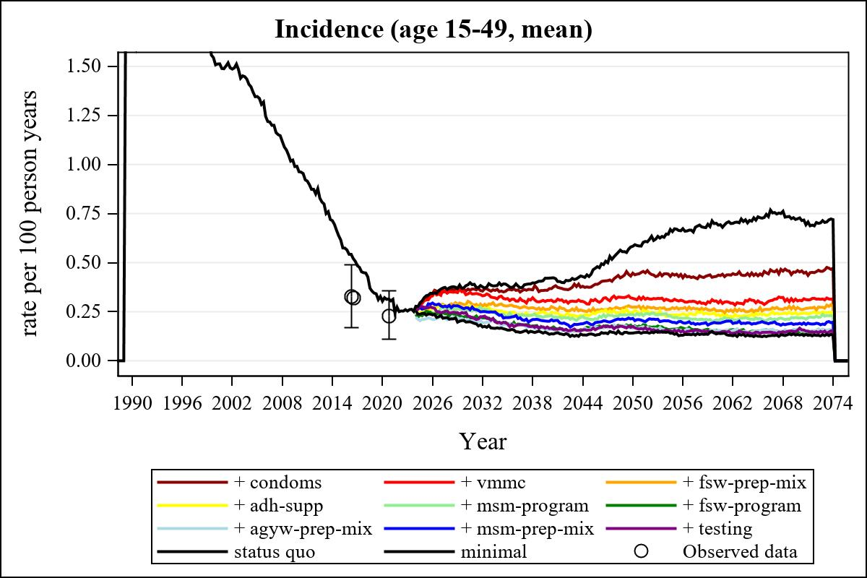

Obs | mean_incidence1549__0
157 | 0.25356

Obs | mean_incidence1549__0 | mean_incidence1549__1 | mean_incidence1549__2 | mean_incidence1549__3
361 | 0.71916 | 0.47203 | 0.31634 | 0.27668

Obs | mean_incidence1549__4 | mean_incidence1549__5 | mean_incidence1549__6 | mean_incidence1549__7
361 | 0.24773 | 0.22954 | 0.15540 | 0.15723

Obs | mean_incidence1549__8 | mean_incidence1549__9 | mean_incidence1549__99
361 | 0.19688 | 0.15175 | 0.12842

