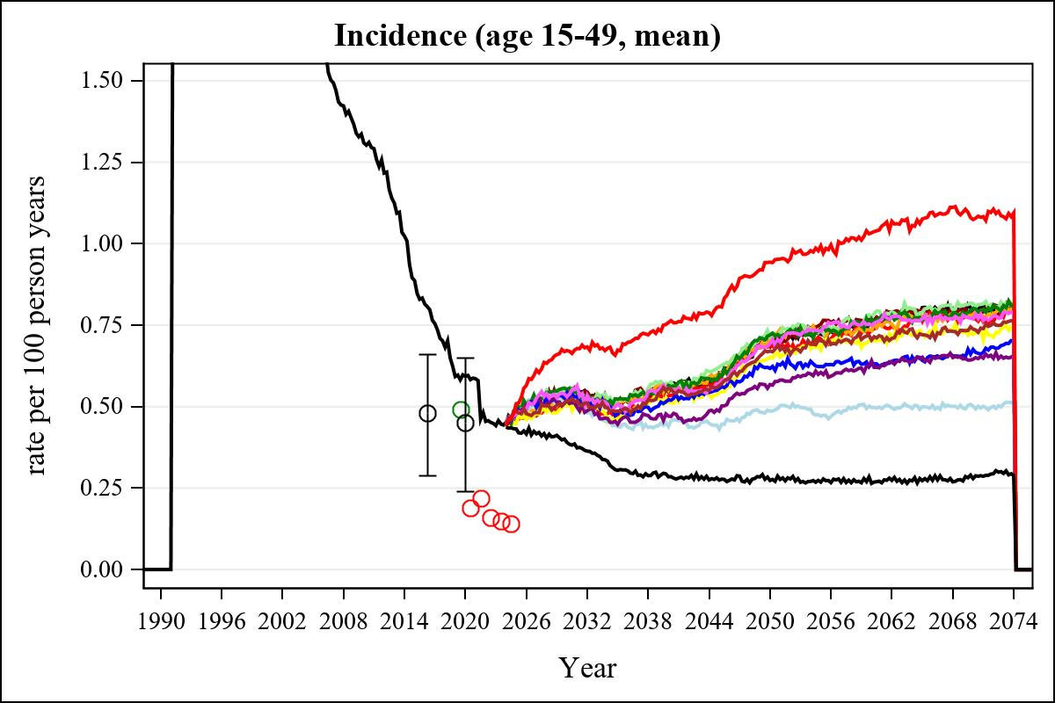

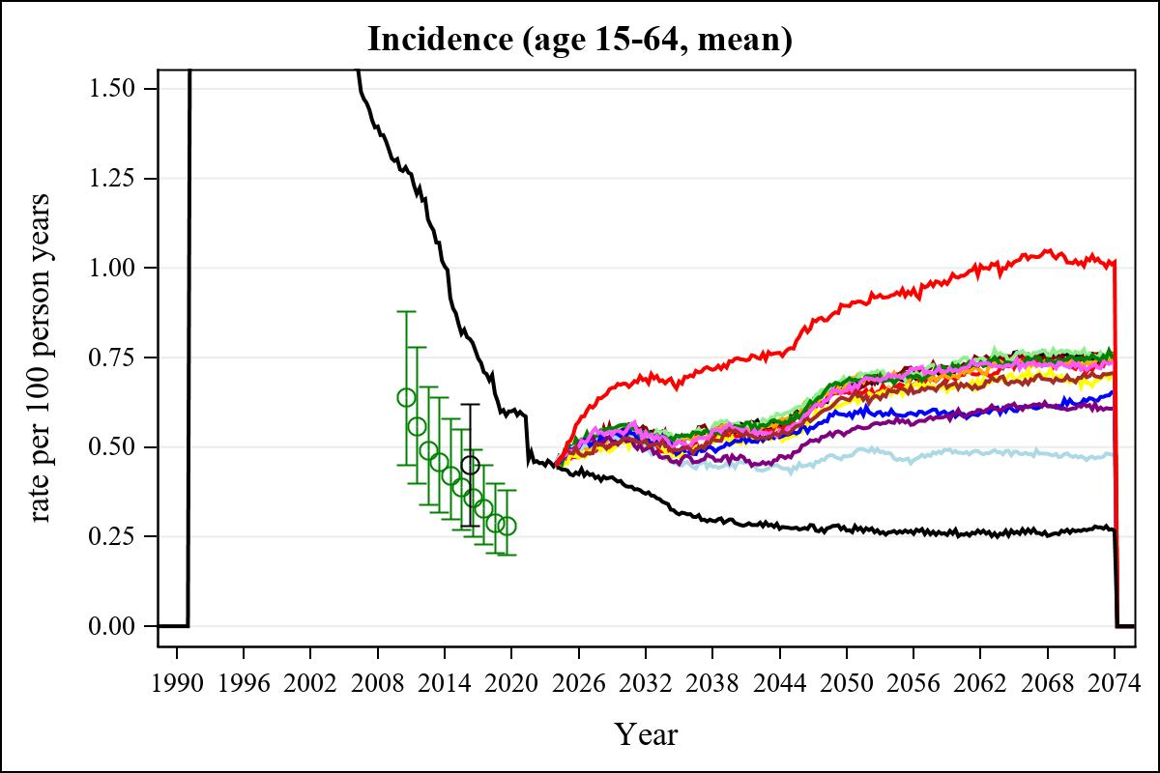

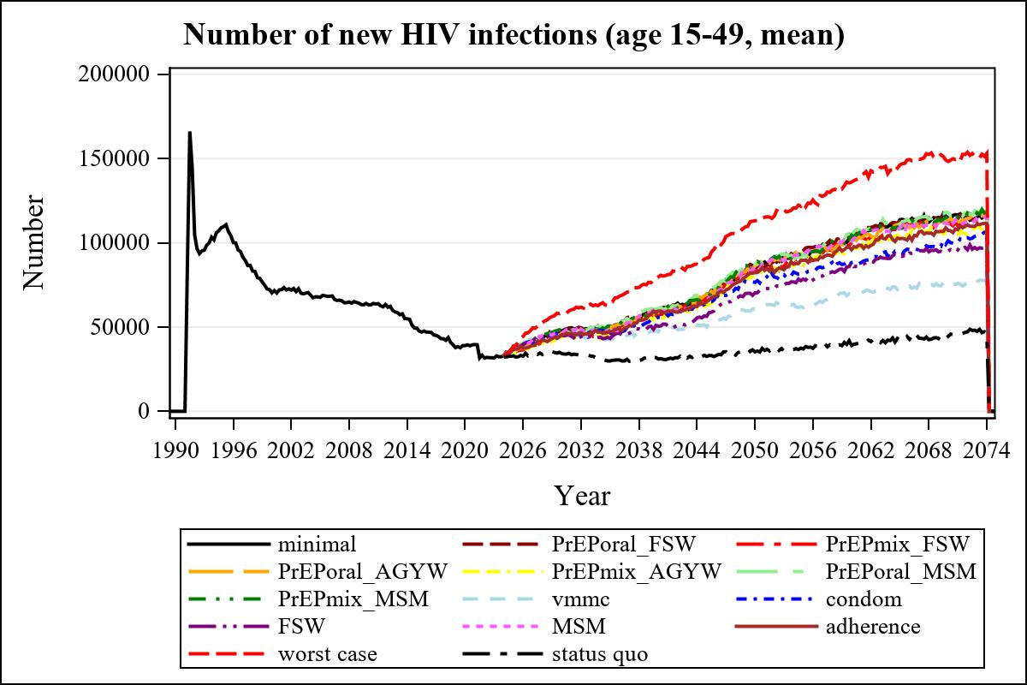

Obs | mean_n_new_inf1549__0 | mean_n_new_inf1549__1 | mean_n_new_inf1549__2 | mean_n_new_inf1549__3
226 | 59648.73 | 58207.11 | 57073.91 | 59038.38

Obs | mean_n_new_inf1549__4 | mean_n_new_inf1549__5 | mean_n_new_inf1549__6 | mean_n_new_inf1549__7
226 | 55002.98 | 60997.19 | 60382.20 | 47221.79

Obs | mean_n_new_inf1549__8 | mean_n_new_inf1549__9 | mean_n_new_inf1549__10 | mean_n_new_inf1549__11
226 | 55862.13 | 50466.88 | 59374.89 | .

Obs | mean_n_new_inf1549__12 | mean_n_new_inf1549__13 | mean_n_new_inf1549__99
226 | 59547.05 | 79784.19 | 31064.48

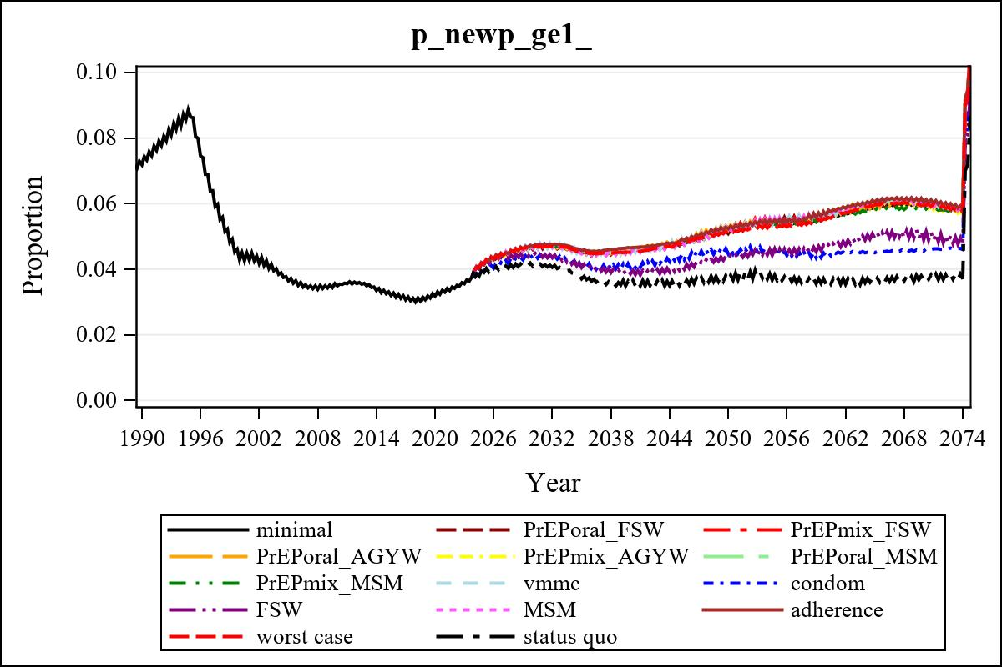

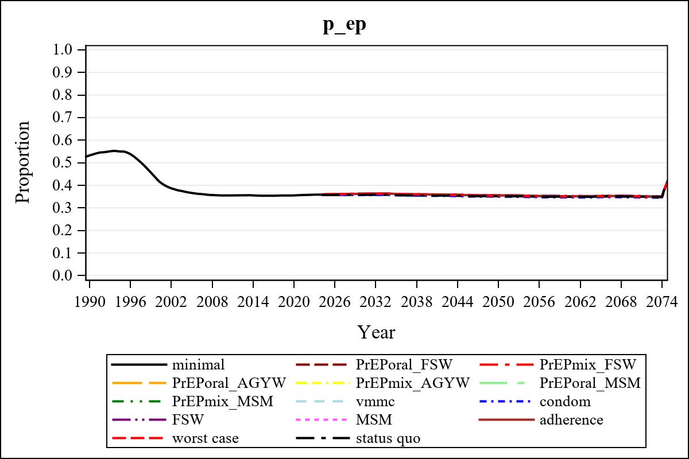

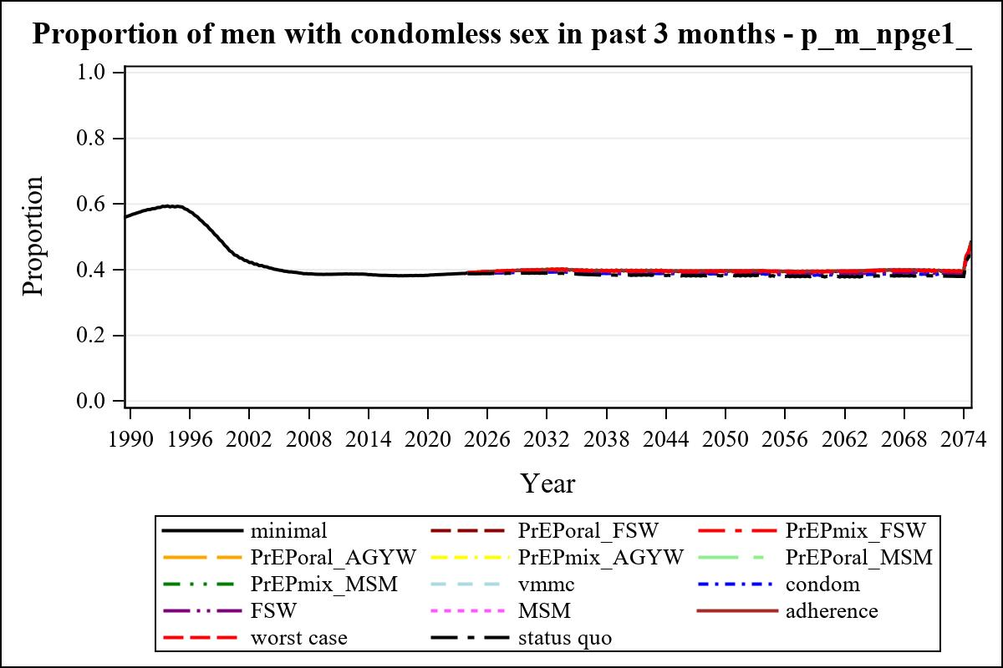

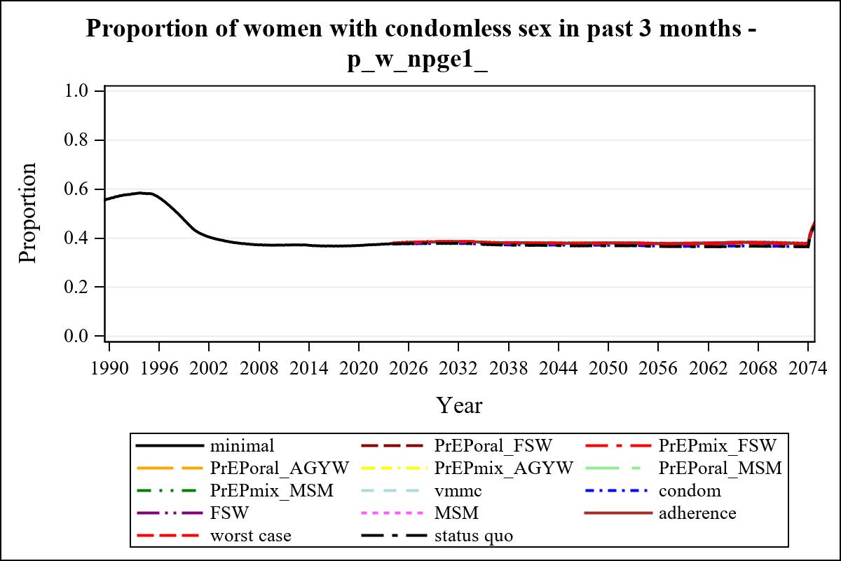

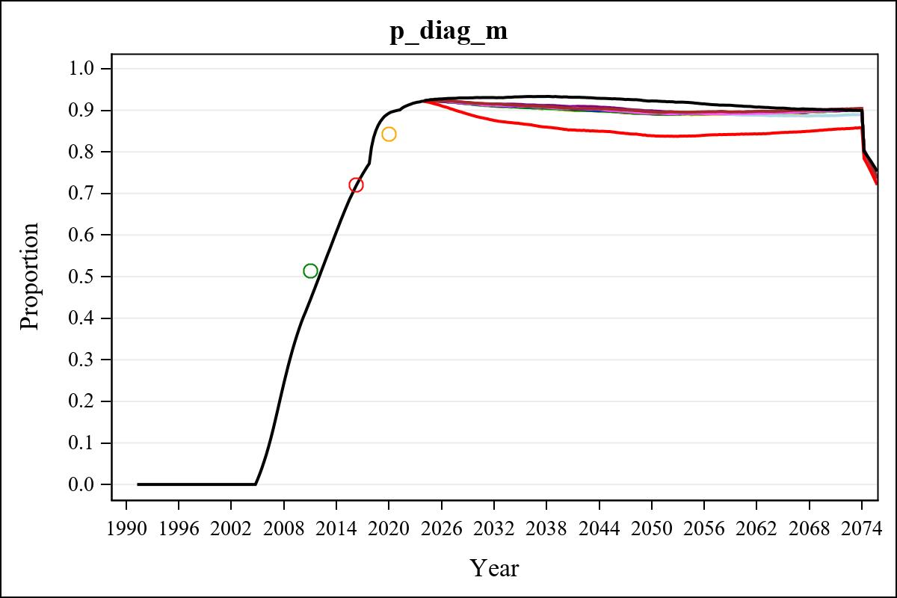

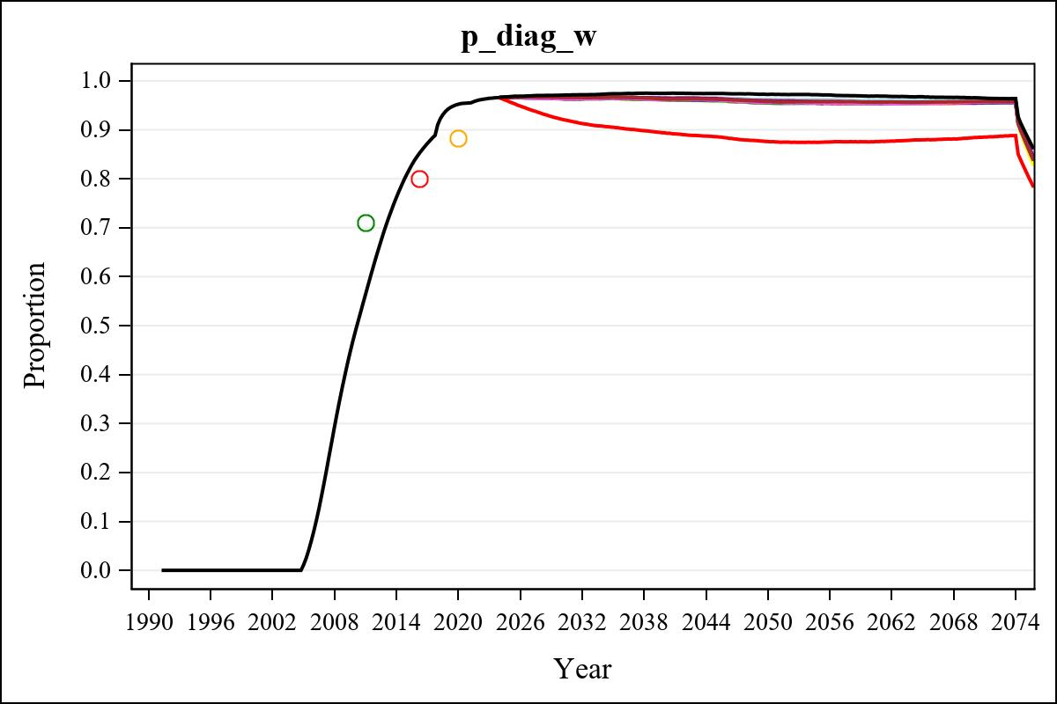

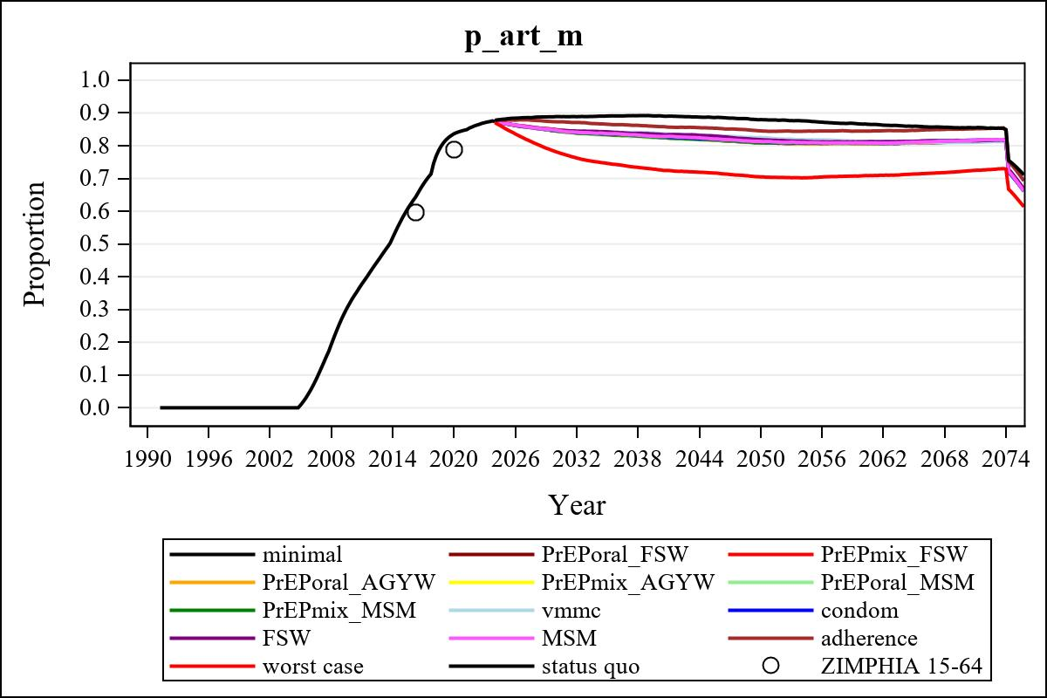

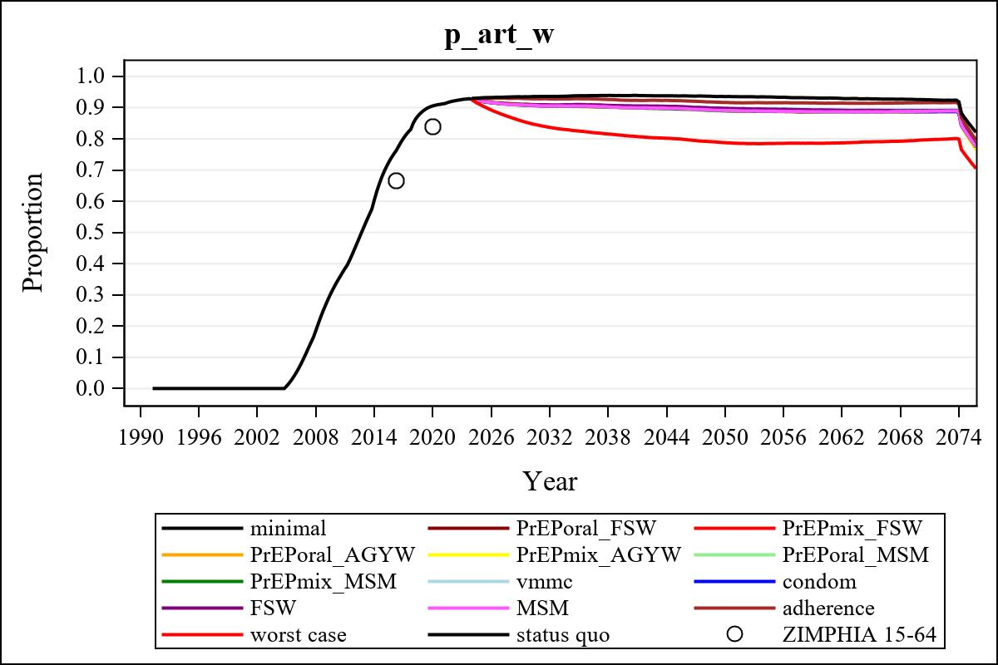

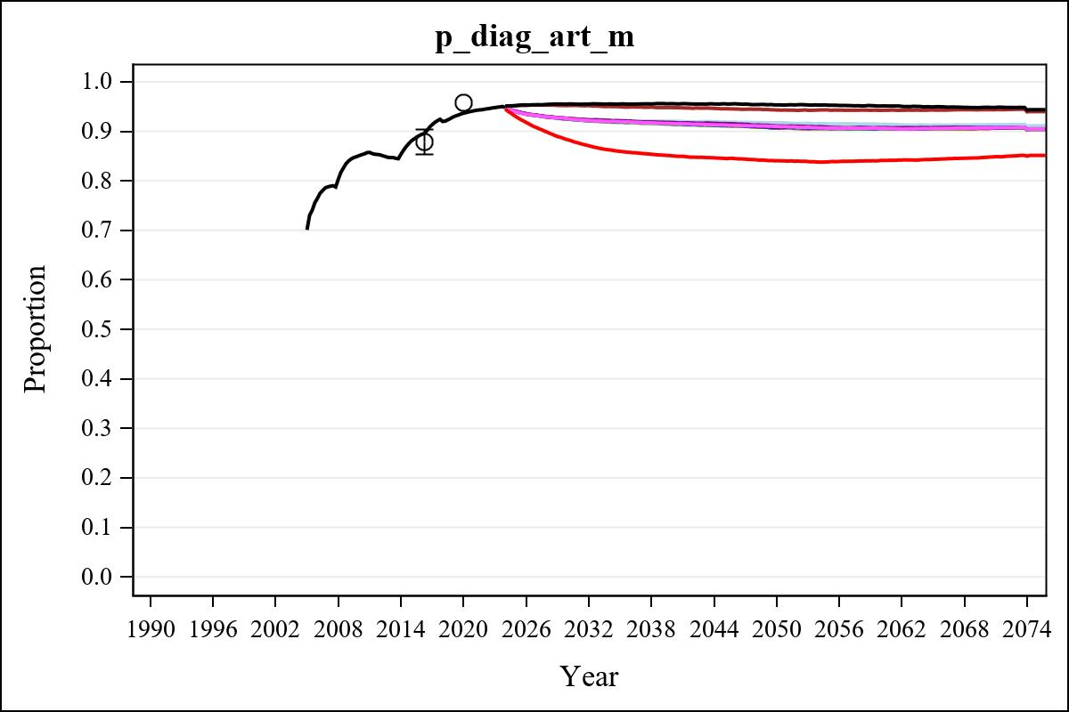

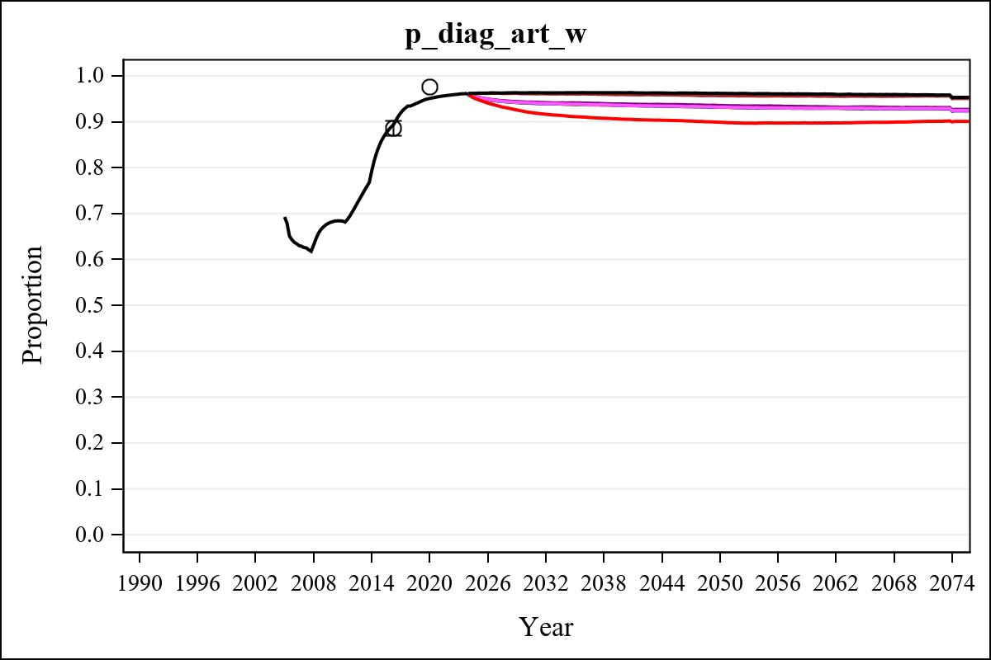

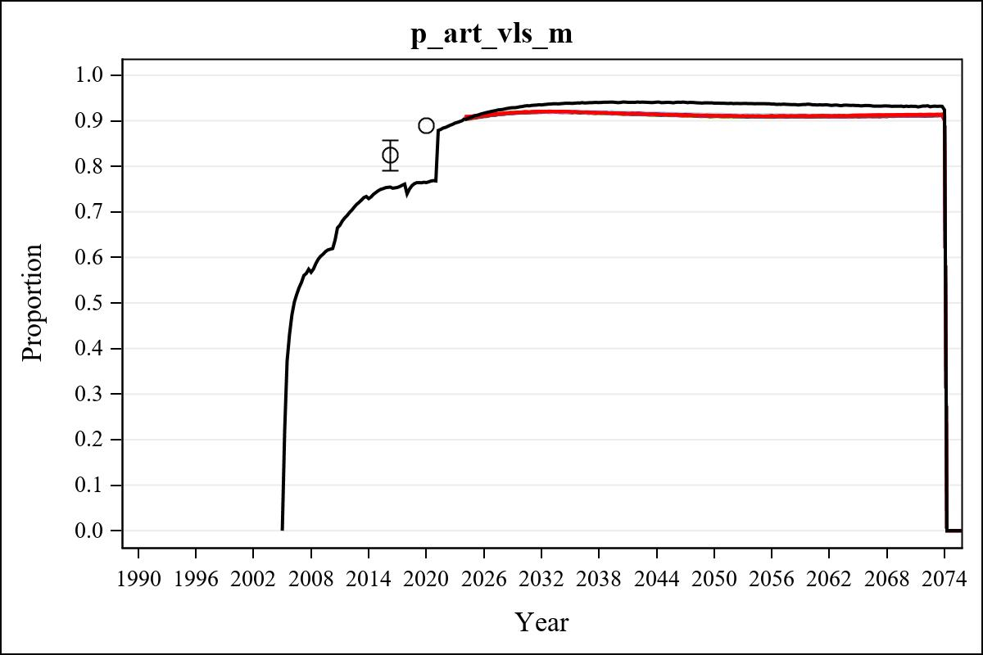

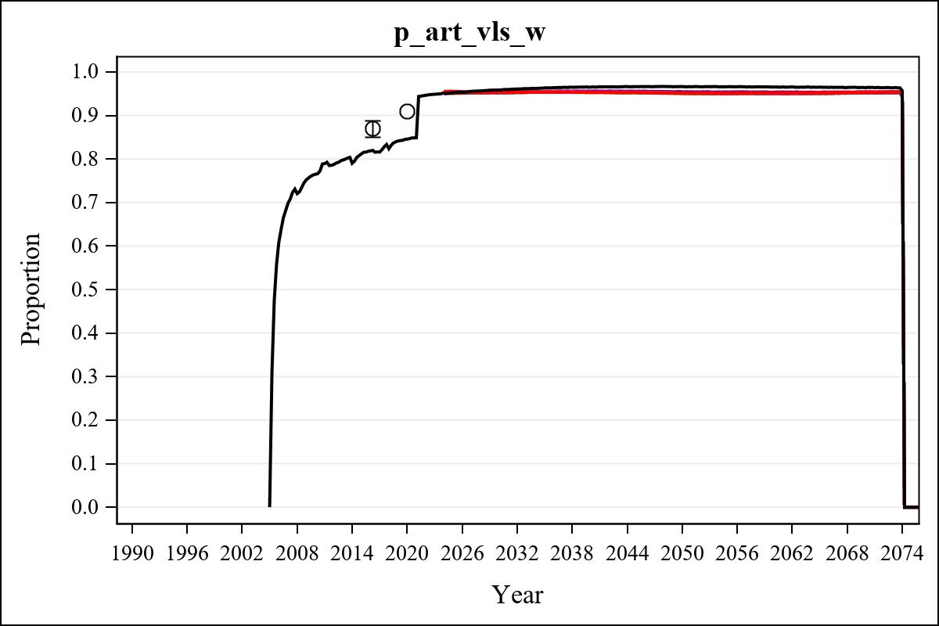

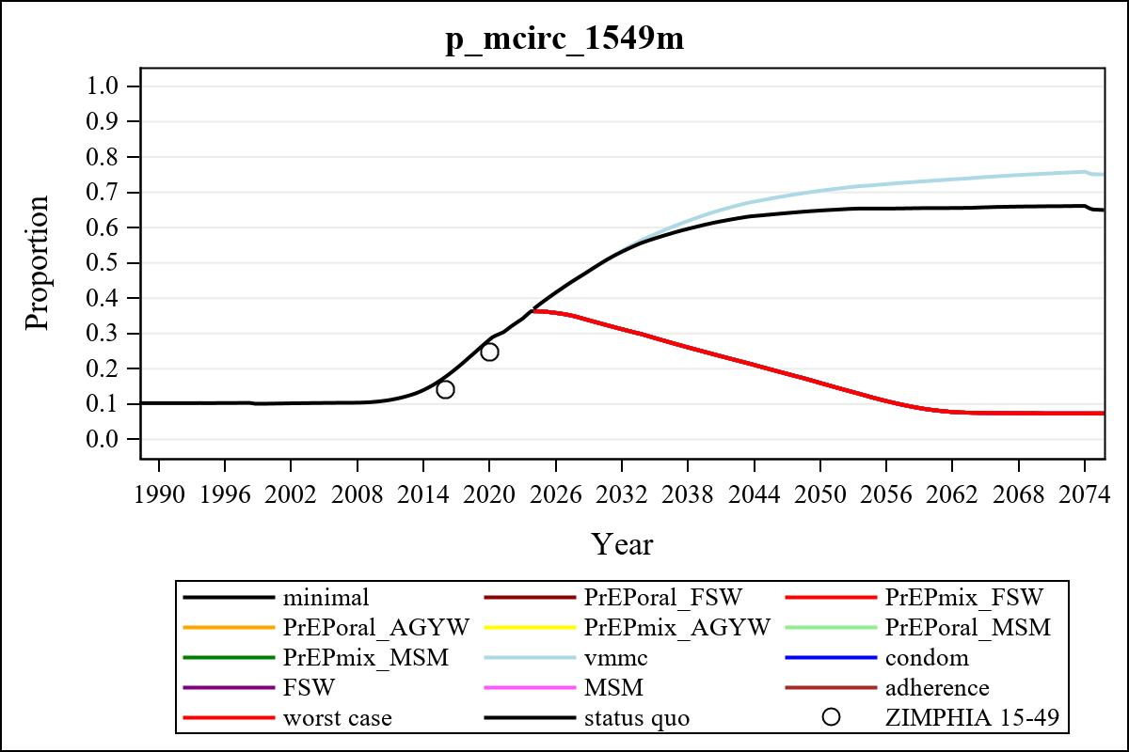

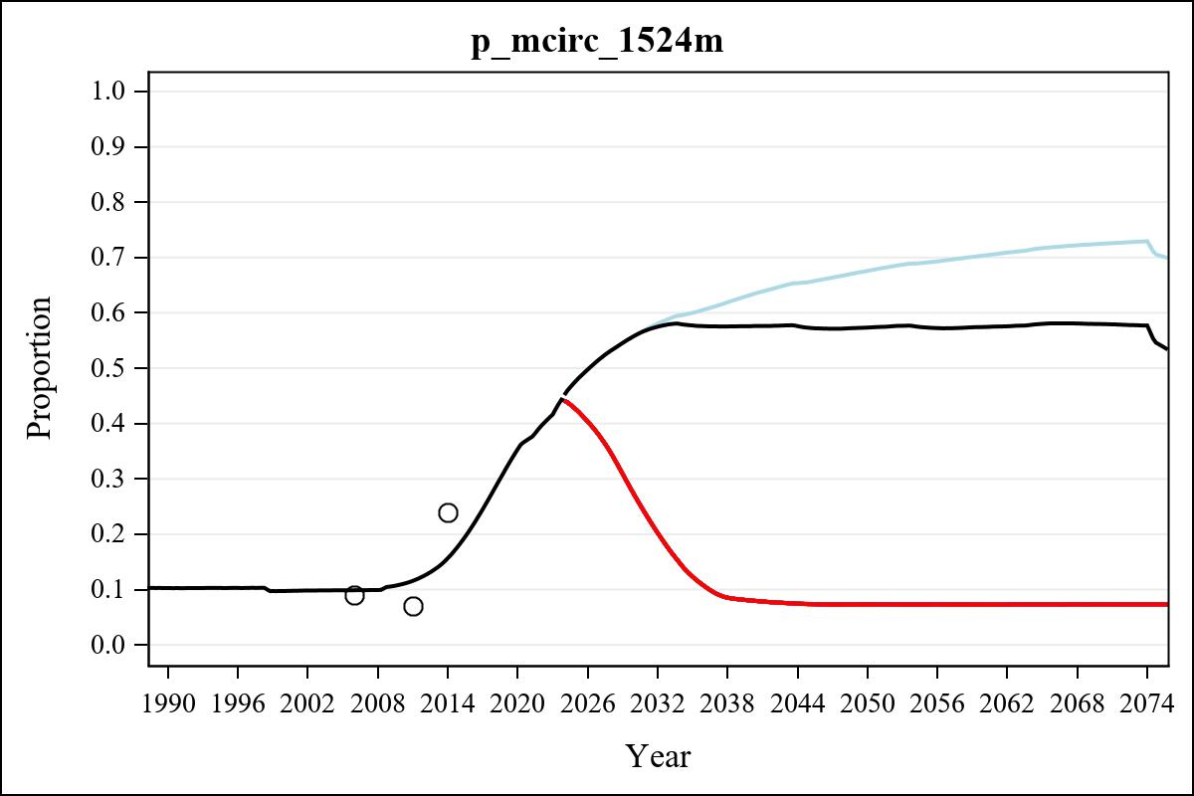

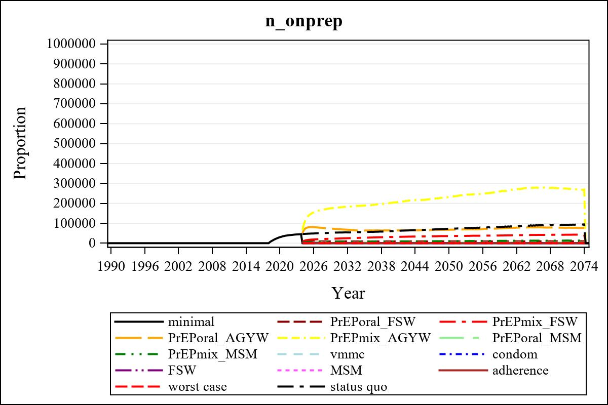

Obs | mean_n_onprep_0 | mean_n_onprep_1 | mean_n_onprep_2 | mean_n_onprep_3
346 | 0 | 9341.24 | 42364.88 | 77499.05

Obs | mean_n_onprep_4 | mean_n_onprep_5 | mean_n_onprep_6 | mean_n_onprep_99
346 | 275295.33 | 2748.60 | 13078.30 | 91783.36

Obs | mean_n_sw_1564__1 | mean_n_undiag_sw_1 | mean_n_elig_prep_1 | mean_n_elig_prep_any_sw_1
186 | 117243.39 | 63819.55 | 64866.22 | 64866.22

Obs | mean_n_onprep_sw_1 | mean_n_onprep_w_1 | mean_n_sw_1564__2 | mean_n_undiag_sw_2
186 | 8731.72 | 8731.72 | 117330.12 | 67623.72

Obs | mean_n_elig_prep_2 | mean_n_elig_prep_any_sw_2 | mean_n_onprep_sw_2 | mean_n_onprep_w_2
186 | 68479.94 | 68479.94 | 23140.28 | 23140.28

Obs | mean_n_onprep_oral_sw_2 | mean_n_onprep_len_sw_2 | mean_n_agyw_pg_3 | mean_n_elig_prep_3
186 | 4550.57 | 18589.71 | 931937.24 | 880997.30

Obs | mean_n_onprep_agyw_pg_3 | mean_n_onprep_w_3 | mean_n_agyw_pg_4 | mean_n_elig_prep_4
186 | 71343.97 | 71343.97 | 931401.83 | 882758.89

Obs | mean_n_onprep_agyw_pg_4 | mean_n_onprep_w_4 | mean_n_onprep_oral_agyw_pg_4
186 | 178146.58 | 178146.58 | 40016.20

Obs | mean_n_onprep_len_agyw_pg_4 | mean_n_alive_msm_5 | mean_n_elig_prep_5 | mean_n_onprep_msm_5
186 | 138130.37 | 63957.52 | 21990.56 | 3113.92

Obs | mean_n_onprep_m_5 | mean_n_alive_msm_6 | mean_n_elig_prep_6 | mean_n_onprep_msm_6
186 | 3113.92 | 63980.21 | 22468.31 | 7763.88

Obs | mean_n_onprep_m_6 | mean_n_onprep_oral_msm_6 | mean_n_onprep_len_msm_6 | mean_pc_elig_onprep_1
186 | 7763.88 | 1684.41 | 6079.47 | 0.13619

Obs | mean_pc_elig_onprep_2 | mean_pc_elig_onprep_3 | mean_pc_elig_onprep_4 | mean_pc_elig_onprep_5
186 | 0.34053 | 0.081627 | 0.19708 | 0.13867

Obs | mean_pc_elig_onprep_6
186 | 0.34316

Obs | mean_n_sw_1564__1 | mean_n_undiag_sw_1 | mean_n_elig_prep_1
186 | 117243.39 | 63819.55 | 64866.22

Obs | mean_n_elig_prep_any_sw_1 | mean_n_onprep_sw_1 | mean_n_onprep_w_1
186 | 64866.22 | 8731.72 | 8731.72

Obs | ratio_oral_len_2 | ratio_oral_len_4 | ratio_oral_len_6
1 | 0.20865 | 0.26877 | 0.21406

