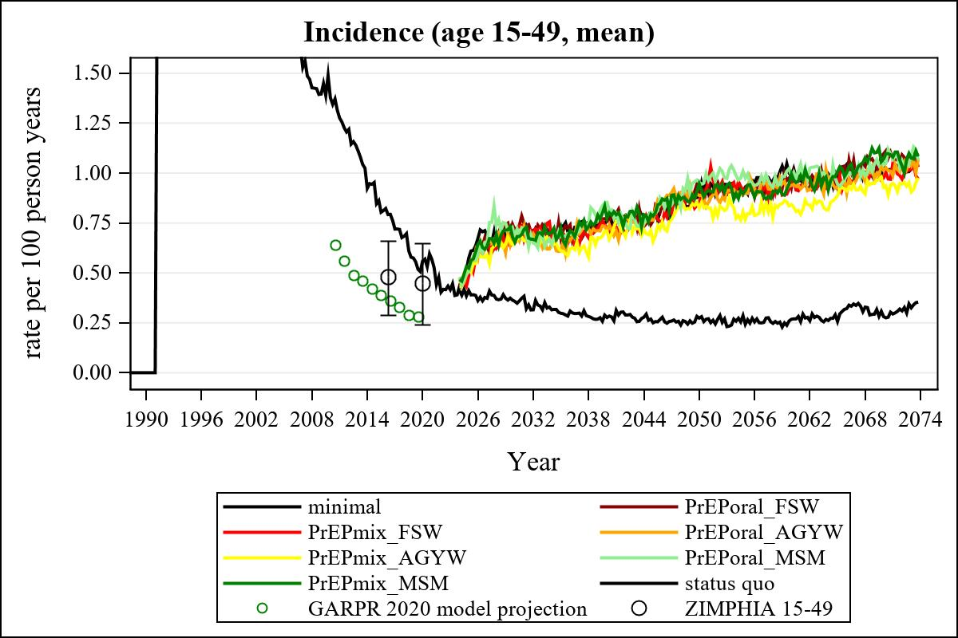

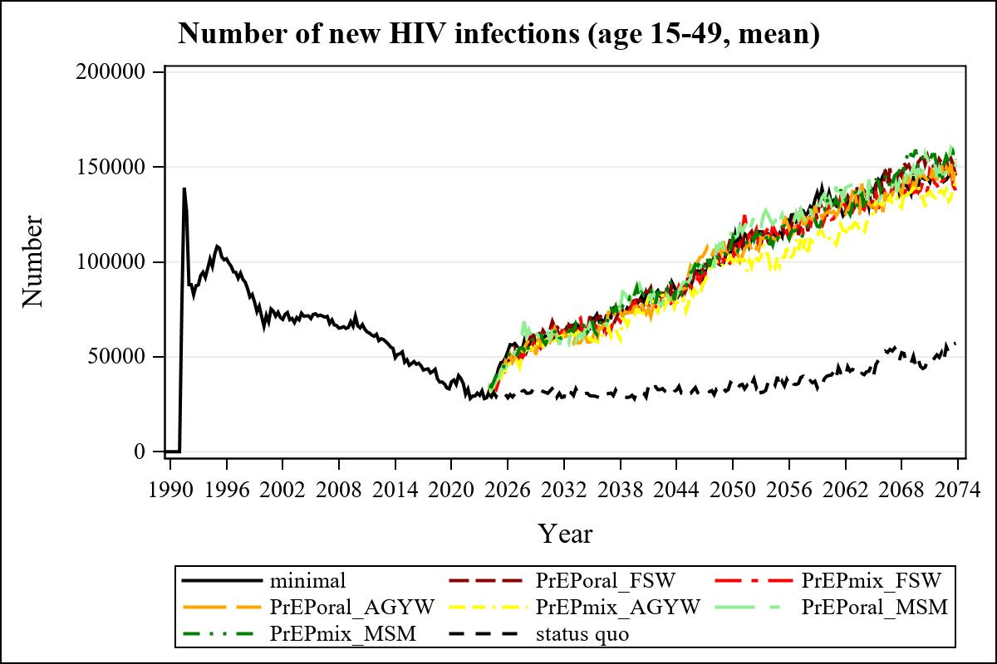

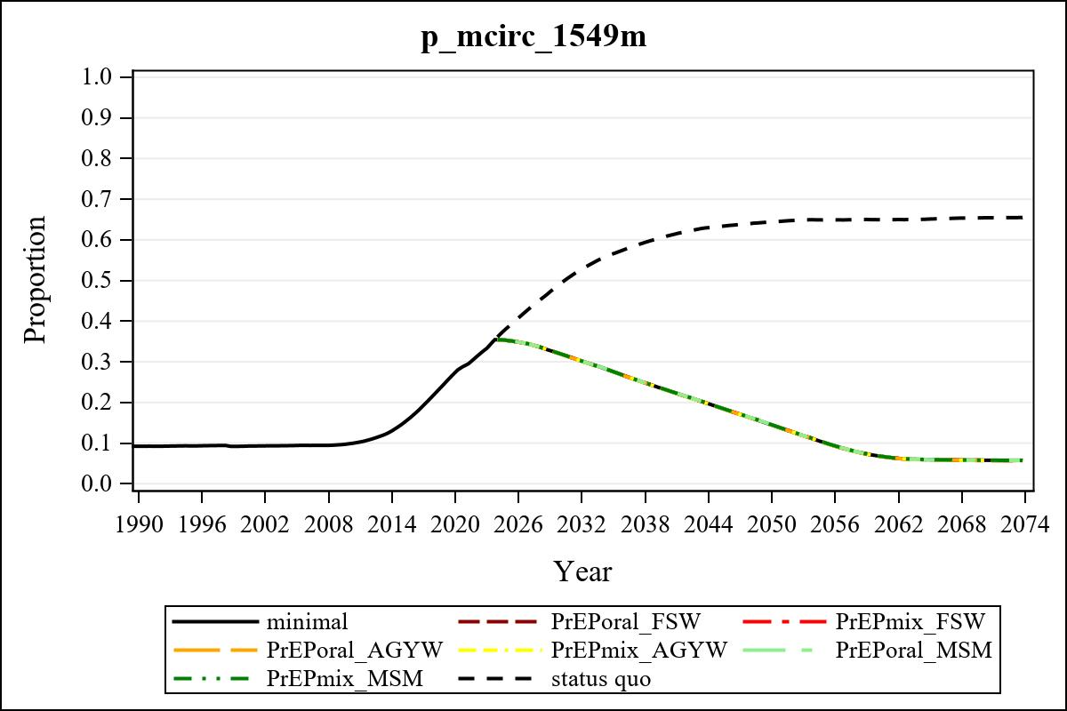

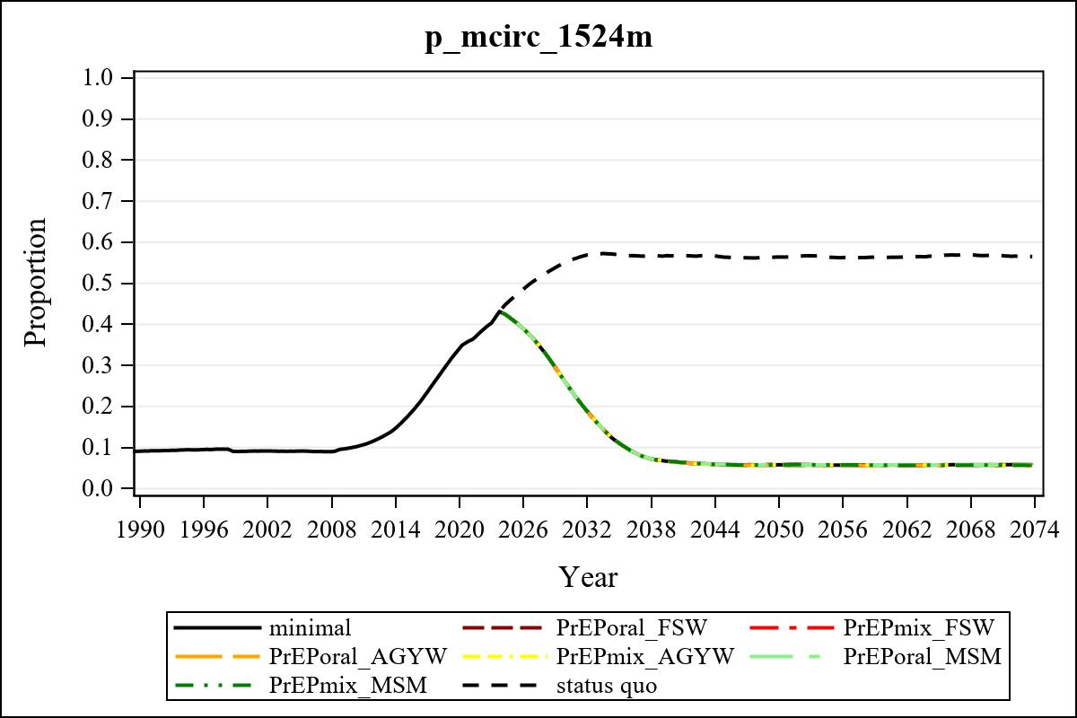

Obs | mean_n_onprep_0
345 | 0

Obs | mean_n_elig_prep_1 | mean_n_sw_1564__1 | mean_n_onprep_sw_1 | mean_n_onprep_w_1
185 | 59348.77 | 113703.80 | 4249.09 | 4249.09

Obs | mean_n_elig_prep_2 | mean_n_sw_1564__2 | mean_n_onprep_sw_2 | mean_n_onprep_w_2
185 | 61926.89 | 115335.03 | 17872.13 | 17872.13

Obs | mean_n_onprep_oral_sw_2 | mean_n_onprep_len_sw_2 | mean_n_elig_prep_3 | mean_n_agyw_pg_3
185 | 2043.41 | 15828.72 | 1020013.20 | 1080873.31

Obs | mean_n_onprep_agyw_pg_3 | mean_n_onprep_w_3 | mean_n_elig_prep_4 | mean_n_agyw_pg_4
185 | 96560.15 | 96560.15 | 1026033.31 | 1084691.69

Obs | mean_n_onprep_agyw_pg_4 | mean_n_onprep_w_4 | mean_n_onprep_oral_agyw_pg_4
185 | 258500.83 | 258500.83 | 55555.92

Obs | mean_n_onprep_len_agyw_pg_4 | mean_n_elig_prep_5 | mean_n_alive_msm_5 | mean_n_onprep_msm_5
185 | 202944.91 | 22013.37 | 63572.11 | 228.940

Obs | mean_n_onprep_m_5 | mean_n_elig_prep_6 | mean_n_alive_msm_6 | mean_n_onprep_msm_6
185 | 228.940 | 21974.90 | 64205.65 | 3077.56

Obs | mean_n_onprep_m_6 | mean_n_onprep_oral_msm_6 | mean_n_onprep_len_msm_6 | mean_pc_elig_onprep_1
185 | 3077.56 | 138.839 | 2938.72 | 0.075719

Obs | mean_pc_elig_onprep_2 | mean_pc_elig_onprep_3 | mean_pc_elig_onprep_4 | mean_pc_elig_onprep_5
185 | 0.29567 | 0.093983 | 0.24882 | 0.011625

Obs | mean_pc_elig_onprep_6
185 | 0.14182

Obs | ratio_oral_len_2 | ratio_oral_len_4 | ratio_oral_len_6
1 | 0.13868 | 0.24773 | 0.021869

