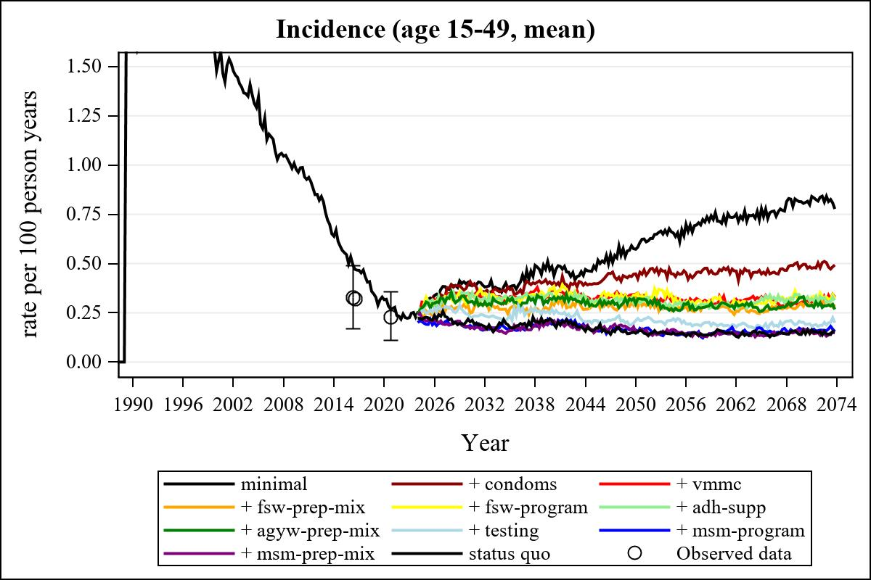

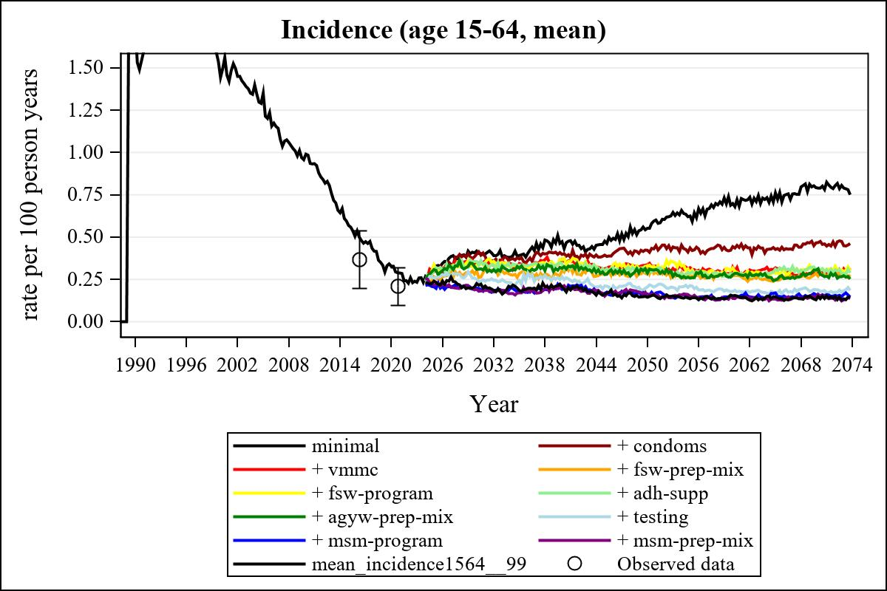

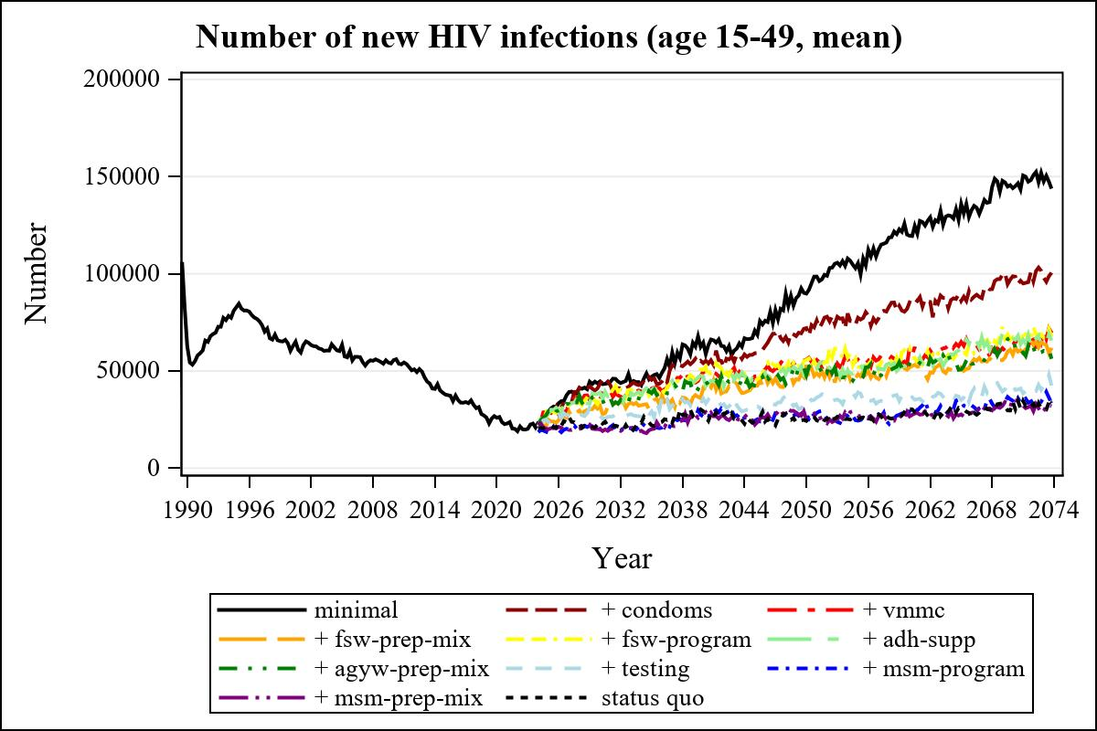

Obs | mean_n_new_inf1549__0 | mean_n_new_inf1549__1 | mean_n_new_inf1549__2 | mean_n_new_inf1549__3
226 | 64563.36 | 54051.93 | 49594.49 | 41130.77

Obs | mean_n_new_inf1549__4 | mean_n_new_inf1549__5 | mean_n_new_inf1549__6 | mean_n_new_inf1549__7
226 | 50533.43 | 47382.74 | 43159.70 | 35821.19

Obs | mean_n_new_inf1549__8 | mean_n_new_inf1549__9 | mean_n_new_inf1549__99
226 | 26595.03 | 27903.69 | 29283.80

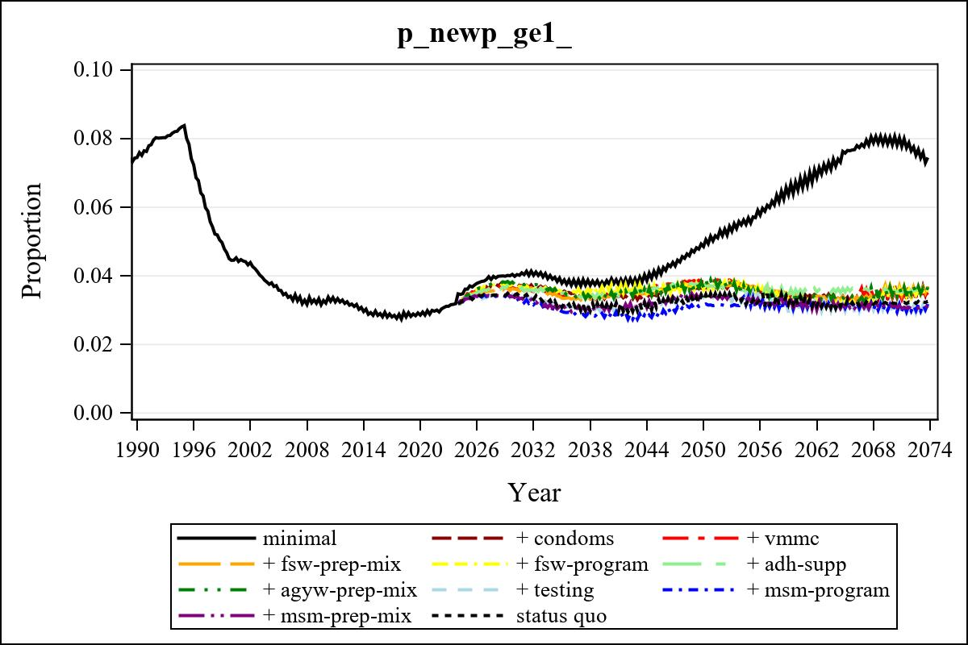

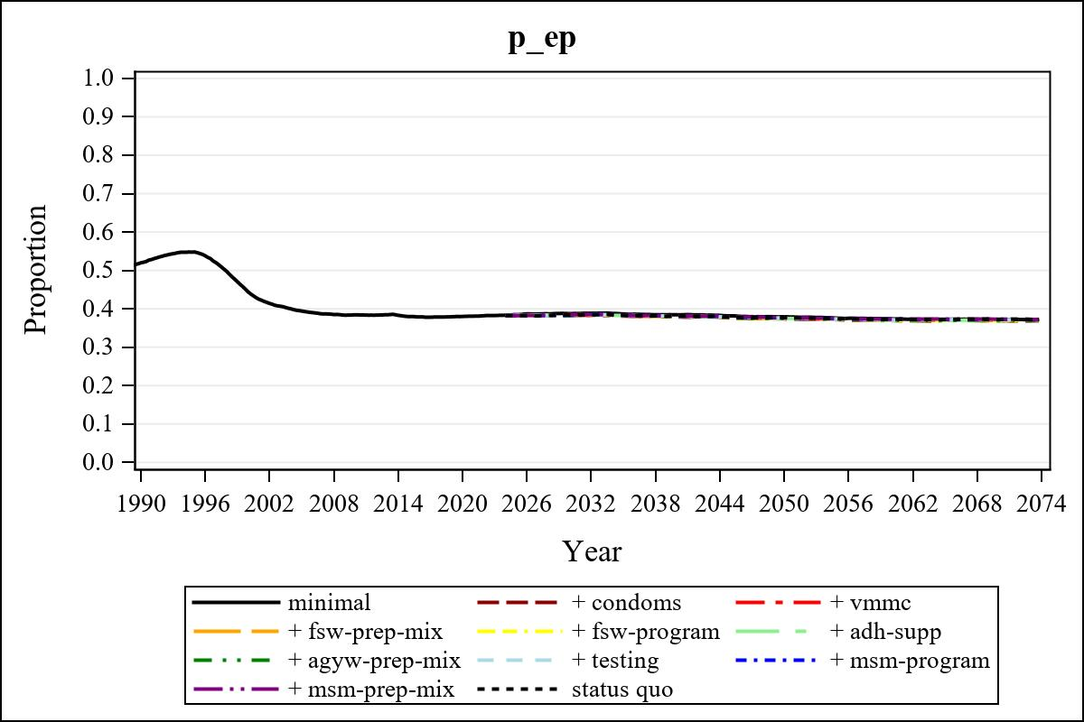

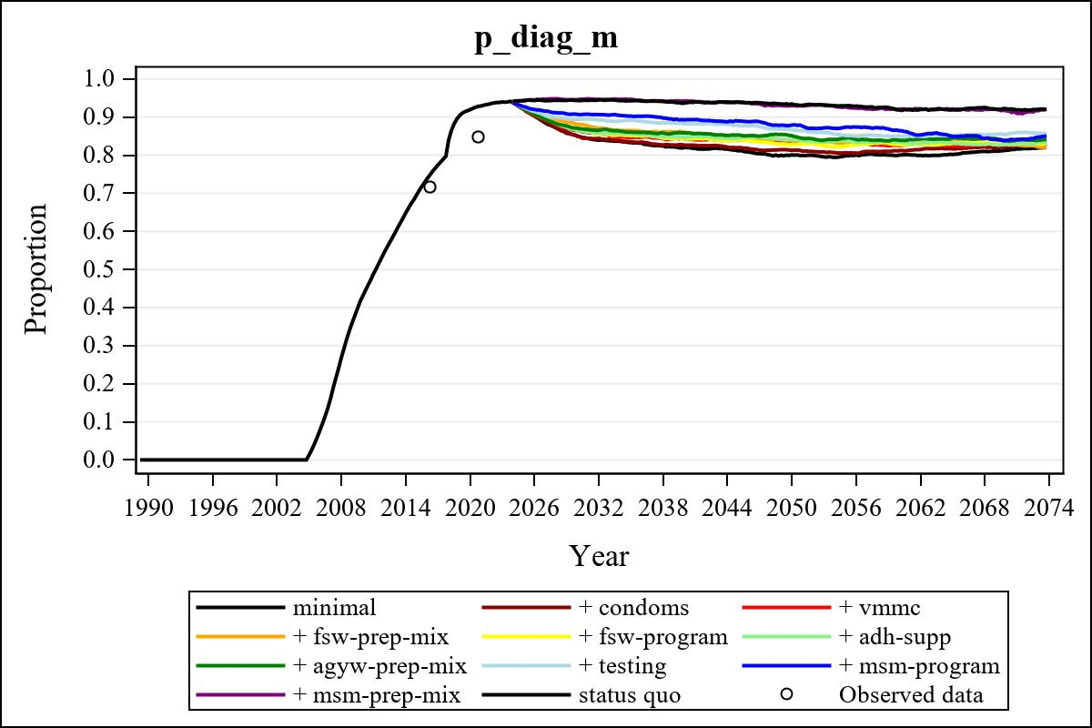

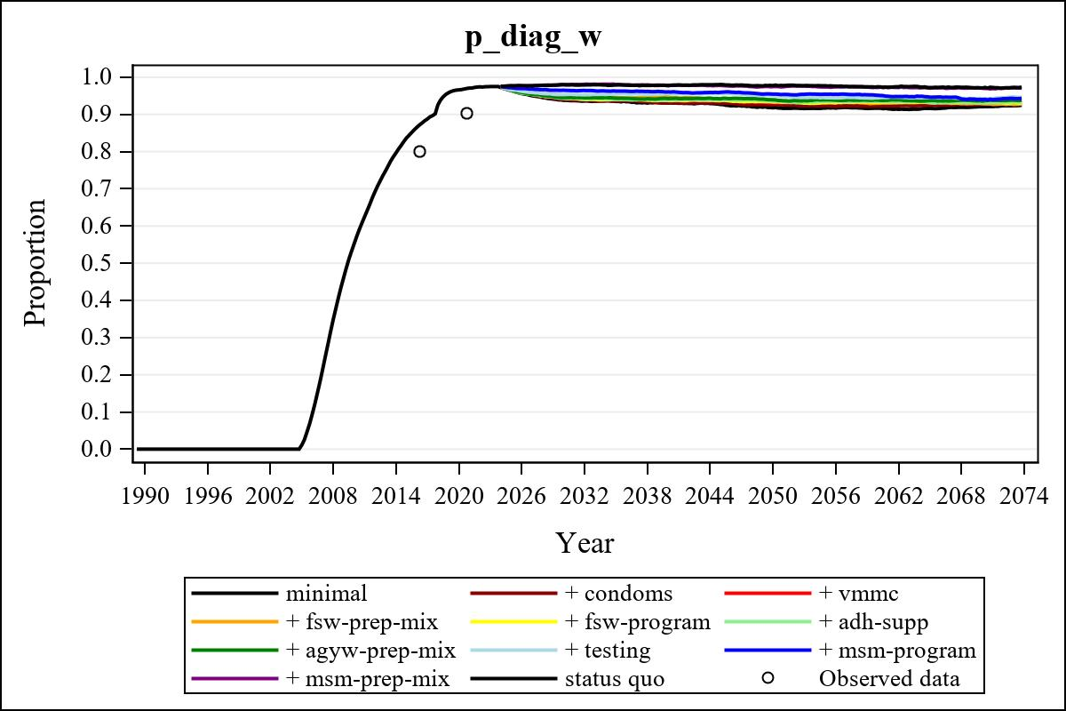

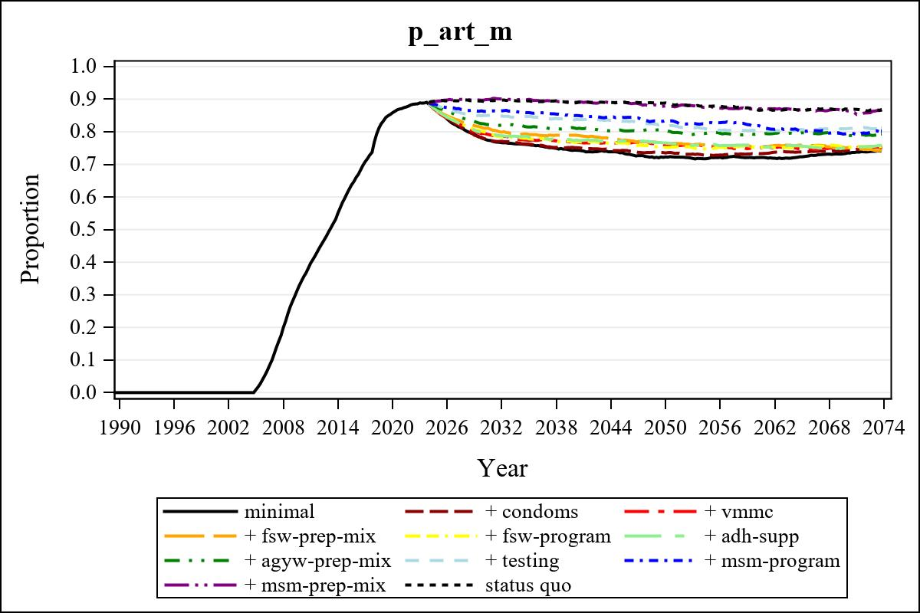

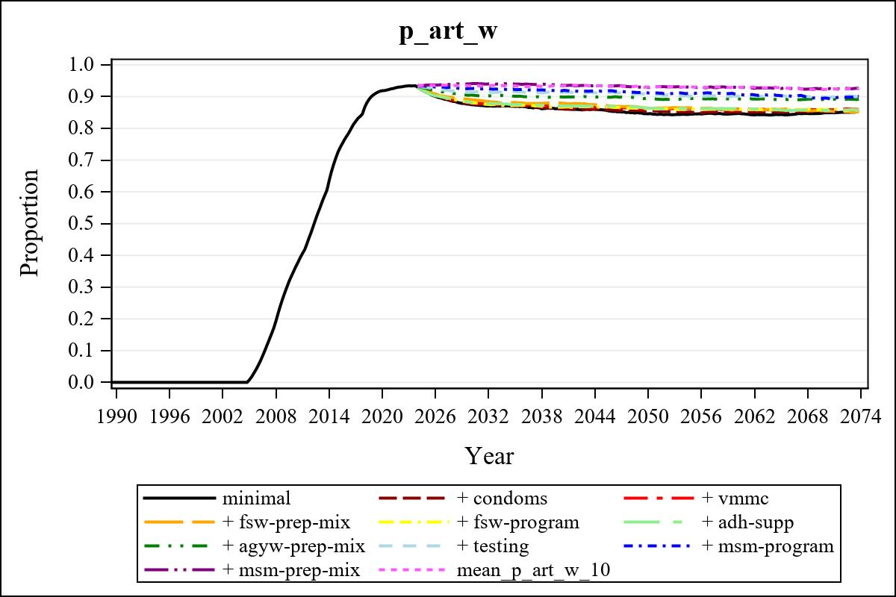

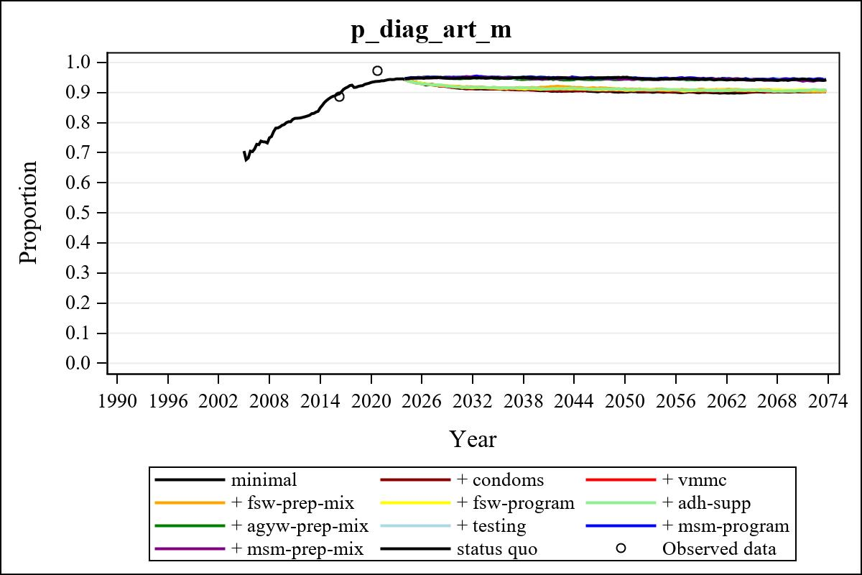

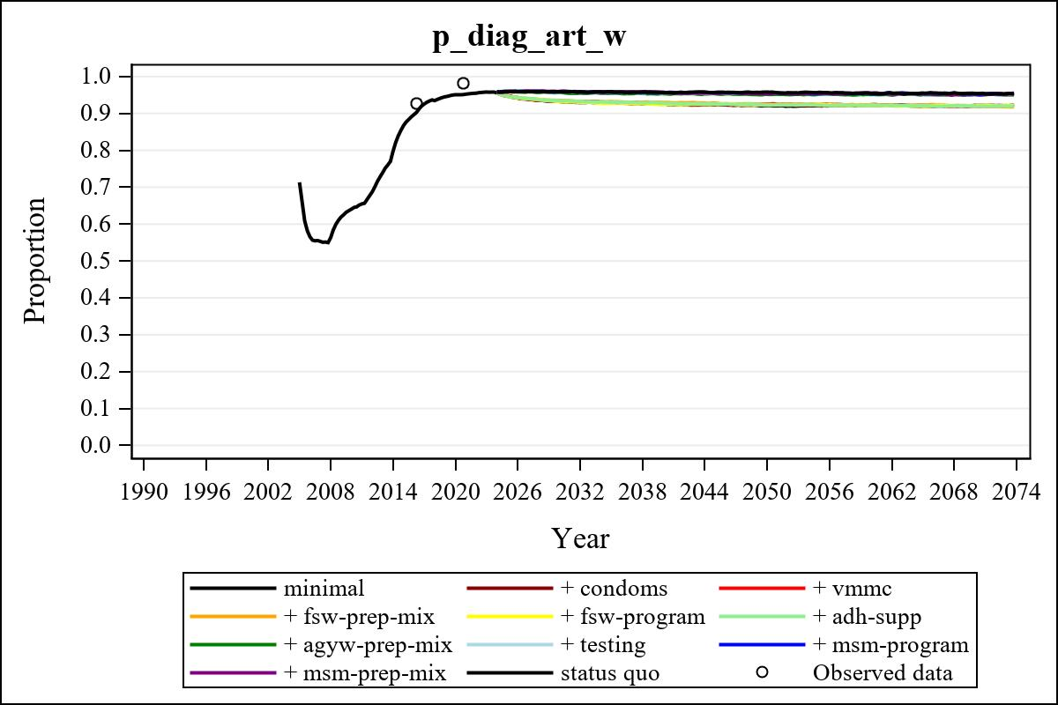

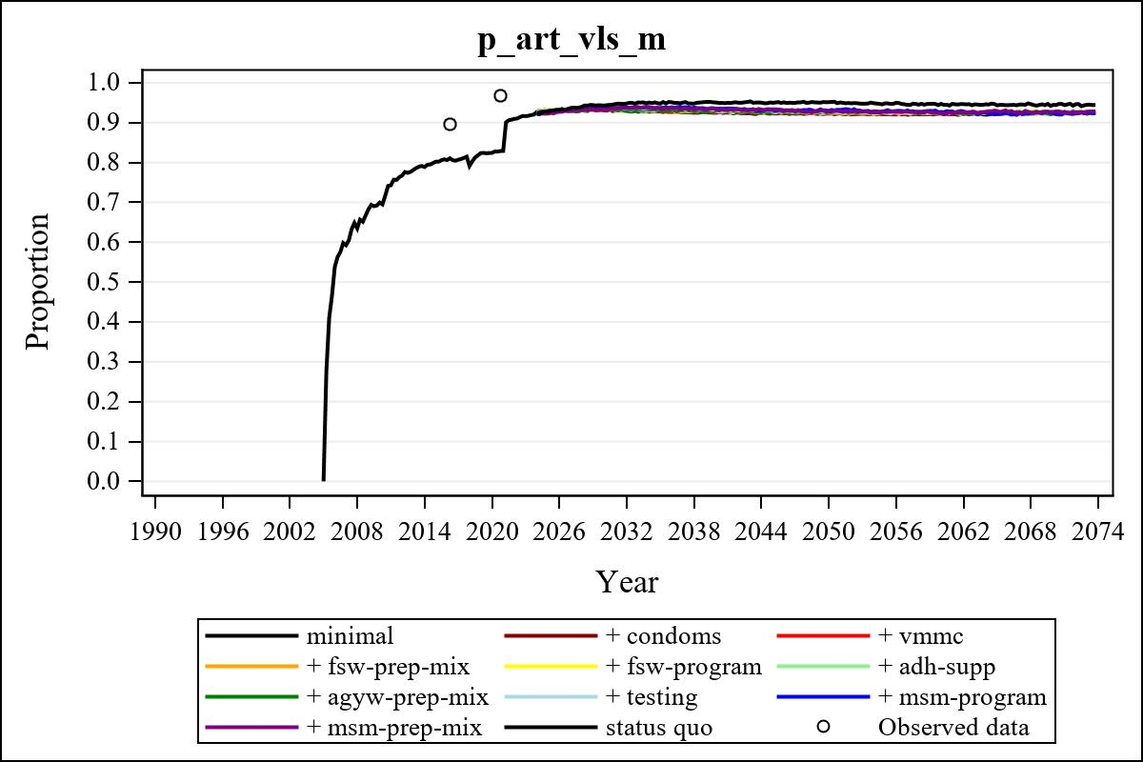

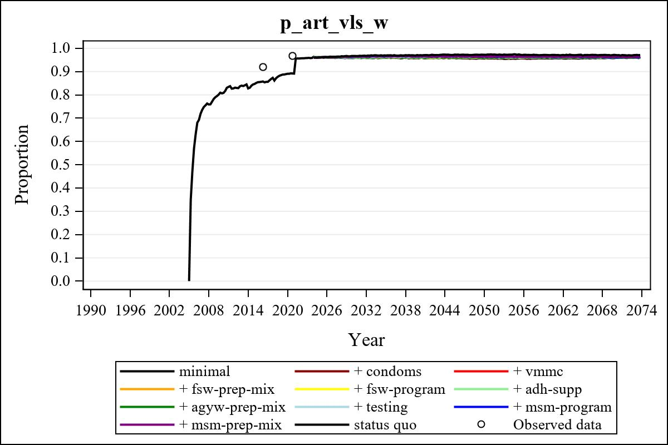

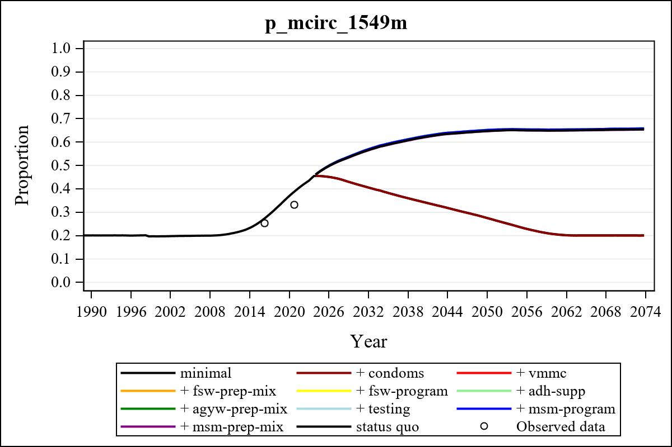

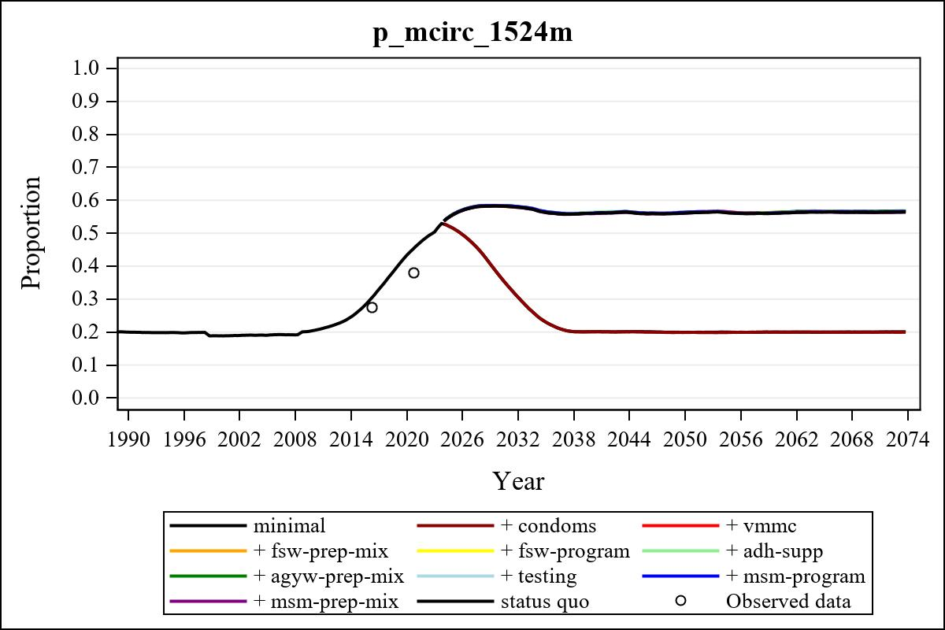

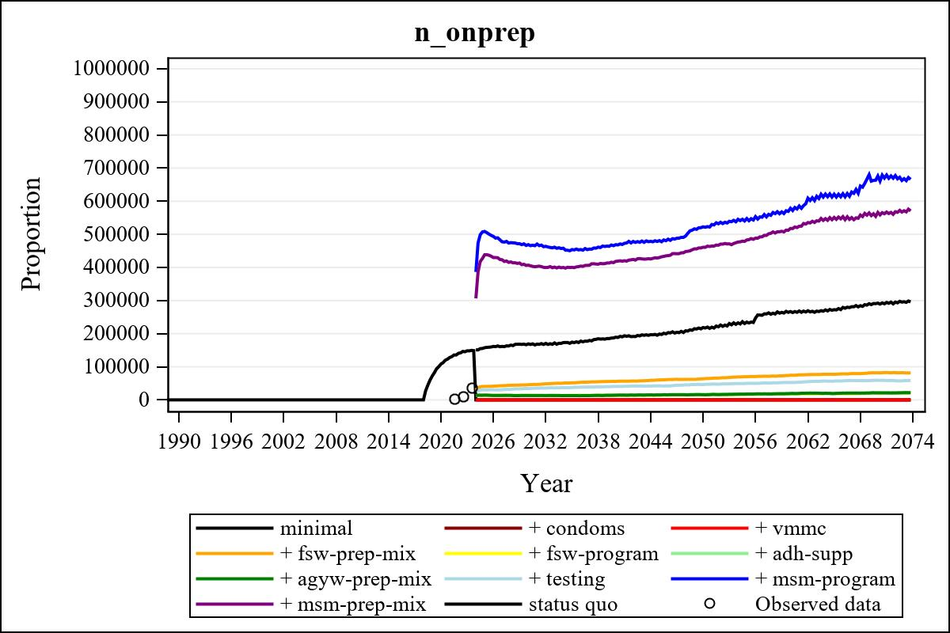

Obs | mean_n_onprep_0 | mean_n_onprep_1 | mean_n_onprep_2 | mean_n_onprep_3
346 | 0 | 0 | 0 | 81754.85

Obs | mean_n_onprep_4 | mean_n_onprep_5 | mean_n_onprep_6 | mean_n_onprep_99
346 | 19643.13 | 21111.71 | 21143.75 | 292162.88

Obs | mean_n_sw_1564__1 | mean_n_undiag_sw_1 | mean_n_elig_prep_1 | mean_n_elig_prep_any_sw_1
186 | 125778.23 | 92216.92 | 0 | 0

Obs | mean_n_onprep_sw_1 | mean_n_onprep_w_1 | mean_n_sw_1564__2 | mean_n_undiag_sw_2
186 | 0 | 0 | 125349.34 | 92614.01

Obs | mean_n_elig_prep_2 | mean_n_elig_prep_any_sw_2 | mean_n_onprep_sw_2 | mean_n_onprep_w_2
186 | 0 | 0 | 0 | 0

Obs | mean_n_onprep_oral_sw_2 | mean_n_onprep_len_sw_2 | mean_n_agyw_pg_3 | mean_n_elig_prep_3
186 | 0 | 0 | 1328034.87 | 99365.98

Obs | mean_n_onprep_agyw_pg_3 | mean_n_onprep_w_3 | mean_n_agyw_pg_4 | mean_n_elig_prep_4
186 | 23887.06 | 46039.35 | 1326230.42 | 31214.44

Obs | mean_n_onprep_agyw_pg_4 | mean_n_onprep_w_4 | mean_n_onprep_oral_agyw_pg_4
186 | 0 | 0 | 0

Obs | mean_n_onprep_len_agyw_pg_4 | mean_n_alive_msm_5 | mean_n_elig_prep_5 | mean_n_onprep_msm_5
186 | 0 | 78320.38 | 31126.21 | 13463.03

Obs | mean_n_onprep_m_5 | mean_n_alive_msm_6 | mean_n_elig_prep_6 | mean_n_onprep_msm_6
186 | 13463.03 | 78169.47 | 31050.65 | 12961.39

Obs | mean_n_onprep_m_6 | mean_n_onprep_oral_msm_6 | mean_n_onprep_len_msm_6 | mean_pc_elig_onprep_1
186 | 12961.39 | 4747.25 | 8214.14 | .

Obs | mean_pc_elig_onprep_2 | mean_pc_elig_onprep_3 | mean_pc_elig_onprep_4 | mean_pc_elig_onprep_5
186 | . | 0.45924 | 0.41146 | 0.42193

Obs | mean_pc_elig_onprep_6
186 | 0.40379

Obs | mean_n_sw_1564__1 | mean_n_undiag_sw_1 | mean_n_elig_prep_1
186 | 125778.23 | 92216.92 | 0

Obs | mean_n_elig_prep_any_sw_1 | mean_n_onprep_sw_1 | mean_n_onprep_w_1
186 | 0 | 0 | 0

Obs | ratio_oral_len_2 | ratio_oral_len_4 | ratio_oral_len_6
1 | . | 0.48978 | 0.48906

