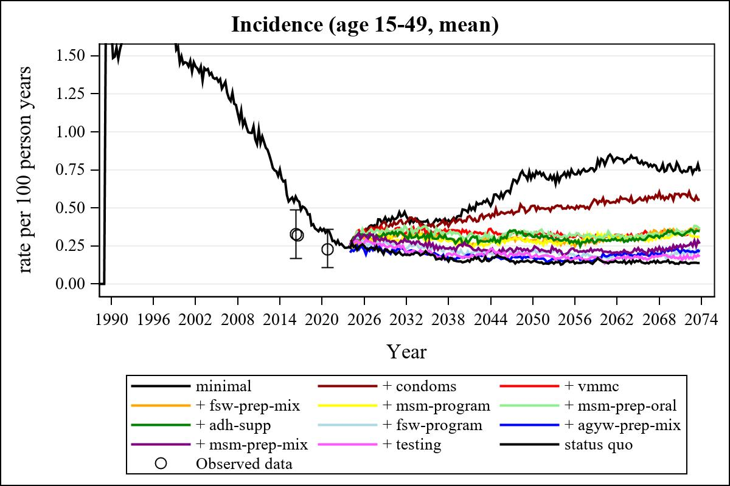

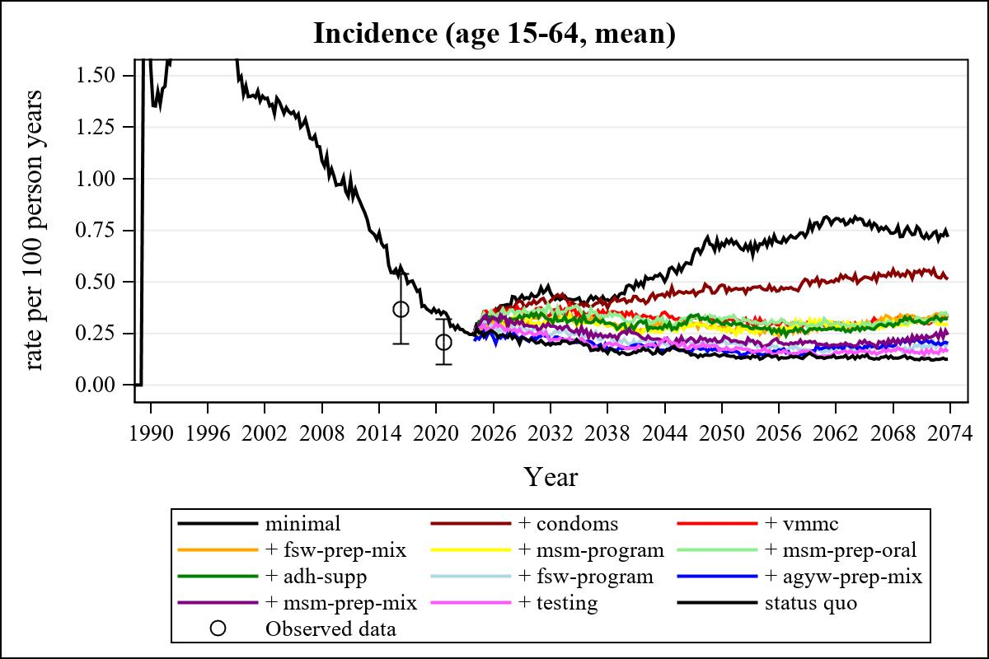

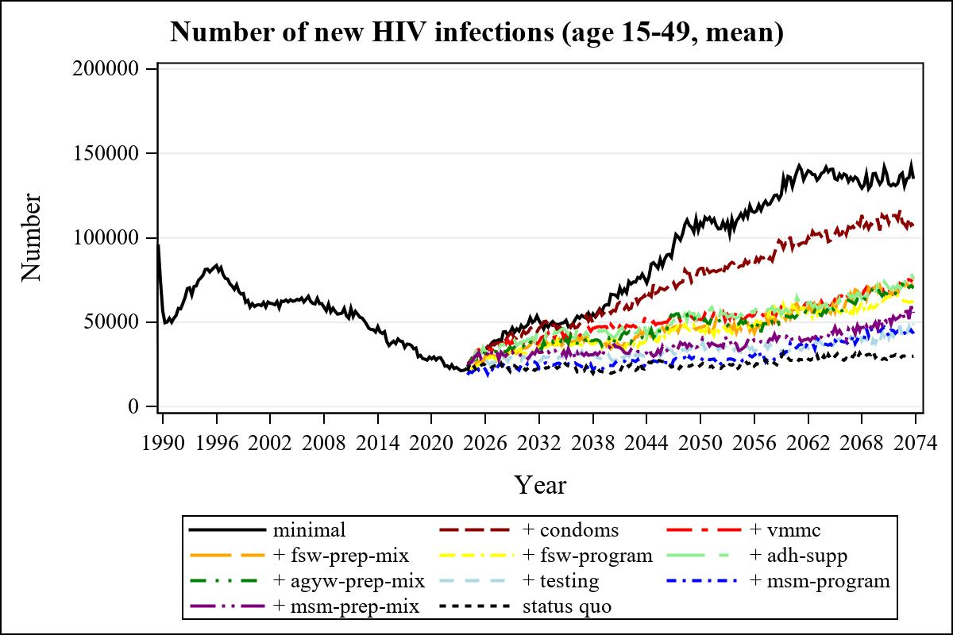

Obs | mean_n_new_inf1549__0 | mean_n_new_inf1549__1 | mean_n_new_inf1549__2 | mean_n_new_inf1549__3
225 | 66593.13 | 55407.99 | 48598.85 | 34589.50

Obs | mean_n_new_inf1549__4 | mean_n_new_inf1549__5 | mean_n_new_inf1549__6 | mean_n_new_inf1549__7
225 | 39426.64 | 42210.53 | 36410.79 | 28046.49

Obs | mean_n_new_inf1549__8 | mean_n_new_inf1549__9 | mean_n_new_inf1549__99
225 | 24358.23 | 34438.69 | 19752.11

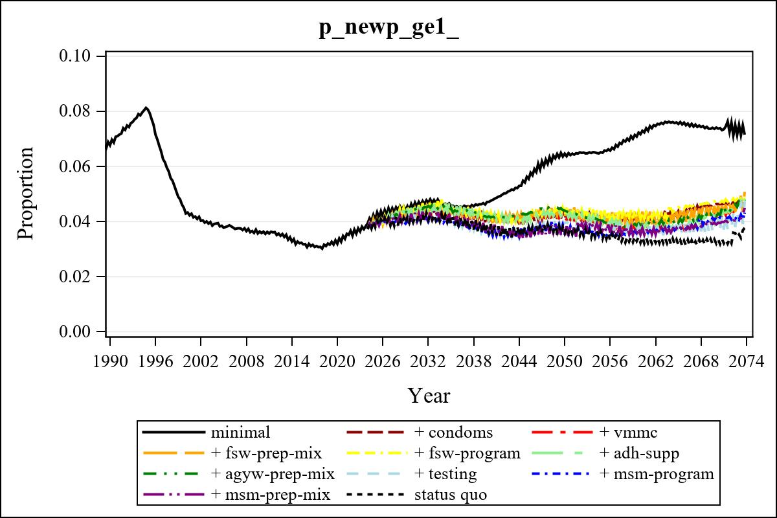

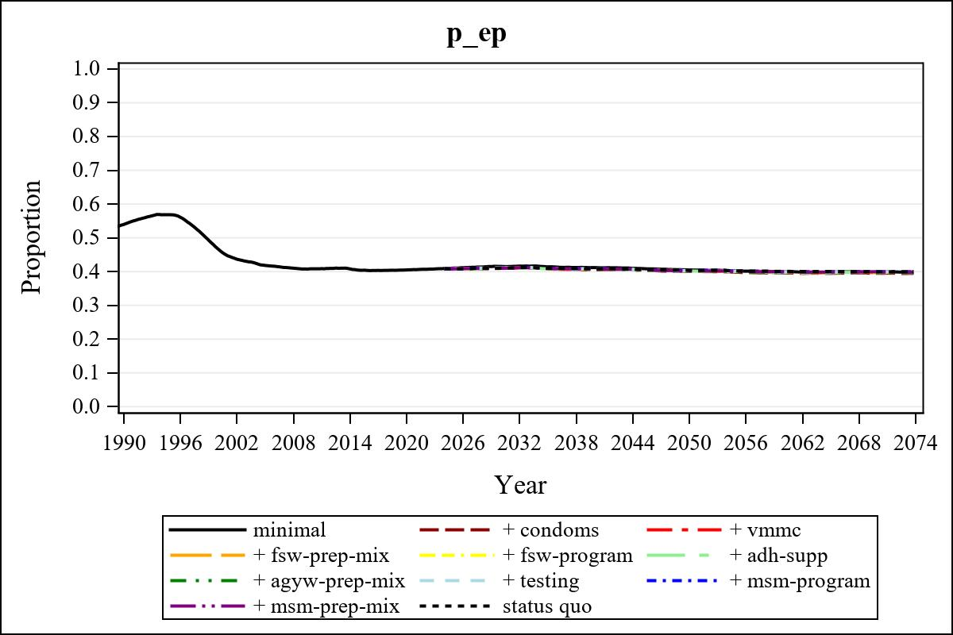

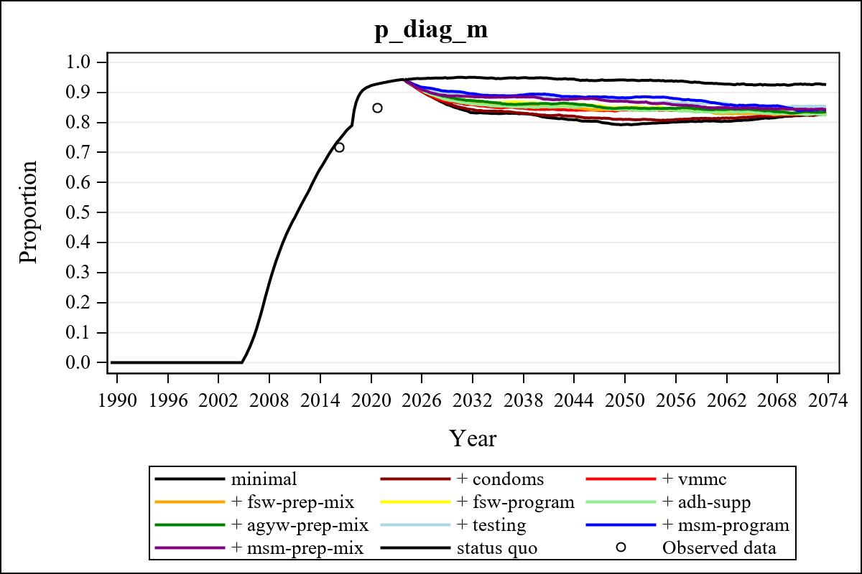

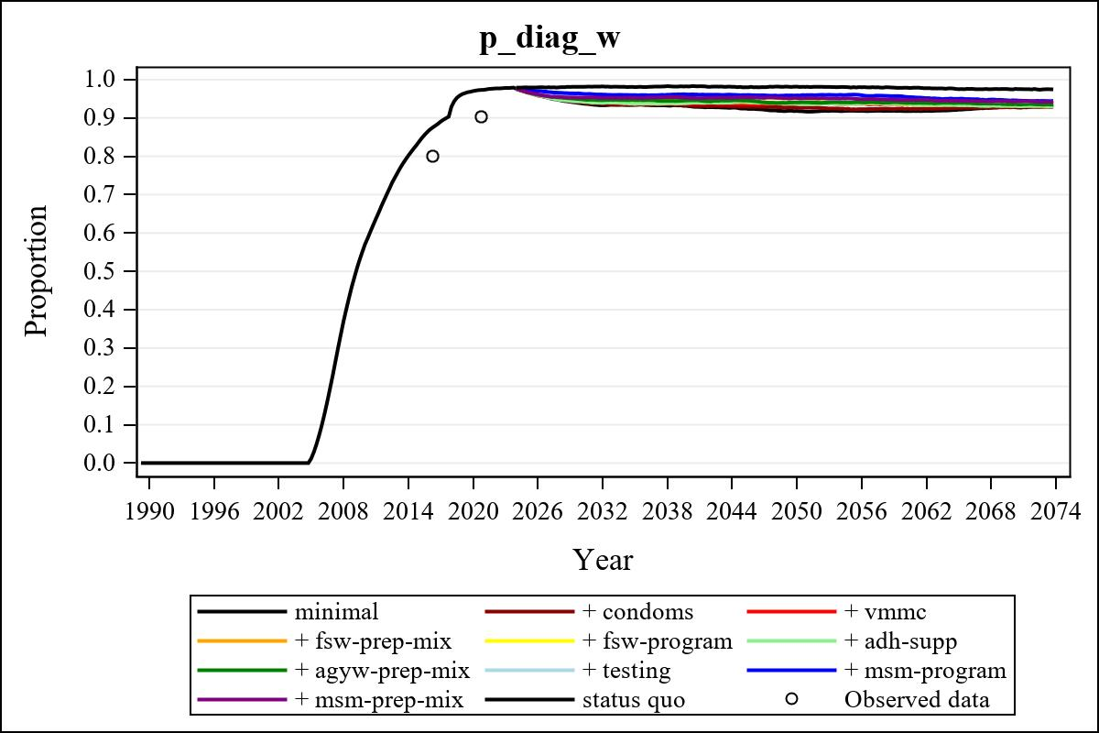

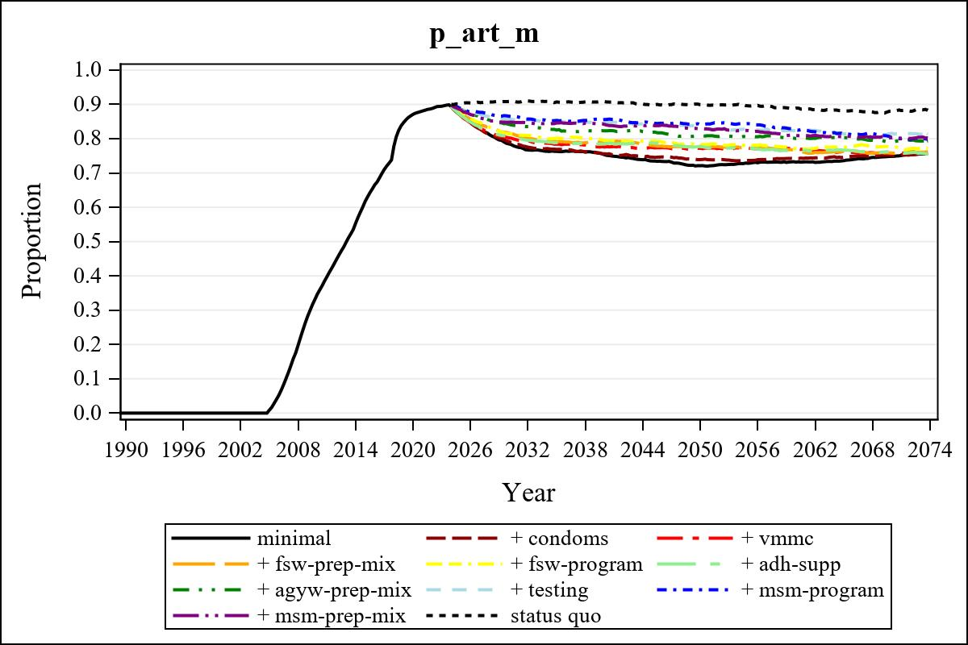

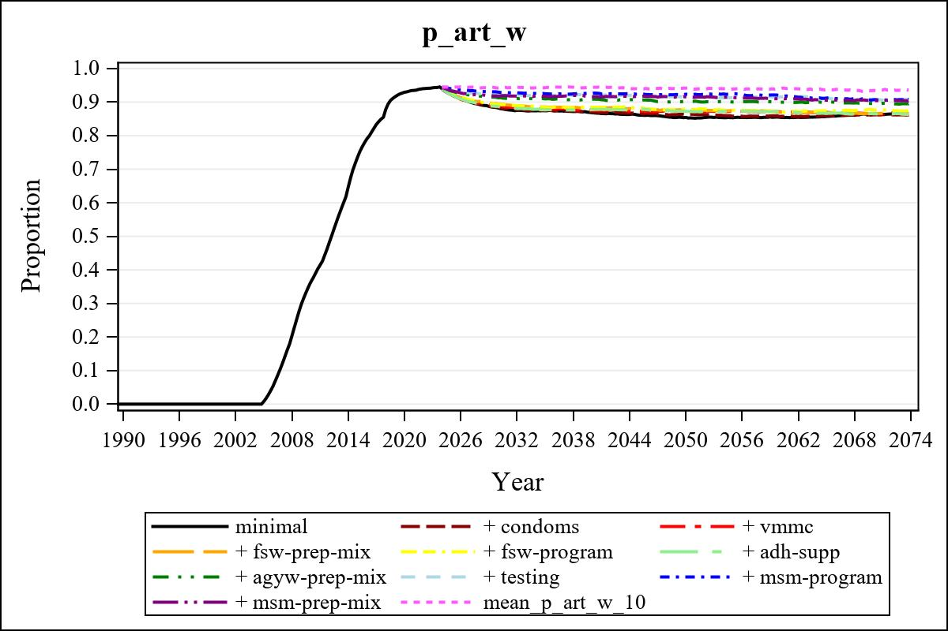

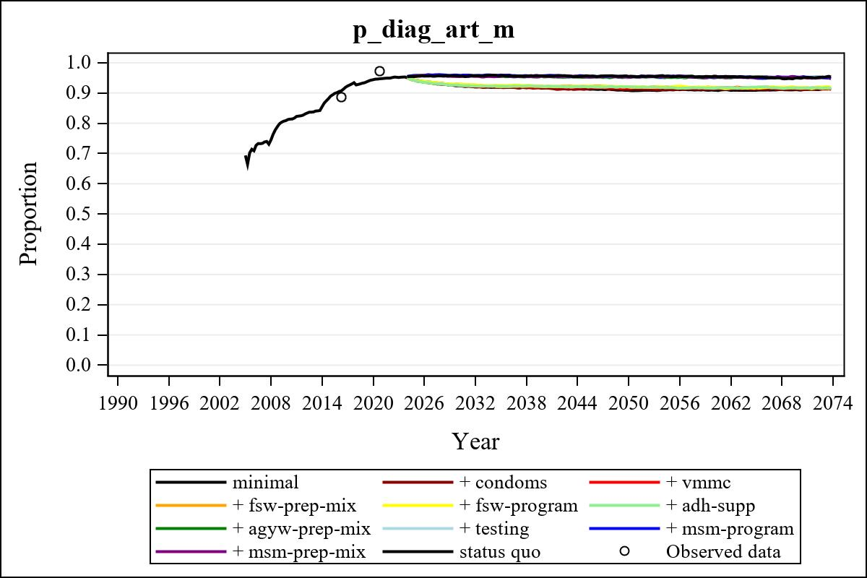

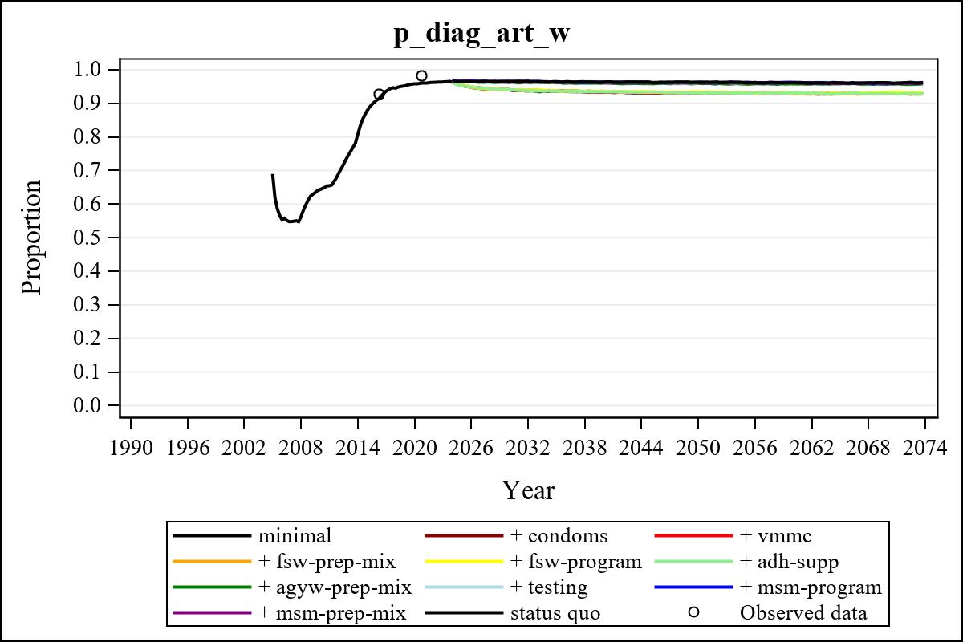

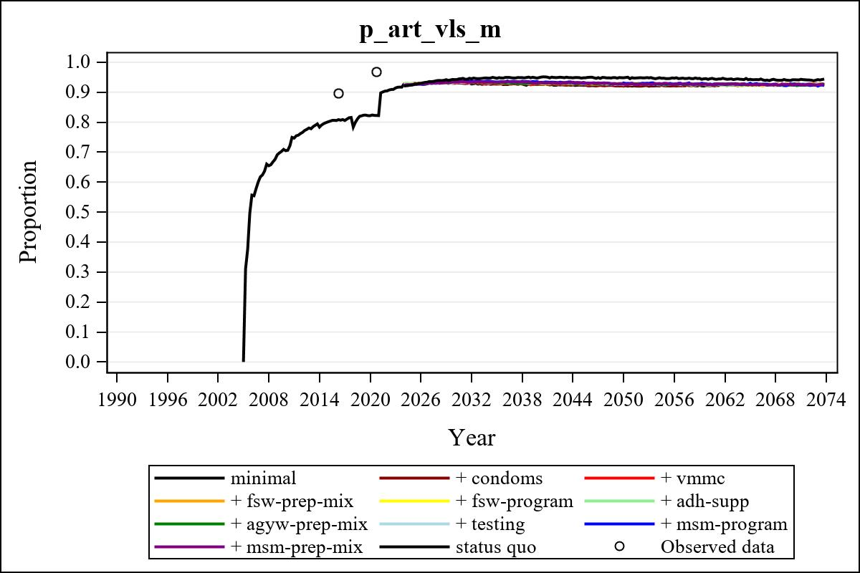

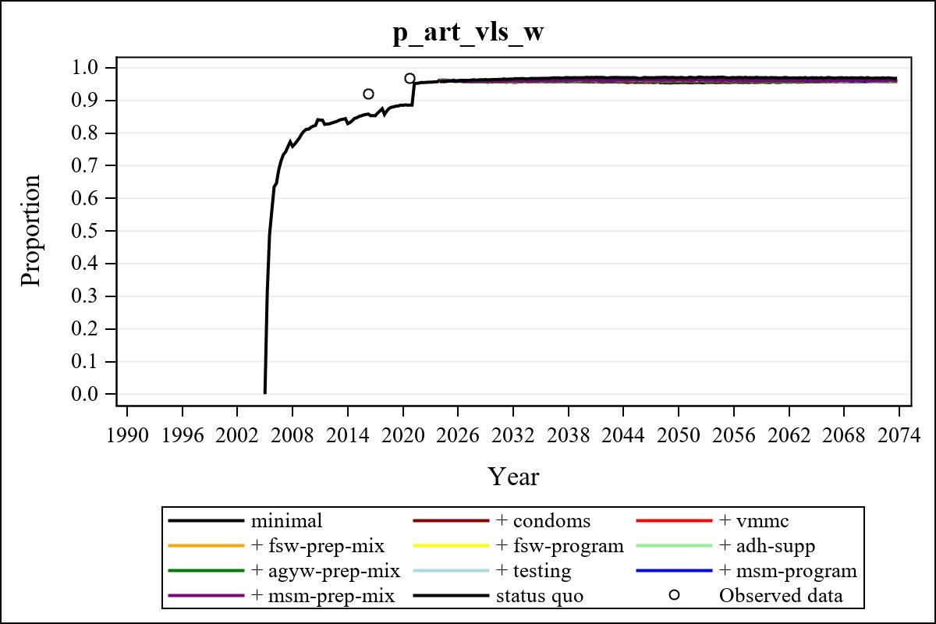

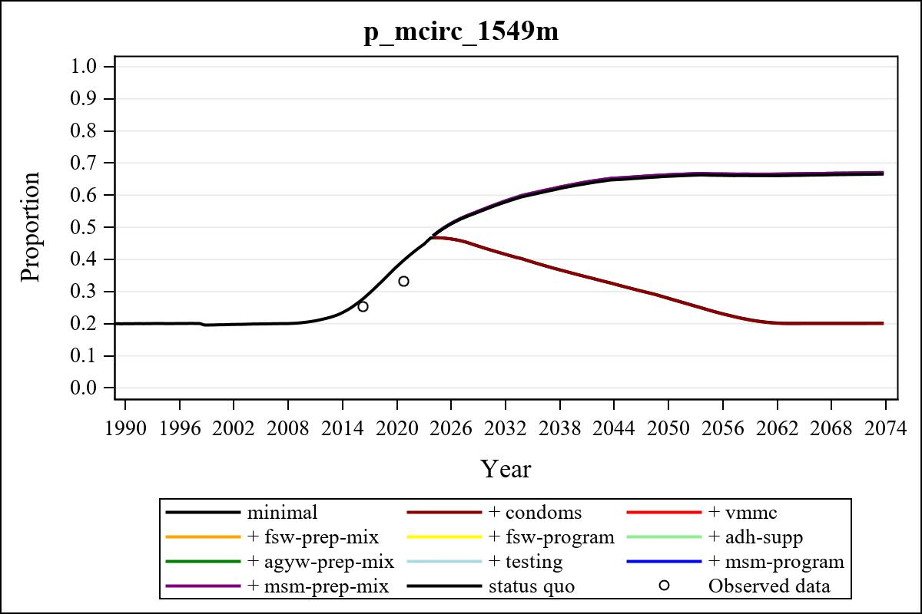

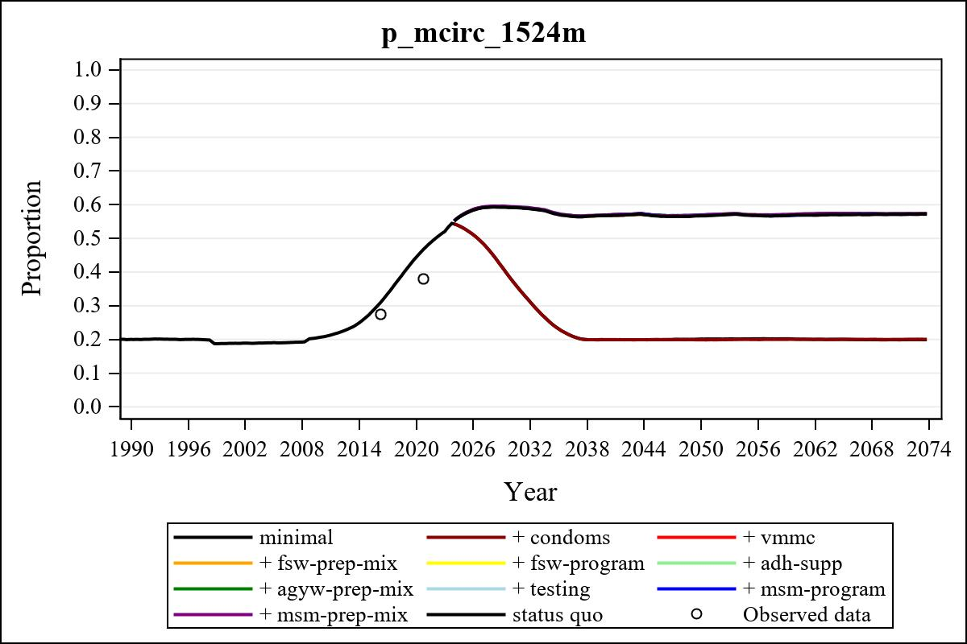

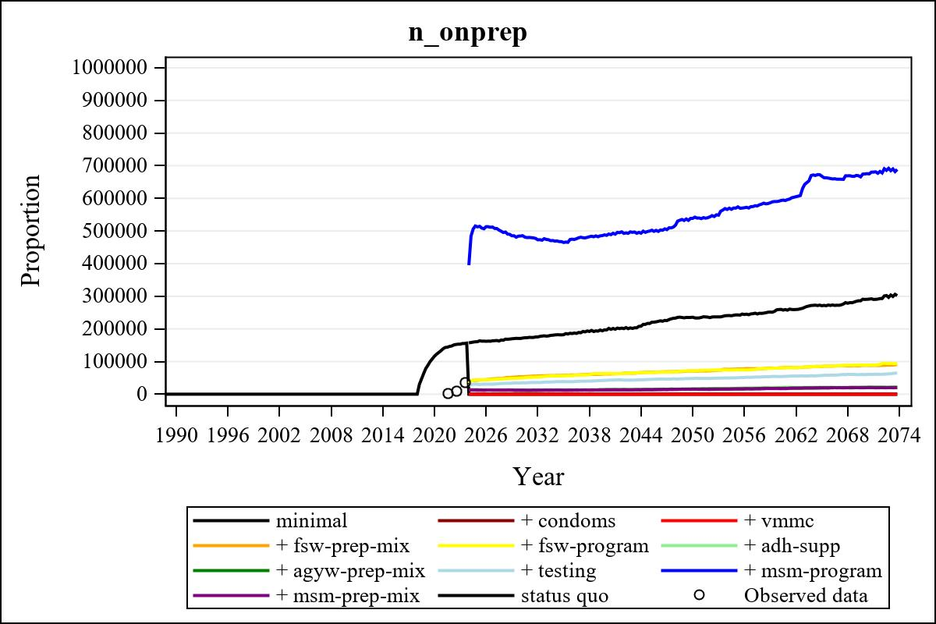

Obs | mean_n_onprep_0 | mean_n_onprep_1 | mean_n_onprep_2 | mean_n_onprep_3
345 | 0 | 0 | 0 | 87969.14

Obs | mean_n_onprep_4 | mean_n_onprep_5 | mean_n_onprep_6 | mean_n_onprep_99
345 | 89227.01 | 21863.95 | 20598.80 | 290389.71

Obs | mean_n_sw_1564__1 | mean_n_undiag_sw_1 | mean_n_elig_prep_1 | mean_n_elig_prep_any_sw_1
185 | 148728.14 | 106992.06 | 0 | 0

Obs | mean_n_onprep_sw_1 | mean_n_onprep_w_1 | mean_n_sw_1564__2 | mean_n_undiag_sw_2
185 | 0 | 0 | 148937.39 | 107089.63

Obs | mean_n_elig_prep_2 | mean_n_elig_prep_any_sw_2 | mean_n_onprep_sw_2 | mean_n_onprep_w_2
185 | 0 | 0 | 0 | 0

Obs | mean_n_onprep_oral_sw_2 | mean_n_onprep_len_sw_2 | mean_n_agyw_pg_3 | mean_n_elig_prep_3
185 | 0 | 0 | 1429366.77 | 117466.14

Obs | mean_n_onprep_agyw_pg_3 | mean_n_onprep_w_3 | mean_n_agyw_pg_4 | mean_n_elig_prep_4
185 | 28248.29 | 53470.05 | 1426556.49 | 115515.52

Obs | mean_n_onprep_agyw_pg_4 | mean_n_onprep_w_4 | mean_n_onprep_oral_agyw_pg_4
185 | 25694.50 | 49381.22 | 9223.63

Obs | mean_n_onprep_len_agyw_pg_4 | mean_n_alive_msm_5 | mean_n_elig_prep_5 | mean_n_onprep_msm_5
185 | 16470.87 | 78906.12 | 31305.61 | 13101.68

Obs | mean_n_onprep_m_5 | mean_n_alive_msm_6 | mean_n_elig_prep_6 | mean_n_onprep_msm_6
185 | 13101.68 | 79208.82 | 30902.42 | 11718.08

Obs | mean_n_onprep_m_6 | mean_n_onprep_oral_msm_6 | mean_n_onprep_len_msm_6 | mean_pc_elig_onprep_1
185 | 11718.08 | 4381.30 | 7336.78 | .

Obs | mean_pc_elig_onprep_2 | mean_pc_elig_onprep_3 | mean_pc_elig_onprep_4 | mean_pc_elig_onprep_5
185 | . | 0.46945 | 0.44705 | 0.41945

Obs | mean_pc_elig_onprep_6
185 | 0.38862

Obs | mean_n_sw_1564__1 | mean_n_undiag_sw_1 | mean_n_elig_prep_1
185 | 148728.14 | 106992.06 | 0

Obs | mean_n_elig_prep_any_sw_1 | mean_n_onprep_sw_1 | mean_n_onprep_w_1
185 | 0 | 0 | 0

Obs | ratio_oral_len_2 | ratio_oral_len_4 | ratio_oral_len_6
1 | . | 0.50334 | 0.51727

