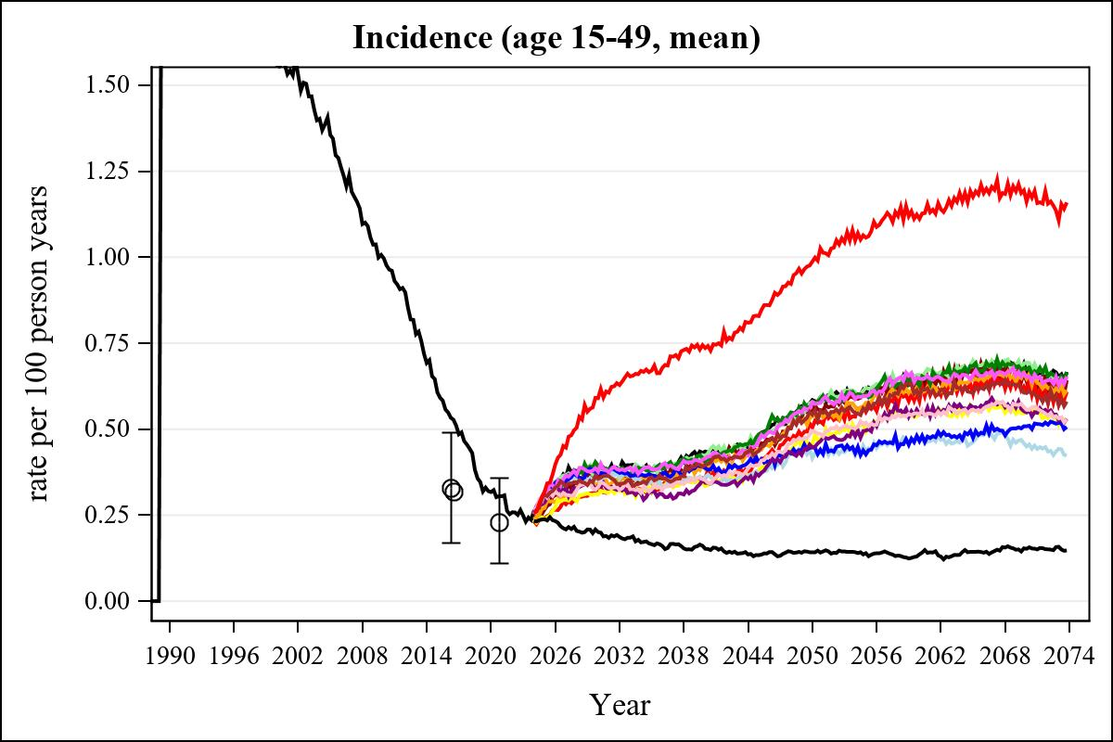

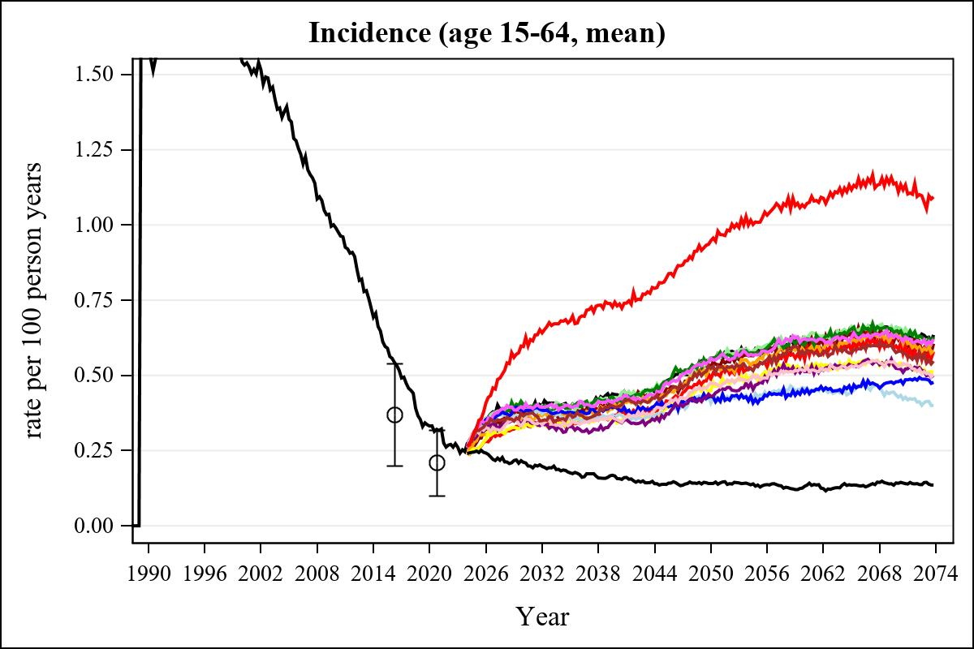

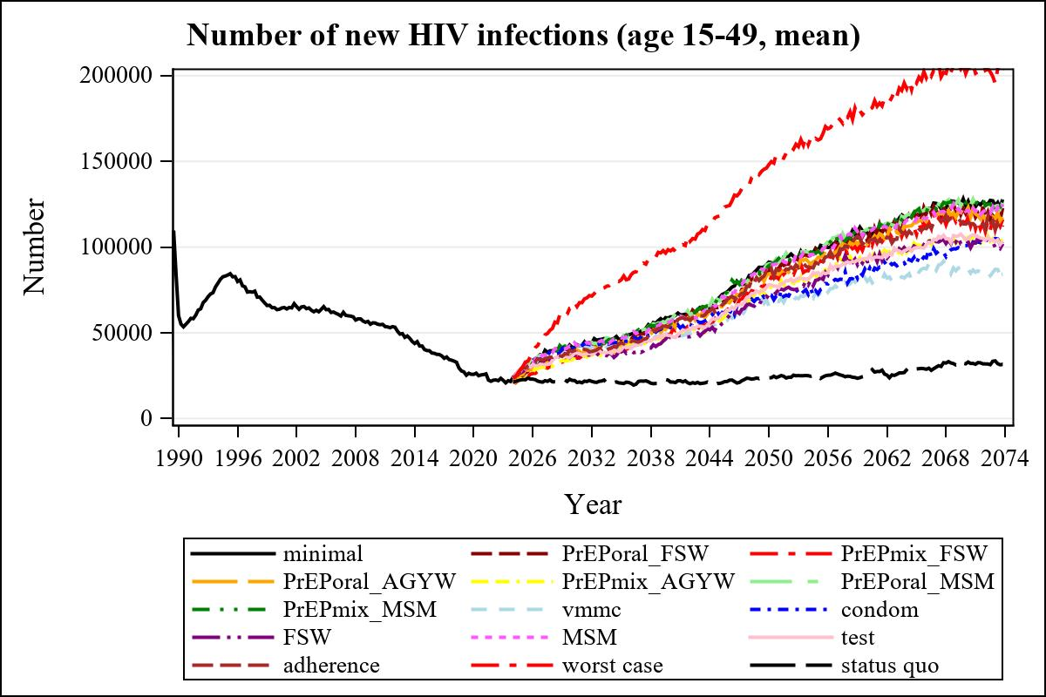

Obs | mean_n_new_inf1549__0 | mean_n_new_inf1549__1 | mean_n_new_inf1549__2 | mean_n_new_inf1549__3
225 | 59354.51 | 55054.31 | 49078.51 | 52933.48

Obs | mean_n_new_inf1549__4 | mean_n_new_inf1549__5 | mean_n_new_inf1549__6 | mean_n_new_inf1549__7
225 | 46044.15 | 57678.37 | 55506.13 | 49503.78

Obs | mean_n_new_inf1549__8 | mean_n_new_inf1549__9 | mean_n_new_inf1549__10 | mean_n_new_inf1549__11
225 | 53069.48 | 47232.40 | 56592.39 | 48406.35

Obs | mean_n_new_inf1549__12 | mean_n_new_inf1549__13 | mean_n_new_inf1549__99
225 | 54346.68 | 97805.98 | 21294.50

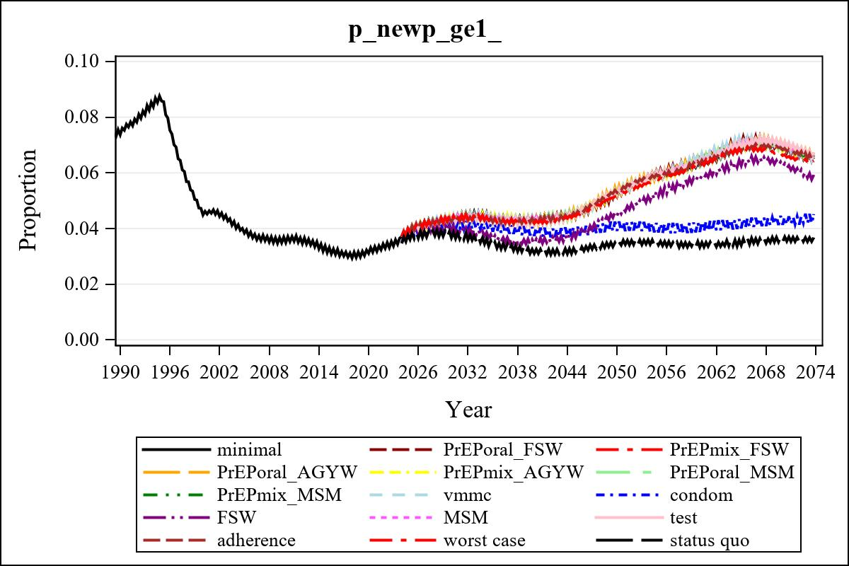

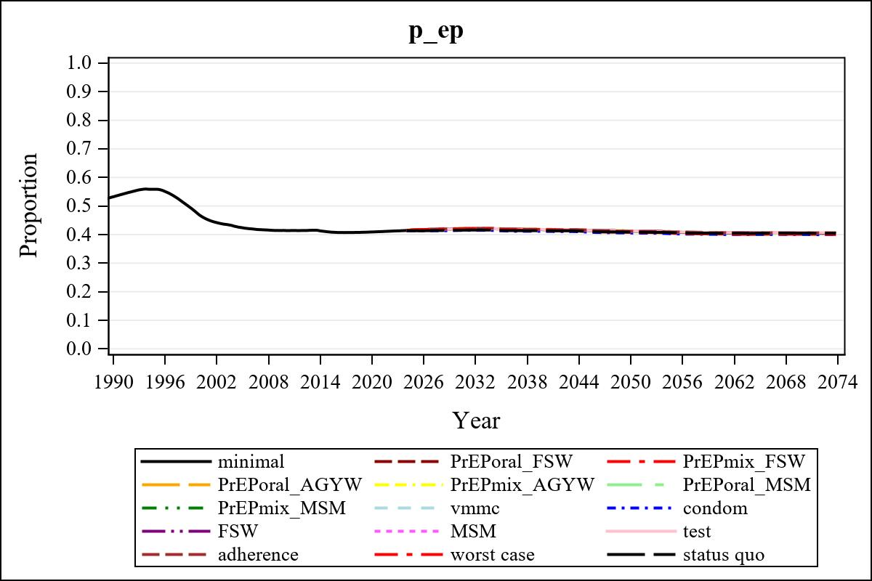

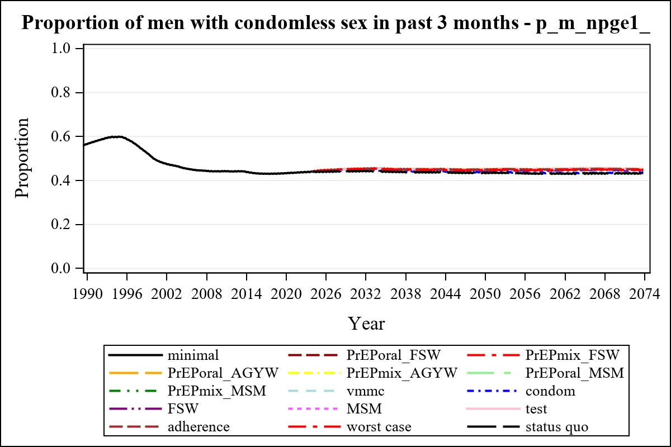

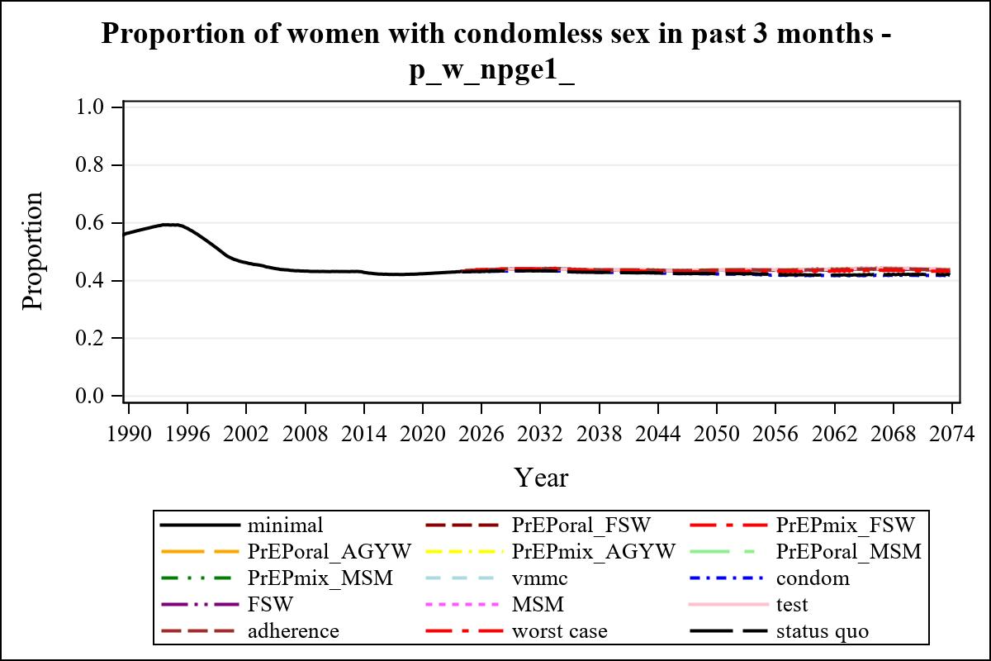

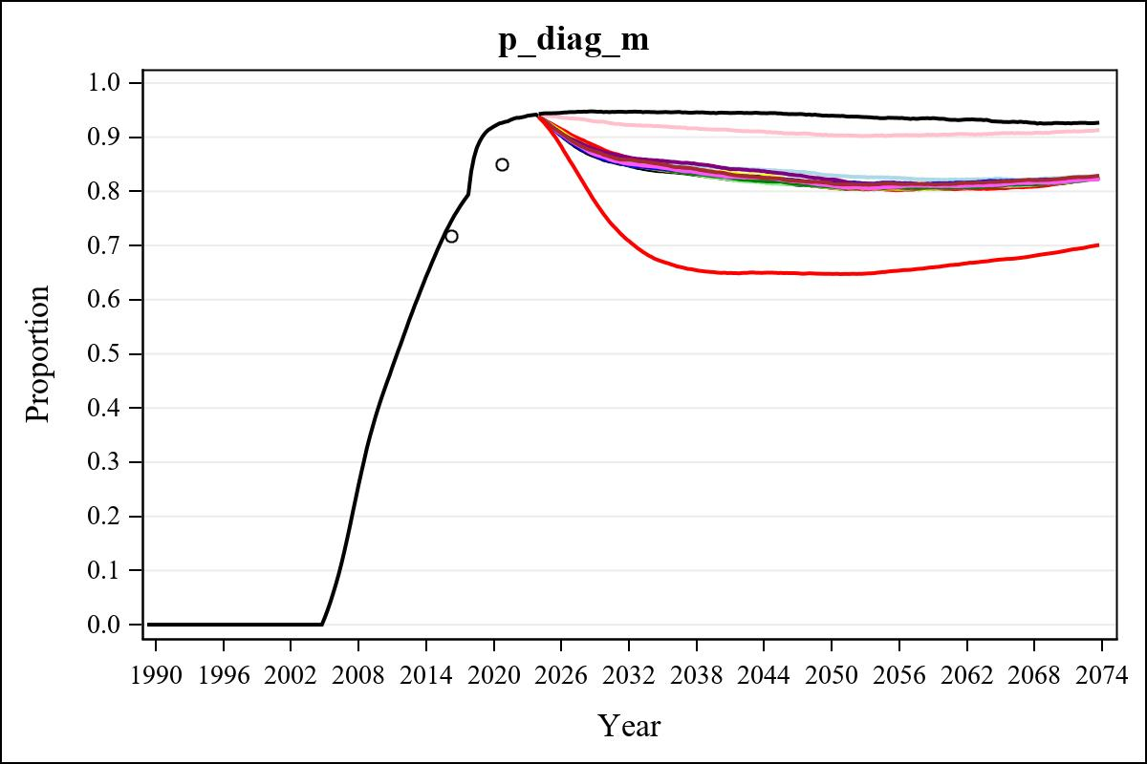

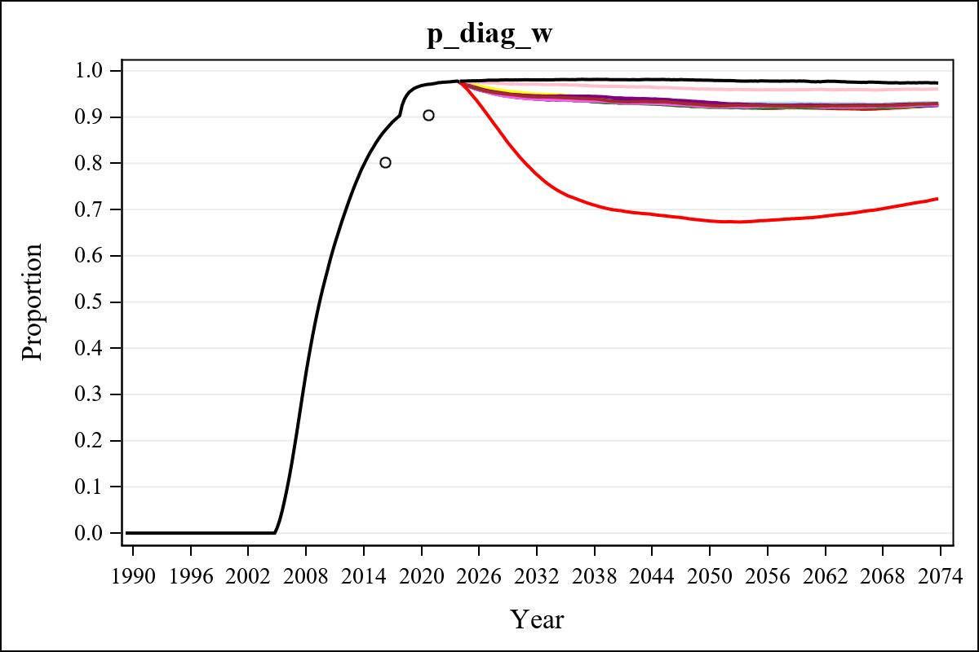

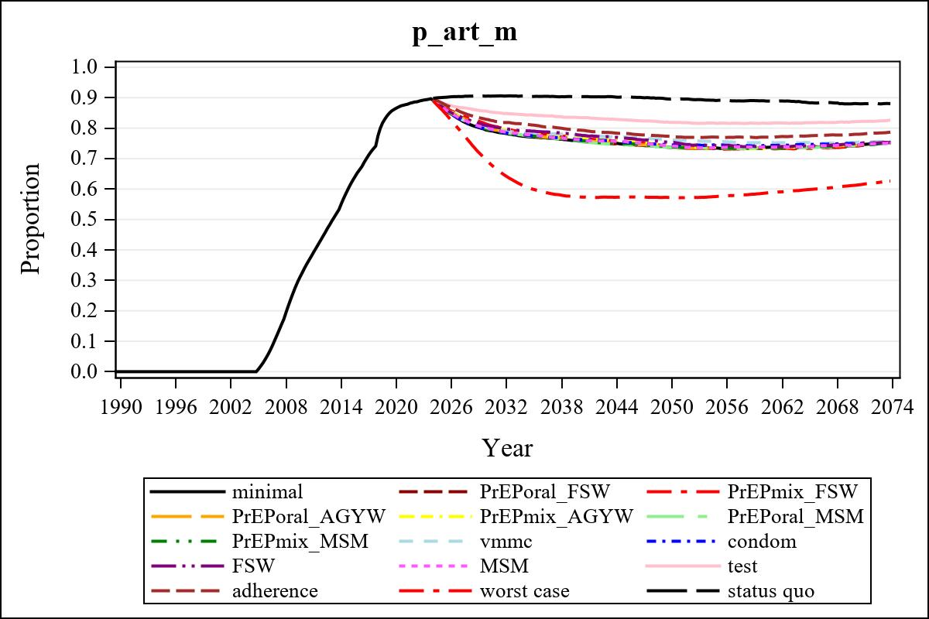

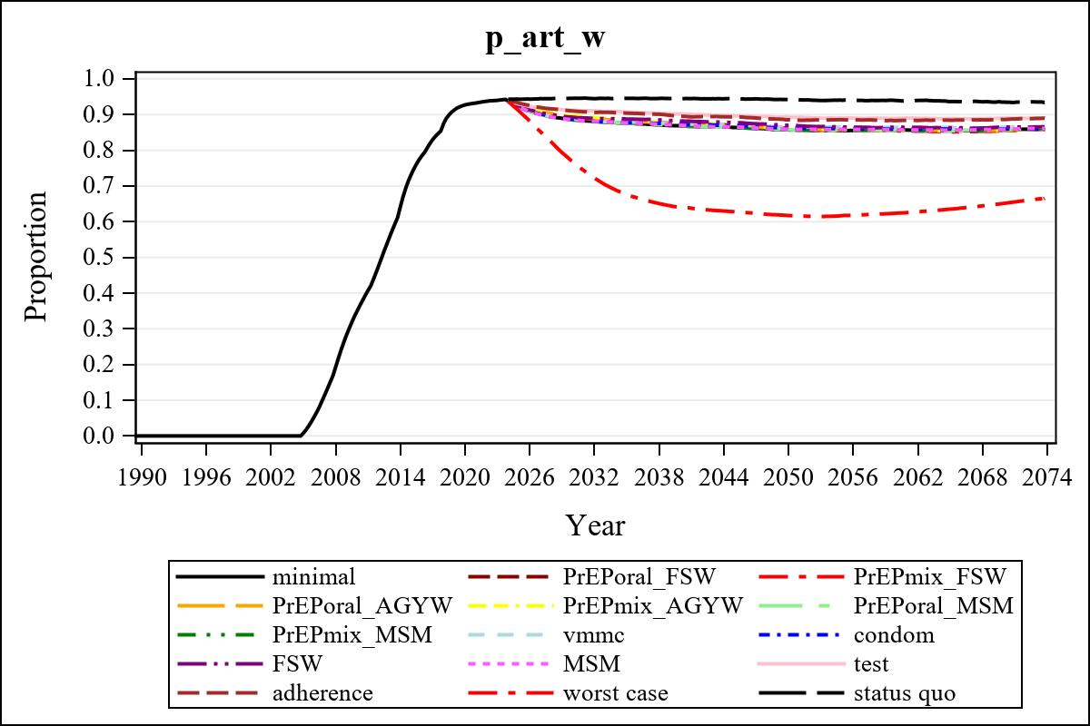

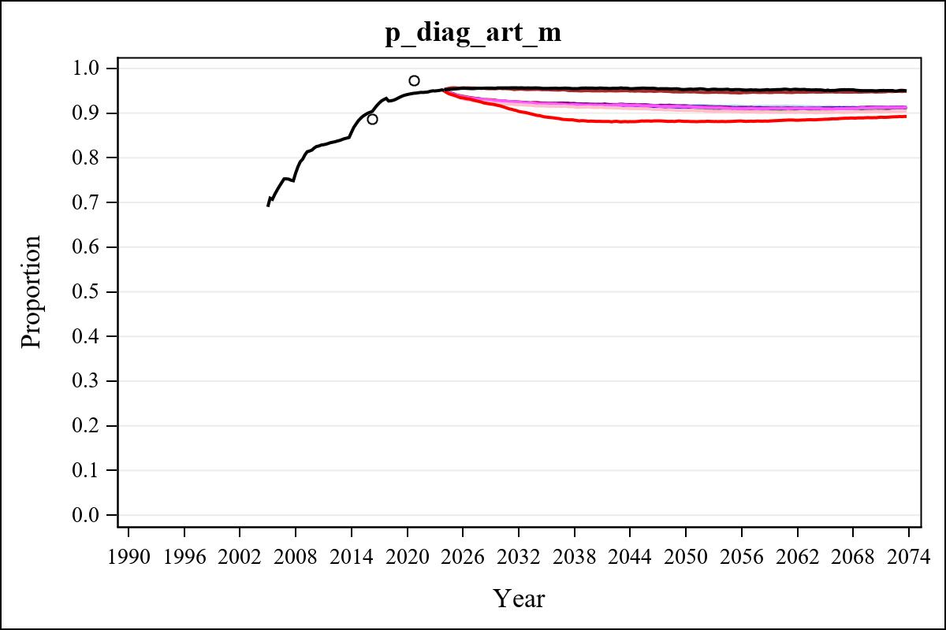

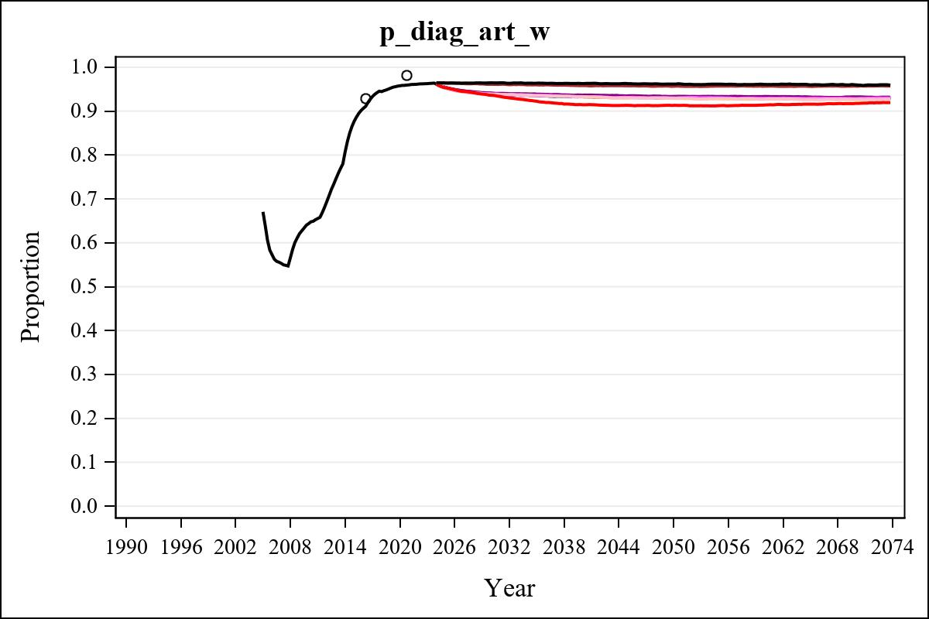

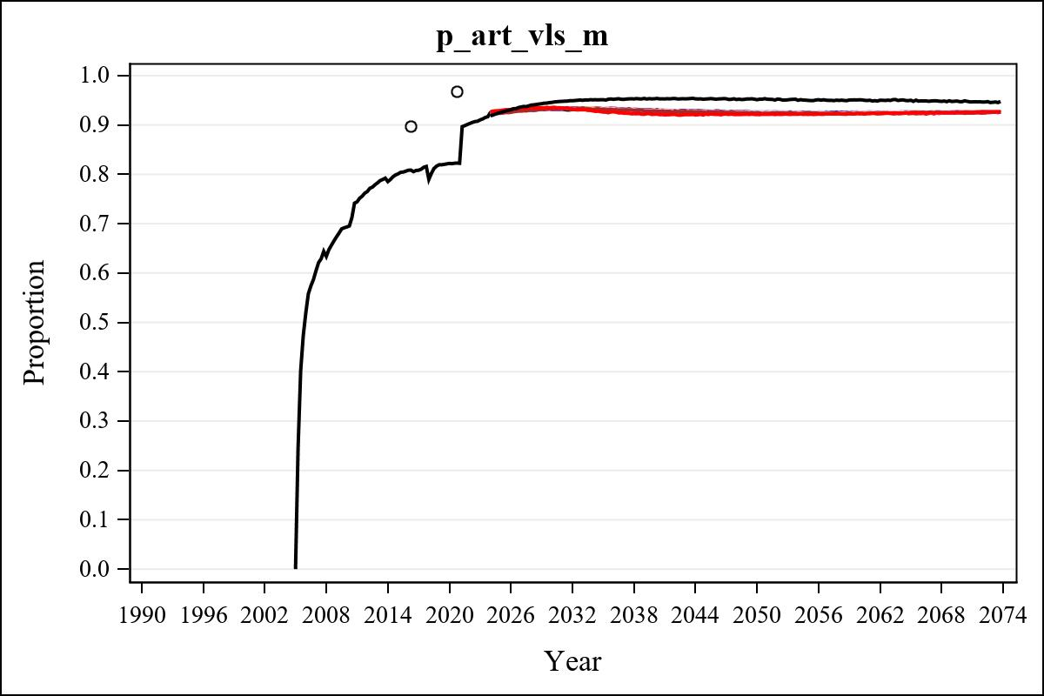

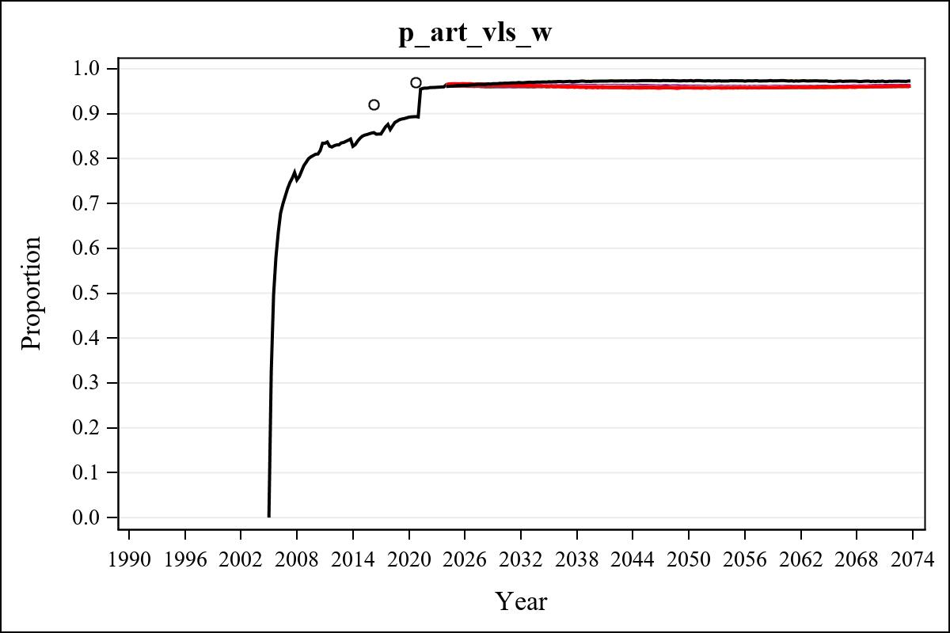

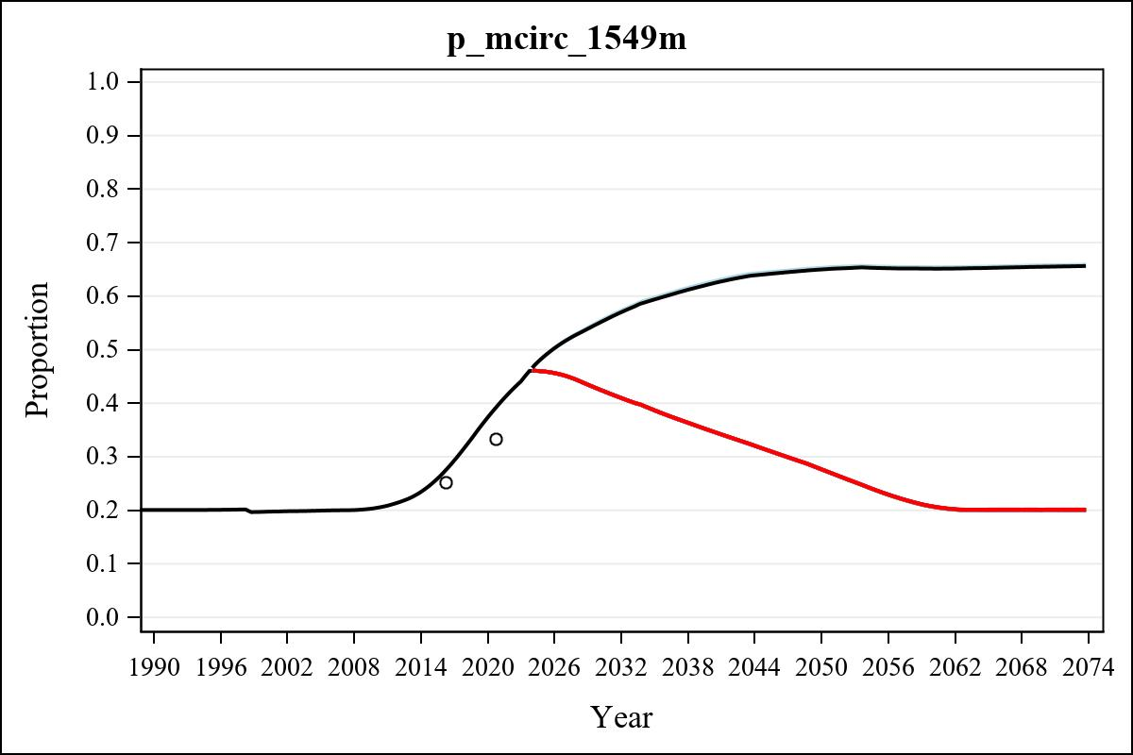

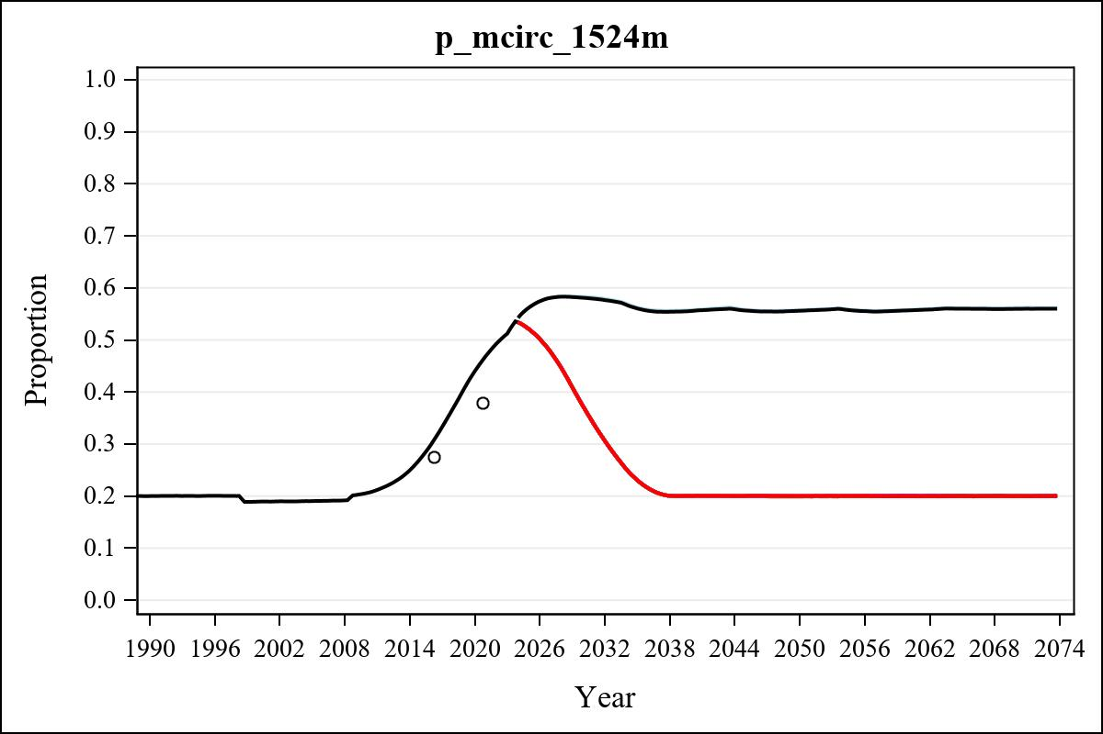

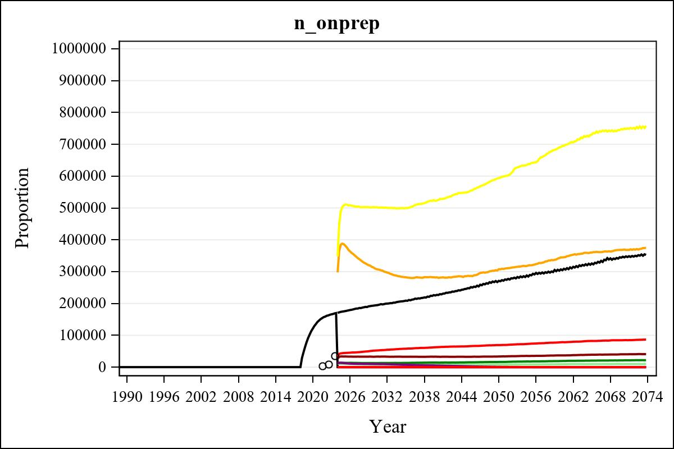

Obs | mean_n_onprep_0 | mean_n_onprep_1 | mean_n_onprep_2 | mean_n_onprep_3
345 | 0 | 40365.85 | 84595.46 | 368612.68

Obs | mean_n_onprep_4 | mean_n_onprep_5 | mean_n_onprep_6 | mean_n_onprep_99
345 | 746453.74 | 9616.22 | 21190.92 | 346850.09

Obs | mean_n_sw_1564__1 | mean_n_undiag_sw_1 | mean_n_elig_prep_1 | mean_n_elig_prep_any_sw_1
185 | 140318.67 | 102495.75 | 103647.00 | 103647.00

Obs | mean_n_onprep_sw_1 | mean_n_onprep_w_1 | mean_n_sw_1564__2 | mean_n_undiag_sw_2
185 | 32801.44 | 32801.44 | 140425.71 | 107850.91

Obs | mean_n_elig_prep_2 | mean_n_elig_prep_any_sw_2 | mean_n_onprep_sw_2 | mean_n_onprep_w_2
185 | 108730.78 | 108730.78 | 51966.91 | 51966.91

Obs | mean_n_onprep_oral_sw_2 | mean_n_onprep_len_sw_2 | mean_n_agyw_pg_3 | mean_n_elig_prep_3
185 | 19221.18 | 32745.74 | 1455906.01 | 1411691.27

Obs | mean_n_onprep_agyw_pg_3 | mean_n_onprep_w_3 | mean_n_agyw_pg_4 | mean_n_elig_prep_4
185 | 310287.60 | 310287.60 | 1454933.38 | 1413850.54

Obs | mean_n_onprep_agyw_pg_4 | mean_n_onprep_w_4 | mean_n_onprep_oral_agyw_pg_4
185 | 501910.13 | 501910.13 | 191263.37

Obs | mean_n_onprep_len_agyw_pg_4 | mean_n_alive_msm_5 | mean_n_elig_prep_5 | mean_n_onprep_msm_5
185 | 310646.76 | 80512.27 | 30671.62 | 8014.60

Obs | mean_n_onprep_m_5 | mean_n_alive_msm_6 | mean_n_elig_prep_6 | mean_n_onprep_msm_6
185 | 8014.60 | 80640.22 | 30859.19 | 12836.87

Obs | mean_n_onprep_m_6 | mean_n_onprep_oral_msm_6 | mean_n_onprep_len_msm_6 | mean_pc_elig_onprep_1
185 | 12836.87 | 4794.98 | 8041.90 | 0.30857

Obs | mean_pc_elig_onprep_2 | mean_pc_elig_onprep_3 | mean_pc_elig_onprep_4 | mean_pc_elig_onprep_5
185 | 0.47170 | 0.22345 | 0.36057 | 0.25664

Obs | mean_pc_elig_onprep_6
185 | 0.41296

Obs | mean_n_sw_1564__1 | mean_n_undiag_sw_1 | mean_n_elig_prep_1
185 | 140318.67 | 102495.75 | 103647.00

Obs | mean_n_elig_prep_any_sw_1 | mean_n_onprep_sw_1 | mean_n_onprep_w_1
185 | 103647.00 | 32801.44 | 32801.44

Obs | ratio_oral_len_2 | ratio_oral_len_4 | ratio_oral_len_6
1 | 0.56091 | 0.59079 | 0.52875

