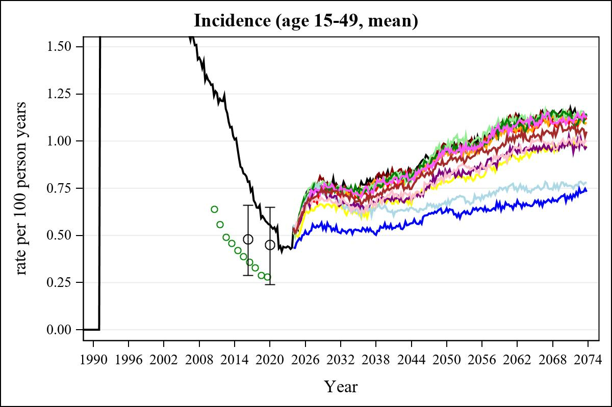

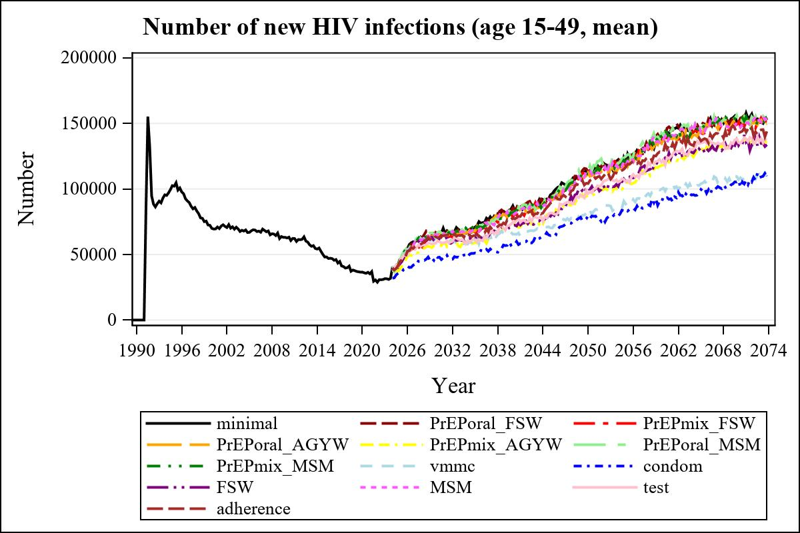

Obs | mean_n_new_inf1549__0 | mean_n_new_inf1549__1 | mean_n_new_inf1549__2 | mean_n_new_inf1549__3
345 | 151127.35 | 151023.63 | 151167.17 | 153109.34

Obs | mean_n_new_inf1549__4 | mean_n_new_inf1549__5 | mean_n_new_inf1549__6 | mean_n_new_inf1549__7
345 | 136134.50 | 151417.31 | 155635.49 | 107210.51

Obs | mean_n_new_inf1549__8 | mean_n_new_inf1549__9 | mean_n_new_inf1549__10 | mean_n_new_inf1549__11
345 | 106672.40 | 133287.76 | 149522.30 | 135322.66

Obs | mean_n_new_inf1549__12
345 | 142946.03

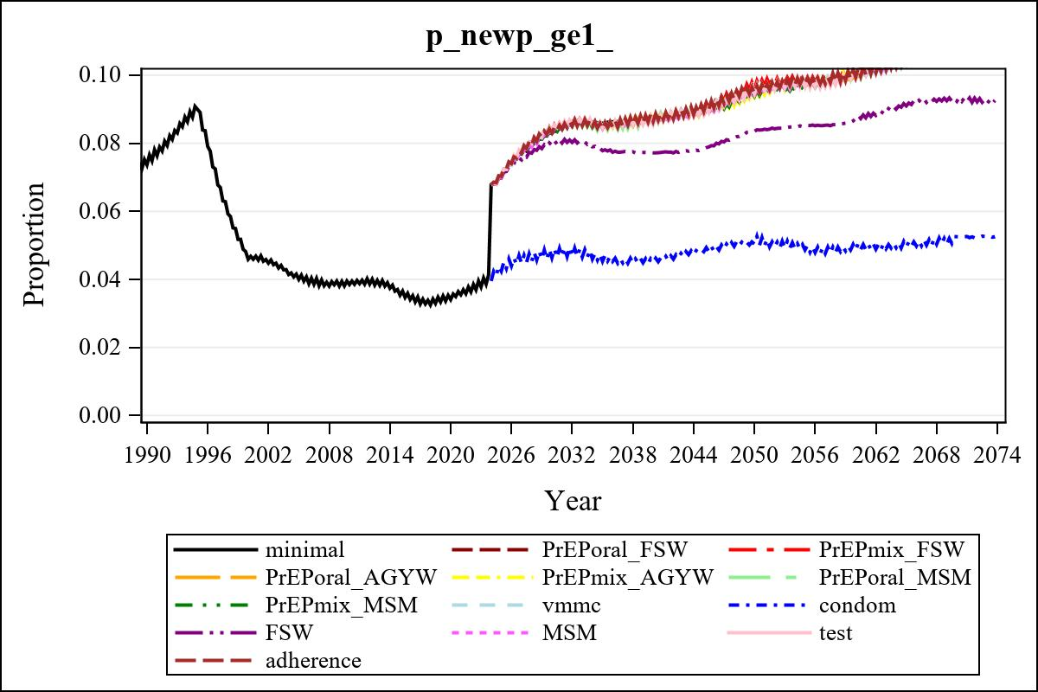

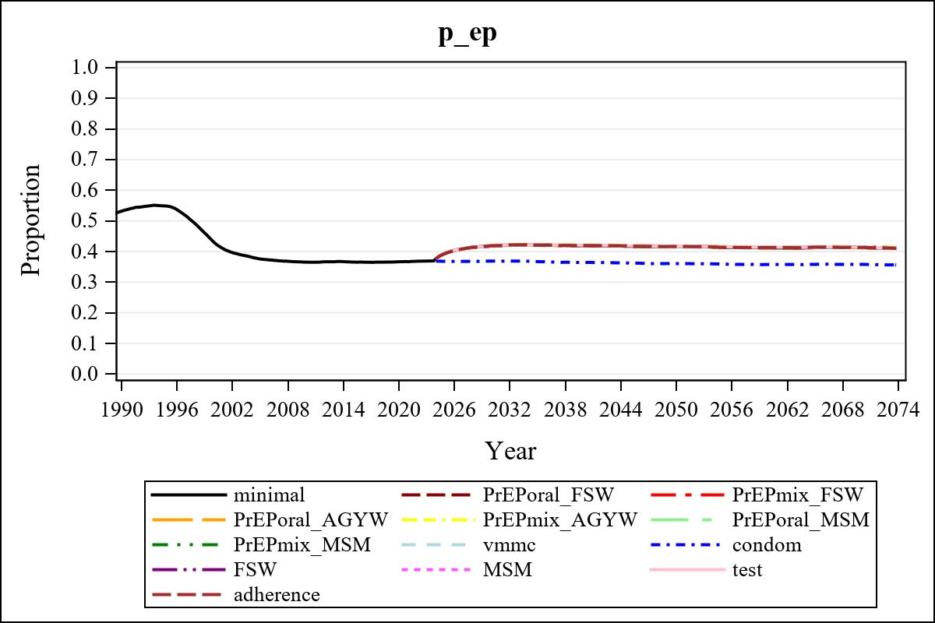

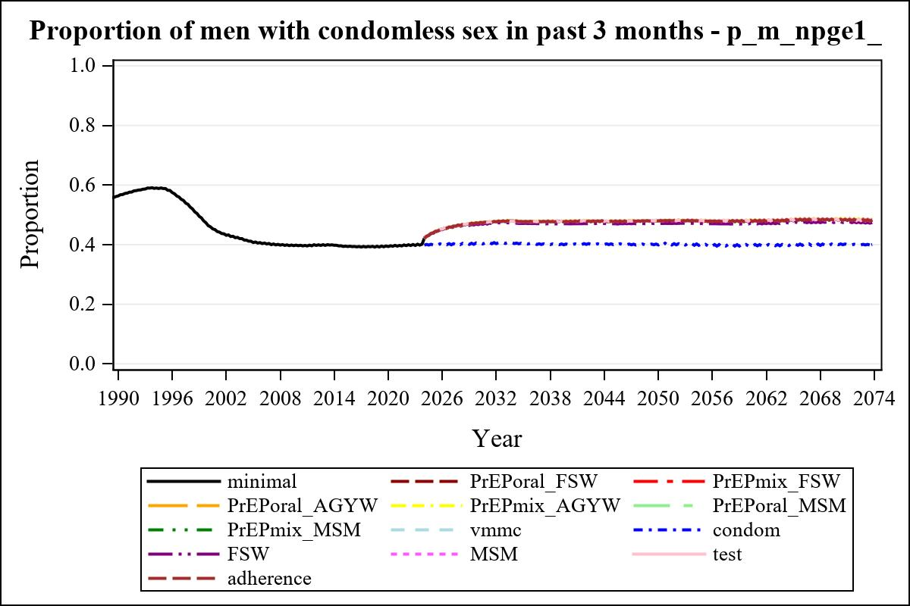

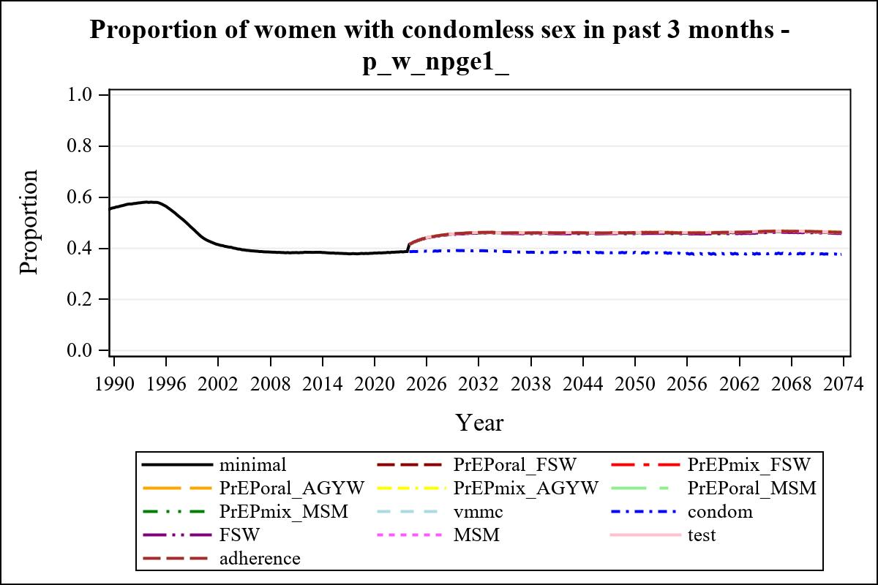

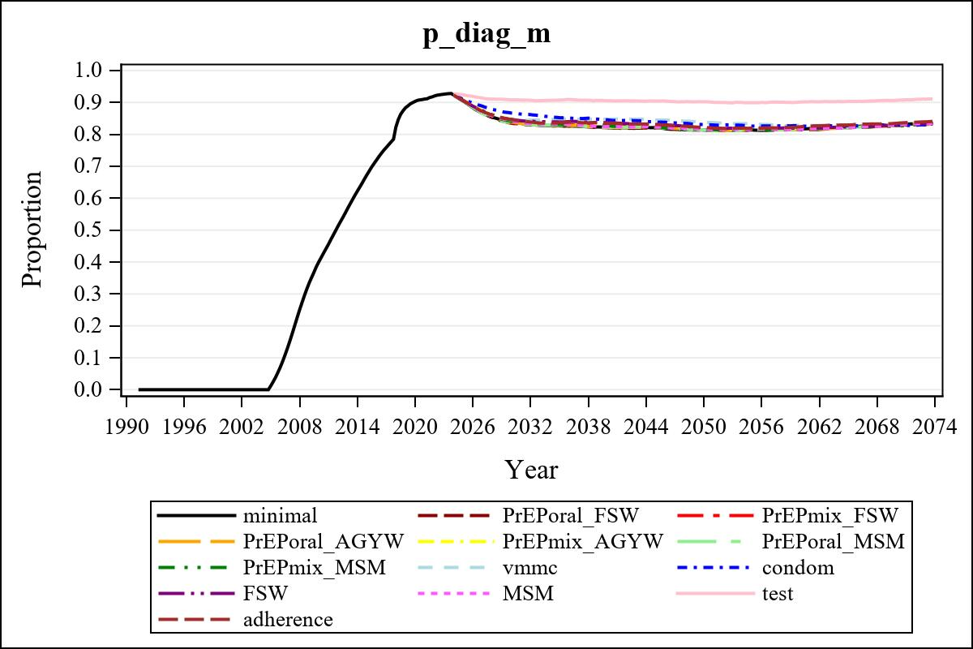

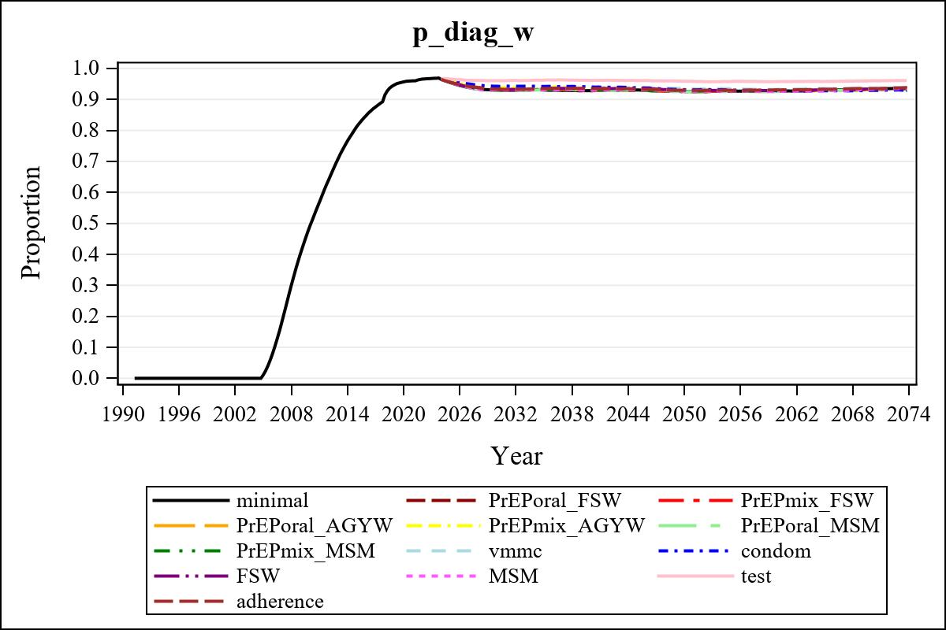

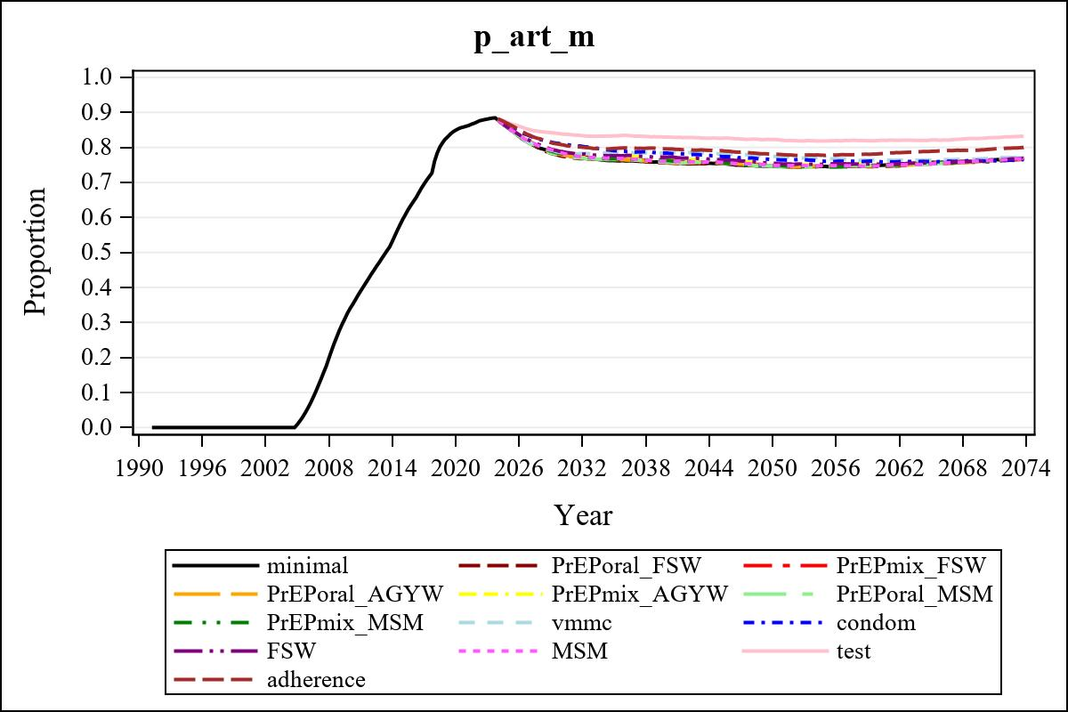

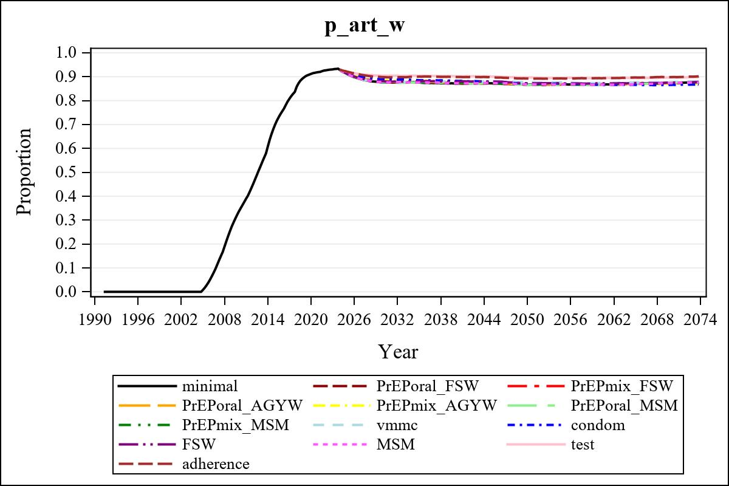

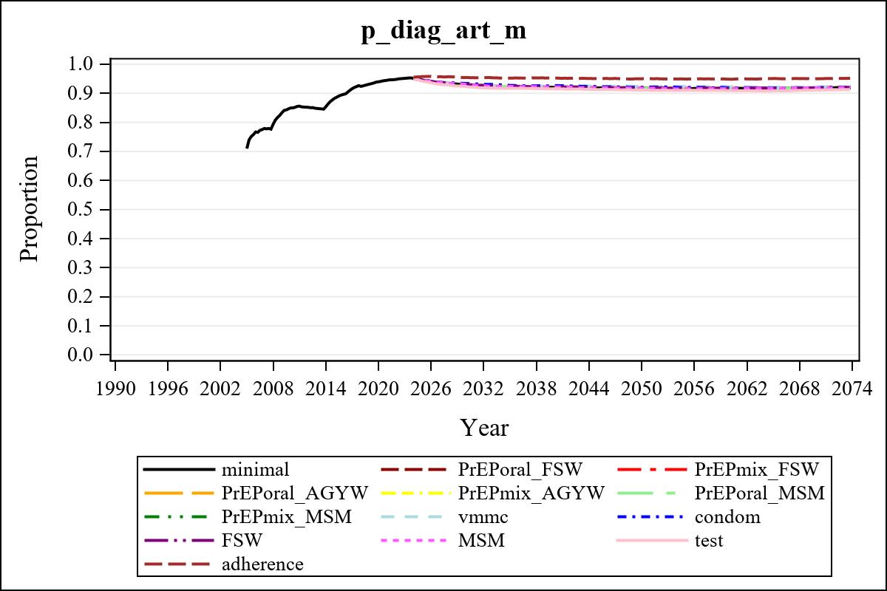

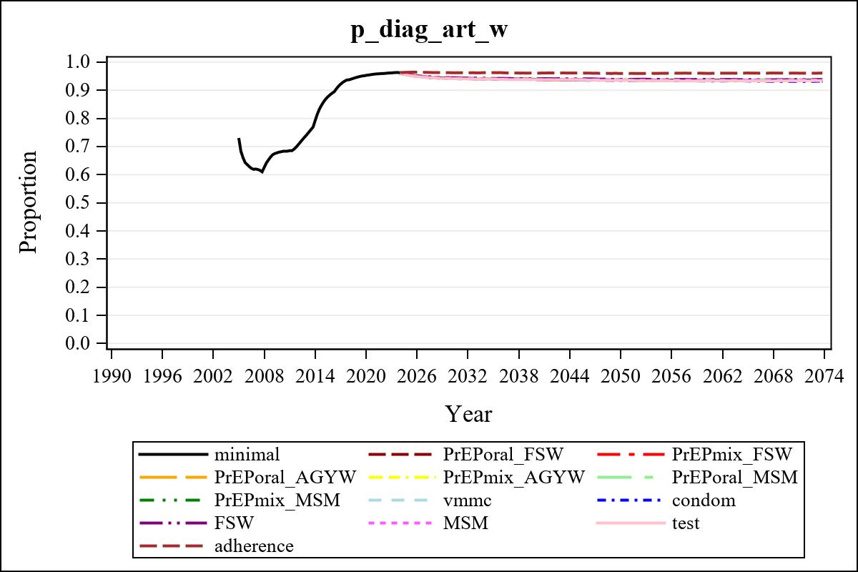

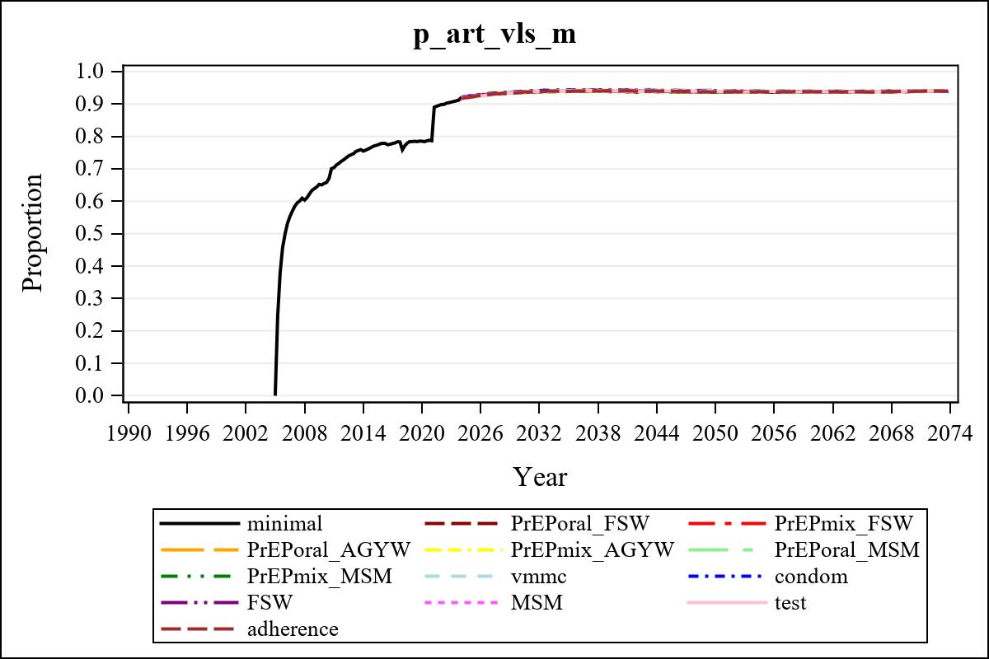

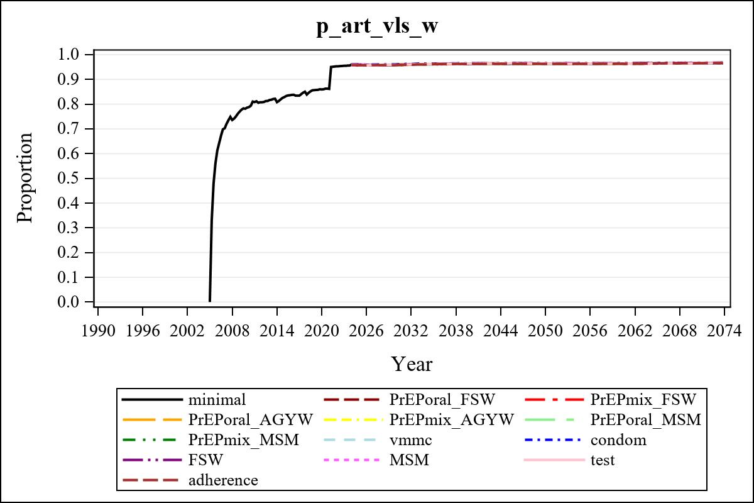

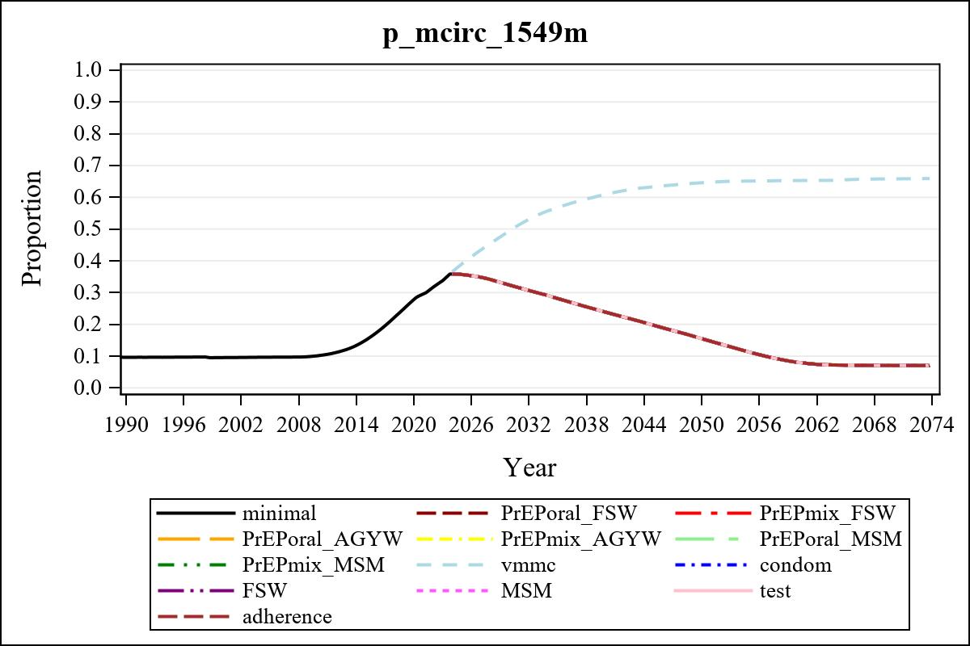

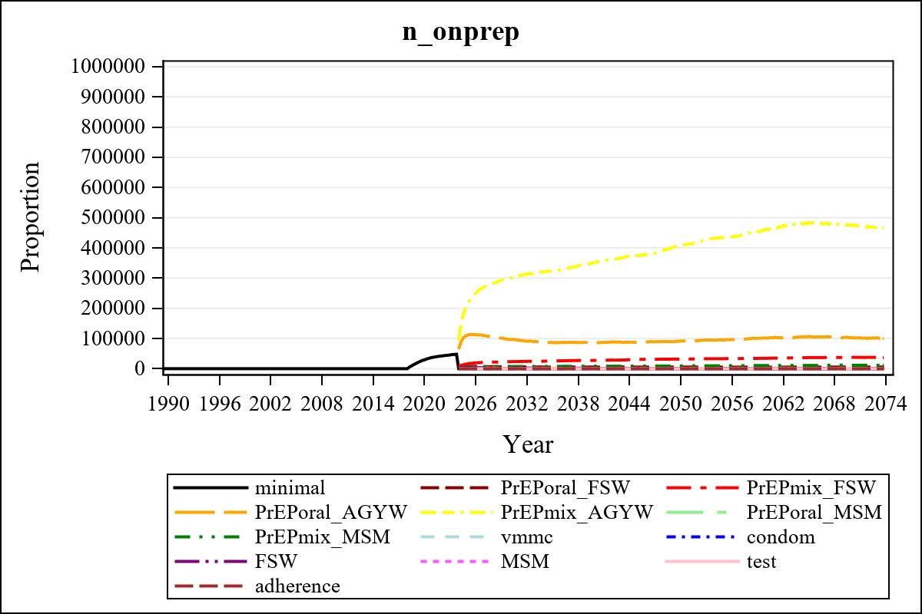

Obs | mean_n_onprep_0
345 | 0

Obs | mean_n_elig_prep_1 | mean_n_sw_1564__1 | mean_n_onprep_sw_1 | mean_n_onprep_w_1
185 | 72219.36 | 133435.64 | 6271.82 | 6271.82

Obs | mean_n_elig_prep_2 | mean_n_sw_1564__2 | mean_n_onprep_sw_2 | mean_n_onprep_w_2
185 | 74541.95 | 132564.73 | 23173.02 | 23173.02

Obs | mean_n_onprep_oral_sw_2 | mean_n_onprep_len_sw_2 | mean_n_elig_prep_3 | mean_n_agyw_pg_3
185 | 2429.46 | 20743.56 | 1004146.29 | 1075151.69

Obs | mean_n_onprep_agyw_pg_3 | mean_n_onprep_w_3 | mean_n_elig_prep_4 | mean_n_agyw_pg_4
185 | 96353.00 | 96353.00 | 1015243.59 | 1079250.67

Obs | mean_n_onprep_agyw_pg_4 | mean_n_onprep_w_4 | mean_n_onprep_oral_agyw_pg_4
185 | 300245.30 | 300245.30 | 45808.51

Obs | mean_n_onprep_len_agyw_pg_4 | mean_n_elig_prep_5 | mean_n_alive_msm_5 | mean_n_onprep_msm_5
185 | 254436.79 | 23414.75 | 66901.71 | 1866.70

Obs | mean_n_onprep_m_5 | mean_n_elig_prep_6 | mean_n_alive_msm_6 | mean_n_onprep_msm_6
185 | 1866.70 | 23843.52 | 67131.28 | 7274.65

Obs | mean_n_onprep_m_6 | mean_n_onprep_oral_msm_6 | mean_n_onprep_len_msm_6 | mean_pc_elig_onprep_1
185 | 7274.65 | 899.937 | 6374.71 | 0.086533

Obs | mean_pc_elig_onprep_2 | mean_pc_elig_onprep_3 | mean_pc_elig_onprep_4 | mean_pc_elig_onprep_5
185 | 0.29976 | 0.096489 | 0.29201 | 0.076227

Obs | mean_pc_elig_onprep_6
185 | 0.29290

Obs | ratio_oral_len_2 | ratio_oral_len_4 | ratio_oral_len_6
1 | 0.10804 | 0.16236 | 0.10328

