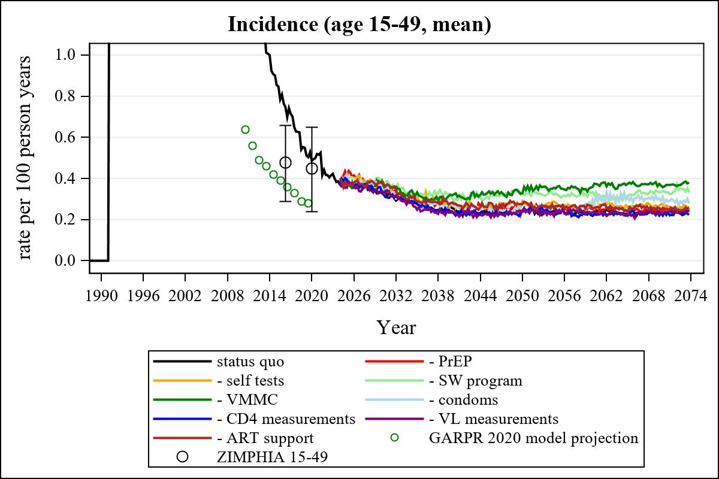

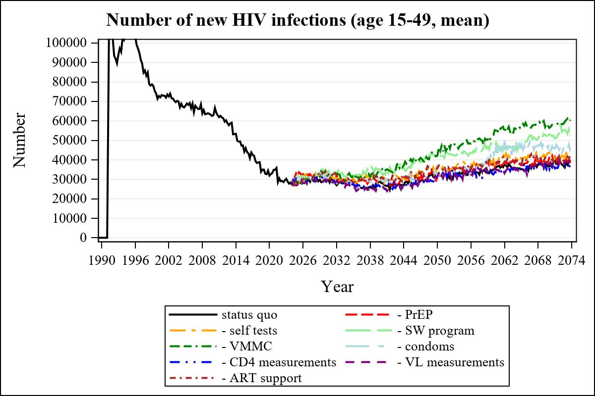

Obs | mean_n_new_inf1549__0 | mean_n_new_inf1549__1 | mean_n_new_inf1549__2
345 | 36676.98 | 41039.93 | 43810.62

Obs | mean_n_new_inf1549__3 | mean_n_new_inf1549__4 | mean_n_new_inf1549__5
345 | 53007.38 | 56412.88 | 48978.85

Obs | mean_n_new_inf1549__6 | mean_n_new_inf1549__7 | mean_n_new_inf1549__8
345 | 35126.10 | 37598.87 | 38050.07

