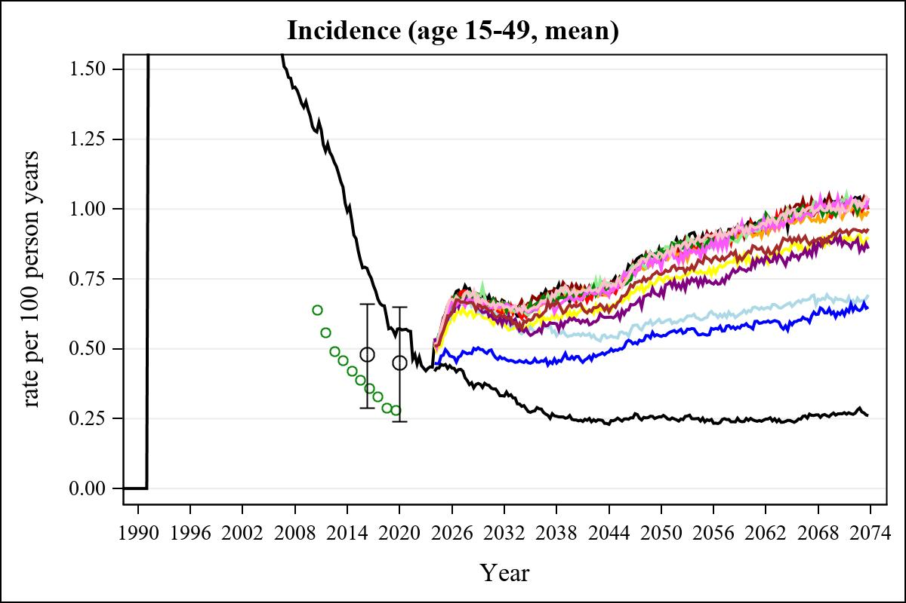

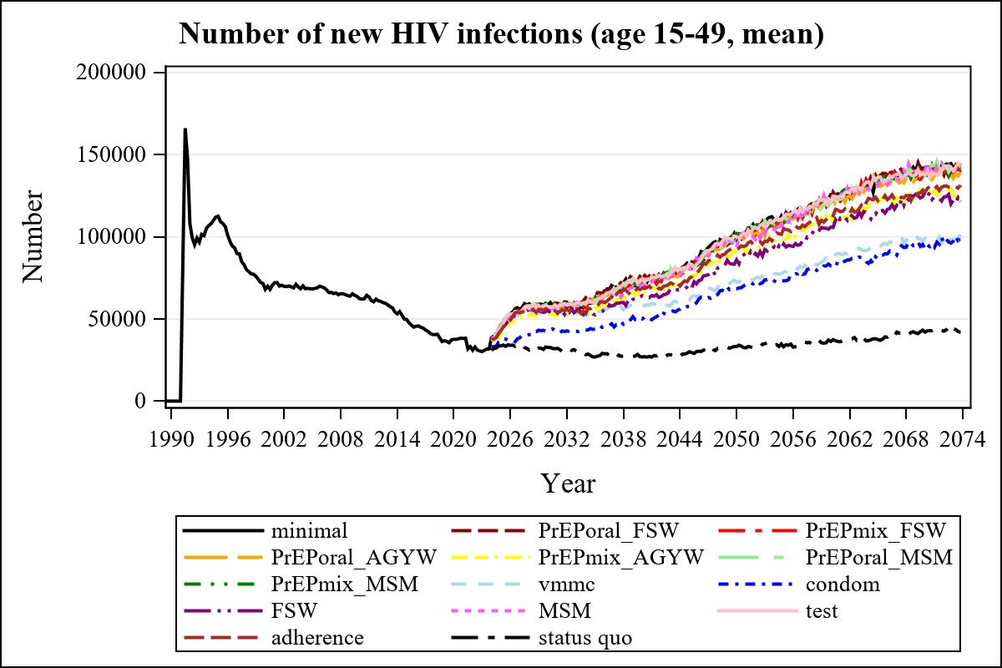

Obs | mean_n_new_inf1549__0 | mean_n_new_inf1549__1 | mean_n_new_inf1549__2 | mean_n_new_inf1549__3
345 | 142217.13 | 139014.96 | 138575.55 | 138536.14

Obs | mean_n_new_inf1549__4 | mean_n_new_inf1549__5 | mean_n_new_inf1549__6 | mean_n_new_inf1549__7
345 | 128177.46 | 141985.67 | 135747.57 | 99331.18

Obs | mean_n_new_inf1549__8 | mean_n_new_inf1549__9 | mean_n_new_inf1549__10 | mean_n_new_inf1549__11
345 | 92515.54 | 127420.20 | 140406.89 | 137472.33

Obs | mean_n_new_inf1549__12 | mean_n_new_inf1549__99
345 | 127290.42 | 42038.81

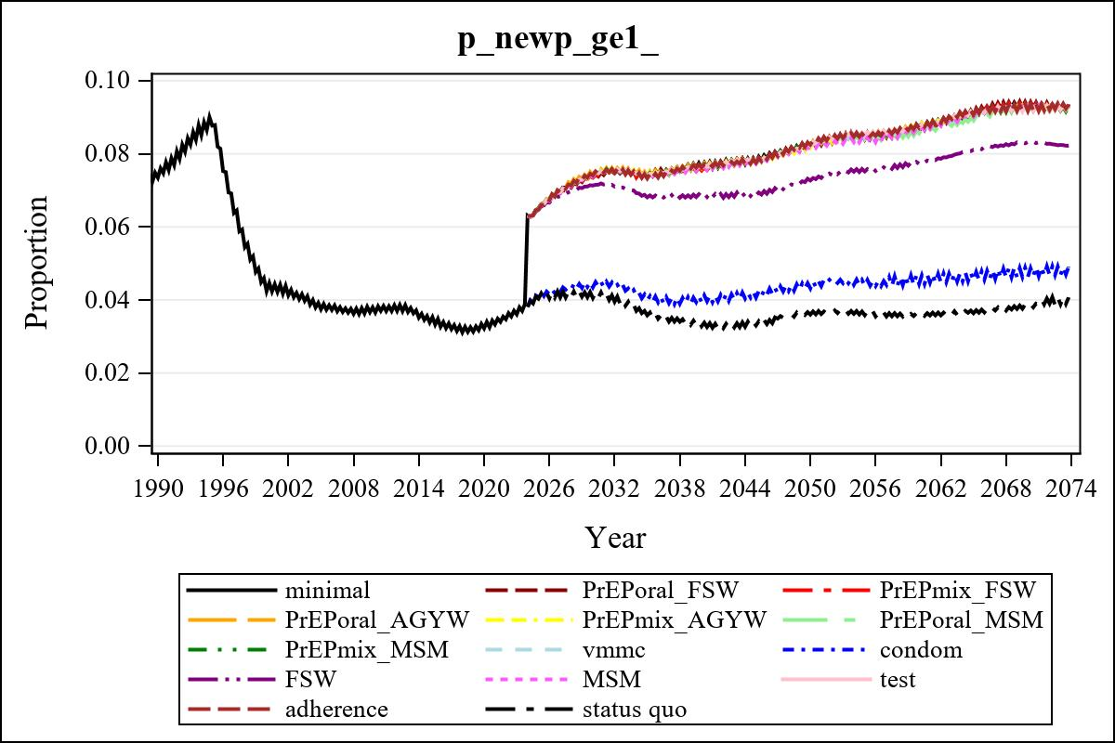

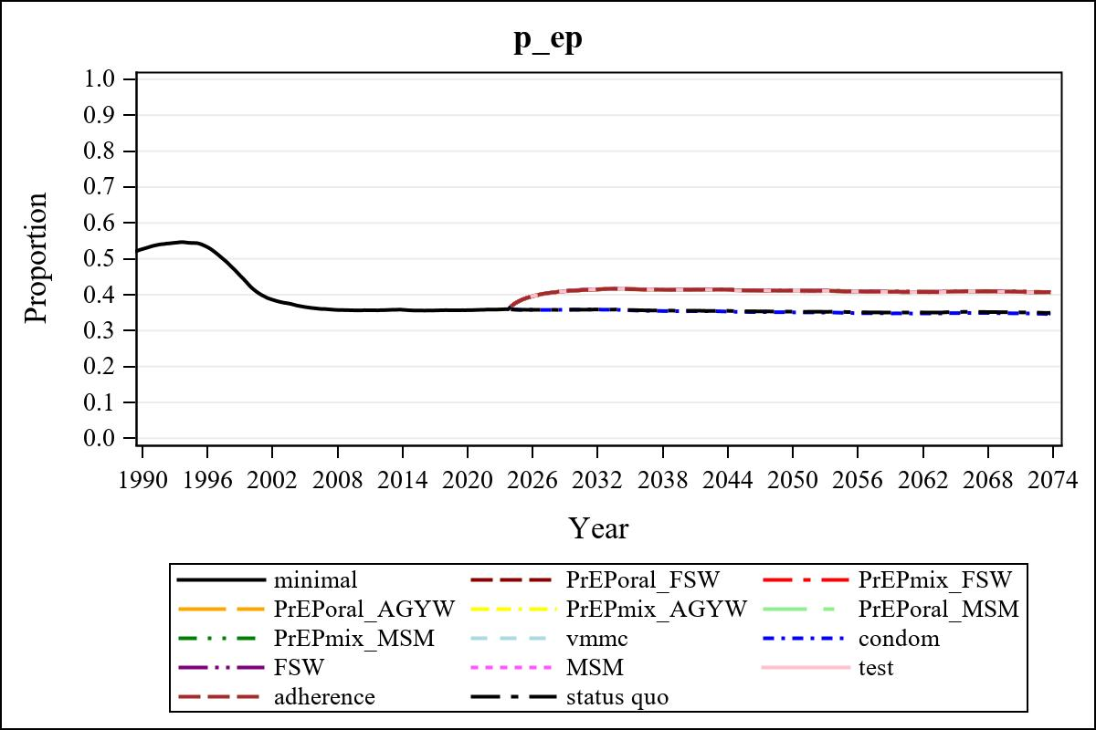

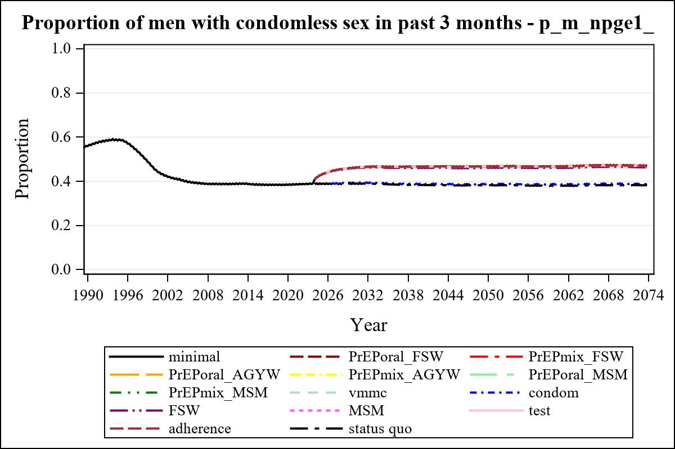

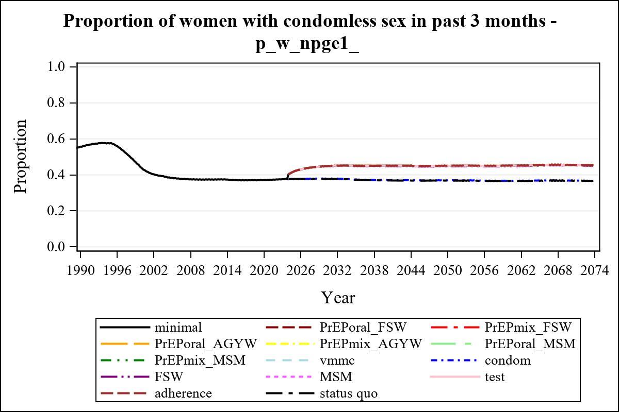

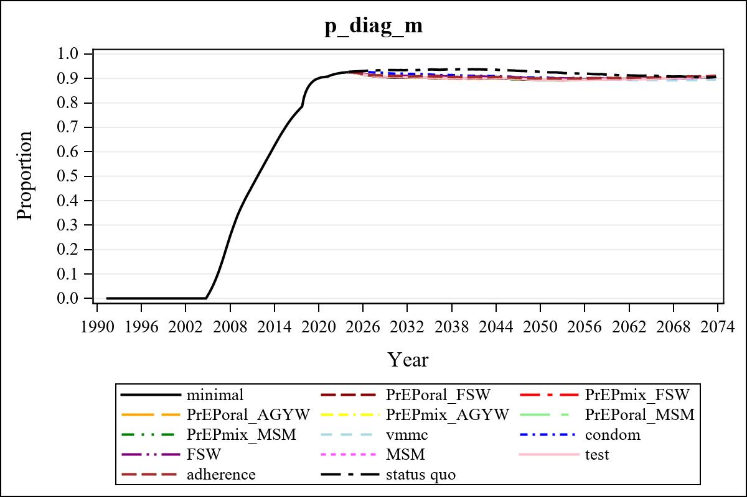

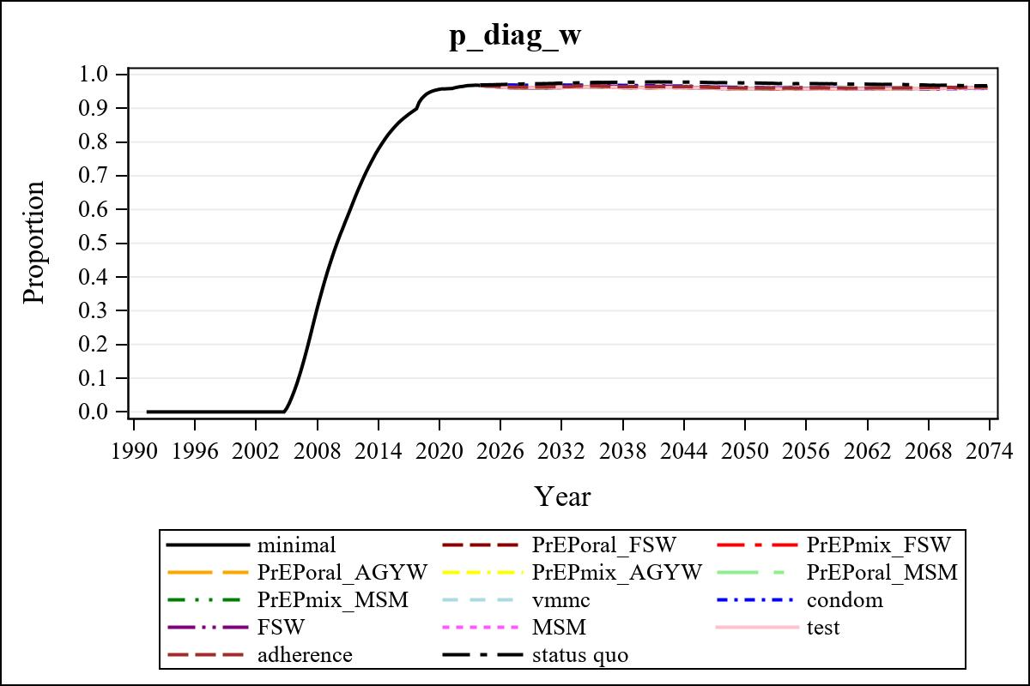

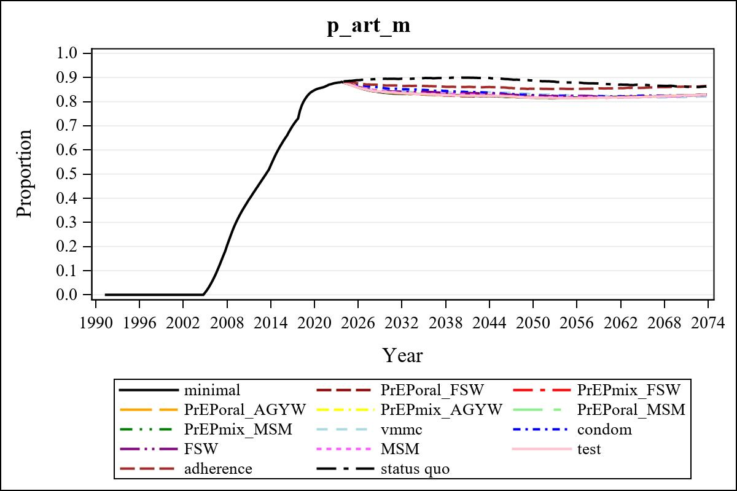

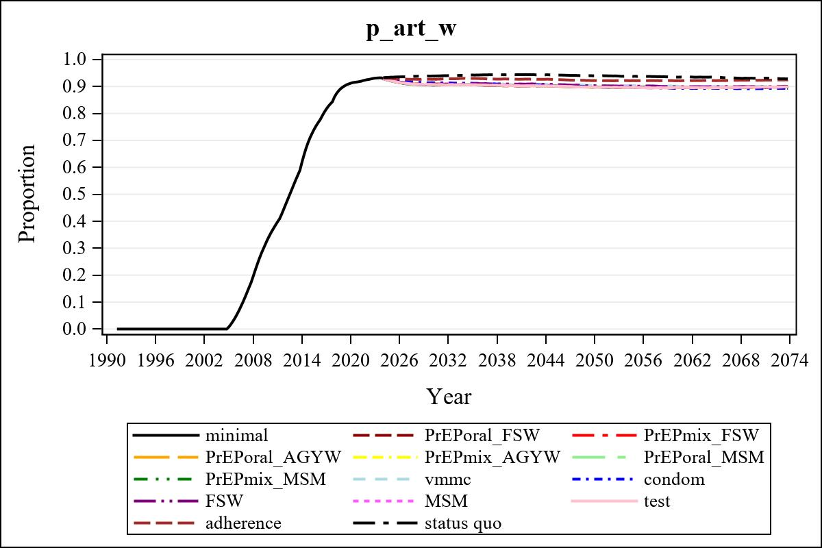

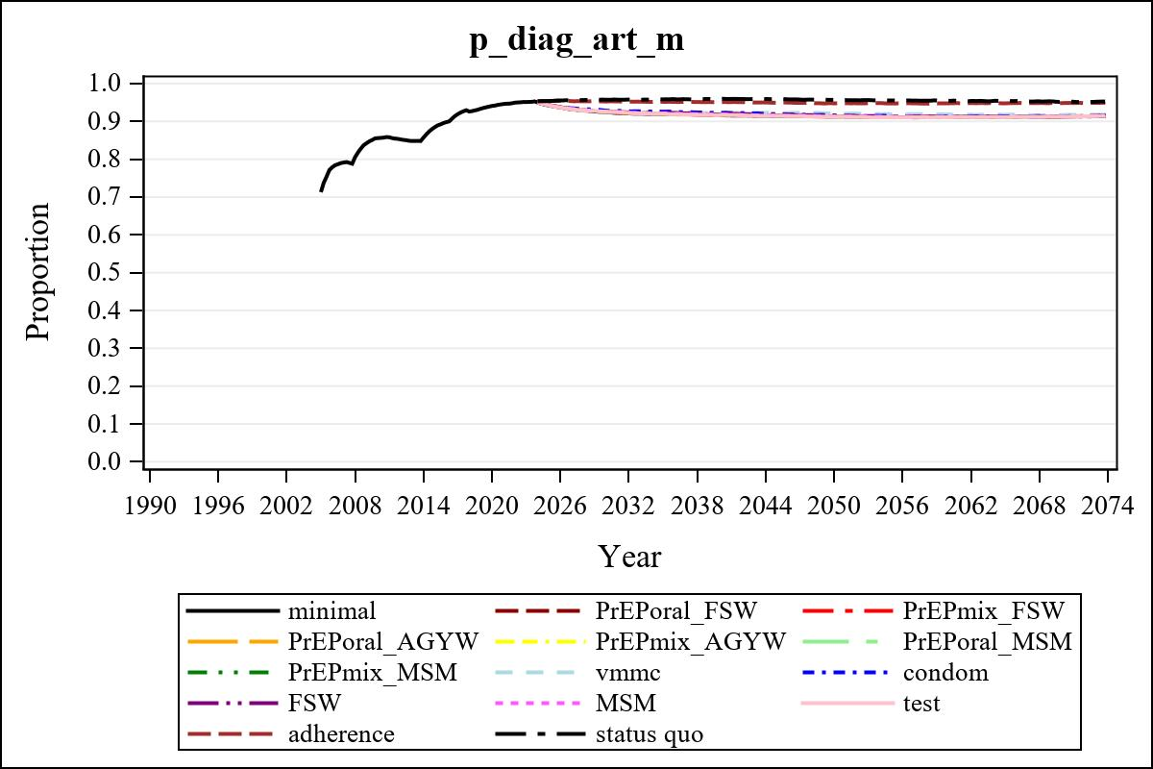

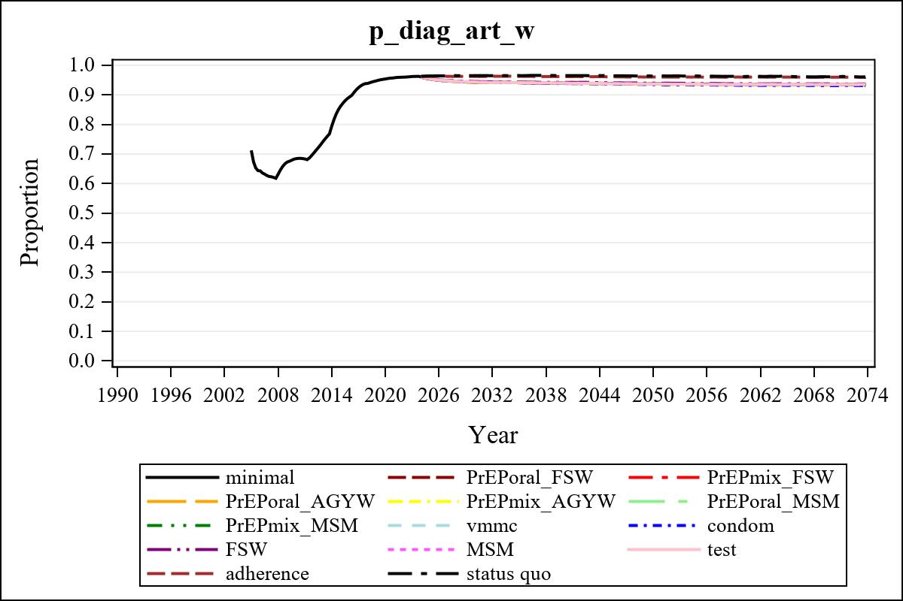

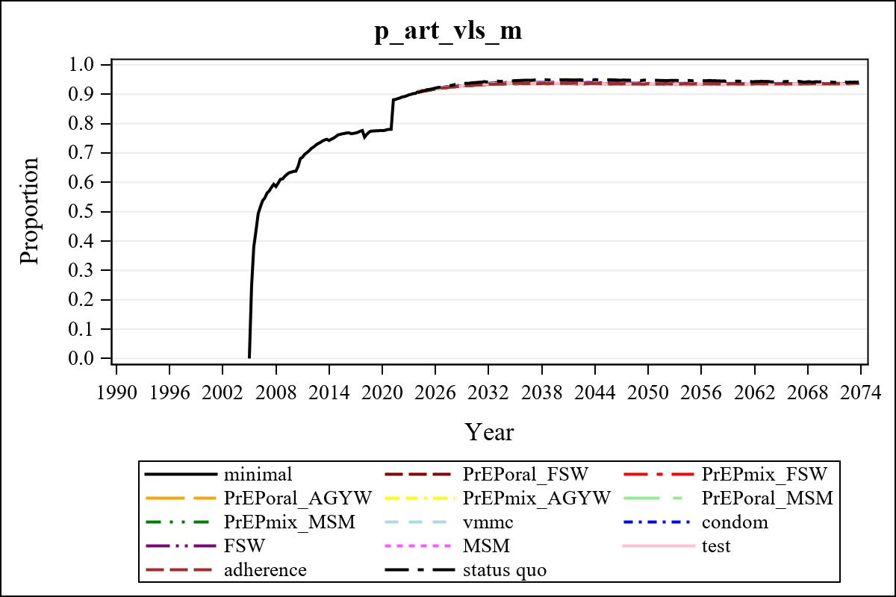

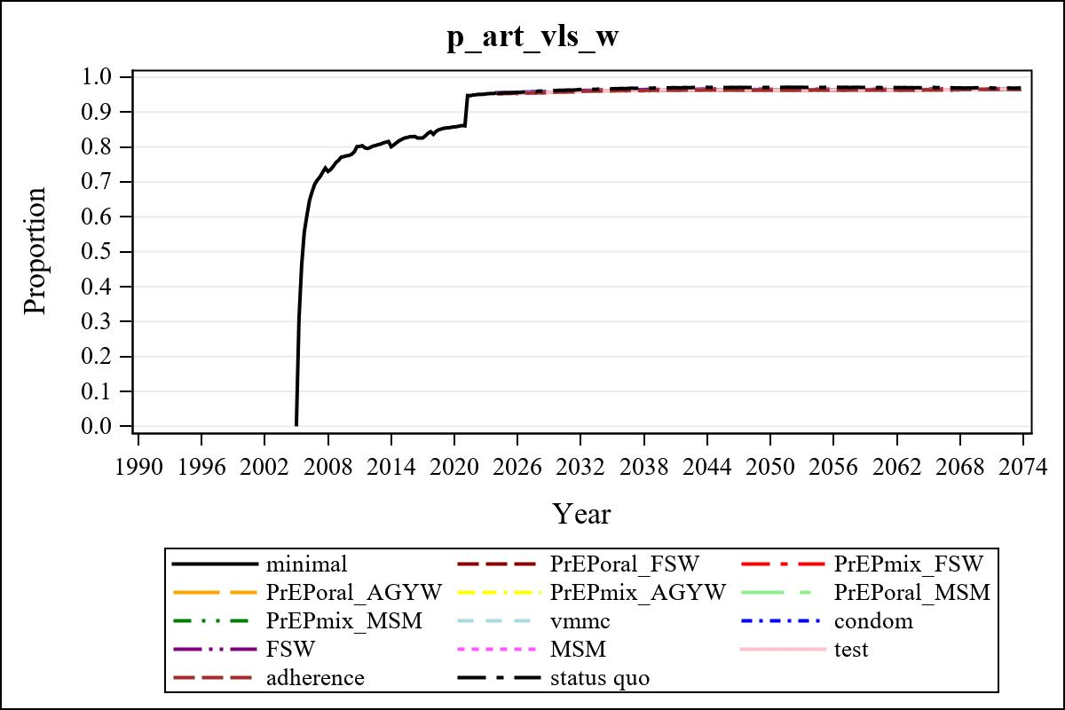

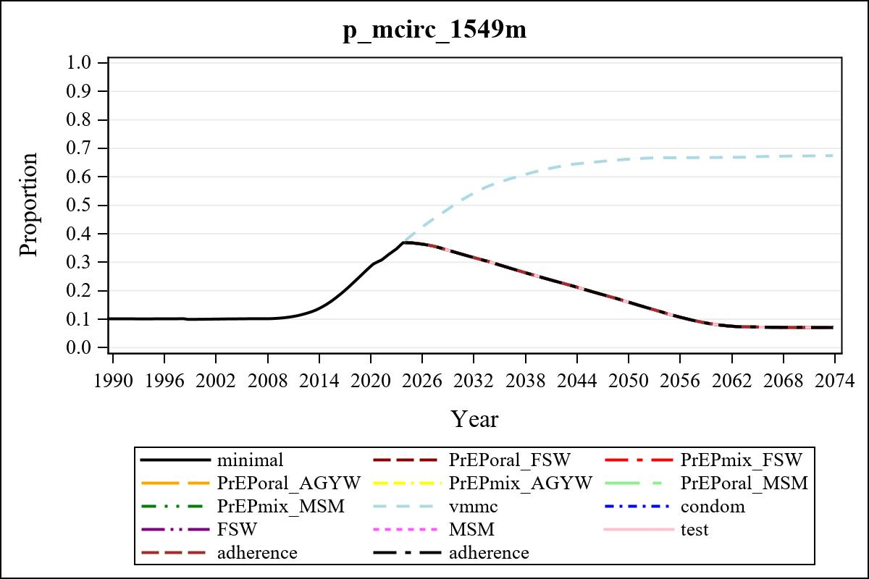

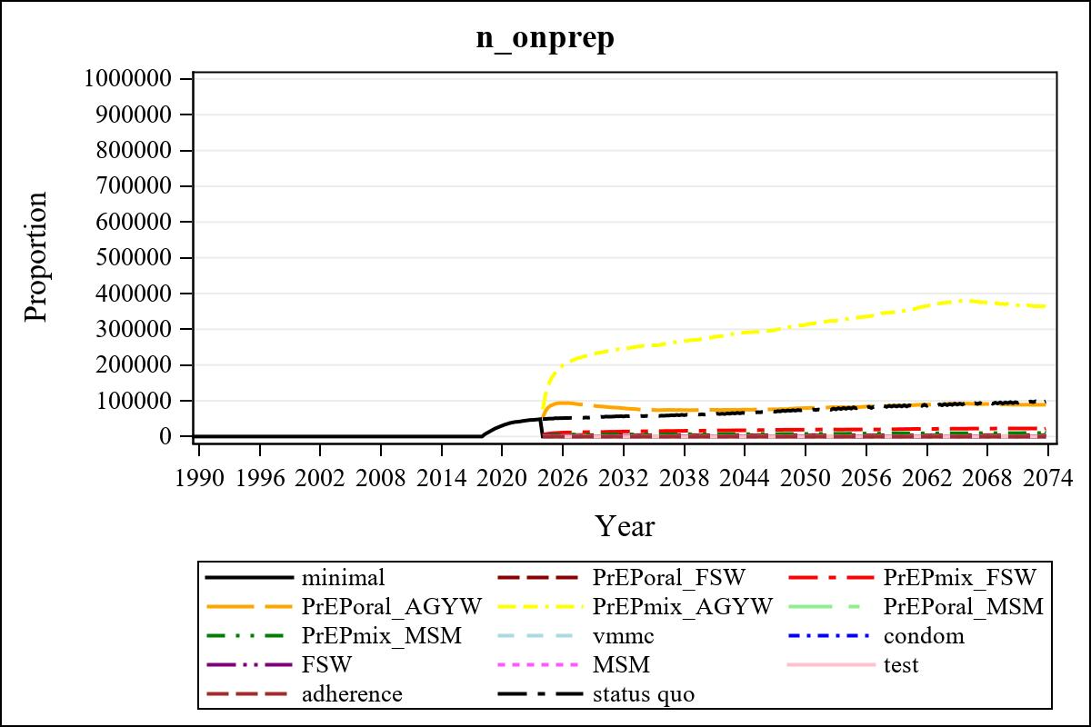

Obs | mean_n_onprep_0
345 | 0

Obs | mean_n_elig_prep_1 | mean_n_sw_1564__1 | mean_n_onprep_sw_1 | mean_n_onprep_w_1
185 | 60874.76 | 113922.14 | 3881.06 | 3881.06

Obs | mean_n_elig_prep_2 | mean_n_sw_1564__2 | mean_n_onprep_sw_2 | mean_n_onprep_w_2
185 | 62430.39 | 114066.76 | 12857.89 | 12857.89

Obs | mean_n_onprep_oral_sw_2 | mean_n_onprep_len_sw_2 | mean_n_elig_prep_3 | mean_n_agyw_pg_3
185 | 1608.28 | 11249.61 | 999227.51 | 1073193.99

Obs | mean_n_onprep_agyw_pg_3 | mean_n_onprep_w_3 | mean_n_elig_prep_4 | mean_n_agyw_pg_4
185 | 83701.14 | 83701.14 | 1004249.07 | 1073471.30

Obs | mean_n_onprep_agyw_pg_4 | mean_n_onprep_w_4 | mean_n_onprep_oral_agyw_pg_4
185 | 236434.68 | 236434.68 | 37971.34

Obs | mean_n_onprep_len_agyw_pg_4 | mean_n_elig_prep_5 | mean_n_alive_msm_5 | mean_n_onprep_msm_5
185 | 198463.34 | 21822.79 | 63912.51 | 1668.53

Obs | mean_n_onprep_m_5 | mean_n_elig_prep_6 | mean_n_alive_msm_6 | mean_n_onprep_msm_6
185 | 1668.53 | 22202.02 | 63836.66 | 5855.85

Obs | mean_n_onprep_m_6 | mean_n_onprep_oral_msm_6 | mean_n_onprep_len_msm_6 | mean_pc_elig_onprep_1
185 | 5855.85 | 765.747 | 5090.11 | 0.067625

Obs | mean_pc_elig_onprep_2 | mean_pc_elig_onprep_3 | mean_pc_elig_onprep_4 | mean_pc_elig_onprep_5
185 | 0.20841 | 0.083462 | 0.23411 | 0.075121

Obs | mean_pc_elig_onprep_6
185 | 0.26376

Obs | ratio_oral_len_2 | ratio_oral_len_4 | ratio_oral_len_6
1 | 0.12398 | 0.17844 | 0.10614

