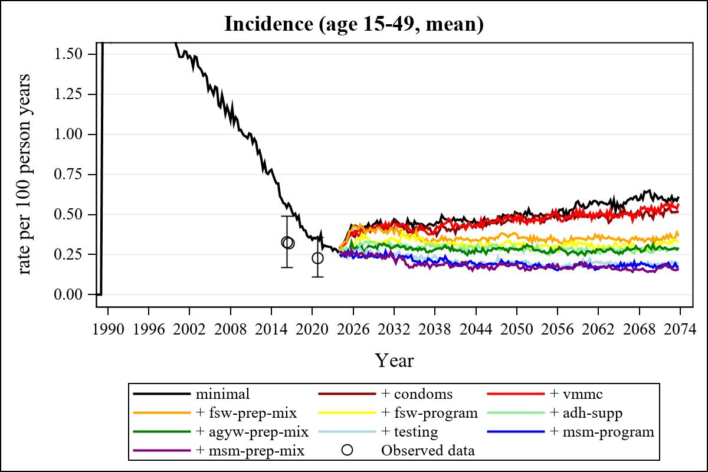

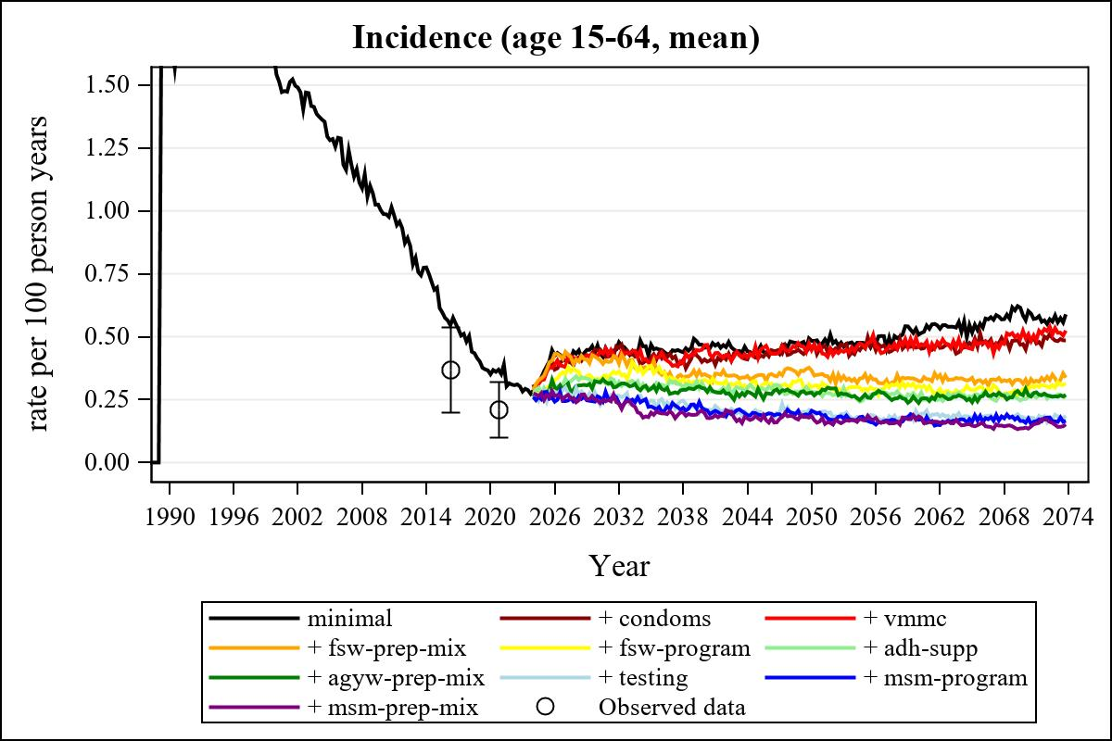

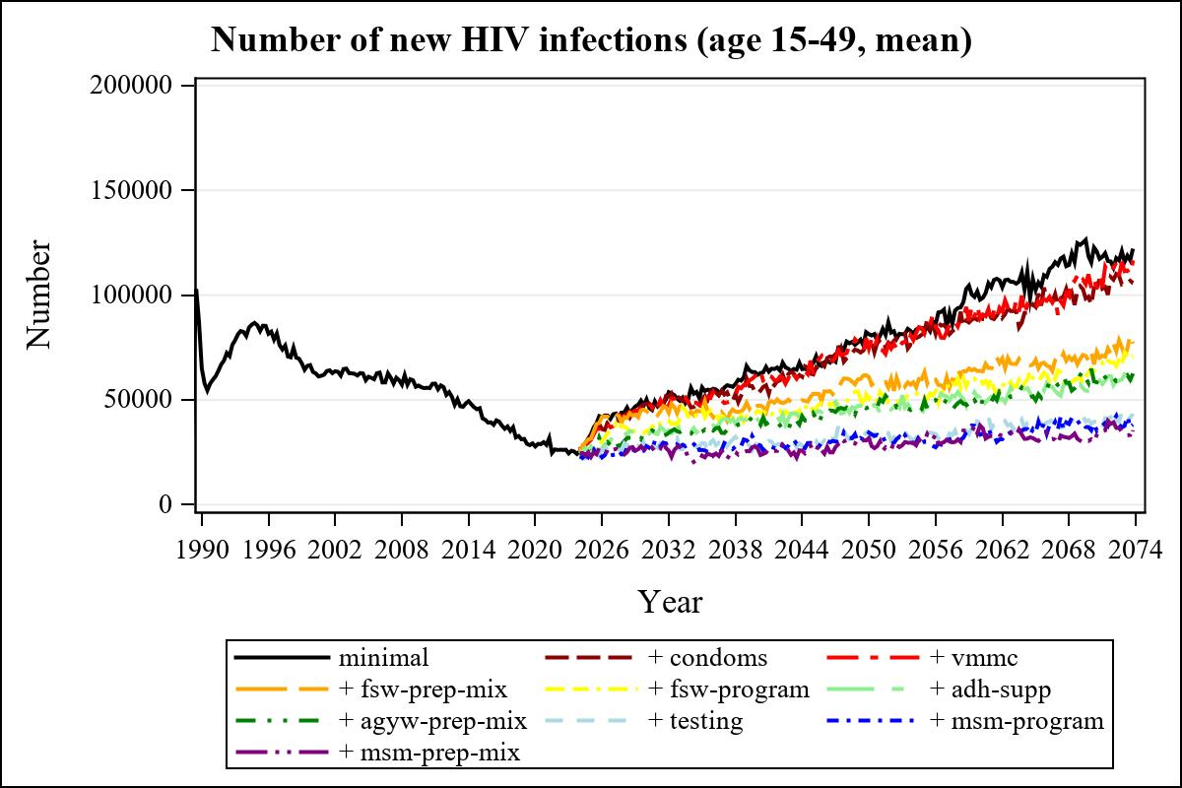

Obs | mean_n_new_inf1549__0 | mean_n_new_inf1549__1 | mean_n_new_inf1549__2 | mean_n_new_inf1549__3
226 | 61993.17 | 55539.53 | 64507.39 | 47294.69

Obs | mean_n_new_inf1549__4 | mean_n_new_inf1549__5 | mean_n_new_inf1549__6 | mean_n_new_inf1549__7
226 | 44789.16 | 40710.53 | 40483.39 | 29233.29

Obs | mean_n_new_inf1549__8 | mean_n_new_inf1549__9 | mean_n_new_inf1549__99
226 | 28622.00 | 26784.35 | .

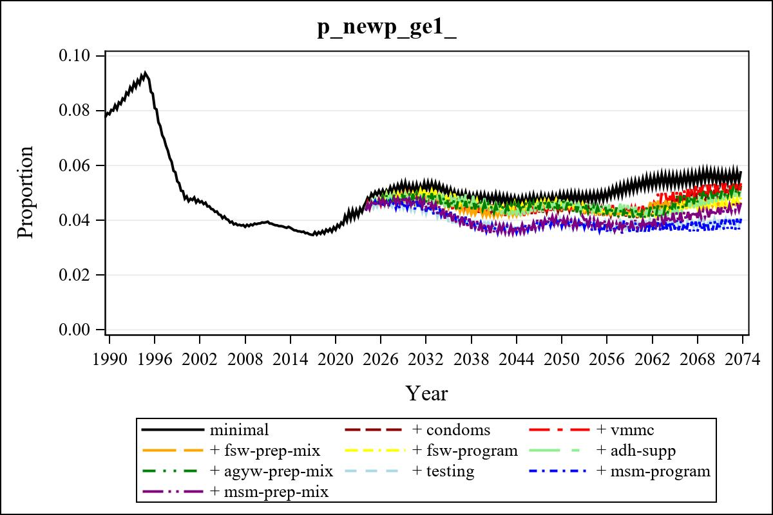

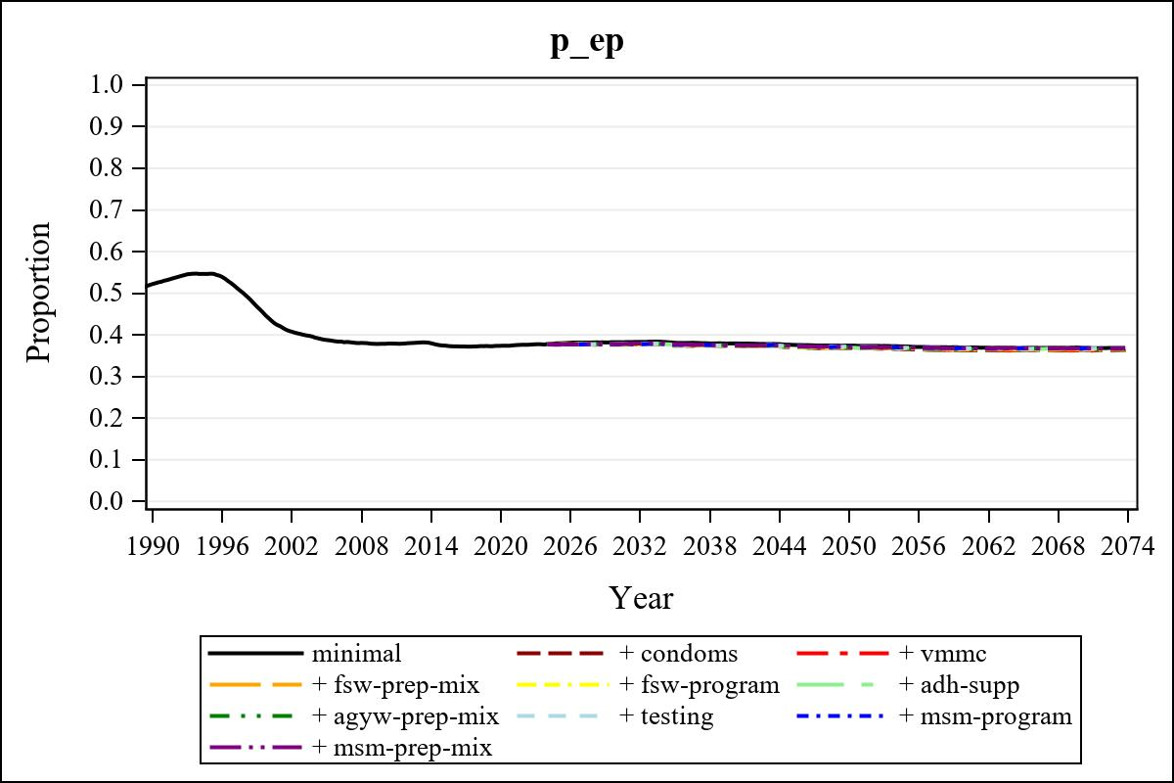

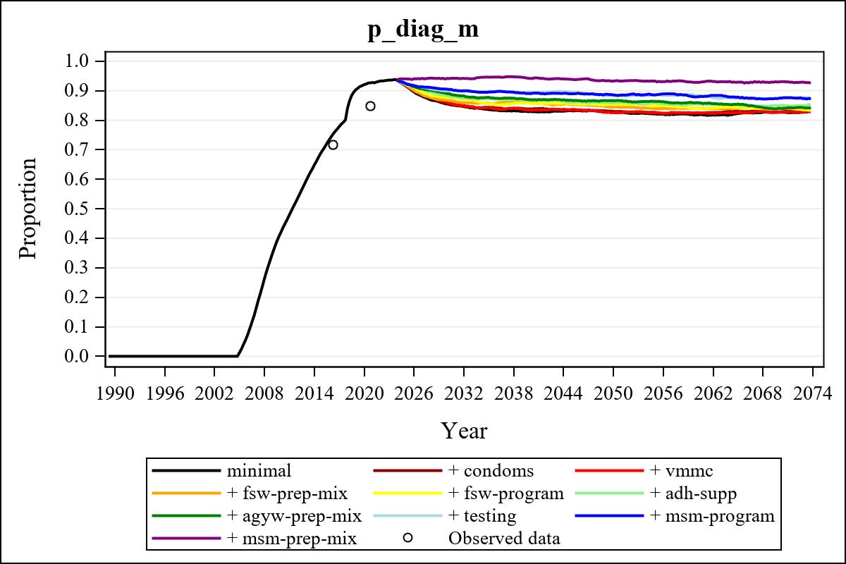

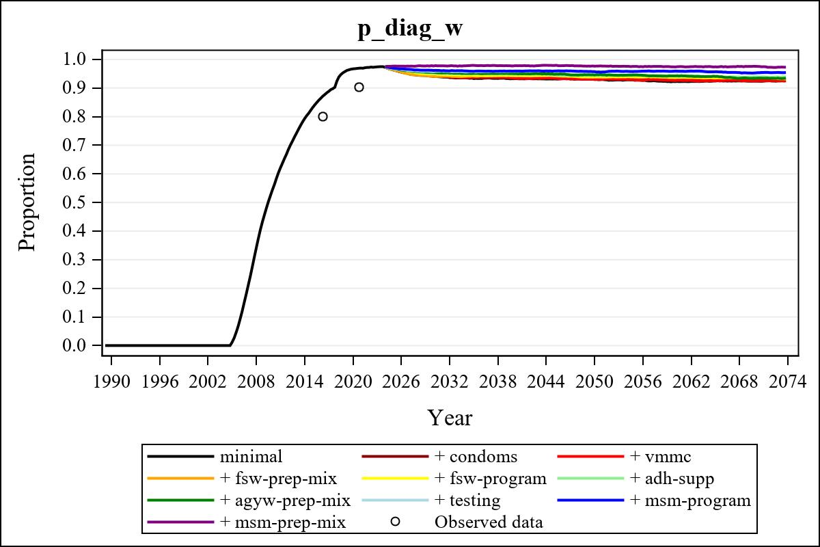

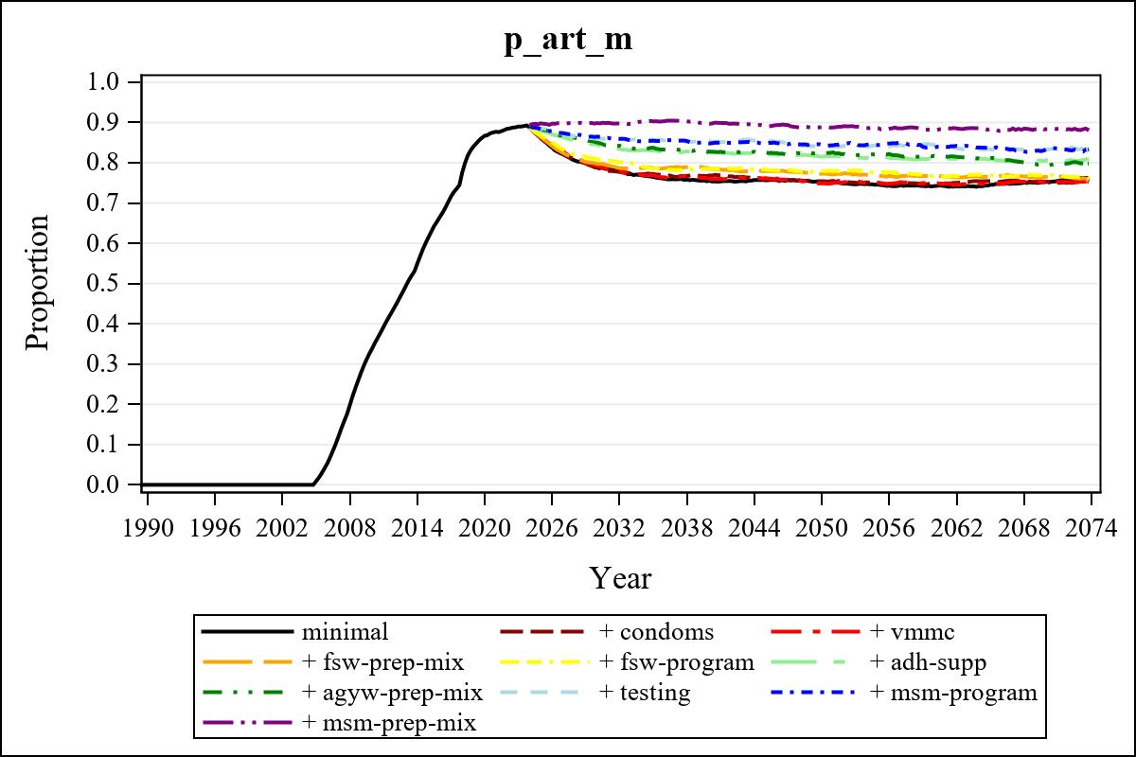

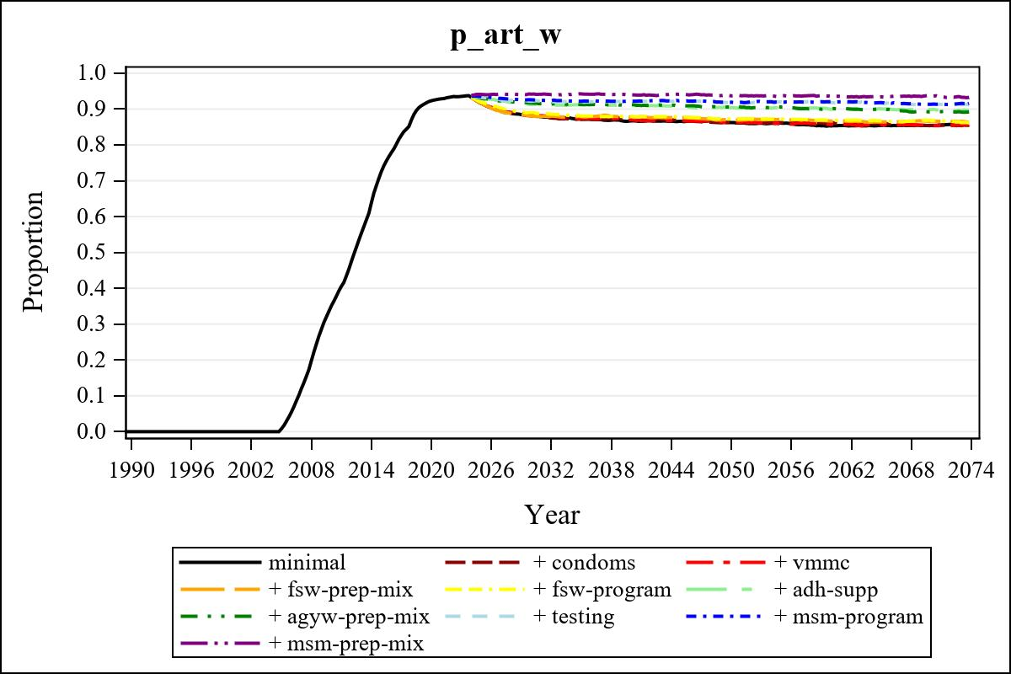

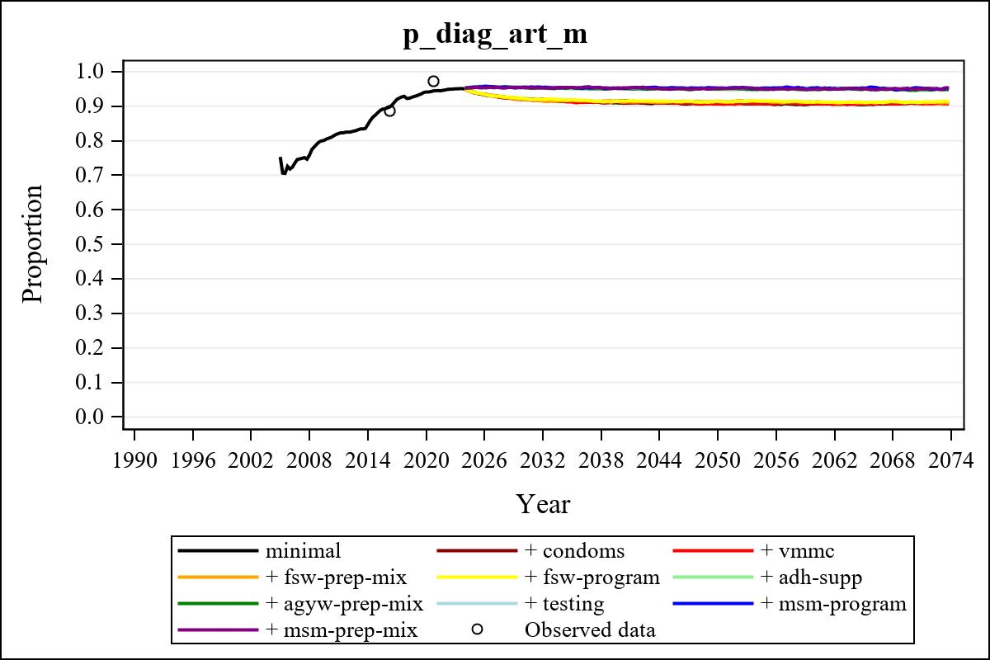

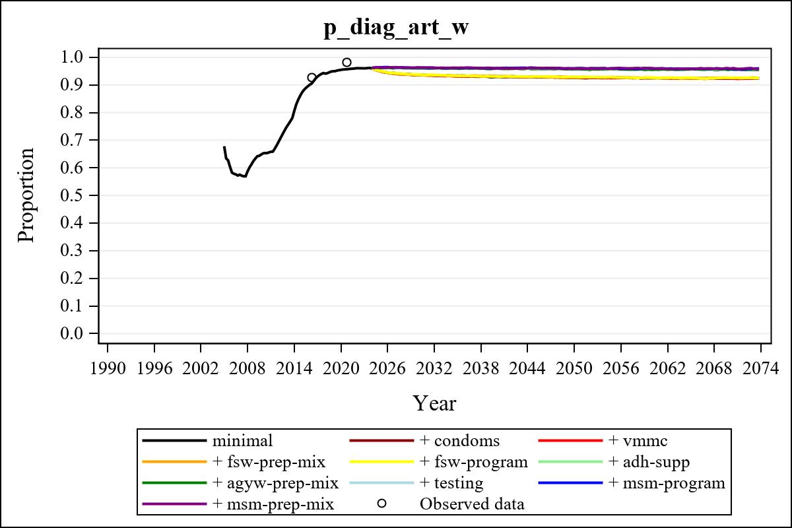

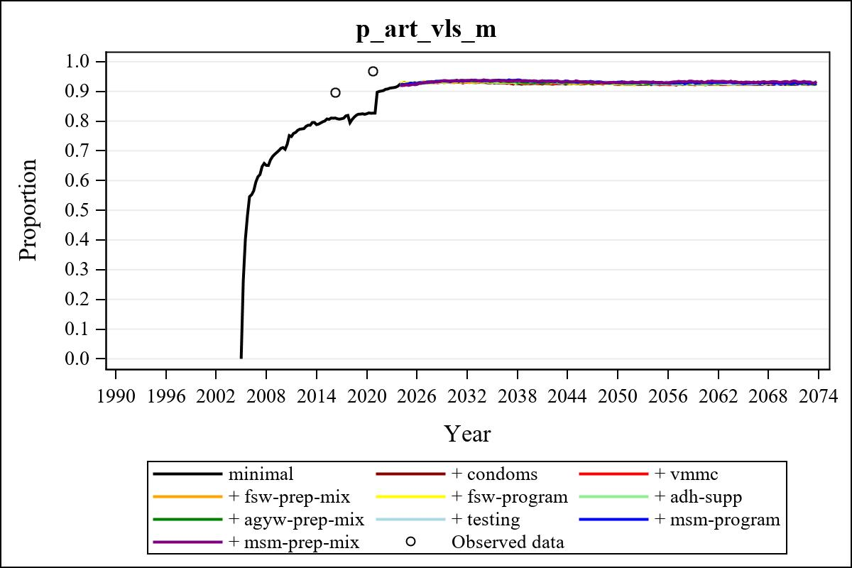

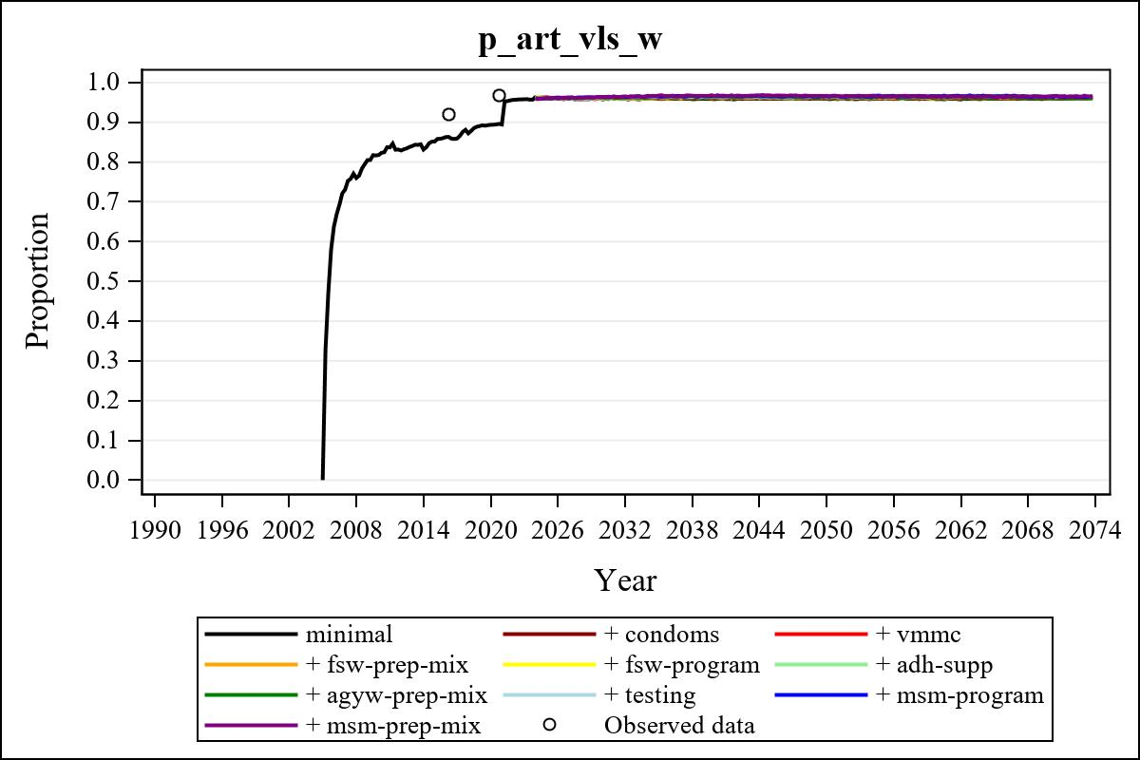

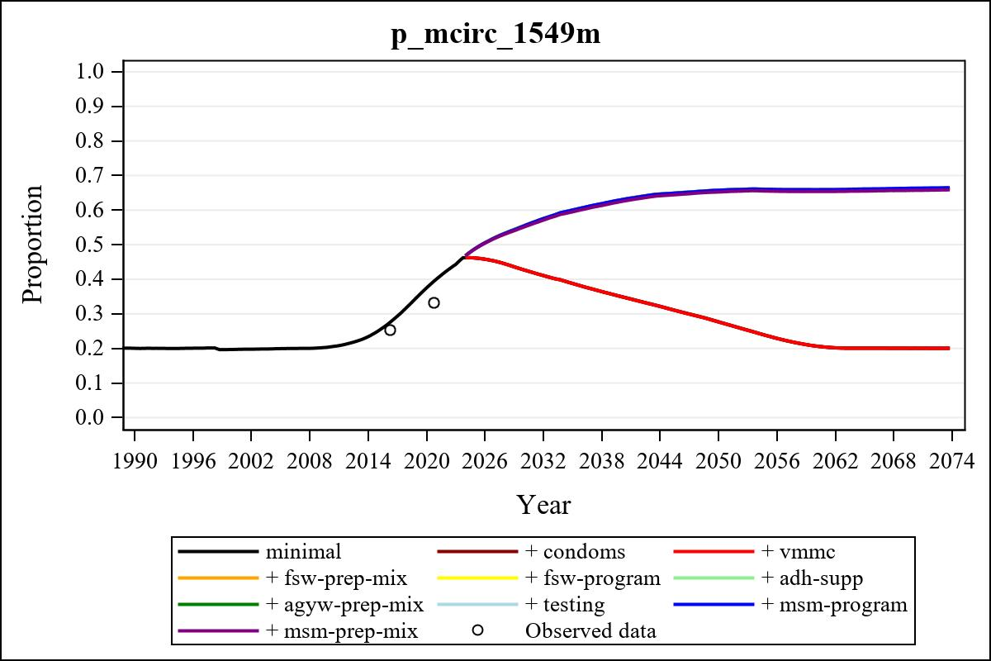

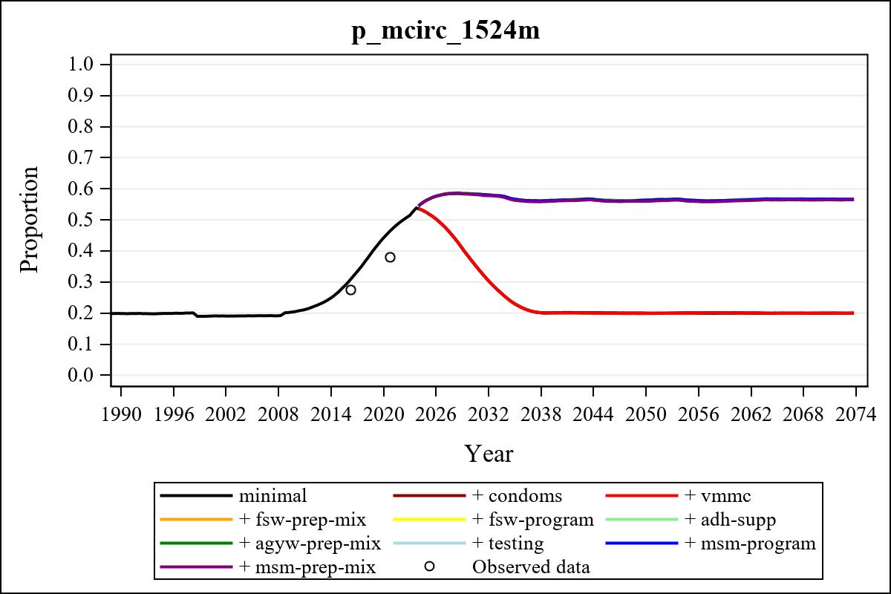

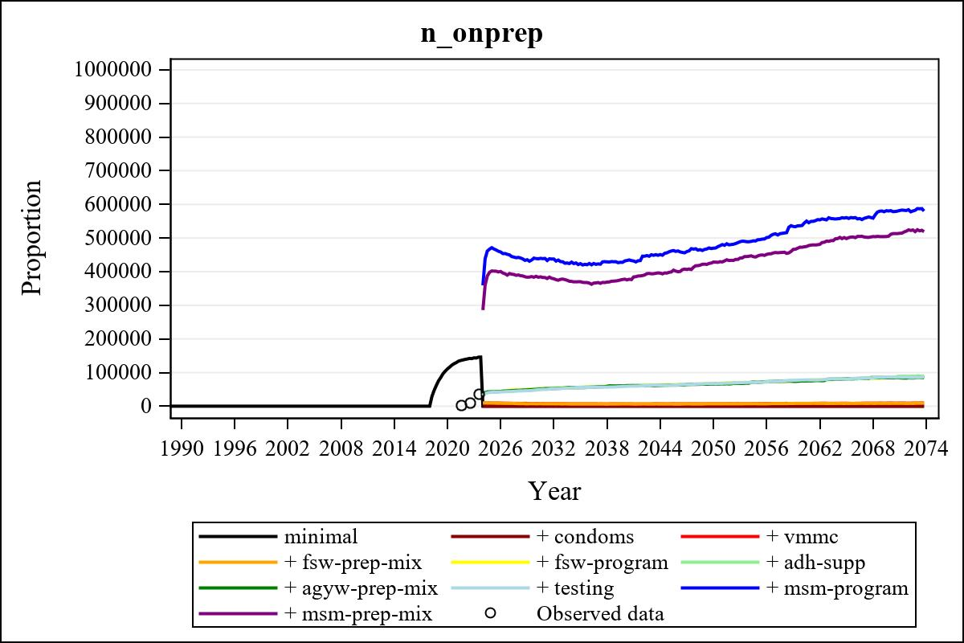

Obs | mean_n_onprep_0 | mean_n_onprep_1 | mean_n_onprep_2 | mean_n_onprep_3
346 | 0 | 0 | 9395.60 | 8506.77

Obs | mean_n_onprep_4 | mean_n_onprep_5 | mean_n_onprep_6 | mean_n_onprep_99
346 | 84641.92 | 84791.12 | 84315.31 | .

Obs | mean_n_sw_1564__1 | mean_n_undiag_sw_1 | mean_n_elig_prep_1 | mean_n_elig_prep_any_sw_1
186 | 150961.71 | 104002.34 | 0 | 0

Obs | mean_n_onprep_sw_1 | mean_n_onprep_w_1 | mean_n_sw_1564__2 | mean_n_undiag_sw_2
186 | 0 | 0 | 151329.52 | 104085.19

Obs | mean_n_elig_prep_2 | mean_n_elig_prep_any_sw_2 | mean_n_onprep_sw_2 | mean_n_onprep_w_2
186 | 30013.36 | 0 | 0 | 0

Obs | mean_n_onprep_oral_sw_2 | mean_n_onprep_len_sw_2 | mean_n_agyw_pg_3 | mean_n_elig_prep_3
186 | 0 | 0 | 1326945.11 | 29074.70

Obs | mean_n_onprep_agyw_pg_3 | mean_n_onprep_w_3 | mean_n_agyw_pg_4 | mean_n_elig_prep_4
186 | 0 | 0 | 1326239.52 | 113747.95

Obs | mean_n_onprep_agyw_pg_4 | mean_n_onprep_w_4 | mean_n_onprep_oral_agyw_pg_4
186 | 26455.84 | 51523.64 | 9915.43

Obs | mean_n_onprep_len_agyw_pg_4 | mean_n_alive_msm_5 | mean_n_elig_prep_5 | mean_n_onprep_msm_5
186 | 16540.41 | 78516.71 | 115889.44 | 0

Obs | mean_n_onprep_m_5 | mean_n_alive_msm_6 | mean_n_elig_prep_6 | mean_n_onprep_msm_6
186 | 0 | 78892.18 | 115019.99 | 0

Obs | mean_n_onprep_m_6 | mean_n_onprep_oral_msm_6 | mean_n_onprep_len_msm_6 | mean_pc_elig_onprep_1
186 | 0 | 0 | 0 | .

Obs | mean_pc_elig_onprep_2 | mean_pc_elig_onprep_3 | mean_pc_elig_onprep_4 | mean_pc_elig_onprep_5
186 | 0.25169 | 0.23627 | 0.46234 | 0.45075

Obs | mean_pc_elig_onprep_6
186 | 0.44102

Obs | mean_n_sw_1564__1 | mean_n_undiag_sw_1 | mean_n_elig_prep_1
186 | 150961.71 | 104002.34 | 0

Obs | mean_n_elig_prep_any_sw_1 | mean_n_onprep_sw_1 | mean_n_onprep_w_1
186 | 0 | 0 | 0

Obs | ratio_oral_len_2 | ratio_oral_len_4 | ratio_oral_len_6
1 | . | 0.51691 | 0.51561

