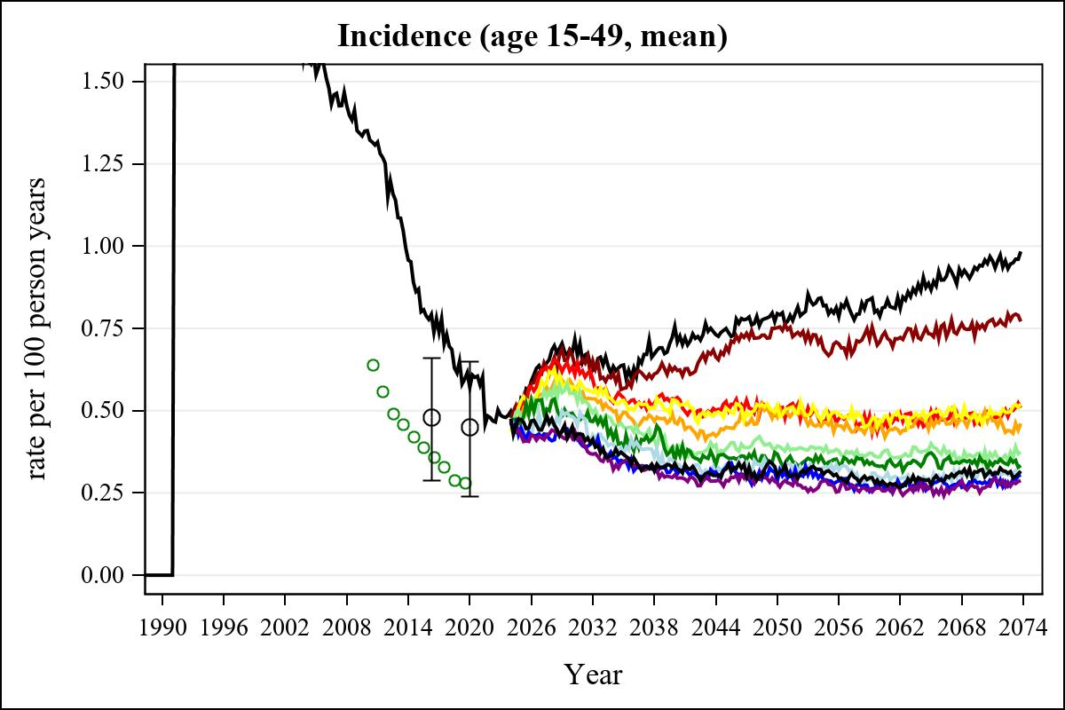

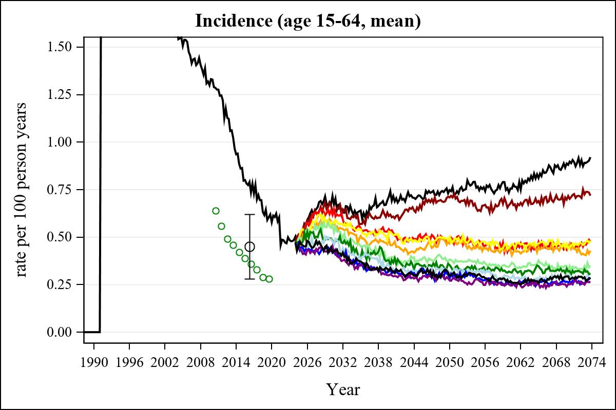

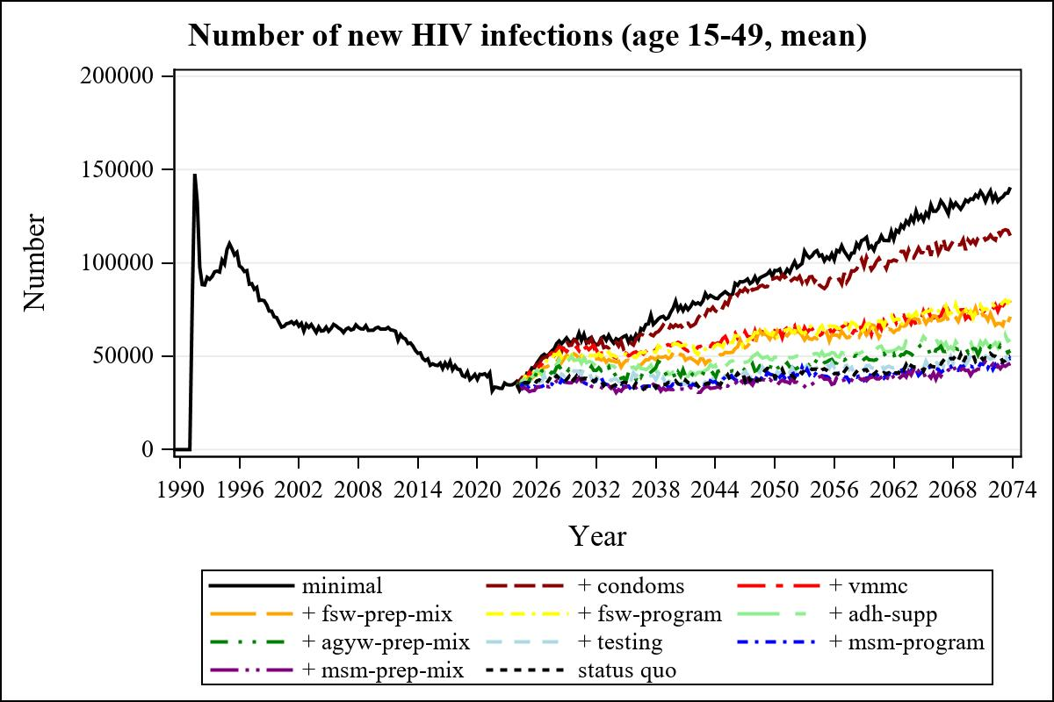

Obs | mean_n_new_inf1549__0 | mean_n_new_inf1549__1 | mean_n_new_inf1549__2 | mean_n_new_inf1549__3
226 | 79460.64 | 66855.63 | 56638.99 | 49255.22

Obs | mean_n_new_inf1549__4 | mean_n_new_inf1549__5 | mean_n_new_inf1549__6 | mean_n_new_inf1549__7
226 | 56701.85 | 41700.79 | 37434.63 | 37343.09

Obs | mean_n_new_inf1549__8 | mean_n_new_inf1549__9 | mean_n_new_inf1549__99
226 | 35059.60 | 33077.04 | 36783.09

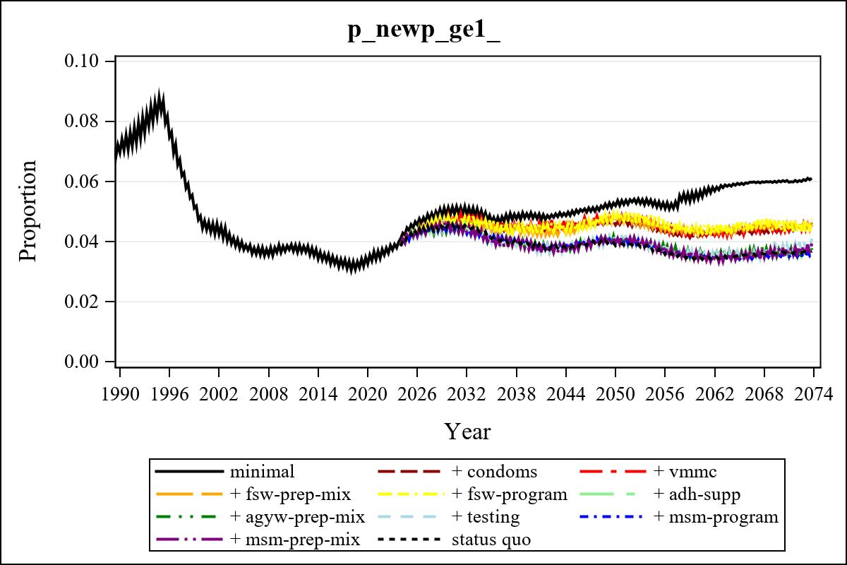

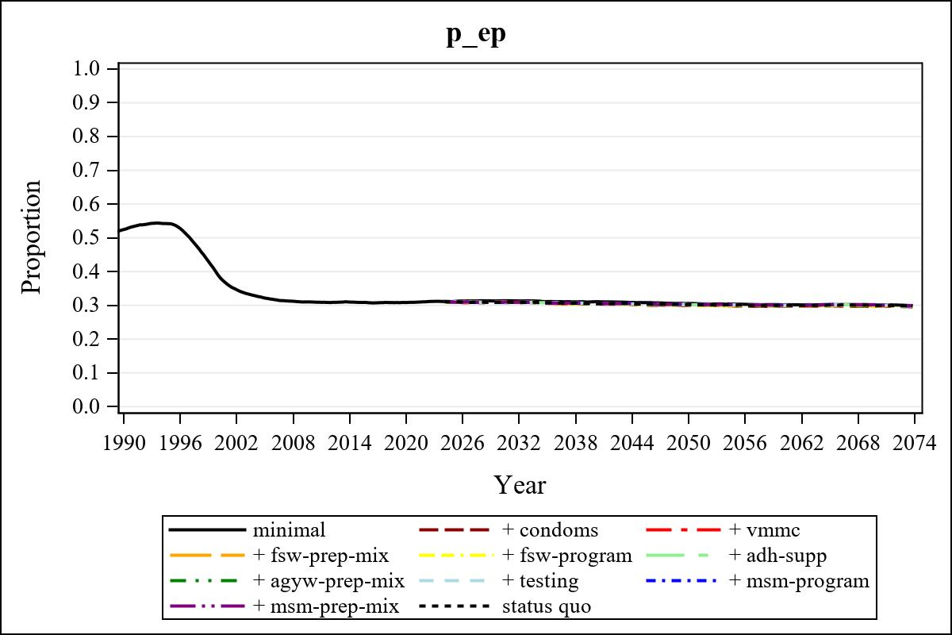

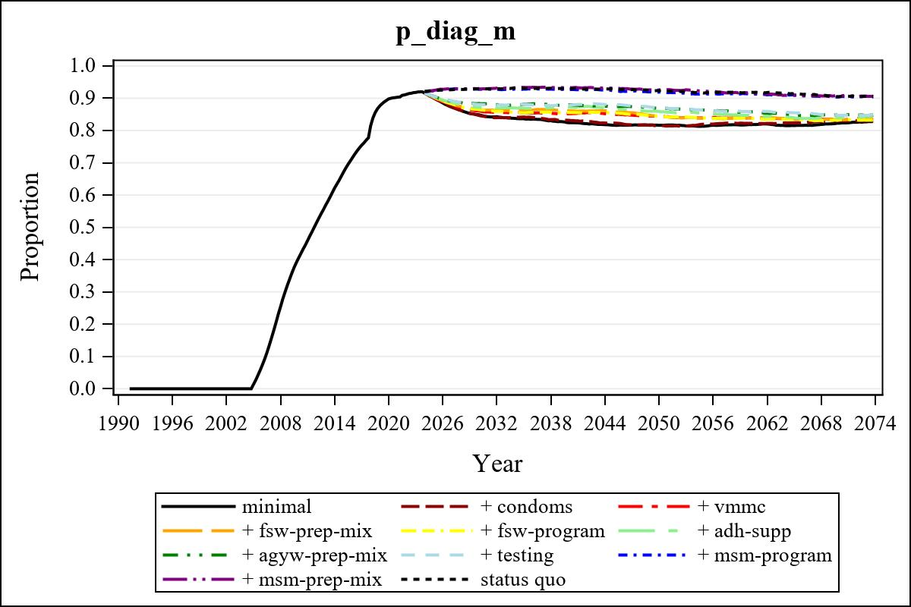

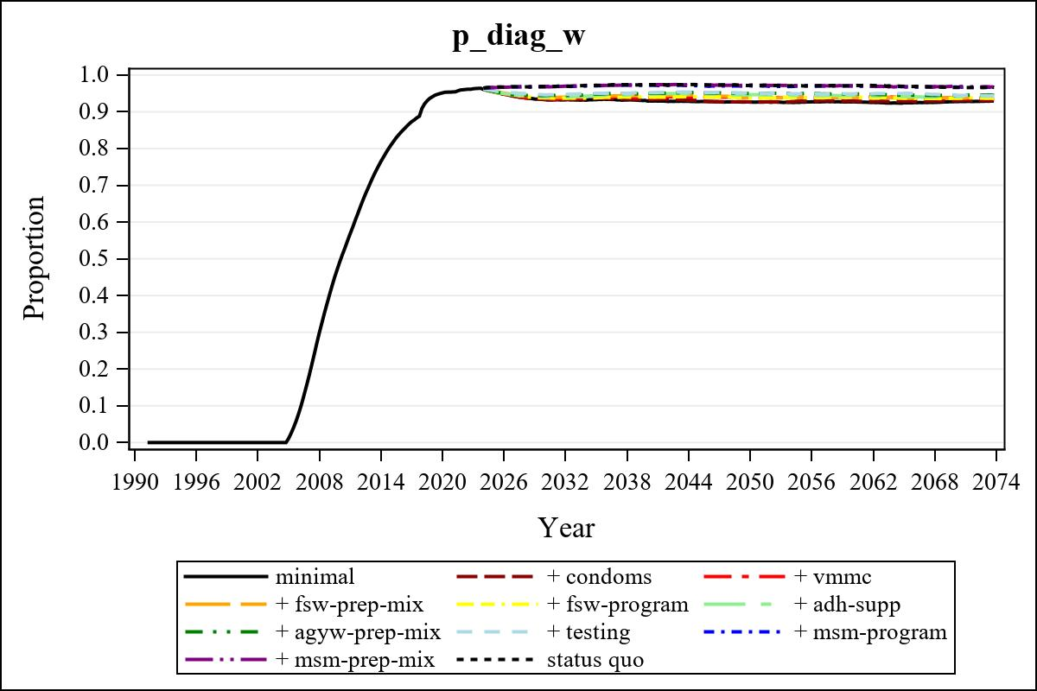

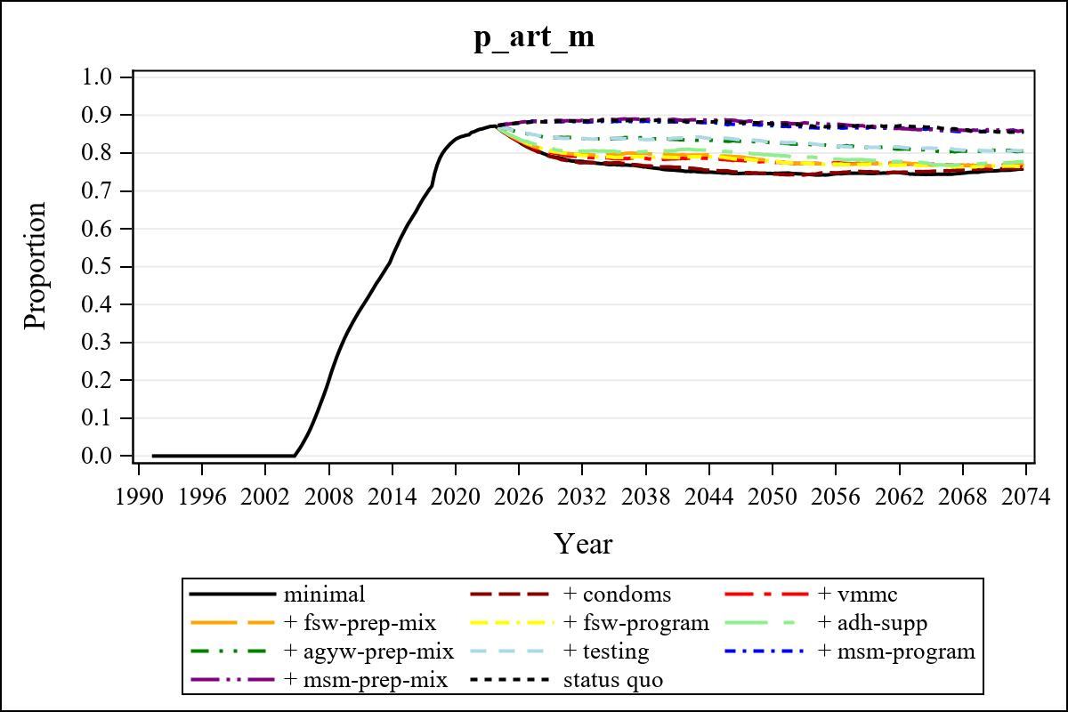

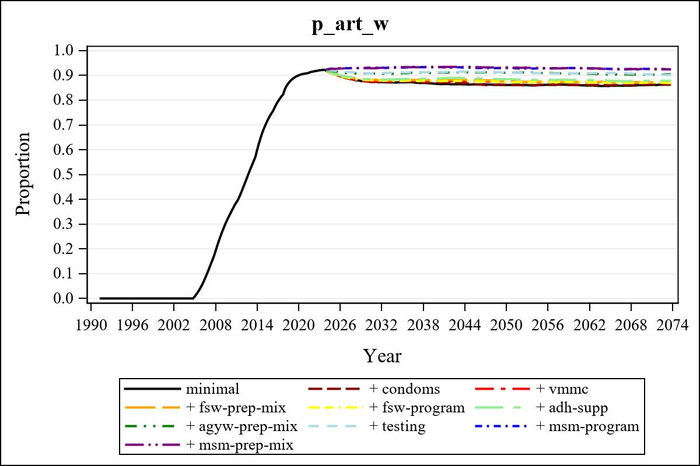

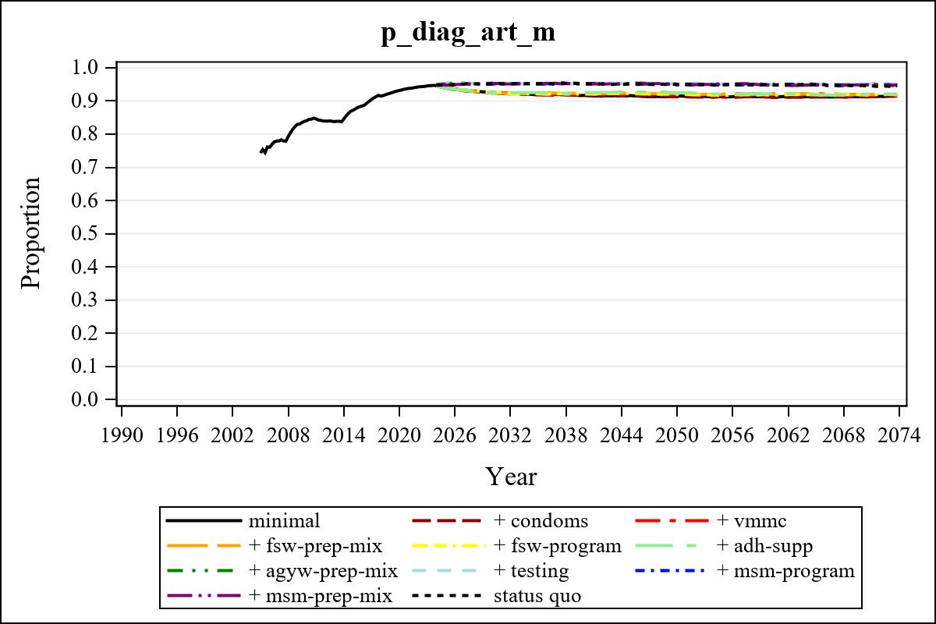

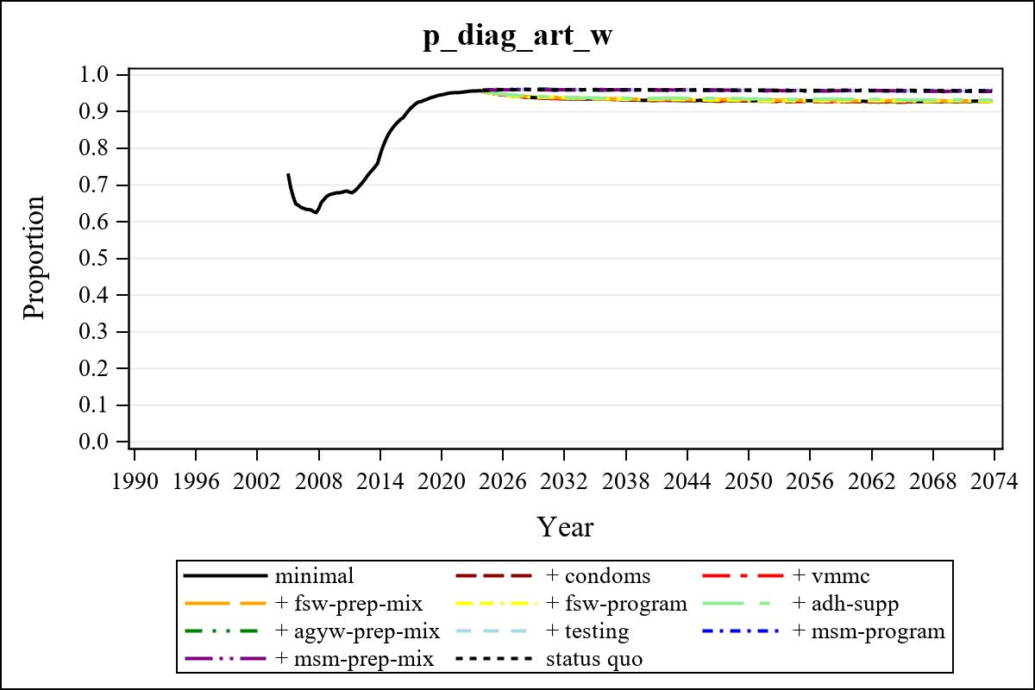

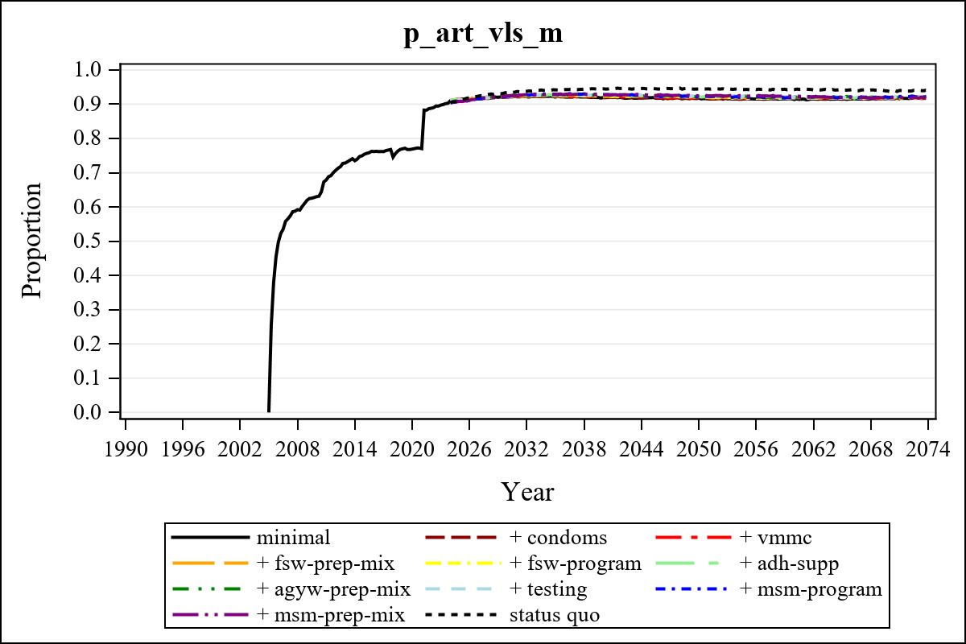

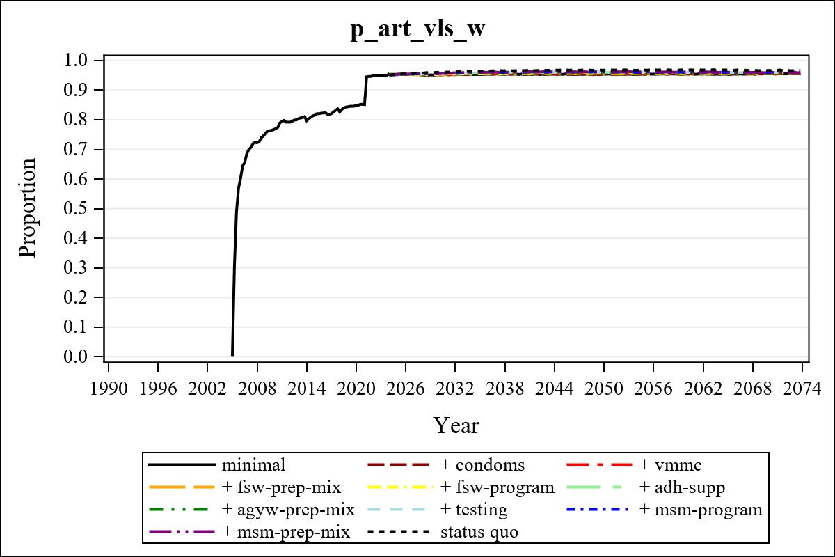

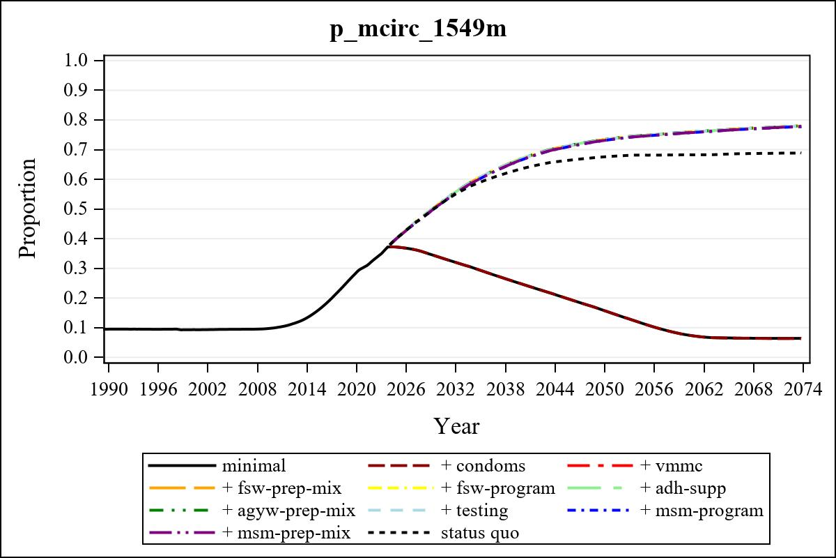

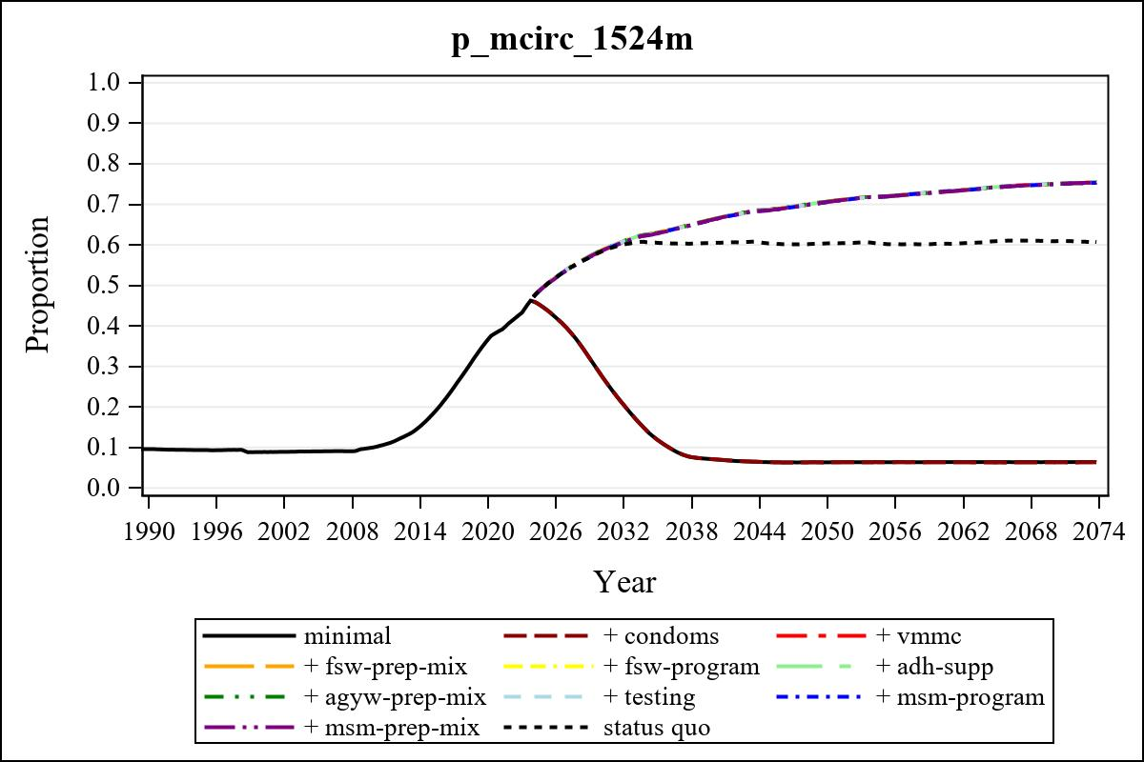

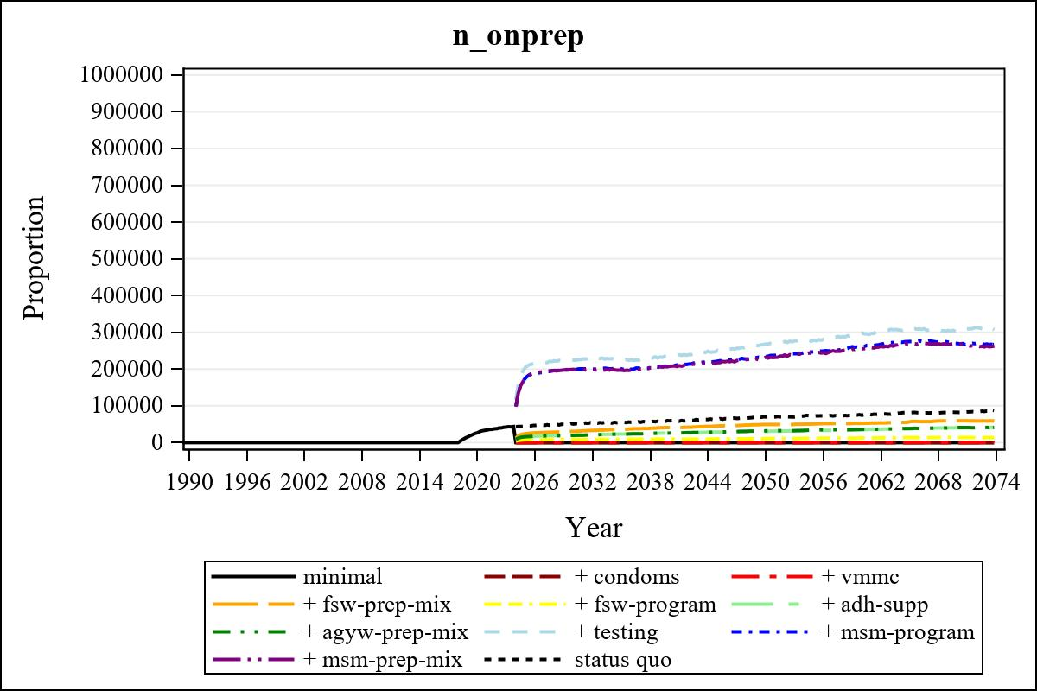

Obs | mean_n_onprep_0 | mean_n_onprep_1 | mean_n_onprep_2 | mean_n_onprep_3
346 | 0 | 0 | 0 | 59276.02

Obs | mean_n_onprep_4 | mean_n_onprep_5 | mean_n_onprep_6 | mean_n_onprep_99
346 | 13779.50 | 40198.77 | 40711.66 | 82109.39

Obs | mean_n_sw_1564__1 | mean_n_undiag_sw_1 | mean_n_elig_prep_1 | mean_n_elig_prep_any_sw_1
186 | 133773.75 | 69717.10 | 0 | 0

Obs | mean_n_onprep_sw_1 | mean_n_onprep_w_1 | mean_n_sw_1564__2 | mean_n_undiag_sw_2
186 | 0 | 0 | 133565.32 | 69357.22

Obs | mean_n_elig_prep_2 | mean_n_elig_prep_any_sw_2 | mean_n_onprep_sw_2 | mean_n_onprep_w_2
186 | 0 | 0 | 0 | 0

Obs | mean_n_onprep_oral_sw_2 | mean_n_onprep_len_sw_2 | mean_n_agyw_pg_3 | mean_n_elig_prep_3
186 | 0 | 0 | 817300.28 | 76468.11

Obs | mean_n_onprep_agyw_pg_3 | mean_n_onprep_w_3 | mean_n_agyw_pg_4 | mean_n_elig_prep_4
186 | 11244.49 | 30513.73 | 814666.32 | 22133.83

Obs | mean_n_onprep_agyw_pg_4 | mean_n_onprep_w_4 | mean_n_onprep_oral_agyw_pg_4
186 | 0 | 0 | 0

Obs | mean_n_onprep_len_agyw_pg_4 | mean_n_alive_msm_5 | mean_n_elig_prep_5 | mean_n_onprep_msm_5
186 | 0 | 65596.71 | 57637.63 | 8543.70

Obs | mean_n_onprep_m_5 | mean_n_alive_msm_6 | mean_n_elig_prep_6 | mean_n_onprep_msm_6
186 | 8543.70 | 65722.54 | 57455.36 | 8354.03

Obs | mean_n_onprep_m_6 | mean_n_onprep_oral_msm_6 | mean_n_onprep_len_msm_6 | mean_pc_elig_onprep_1
186 | 8354.03 | 2040.70 | 6313.33 | .

Obs | mean_pc_elig_onprep_2 | mean_pc_elig_onprep_3 | mean_pc_elig_onprep_4 | mean_pc_elig_onprep_5
186 | . | 0.39777 | 0.37098 | 0.34977

Obs | mean_pc_elig_onprep_6
186 | 0.33544

Obs | mean_n_sw_1564__1 | mean_n_undiag_sw_1 | mean_n_elig_prep_1
186 | 133773.75 | 69717.10 | 0

Obs | mean_n_elig_prep_any_sw_1 | mean_n_onprep_sw_1 | mean_n_onprep_w_1
186 | 0 | 0 | 0

Obs | ratio_oral_len_2 | ratio_oral_len_4 | ratio_oral_len_6
1 | . | 0.23199 | 0.17878

