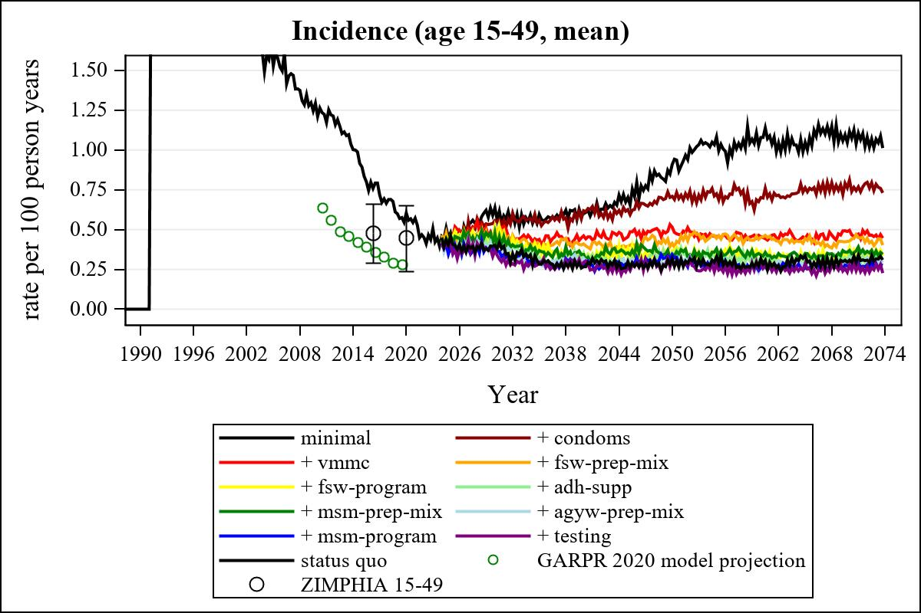

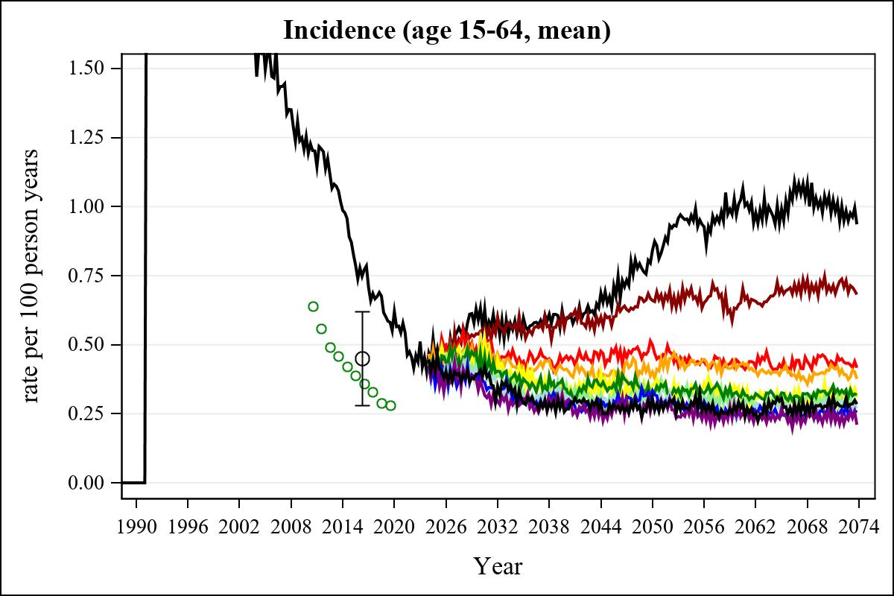

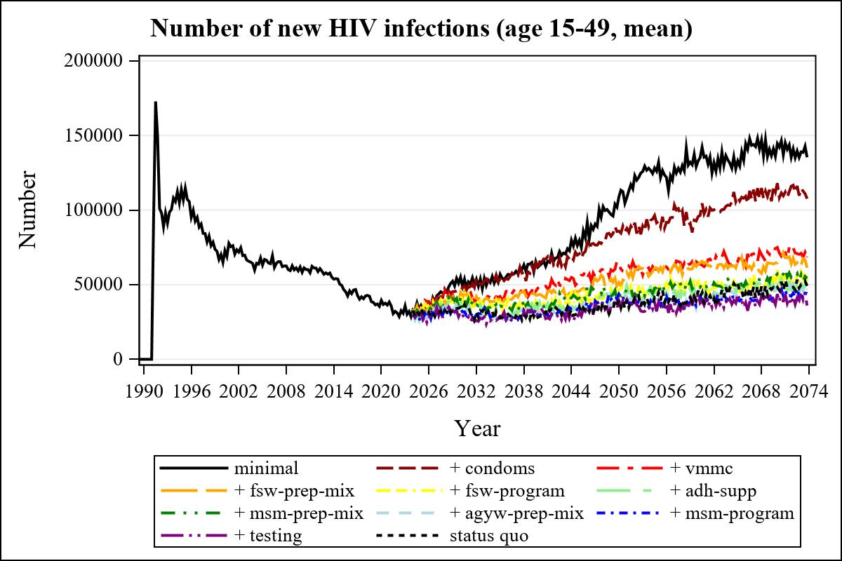

Obs | mean_n_new_inf1549__0 | mean_n_new_inf1549__1 | mean_n_new_inf1549__2 | mean_n_new_inf1549__3
226 | 62951.37 | 65373.95 | 49100.35 | 43596.55

Obs | mean_n_new_inf1549__4 | mean_n_new_inf1549__5 | mean_n_new_inf1549__6 | mean_n_new_inf1549__7
226 | 37760.34 | 37593.03 | 36959.10 | 34748.27

Obs | mean_n_new_inf1549__8 | mean_n_new_inf1549__9 | mean_n_new_inf1549__99
226 | 29311.37 | 31932.34 | 28744.75

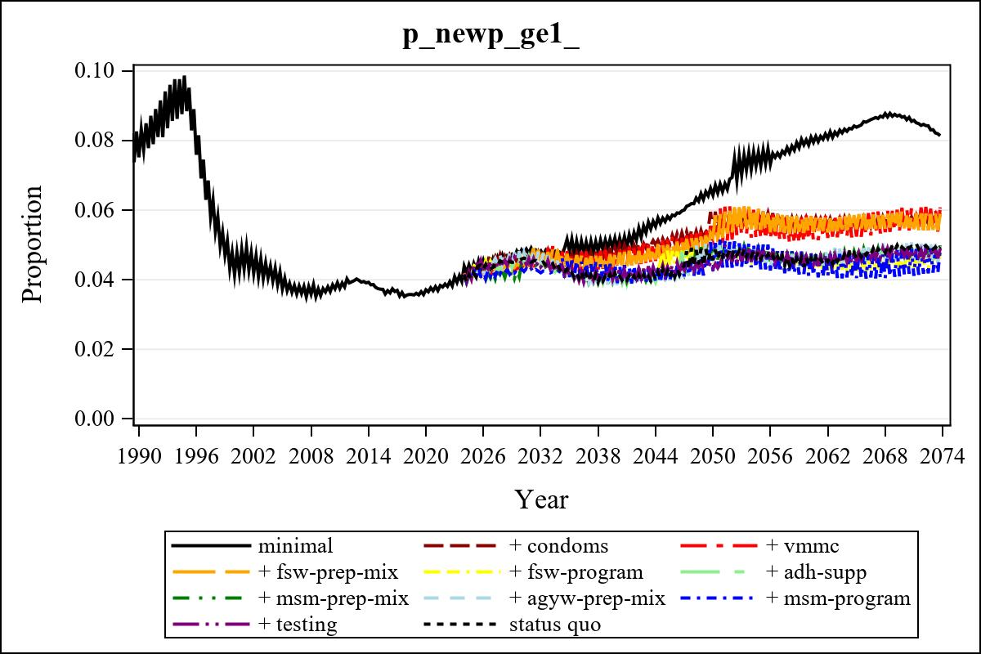

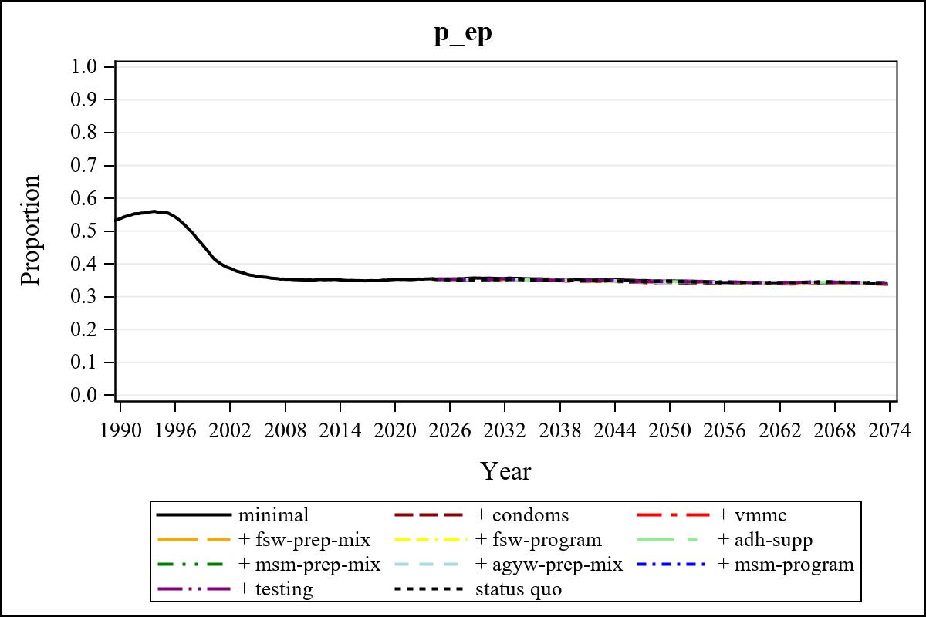

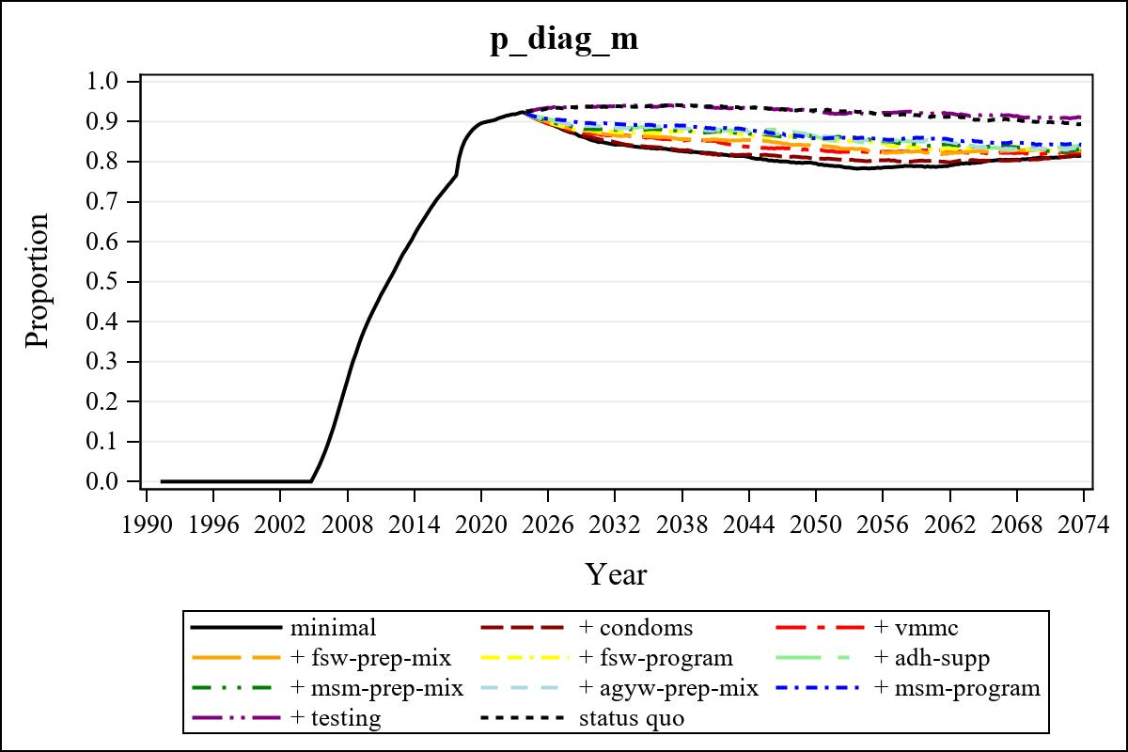

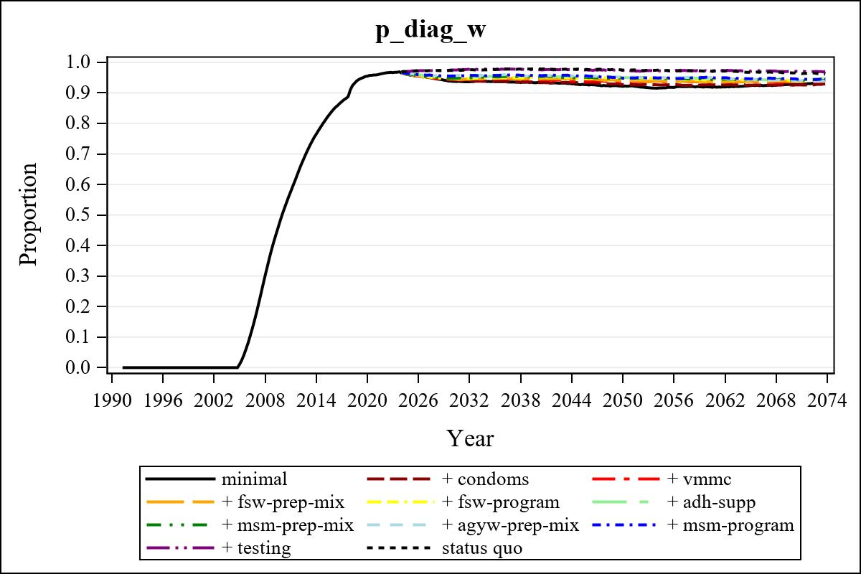

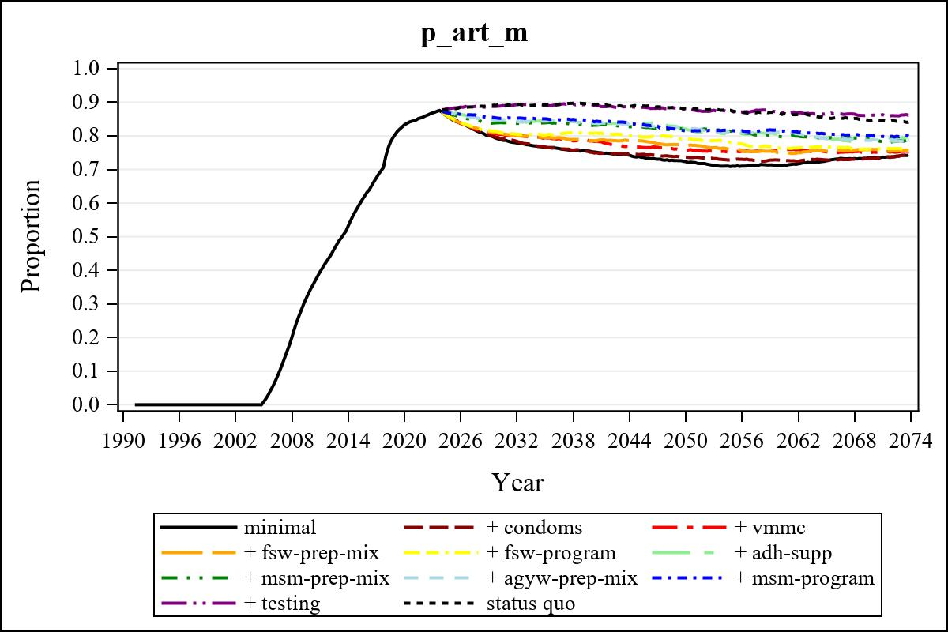

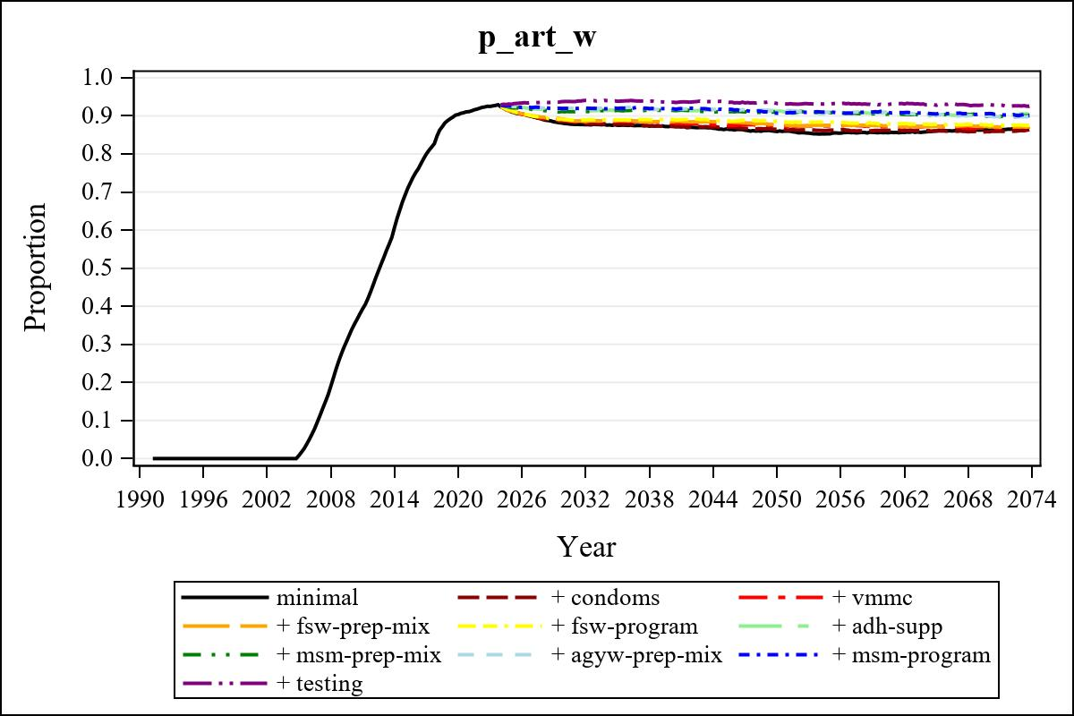

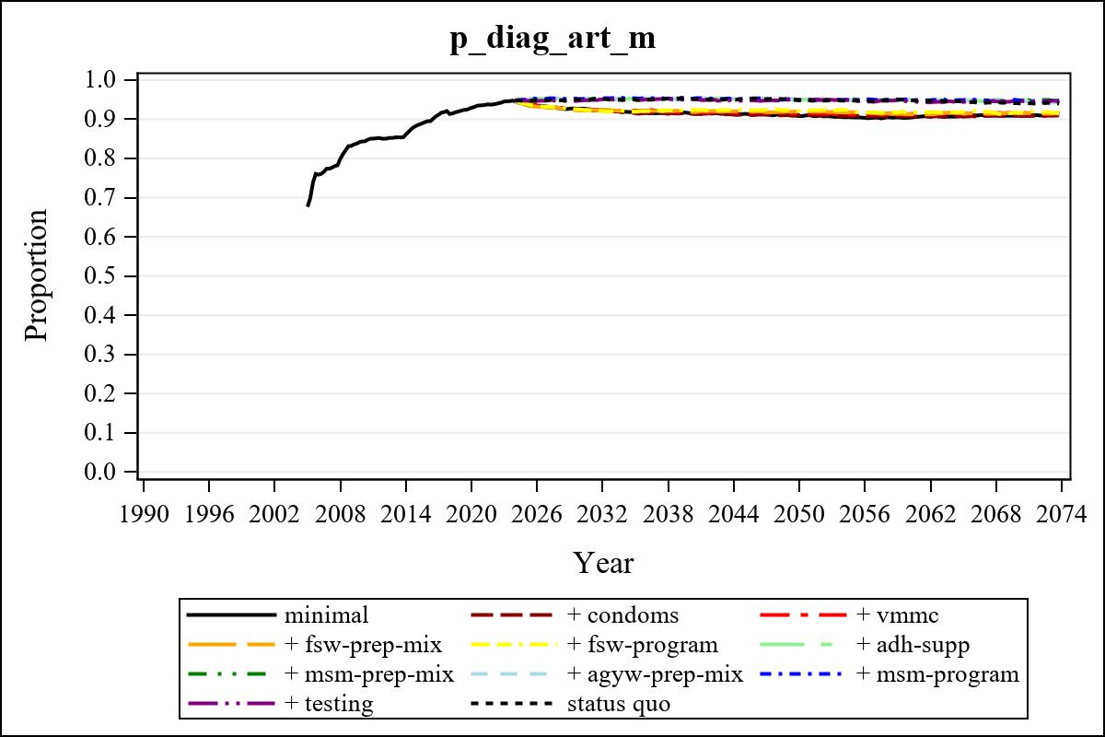

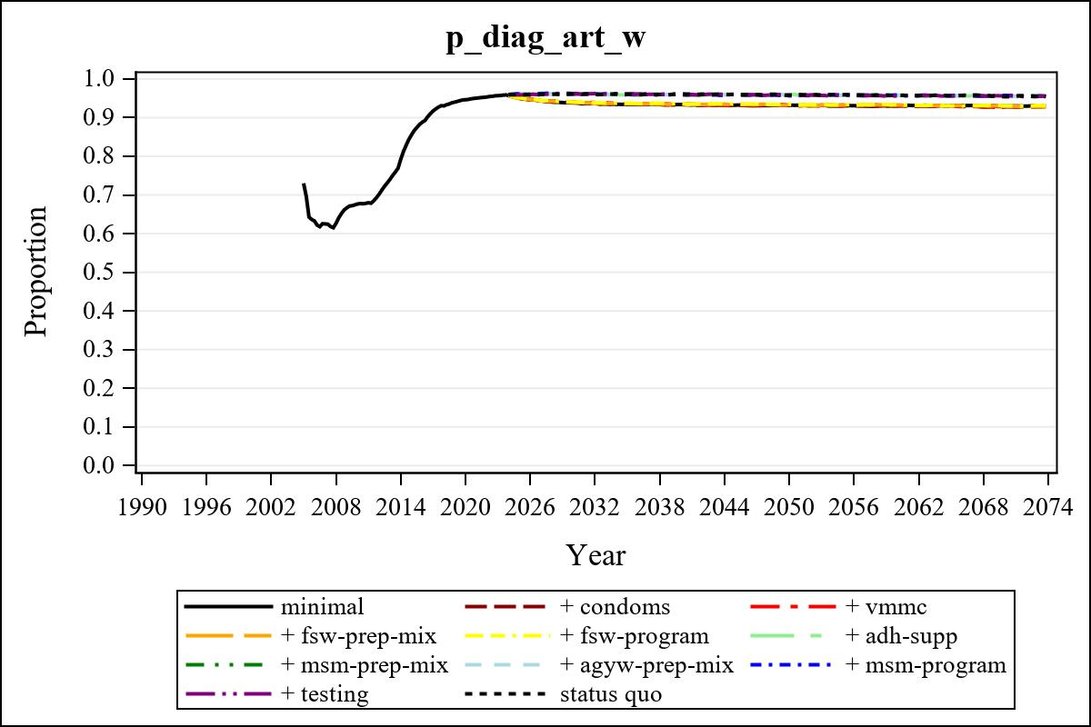

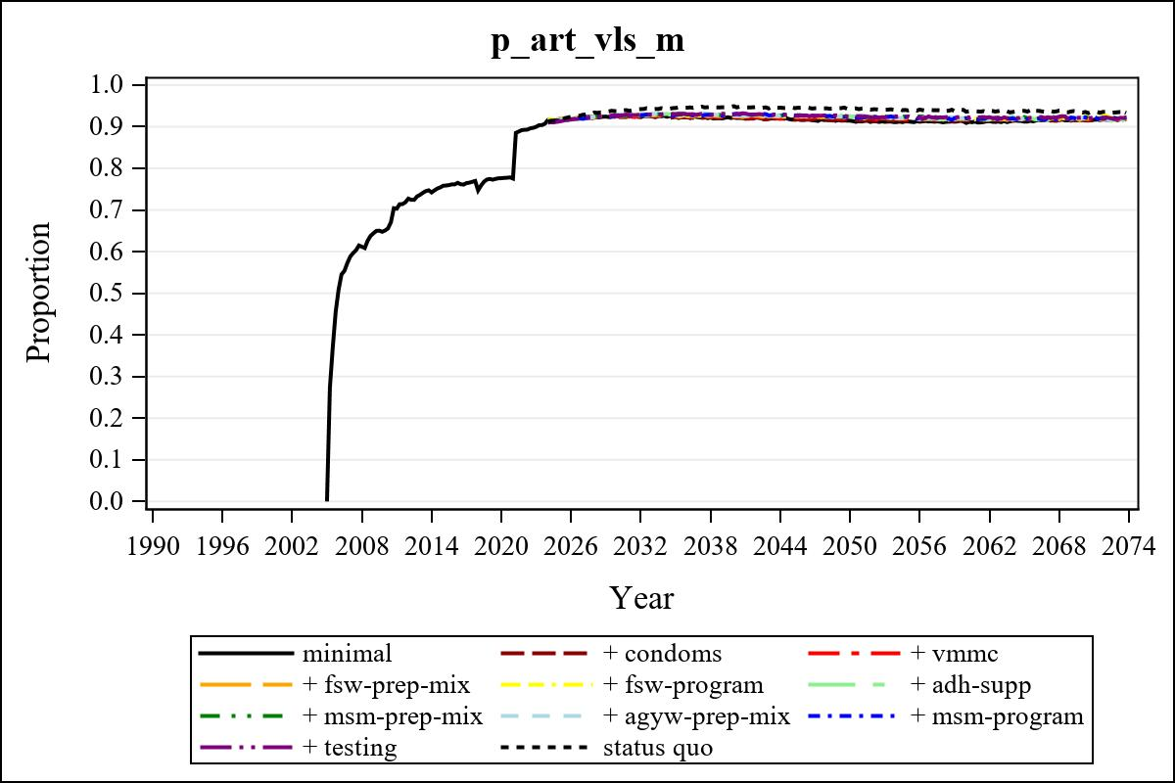

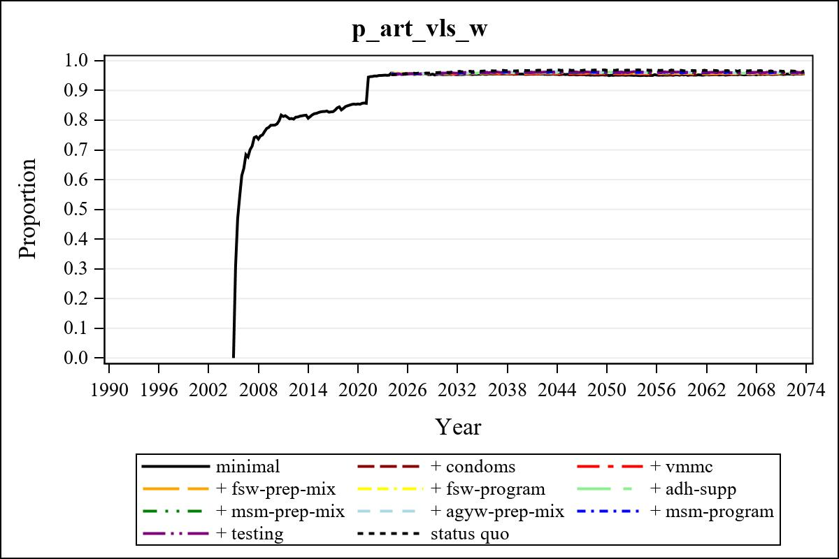

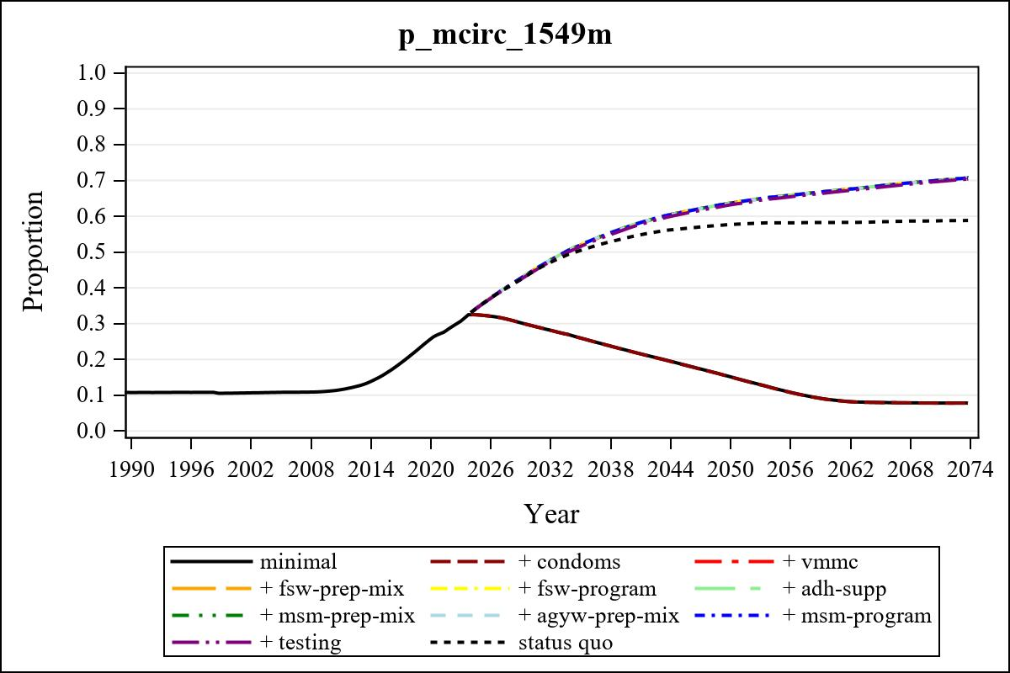

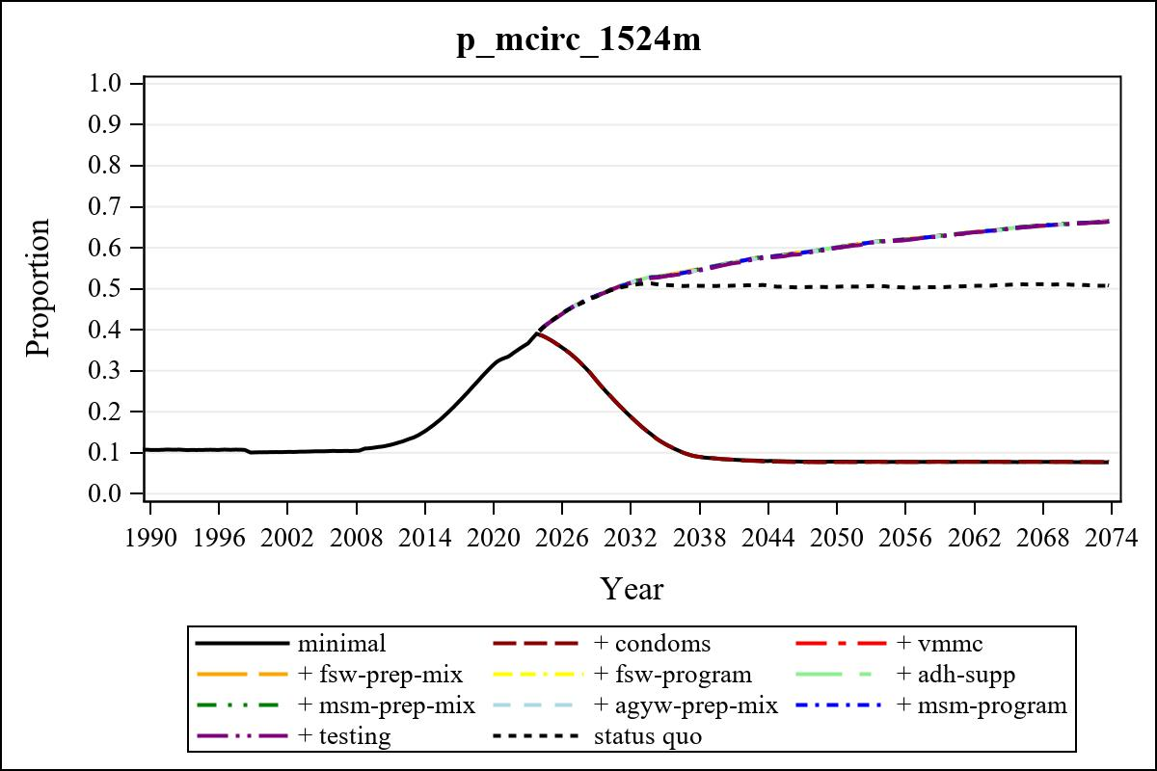

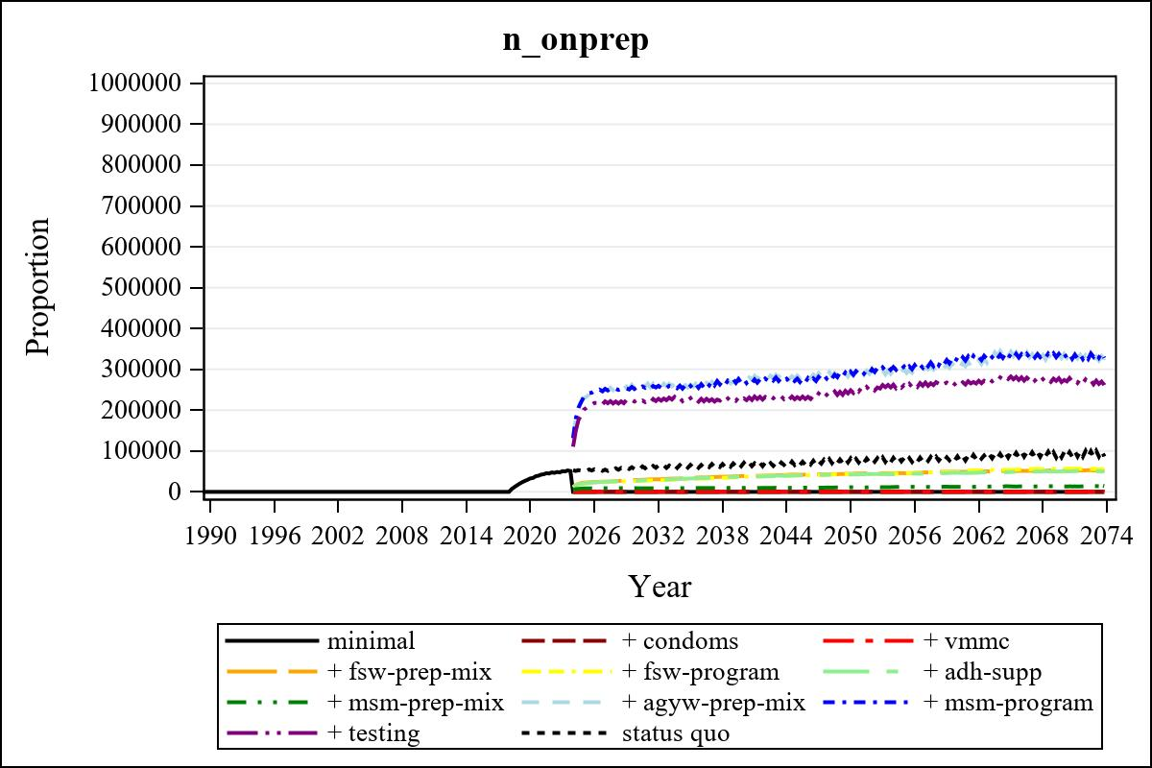

Obs | mean_n_onprep_0 | mean_n_onprep_1 | mean_n_onprep_2 | mean_n_onprep_3
346 | 0 | 0 | 0 | 53116.57

Obs | mean_n_onprep_4 | mean_n_onprep_5 | mean_n_onprep_6 | mean_n_onprep_99
346 | 56290.63 | 50575.92 | 13301.56 | 97381.49

Obs | mean_n_sw_1564__1 | mean_n_undiag_sw_1 | mean_n_elig_prep_1 | mean_n_elig_prep_any_sw_1
186 | 114531.30 | 65629.23 | 0 | 0

Obs | mean_n_onprep_sw_1 | mean_n_onprep_w_1 | mean_n_sw_1564__2 | mean_n_undiag_sw_2
186 | 0 | 0 | 116205.91 | 66945.96

Obs | mean_n_elig_prep_2 | mean_n_elig_prep_any_sw_2 | mean_n_onprep_sw_2 | mean_n_onprep_w_2
186 | 0 | 0 | 0 | 0

Obs | mean_n_onprep_oral_sw_2 | mean_n_onprep_len_sw_2 | mean_n_agyw_pg_3 | mean_n_elig_prep_3
186 | 0 | 0 | 919334.25 | 72445.86

Obs | mean_n_onprep_agyw_pg_3 | mean_n_onprep_w_3 | mean_n_agyw_pg_4 | mean_n_elig_prep_4
186 | 10707.05 | 28936.95 | 937287.52 | 71114.08

Obs | mean_n_onprep_agyw_pg_4 | mean_n_onprep_w_4 | mean_n_onprep_oral_agyw_pg_4
186 | 9579.72 | 26807.19 | 1702.26

Obs | mean_n_onprep_len_agyw_pg_4 | mean_n_alive_msm_5 | mean_n_elig_prep_5 | mean_n_onprep_msm_5
186 | 7877.45 | 66207.77 | 73349.85 | 0

Obs | mean_n_onprep_m_5 | mean_n_alive_msm_6 | mean_n_elig_prep_6 | mean_n_onprep_msm_6
186 | 0 | 65834.13 | 24558.08 | 8893.13

Obs | mean_n_onprep_m_6 | mean_n_onprep_oral_msm_6 | mean_n_onprep_len_msm_6 | mean_pc_elig_onprep_1
186 | 8893.13 | 2121.61 | 6771.52 | .

Obs | mean_pc_elig_onprep_2 | mean_pc_elig_onprep_3 | mean_pc_elig_onprep_4 | mean_pc_elig_onprep_5
186 | . | 0.39566 | 0.37796 | 0.37355

Obs | mean_pc_elig_onprep_6
186 | 0.35875

Obs | mean_n_sw_1564__1 | mean_n_undiag_sw_1 | mean_n_elig_prep_1
186 | 114531.30 | 65629.23 | 0

Obs | mean_n_elig_prep_any_sw_1 | mean_n_onprep_sw_1 | mean_n_onprep_w_1
186 | 0 | 0 | 0

Obs | ratio_oral_len_2 | ratio_oral_len_4 | ratio_oral_len_6
1 | . | 0.17767 | 0.22257

