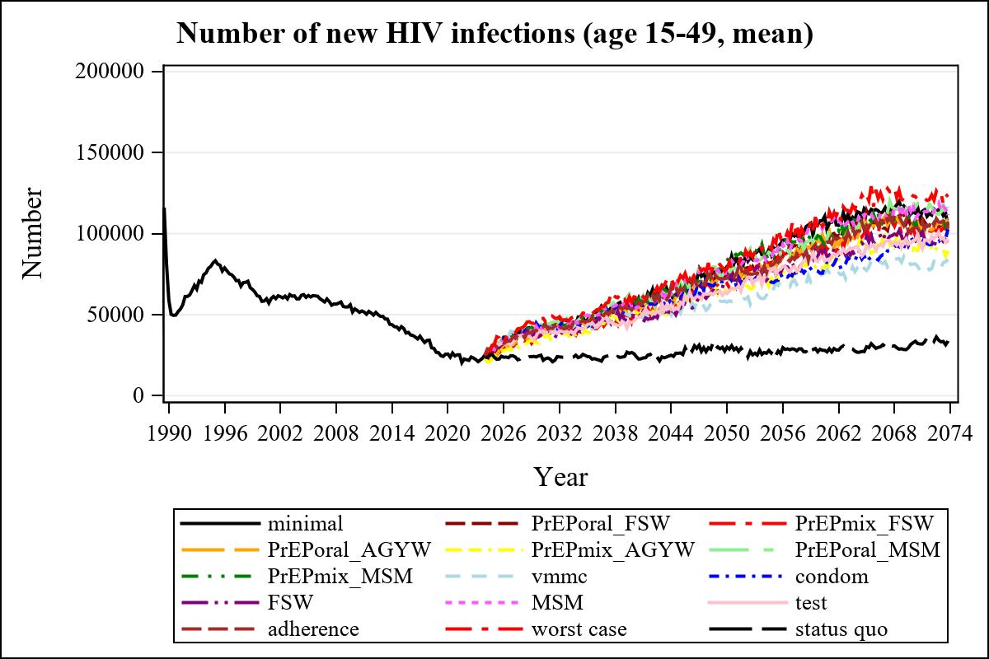

Obs | mean_n_new_inf1549__0 | mean_n_new_inf1549__1 | mean_n_new_inf1549__2 | mean_n_new_inf1549__3
345 | 113408.40 | 105670.66 | 104016.25 | 105549.16

Obs | mean_n_new_inf1549__4 | mean_n_new_inf1549__5 | mean_n_new_inf1549__6 | mean_n_new_inf1549__7
345 | 90363.70 | 119385.07 | 104128.50 | 81280.76

Obs | mean_n_new_inf1549__8 | mean_n_new_inf1549__9 | mean_n_new_inf1549__10 | mean_n_new_inf1549__11
345 | 95399.31 | 94539.69 | 118074.88 | 95701.04

Obs | mean_n_new_inf1549__12 | mean_n_new_inf1549__13 | mean_n_new_inf1549__99
345 | 103453.93 | 123436.16 | 32720.08

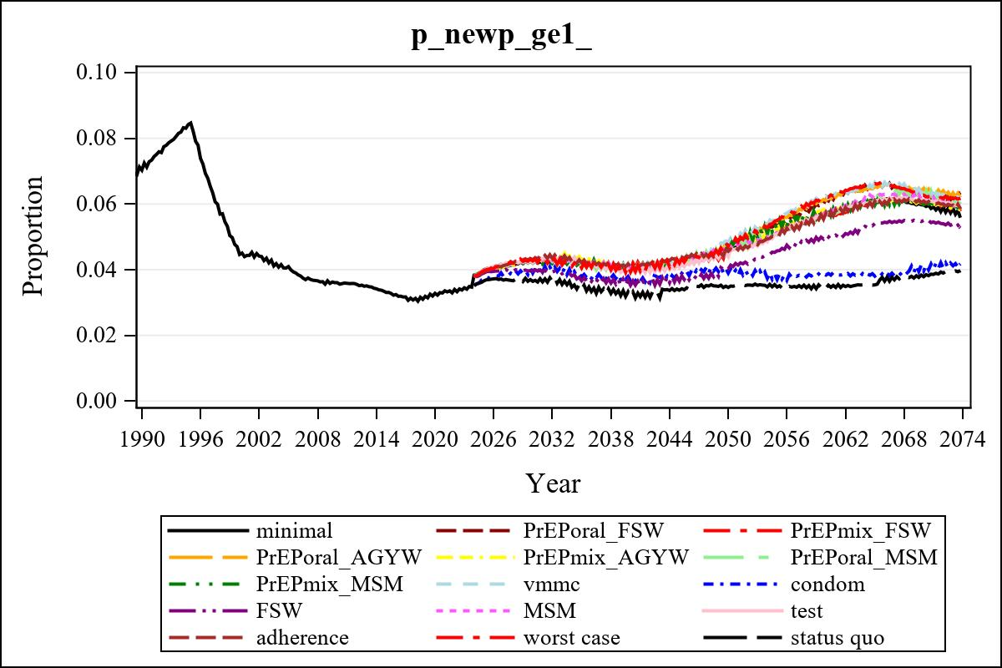

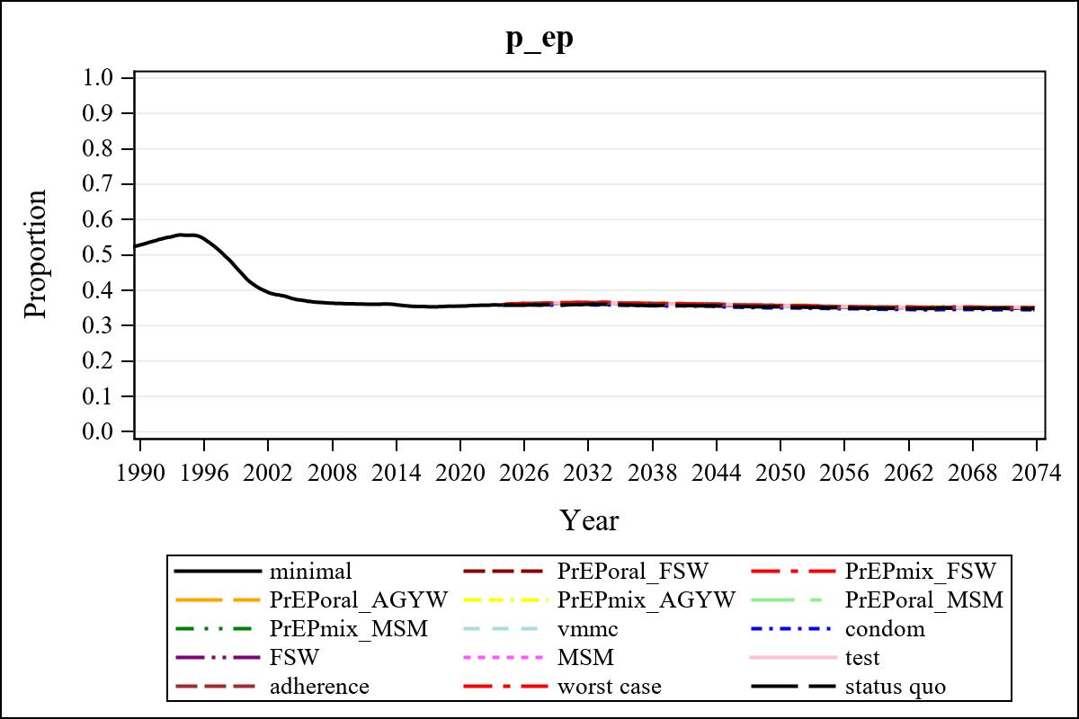

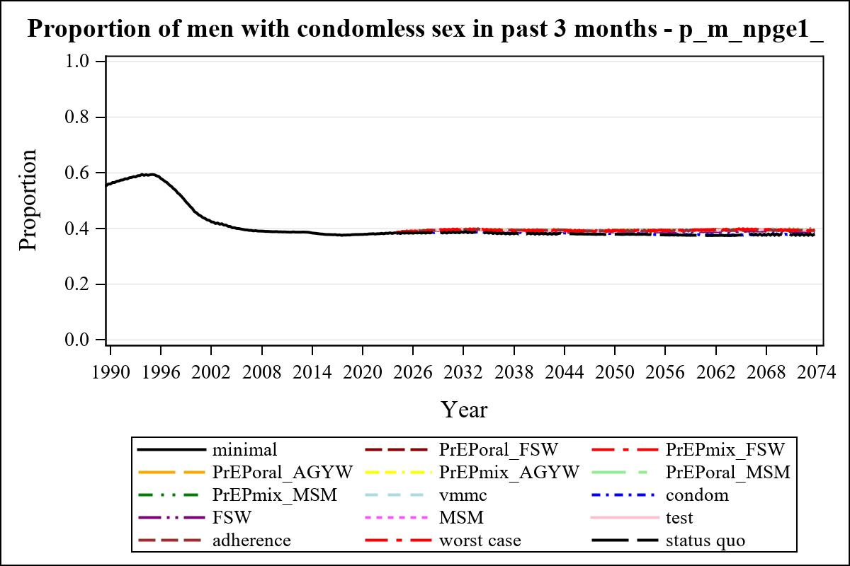

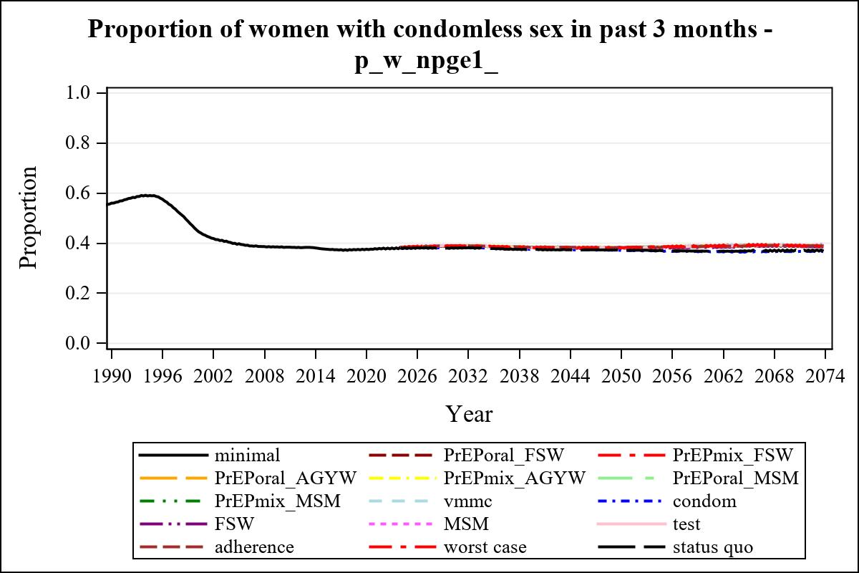

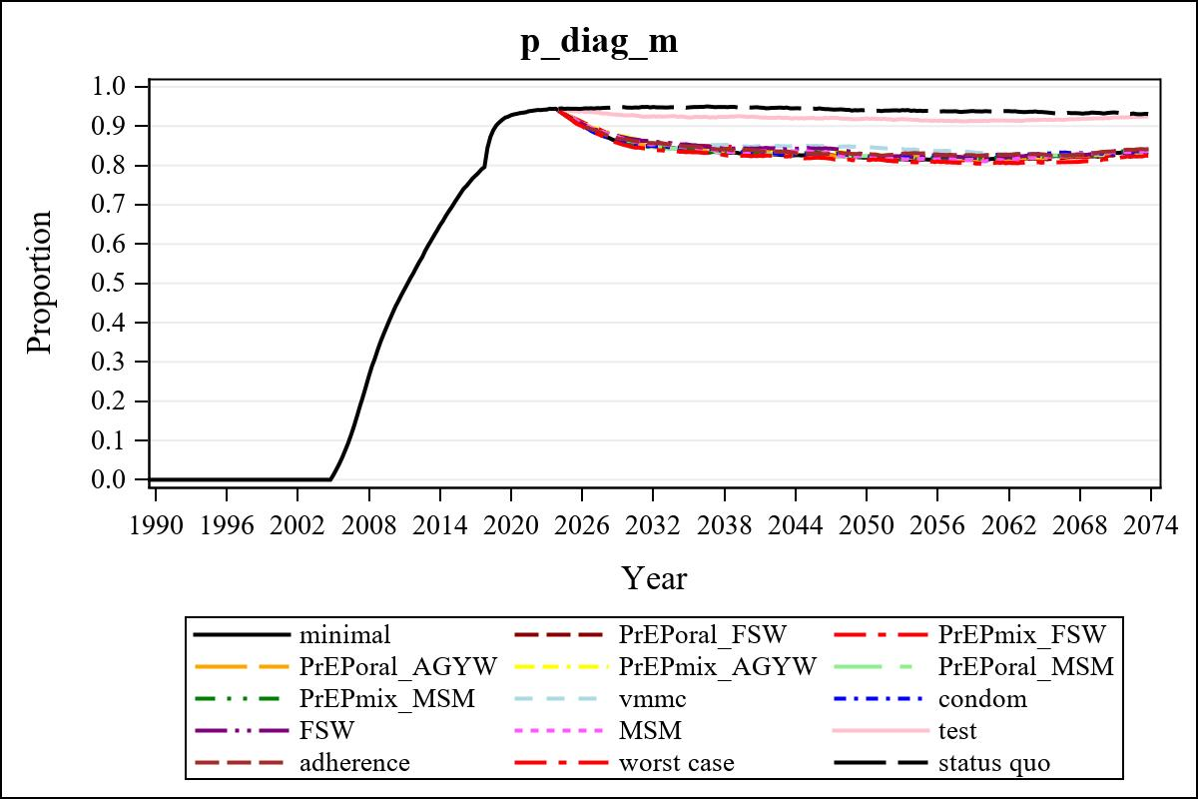

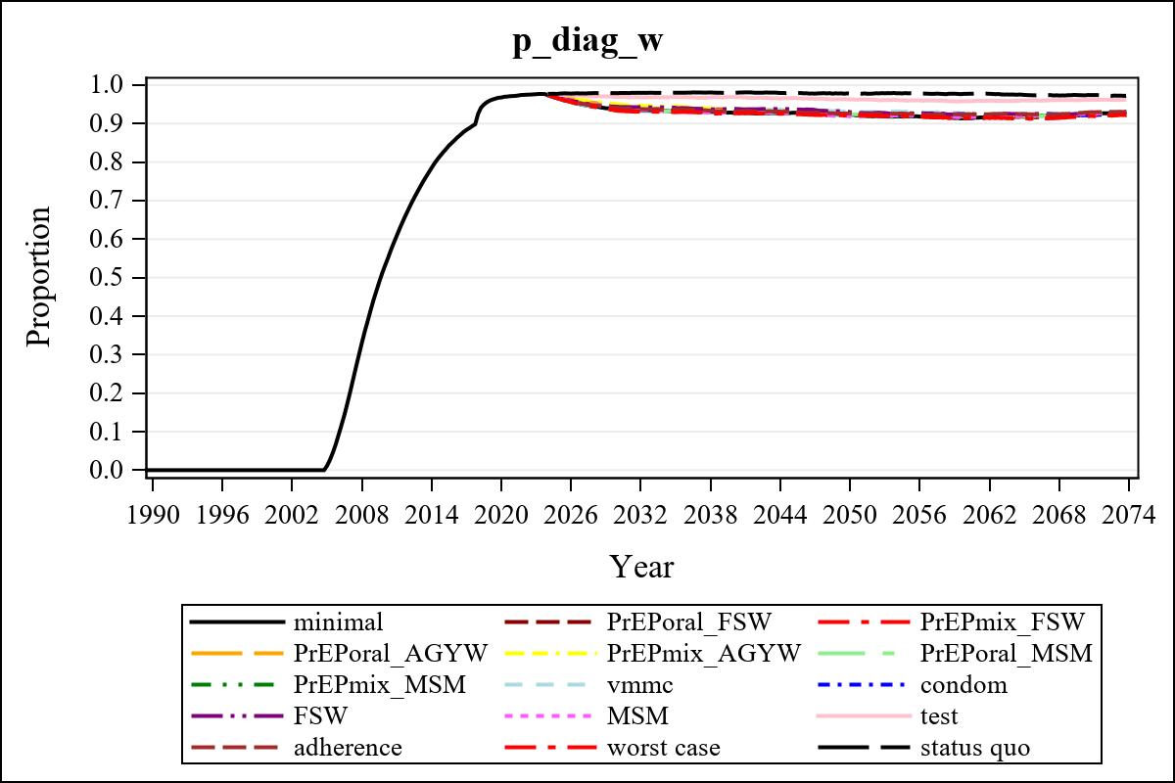

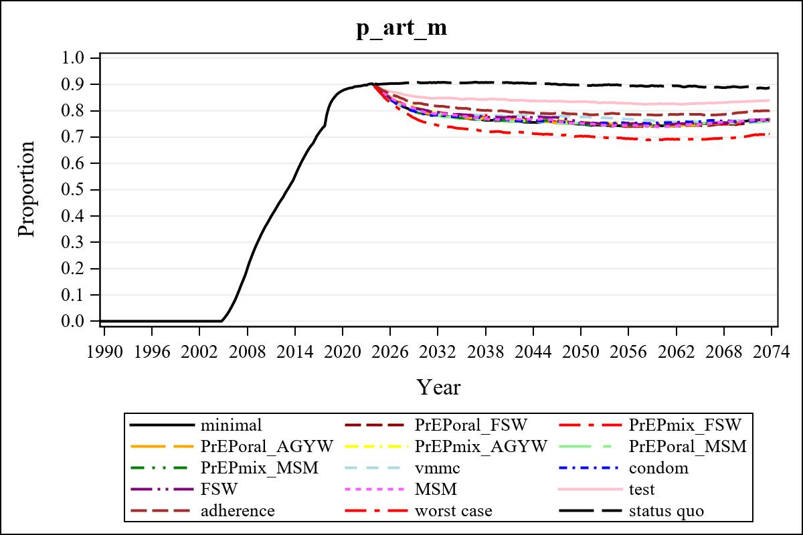

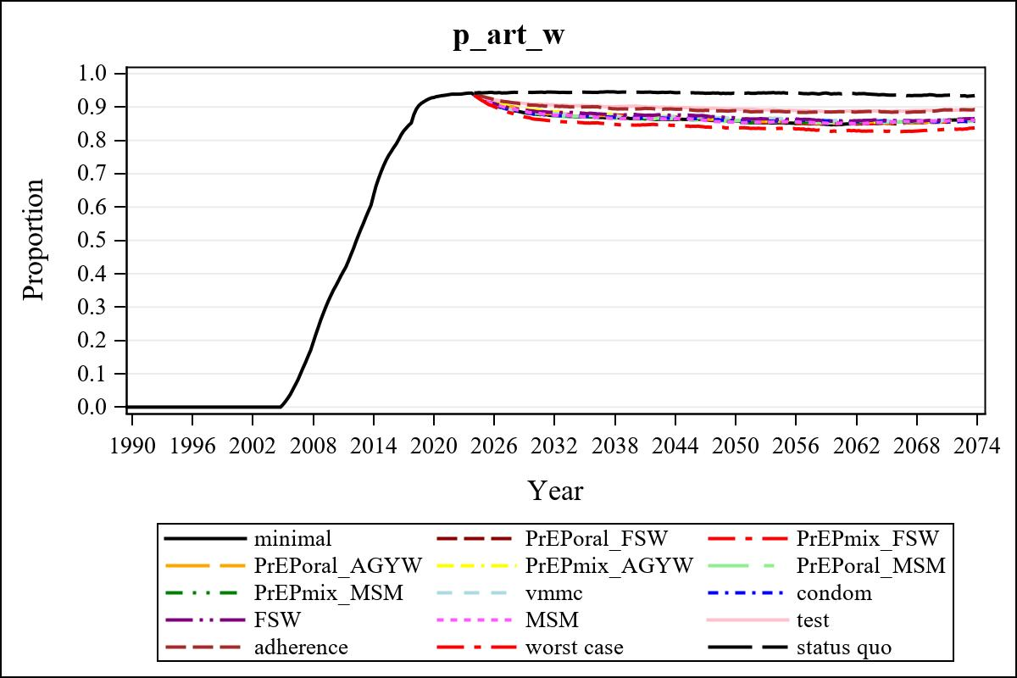

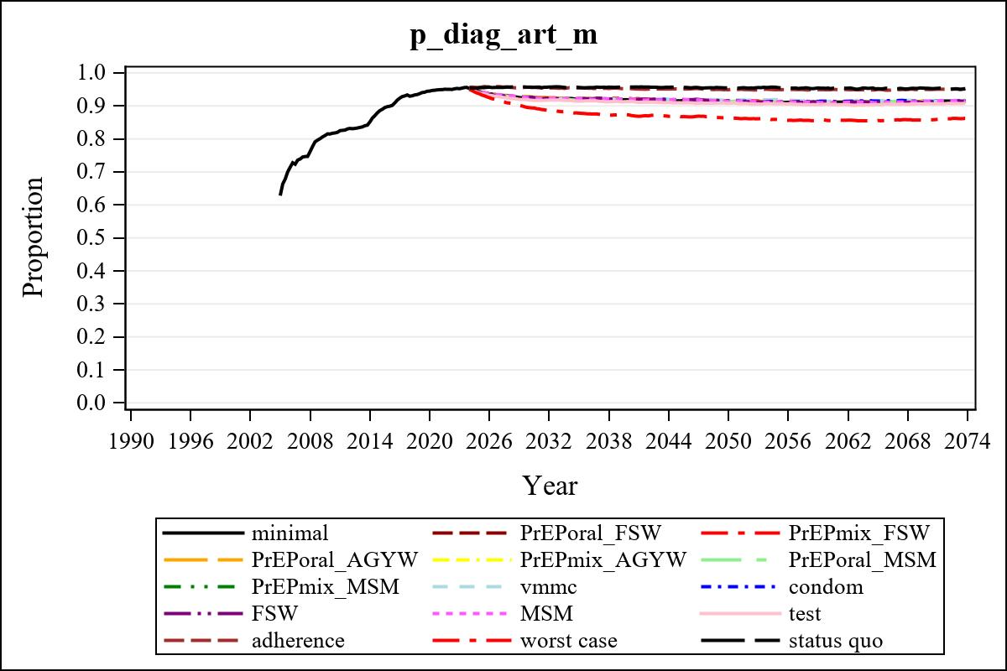

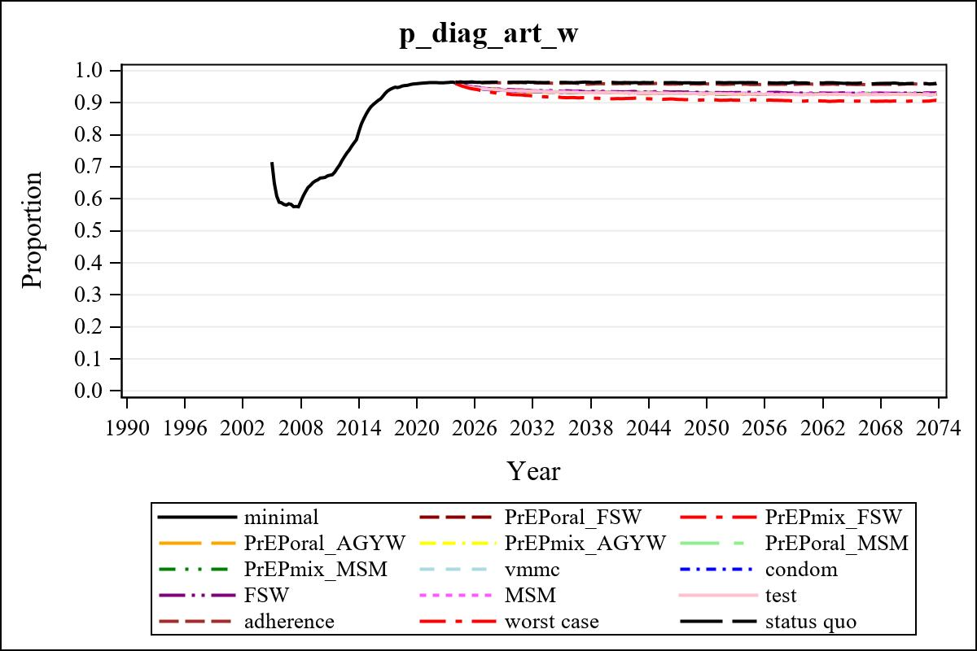

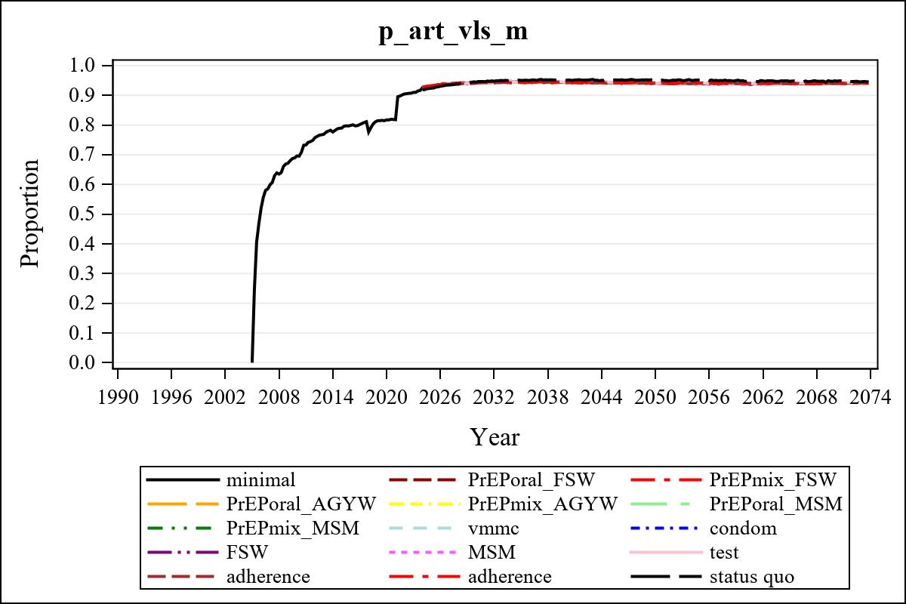

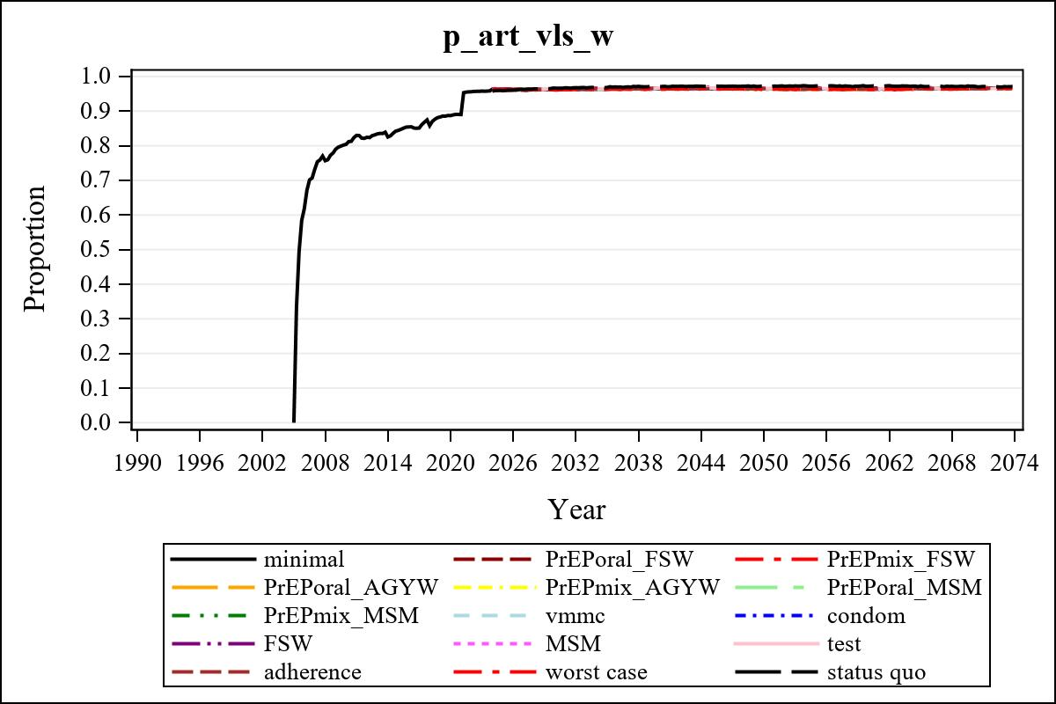

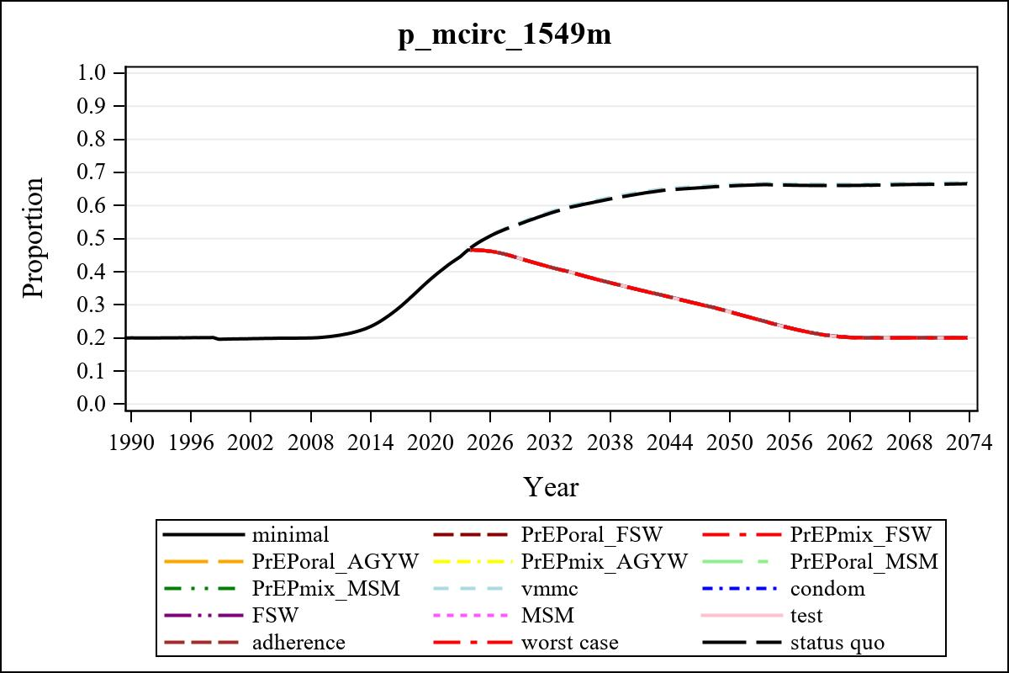

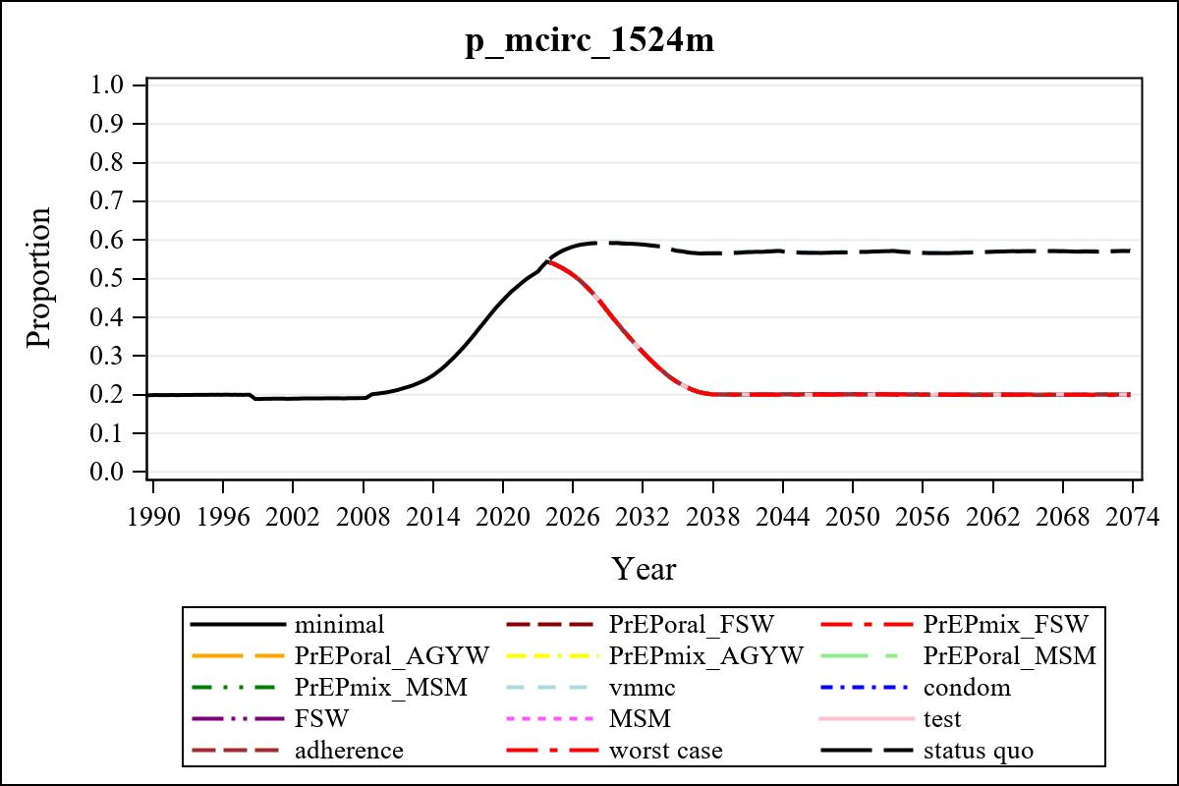

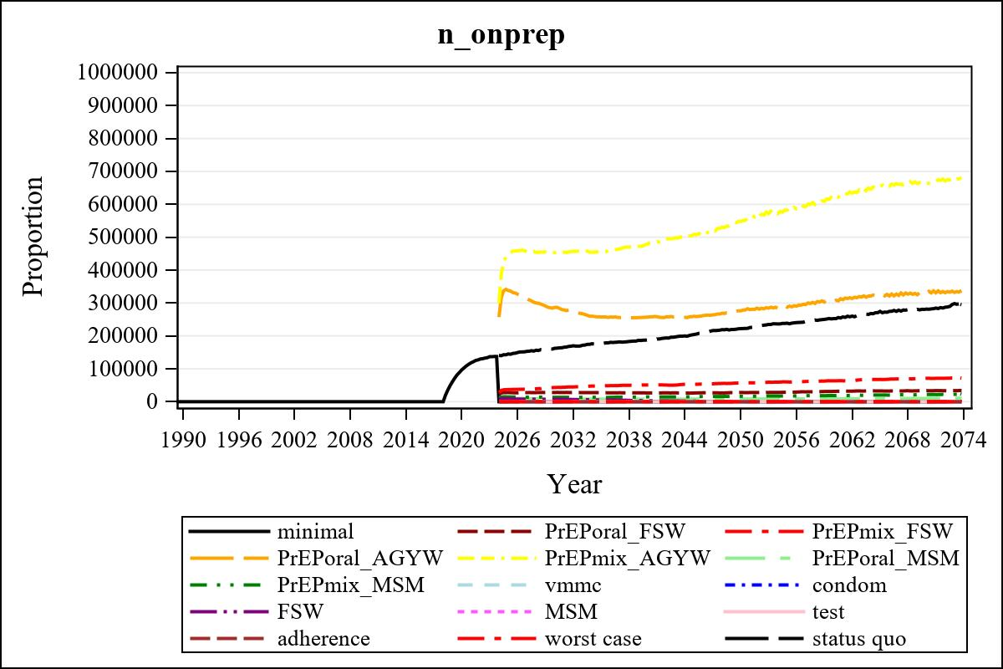

Obs | mean_n_onprep_0
345 | 0

Obs | mean_n_sw_1564__1 | mean_n_undiag_sw_1 | mean_n_elig_prep_1 | mean_n_elig_prep_any_sw_1
185 | 121672.40 | 88759.70 | 89626.77 | 89626.77

Obs | mean_n_onprep_sw_1 | mean_n_onprep_w_1 | mean_n_sw_1564__2 | mean_n_undiag_sw_2
185 | 27837.38 | 27837.38 | 120847.58 | 91405.46

Obs | mean_n_elig_prep_2 | mean_n_elig_prep_any_sw_2 | mean_n_onprep_sw_2 | mean_n_onprep_w_2
185 | 92187.44 | 92187.44 | 43251.43 | 43251.43

Obs | mean_n_onprep_oral_sw_2 | mean_n_onprep_len_sw_2 | mean_n_agyw_pg_3 | mean_n_elig_prep_3
185 | 16388.27 | 26863.16 | 1304890.28 | 1262462.79

Obs | mean_n_onprep_agyw_pg_3 | mean_n_onprep_w_3 | mean_n_agyw_pg_4 | mean_n_elig_prep_4
185 | 286709.76 | 286709.76 | 1308985.85 | 1269485.33

Obs | mean_n_onprep_agyw_pg_4 | mean_n_onprep_w_4 | mean_n_onprep_oral_agyw_pg_4
185 | 453032.04 | 453032.04 | 170455.06

Obs | mean_n_onprep_len_agyw_pg_4 | mean_n_alive_msm_5 | mean_n_elig_prep_5 | mean_n_onprep_msm_5
185 | 282576.99 | 81917.04 | 32156.86 | 8463.48

Obs | mean_n_onprep_m_5 | mean_n_alive_msm_6 | mean_n_elig_prep_6 | mean_n_onprep_msm_6
185 | 8463.48 | 81806.07 | 32300.14 | 13435.84

Obs | mean_n_onprep_m_6 | mean_n_onprep_oral_msm_6 | mean_n_onprep_len_msm_6 | mean_pc_elig_onprep_1
185 | 13435.84 | 5081.68 | 8354.16 | 0.31334

Obs | mean_pc_elig_onprep_2 | mean_pc_elig_onprep_3 | mean_pc_elig_onprep_4 | mean_pc_elig_onprep_5
185 | 0.47426 | 0.22901 | 0.35393 | 0.25923

Obs | mean_pc_elig_onprep_6
185 | 0.41469

Obs | mean_n_sw_1564__1 | mean_n_undiag_sw_1 | mean_n_elig_prep_1
185 | 121672.40 | 88759.70 | 89626.77

Obs | mean_n_elig_prep_any_sw_1 | mean_n_onprep_sw_1 | mean_n_onprep_w_1
185 | 89626.77 | 27837.38 | 27837.38

Obs | ratio_oral_len_2 | ratio_oral_len_4 | ratio_oral_len_6
1 | 0.58855 | 0.59001 | 0.54470

