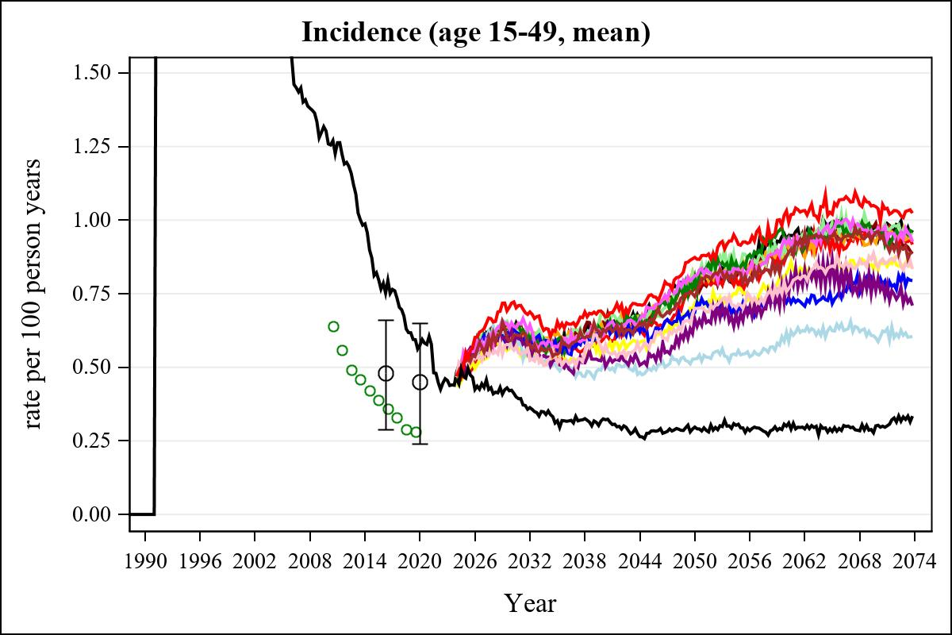

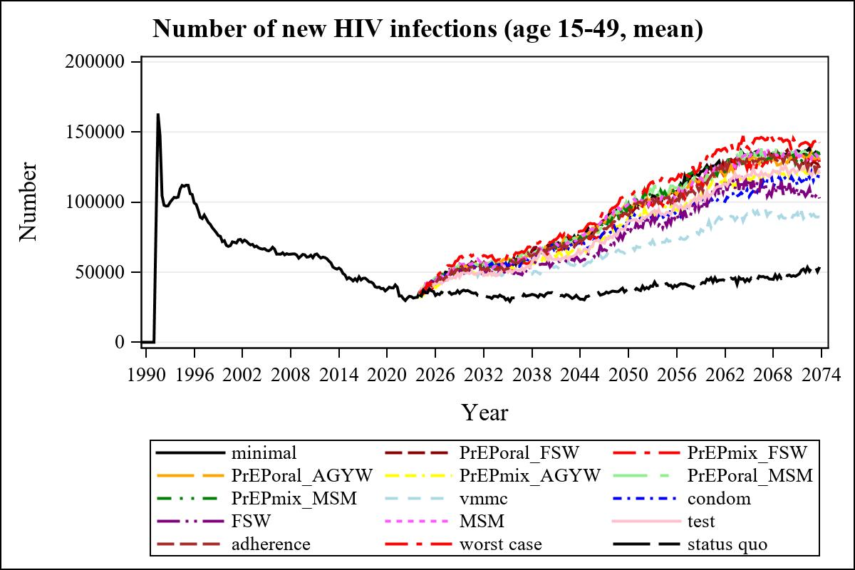

Obs | mean_n_new_inf1549__0 | mean_n_new_inf1549__1 | mean_n_new_inf1549__2 | mean_n_new_inf1549__3
345 | 130359.28 | 132899.83 | 134759.94 | 130960.52

Obs | mean_n_new_inf1549__4 | mean_n_new_inf1549__5 | mean_n_new_inf1549__6 | mean_n_new_inf1549__7
345 | 117811.33 | 133184.14 | 133334.63 | 85233.57

Obs | mean_n_new_inf1549__8 | mean_n_new_inf1549__9 | mean_n_new_inf1549__10 | mean_n_new_inf1549__11
345 | 114859.44 | 113528.61 | 134995.34 | 119780.48

Obs | mean_n_new_inf1549__12 | mean_n_new_inf1549__13 | mean_n_new_inf1549__99
345 | 134146.61 | 143079.84 | 48012.50

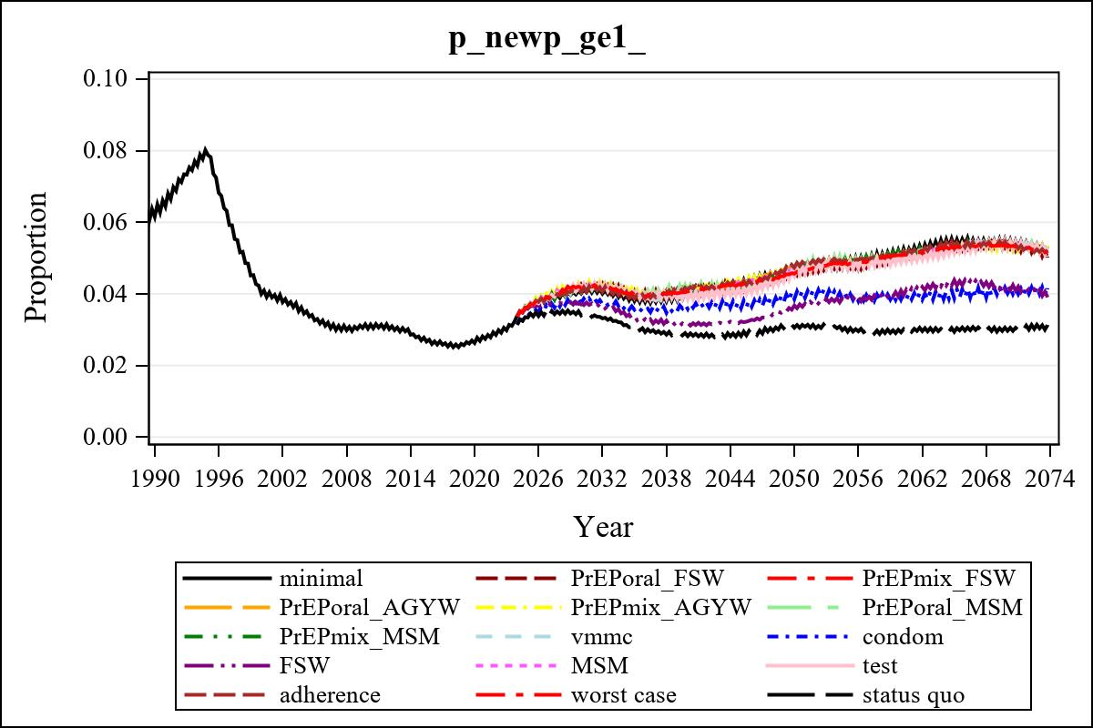

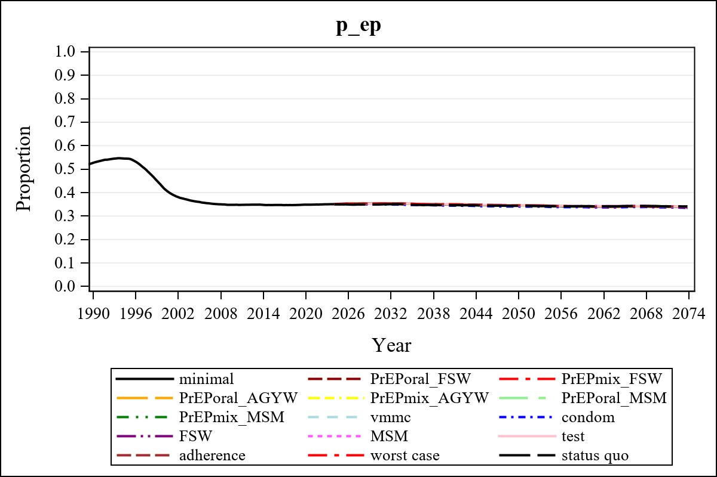

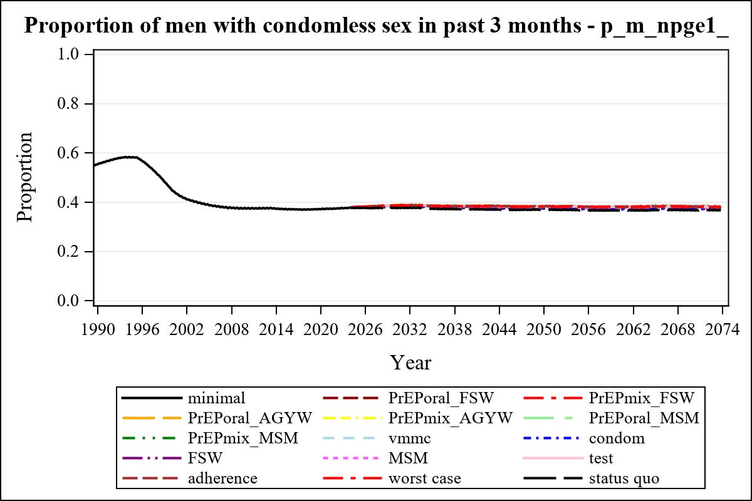

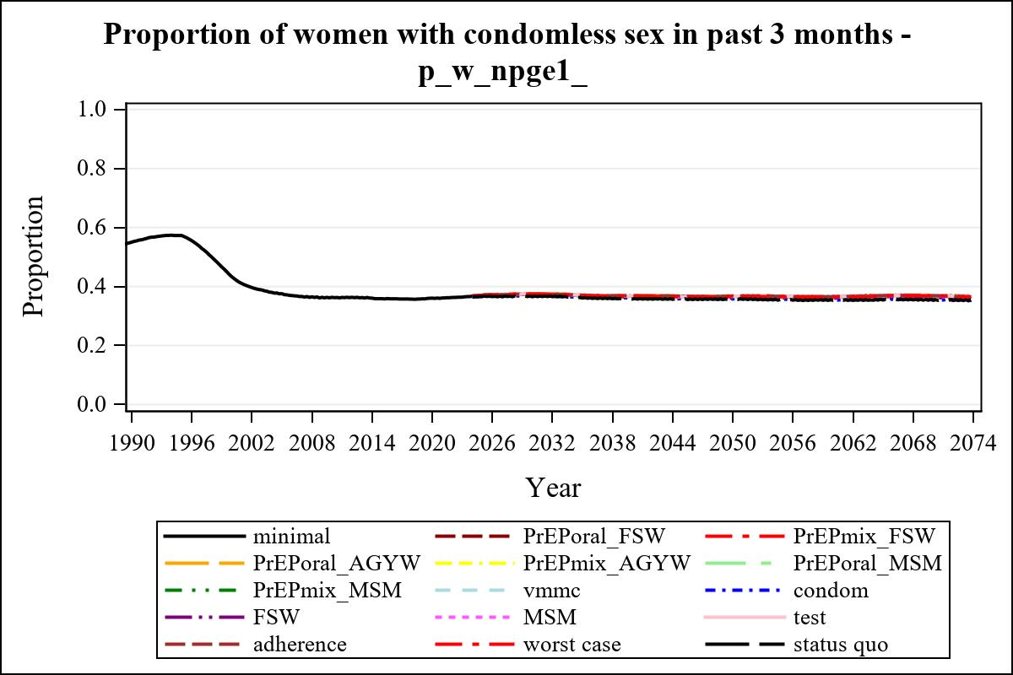

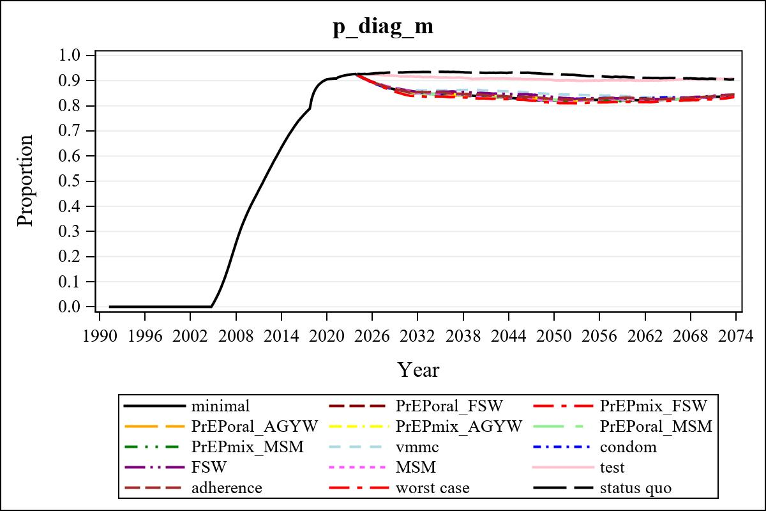

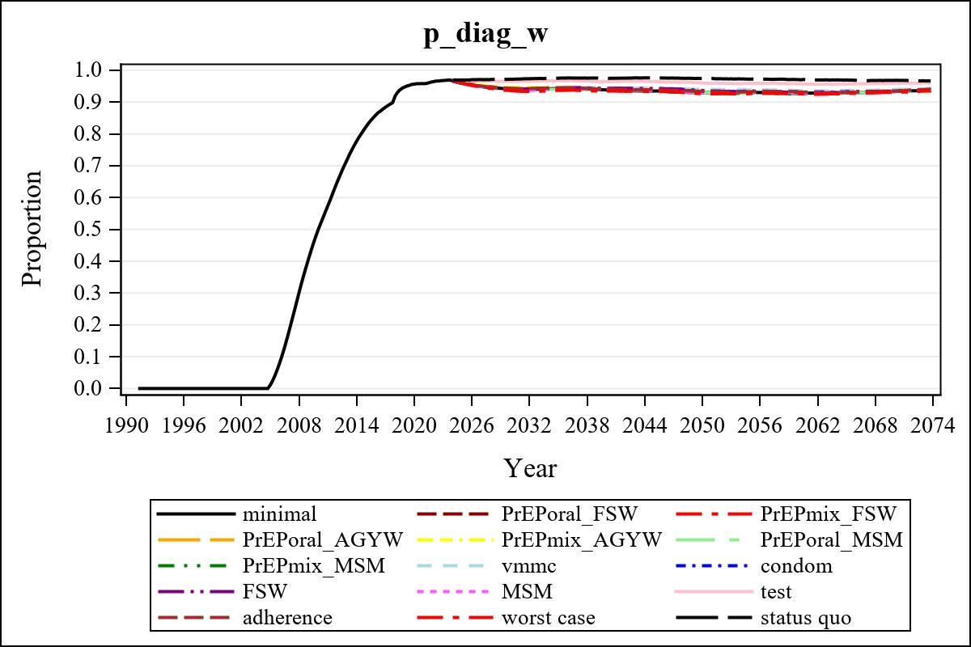

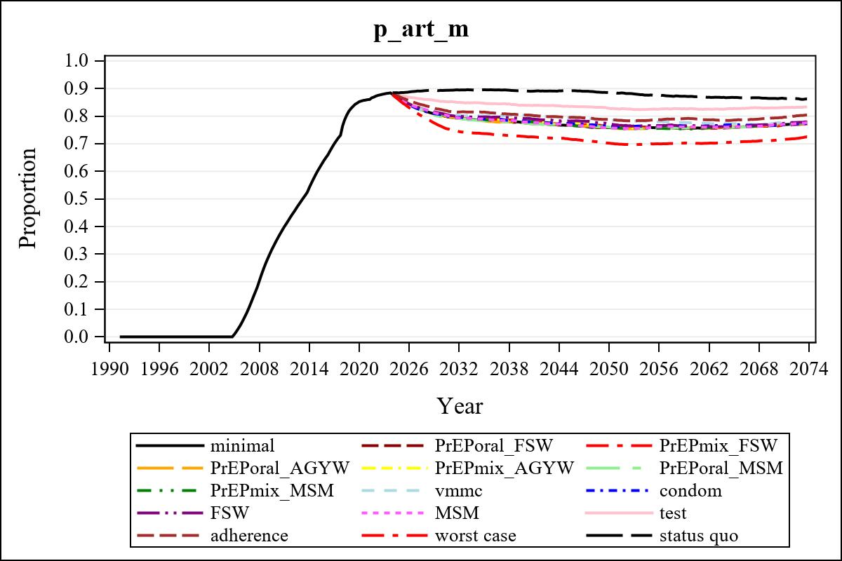

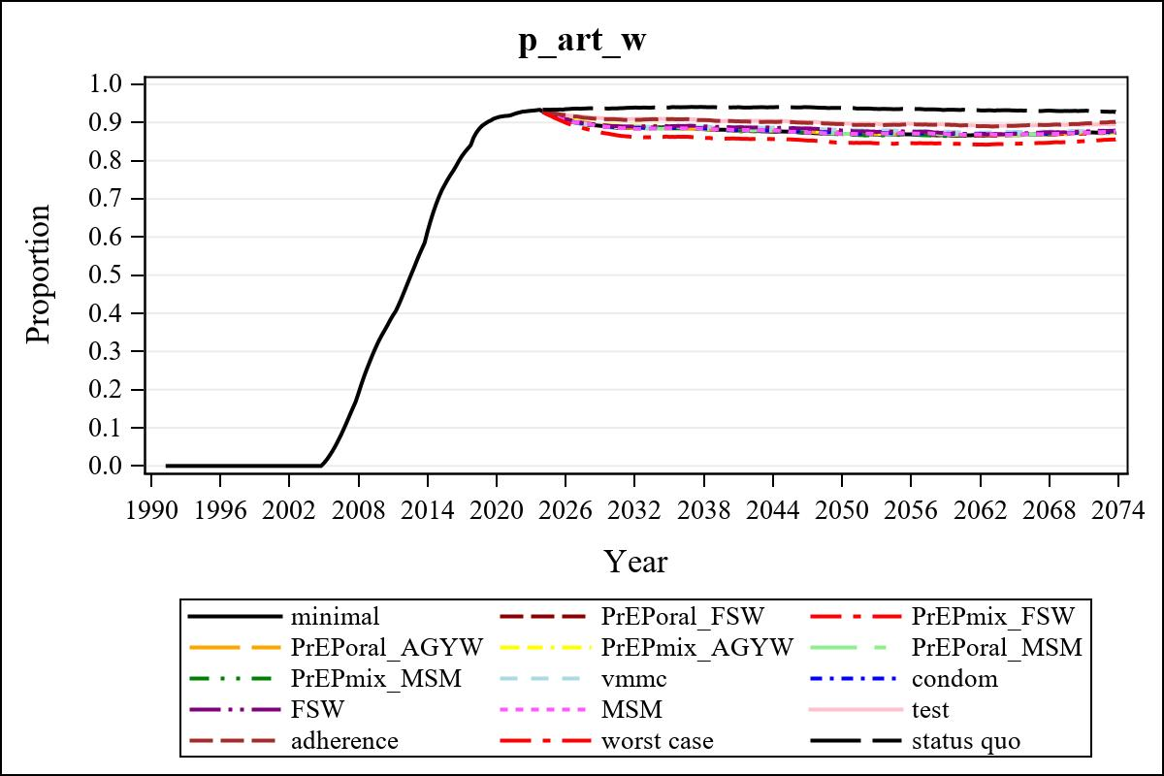

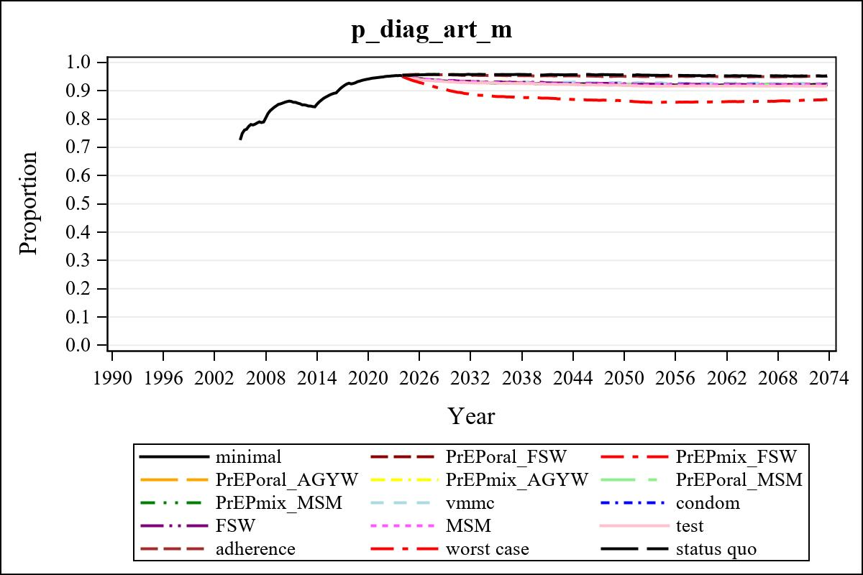

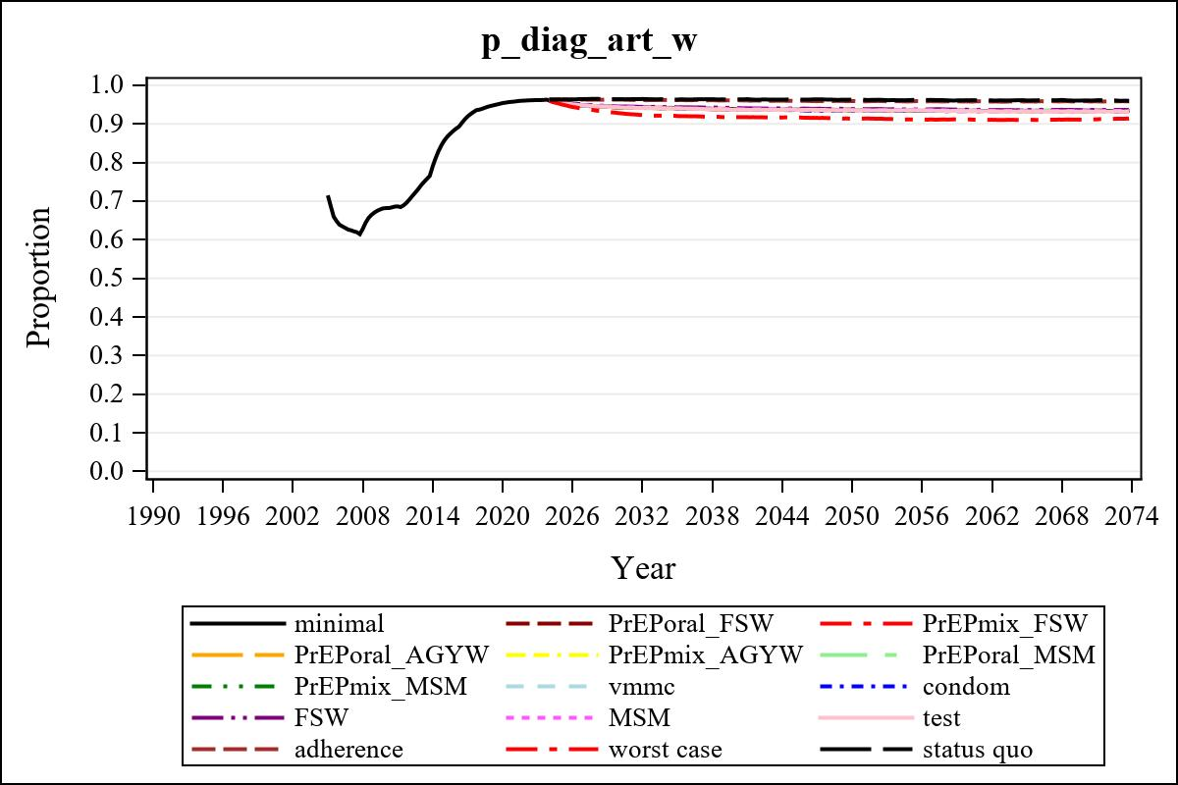

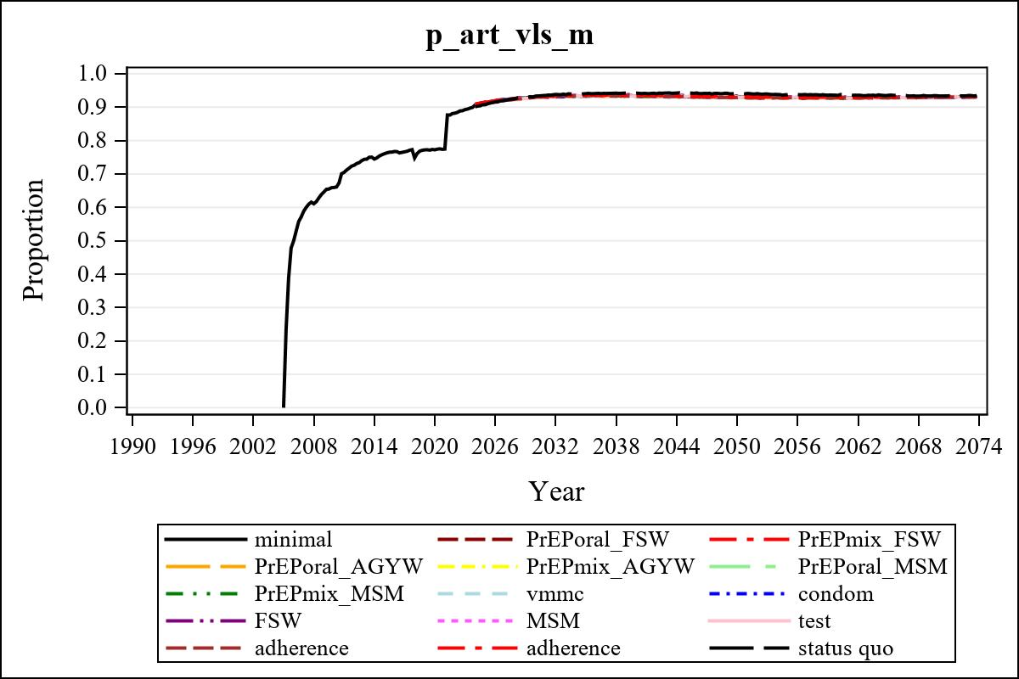

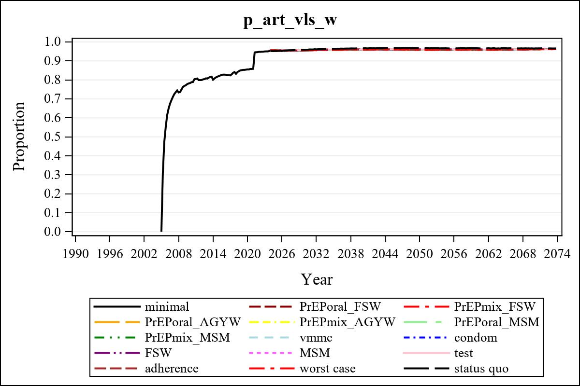

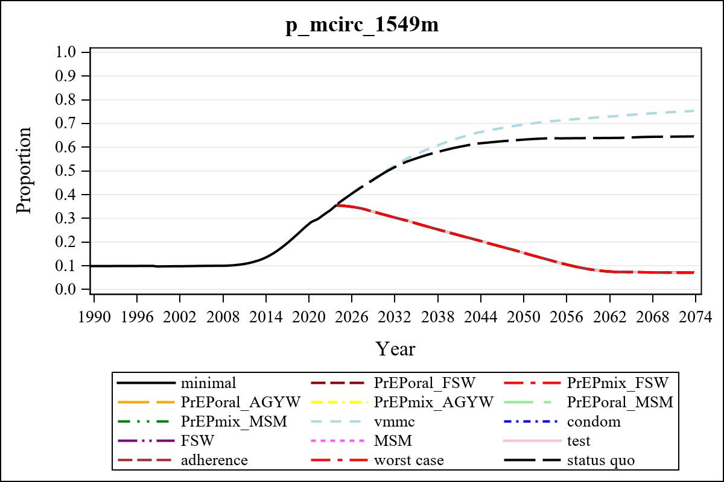

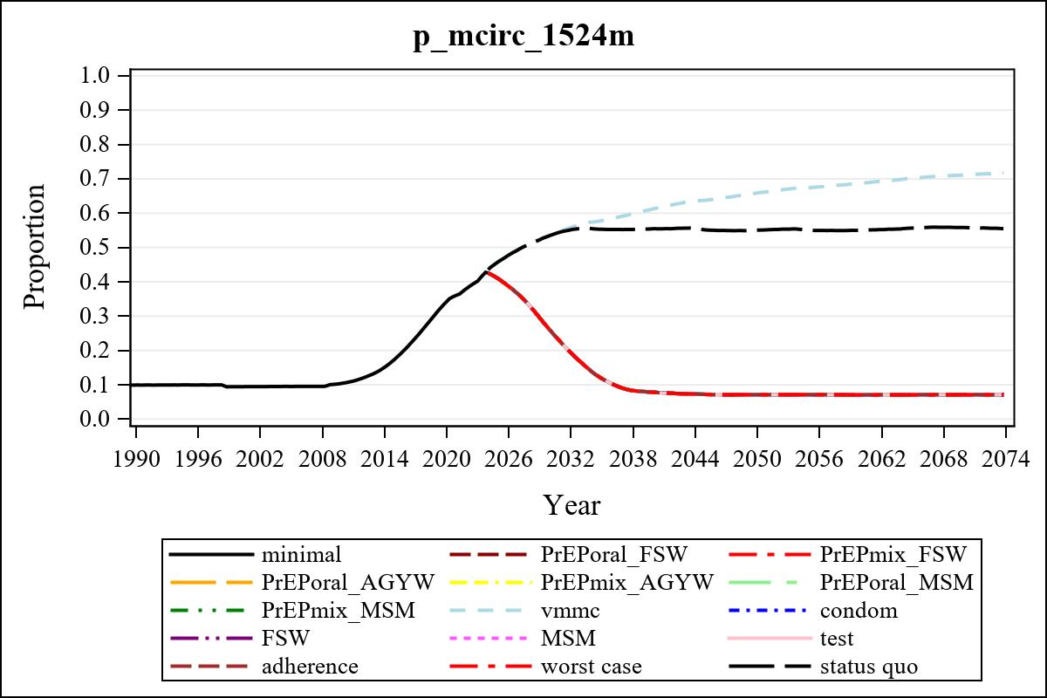

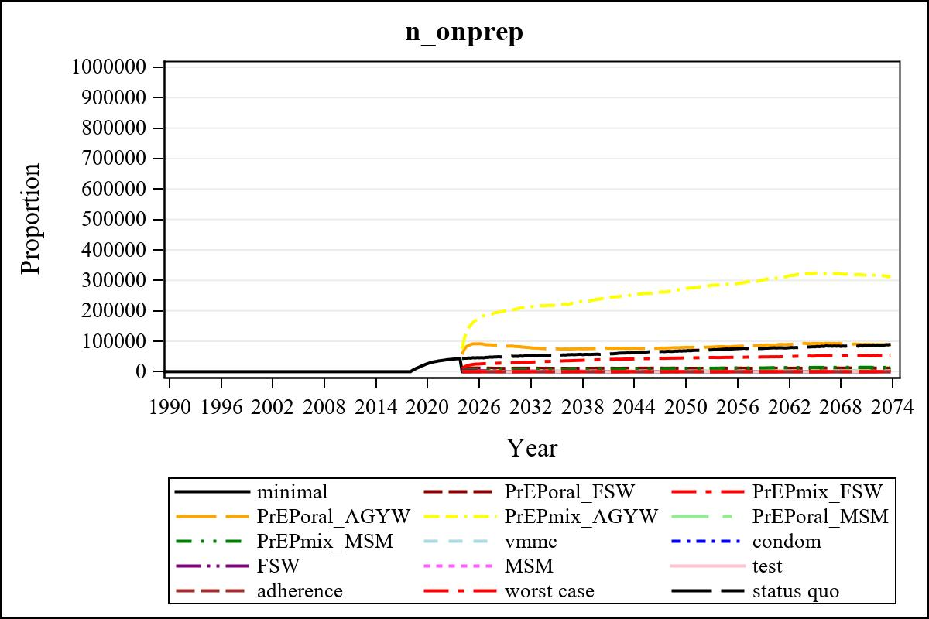

Obs | mean_n_onprep_0
345 | 0

Obs | mean_n_sw_1564__1 | mean_n_undiag_sw_1 | mean_n_elig_prep_1 | mean_n_elig_prep_any_sw_1
185 | 125052.86 | 68499.42 | 69644.82 | 69644.82

Obs | mean_n_onprep_sw_1 | mean_n_onprep_w_1 | mean_n_sw_1564__2 | mean_n_undiag_sw_2
185 | 11368.26 | 11368.26 | 126043.71 | 73154.66

Obs | mean_n_elig_prep_2 | mean_n_elig_prep_any_sw_2 | mean_n_onprep_sw_2 | mean_n_onprep_w_2
185 | 74114.65 | 74114.65 | 29622.47 | 29622.47

Obs | mean_n_onprep_oral_sw_2 | mean_n_onprep_len_sw_2 | mean_n_agyw_pg_3 | mean_n_elig_prep_3
185 | 5881.75 | 23740.73 | 916906.56 | 865054.14

Obs | mean_n_onprep_agyw_pg_3 | mean_n_onprep_w_3 | mean_n_agyw_pg_4 | mean_n_elig_prep_4
185 | 83190.42 | 83190.42 | 917421.72 | 868550.40

Obs | mean_n_onprep_agyw_pg_4 | mean_n_onprep_w_4 | mean_n_onprep_oral_agyw_pg_4
185 | 203416.36 | 203416.36 | 46816.56

Obs | mean_n_onprep_len_agyw_pg_4 | mean_n_alive_msm_5 | mean_n_elig_prep_5 | mean_n_onprep_msm_5
185 | 156599.81 | 62616.06 | 21753.69 | 3122.39

Obs | mean_n_onprep_m_5 | mean_n_alive_msm_6 | mean_n_elig_prep_6 | mean_n_onprep_msm_6
185 | 3122.39 | 62382.04 | 21835.16 | 7770.07

Obs | mean_n_onprep_m_6 | mean_n_onprep_oral_msm_6 | mean_n_onprep_len_msm_6 | mean_pc_elig_onprep_1
185 | 7770.07 | 1508.76 | 6261.31 | 0.16408

Obs | mean_pc_elig_onprep_2 | mean_pc_elig_onprep_3 | mean_pc_elig_onprep_4 | mean_pc_elig_onprep_5
185 | 0.40376 | 0.095284 | 0.23240 | 0.14239

Obs | mean_pc_elig_onprep_6
185 | 0.34718

Obs | mean_n_sw_1564__1 | mean_n_undiag_sw_1 | mean_n_elig_prep_1
185 | 125052.86 | 68499.42 | 69644.82

Obs | mean_n_elig_prep_any_sw_1 | mean_n_onprep_sw_1 | mean_n_onprep_w_1
185 | 69644.82 | 11368.26 | 11368.26

Obs | ratio_oral_len_2 | ratio_oral_len_4 | ratio_oral_len_6
1 | 0.21659 | 0.27188 | 0.20428

