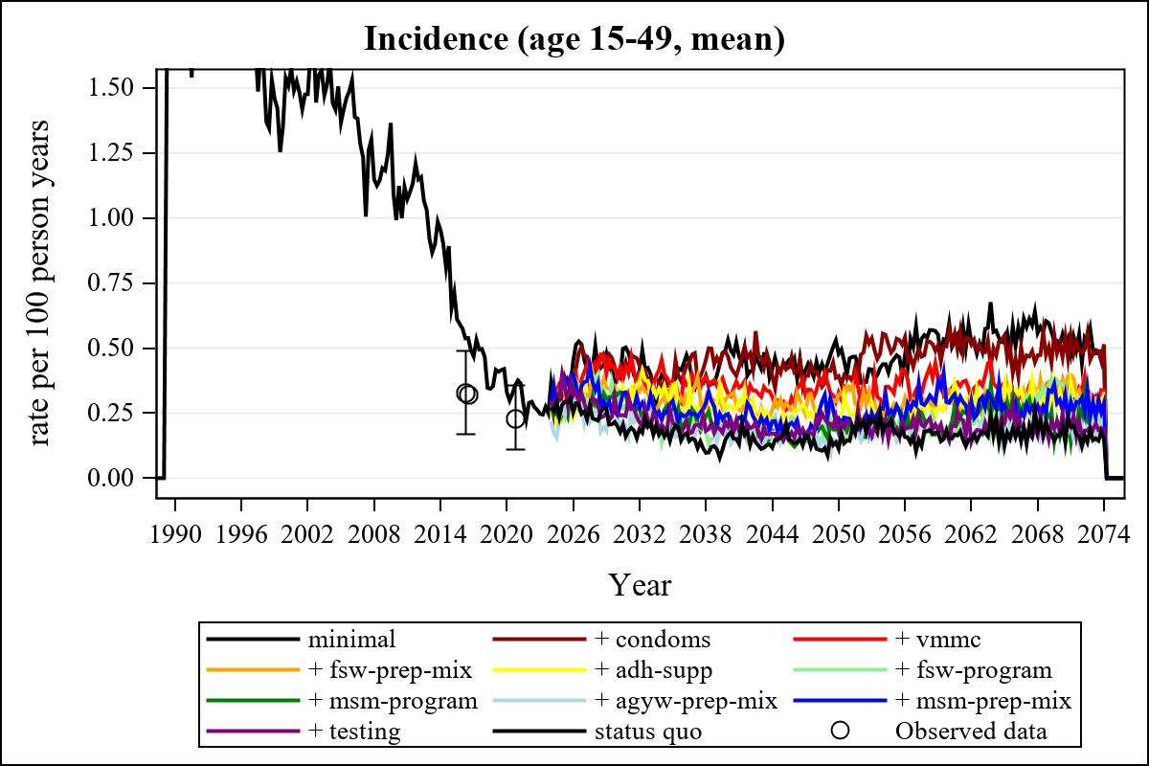

Obs | mean_incidence1549__0
161 | 0.36586

Obs | mean_incidence1549__0 | mean_incidence1549__1 | mean_incidence1549__2 | mean_incidence1549__3
357 | 0.49196 | 0.47781 | 0.30745 | 0.30138

Obs | mean_incidence1549__4 | mean_incidence1549__5 | mean_incidence1549__6 | mean_incidence1549__7
357 | 0.30121 | 0.20048 | 0.18277 | 0.24952

Obs | mean_incidence1549__8 | mean_incidence1549__9 | mean_incidence1549__99
357 | 0.29227 | 0.18536 | 0.14569

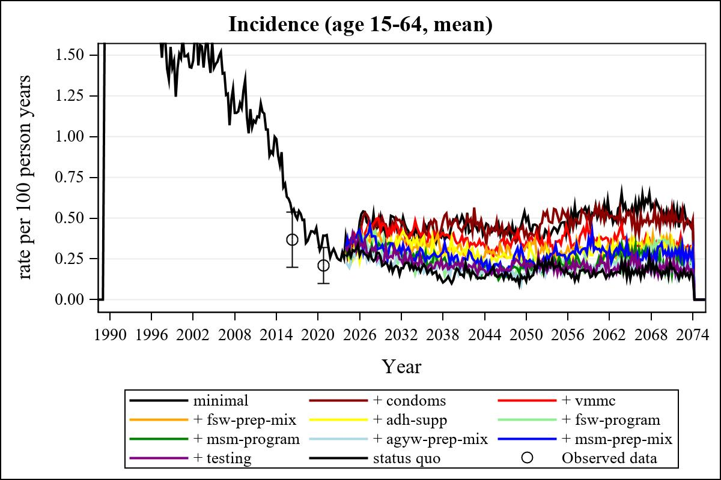

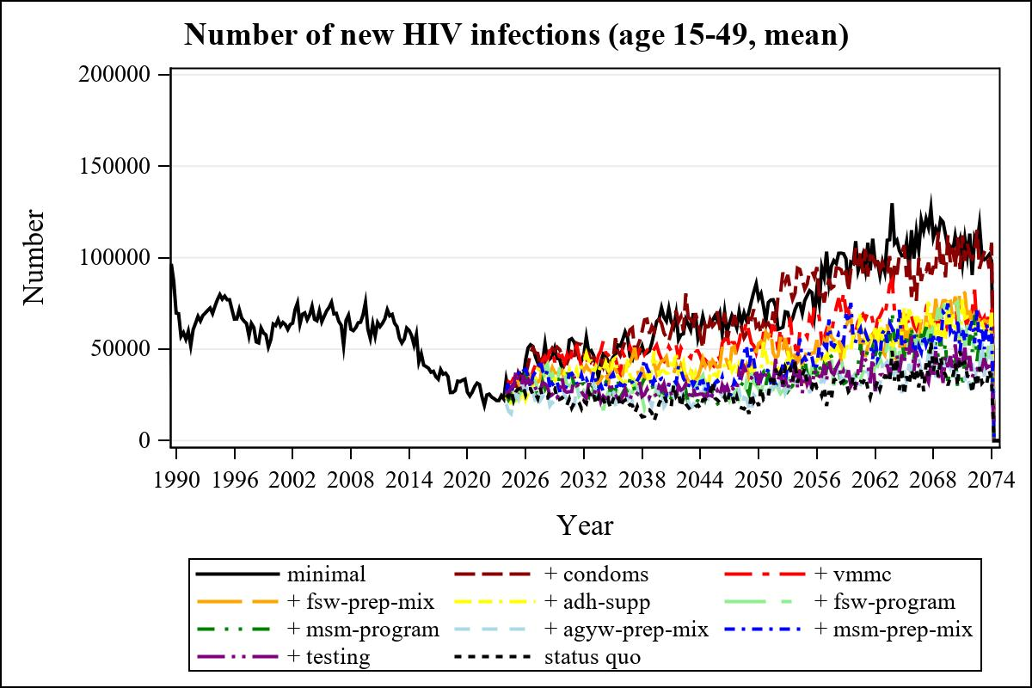

Obs | mean_n_new_inf1549__0 | mean_n_new_inf1549__1 | mean_n_new_inf1549__2 | mean_n_new_inf1549__3
225 | 72550.19 | 63979.38 | 44383.50 | 43442.73

Obs | mean_n_new_inf1549__4 | mean_n_new_inf1549__5 | mean_n_new_inf1549__6 | mean_n_new_inf1549__7
225 | 38106.91 | 26188.14 | 28954.72 | 26804.84

Obs | mean_n_new_inf1549__8 | mean_n_new_inf1549__9 | mean_n_new_inf1549__99
225 | 33884.21 | 27584.27 | 23042.98

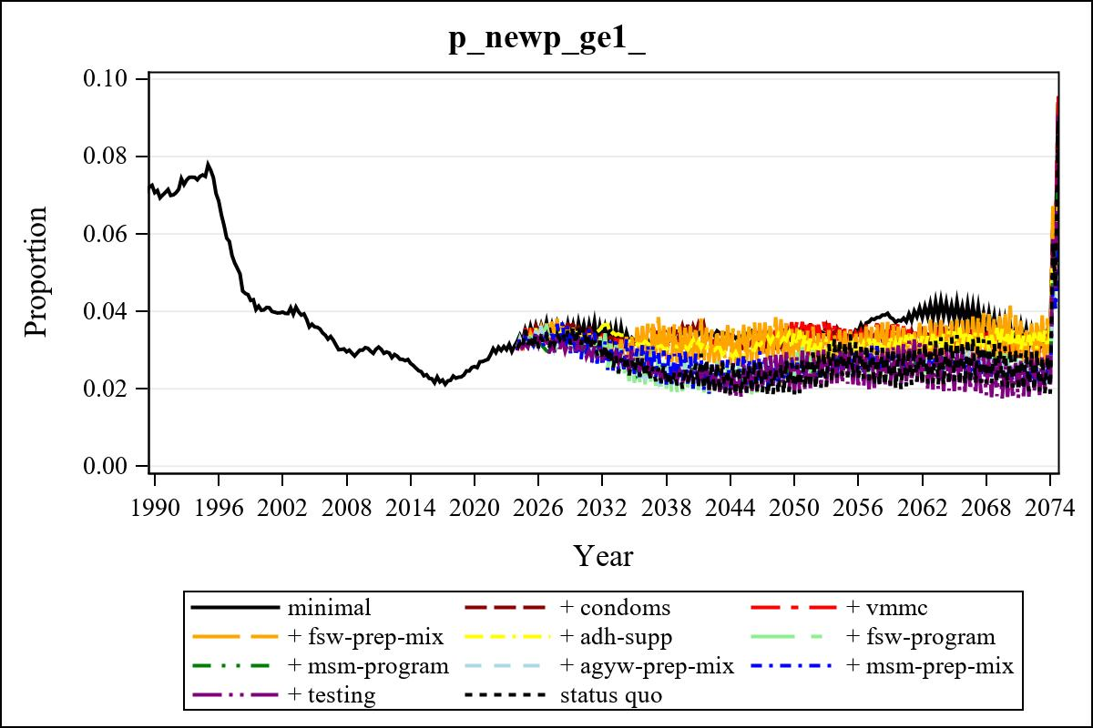

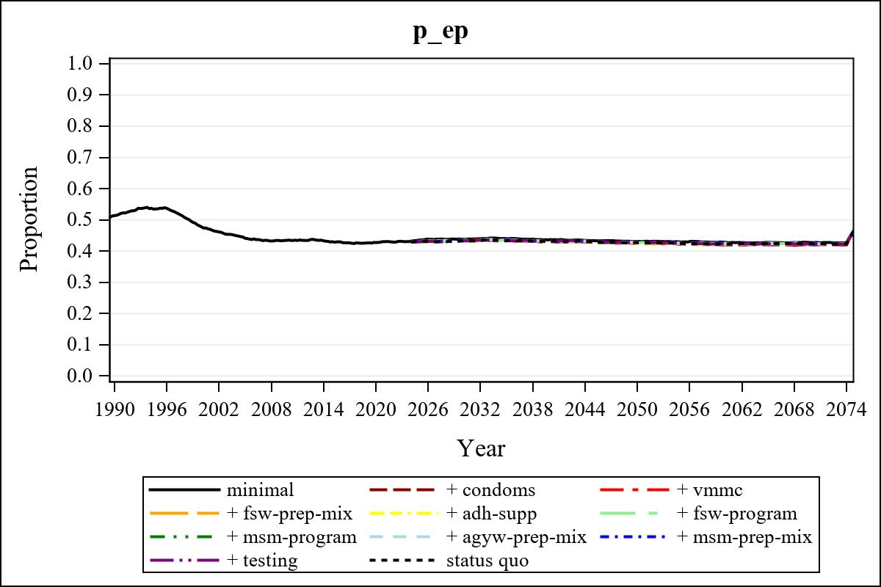

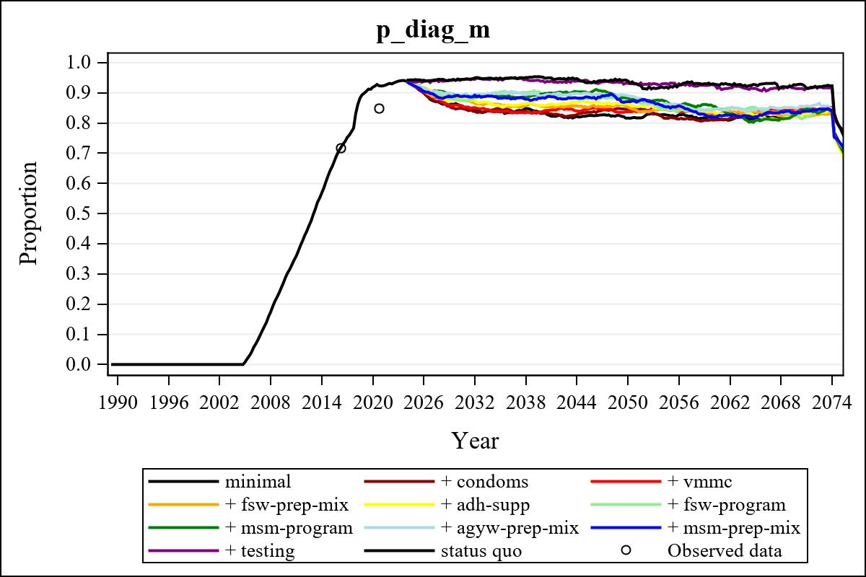

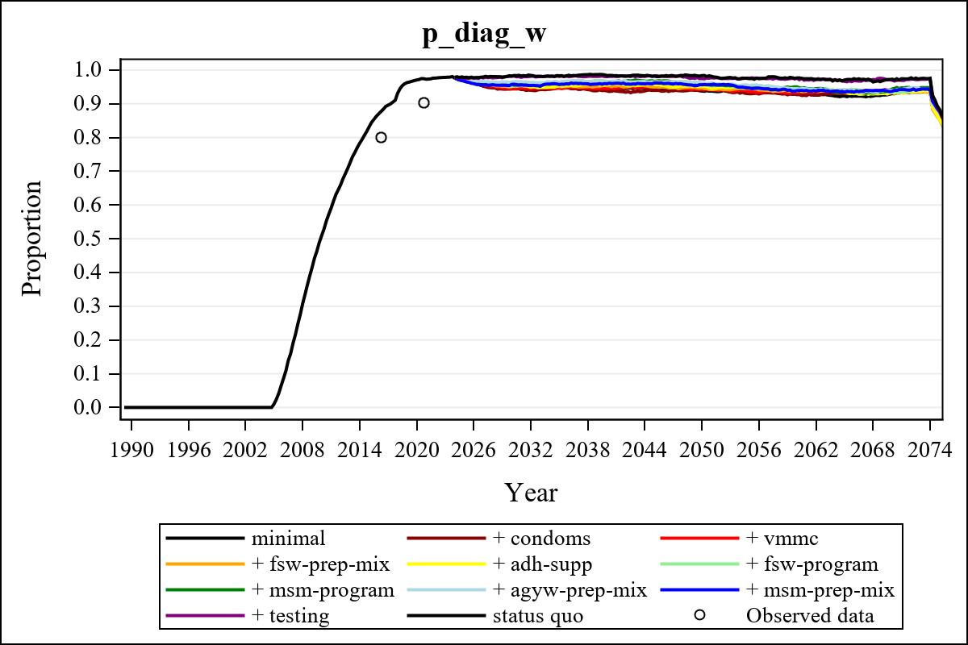

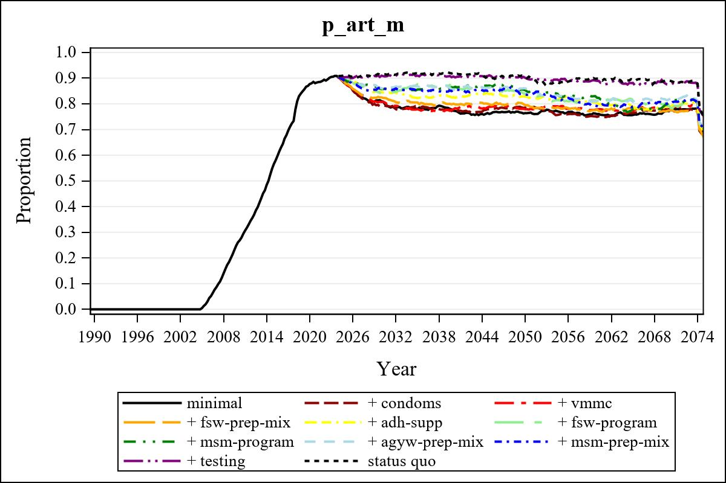

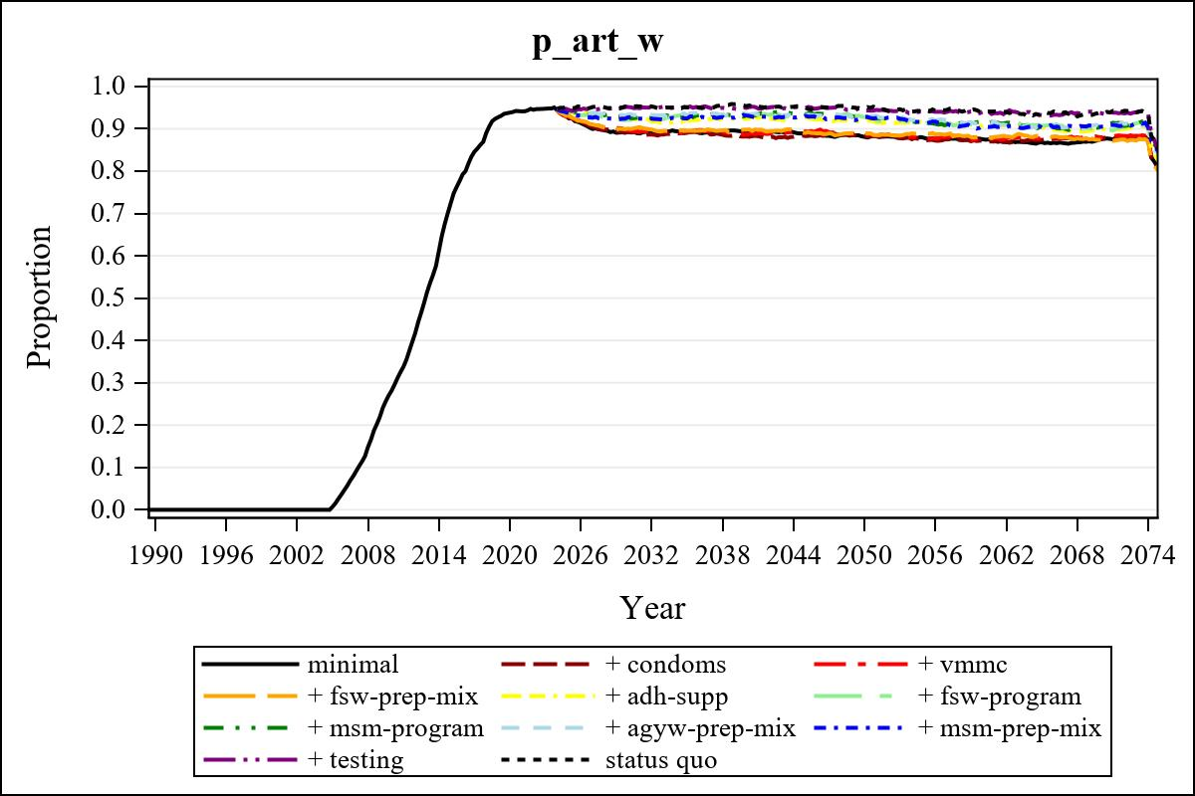

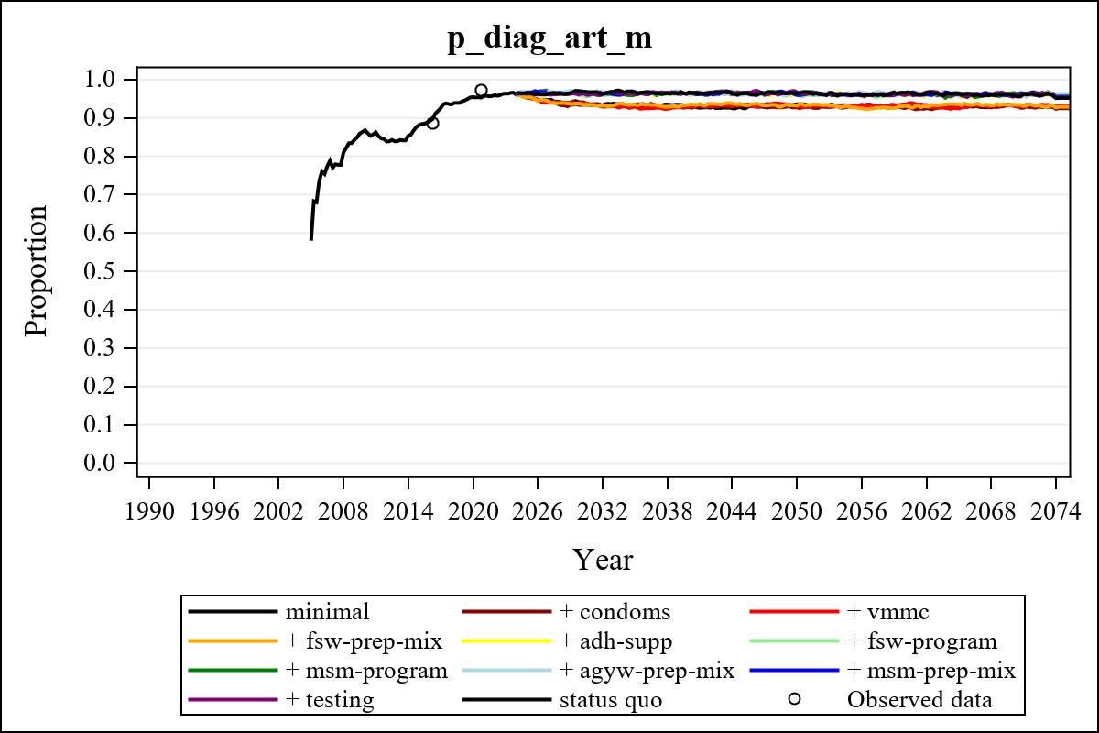

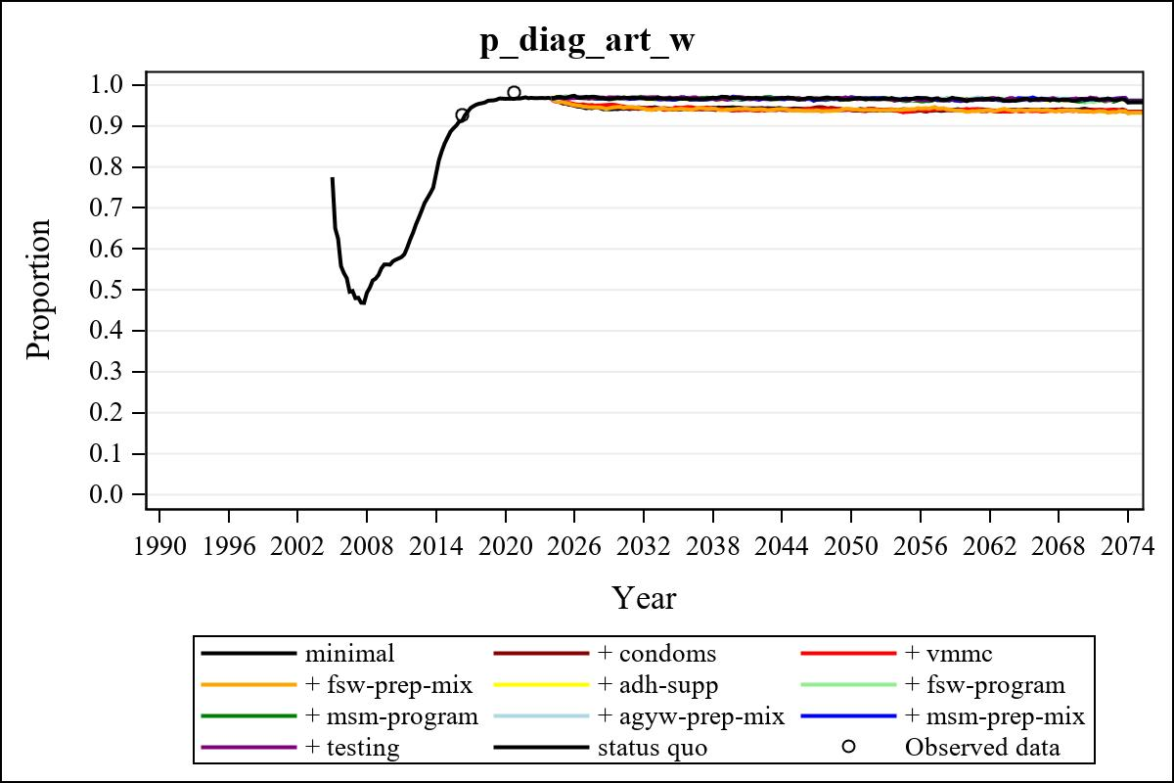

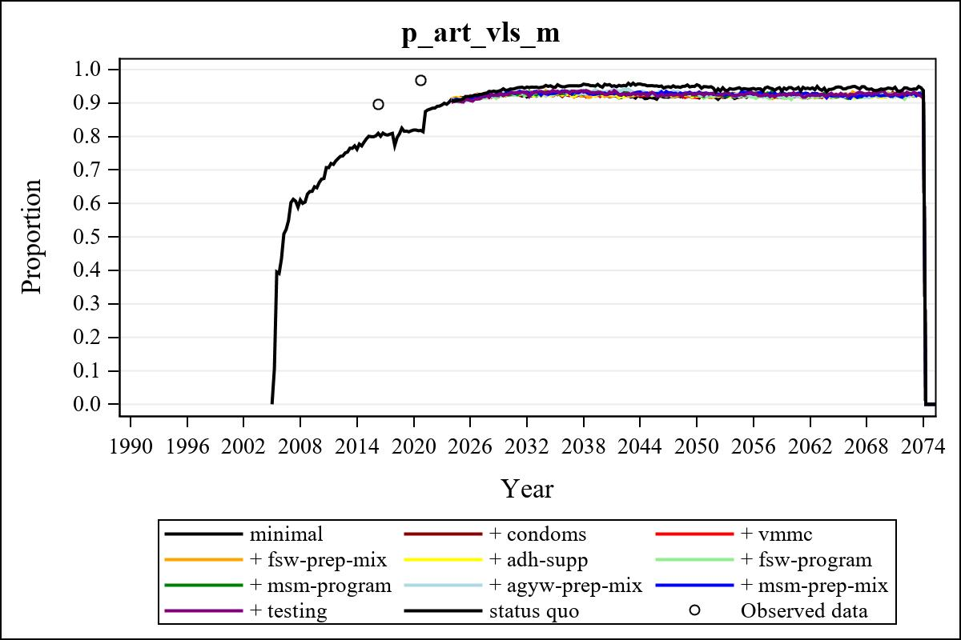

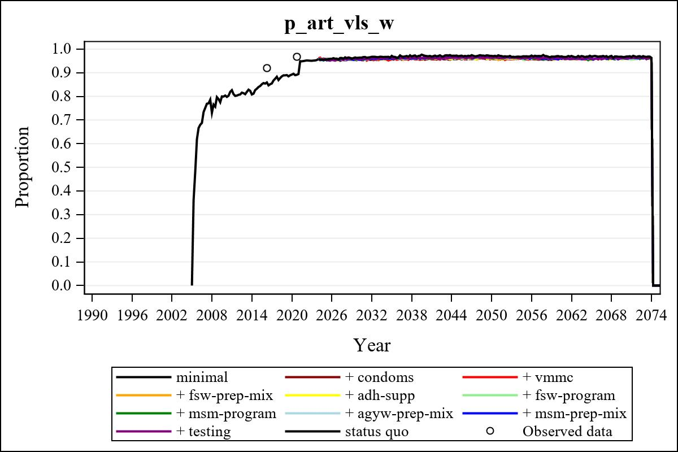

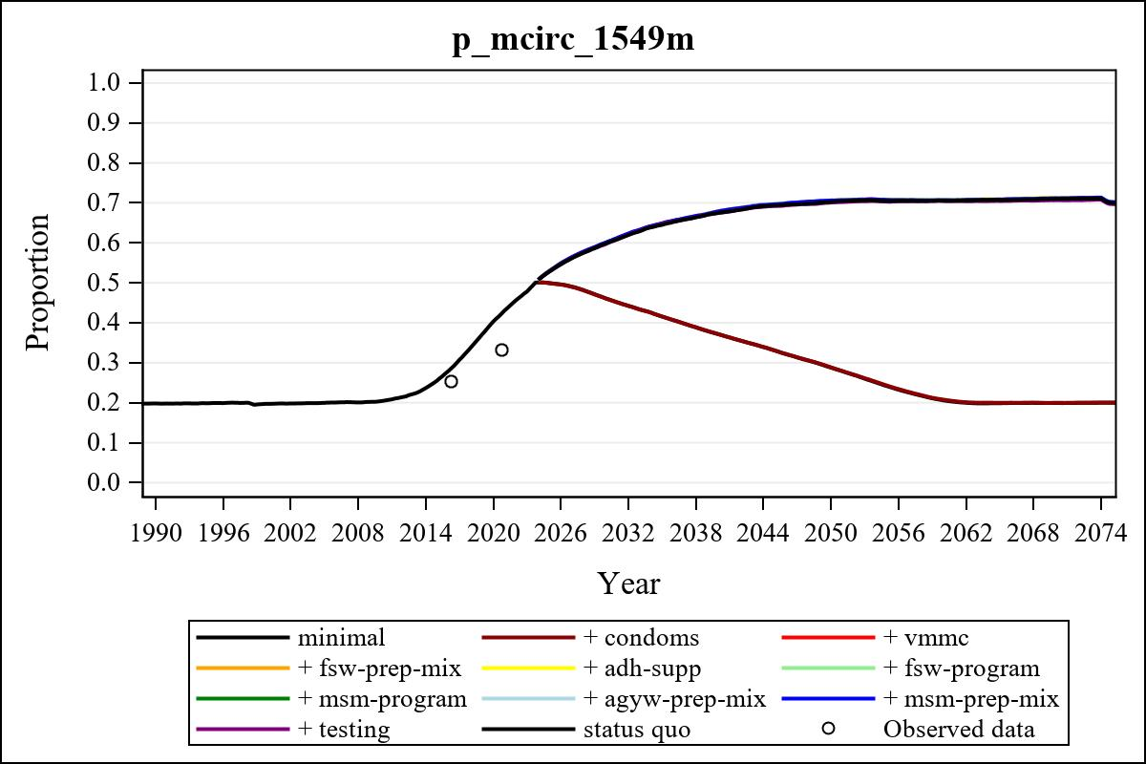

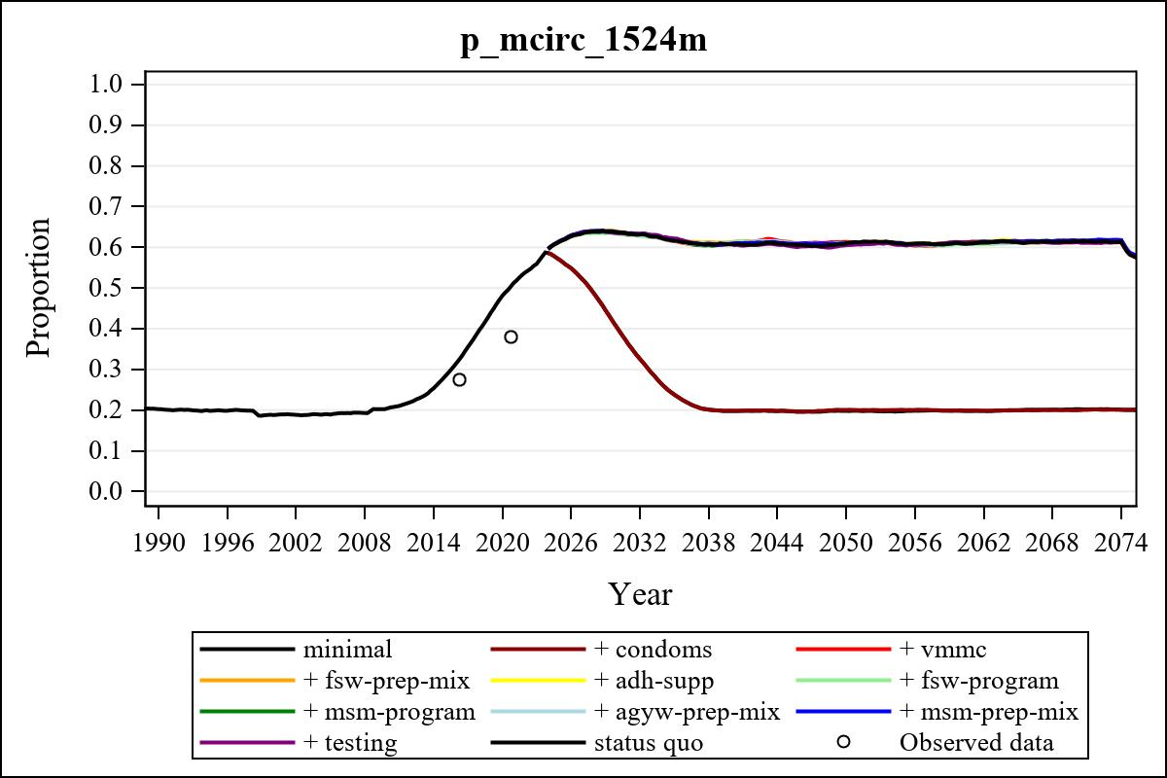

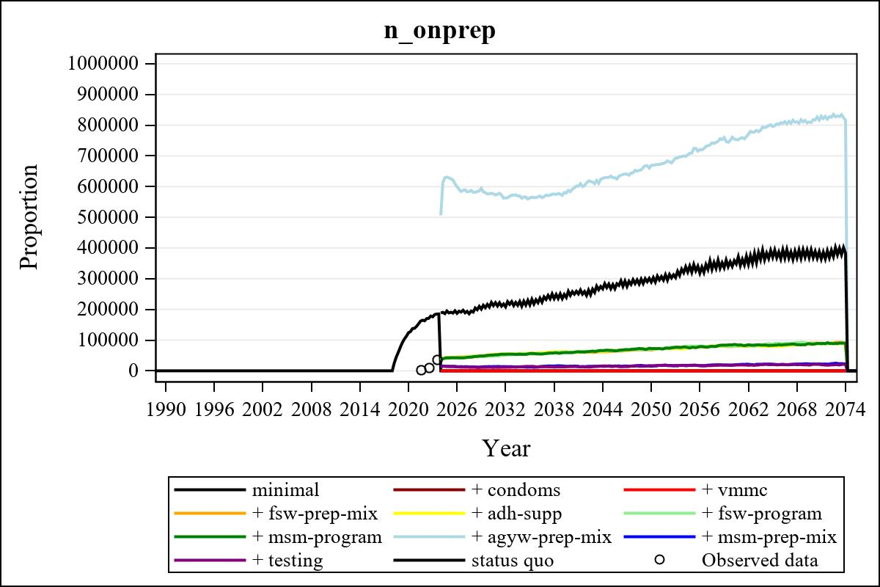

Obs | mean_n_onprep_0 | mean_n_onprep_1 | mean_n_onprep_2 | mean_n_onprep_3
345 | 0 | 0 | 0 | 90218.52

Obs | mean_n_onprep_4 | mean_n_onprep_5 | mean_n_onprep_6 | mean_n_onprep_99
345 | 87779.70 | 89796.13 | 86452.08 | 368896.91

Obs | mean_n_sw_1564__1 | mean_n_undiag_sw_1 | mean_n_elig_prep_1 | mean_n_elig_prep_any_sw_1
185 | 125347.00 | 83657.23 | 0 | 0

Obs | mean_n_onprep_sw_1 | mean_n_onprep_w_1 | mean_n_sw_1564__2 | mean_n_undiag_sw_2
185 | 0 | 0 | 123979.94 | 84275.38

Obs | mean_n_elig_prep_2 | mean_n_elig_prep_any_sw_2 | mean_n_onprep_sw_2 | mean_n_onprep_w_2
185 | 0 | 0 | 0 | 0

Obs | mean_n_onprep_oral_sw_2 | mean_n_onprep_len_sw_2 | mean_n_agyw_pg_3 | mean_n_elig_prep_3
185 | 0 | 0 | 1484835.71 | 94075.35

Obs | mean_n_onprep_agyw_pg_3 | mean_n_onprep_w_3 | mean_n_agyw_pg_4 | mean_n_elig_prep_4
185 | 27265.21 | 48200.31 | 1487075.38 | 100899.23

Obs | mean_n_onprep_agyw_pg_4 | mean_n_onprep_w_4 | mean_n_onprep_oral_agyw_pg_4
185 | 29339.30 | 52451.12 | 11508.26

Obs | mean_n_onprep_len_agyw_pg_4 | mean_n_alive_msm_5 | mean_n_elig_prep_5 | mean_n_onprep_msm_5
185 | 17831.04 | 72530.24 | 98489.09 | 0

Obs | mean_n_onprep_m_5 | mean_n_alive_msm_6 | mean_n_elig_prep_6 | mean_n_onprep_msm_6
185 | 0 | 72875.86 | 98475.37 | 0

Obs | mean_n_onprep_m_6 | mean_n_onprep_oral_msm_6 | mean_n_onprep_len_msm_6 | mean_pc_elig_onprep_1
185 | 0 | 0 | 0 | .

Obs | mean_pc_elig_onprep_2 | mean_pc_elig_onprep_3 | mean_pc_elig_onprep_4 | mean_pc_elig_onprep_5
185 | . | 0.50889 | 0.51645 | 0.47115

Obs | mean_pc_elig_onprep_6
185 | 0.50597

Obs | mean_n_sw_1564__1 | mean_n_undiag_sw_1 | mean_n_elig_prep_1
185 | 125347.00 | 83657.23 | 0

Obs | mean_n_elig_prep_any_sw_1 | mean_n_onprep_sw_1 | mean_n_onprep_w_1
185 | 0 | 0 | 0

Obs | ratio_oral_len_2 | ratio_oral_len_4 | ratio_oral_len_6
1 | . | 0.56241 | 0.49635

