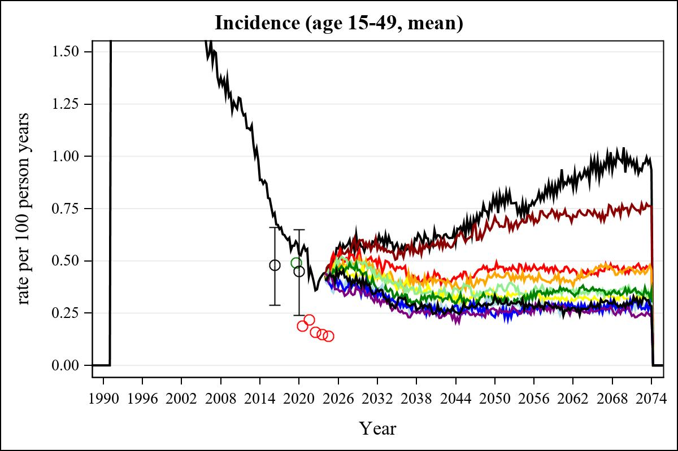

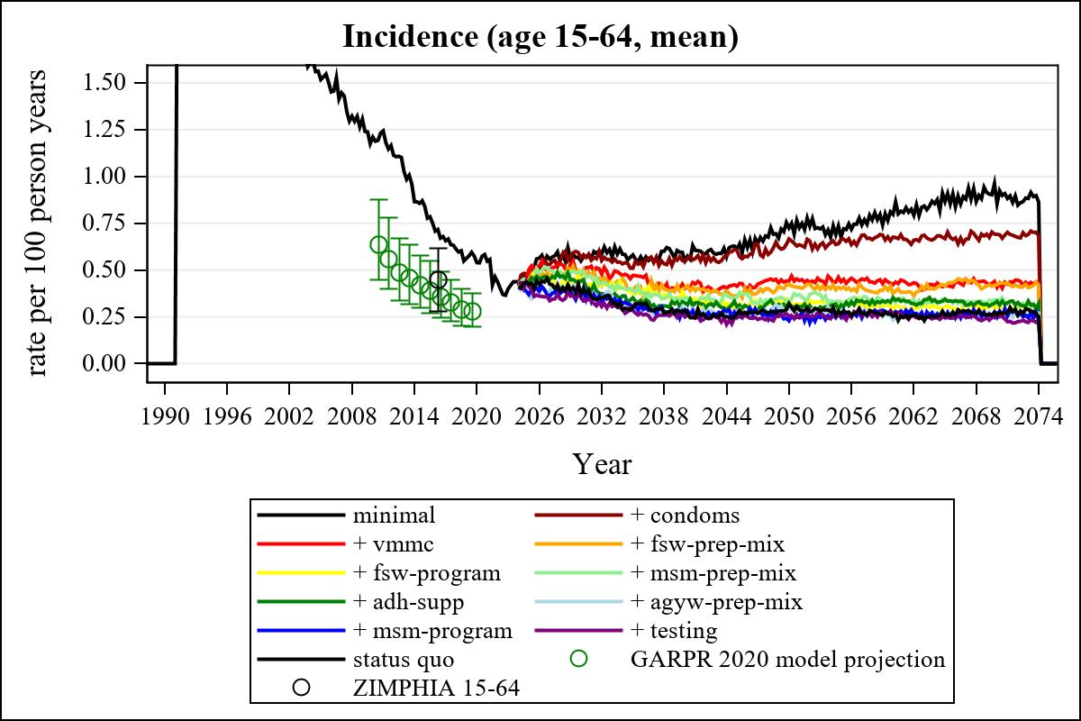

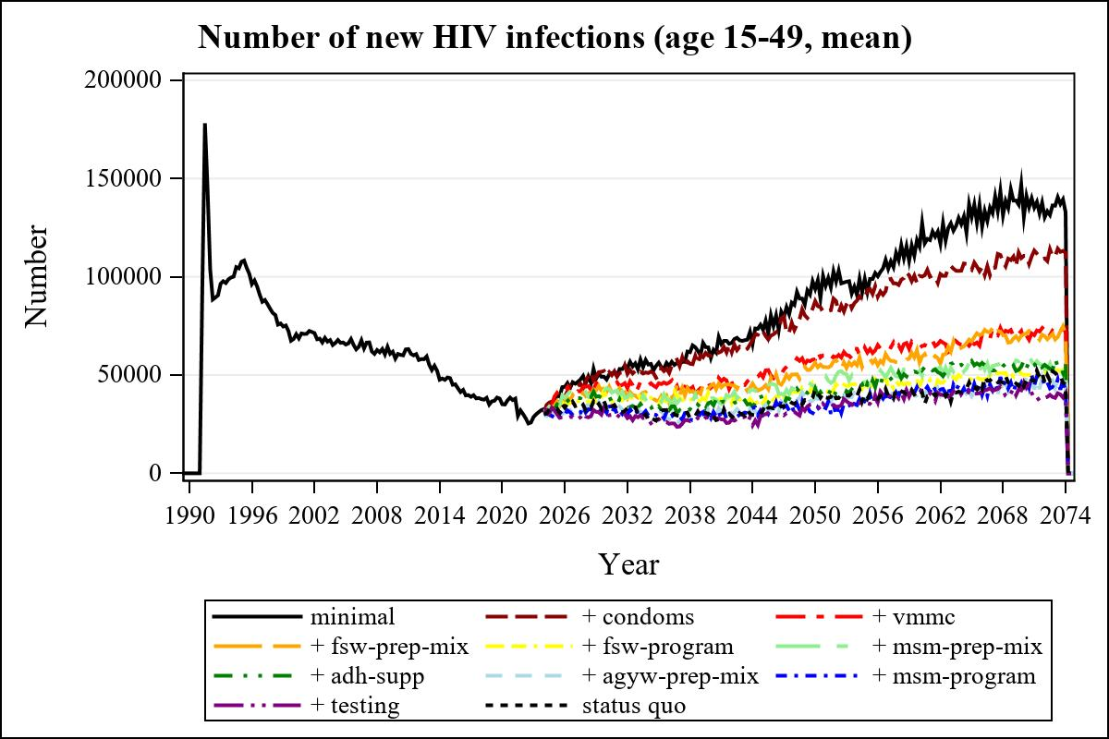

Obs | mean_n_new_inf1549__0 | mean_n_new_inf1549__1 | mean_n_new_inf1549__2 | mean_n_new_inf1549__3
225 | 58742.27 | 59878.89 | 43530.03 | 44612.75

Obs | mean_n_new_inf1549__4 | mean_n_new_inf1549__5 | mean_n_new_inf1549__6 | mean_n_new_inf1549__7
225 | 39578.90 | 38153.60 | 36235.92 | 30680.51

Obs | mean_n_new_inf1549__8 | mean_n_new_inf1549__9 | mean_n_new_inf1549__99
225 | 28070.52 | 26641.43 | 31687.64

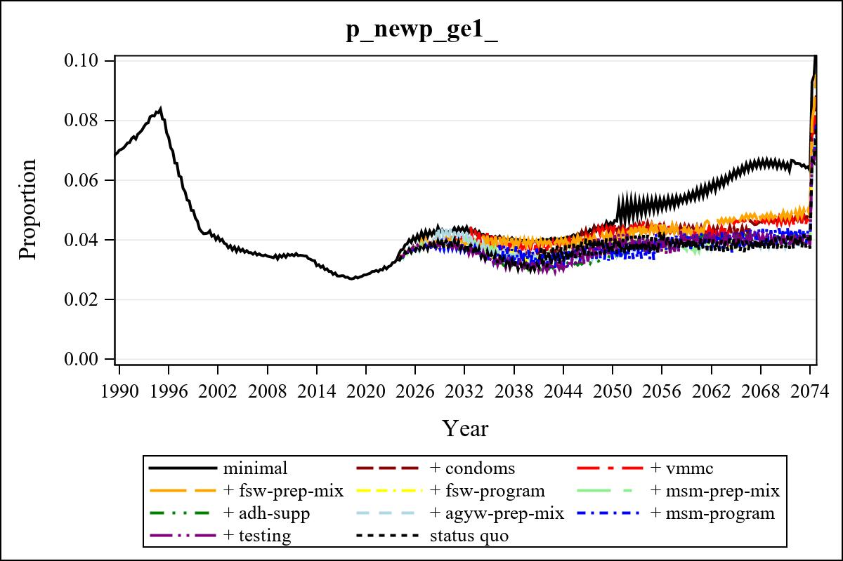

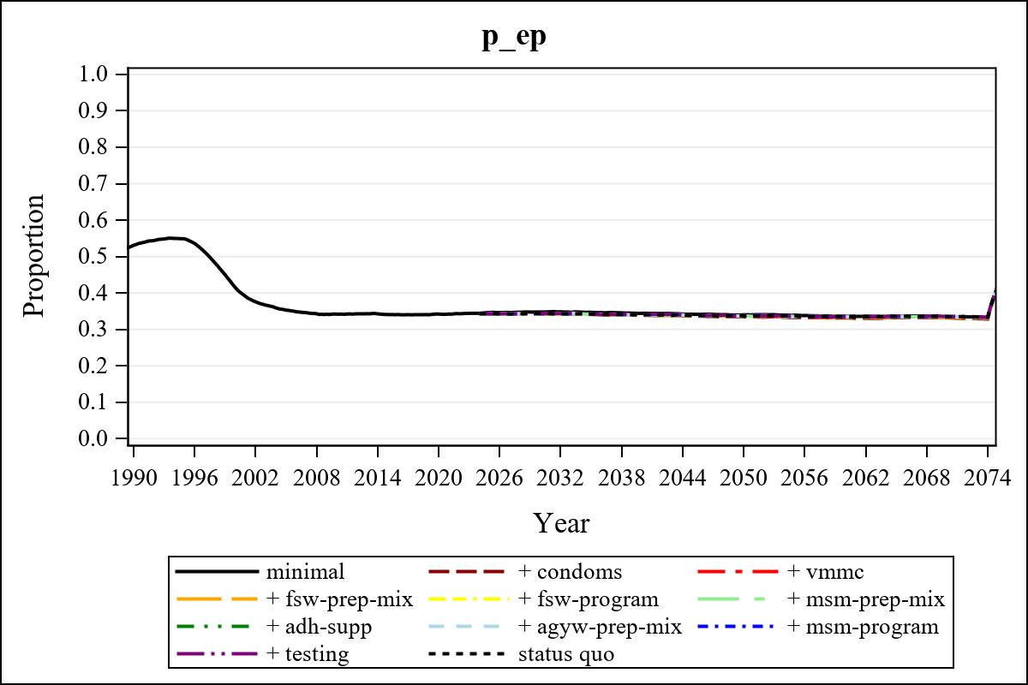

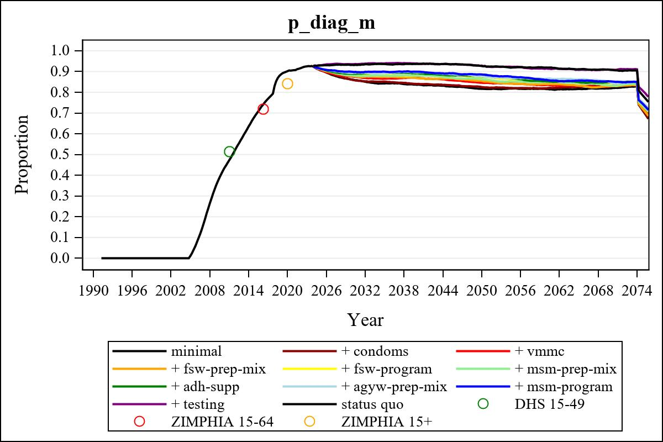

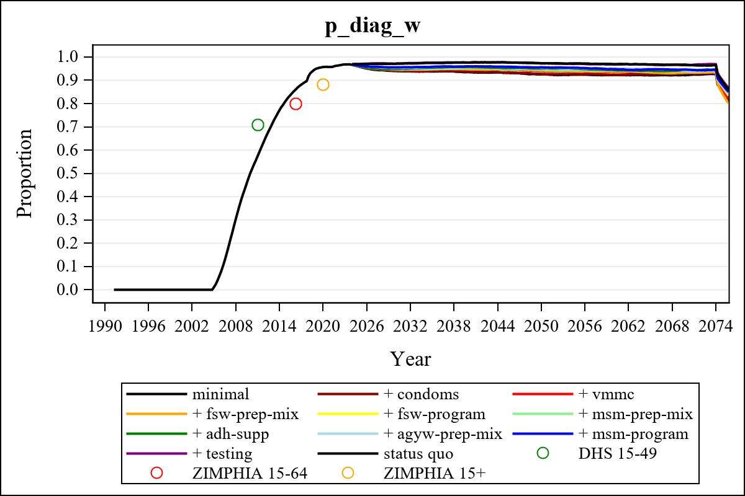

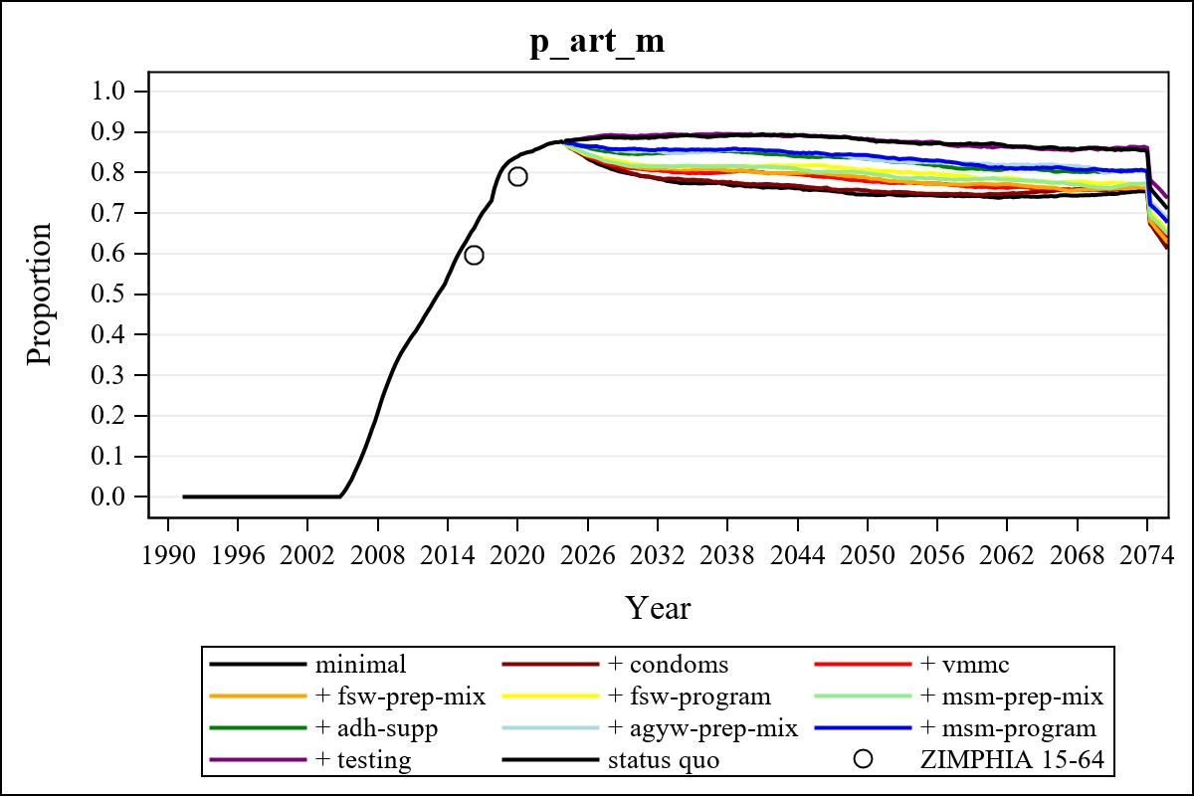

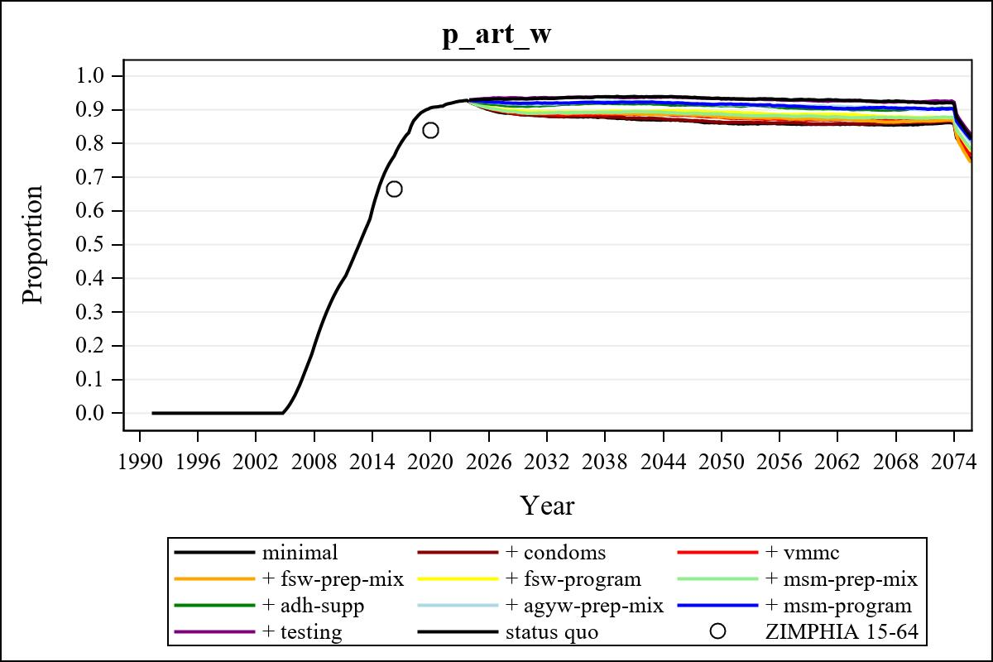

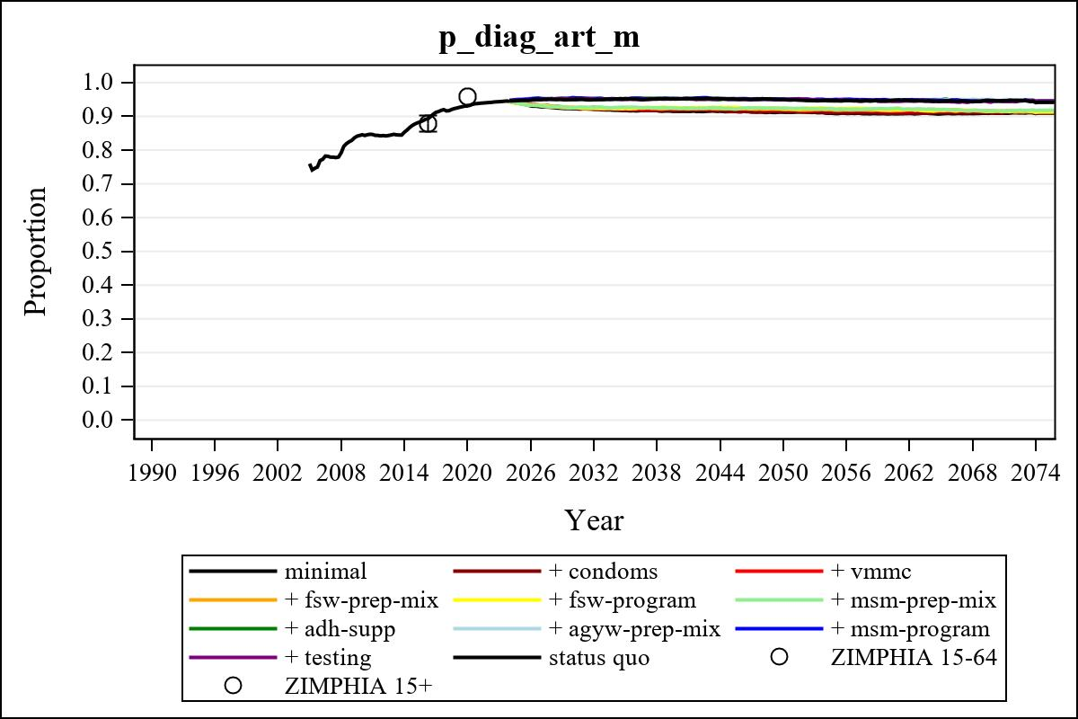

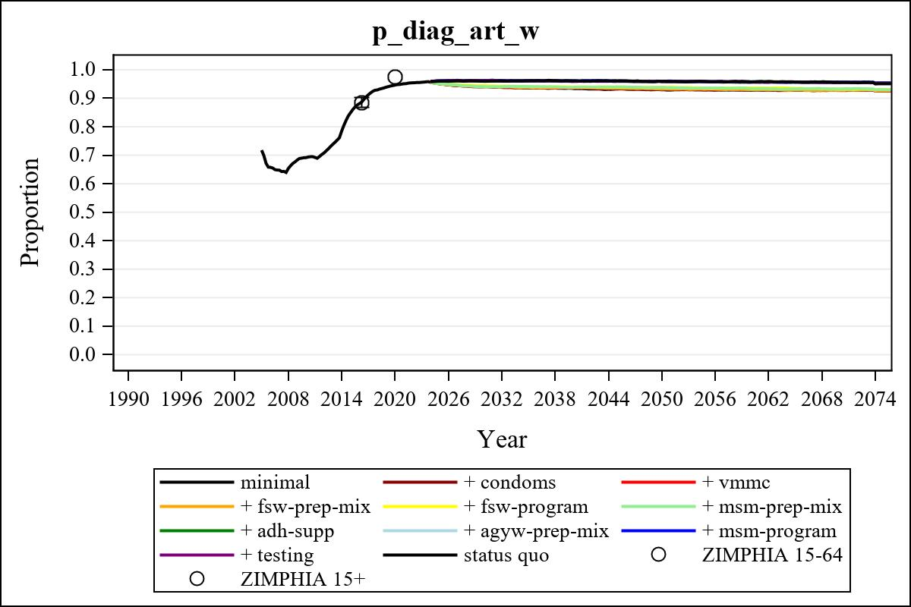

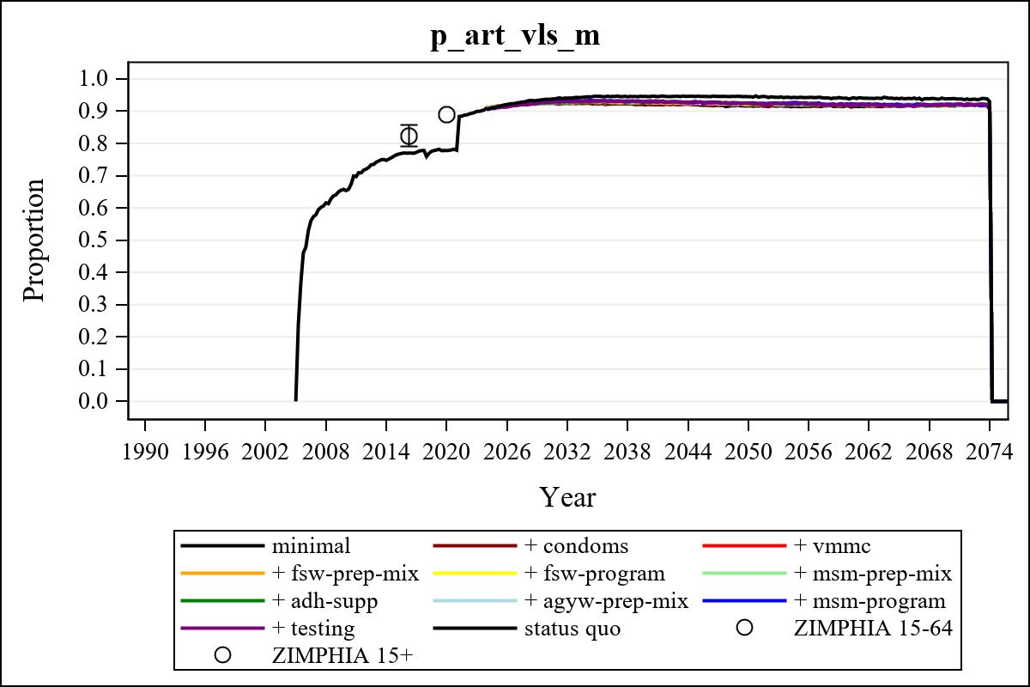

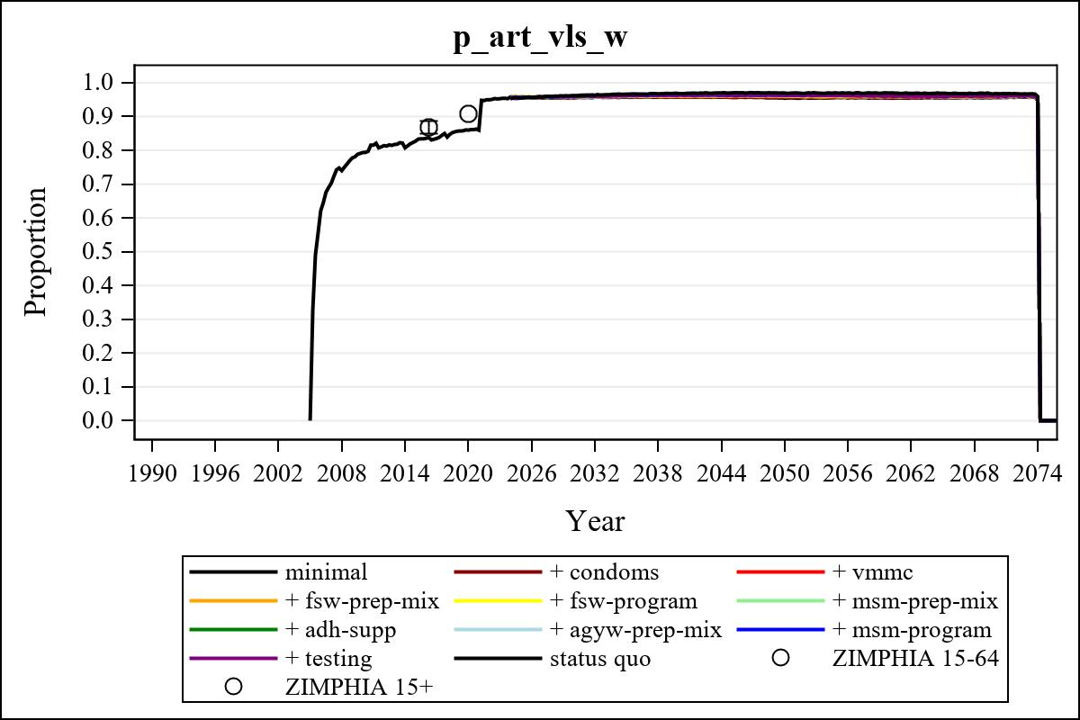

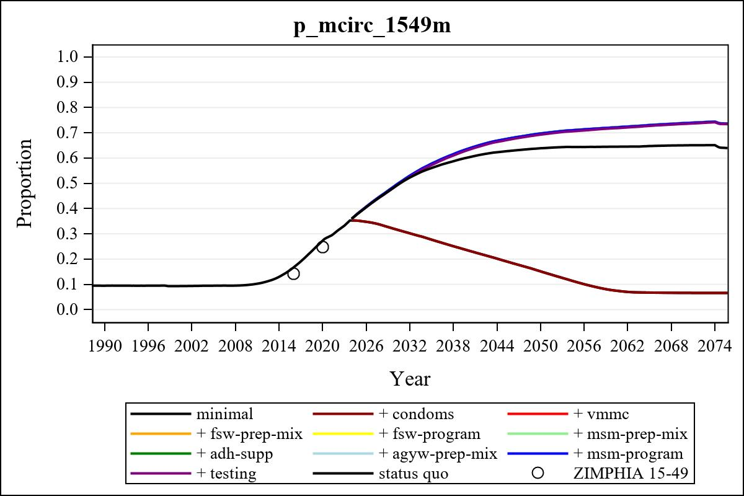

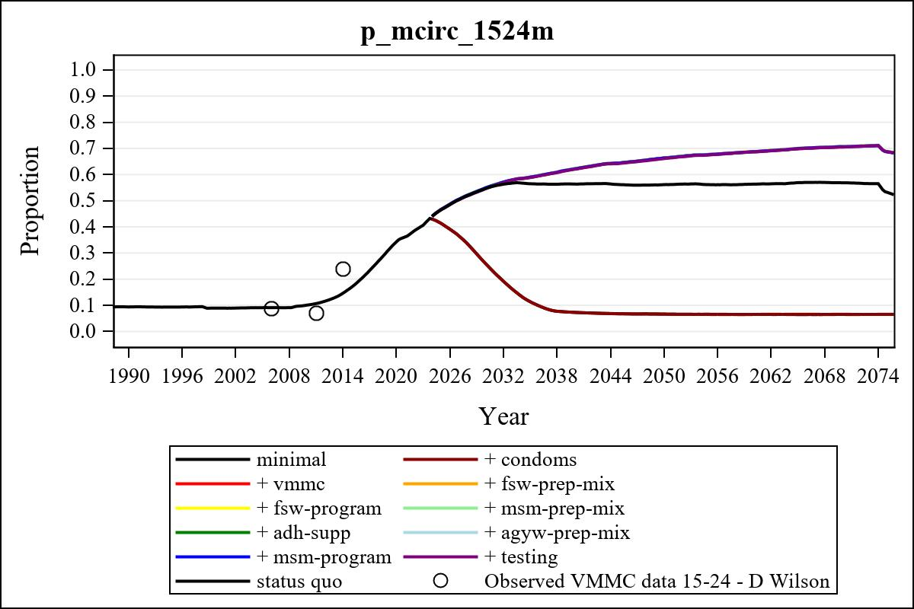

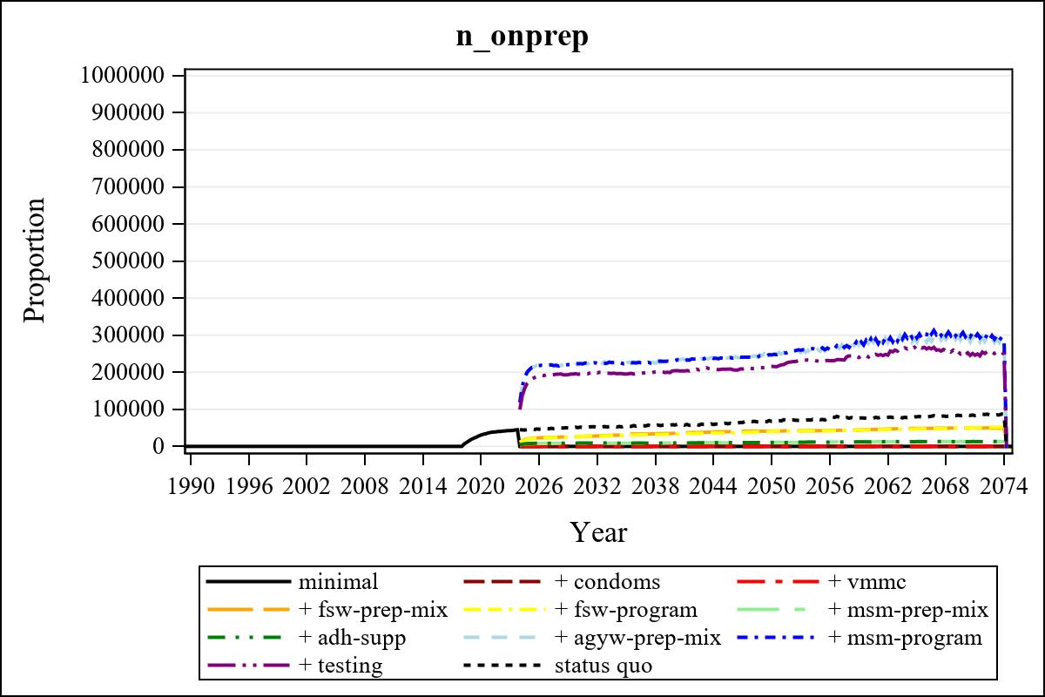

Obs | mean_n_onprep_0 | mean_n_onprep_1 | mean_n_onprep_2 | mean_n_onprep_3
345 | 0 | 0 | 0 | 49703.72

Obs | mean_n_onprep_4 | mean_n_onprep_5 | mean_n_onprep_6 | mean_n_onprep_99
345 | 49726.81 | 13008.17 | 12486.51 | 83201.26

Obs | mean_n_sw_1564__1 | mean_n_undiag_sw_1 | mean_n_elig_prep_1 | mean_n_elig_prep_any_sw_1
185 | 116471.30 | 68753.58 | 0 | 0

Obs | mean_n_onprep_sw_1 | mean_n_onprep_w_1 | mean_n_sw_1564__2 | mean_n_undiag_sw_2
185 | 0 | 0 | 114504.08 | 67934.50

Obs | mean_n_elig_prep_2 | mean_n_elig_prep_any_sw_2 | mean_n_onprep_sw_2 | mean_n_onprep_w_2
185 | 0 | 0 | 0 | 0

Obs | mean_n_onprep_oral_sw_2 | mean_n_onprep_len_sw_2 | mean_n_agyw_pg_3 | mean_n_elig_prep_3
185 | 0 | 0 | 865005.36 | 74537.96

Obs | mean_n_onprep_agyw_pg_3 | mean_n_onprep_w_3 | mean_n_agyw_pg_4 | mean_n_elig_prep_4
185 | 9816.90 | 26292.99 | 865830.70 | 75431.83

Obs | mean_n_onprep_agyw_pg_4 | mean_n_onprep_w_4 | mean_n_onprep_oral_agyw_pg_4
185 | 9560.28 | 26658.42 | 1898.06

Obs | mean_n_onprep_len_agyw_pg_4 | mean_n_alive_msm_5 | mean_n_elig_prep_5 | mean_n_onprep_msm_5
185 | 7662.22 | 64518.59 | 24058.49 | 8509.30

Obs | mean_n_onprep_m_5 | mean_n_alive_msm_6 | mean_n_elig_prep_6 | mean_n_onprep_msm_6
185 | 8509.30 | 64140.48 | 23709.10 | 8903.29

Obs | mean_n_onprep_m_6 | mean_n_onprep_oral_msm_6 | mean_n_onprep_len_msm_6 | mean_pc_elig_onprep_1
185 | 8903.29 | 1786.60 | 7116.69 | .

Obs | mean_pc_elig_onprep_2 | mean_pc_elig_onprep_3 | mean_pc_elig_onprep_4 | mean_pc_elig_onprep_5
185 | . | 0.36409 | 0.36073 | 0.34212

Obs | mean_pc_elig_onprep_6
185 | 0.37104

Obs | mean_n_sw_1564__1 | mean_n_undiag_sw_1 | mean_n_elig_prep_1
185 | 116471.30 | 68753.58 | 0

Obs | mean_n_elig_prep_any_sw_1 | mean_n_onprep_sw_1 | mean_n_onprep_w_1
185 | 0 | 0 | 0

Obs | ratio_oral_len_2 | ratio_oral_len_4 | ratio_oral_len_6
1 | . | 0.18660 | 0.20474

