SEARCH Hypertension Modelling with HIV Synthesis

Matt Hickey

23 August, 2023

# Comparison of model output in 2015 to data from the literature

Based on 3000 model runs

## Definitions

SOC = Standard of Care (Synthesis model output)  
GBD = Global Burden of Disease data

## Data Sources

Hypertension prevalence, diagnosis, treatment, and control using STEPS survey data from 15 countries in sub-Saharan Africa (2005-2015; Geldsetzer Lancet 2019)

Systolic blood pressure for men and women based on 2015 Global Burden of Disease survey data as published in Forouzanfar MH, Liu P, Roth GA, et al. Global Burden of Hypertension and Systolic Blood Pressure of at Least 110 to 115 mm Hg, 1990-2015. JAMA. 2017;317(2):165-182. <doi:10.1001/jama.2016.19043>

## SBP Increase with Age

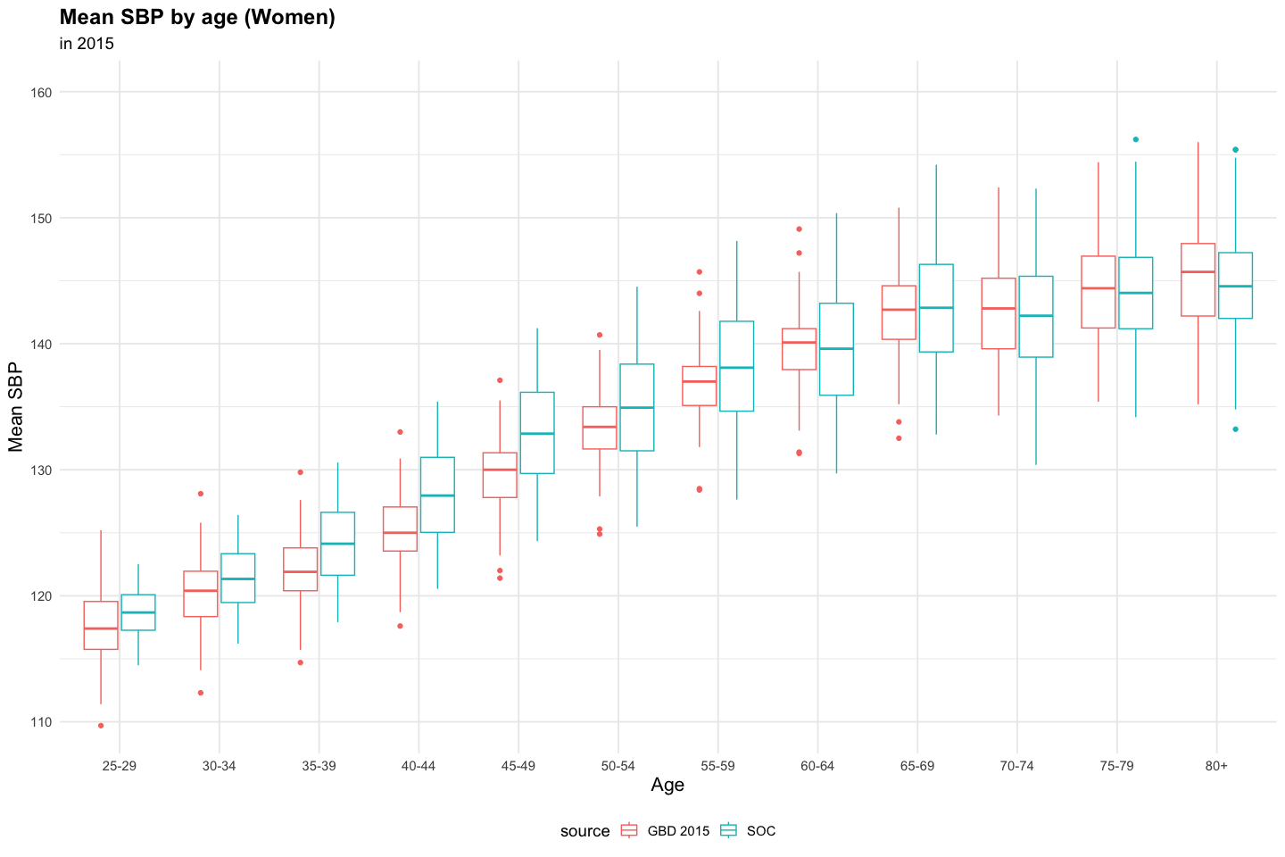

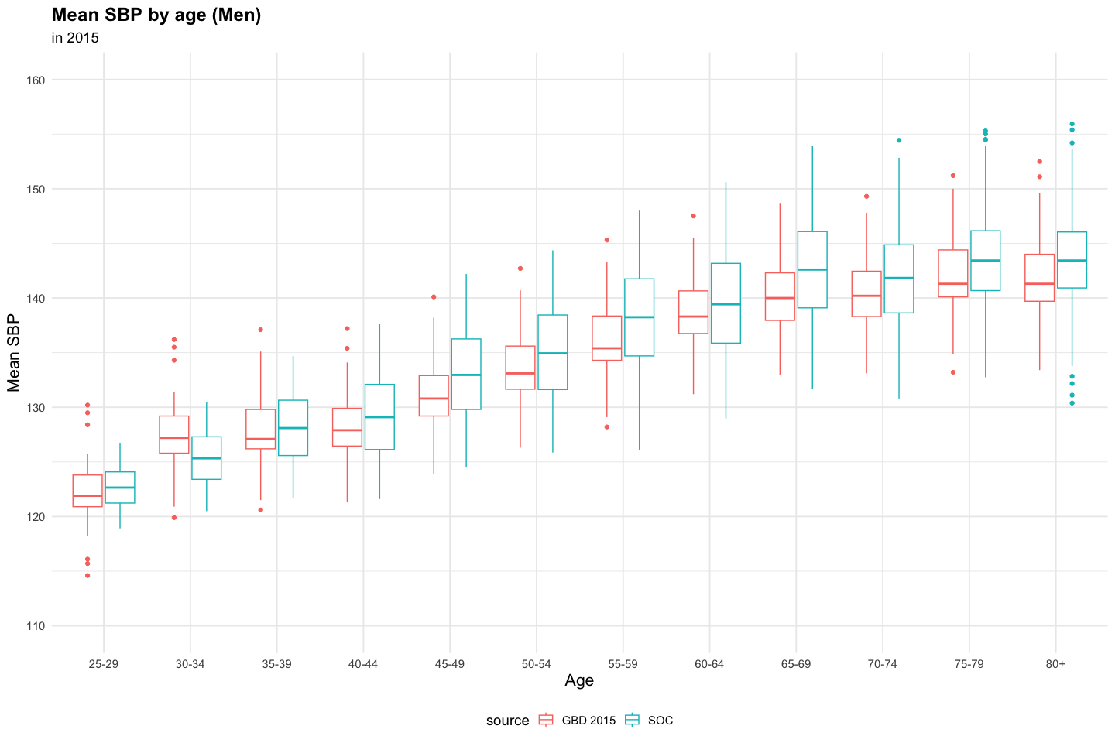

## Hypertension Prevalence

Hypertension defined as true SBP >=140 mmHg, regardless of whether measured.

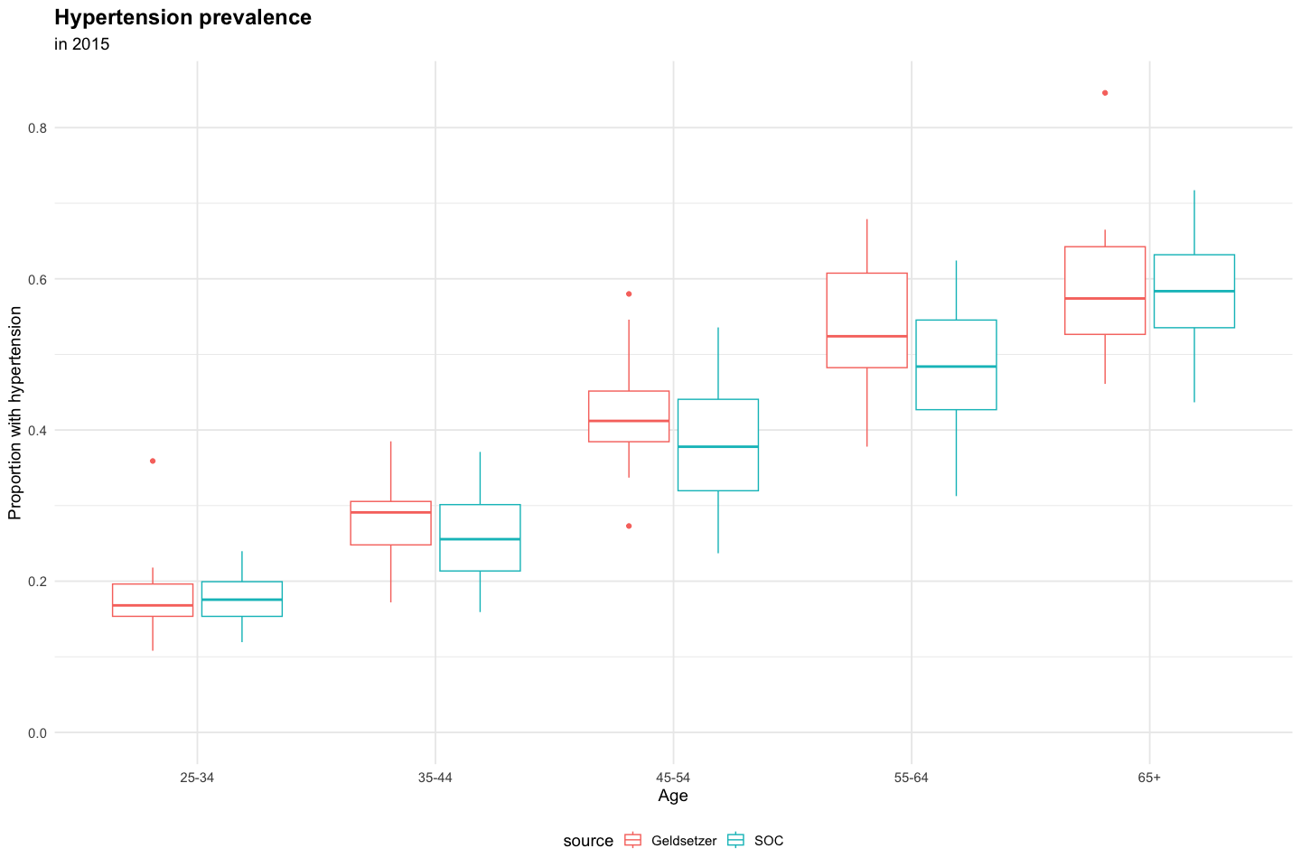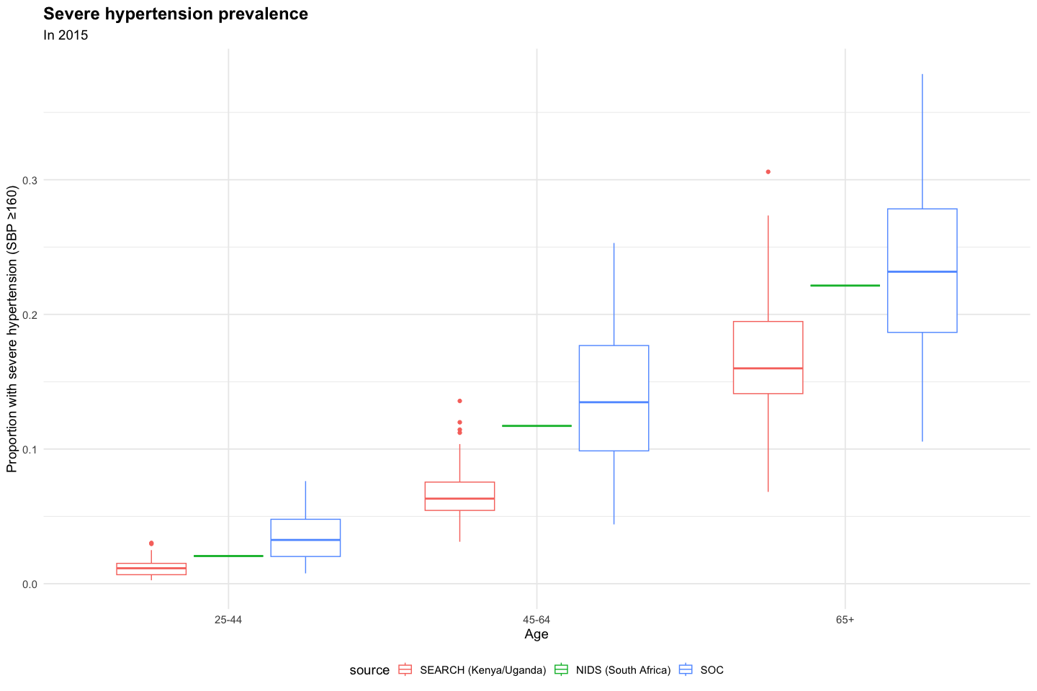

## Hypertension Diagnosis

* Measured SBP value if measured: true SBP + random error with SD 10 mmHg
* Hypertension diagnosis made if any of the following:
  1. measured SBP >=140 mmHg on two consecutive clinic visits
  2. measured SBP >=160 mmHg once
  3. started on antihypertensive medication (see Hypertension Treatment section below)

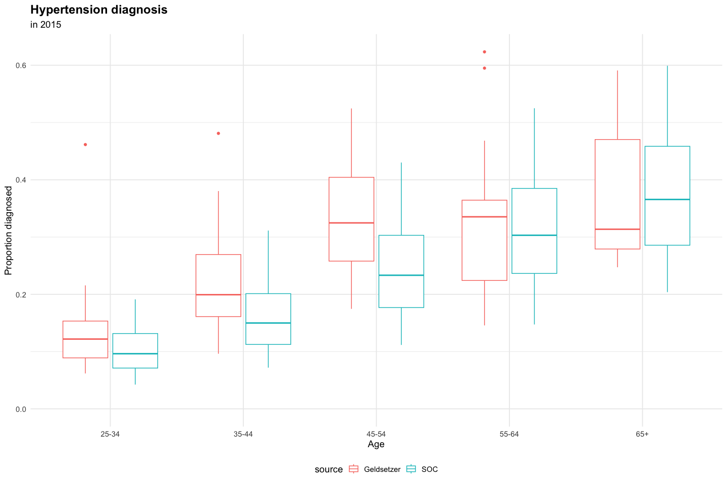

## Hypertension Treatment

Defined as currently taking antihypertensive medications. 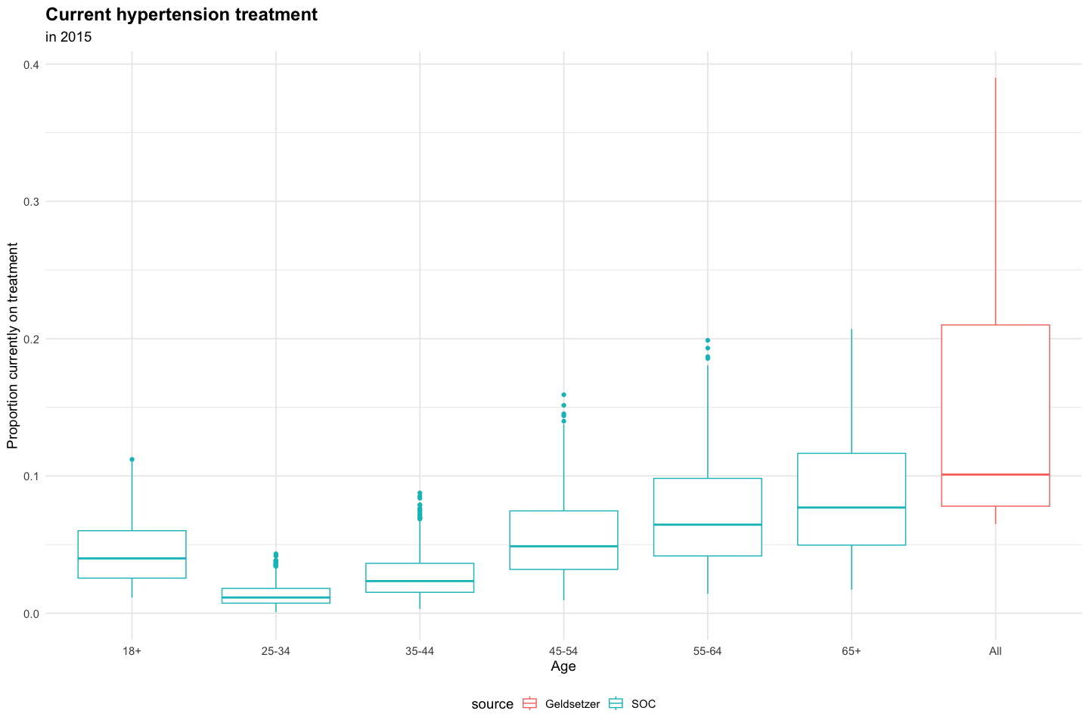

**Note:** The model considers treatment to be on medications and adherent to those medications. Real-world data is based on self-report of treatment and may include some who report taking medications but are non-adherent.

Geldsetzer Lancet 2019 includes country-specific data on 13 countries in SSA with data on medication treatment and reports an overall prevalence of pharmacologic hypertension treatment of 13.0% (95% CI 12.0-14.2%) when weighting countries by population size.

country

tx

tx_95ci

Tanzania

6%

(4.9-8.4)

Mozambique

7%

(4.4-9.6)

Uganda

8%

(5.8-9.5)

Kenya

8%

(5.8-10.1)

Togo

8%

(5.7-11.1)

BurkinaFaso

9%

(6.9-11.9)

Ghana

10%

(7.3-13.4)

Benin

15%

(12.6-17.6)

Liberia

16%

(12.6-19.4)

Swaziland

21%

(17.5-24.8)

SouthAfrica

28%

(24.4-30.7)

Lesotho

37%

(33.6-40.9)

Namibia

39%

(35.9-42.1)

Proportion on treatment in SSA from other literature:

* 18% (2005; Ataklte Hypertens 2015)
* 8% (2015; Kenya STEPS)

Defined as ever taking antihypertensive medications. 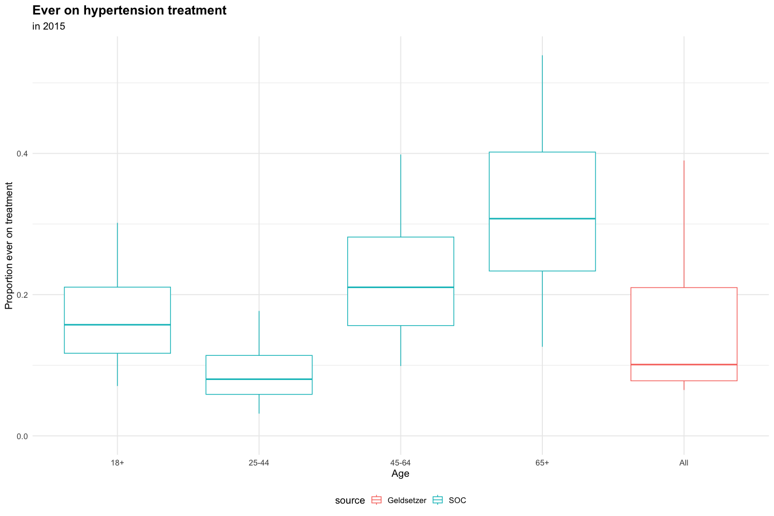

## Hypertension Control

* Control defined as current true SBP <140 among persons with maximum SBP >=140 (pre-treatment)

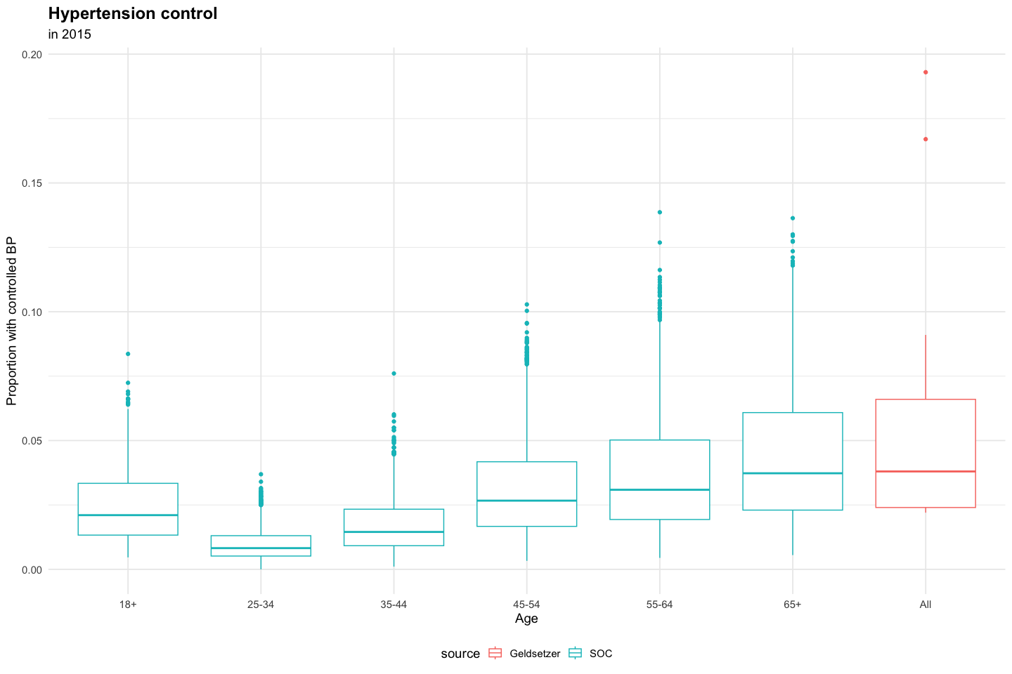

Geldsetzer Lancet 2019 includes country-specific data on 13 countries in SSA with data on hypertension control and reports an overall prevalence of hypertension control (<140/90 mmHg) of 4.3% (95% CI 3.6- 4.9%).

country

control

control_95ci

Ghana

2%

(1.2-3.5)

Tanzania

2%

(1.4-3.1)

Uganda

2%

(1.5-3.4)

Mozambique

2%

(1.4-3.7)

Kenya

3%

(1.3-5.0)

Togo

3%

(1.9-5.4)

BurkinaFaso

4%

(2.2-5.8)

Benin

4%

(2.7-5.9)

Liberia

4%

(2.7-6.0)

Swaziland

7%

(4.1-9.7)

SouthAfrica

9%

(6.9-11.5)

Namibia

17%

(14.4-19.1)

Lesotho

19%

(16.4-22.3)

Proportion with controlled hypertension in SSA from other literature:

* 7% (Ataklte Hypertens 2015)
* 3% (Kenya STEPS)

## CVD Events

**Data source:** Global Burden of Disease Collaborative Network. Global Burden of Disease Study 2019 (GBD 2019) Results. Seattle, United States: Institute for Health Metrics and Evaluation (IHME), 2020. Available from <https://vizhub.healthdata.org/gbd-results/>.

### Incidence of Ischemic Heart Disease (moderate/severe events only)

Incidence of ischemic heart disease (angina and myocardial infarction(MI)) based on Global Burden of Disease data, assuming that angina/silent MI are under-ascertained, thus we compare incidence only of moderate/severe MI to available incidence data.

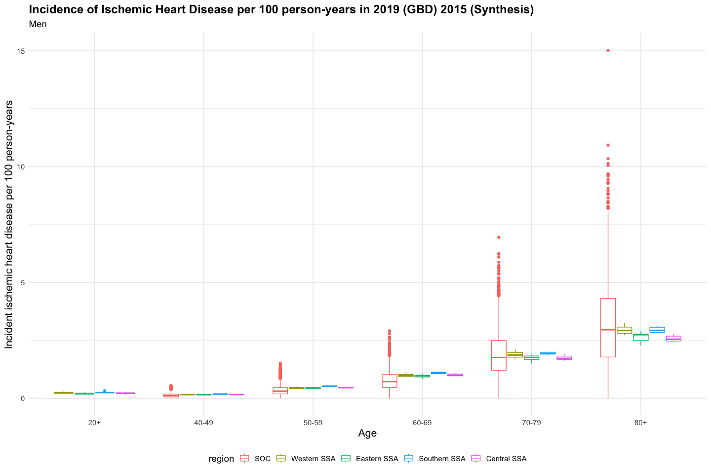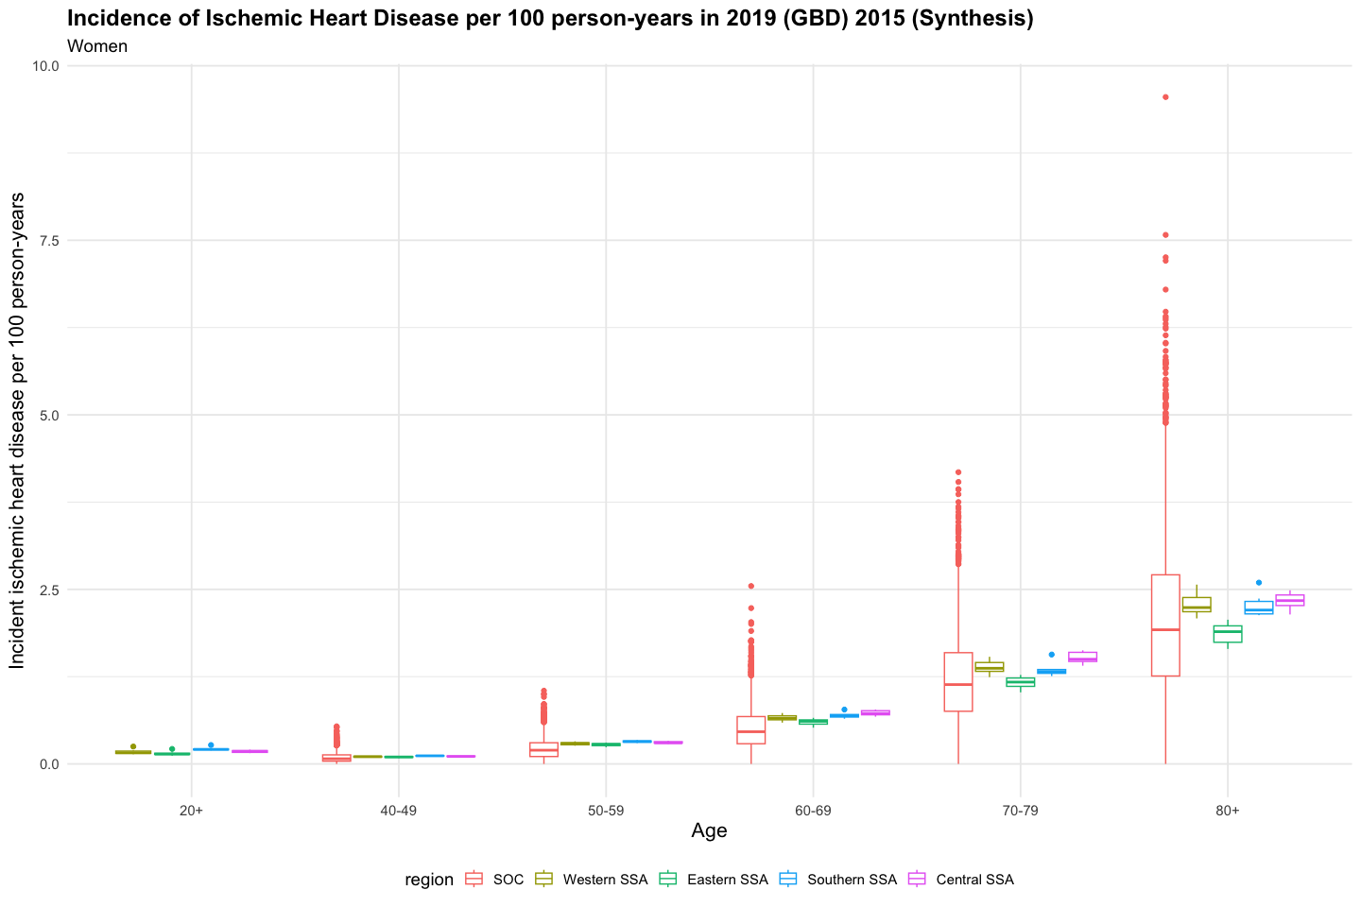

## `summarise()` has grouped output by 'source', 'sex'. You can override using the  
## `.groups` argument.

source

sex

age

Incidence

min

Q1

median

Q3

max

SOC

All

18+

0.20

0.05

0.15

0.20

0.24

0.41

SOC

Female

40-49

0.09

0.00

0.04

0.07

0.13

0.54

SOC

Female

50-59

0.22

0.00

0.11

0.20

0.30

1.05

SOC

Female

60-69

0.51

0.00

0.29

0.46

0.68

2.55

SOC

Female

70-79

1.22

0.00

0.75

1.14

1.59

4.18

SOC

Female

80+

2.07

0.00

1.26

1.92

2.71

9.55

SOC

Male

40-49

0.13

0.00

0.06

0.12

0.19

0.57

SOC

Male

50-59

0.35

0.00

0.19

0.31

0.46

1.52

SOC

Male

60-69

0.78

0.00

0.48

0.72

1.02

2.91

SOC

Male

70-79

1.90

0.00

1.21

1.77

2.49

6.95

SOC

Male

80+

3.18

0.00

1.79

2.96

4.31

15.01

SSA

Female

20+

0.17

0.12

0.14

0.16

0.19

0.27

SSA

Female

40-49

0.10

0.09

0.10

0.11

0.11

0.12

SSA

Female

50-59

0.29

0.24

0.28

0.29

0.31

0.34

SSA

Female

60-69

0.65

0.52

0.61

0.65

0.70

0.78

SSA

Female

70-79

1.33

1.03

1.24

1.33

1.43

1.63

SSA

Female

80+

2.15

1.65

1.98

2.18

2.35

2.60

SSA

Male

20+

0.23

0.15

0.21

0.23

0.25

0.32

SSA

Male

40-49

0.16

0.14

0.16

0.16

0.17

0.20

SSA

Male

50-59

0.46

0.38

0.44

0.46

0.49

0.55

SSA

Male

60-69

1.00

0.83

0.95

1.00

1.06

1.15

SSA

Male

70-79

1.83

1.51

1.74

1.83

1.92

2.12

SSA

Male

80+

2.80

2.27

2.72

2.80

2.96

3.25

### Prevalence of Ischemic Heart Disease

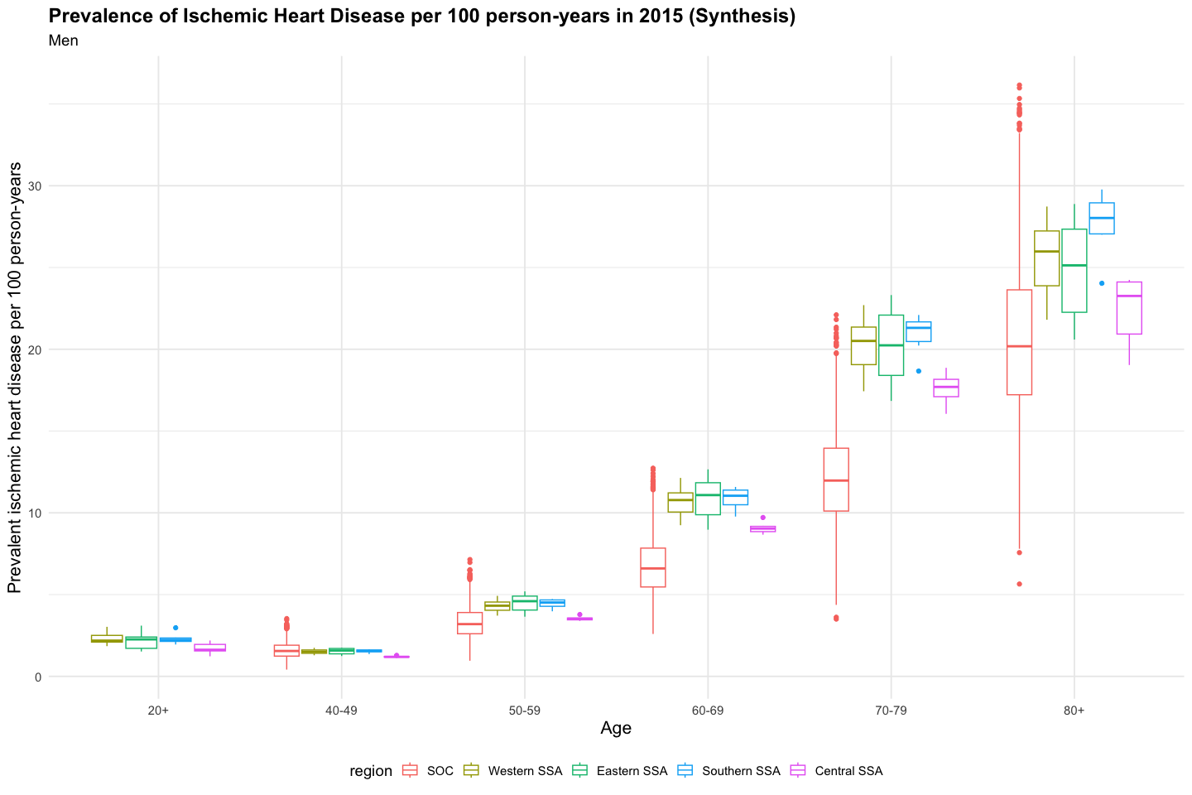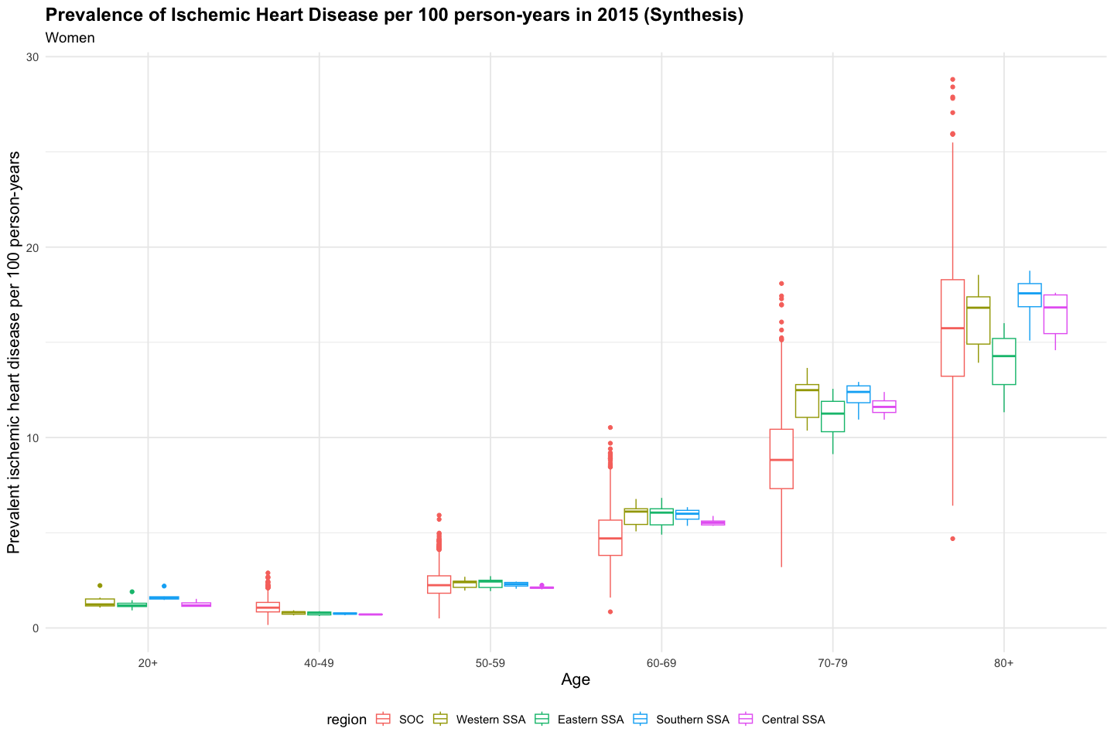

### Incidence of Stroke

Incidence of stroke based on Global Burden of Disease data, assuming that mild strokes under-ascertained, thus we compare incidence only of moderate/severe stroke to available incidence data.

#### Any Stroke (moderate/severe only)

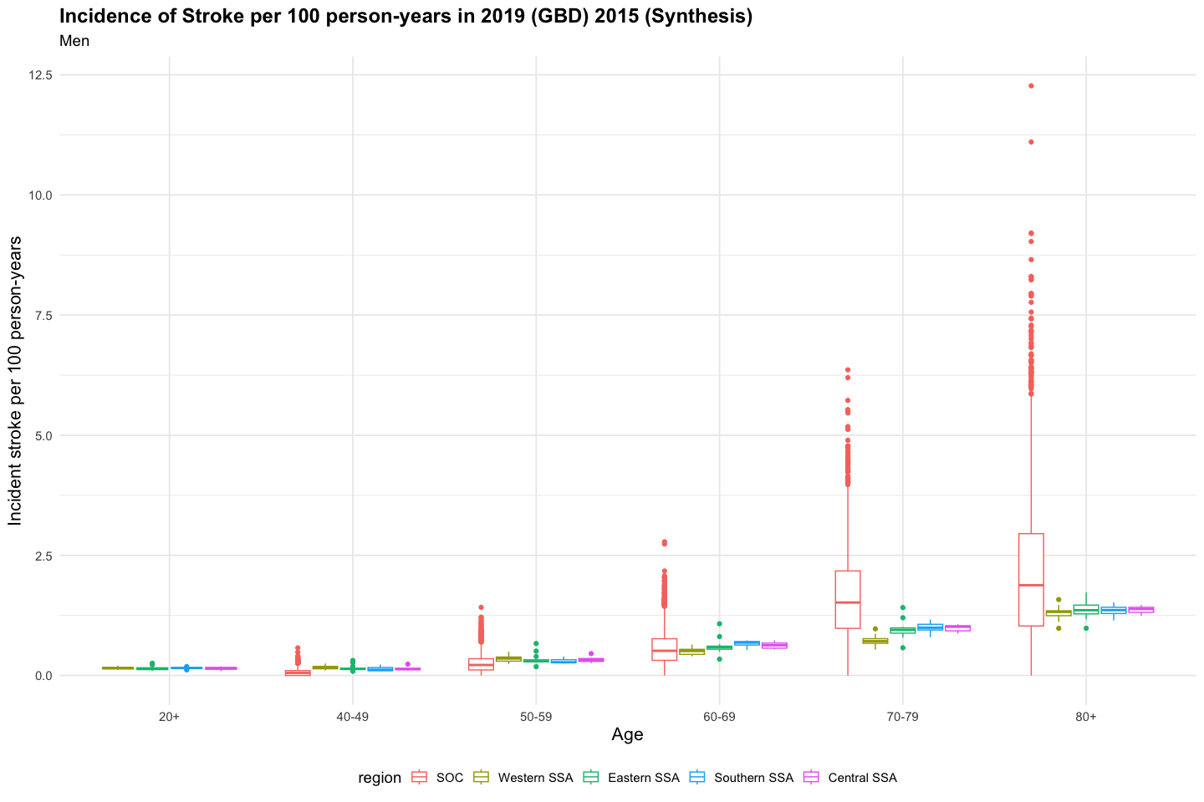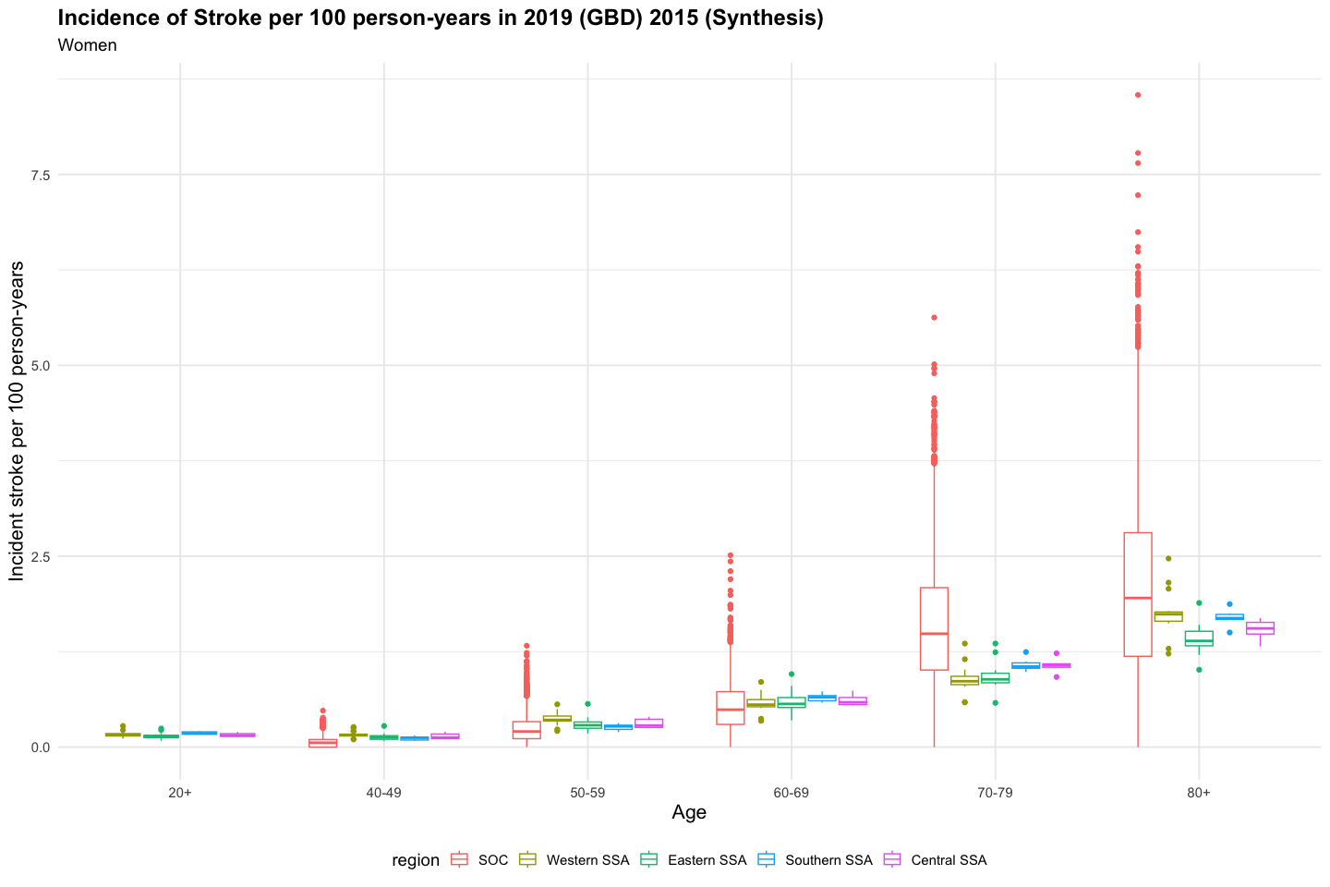

## `summarise()` has grouped output by 'source', 'sex'. You can override using the  
## `.groups` argument.

source

sex

age

Incidence

min

Q1

median

Q3

max

SOC

All

18+

0.18

0.04

0.13

0.17

0.22

0.43

SOC

Female

40-49

0.07

0.00

0.00

0.06

0.10

0.48

SOC

Female

50-59

0.24

0.00

0.11

0.20

0.33

1.33

SOC

Female

60-69

0.54

0.00

0.30

0.49

0.73

2.51

SOC

Female

70-79

1.61

0.00

1.01

1.48

2.09

5.63

SOC

Female

80+

2.09

0.00

1.19

1.95

2.81

8.54

SOC

Male

40-49

0.07

0.00

0.00

0.05

0.10

0.57

SOC

Male

50-59

0.25

0.00

0.11

0.22

0.35

1.42

SOC

Male

60-69

0.57

0.00

0.31

0.51

0.76

2.78

SOC

Male

70-79

1.64

0.00

0.98

1.52

2.18

6.36

SOC

Male

80+

2.12

0.00

1.03

1.88

2.95

12.27

SSA

Female

20+

0.16

0.08

0.14

0.16

0.18

0.28

SSA

Female

40-49

0.14

0.08

0.11

0.14

0.16

0.28

SSA

Female

50-59

0.33

0.18

0.27

0.32

0.38

0.57

SSA

Female

60-69

0.60

0.34

0.53

0.57

0.66

0.96

SSA

Female

70-79

0.95

0.58

0.85

0.92

1.05

1.36

SSA

Female

80+

1.61

1.01

1.45

1.63

1.74

2.47

SSA

Male

20+

0.15

0.09

0.13

0.15

0.16

0.26

SSA

Male

40-49

0.16

0.09

0.13

0.14

0.19

0.31

SSA

Male

50-59

0.33

0.18

0.28

0.31

0.37

0.67

SSA

Male

60-69

0.58

0.34

0.51

0.56

0.63

1.08

SSA

Male

70-79

0.87

0.54

0.72

0.87

0.97

1.41

SSA

Male

80+

1.34

0.98

1.25

1.34

1.42

1.73

### Prevalence of Stroke

Defined as any prior history of stroke among living adults.

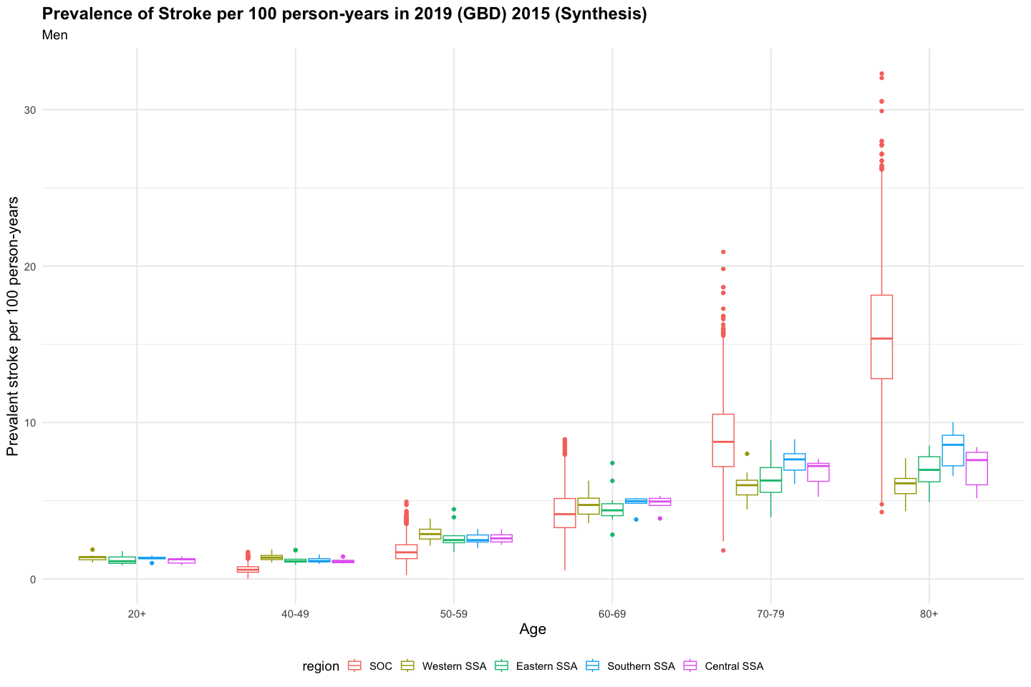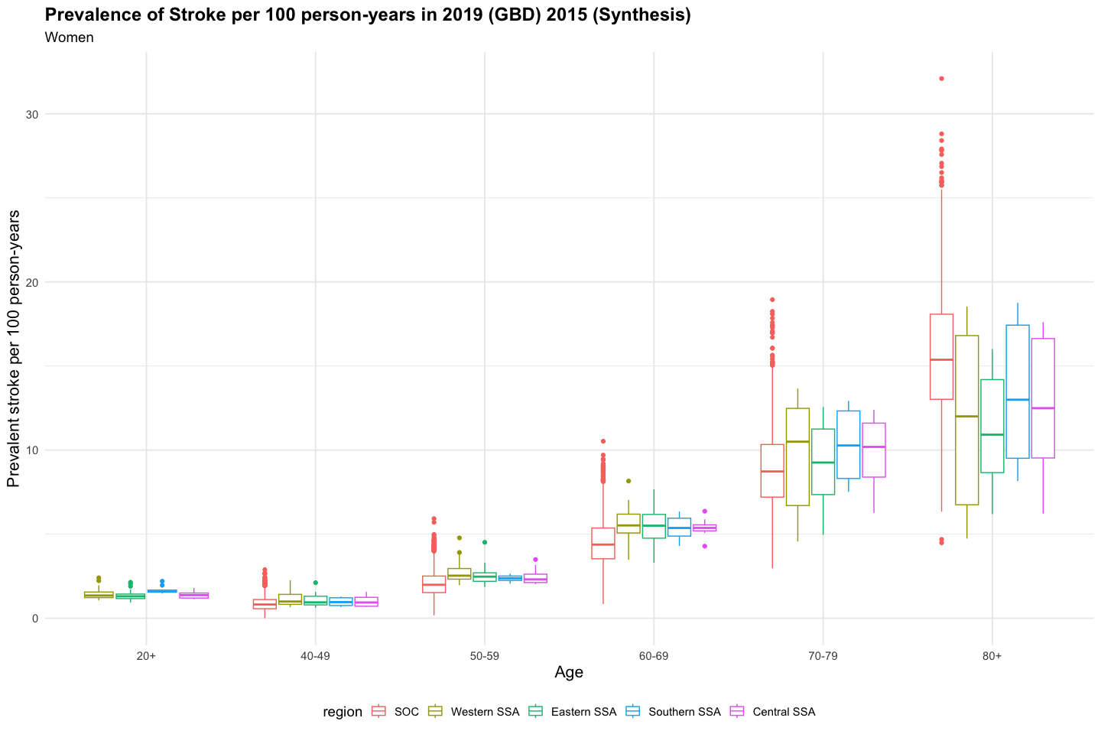

## CVD Mortality

Mortality resulting from ischemic heart disease or stroke.

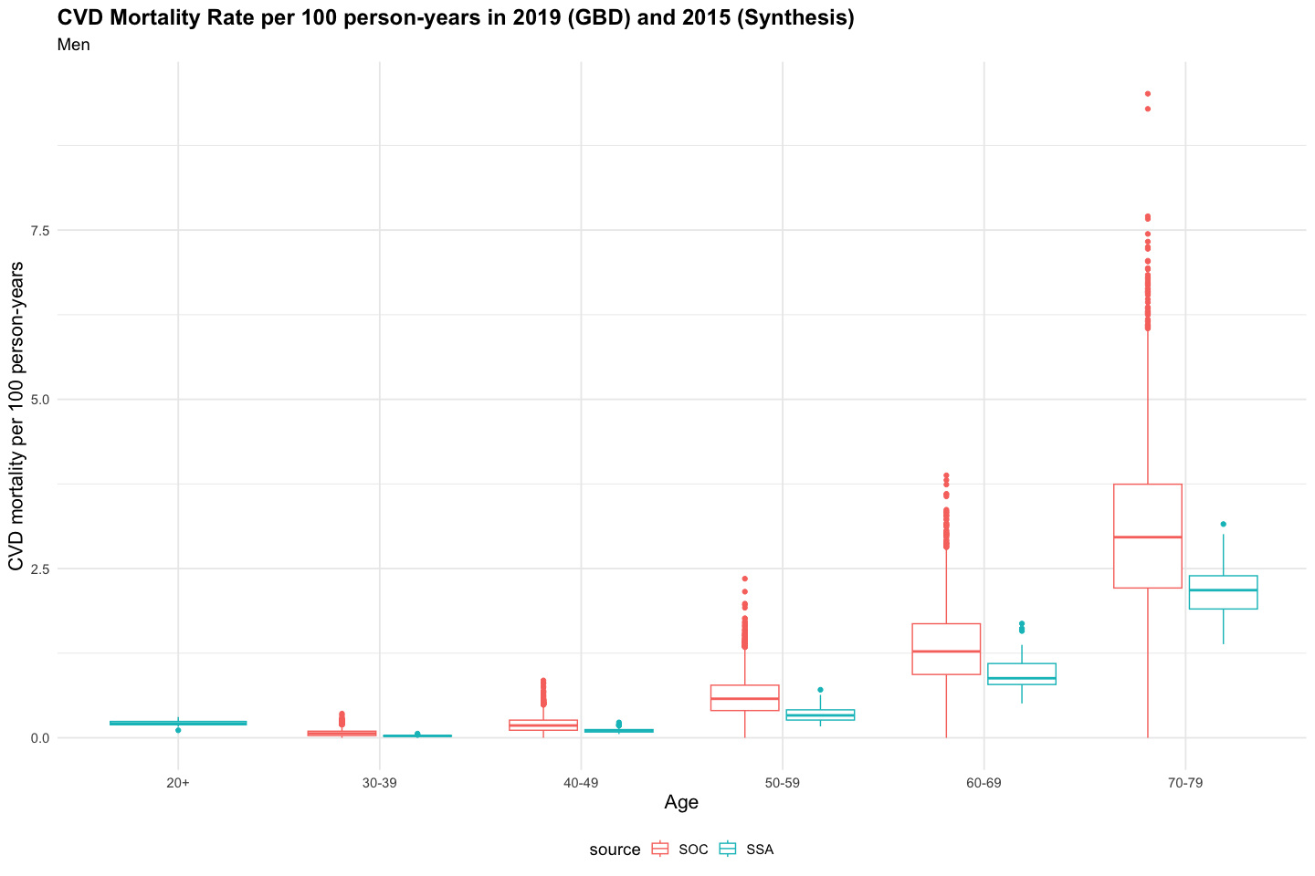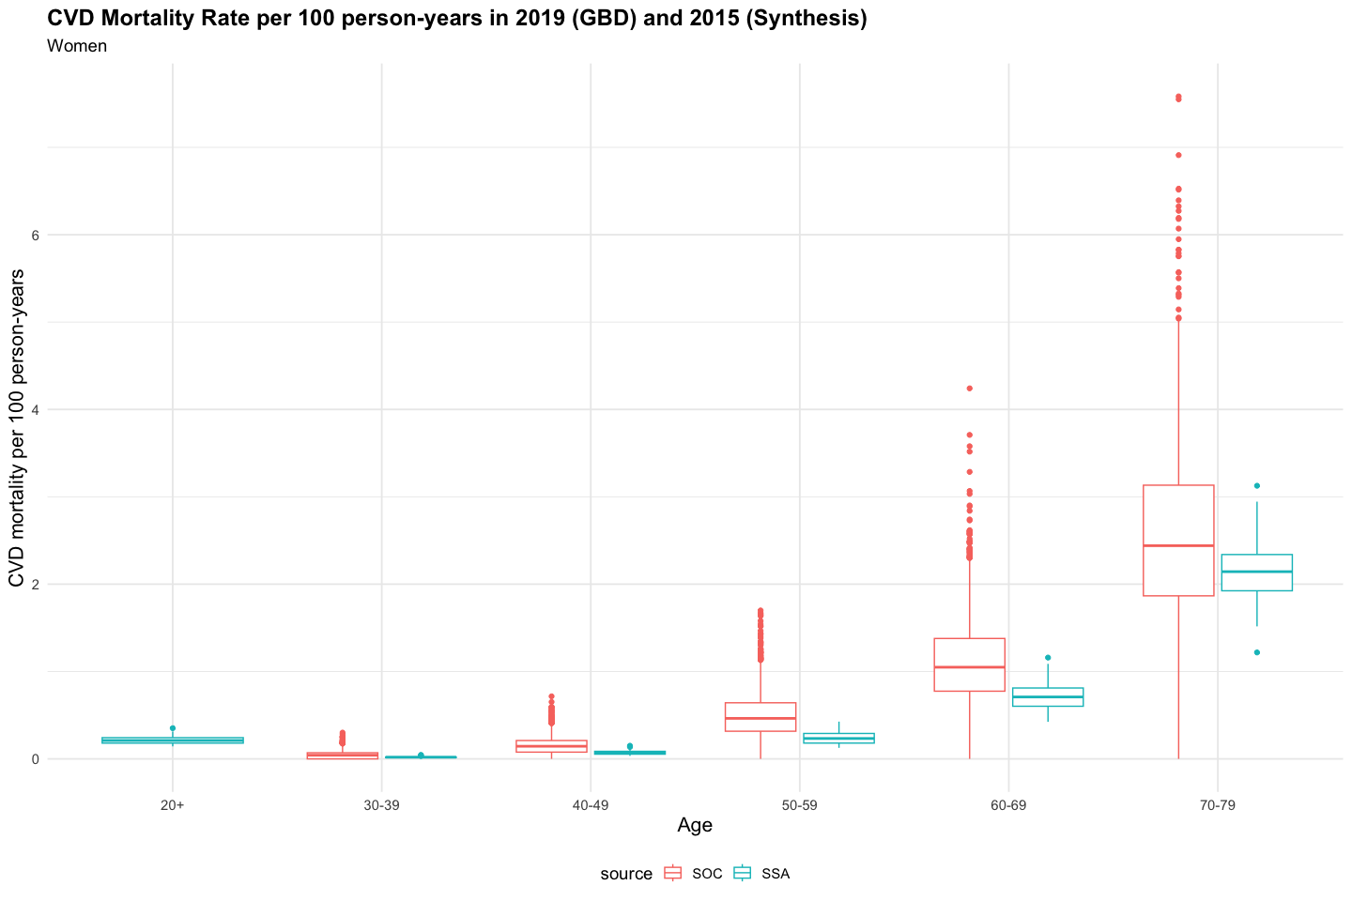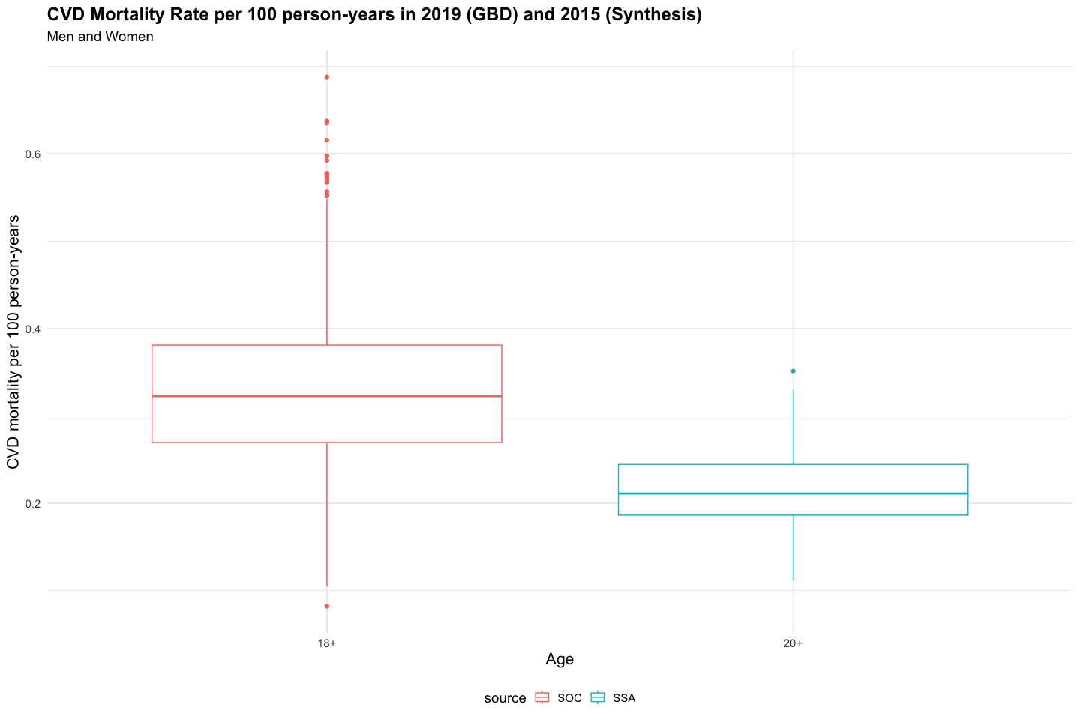

## `summarise()` has grouped output by 'source', 'sex'. You can override using the  
## `.groups` argument.

source

sex

age

Mortality rate

min

Q1

median

Q3

max

SOC

All

18+

0.328

0.082

0.269

0.323

0.381

0.688

SOC

All

40-59

0.325

0.000

0.243

0.312

0.394

0.942

SOC

All

60-79

1.735

0.408

1.392

1.683

2.047

4.284

SOC

All

All

0.296

0.071

0.242

0.292

0.345

0.624

SOC

Female

30-39

0.048

0.000

0.000

0.042

0.070

0.301

SOC

Female

40-49

0.156

0.000

0.077

0.144

0.210

0.716

SOC

Female

50-59

0.496

0.000

0.316

0.464

0.642

1.699

SOC

Female

60-69

1.103

0.000

0.775

1.049

1.378

4.241

SOC

Female

70-79

2.545

0.000

1.866

2.440

3.133

7.584

SOC

Male

30-39

0.072

0.000

0.033

0.065

0.098

0.358

SOC

Male

40-49

0.194

0.000

0.112

0.182

0.262

0.848

SOC

Male

50-59

0.613

0.000

0.403

0.577

0.777

2.350

SOC

Male

60-69

1.343

0.000

0.936

1.276

1.685

3.877

SOC

Male

70-79

3.048

0.000

2.213

2.964

3.746

9.514

SSA

Female

20+

0.215

0.143

0.180

0.210

0.243

0.351

SSA

Female

30-39

0.020

0.010

0.014

0.019

0.021

0.045

SSA

Female

40-49

0.074

0.034

0.054

0.071

0.087

0.151

SSA

Female

50-59

0.244

0.126

0.181

0.234

0.291

0.426

SSA

Female

60-69

0.720

0.424

0.602

0.709

0.812

1.159

SSA

Female

70-79

2.145

1.218

1.924

2.143

2.339

3.126

SSA

Male

20+

0.219

0.112

0.192

0.212

0.242

0.308

SSA

Male

30-39

0.030

0.016

0.025

0.029

0.032

0.062

SSA

Male

40-49

0.114

0.056

0.085

0.109

0.122

0.228

SSA

Male

50-59

0.355

0.168

0.262

0.332

0.413

0.710

SSA

Male

60-69

0.972

0.508

0.788

0.880

1.097

1.688

SSA

Male

70-79

2.197

1.384

1.903

2.181

2.394

3.157

# Intervention Scenarios (2023 - 2073)

**Hypertension care cascade for intervention packages compared to standard of care**

## Prevalence

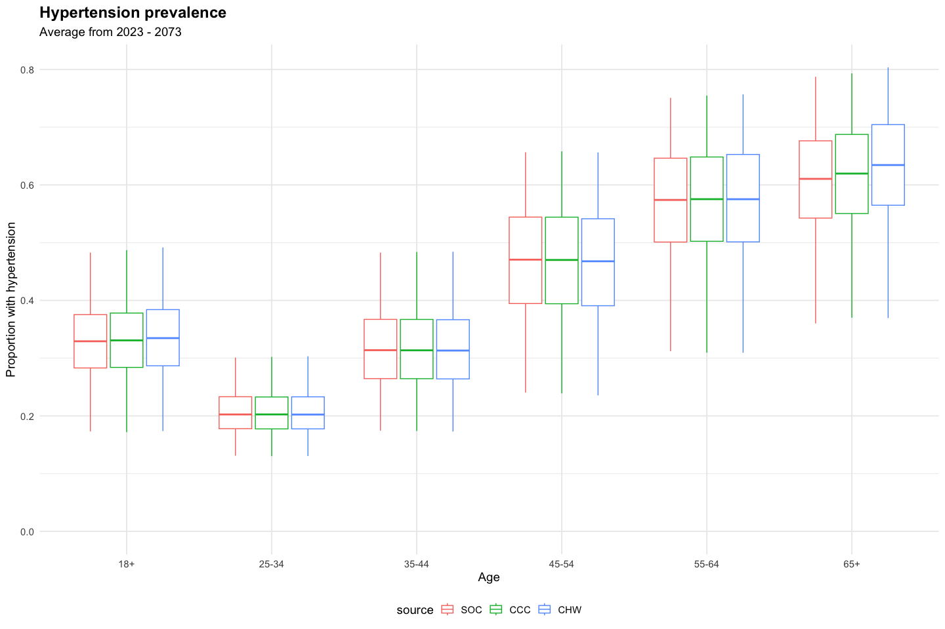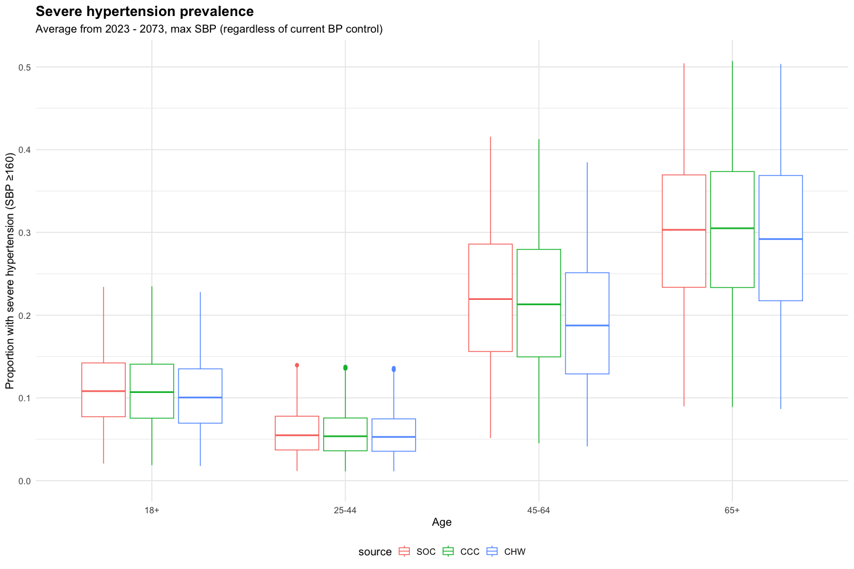

## Diagnosis

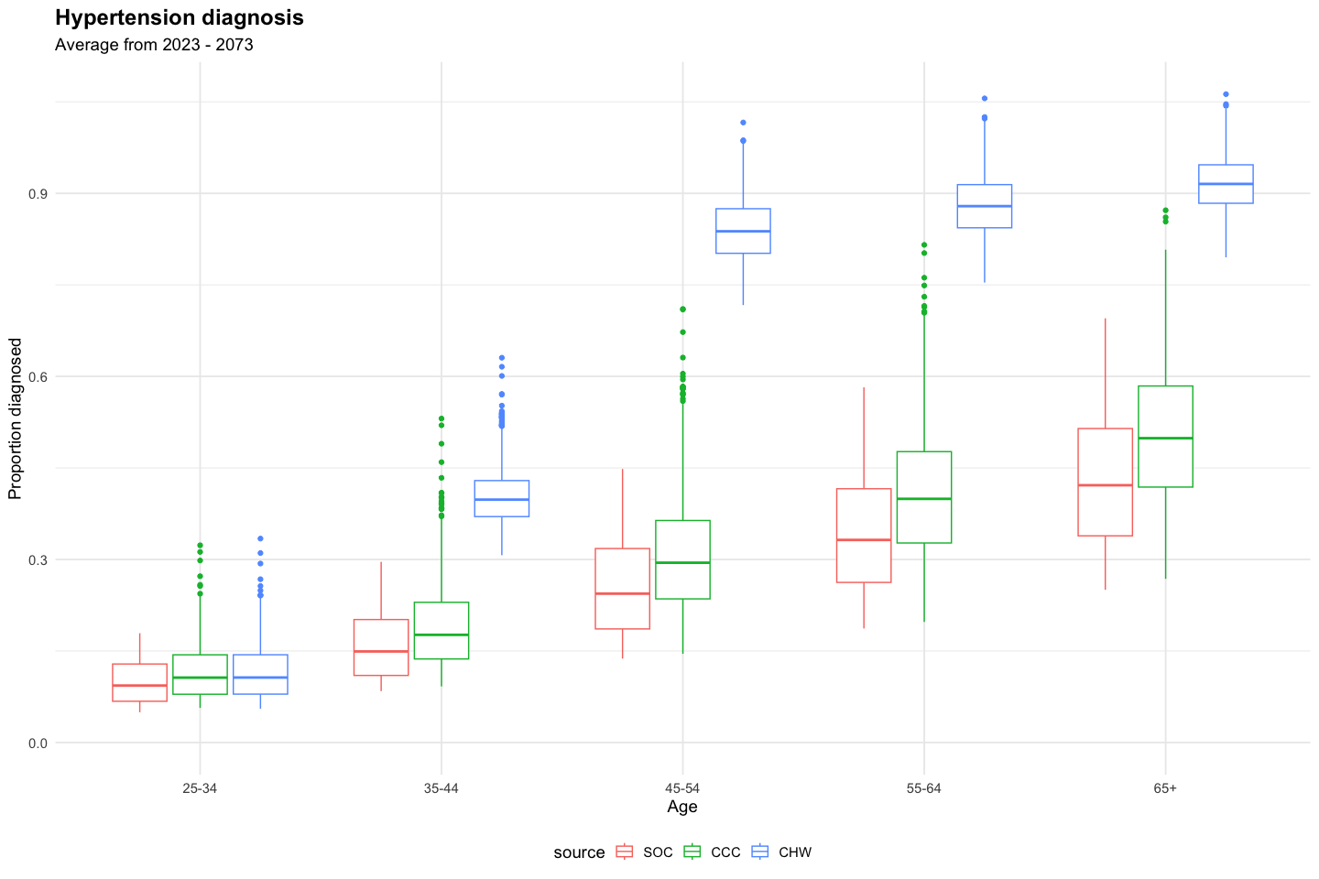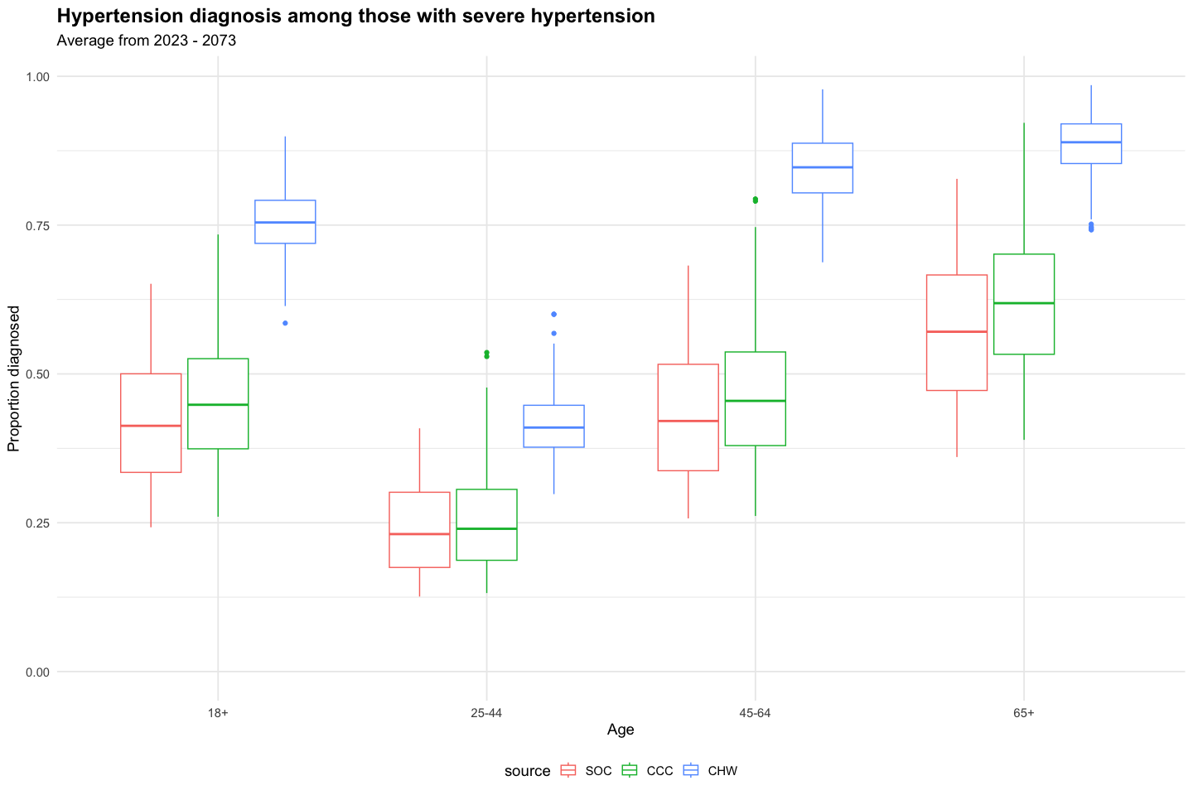

**Note:** Diagnosis can be >100% because the denominator is the proportion with true hypertension (SBP >=140) and the numerator is all with diagnosed hypertension including those who were overdiagnosed (measured BP >=140 but true BP <140). See additional graphs for overdiagnosis below.

## Overdiagnosis

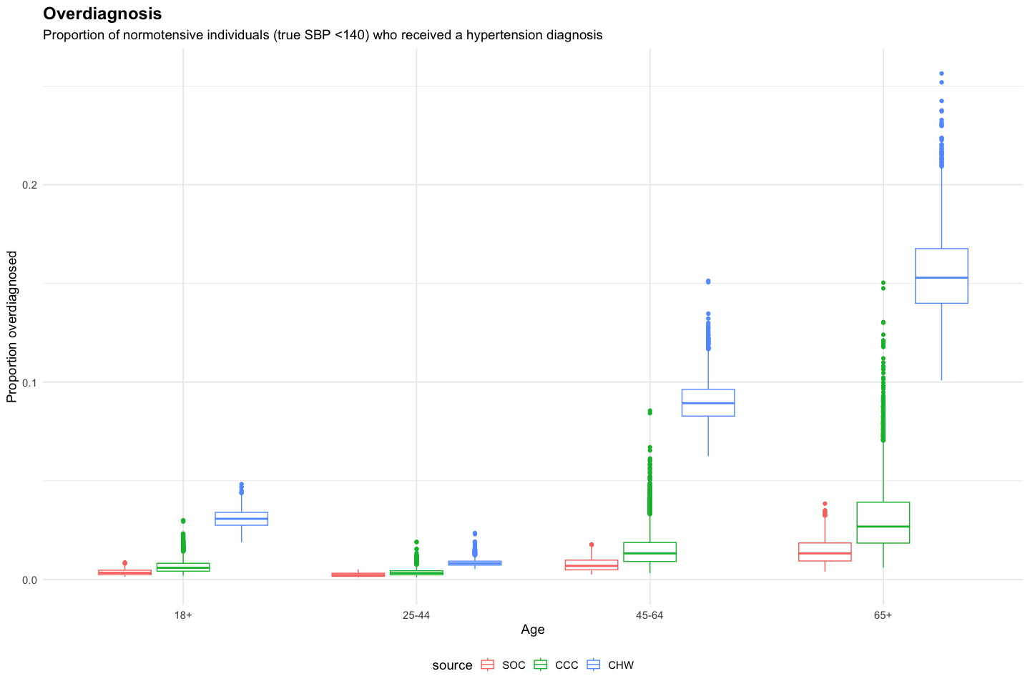

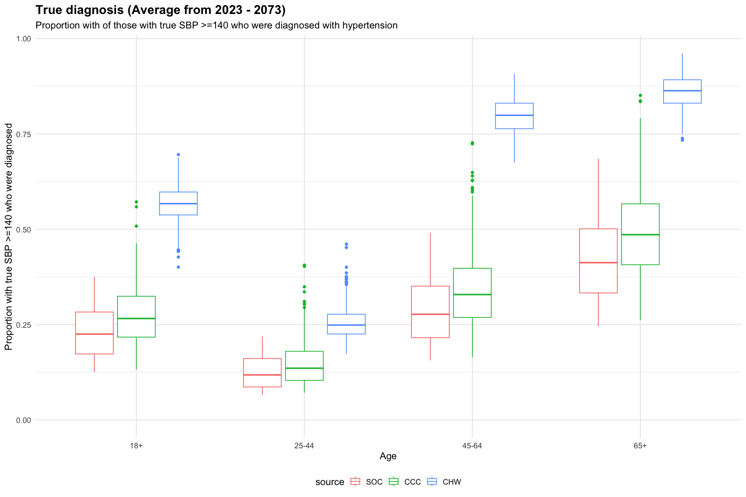

## Treatment

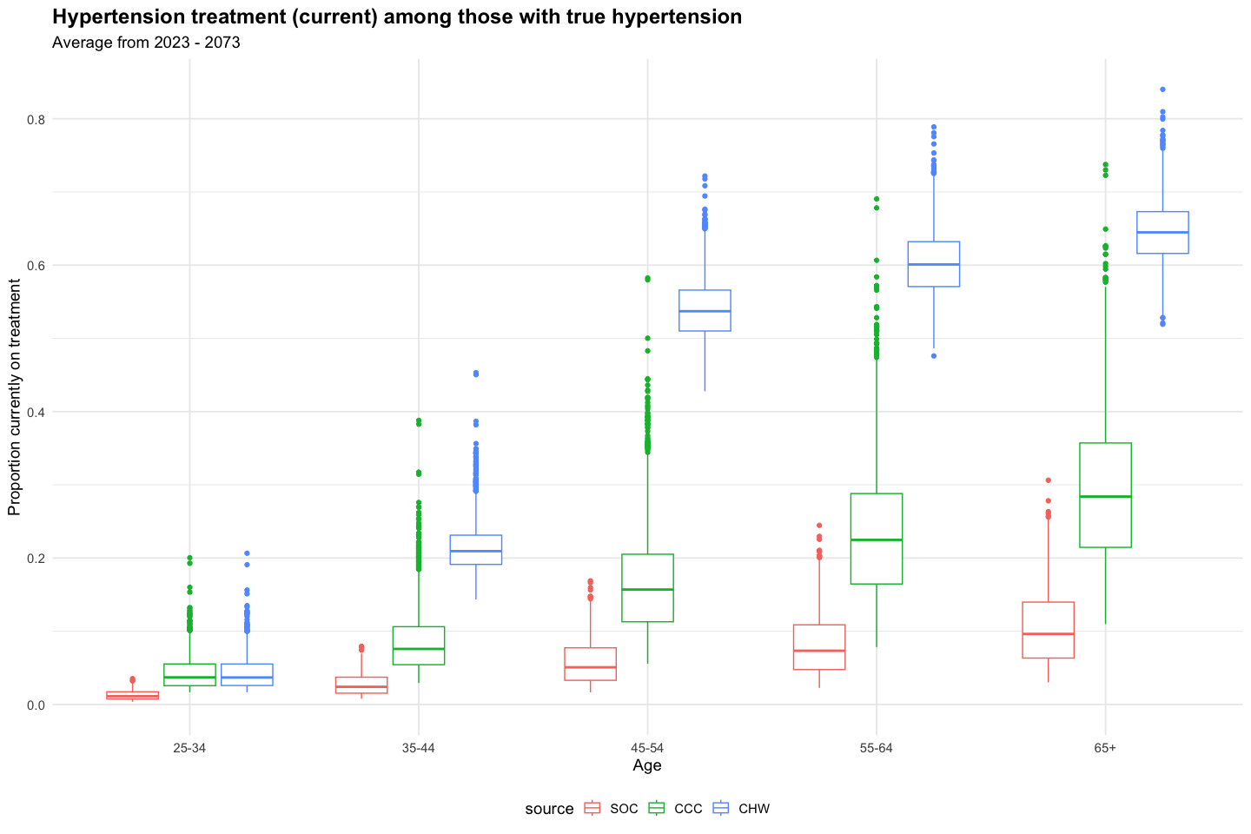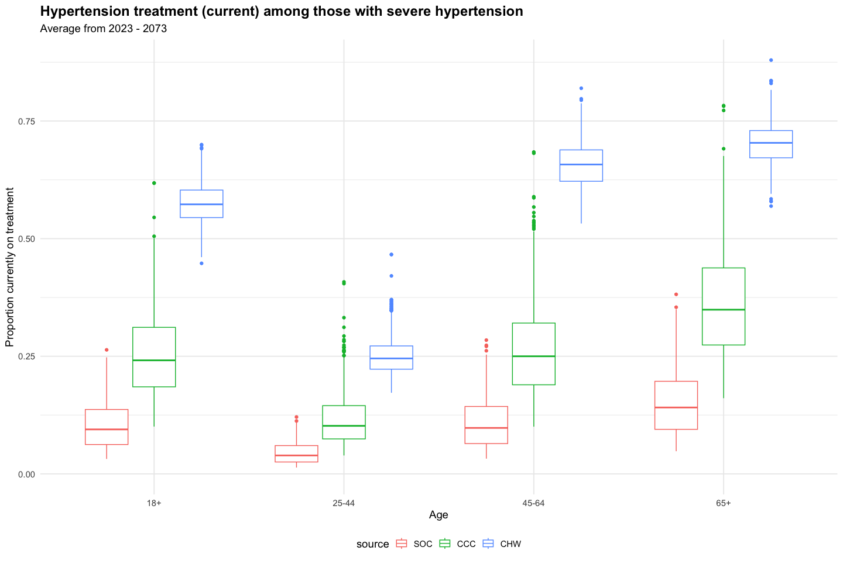

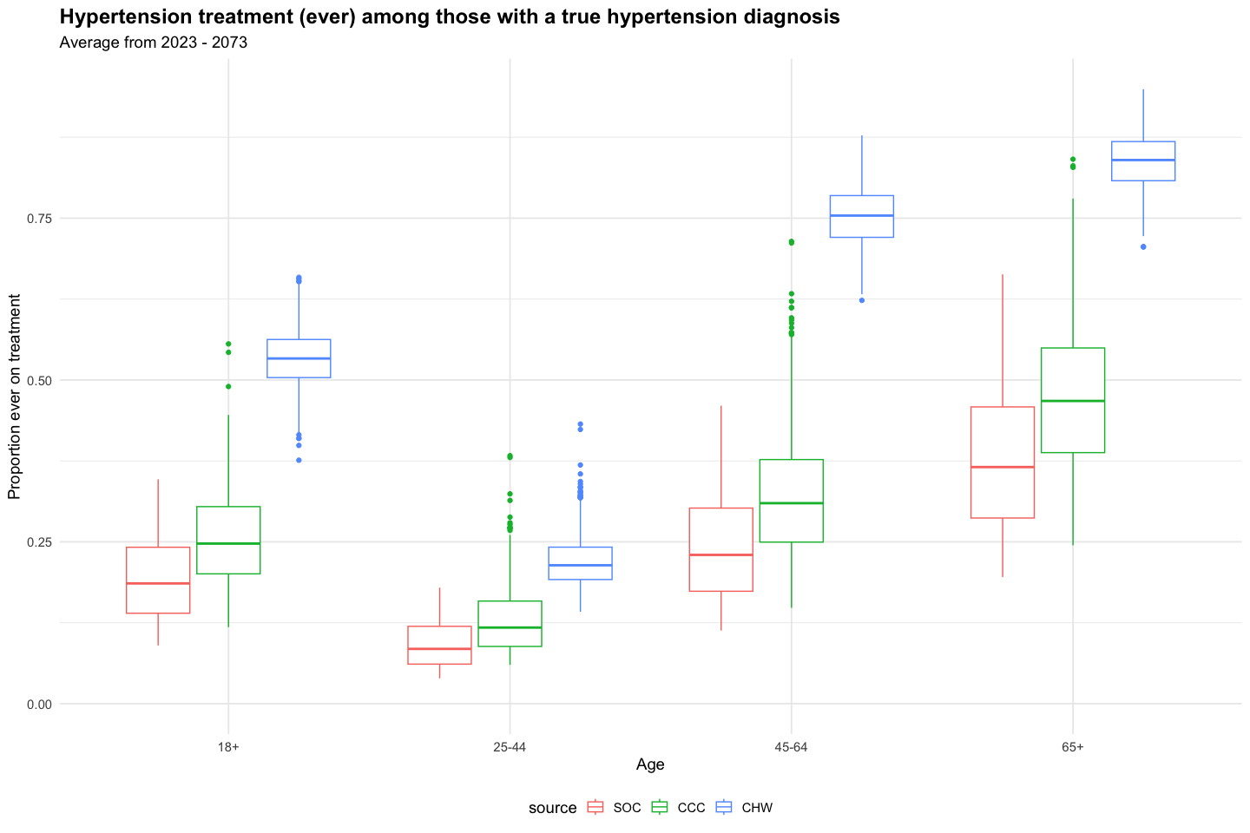

### Overtreatment

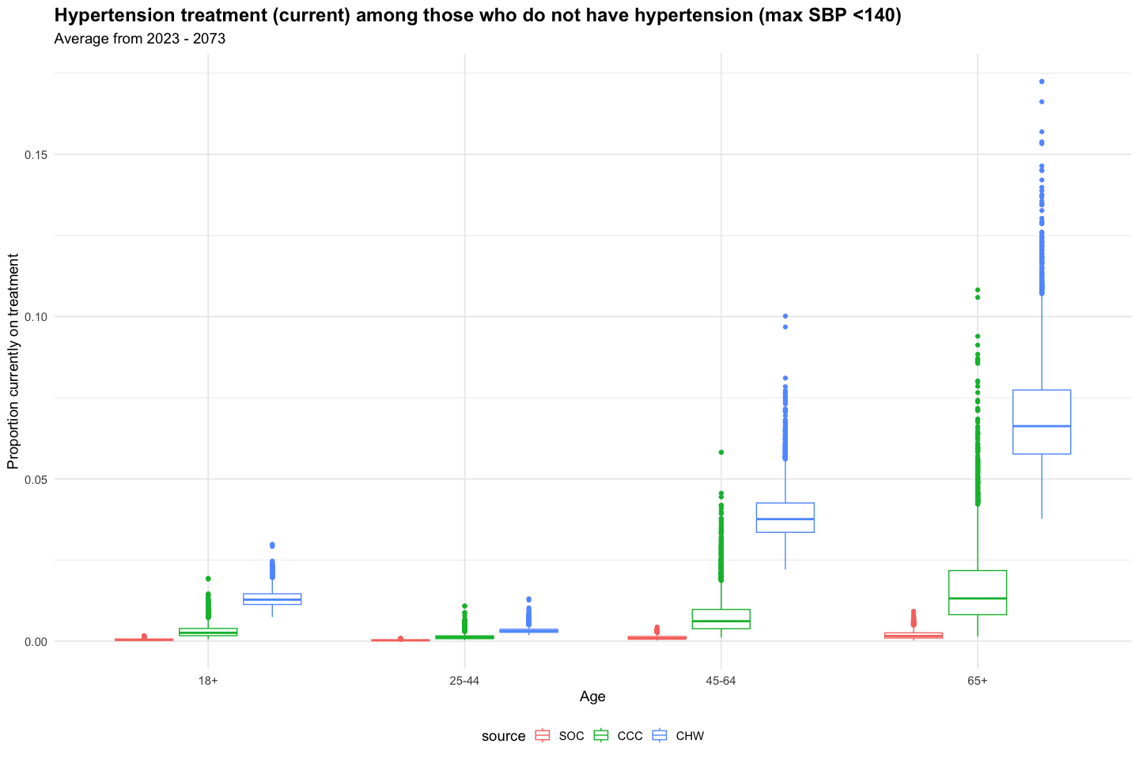

## HTN control

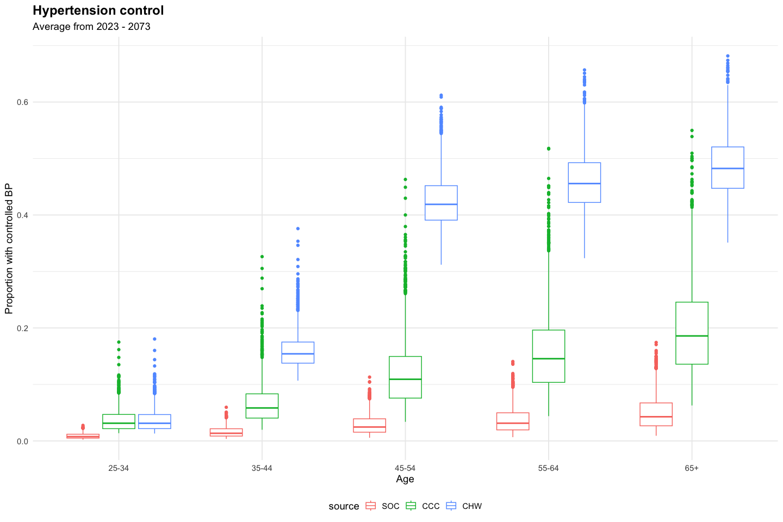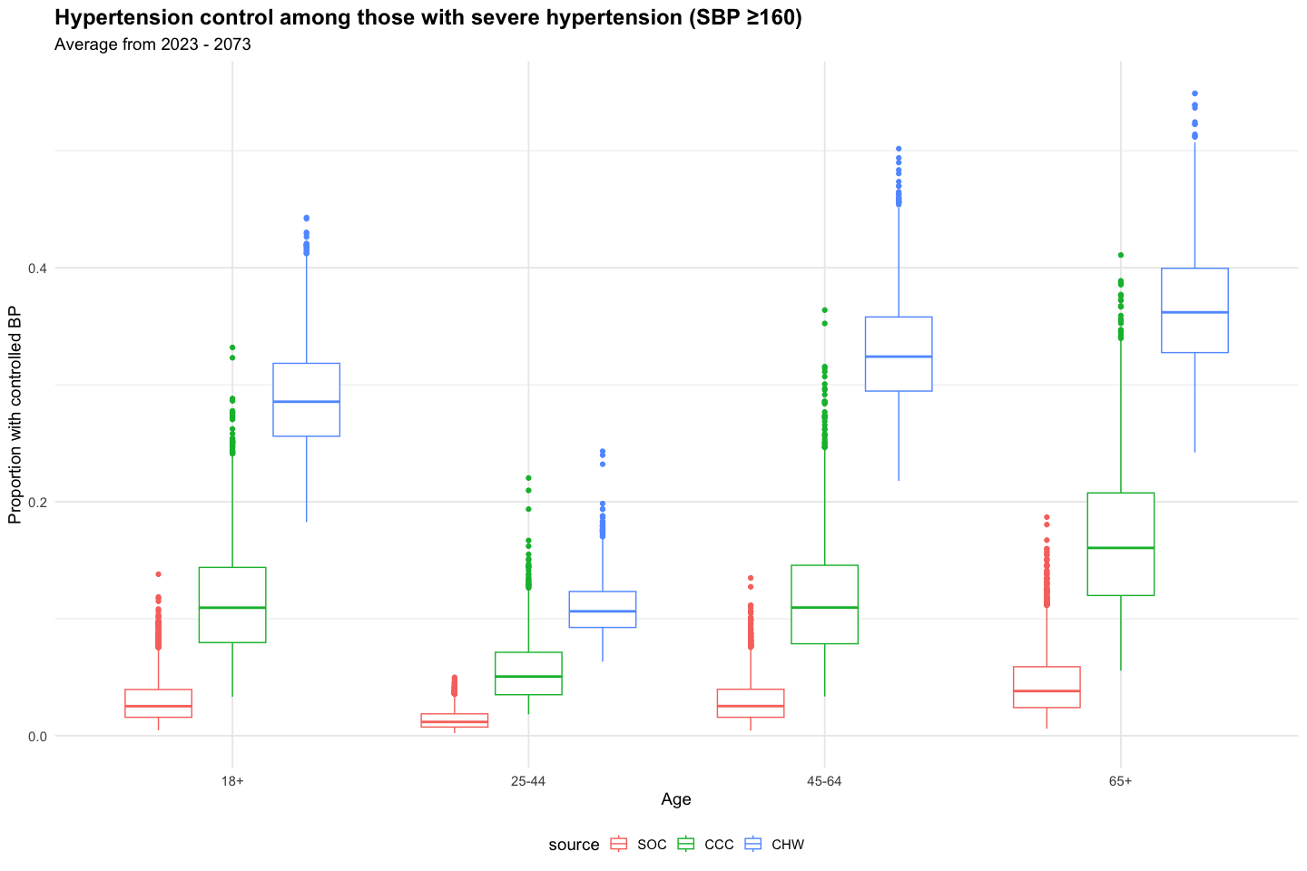

## SBP Increase with Age

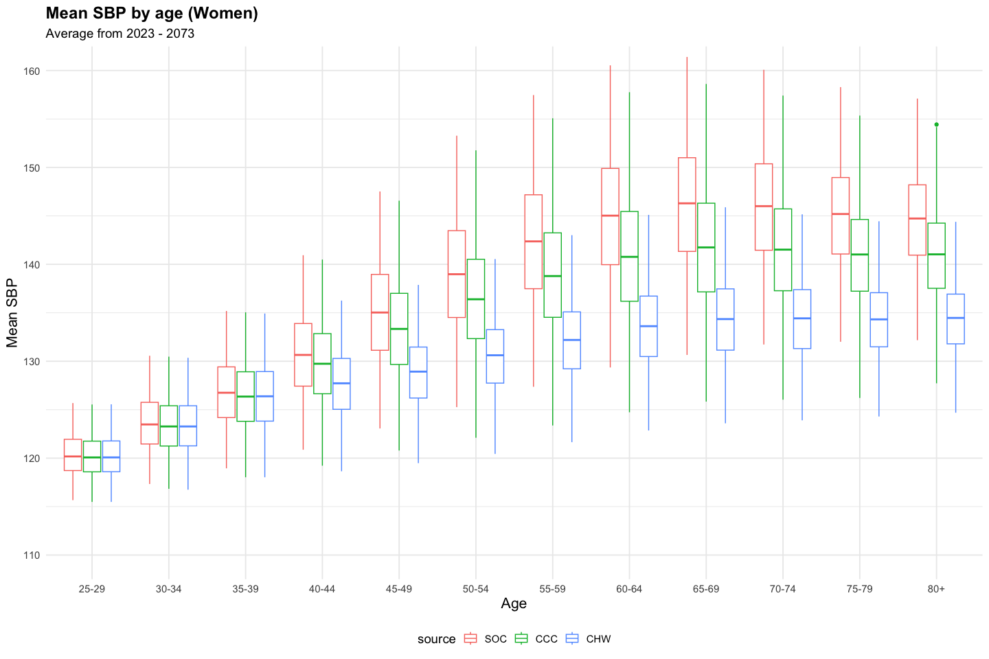

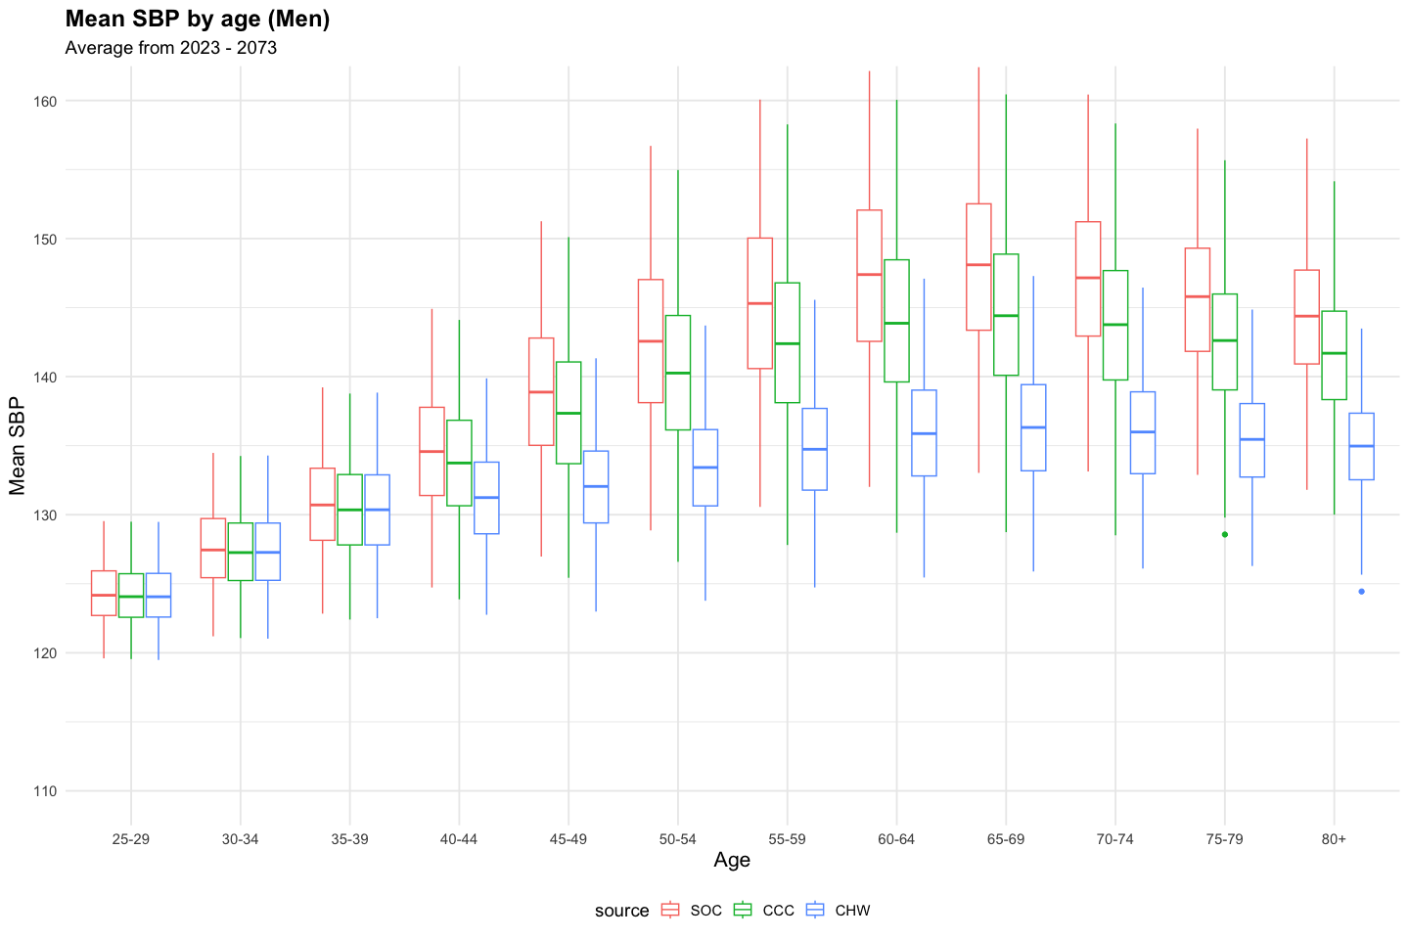

## CVD Event incidence

#### Incident Ischemic Heart Disease Events (moderate/severe events only)

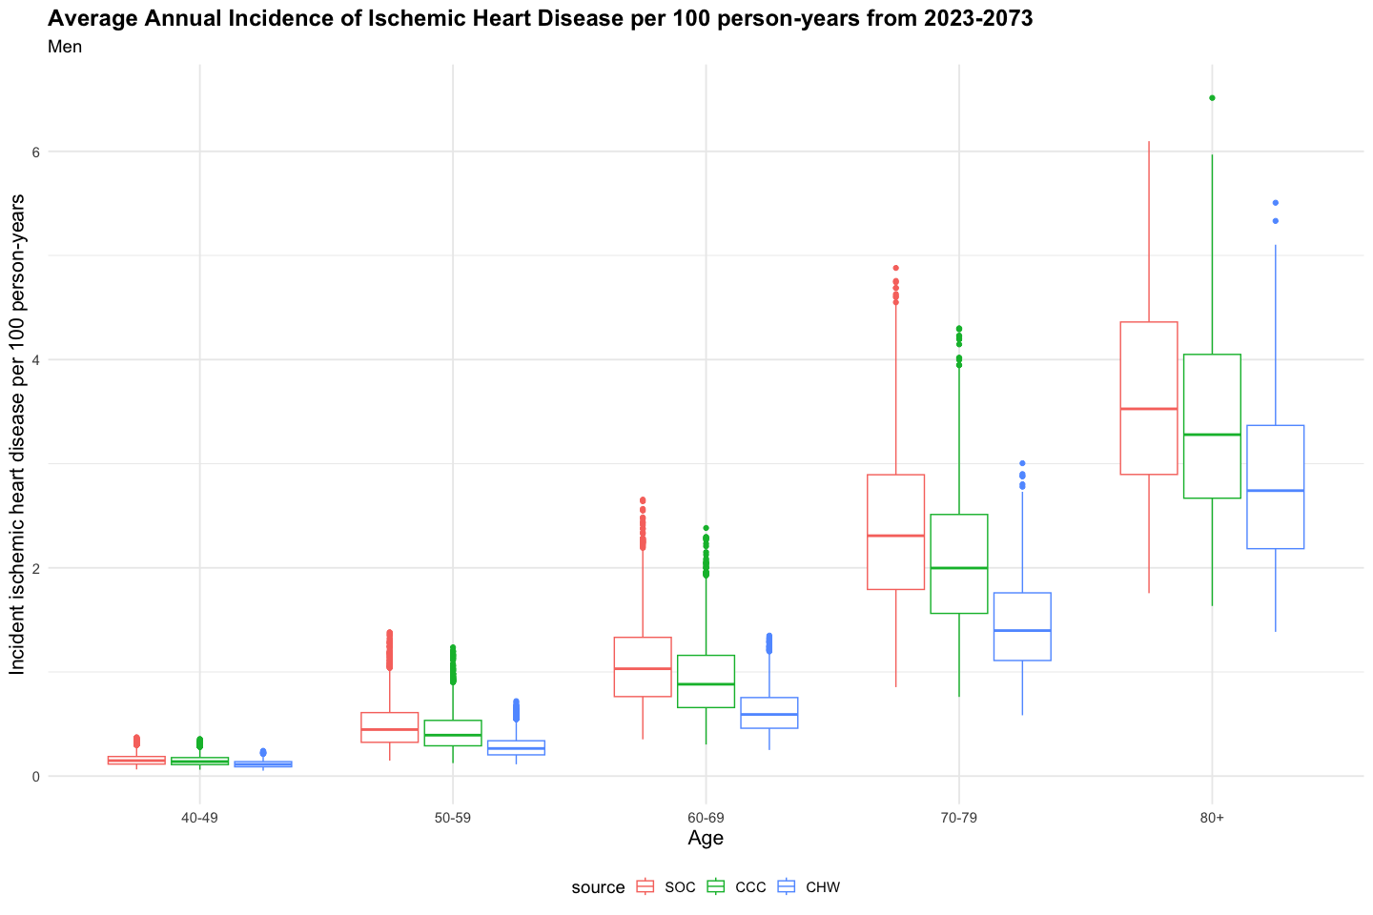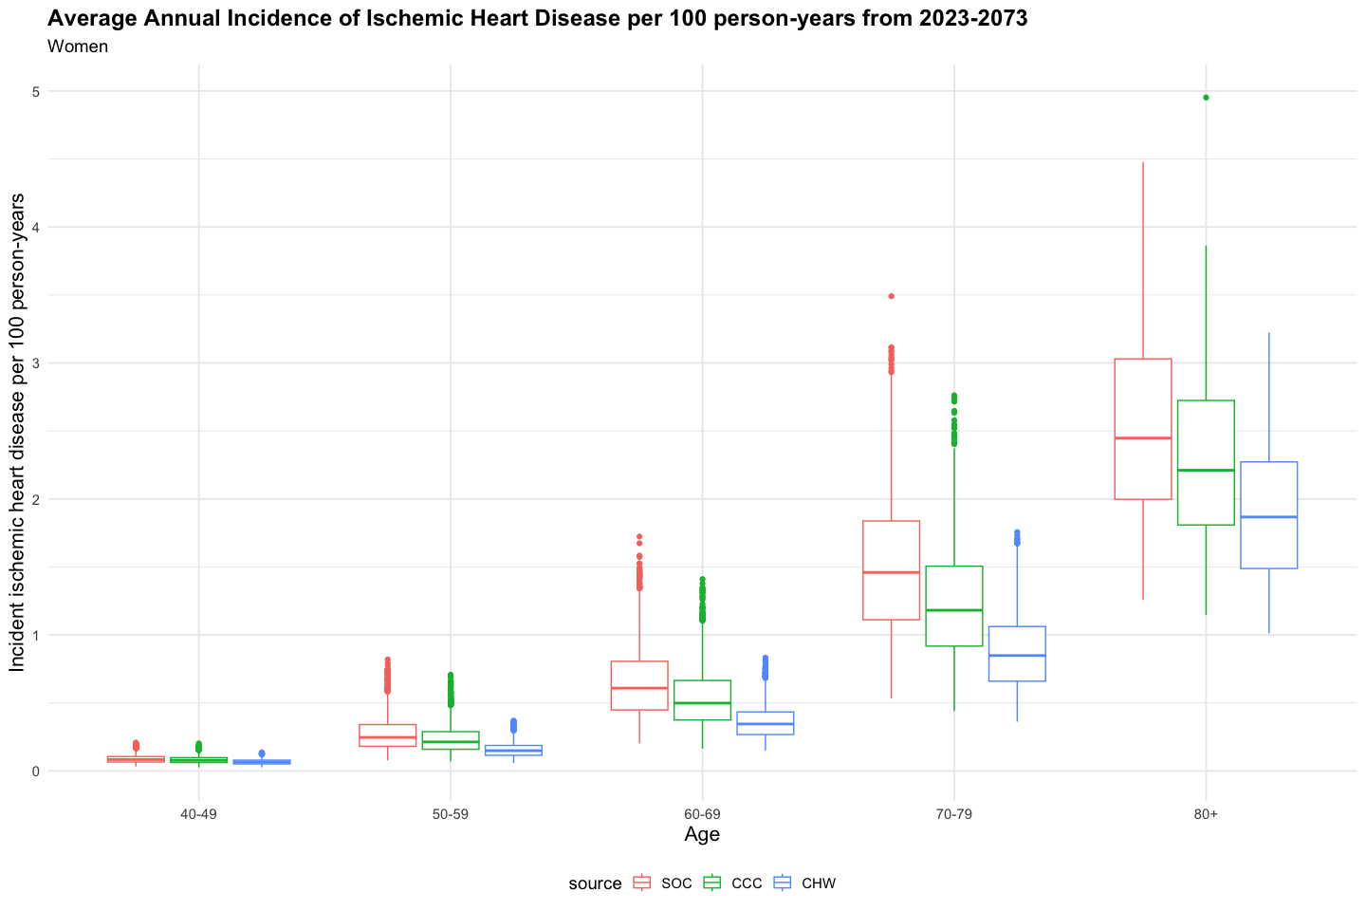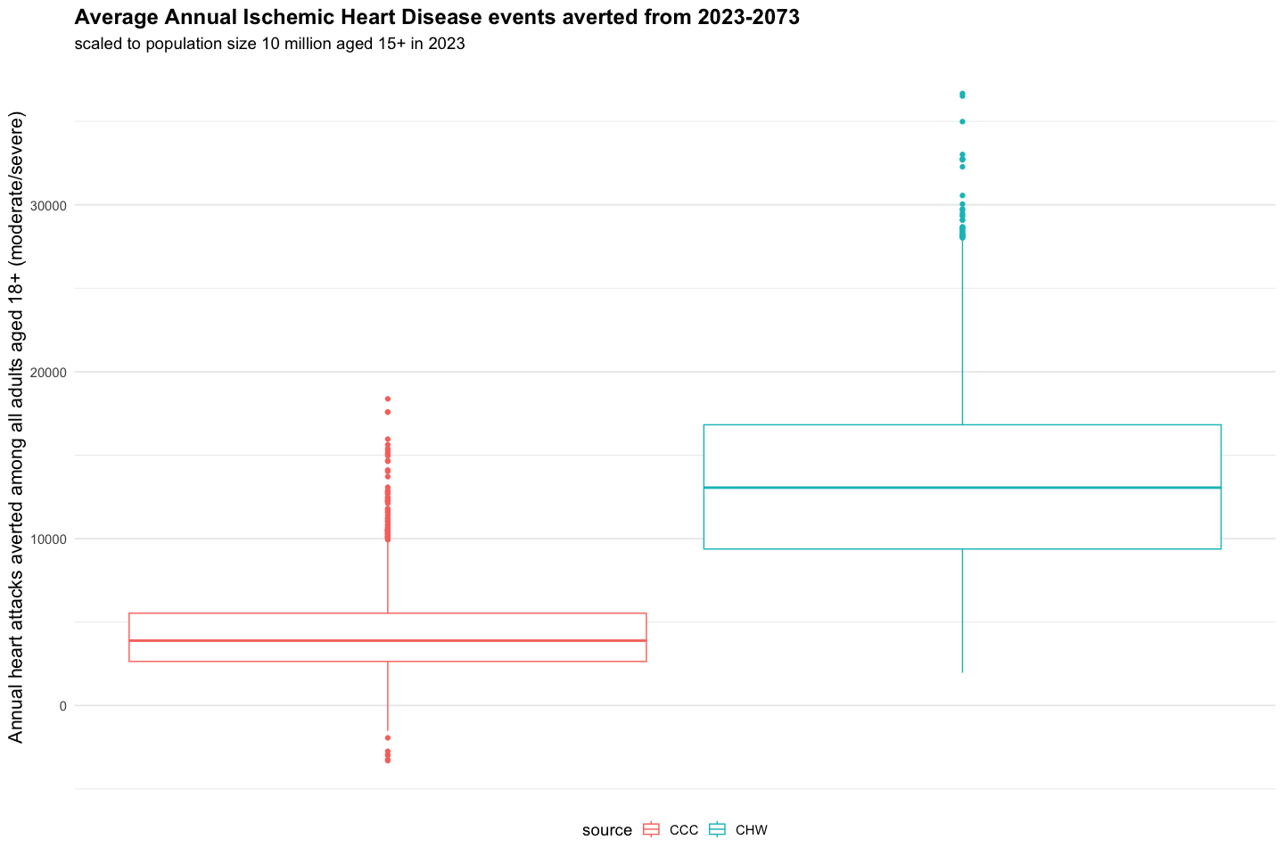

source

Mean annual number of moderate/severe heart attacks deaths averted (standardized to population of 10 million adults)

5%

Q1

median

Q3

95%

CCC

4275.39

1194.49

2641.39

3886.26

5532.54

8745.44

CHW

13507.68

5675.59

9376.25

13052.69

16818.99

23524.51

#### Incident Stroke (moderate/severe events only)

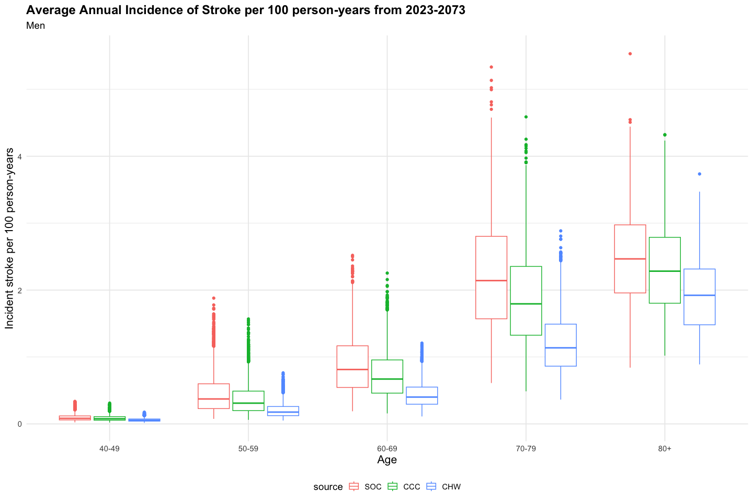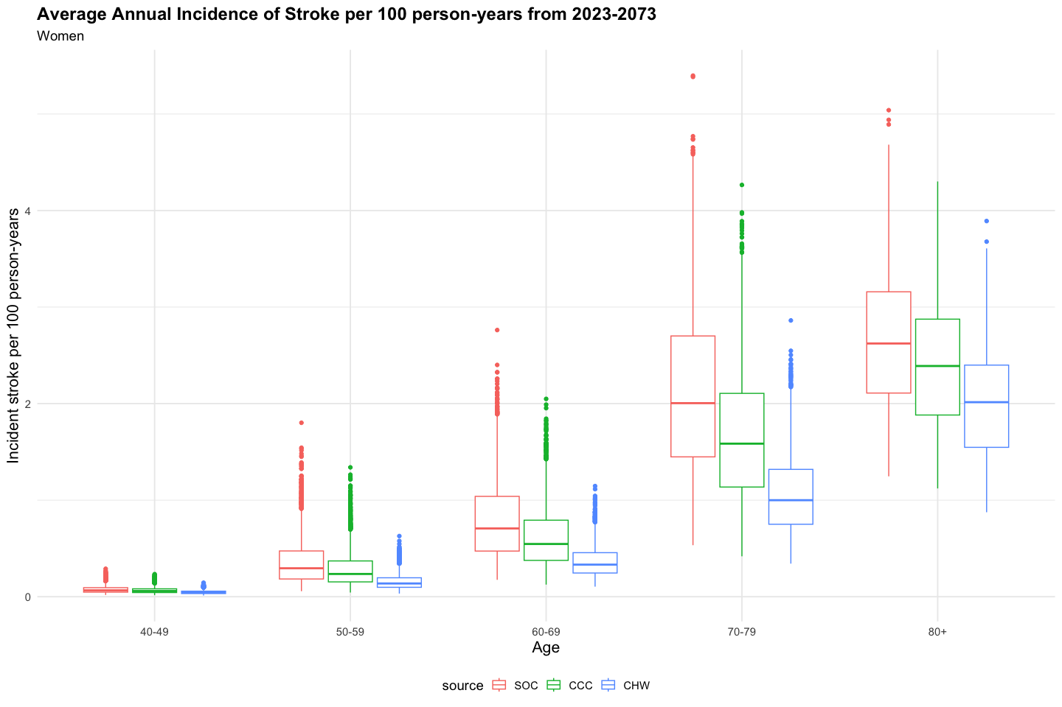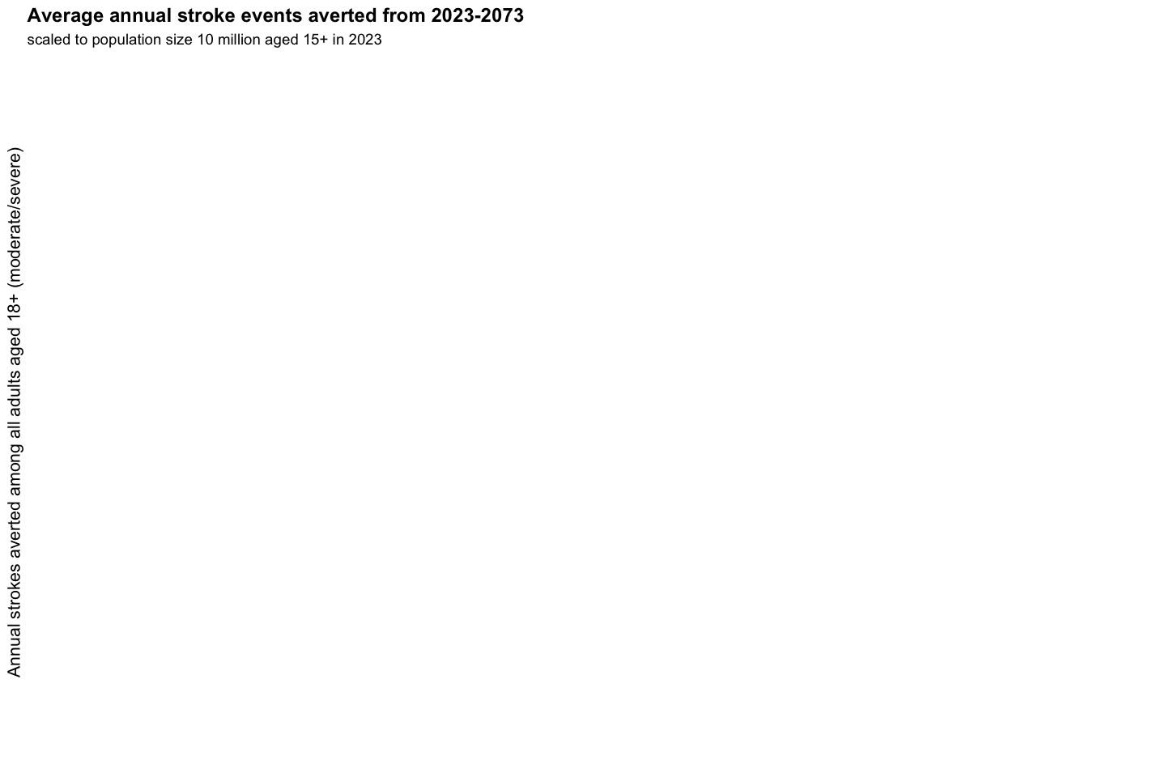

source

Mean annual number of moderate/severe strokes averted (standardized to population of 10 million adults)

5%

Q1

median

Q3

95%

## CVD Mortality

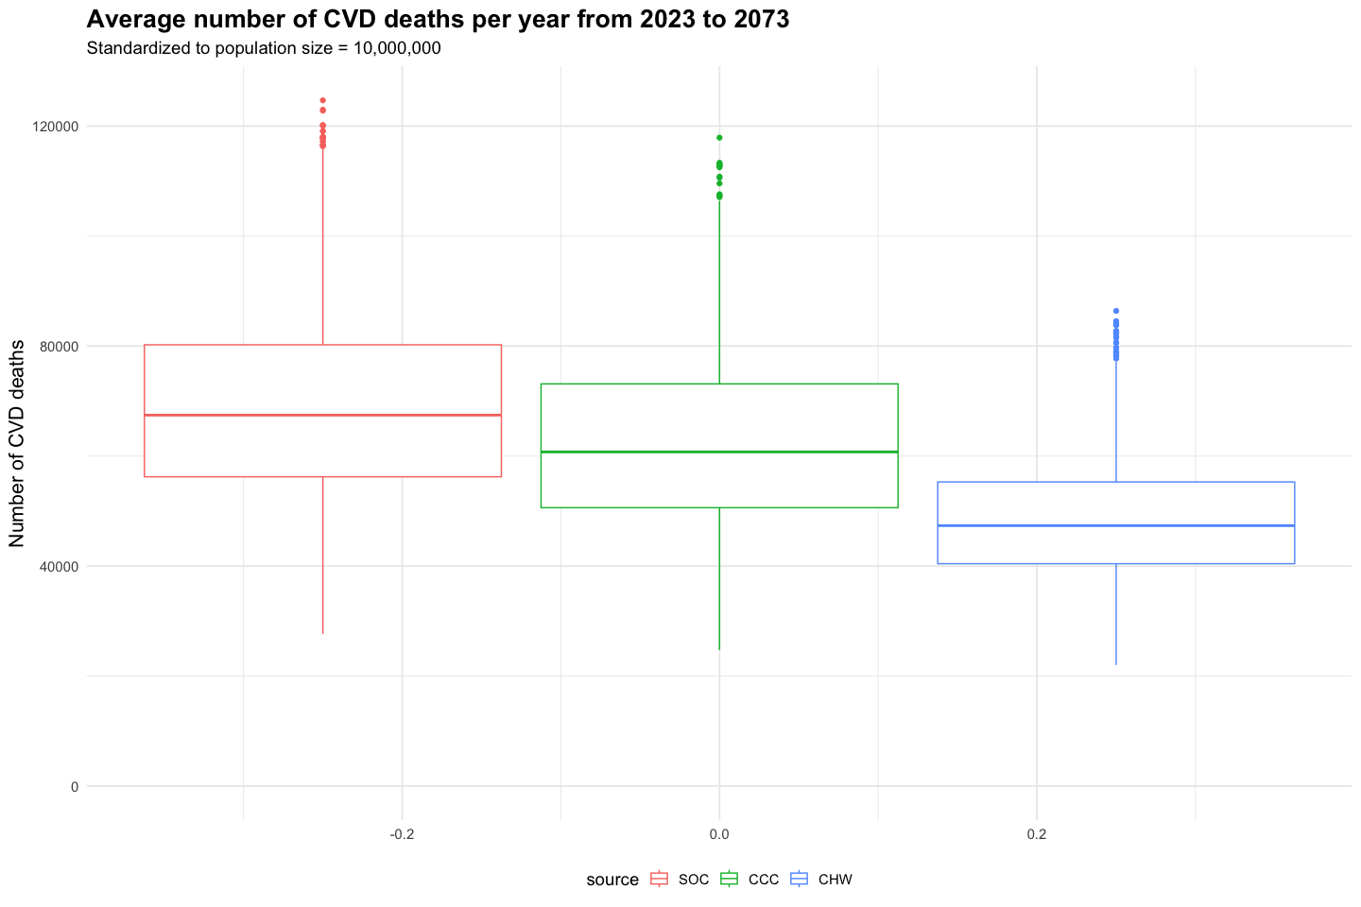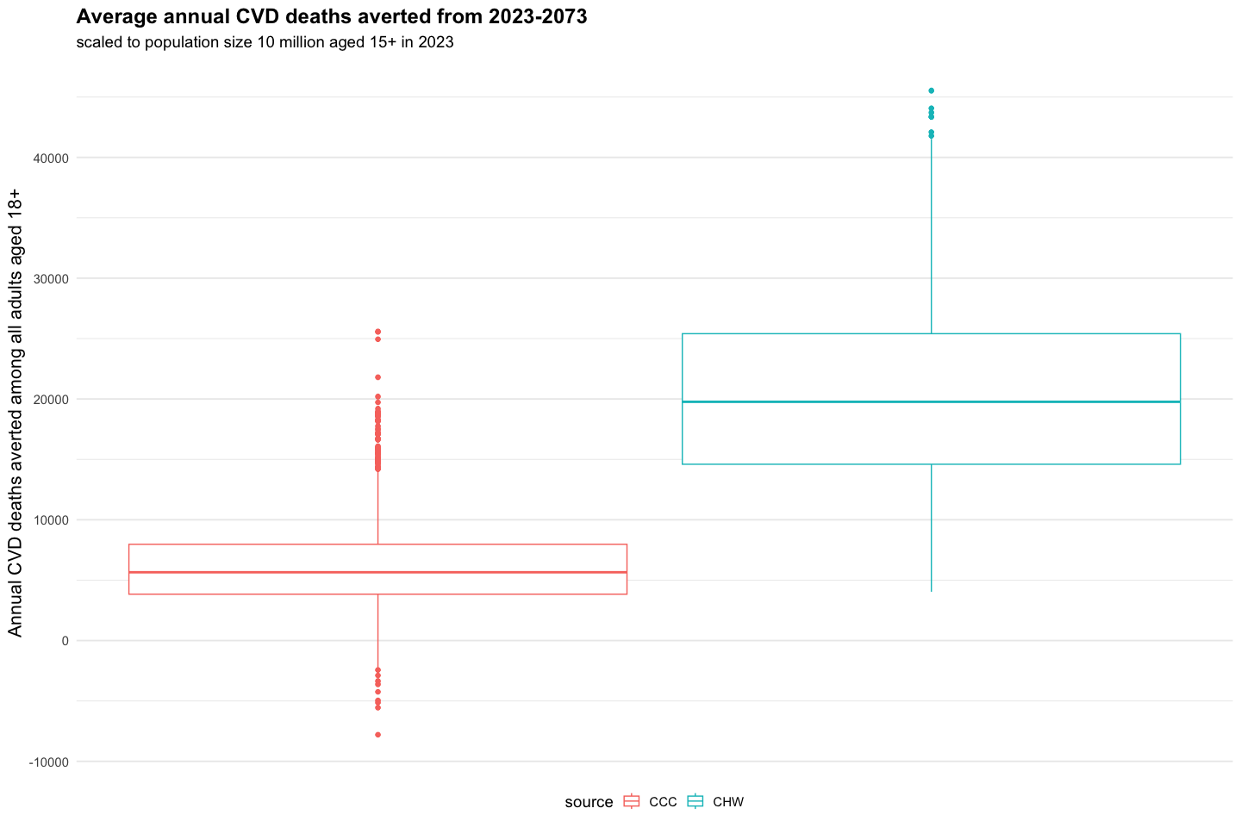

source

Mean annual number of CVD deaths (standardized to population of 10 million adults)

5%

Q1

median

Q3

95%

SOC

68633.83

42337.17

56210.57

67423.03

80210.74

99492.58

CCC

62437.77

38609.32

50601.79

60735.94

73092.05

91879.29

CHW

48289.03

32145.57

40424.89

47324.71

55273.29

67596.77

source

Mean annual number of CVD deaths averted (standardized to population of 10 million adults)

5%

Q1

median

Q3

95%

CCC

6196.06

1949.01

3836.71

5653.78

7967.36

12314.37

CHW

20344.81

8891.18

14596.37

19765.35

25405.05

33584.88

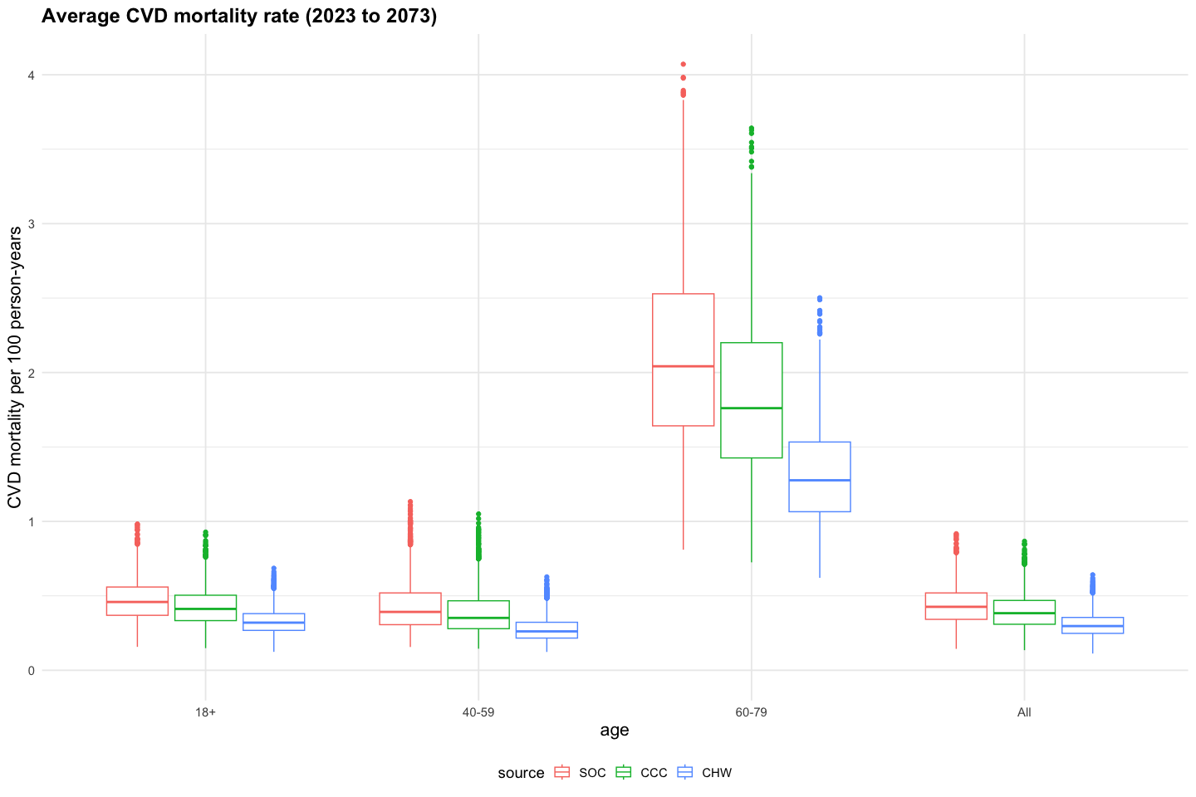

source

Mean annual CVD mortality rate

min

Q1

median

Q3

max

SOC

0.86

0.14

0.37

0.49

0.96

4.07

CCC

0.76

0.13

0.33

0.45

0.85

3.64

CHW

0.56

0.11

0.26

0.33

0.63

2.50

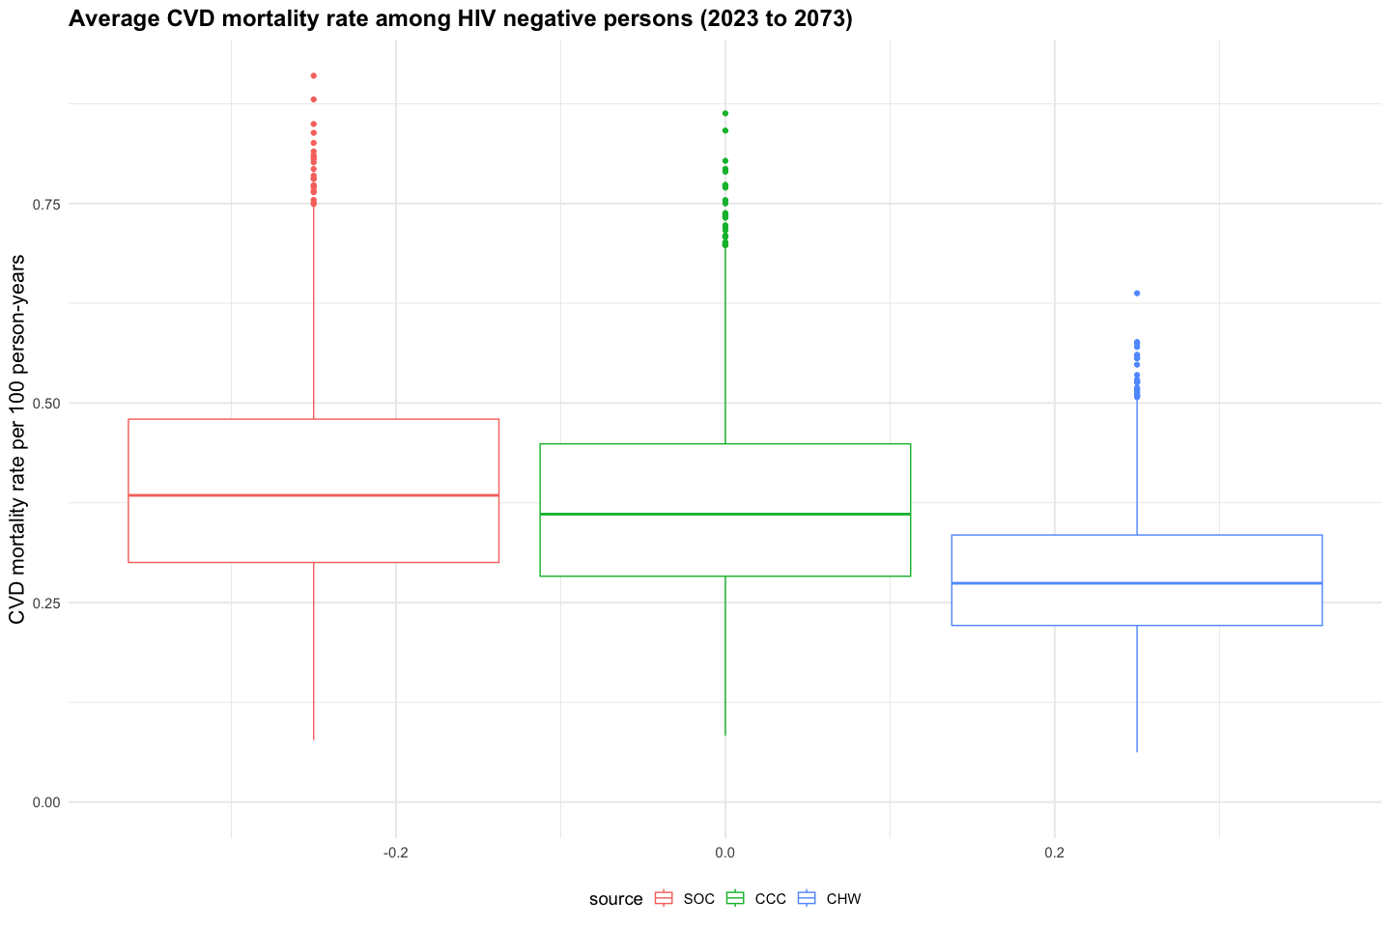

source

Mean CVD mortality rate among HIV-neg

min

Q1

median

Q3

max

SOC

0.40

0.08

0.30

0.38

0.48

0.91

CCC

0.37

0.08

0.28

0.36

0.45

0.86

CHW

0.28

0.06

0.22

0.27

0.33

0.64

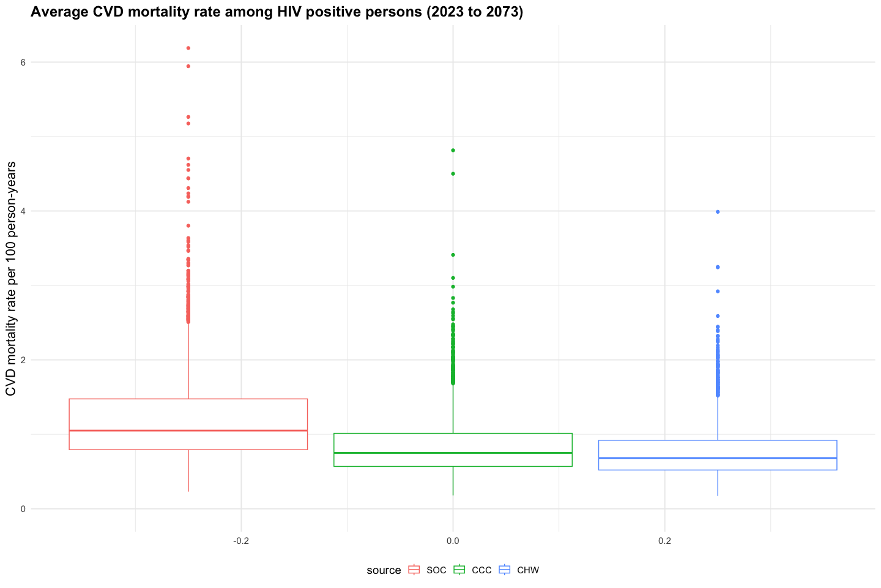

source

Mean CVD mortality rate among HIV+

min

Q1

median

Q3

max

SOC

1.09

0.42

0.95

1.09

1.24

1.66

CCC

1.07

0.42

0.93

1.07

1.22

1.62

CHW

1.01

0.40

0.89

1.01

1.14

1.45

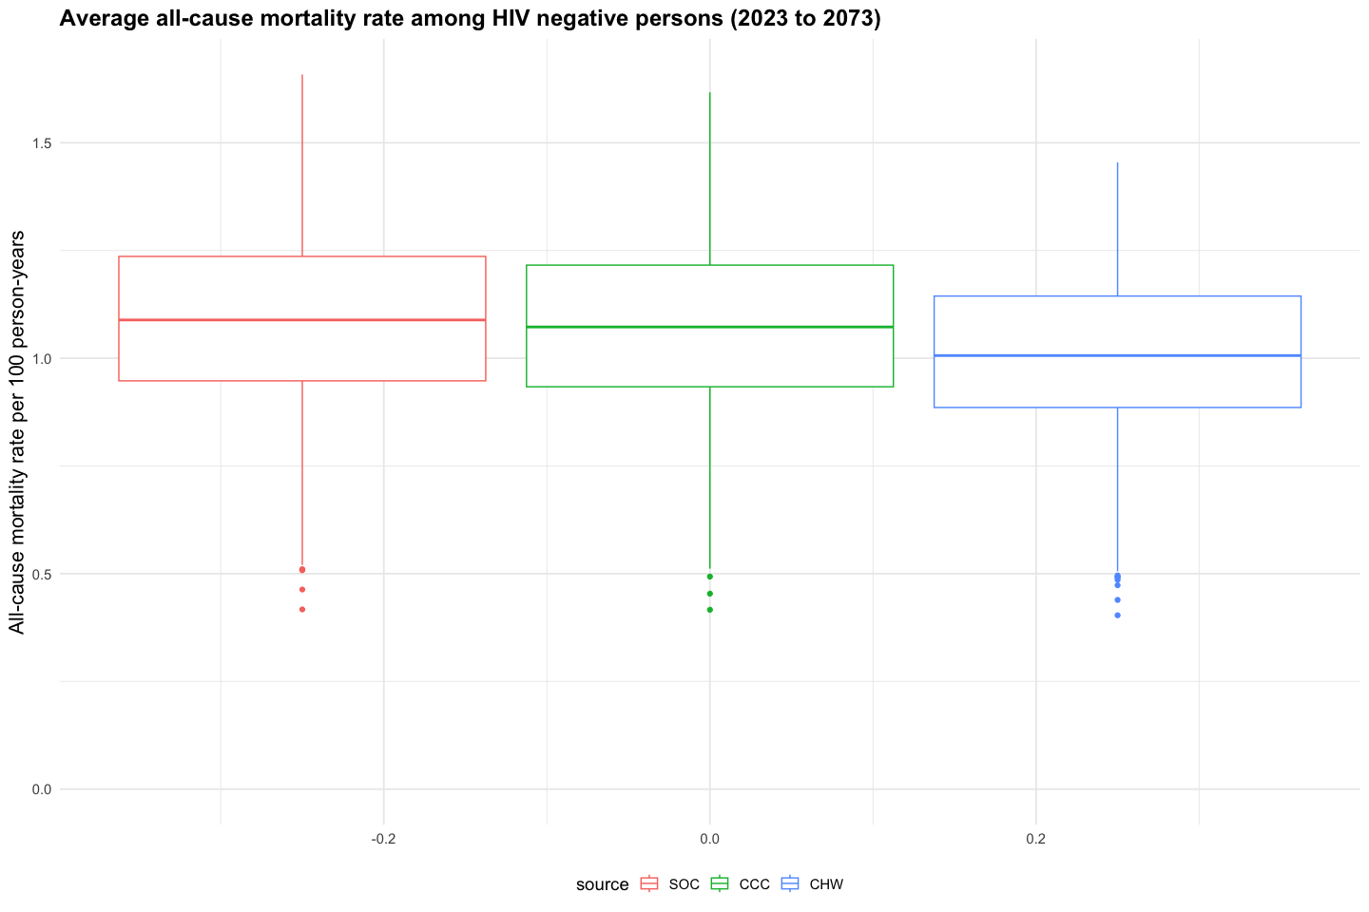

source

Mean all-cause mortality rate among HIV-neg

min

Q1

median

Q3

max

SOC

1.09

0.42

0.95

1.09

1.24

1.66

CCC

1.07

0.42

0.93

1.07

1.22

1.62

CHW

1.01

0.40

0.89

1.01

1.14

1.45

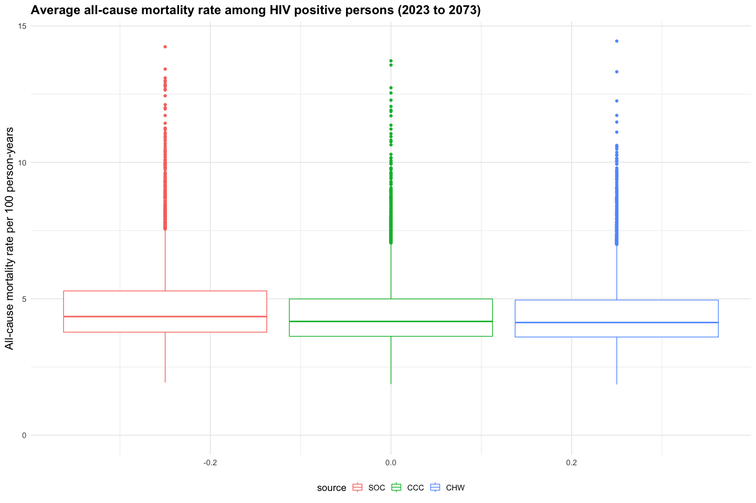

source

Mean all-cause mortality rate among HIV+

min

Q1

median

Q3

max

SOC

4.81

1.93

3.78

4.35

5.29

14.23

CCC

4.56

1.87

3.63

4.17

4.99

13.72

CHW

4.52

1.86

3.60

4.13

4.95

14.44

## Cost

Cost assumptions (in USD):

* Community health worker screening: $3/person screened (estimates from SEARCH)
* Transportation voucher: $5/person linked (Hickey 2022)
* Clinic visits: $20/visit if uncontrolled and $10/visit if controlled (Shade 2021, Shiri 2021)
* HTN medications (90-day supply) (Resolve to Save Lives 2022)
  + Med 1 & 2: $1.5
  + Med 3: $3
* Acute MI/CVA treatment (Subramanian 2019)
  + MI: $2270
  + CVA: $2420
  + cost of acute care that is not effective (poor-quality):
    - MI: $1135
    - CVA: $1210
    - we assume that some poor quality care may be due in part to limited staffing, diagnositic equipment, and medications - and therefore may also cost less. In other cases, similar interventions/diagnostic tests may be undertaken, though the effectiveness will be lower due to delays in care. We assume that such care for acute MI/CVA costs 50% of the cost of effective acute care

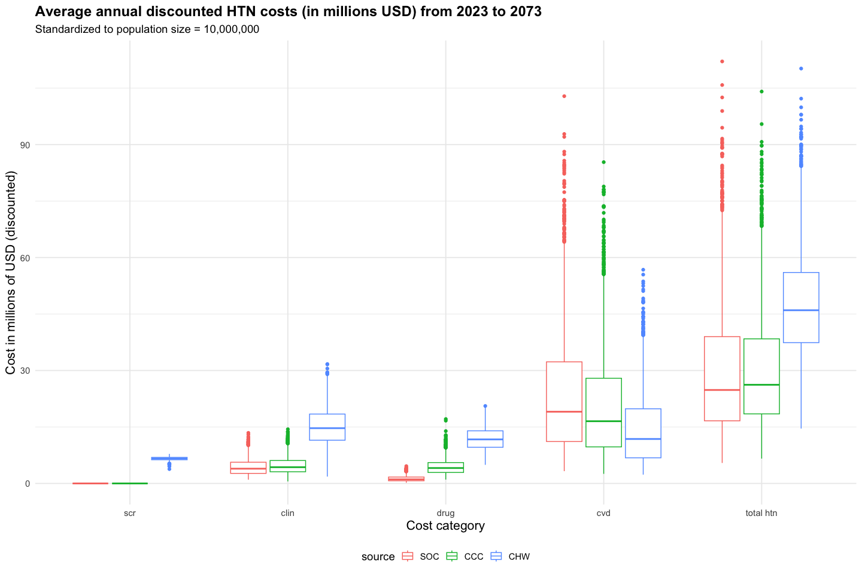

source

Mean annual discounted hypertension cost from 2023-2073 (millions USD)

min

Q1

median

Q3

max

SOC

29.4

5.4

16.6

24.8

39.0

112.1

CCC

29.9

6.6

18.5

26.2

38.4

104.1

CHW

47.9

14.6

37.4

46.0

56.0

110.2

## Cost-effectiveness

### Cost-effectiveness frontier

