Introduction

Methods

Results

Discussion

Tables

**Table 1 Study Information**

|  | **PEG 1** | **PEG 2** |
| --- | --- | --- |
| Sample size (female/male) | 231/310 | 64/145 |
| Age (mean, range) | 69 (35-92) | 71 (46-92) |

**Supplementary Table 1** Fractional Ancestry Information among four clusters1

|  | **PEG 1 clusters** | | | | **PEG 2 clusters** | | | |
| --- | --- | --- | --- | --- | --- | --- | --- | --- |
| Self-reported ethnicity | 1 | 2 | 3 | 4 | 1 | 2 | 3 | 4 |
| Latino | 0.038 | 0.490 | 0.470 | 0.002 | 0.034 | 0.492 | 0.472 | 0.001 |
| White | 0.011 | 0.007 | 0.976 | 0.006 | 0.009 | 0.017 | 0.970 | 0.004 |
| Asian | 0.280 | 0.717 | 0.002 | 0.001 | 0.279 | 0.718 | 0.002 | 0.001 |
| Native American | 0.024 | 0.008 | 0.965 | 0.003 | 0.005 | 0.003 | 0.985 | 0.008 |
| Other |  |  |  |  | 0.003 | 0.002 | 0.991 | 0.004 |

1 ethnicity clusters defined in STRUCTURE software program

**Table 2: List of ten meQTLs ranked by statistical evidence, discovered in PEG1 and replicated in PEG2**

(Supplementary table lists all results at FDR<0.05)

| **type** | **snp** | **allele** | **gene** | **cohort** | **p-value** | **FDR** | **beta** | **cohort** | **p-value** | **FDR** | **beta** |
| --- | --- | --- | --- | --- | --- | --- | --- | --- | --- | --- | --- |
| cis | GSA-rs1040961 | G | cg17707870 | peg1 | 2.65E-242 | 2.50E-234 | 0.463637 | peg2 | 1.25E-83 | 1.23E-76 | 0.48246 |
| cis | rs10010994 | C | cg17858192 | peg1 | 9.19E-232 | 4.35E-224 | 0.384347 | peg2 | 9.10E-75 | 2.70E-68 | 0.38966 |
| cis | exm2267473 | G | cg09084244 | peg1 | 1.33E-217 | 4.20E-210 | 0.425392 | peg2 | 2.73E-72 | 5.70E-66 | 0.415686 |
| cis | rs10184015 | A | cg02502145 | peg1 | 6.88E-215 | 1.63E-207 | 0.458718 | peg2 | 9.63E-80 | 4.72E-73 | 0.483753 |
| cis | rs2532925 | G | cg04145681 | peg1 | 9.34E-215 | 1.77E-207 | 0.473452 | peg2 | 2.21E-76 | 7.74E-70 | 0.458496 |
| cis | GSA-rs1035142 | T | cg07227024 | peg1 | 1.79E-205 | 2.83E-198 | 0.429669 | peg2 | 1.97E-75 | 6.23E-69 | 0.438633 |
| cis | GSA-rs10750097 | G | cg12556569 | peg1 | 1.30E-203 | 1.75E-196 | 0.384724 | peg2 | 3.05E-80 | 1.57E-73 | 0.408519 |
| cis | rs2883456 | C | cg11144103 | peg1 | 2.55E-203 | 3.01E-196 | 0.437497 | peg2 | 1.28E-93 | 4.18E-86 | 0.46732 |
| cis | rs1939015 | G | cg10306192 | peg1 | 7.31E-200 | 7.68E-193 | 0.493061 | peg2 | 3.28E-93 | 8.04E-86 | 0.539282 |
| cis | rs1043793 | A | cg02502145 | peg1 | 2.07E-198 | 1.95E-191 | 0.452547 | peg2 | 1.71E-47 | 3.06E-42 | 0.439154 |

**Table 3: List of ten meQTLs ranked by statistical evidence, discovered in PEG1 and replicated by Nall GWAS**

|  |  |  |  |  | **meQTL evidence** | | | **GWAS evidence** | | | |
| --- | --- | --- | --- | --- | --- | --- | --- | --- | --- | --- | --- |
| **type** | **snp** | **allele** | **probe** | **cohort** | **pvalue** | **FDR** | **beta** | **beta** | **se** | **pvalue** | **gene** |
| cis | rs72660967 | T | cg06961873 | peg1 | 1.79E-158 | 2.92E-152 | 0.408418 | 0.0439 | 0.019 | 0.0206 | missing |
| cis | rs10903129 | A | cg06961873 | peg1 | 7.88E-158 | 1.22E-151 | -0.409488 | -0.0435 | 0.0168 | 0.009549 | missing |
| cis | rs3087801 | G | cg10776061 | peg1 | 3.55E-157 | 5.42E-151 | 0.37696 | -0.0401 | 0.0185 | 0.03017 | missing |
| cis | rs9276490 | A | cg18572898 | peg1 | 1.70E-153 | 1.78E-147 | 0.41004 | -0.0448 | 0.0224 | 0.04595 | missing |
| cis | rs9649865 | A | cg25543264 | peg1 | 4.91E-152 | 4.65E-146 | 0.385467 | 0.0505 | 0.0223 | 0.02349 | missing |
| cis | rs166849 | G | cg13143872 | peg1 | 5.40E-150 | 4.65E-144 | 0.312391 | -0.0391 | 0.0192 | 0.04131 | missing |
| cis | rs10191694 | A | cg15147113 | peg1 | 2.74E-148 | 2.23E-142 | 0.108973 | 0.0717 | 0.0235 | 0.002248 | missing |
| cis | rs7799245 | G | cg11957130 | peg1 | 7.39E-146 | 4.95E-140 | 0.440158 | 0.0685 | 0.0246 | 0.005368 | missing |
| cis | rs9276490 | A | cg07389699 | peg1 | 1.04E-145 | 6.40E-140 | 0.342294 | -0.0448 | 0.0224 | 0.04595 | missing |
| cis | rs9689 | A | cg06961873 | peg1 | 2.71E-135 | 1.34E-129 | -0.392911 | -0.0392 | 0.0175 | 0.02491 | missing |

**Figure 1: meQTL enrichment in GO Biological Process (GREAT analysis)**

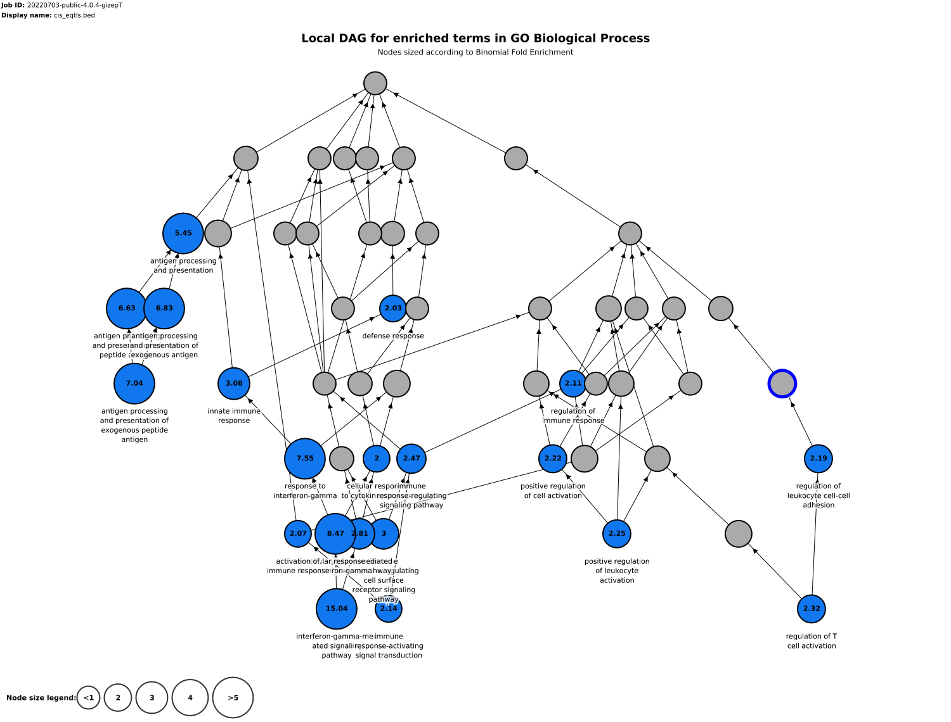

**Table 4: List of ten meQTLs ranked by statistical evidence, also found in BIOS repository**

|  | **SNP** | | **Probe** | |  |  |  |  |  |
| --- | --- | --- | --- | --- | --- | --- | --- | --- | --- |
| **Chr** | **ID** | **Position** | **ID** | **Position** | **Alleles** | **Tested Allele** | **Z-score** | **p-value** | **HGNCName** |
| 13 | rs11616903 | 50424677 | cg04520693 | 50425377 | C/T | T | 72.6668802 | 3.27167E-310 | RNY4P30 |
| 4 | rs4406078 | 57521325 | cg19978674 | 57523802 | T/C | T | 72.1343579 | 3.27167E-310 | HOPX |
| 2 | rs12475055 | 102878891 | cg23719516 | 102870432 | A/C | A | -71.8785276 | 3.27167E-310 | AC007248.6 |
| 11 | rs515449 | 122047290 | cg13160852 | 122047052 | G/A | A | -71.3891567 | 3.27167E-310 | RP11-820L6.1 |
| 8 | rs10086636 | 126604637 | cg08775595 | 126608666 | C/T | T | -71.3193873 | 3.27167E-310 | RP11-136O12.2 |
| 4 | rs11730732 | 119761678 | cg11663691 | 119759924 | A/G | A | 71.2074002 | 3.27167E-310 | SEC24D |
| 8 | rs10090179 | 144339053 | cg19504605 | 144339082 | G/A | A | -71.1133419 | 3.27167E-310 | ZFP41 |
| 8 | rs1454616 | 126611214 | cg08775595 | 126608666 | T/C | C | -71.0101274 | 3.27167E-310 | RP11-136O12.2 |
| 14 | rs10483261 | 22356551 | cg16702660 | 22361306 | T/C | C | -70.9943176 | 3.27167E-310 | TRAV8-4 |
| 17 | rs9894429 | 79596811 | cg21028142 | 79581735 | C/T | T | 70.9090052 | 3.27167E-310 | NPLOC4 |