LSDiff plugin manual (release v0.9.0)
(Last updated 10 Nov 2009)

Requirements
LSDiff has been extensively tested on Eclipse version 3.5 on a Windows platform. Support is expected but not guaranteed for any version of Eclipse after 3.2.

1. Using the LSDiff plugin

The LSDiff plugin is implemented as a view. It can be found in Show View -> Other -> LSDiff -> LSDiff Rules.

To start, click on the Open Project button.
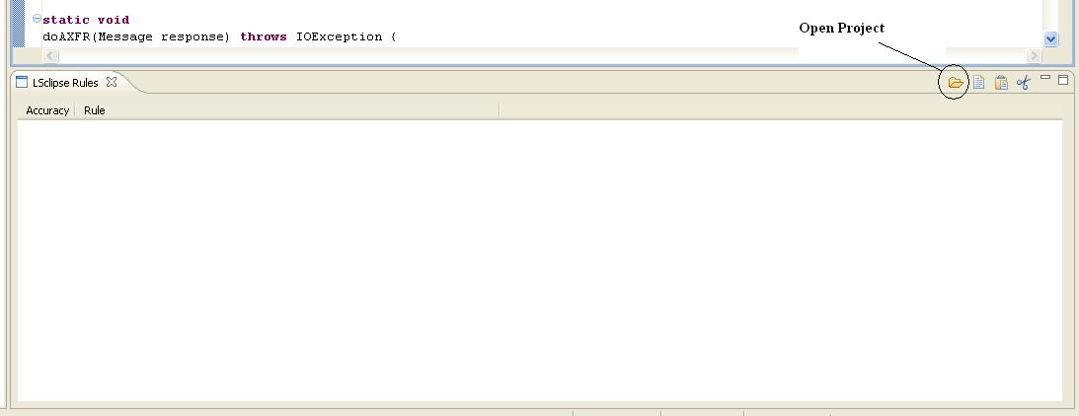

This will launch the File Selection dialog. This dialog selects the program versions to be parsed by LSDiff. There are two ways to do selection.

a) Select by Workspace Diff

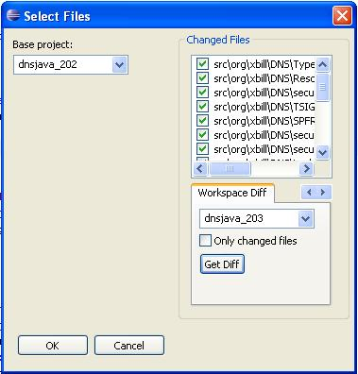 | To find changes by workspace diff, do the following:  i. Create one project in Eclipse for each version of the program and open them. Make sure they are named differently.  ii. Select the earlier version as the base project.  iii. Switch to the 'Workspace Diff' tab and select the later version as the changed project.  iv. Click on 'Get Files' to find changed files.

b) Select by SVN Log

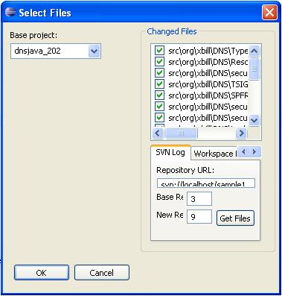  * There is no need to create another project for the changed version. It is automatically created from the base version and changed files. | To find changes by SVN log:  i. Make sure the base version is opened as an Eclipse project. *  ii. Select the base project.  iii. Enter the SVN URL. This URL must point to the project root (ie not the repository root or to a subfolder in the project).  iv. Enter the base and new revision numbers. The base revision must be identical to the currently selected base project.  v. Click on 'Get Files' to find changed files based on the SVN log.

After selecting versions to compare, start LSDiff by click the OK button.
This process may take several minutes.
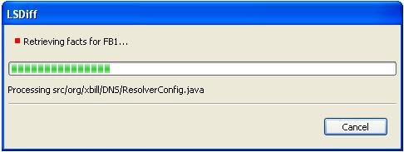

When it is done, the rules found by LSDiff will appear in the view.
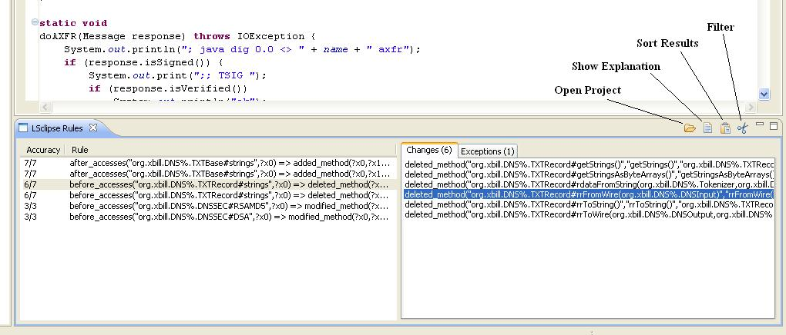
Accuracy refers to how often the consequent of the rule is matched out of the total number of time the antecedent of the rule is matched. Clicking on the Explain button will show the Matches and Exceptions to the rule. Double-clicking will jump the cursor to the next location of this match.

2. Interpreting rules

The result of running LSDiff is a set of ungrounded logic rules and the set of structural facts that support them.
In this screenshot the selected rule is:

before_accesses(“org.xbill/DNS%.TXTRecord#strings”,?x0) =>
deleted_method(?x0,?x1,?x2)

There are six facts that support this rule and one exception where the antecedant is found but not the consequent. Facts are structural differences between the program versions. For example, the selected structural changed is the method org.xbill.DNS%.TXTRecord#rrFromWire was deleted in the new version.

3. Known Issues (as of release v0.9.0)

a. Retrieving changes via SVN does not work. The most reliable way to use LSDiff now is via workspace diff.

b. Natural language translations of inferred rules are currently not available. This feature will be available soon!

c. Sorting and filtering of rules by type and accuracy is currently not available.

