Using Outlook Tasks to Manage E-Resources: Instructions for Distributors
1/30/07 cmh_rev

- All e-resource cataloging requests should be sent to the ERDb-new shared email account (erdb-new@library.ucla.edu), or forwarded there if received in some other way. List owner for the ERDb-new shared email account reviews new messages, and either assigns the task to a cataloger, or sets the category of the email to match the section to which the task should be assigned. Once the task has been assigned, owner or distributor will archive the message by moving it to the ERDb-new account’s Sent items folder.

  - Assigning tasks

From the ERDb-new shared email account, drag the email to the ERDb-new shared Tasks account, and drop it there. It will open a new task window. Set the category to match the appropriate section. Assign the task to a cataloger, including any special instructions (e.g. bib record number for overlay, etc.). Set a start date corresponding to the day the task is assigned and a due date 1 month away for non-rush requests or 1 week away for rush requests. Set the Status for the task to In Process. Leave the defaults of Keep an updated copy of this task on my task list and Send me a status report when this task is complete checked.

Subject lines for tasks should begin with the word “NEW” followed by the ERDb resource # (if there is one), or by the word “NEW” followed by the requestor’s user id and the first three words of the title. If there is a rush request for the resource, add the word “RUSH” to the beginning of the Subject.

Examples:
a. NEW: ERDb resource #117848
b. RUSH NEW: dhirsch: Irak Turkleri Kultur

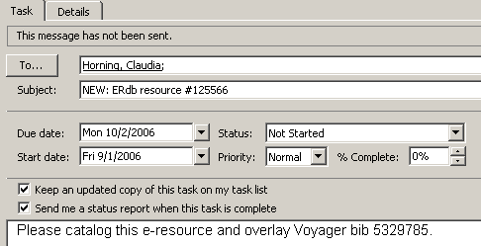

  - Flagging messages for review

For email requests not assigned directly, list owner will “flag” the message for review by the appropriate distributor. Each distributor is responsible for reviewing and assigning (see above) the tasks for their section.

To flag a message, highlight it, and then select Follow Up in the Actions menu and choose the colored flag associated with the section. (Alternate method: Highlight the message, and right-click on the greyed-out flag in the far right column, and then select the correct flag.)

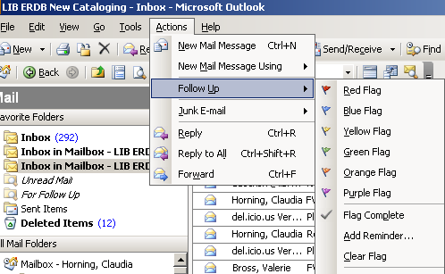

- Once tasks have been distributed to catalogers, they will display in the shared ERDb-new tasks account as “owned” by the cataloger. Catalogers must either accept or decline the task.

  - If the cataloger accepts the task, they should set the Status of the task to “Complete” once the resource has been cataloged. The cataloger should include either the Voyager bib id or the OCLC # for the cataloged title.

  - If a cataloger accepts a task but can’t complete it, s/he should assign the task back to the ERDb-new shared account (erdb-newcat@library.ucla.edo), including an explanation for the reassignment. The subject line of the task should be edited to begin with “REASSIGN.” Owner/distributors will review and re-assign appropriately.

If the cataloger declines the task, ownership reverts back to the shared ERDb-new task account, and the task will be reassigned to another cataloger.

Notifications are sent to the shared ERDb-new email account when the status of tasks changes. Once a task completion notice has been received, the list owner will notify the original requestor that the work has been done.
- Owner(s) and distributors are responsible for monitoring the shared task list to make sure assignments are being completed in a timely fashion. If a cataloger becomes unavailable, owner or distributor will delete the tasks from that cataloger’s task list and re-assign them to other catalogers.

