Recording Publication Dates for IRs
8/23/07

3 relevant rules:
- AACR2 1.4F8
- LCRI 1.4F8
- IR.6.2.2

AACR2 1.4F8
- If viewing 1st iteration: give date in 260 $c, followed by hyphen
- If not viewing 1st iteration: give date in 362
- Option: give date in 260 $c, “if the information can readily be ascertained”

LCRI 1.4F8
- “When the resource includes an explicit statement,” apply AACR2 option and give date in 260 $c
- Examples of explicit statements:
“Created on March 10, 2001.”
“Began publication in 1998.”
- Statement must be in the resource itself
- Examples of 362 wording and formatting:
362 1 $a Began in 2000?
362 1 $a Began in 2001 or 2002.
362 1 $a Began between 1997 and 1999.
not 362 1 $a Began in 2002.

BIBCO Participants’ Manual, Appendix A, IR.6.2.2
- It’s rare to view the 1st iteration
- Examples of explicit statements and sources where these statements can be found (eg. home page, login screen, menu, communications with the publisher, etc.)
- Range of copyright dates: intellectual content vs. date of publication
- 1st in range of copyright dates is not an explicit statement of publication date
- Single copyright date isn’t necessarily the beginning date

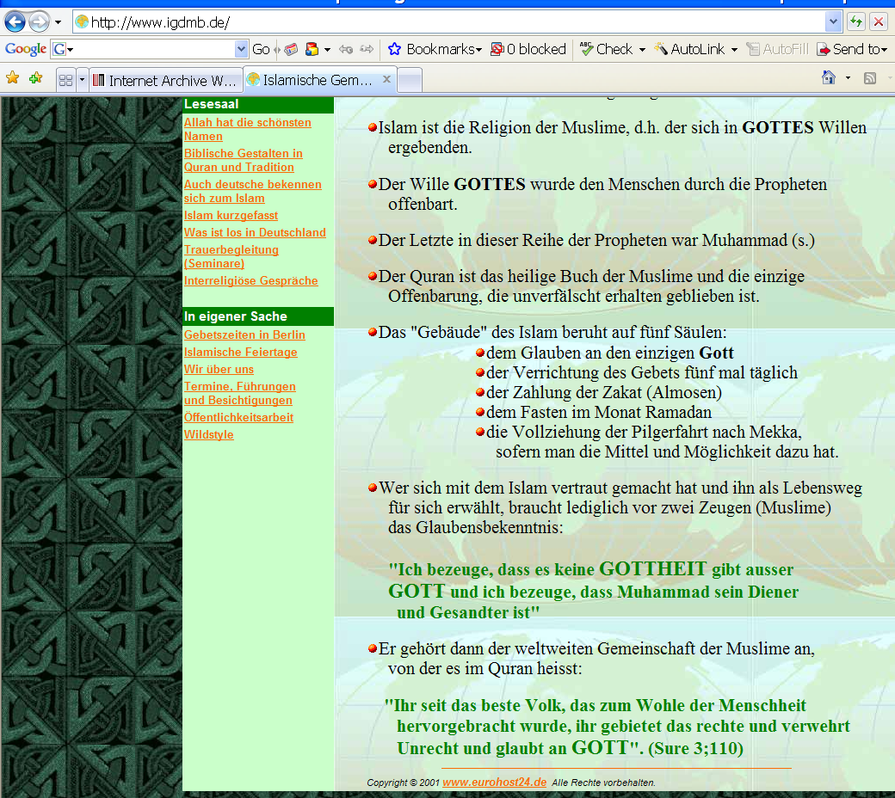

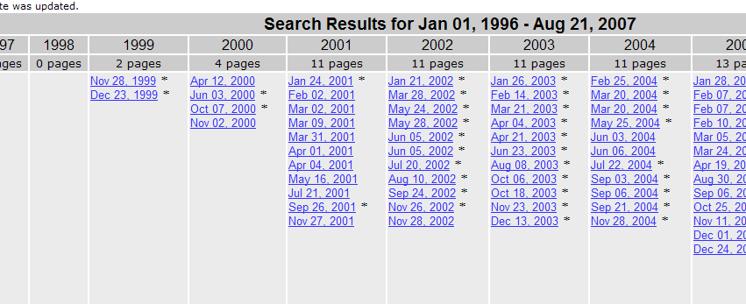

Lacks explicit statement. Copyright date of 2001. Internet Archive shows the first iteration was in 1999.

Transcription: 362 1 ‡a Began in 1999?

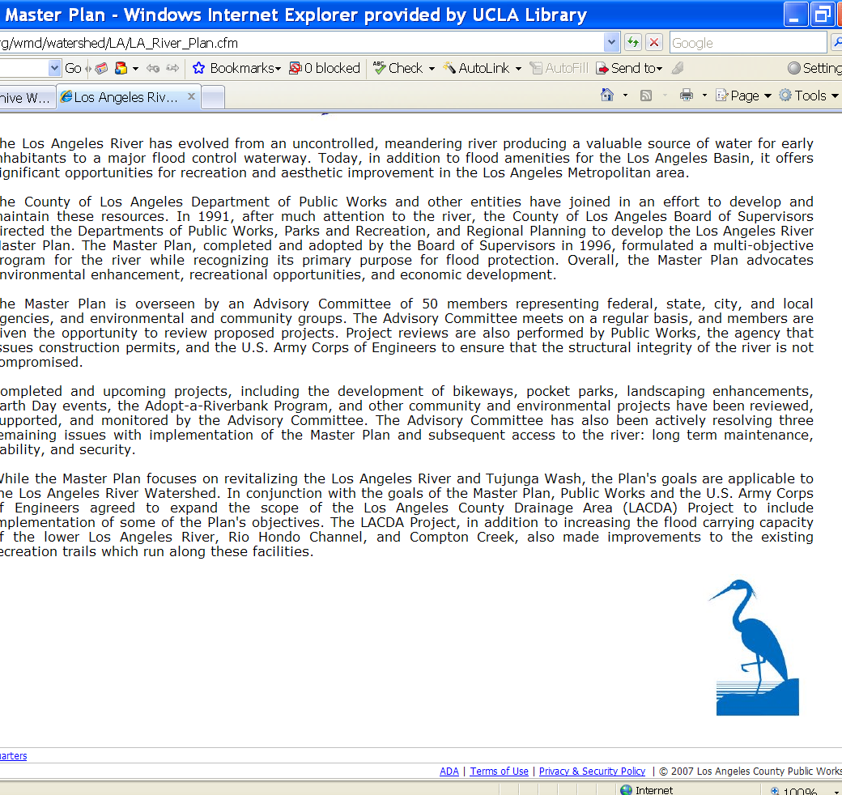

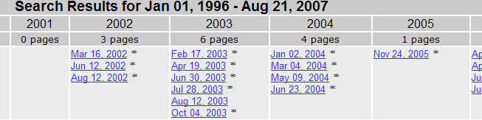

Lacks explicit statement. Copyright date of 2007. Internet Archive shows the first iteration was in 2002.

362 1 ‡a Began in 2002?

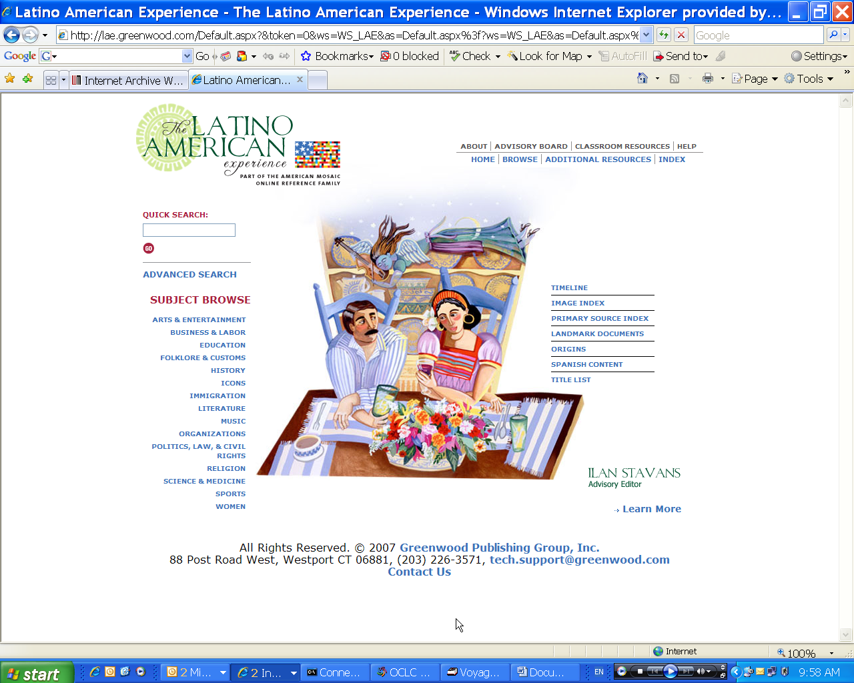

“First Iteration”
260 ‡c vs. 362

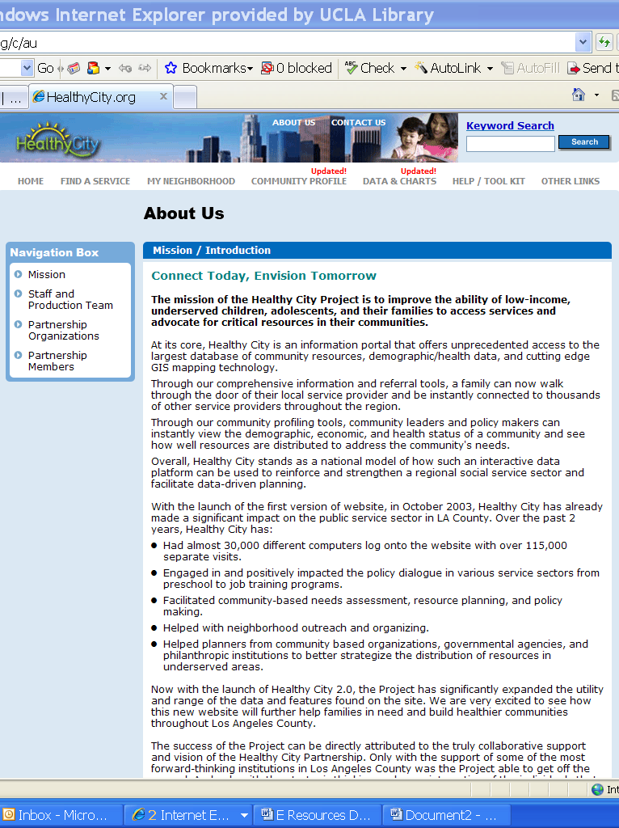

Explicit statement!

Transcription: 260 ‡a Los Angeles, CA : ‡b Healthy City, ‡c [2003]-
 

