Session 8: Exercises

Part A. What is an electronic serial? For exercises 1 and 2 decide whether this resource would or would not be cataloged as a serial and give your reasons why.

Example 1.
Cover pictures on the archive page are hot links to issues.

Home page: | the magazine of classic 20th century popular culture
 | February 1999 issue 2 · volume 4
 | RETRO
Archive page: | March/April 1996

- Enumeration and chronology appear on the home page and link to the current issue.
- The March/April issue is available so there are clearly designated issues.

Example 2.

There are no individual issues. News stories and fishing reports are updated daily, weekly, etc.

Home page: | Alaska Outdoor Journal.com
 | Alaska's only real-time Internet magazine!
 | Sunrise: 9:42 Last Update: 01/23/99 5:29 AM Sunset: 4.52

1. This is not a serial since there are no designated issues. There is only a date of update. This is an integrating resource, despite the fact that it calls itself a journal and a magazine.

Part B. Description of electronic serials

Examples 1 through 3:

Use the workforms provided in Appendix D to record the cataloging data from the information provided in the following pages.

- Select the chief source;
- transcribe and tag the title proper;
- select and tag a main entry, if any;
- make any title added entries thought useful;
- record the appropriate designations;
- make any notes thought appropriate;
- and, add the 856 URL information.

Example 4:

This magazine exists in both a print and an online version. Catalog the title using both the two record approach and the single record approach.

Example 1

Note: there is no print equivalent for this journal. See: http://eserver.org/cultronix/ (viewed 2/4/99)

Screen shot: Table of contents, first issue



Cultronix is an interdisciplinary journal of art and cultural studies, addressing critical issues in contemporary institutions and practices. It publishes contributions spanning a wide range of media, and encourages contributors to use new media in order to expand critical and theoretical work to Internet reading audiences.


01/01/
Cultronix editorial board
Introduction
Camilla Griggers
Surge Suppressor
Chris Chesher
Colonizing Virtual Reality
Jody Baker
Modeling Industrial Thresholds
Laura Martz
Lucidity and the Anti-Work Ethic
Ed Um-Bucholtz and Geoff Sauer
Inside the Beast: the Machinic Phylum
Phoebe Sengers
Wallowing in the Quagmire of Language
Introduction
Cultronix editorial board

{material omitted}

Letters to the Editor

Publication made possible by the English Server at Carnegie Mellon.

Call for submissions page:

Cultronix invites submissions for our fifth issue, titled "Position/Possession".
Cultronix 5 will attempt to map the intersections of position and possession. We see this as necessary in the case of the Internet, which has been territorialized using spatial metaphors (like web, highway, network, mall, community, market, and frontier), to quietly reproduce a preexisting structure on a new imaginary space without public critical inquiry. This issue might include submissions on copyright, disperse communities, spams, censorship... Articles that discuss how these cultural geographies understand the world in terms of property (including intellectual property) are especially encouraged. Questions or discussions of the utility, boundaries or limits of this topic are welcome on our mailing list. Submissions may be in plain-text, formatted text, graphics, audio, video or interactive multimedia. Contact us by e-mail or fax if you have questions about the file formats we recommend and/or can support.

e-mail: cultsubmissions@eserver.org
fax: (412) 268-7989
ftp: ftp://eserver.org/www/cultronix/dropbox/
mailing list: cultronix@eserver.org
u.s. mail: Cultronix
English Department, CMU
259 Baker Hall
Pittsburgh, PA 15213-3890 USA

Example 1:

Cataloging record:

Type a ELvl I Srce d GPub Ctrl Lang eng
BLvl s Form s Conf ■ Freq ■ MRec Ctry pau
S/L 0 Orig ■ EntW Regl ■ Alph
Desc a SrTp p Cont DtSt c Dates 1994,9999

006 $a [m ]
007 $a c $b r
245 00 $a Cultronix $h [electronic resource].
260 -- $a Pittsburgh, PA : $b English Dept., CMU
362 1- $a Began with issue 1 (fall 1994)-
500 -- $a Description based on first issue; title from table of contents (publisher’s Web site, viewed Feb. 4, 1999).
856 40 $u http://eserver.org/cultronix/

Note: there is no 856 for the email address since it is for submissions only.

Example 2

Note: there is no print equivalent for this journal. See: http://www.scifi.com/sfw/ (viewed 2/4/99)

Journal home page:

________________________________

Feb. 1, 1999  Issue 94  Vol. 5, No. 5 |  | Now More Than  88,000  Registered Readers!

Sign up on our mailing list for your chance to win a free T-shirt:
Featured Artist: Eric Knight Holbrook

--------------------------------------------------------------------------------

IN THIS ISSUE

--------------------------------------------------------------------------------
Cool Stuff and Games return to our pages, while Anime and Sound Space get the week off. We're also bringing an end to the Pokemon debate in our letters column, we have tons of news about your favorite TV shows, and more.

NEWS OF THE WEEK

TNT may drop Crusade, Fox cancels Brimstone, Gene Roddenberry's Earth: Final Conflict is renewed, and more.
ON SCREEN

Go behind the scenes with Leonard Nimoy, John de Lancie and the Alien Voices acting troupe to see how The Lost World was made.

OFF THE SHELF

Stephen Baxter explores the Xeelee universe with Vacuum Diagrams, while John Barnes treats readers to both stories and essays in Apostrophes and Apocalypses.
CLASSICS

The alien invasion of Earth has begun, but instead of death rays and flying saucers we're fighting ourselves in Robert A. Heinlein's The Puppet Masters.

{material omitted}
(c) Copyright 1999, Science Fiction Weekly ™
________________________________
Table of contents of earliest available issue:

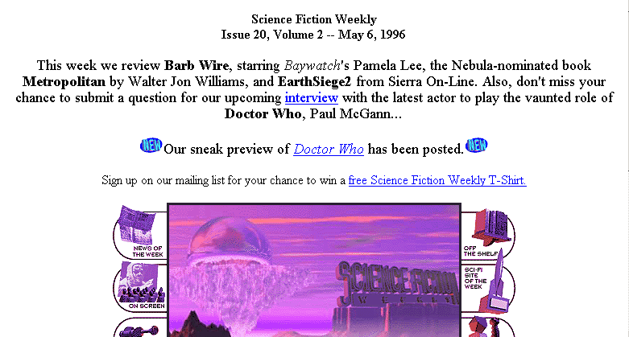
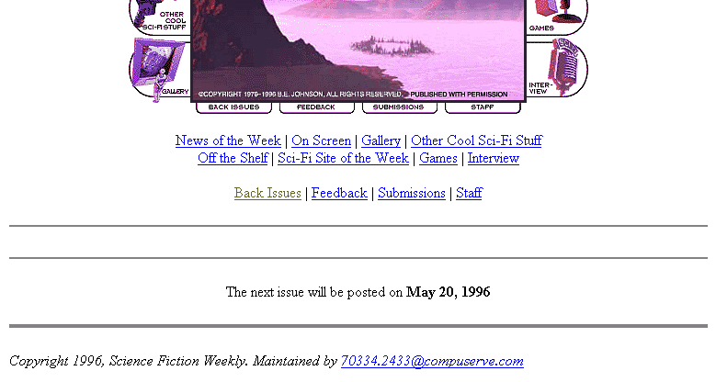

Staff page:

Science Fiction Weekly is published every other week on the World Wide Web. It is freely available to users at the URL: http://www.scifiweekly.com. All inquiries and editorial submissions may be sent to:
Science Fiction Weekly
120 Cedar Grove Lane, Suite 347
Somerset, NJ 08873
1-732-560-7307 phone/fax

Example 2

Cataloging record

Type a ELvl I Srce d GPub Ctrl Lang eng
BLvl s Form s Conf ■ Freq ■ MRec Ctry nju
S/L 0 Orig ■ EntW Regl ■ Alph
Desc a SrTp p Cont DtSt c Dates 199u,9999

006 $a [m ]
007 $a c $b r
245 00 $a Science fiction weekly $h [electronic resource].
260 -- $a Somerset, NJ : $b Science Fiction Weekly
310 -- $a Biweekly
500 -- $a Description based on v 2, issue 20 (May 6, 1996); title from table of contents (publisher’s Web site, viewed Feb. 4, 1999).
500 -- $a Latest issue consulted: Vol. 5, no. 5 (Feb. 1, 1999) = issue 94.
856 40 $u http://www.scifiweekly.com

Example 3

Note that several other print journals have the same title but that there is no paper version of this title.

Journal home page at: http://www.retroactive.com/ (viewed (1/28/99)



Archive page: the small cover image is a hot link to the March/April 1996 issue.

THIS PAGE shows RETRO's back issues from 1996, RETRO's first year. We started publishing in March, 1996. To see the contents of each issue, just click on the image. For 1998, go here. For 1997, go here.
Bottom of Form 1
Bottom of Form 1


March/April 1996: "Hawaii"

Top portion of table of contents page:
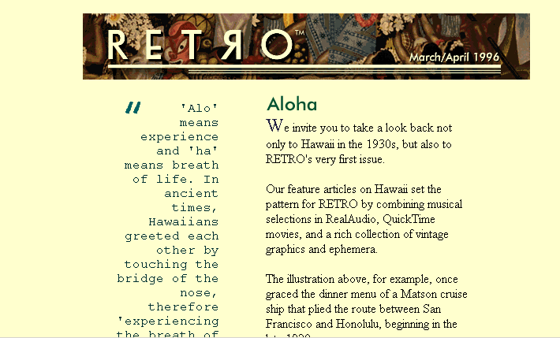
{part of this screen omitted} Bottom portion of the same table of contents page:
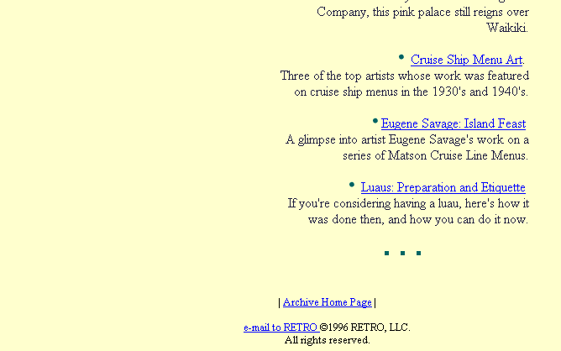

About Retro page:

What is RETRO?
RETRO is an online magazine that celebrates classic popular culture of the first three-fourths of the 20th century. We feature articles on vintage personalities, politics, music, media & entertainment, fashion, design, decorating and a whole lot more.
RETRO is written for people who are vintage period enthusiasts. We strive to take a lighthearted, informative approach to the classics of 20th century popular culture and style. And we search hard for the offbeat instead of the mainstream. We firmly believe that quality never goes out of style. Our mission is to help people enjoy life more in the present by grooving on the finest of the past.
How do I subscribe to your print magazine?
There is no print version of RETRO. RETRO is 100% online and electronic. And it's free.
How can I tell what's new?

A new issue of RETRO, with new feature articles, is posted the first of each month. The Table of Contents always shows what's new -- it's the best place to look.

{material omitted}

How can I contact RETRO?
You can send us e-mail by clicking on the button at the bottom of each web page, or send directly to hey@retroactive.com. Our snail mail address is P.O. Box 636, Nokomis, FL, 34274. We always welcome your feedback and suggestions.
Example 3

Cataloging record

Type a ELvl I Srce d GPub Ctrl Lang eng
BLvl s Form s Conf ■ Freq ■ MRec Ctry flu
S/L 0 Orig ■ EntW Regl ■ Alph
Desc a SrTp p Cont DtSt c Dates 1996,9999

006 $a [m ]
007 $a c $b r
245 00 $a Retro $h [electronic resource].
260 -- $a Nokomis, FL : $b Retro
310 -- $a Monthly
362 1- $a Began with Mar./Apr. 1996.
500 -- $a Description based on first issue; title from table of contents (publisher’s Web site, viewed Jan. 28, 1999).
856 40 $u http://www.retroactive.com/

Example 4

Note that this title is issued in both a print and an online version. It is available at: http://www.worth.com/

Journal home page:

_______________________________________________

Nearly everything from the online and print editions of Worth ends up here. You can browse the magazine categorically, or look for an article according to the issue in which it appeared.
Occasionally, an article may not be available. We understand that this may be an inconvenience and hope that the quality and depth of what is available will make up for any gaps in our files.
Worth Online Archives
Worth Magazine Articles by Subject
Worth Magazine Articles by Date



Peter Lynch & Friends Uncover the Best Stocks to Buy Now
Once again, your man in Boston picks the brains of seven of his stock-picking peers. The result: 14 buy recommendations and some lessons you can take to the bank.

Worth Stock Challenge VIII results  See how your picks compare to those of our winner and the best possible.  http://www.equitymag.com/http://www.equitymag.com/EQUITY: It's About Women and Money  A women's financial ...  {material omitted} |  | Table of Contents  February 1999 Issue  Top Stories  The Meridian Candidate  The bite-by-deferred-bite journal of one overweight pharmaceutical pioneer.  Net Investor: Can We Chat?  The online investing …  {material omitted}

We welcome your comments and questions. Contact info@worth.com
© 1997 Capital Publishing Limited Partnership
_______________________________________________

Table of contents page for earliest issue online:

99/02 - Table of Contents
February 1999 Issue
FEATURES
Lynch & Company
Once again, seven experienced money managers talk shop with Peter Lynch. Each picks a favorite stock for the next twelve months and another for the long run. Listen and learn.
First: New, Improved
Editor John Koten introduces a cornucopia of new departments for a redesigned Worth.
Jim Rogers: All in the Family
First stop on Rogers;s three-year sojourn: Iceland. Jim finds a close- knit, well-functioning community that's not crazy about letting foreigners' money in.
By the Numbers: Poles Apart
Jonathan Butler returns to Worth to crunch the numbers where skis crunch the snow: how the big three ski-resort stocks take different trails to valuation.
Family Practice
The recent changes in Medicare make now the right time to update your parents - and yourself.
COLUMNS
JIM ROGERS: All in the Family
First stop: Iceland, home to one of the world's most intriguing and most exasperating economies.
DEPARTMENTS
NEED TO KNOW
PERSONAL ADVISER
more...
Also
FIRST THINGS FIRST
FOLLOW-UP
LETTERS
ADVOCATE

Example 4

Single Record

Type a ELvl Srce d GPub Ctrl Lang eng
BLvl s Form Conf 0 Freq m MRec Ctry mau
S/L 0 Orig EntW Regl r Alph a
Desc a SrTp p Cont DtSt c Dates 1992,9999

010 -- $a 92660054 $z sn 92000031
022 0- $a 1060-5967
037 -- $b Worth, POB 55420, Boulder, CO 80322-5420 $c $15.00 (U.S.) $a $21.00 (Can.)
040 -- $a NSDP $c NSDP $d MH $d DLC $d NST $d InU $d GU
042 -- $a nsdp $a lc
043 -- $ an-us---
050 00 $a HG4501 $b .W67
082 00 $a 332.6/0973/05 $2 20
210 0- $a Worth $b (Boston Mass.)
222 -0 $a Worth $b (Boston, Mass.)
245 00 $a Worth.
260 -- $a Boston, MA : $b Capital Pub. Co., $c c1992-
300 -- $a v. : $b ill. ; $c 28 cm.
310 -- $a Monthly, $b 1994-
321 -- $a Bimonthly, $b 1992-1993
362 0- $a Vol. 1, no. 1 (Feb./Mar. 1992)-
500 -- $a Title from cover.
515 -- $a Issue for Feb./Mar. 1992 called also Premiere issue.
530 -- $a Also issue online as: Worth online.
650 -0 $a Investments $z United States $v Periodicals.
650 -0 $a Mutual funds $z United States $v Periodicals.
650 -0 $a Investments $v Periodicals.
650 -0 $a Mutual funds $v Periodicals.
740 0- $a Worth online.
780 00 $t Investment vision $x 1055-2375 $w (DLC) 91640692 $w (OCoLC)22272186
856 41 $u http://www.worth.com/

Separate Records

Record for the online version:

Type a ELvl Srce d GPub Ctrl Lang eng
BLvl s Form s Conf ■ Freq ■ MRec Ctry mau
S/L 0 Orig ■ EntW Regl ■ Alph
Desc a SrTp p Cont DtSt c Dates 1992,9999

006 $a [m ]
007 $a c $b r
245 00 $a Worth online $h [electronic resource].
260 -- $a [Boston, Mass.] : $b Capital Pub. Ltd. Partnership
310 -- $a Monthly
362 1- $a Print began with v. 1, no. 1 (Feb./Mar. 1992).
500 -- $a Description based on February 1999 issue; title from journal home page (publisher’s Web site, viewed Jan. 28, 1999).
776 08 $i Print version: $t Worth $x 1060-5967 $w (DLC) 92660054
856 40 $u http://www.worth.com/

Record for print version

Type a ELvl Srce d GPub Ctrl Lang eng
BLvl s Form Conf 0 Freq m MRec Ctry mau
S/L 0 Orig EntW Regl r Alph a
Desc a SrTp p Cont DtSt c Dates 1992,9999

010 -- $a 92660054 $z sn 92000031
022 0- $a 1060-5967
037 -- $b Worth, POB 55420, Boulder, CO 80322-5420 $c $15.00 (U.S.) $a $21.00 (Can.)
040 -- $a NSDP $c NSDP $d MH $d DLC $d NST $d InU $d GU
042 -- $a nsdp $a lc
043 -- $ an-us---
050 00 $a HG4501 $b .W67
082 00 $a 332.6/0973/05 $2 20
210 0- $a Worth $b (Boston Mass.)
222 -0 $a Worth $b (Boston, Mass.)
245 00 $a Worth.
260 -- $a Boston, MA : $b Capital Pub. Co., $c c1992-
300 -- $a v. : $b ill. ; $c 28 cm.
310 -- $a Monthly, $b 1994-
321 -- $a Bimonthly, $b 1992-1993
362 0- $a Vol. 1, no. 1 (Feb./Mar. 1992)-
500 -- $a Title from cover.
515 -- $a Issue for Feb./Mar. 1992 called also Premiere issue.
530 -- $a Also issued online as: Worth online.
650 -0 $a Investments $z United States $v Periodicals.
650 -0 $a Mutual funds $z United States $v Periodicals.
650 -0 $a Investments $v Periodicals.
650 -0 $a Mutual funds $v Periodicals.
776 0- $t Worth online $w …
780 00 $t Investment vision $x 1055-2375 $w (DLC) 91640692 $w (OCoLC)22272186
856 41 $u http://www.worth.com/

