Case Wiki/Cases/Author index to Esquire

History: Herman Baron created a cumulative author index to Esquire covering the years 1933-1973. The index was published by Scarecrow Press in 1976. The introduction begins:
Esquire was the first American magazine advertised as being strictly for men. Throughout its history, it has featured the most prominent authors, poets and illustrators. It is unique in its field.

Title page:  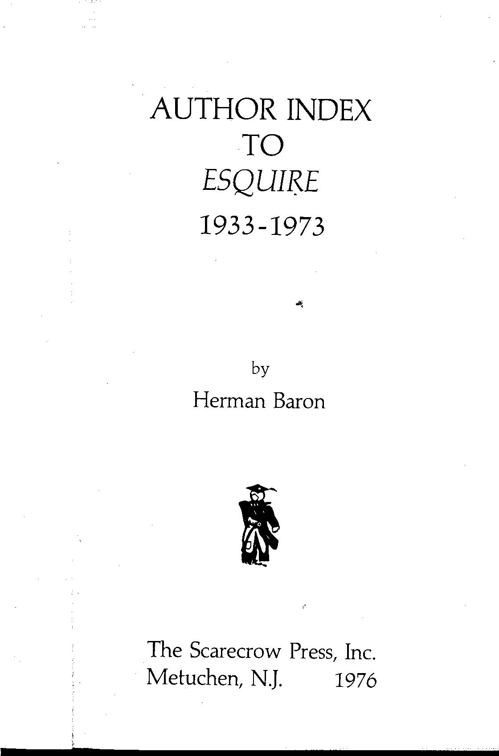 | Preface:  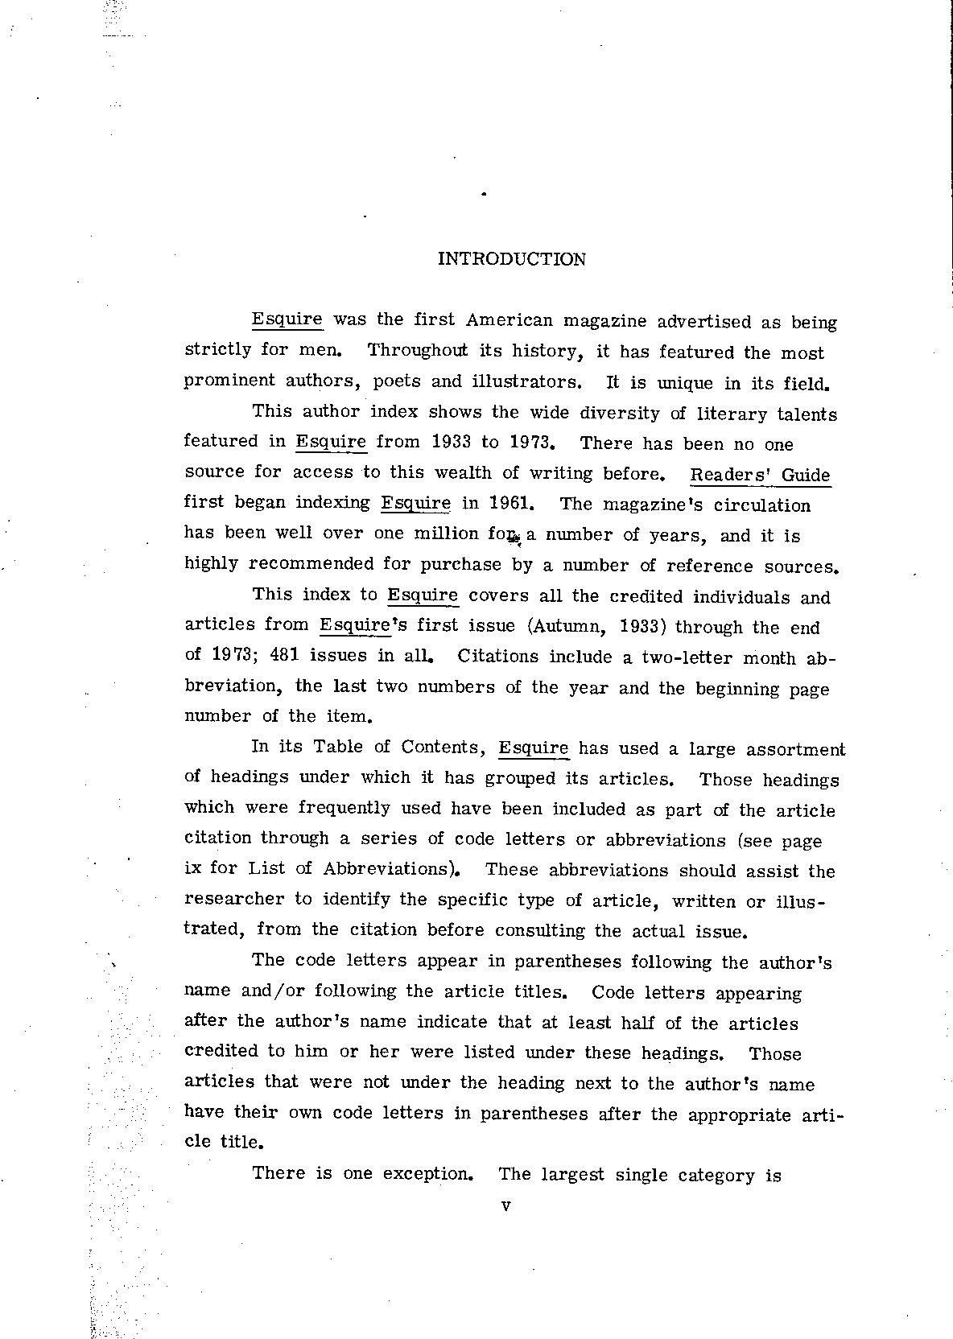

~~~~ [four tildes]

Categories
[[Category:English]]
[[:Category:Language]]

[[Category:Print]]
[[:Category:Format]]

[[Category:Monograph]]
[[:Category:Publication Type]]

Keywords
[[Category:Popular magazines]]
[[:Category:Keywords]]

