Case Wiki/Cases/Reckless Ralph’s dime novel round-up

History:
Jan.-Apr. 1931: Published as Dime novel roundup
May 1931-Oct. 1953: Published as Reckless Ralph’s dime novel round-up
Nov. 1953-present: Published as Dime novel round-up
Cover:  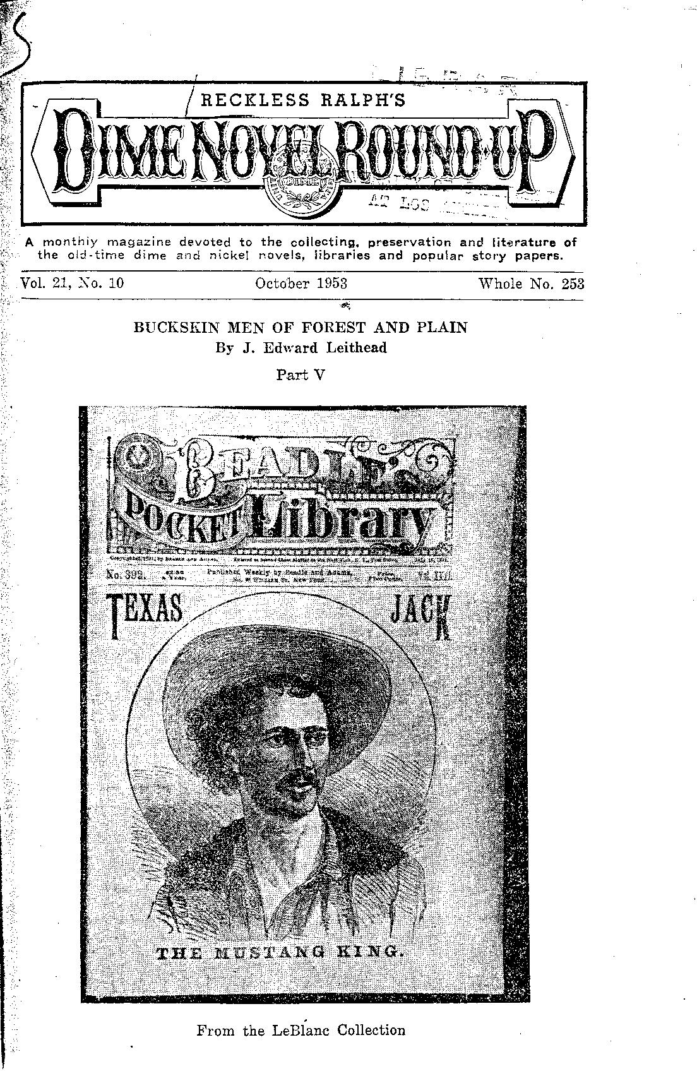 | Masthead:  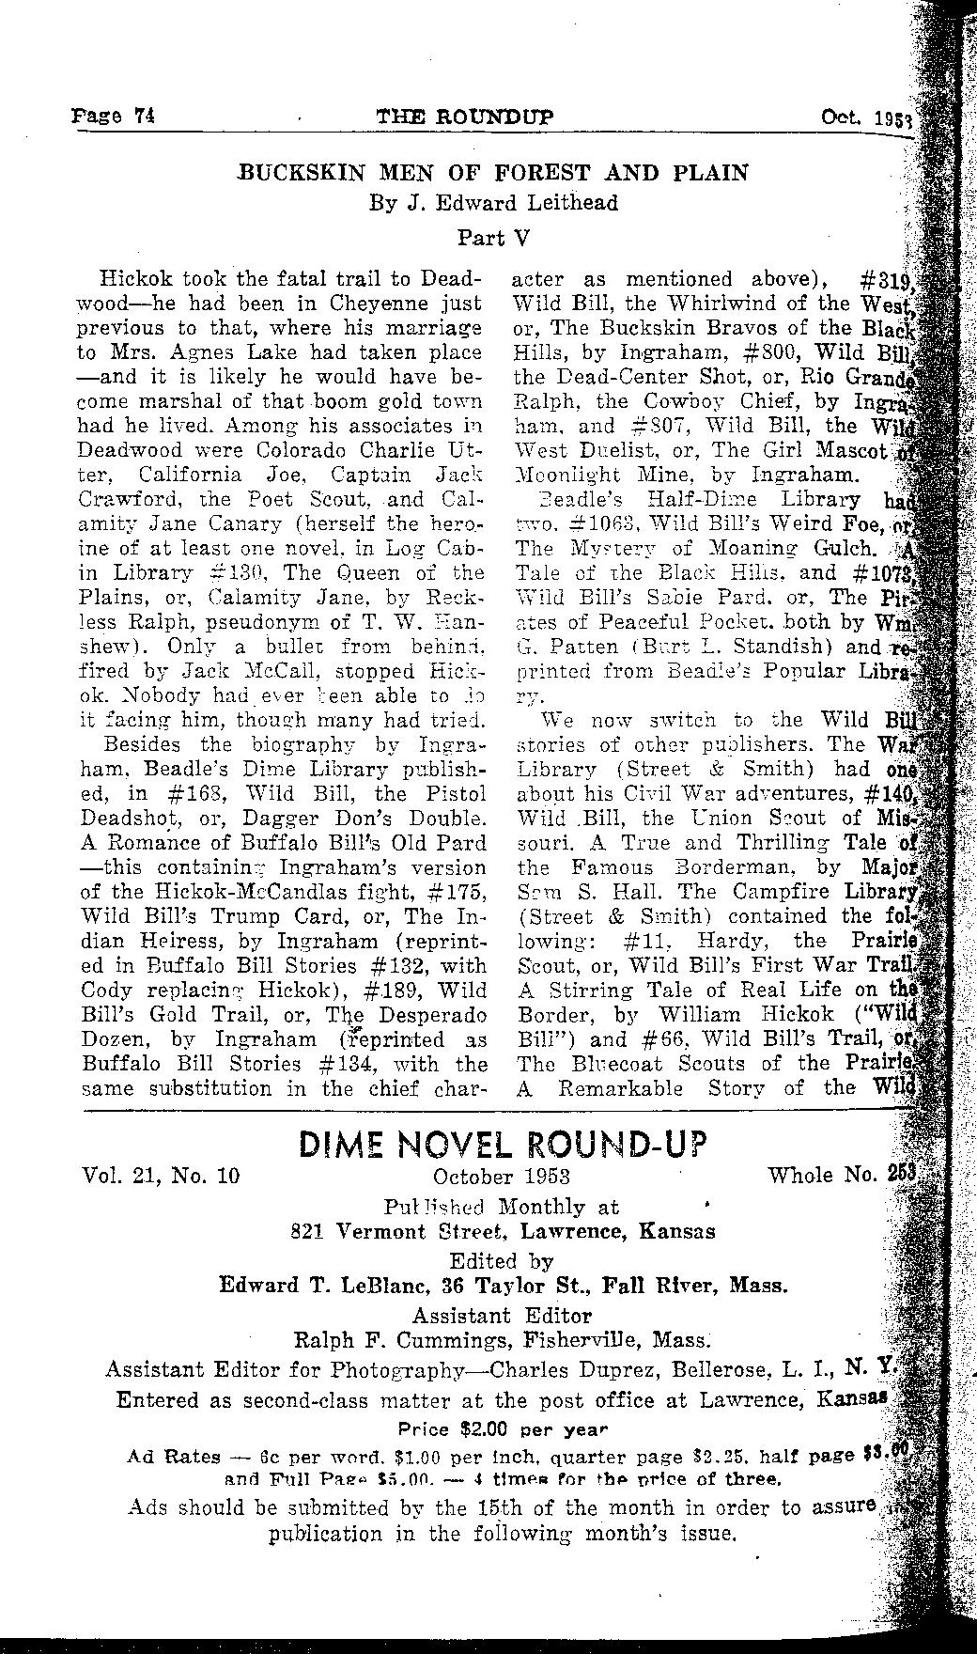

OCLC1566649: Latest entry record
OCLC5525589: Pre-AACR2 record

~~~~ [four tildes]

Related Case
[[Case/Dime novel round-up]]

Categories
[[Category:eng]]
[[:Category:Language]]

[[Category:Print]]
[[:Category:Format]]

[[Category:Monograph]]
[[:Category:Publication Type]]

Keywords
[[Category:Popular magazines]]
[[:Category:Keywords]]

