Loading a Powerpoint Presentation (Elluminate 9.5)
8/18/2009

An easy way to load a Powerpoint presentation is to enter the session early and upload files through the whiteboard. Be sure to allow time (10-15 minutes), since each slide must be converted to a screen snapshot and migrated to the native Elluminate format.
Tips:
- Animation will not migrate. Disable it before uploading.
- Some adjustment of the Powerpoint & re-loading may be needed to optimize clarity of fonts

Here are the steps:
- Enter the session as a moderator or chair
- Click on the folder icon of the whiteboard tool panel.
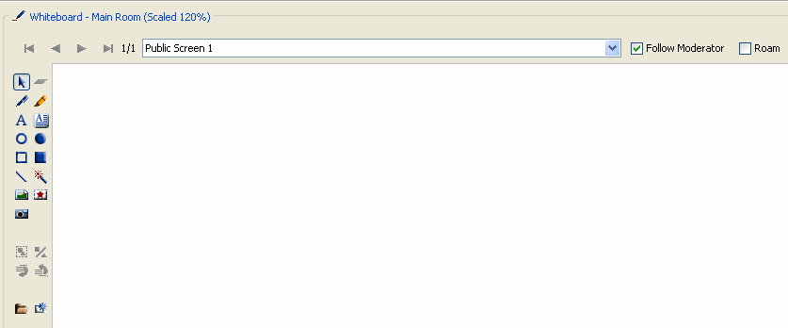
Folder= Click to upload files

- Choose the position for the powerpoint slides (I usually choose "replace screen" if that screen is a blank whiteboard window).
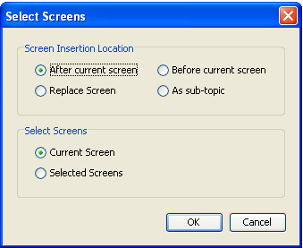

- Choose whether to import quickly or with better clarity. (I usually choose better quality if loading the slides ahead of time. But my presentations so far have not been noticeably different either way.)

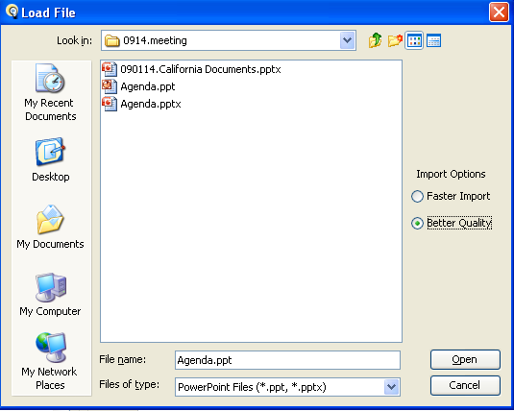

- Specify screen size (This may be useful for full-screen presentations.)
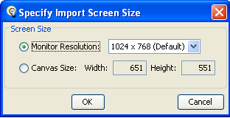

- A dialog box will appear as the powerpoint slides are converted to Elluminate's native format
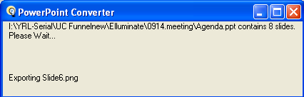

- The result:
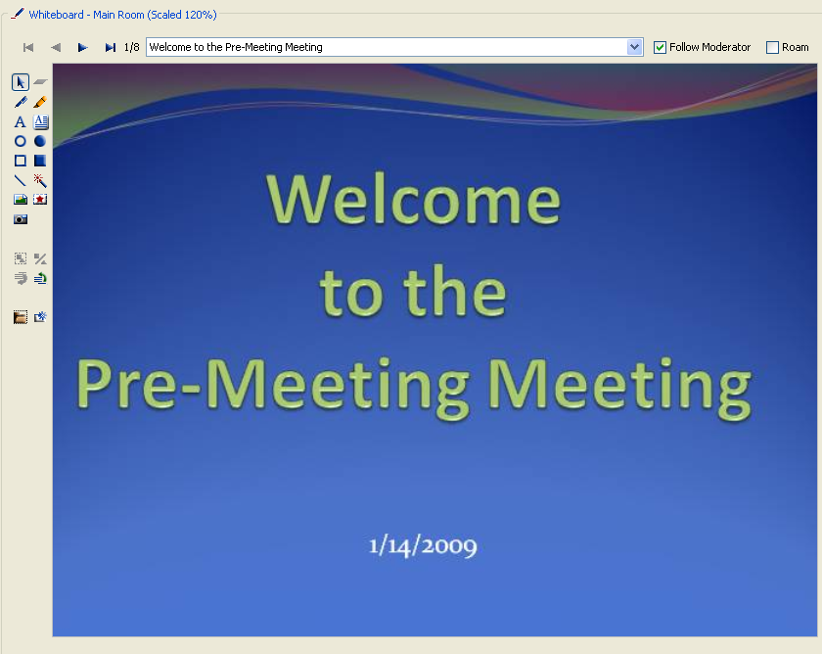

- Some presenters prefer to give the presentation within the whiteboard, so that participants can use the markup tools. But one may also present the slides using the whole screen. To do so, click on the movie screen icon

- The result (to others):
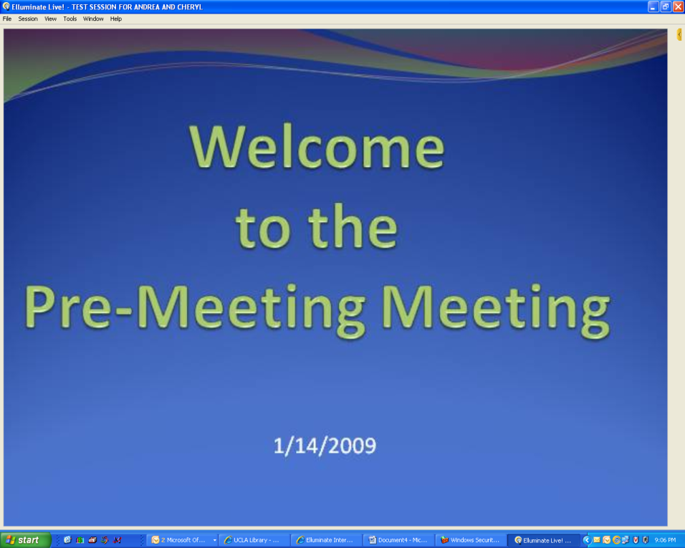
- To adjust the microphone or to re-set the screen to fit the whiteboard, participants may click on the small triangle in the upper right corner. They will then see the two options:
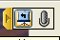

- The presenter may prefer to continue to use the whiteboard version of the presentation, in order to control the flow of slides. (Note the yellow border around the whiteboard. It's subtle.)
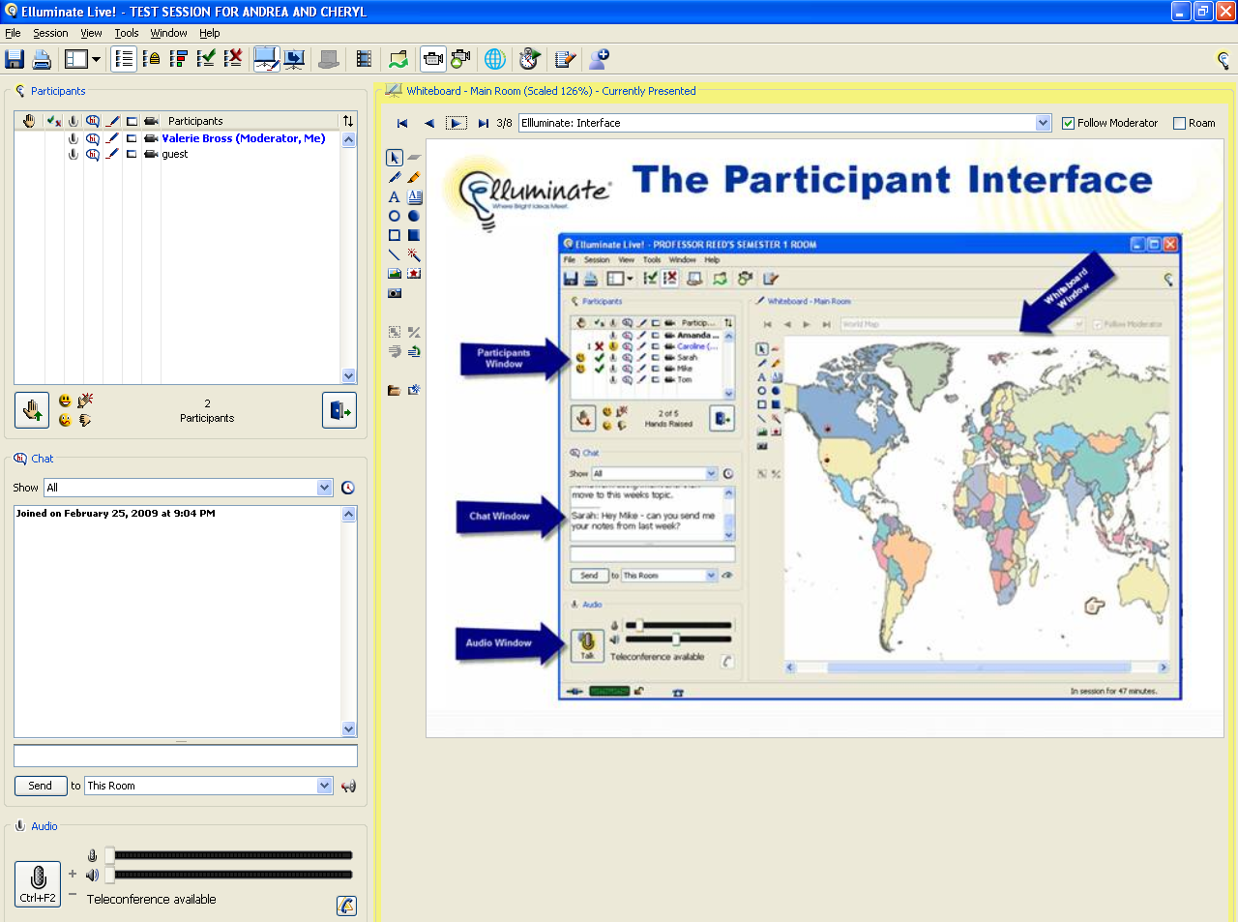

- To end the use of the full-screen view for participants & bring them back to the "meeting room," click again on the movie screen icon:
