Pre-Loading a Powerpoint Session (Elluminate 9.0)
8/18/2009

Purpose: Pre-load slides for presentations to avoid a last-minute scramble

- First, create a whiteboard file (.wbd)
  - Open up a test session
  - Click on the file folder to the left of the Whiteboard
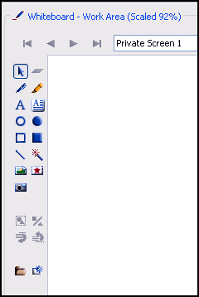

- Browse to the folder on your desktop with the Powerpoint file
- Click through the menus that display (see Moderator's Guide for discussion of the ptions); eventually, the program will begin to make a Whiteboard screen capture of each Powerpoint slide.
- Choose File // Save // Whiteboard
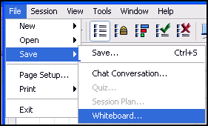

- Save file as .wbd
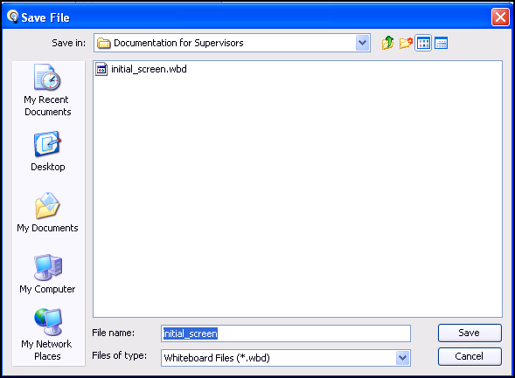

- Then, load the Whiteboard file and attach it to a session
- Go to Utilities; choose "Session Management"
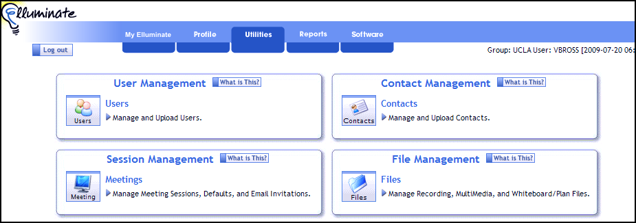

- Load file through "Session Management" module
  - Highlight the session
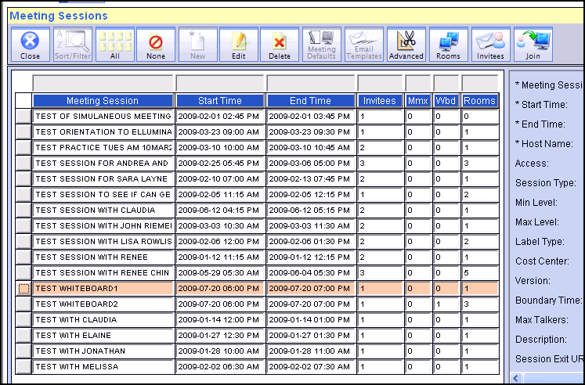

  - Click Advanced Edit
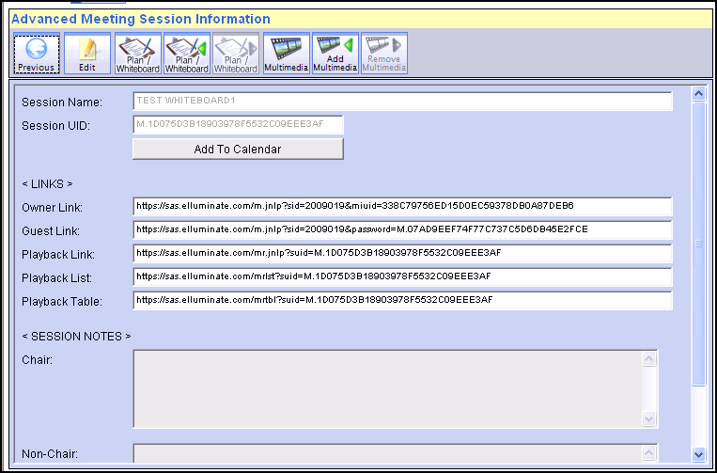

  - Click the first icon for Plan/Whiteboard and upload the Whiteboard

  - Click the second icon for Plan/Whiteboard 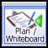 and highlight the Whiteboard file
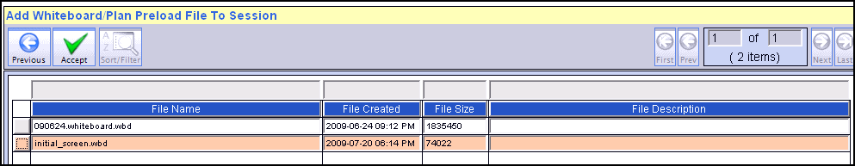

*** Then click "accept" (Green Check)***
(this is what attaches your Whiteboard file to a specific session)

On the day that the session is to be held, the session should open with the Whiteboard
