Screen Captures: Review of ethnology : RE

Problem:

1. The library acquisitions staff requested that I catalog the newsletter of the International Union of Anthropological and Ethnological Sciences Commission on Urgent Anthropological Research (ISSN: 0538-5865). However, the early issues of this newsletter were embedded in Review of ethnology. For surrogates, see web site: http://unitproj.library.ucla.edu/cataloging/serials/ISSN/issn.cfm

2. So first I had to look at Review of ethnology : RE.

On July 19, 2005, the Review of ethnology was represented in Ulrichs as “RE” with ISSN 0048-6507.

Ulrichs:
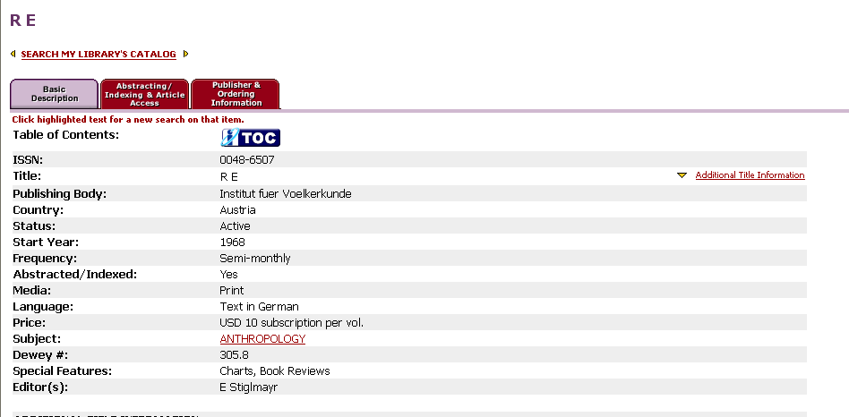

http://aleph.onb.ac.at/

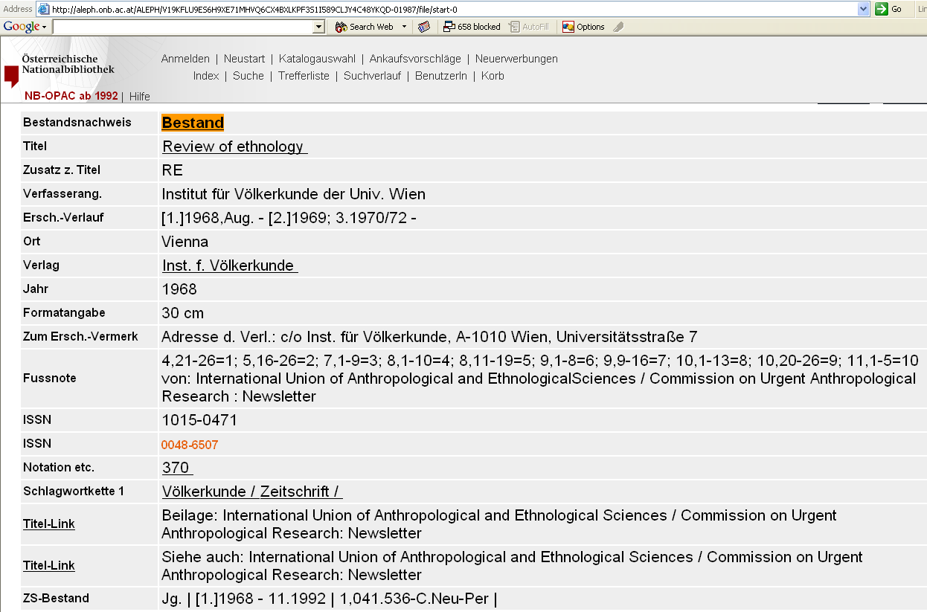

ISSN Portal:
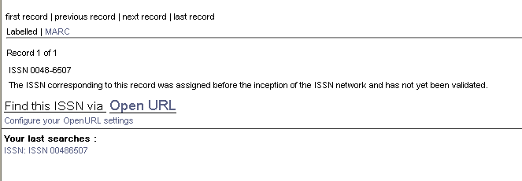

My authentication request was based on a mis-reading of the message, “The ISSN corresponding to this record was assigned before the inception of the ISSN network and has not yet been validated.”
I mis-understood this message to mean that ISSN Portal had a record of this number, but the authentication process had not been completed. [Comment: Now I realize that this is an automatically-generated message. It just means that the ISSN passed the digit-check, not that the ISSN should exist. At the time, though, I was just learning to use the ISSN Portal.]

On July 20, 2005, I called Shawn Chen (Associate Editor,Ulrich’s Periodicals Guide, 1-800-346-6049) about this record. He consulted with the Ulrich’s staff for Austria, and determined that the Ulrich’s record should have had “1015-0471” and that this title had, in any case, ceased.

According to his staff, Review of ethnology was continued by Newsletter (International Union of Anthropological and Ethnological Sciences). Today (Nov. 7, 2005), Ulrich’s has the following record:
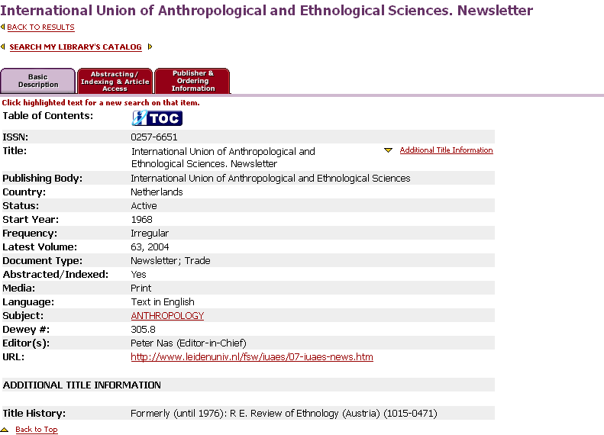

The ISSN associated with this Ulrich’s record is for the newsletter of the Commission on Urgent Anthropological Research, rather than the parent body (IUAES). So, the Ulrich’s record may still need some editing.

But regarding the publication status of Review of ethnology, the Ulrich’s record may be correct. Perhaps it is no longer being published. The IUAES web site: http://www.leidenuniv.nl/fsw/iuaes/ carries no mention of Review of ethnology; corroboration that Review of ethnology has ceased.

3. One more note about the newsletter of the Commission on Urgent Anthropological Research: according to the Commission’s web site, the newsletter was still being published in 2003: http://www.leidenuniv.nl/fsw/iuaes/06-16urgent.htm

