Scheduling & Using the Research Commons for Elluminate at UCLA
8/18/2009

At the Research Library, you may reserve the Research Commons stations yourself by logging into IRMA http://irma.clicc.ucla.edu/mrm7 and using the username ‘library’ and the password …. [ask LIT for password]

All staff & faculty can reserve the workstations. In the "Available Locations" pane, scroll to "Research Library." Click on that line and click on "Research Commons"; then choose "RC individual workstations." Fill out "Course or Meeting, " Instructor first name, Instructor last name, email, telephone number, and booked by. Then press "save and close."

The workstations that can be scheduled are workstation #1 (Mac station by the wall), workstation #2 (Dell PC station with double-monitor by the wall), and workstation #3 (Dell PC station with double-monitor to right of wkstation #1). The workstation numbers do NOT correspond to these numbers--you just have to know when scheduling them. All of the workstations have the same camera attached.

Tips:
- Bring your own headset with microphone. The CLICC lending station has headsets, but not with microphones.
- The behavior of a workstation depends on the previous user to some extent. Come early on the day of the session to re-test the configuration; contact LIT if you cannot figure out how to get to the settings.

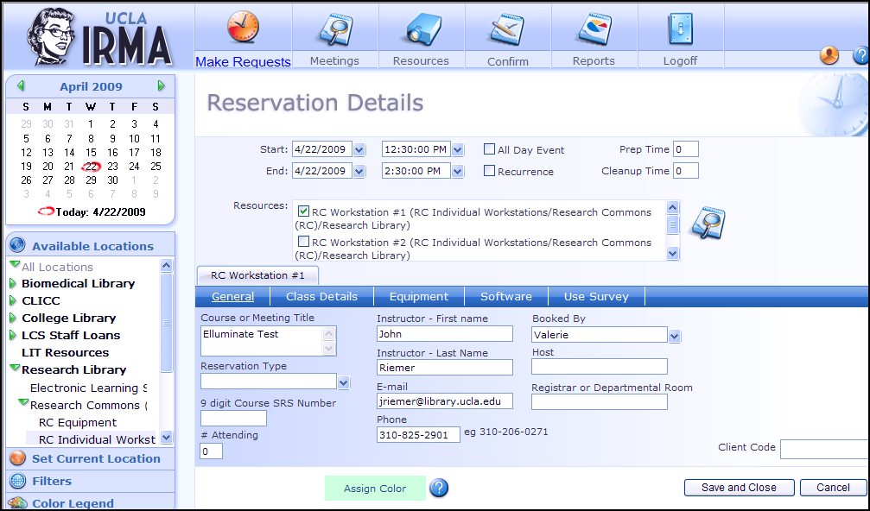

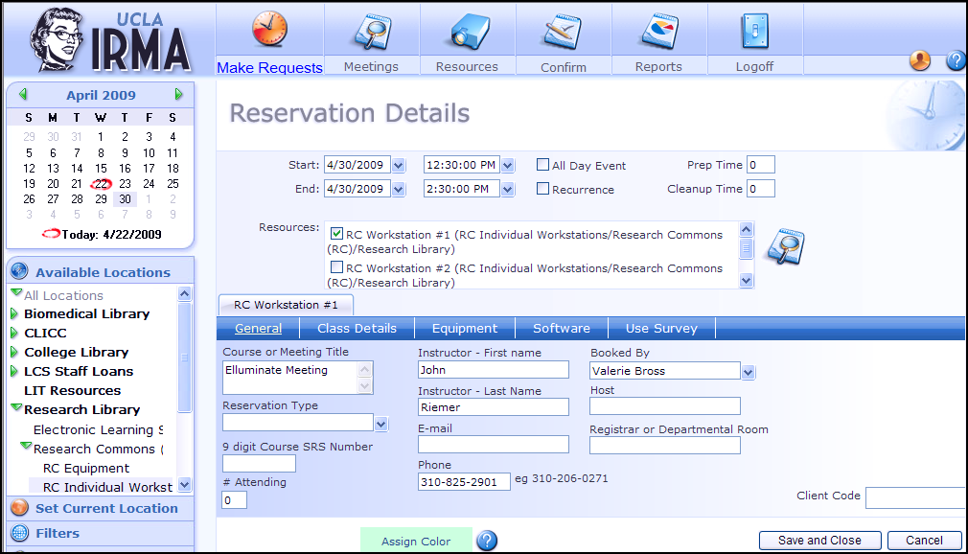

- Getting Help:
  - General equipment problems: If you have general problems with the workstations, contact the helpdesk: helpdesk@library.ucla.edu
  - Elluminate questions: If you are live in an Elluminate session & having problems (audio, Web cam, or other Elluminate functions) then send an email to the following people with the subject header: Elluminate: In a meeting & need help:
    - Jessica Mentesoglu: jmentesoglu@library.ucla.edu
    - Jonathan Wilson: jonathanwilson@library.ucla.edu
    - Salvador Zapien: szapien@library.ucla.edu

NOTE: If you need help on Thursday, April 30 while in the Elluminate session, email Sal Zapien directly. He said that the others will be out that day, but that he would be vigilant. I will ask Les if he will send Sal a link to the Elluminate session, so he can observe the problem you are having and give advice.

- Mac Workstation
  - Attach headset to USB port
  - Log onto the Mac using the "CLICC User" option. Do NOT sign in as "other user." Log in using Bruin ID and password. Multiple tries may be needed to log in successfully. Do not give up!
  - Open your UCLA email and pull up the Elluminate session link. BE CAREFUL! The link is very long & the end often shows up on a separate line. If you try to run Elluminate you will see a session not valid message.
  - Use Firefox browser. Since Firefox has Java integrated in the operating system, it works better than IE. Paste the Elluminate link in your browser address line. Accept the license when it displays.
  - To re-size windows in the Mac, look for a triangle in the lower right corner of the window and pull on it. If a window lacks a triangle, it will not re-size.
  - When you are in Elluminate, go to the top menu and click Tools--Audio--Audio Wizard.
  - To activate the Web cam, go to Tools--Video and make sure that is clicked. Then look for the video launch icon above the whiteboard area and select that. Choose the quality/color for the video and then click "transmit" to begin web cam.
  - After the session, be sure to log off of the Mac by clicking on the apple icon in the upper left corner.
- PC Workstations
  - Attach headset to USB port
  - Log onto the PC using Bruin ID and password. Multiple tries may be needed to log in successfully.
  - Open your UCLA email and pull up the Elluminate session link. BE CAREFUL! The link is very long & the end often shows up on a separate line. If you try to run Elluminate you will see a session not valid message.
  - Use Firefox browser. Since Firefox has Java integrated in the operating system, it works better than IE. Paste the Elluminate link in your browser address line. You should see a window asking whether you would like to launch Java or save the meeting.jnp file. Click on the option to launch through Java; accept the license to complete the launch. (If you use IE rather than Firefox, you will need to save the meeting.jnp file to the desktop, find the icon for the file on the desktop, and double-click.)
  - When you are in Elluminate, go to the top menu and click Tools--Audio--Audio Wizard
  - To activate the Web cam, go to Tools--Video and make sure that is clicked. Then look for the video launch icon above the whiteboard area and select that. Choose the quality/color for the video and then click "transmit" to begin web cam.
  - After the session, be sure to log off the PC by choosing "logoff" from the start menu. The PC should re-boot to wipe out all session-specific files. BE CAREFUL. If the PC does not reboot, then you are still logged in. (The PCs are supposed to time out, but for one personal experience, two hours later, the session was still open.) If you cannot get the workstation to re-boot, ask one of the Reference staff to help.

