FRBR Review

- FRBR (Functional Requirements for Bibliographic Records) was developed to meet two primary objectives:
- Provide a clearly defined, structured framework for relating the data recorded in bibliographic records to the needs of the users of those records
- Recommend a basic level of functionality for records created by national bibliographic agencies

- The key objects of interest to users of bibliographic data are called ENTITIES

- There are three groups of entities:
- Group 1: Work, Expression, Manifestation, Item (often collectively referred to as “WEMI”)
- Group 2: Person, [Family], Corporate Body
- Group 3: Concept, Object, Event, Place, Group 1 entities, Group 2 entities

- There are two main aspects of entities:
- Attributes
- Relationships

- Attributes:
- Group 1 Examples
  - Work Attributes: Date of Work, Form of Work, Title of the Work, etc.
  - Expression Attributes: Content Type, Language of Expression, Illustrative Content, Supplementary Content, etc.
  - Manifestation Attributes: Title, Publication Statement, Carrier Type, Media Type, Extent, Dimensions, etc.
  - Item Attributes: Identifier for the Item, Custodial History of Item, Item-Specific Carrier Characteristic, etc.
- Group 2 Examples
  - Person Attributes: Place of Birth, Profession or Occupation, Gender, Place of Residence, etc.
  - Family Attributes: Type of Family, Prominent Member of the Family, Family History, etc.
  - Corporate Body Attributes: Name of the Corporate Body, Number of a Conference, etc.
- Group 3 Examples
  - Concept Attributes: Term for the Concept, etc.
  - Object Attributes: Name of the Object, etc.
  - Event Attributes: Name of the Event, etc.
  - Place Attributes: Name of the Place, etc.

- Relationships
- Primary Relationship and definitions of work, expression, manifestation, and item
- WORK: Distinct intellectual artistic creation
- EXPRESSION: Intellectual or artistic realization of a work in the form of alphanumeric, musical or choreographic notation, sound, image, object, movement, etc., or any combination of such forms
- MANIFESTATION: Physical embodiment of an expression of a work
- ITEM: A single exemplar of a manifestation
- “Responsibility” relationships between group 2 entities and group 1 entities—the resources for which they are responsible
- “Subject” relationships between “works” and the group 3 entities

“Primary relationships”  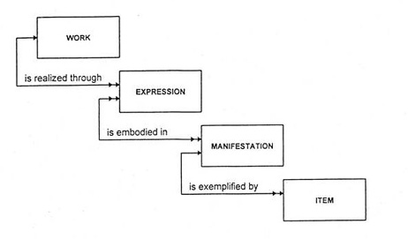  "Responsibility" Relationships  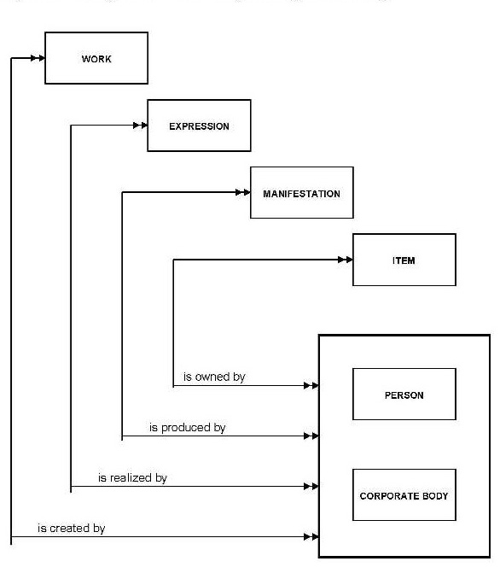 | "Subject" Relationships  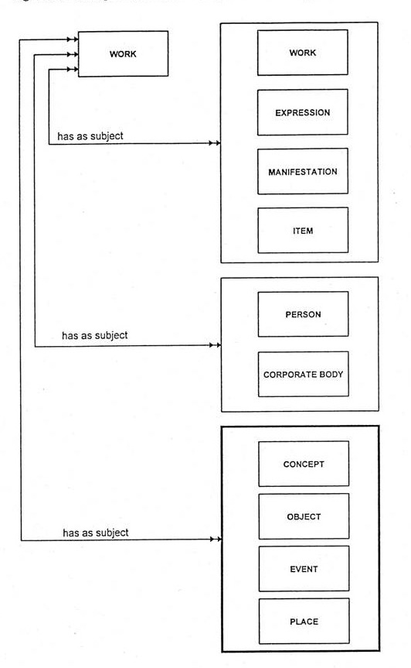

- RDA Database Implementation Scenario 1 (Relational/object-oriented database structure) using a 1952 publication of an English translation of Don Quixote.

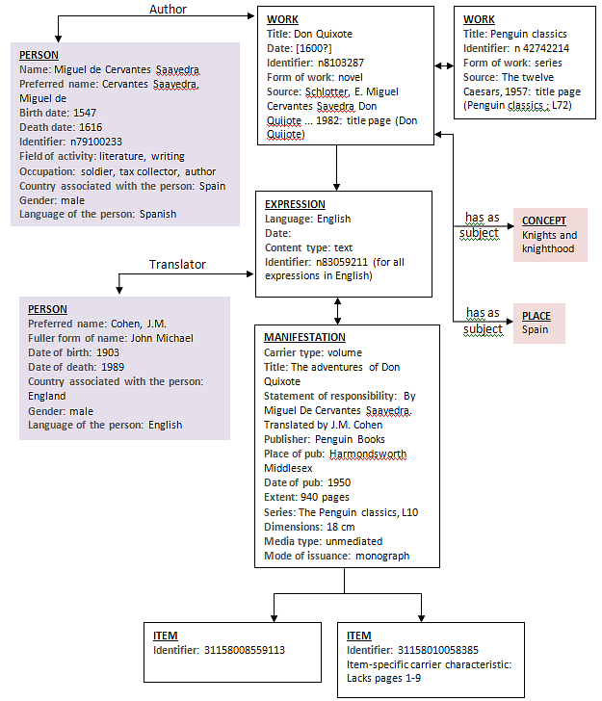

- The aim of all of this is to create bibliographic description that supports four user tasks:
- Find
- Identify
- Select
- Obtain

Introduced in the FRAD (Functional Requirements for Authority Data) study.
IFLA Study Group on the Functional Requirements for Bibliographic Records. Functional Requirements for Bibliographic Records: Final Report. Available: <http://www.ifla.org/publications/functional-requirements-for-bibliographic-records >. Accessed: February 23, 2012.
Resources used: Voyager Bib record: 976091.

