Connexion: Constant Data Forms for e-Monographs and e-IRs
2/6/2007

Purpose: To illustrate some uses of Constant Data Forms for cataloging e-monographs & e-IRs

What Needs to be Added to Your Connexion Files

- E-Resources.mbk
- The forms from constdatER.bibcd.db

Strategies for using CONSTANT DATA forms:

- Create an original-cataloged bib record
  - Ctrl-alt-shift-g: Retrieve macro window
  - Select the template: IntegRes (online integrating resource); MonoHTML (online HTML monograph); MonoPDF (online PDF monograph)
  - Alt-r: run the macro
- Use constant data as a cue sheet
  - Ctrl-ℓ + highlight + <Enter>: Call up list of Constant Data Forms
  - Shift-F4 (to pin constant data) [optional]
  - Alt-w, t (to tile vertically)

- Extract metadata & compare constant data to result
  - Ctrl-ℓ + highlight + <Enter>: Call up list of Constant Data Forms
  - Shift-F4 (to pin constant data) [optional]
  - From menu: Cataloging—Create/extract metadata
  - Alt-w, t (to tile vertically)

- HTML e-monograph
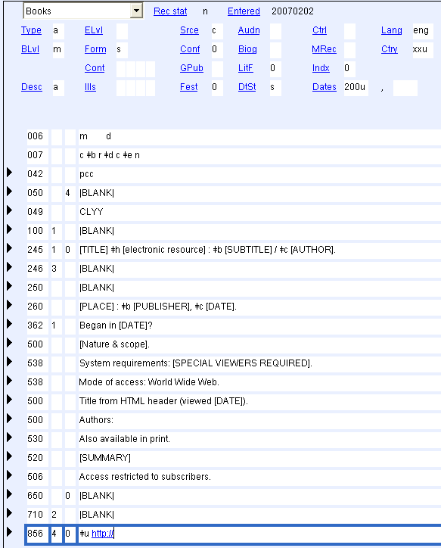

PDF e-monograph
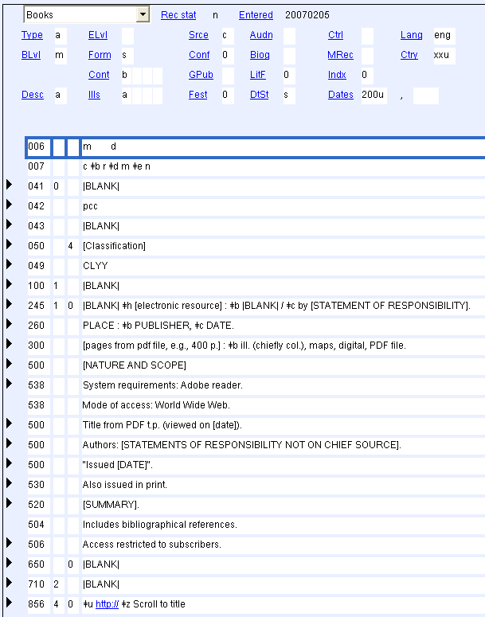

e-IR: Note: This form has notes in AACR2 order; you may also choose to put notes in tag order

