Using Outlook Tasks to Manage E-Resources: Instructions for Catalogers
1/25/07 cmh_rev

- Requests to catalog e-resources are sent to a shared email account, and then distributed to catalogers as Outlook Tasks. When a task is assigned to you, you will receive an email alert from “LIB ERDB New Cataloging” in your inbox. The subject line will begin “Task Request: NEW” (“Task Request: RUSH NEW” for priority cataloging requests).

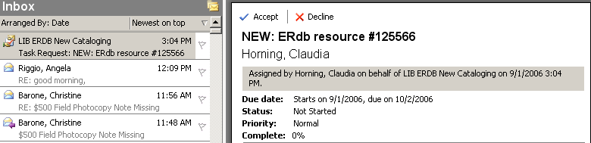

Please review the message and the e-resource to determine whether or not you are able to accept the assignment, and then either accept or decline the task. Please accept tasks unless you have a good reason to decline (e.g. going on vacation, don’t have the language expertise, etc.).

If you decline a task, please explain why by editing the response before sending. (If you accept a task, there is no need to edit the response.) Once you have accepted or declined a task, the message will disappear from your inbox.

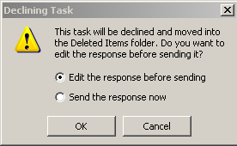

If you have questions about a task, please do not decline it. Accept the task and then consult as appropriate.

- Once you’ve accepted a task, it will appear in your individual Outlook Task list. You can open it by double-clicking on the task. Do not change Start or Due dates for the task, or the Status (until the task is complete). You may set a reminder to complete the task by checking the Reminder box and selecting a date and time for the reminder.
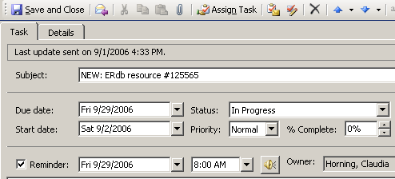

- Catalog the e-resource. Rush e-resources should be completed within 1 week, and non-rush e-resources within 1 month. Once you’ve finished, set the Status of the task to Completed and provide either an OCLC or Voyager record number, and then Save and Close.

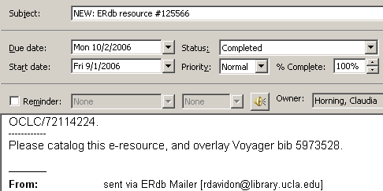

- If you would like to delete completed tasks from your individual task list, you can do so by highlighting the task and going to Edit > Delete, or by right-clicking on it and choosing Delete.

