Digital Library Collection System
Training for Cataloging and Metadata Center
October 3, 2007

- Introduction to Digital Library Collection System (DLCS)

- Reporting DLCS errors
Primary contact: Claudia Horning

- Accounts and managing your password

- Orientation to the DLCS interface

- Using controlled vocabularies in DLCS

- Metadata Records – Creating & Editing

- Ingesting data

- Searching and Downloading data

- Viewing an item

- Introduction to Digital Library Collection System (DLCS)

The main login screen.
http://digital2.library.ucla.edu/dlcs

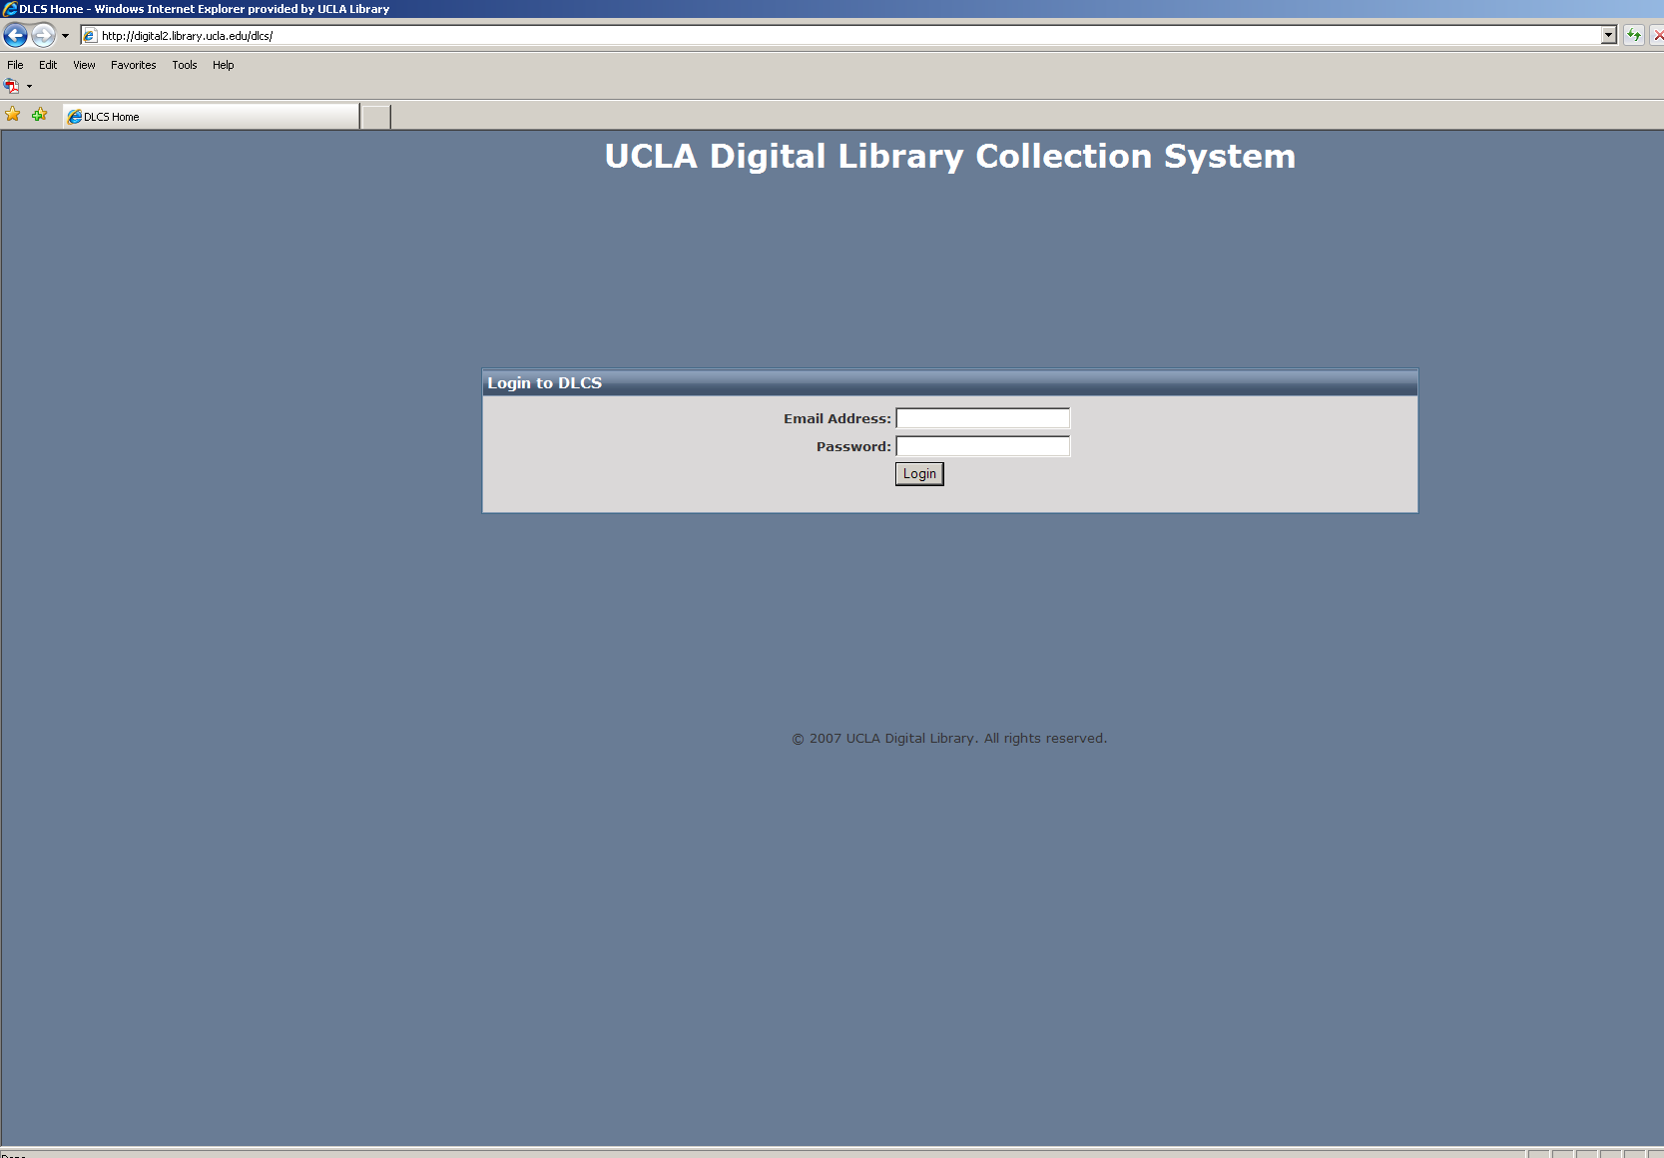

- Reporting DLCS errors

A common error page.

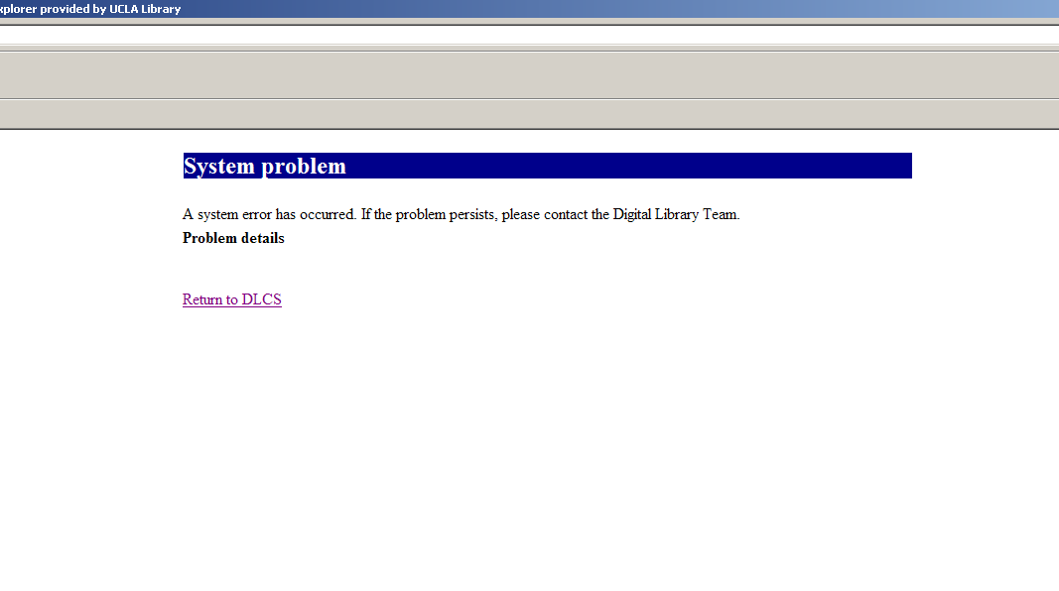
3. Accounts and managing your password

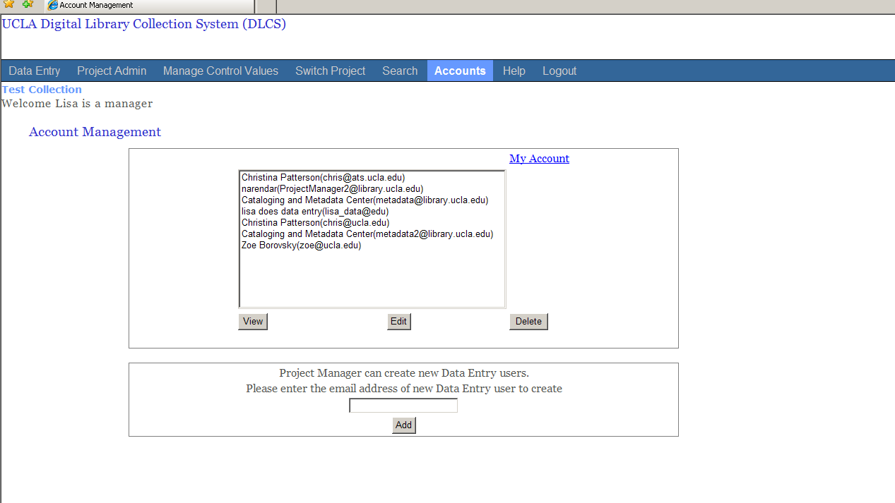

4. Orientation to the DLCS interface

The first page after you select a project. Main navigation links at the top and left of the page.

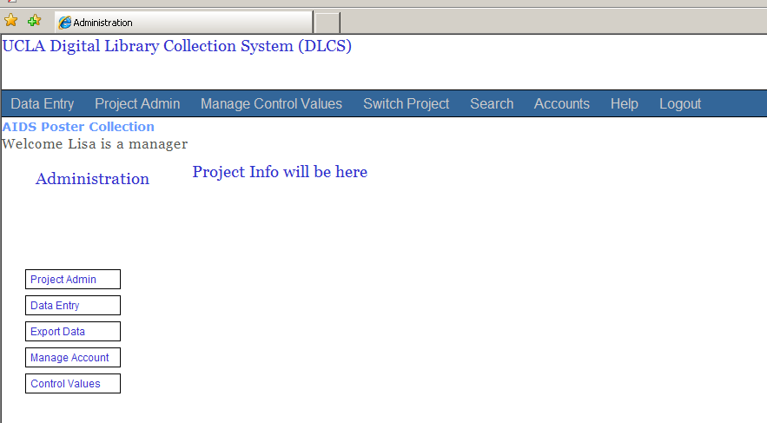

5. Using controlled vocabularies in DLCS – Entering new controlled values into the system

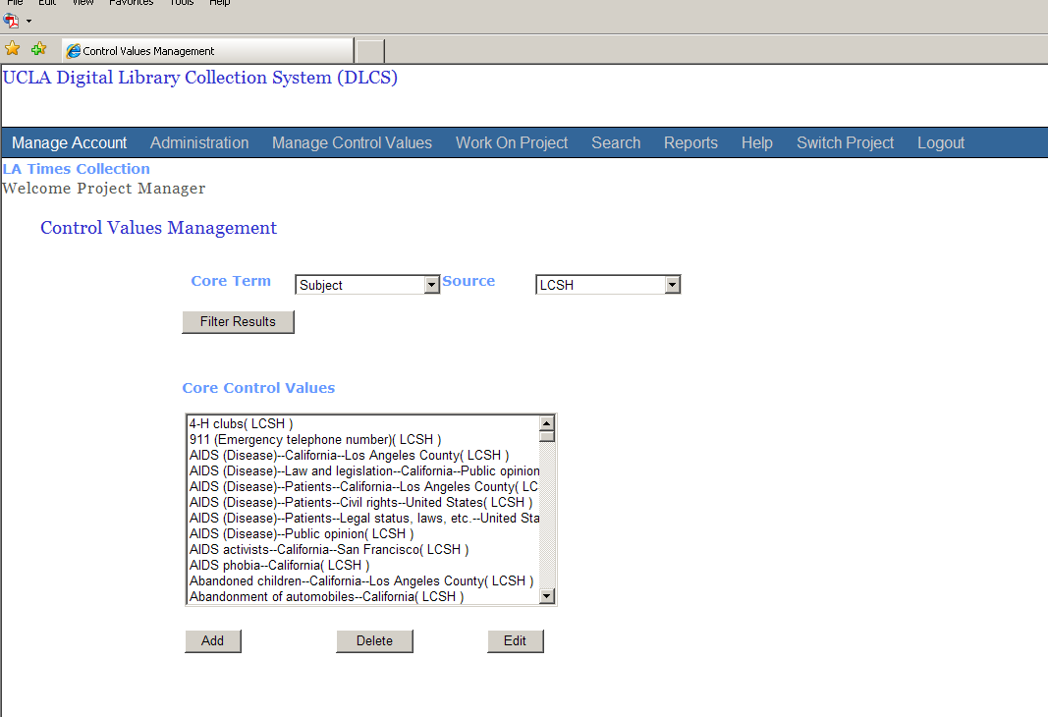

5. Using controlled vocabularies in DLCS – Adding new values for use in the project

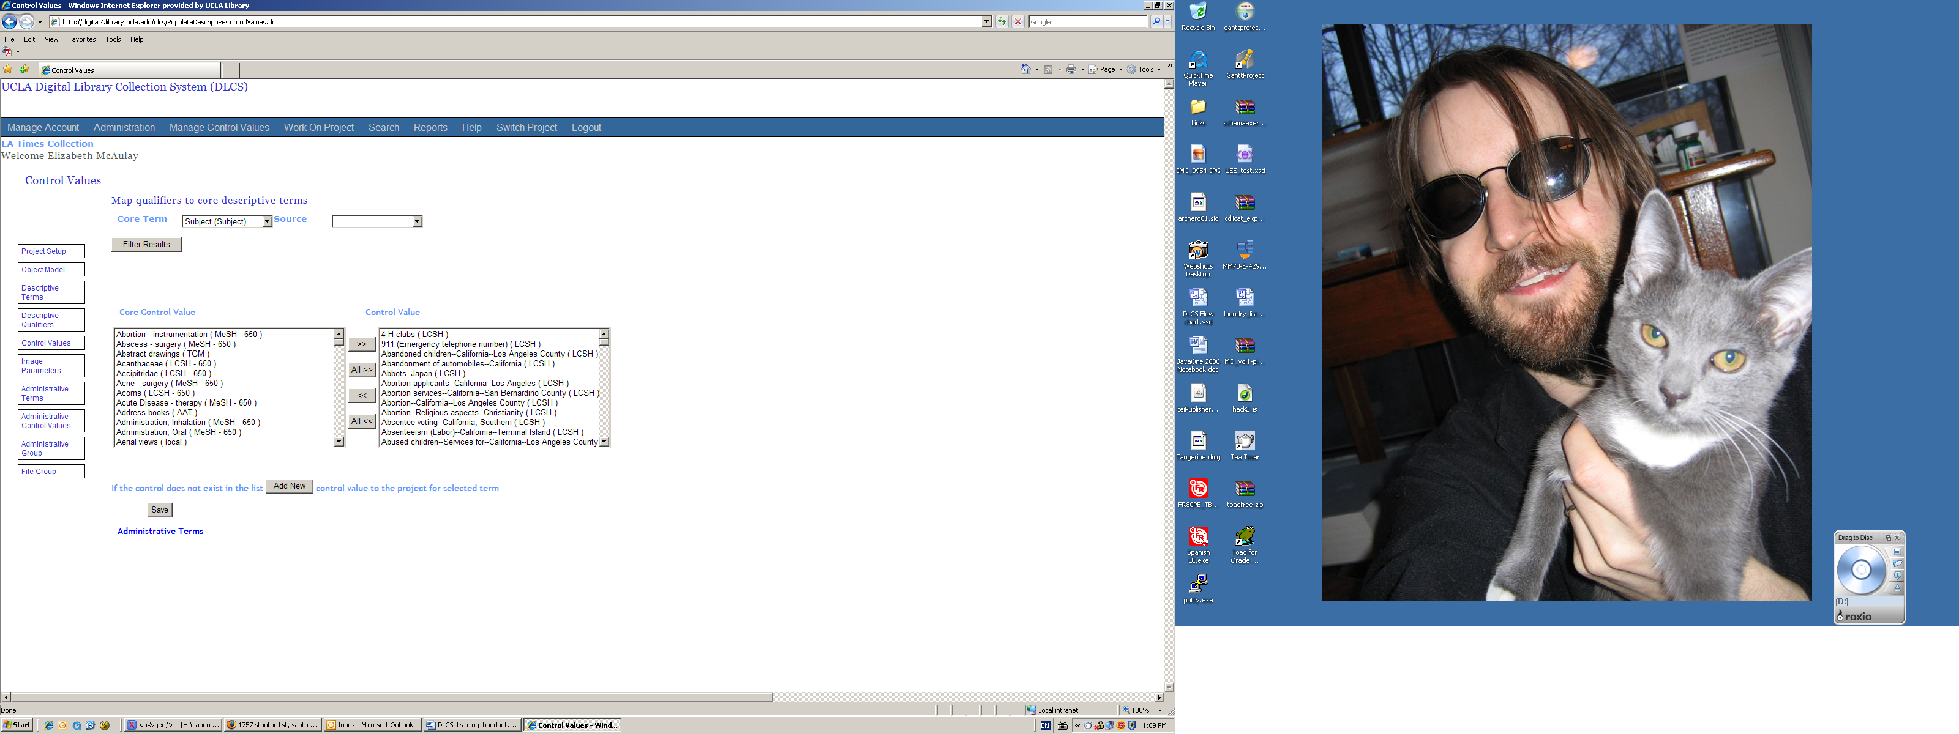

6. Metadata Records – Creating & Editing

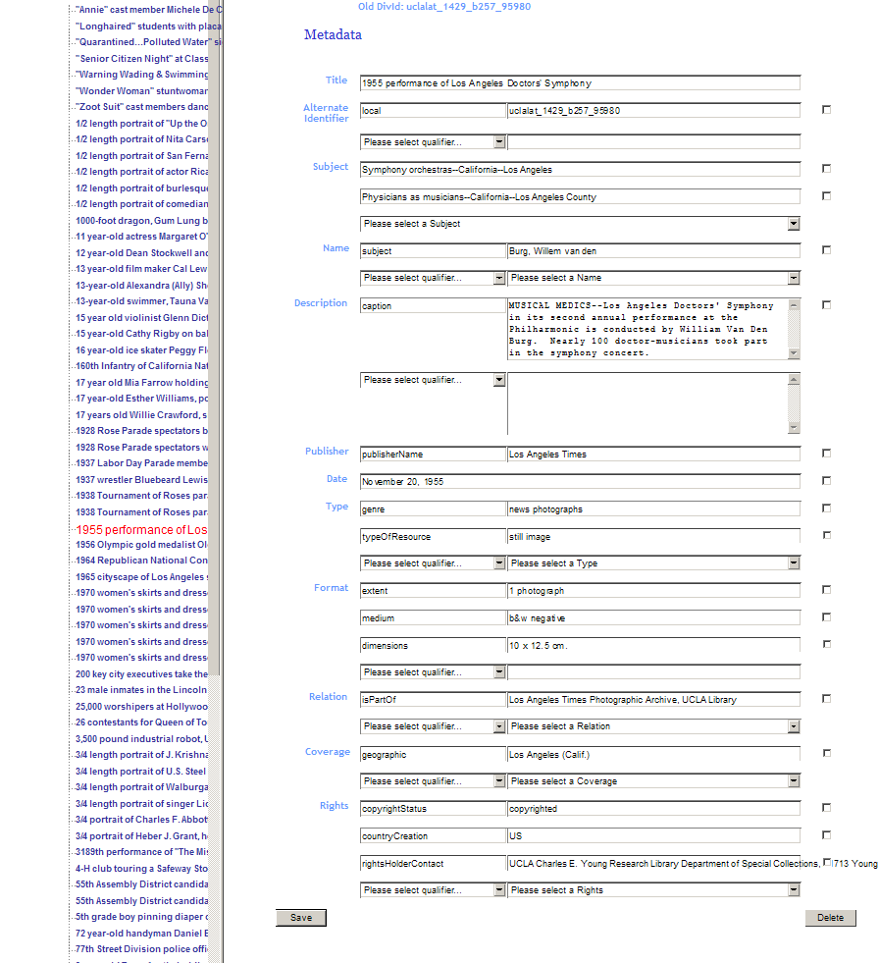
7. Ingesting Data

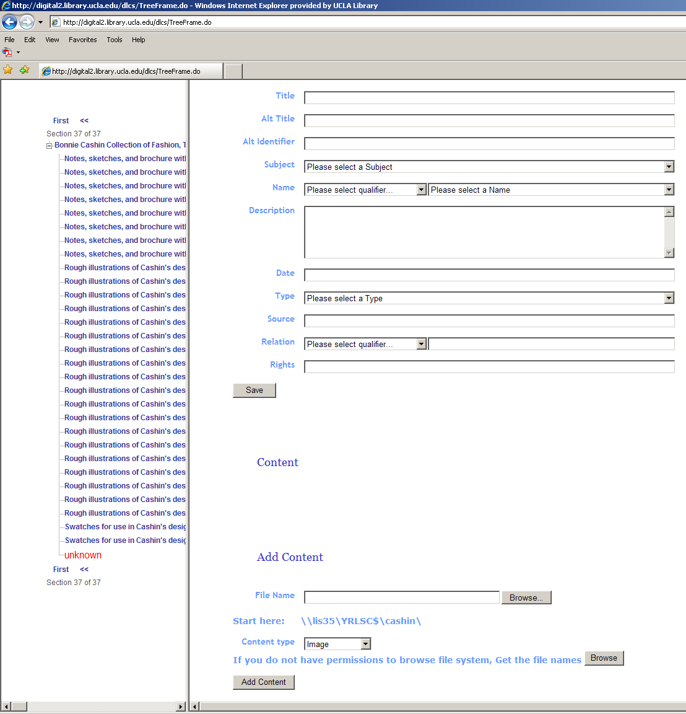
8. Searching and Downloading data

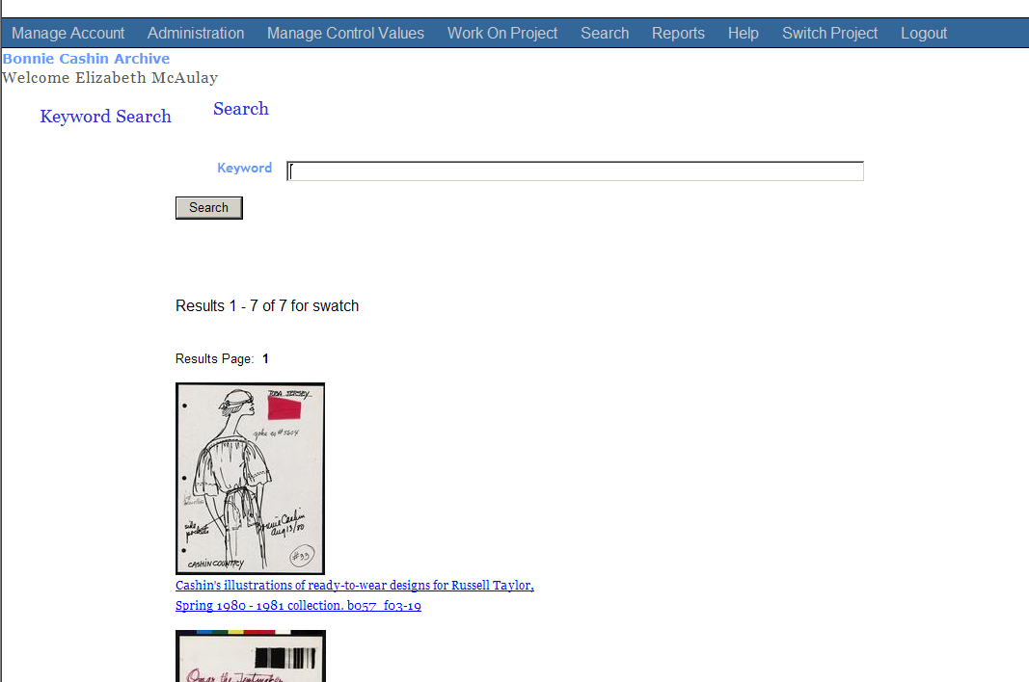
8. Searching and Downloading data

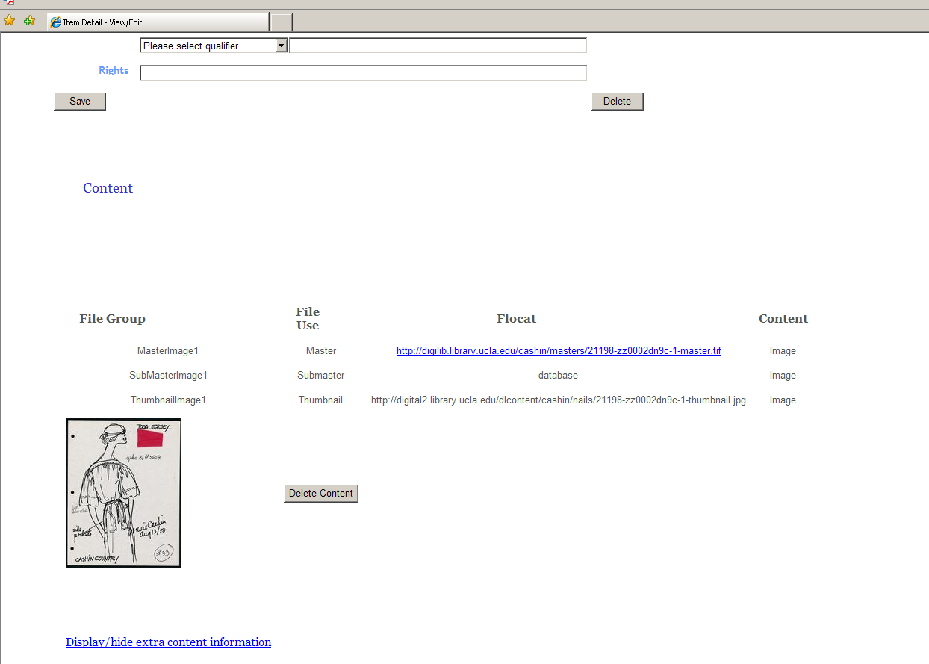

- Viewing an item

