SECOND LIFE: AN INTRODUCTION

Presentation by Rhonda Super
aka
50 Winx

March, 2008

PEW STUDY
Of the 53% of U.S. adults who said they visited libraries in 2007, the biggest users were young adults aged 18 to 30 in the tech-loving group known as Generation Y, the survey by the Pew Internet & American Life Project said.
Internet users were more than twice as likely to patronize libraries as non-Internet users, according to the survey.
More than two-thirds of library visitors in all age groups said they used computers while at the library.
The survey showed 62% of Generation Y respondents said they visited a public library in the past year, with a steady decline in usage according to age. Some 57% of adults aged 43 to 52 said they visited a library in 2007, followed by 46% of adults aged 53 to 61, 42% of adults aged 62 to 71, and just 32% of adults over 72.
Public libraries now offer virtual homework help and special gaming software programs, and some librarians even have created characters in the Second Life virtual world.
Computer World, December 31, 2007. Retrieved January 1, 2008 from: http://www.computerworld.com/action/article.do?command=viewArticleBasic&taxonomyName=storage&articleId=9054700&taxonomyId=19&intsrc=kc_top

ACRL’S ENVIRONMENTAL SCAN 2007

Three of ACRL’s top 10 assumptions for the future of academic libraries and librarians (in ranked order):

3. Students and faculty will continue to demand increasing access to library resources and services, and to expect to find a rich digital library presence both in enterprise academic systems and as a feature of social computing.

5. The evolution of information technology will shape both the practice of scholarly inquiry and the daily routine of students and faculty, and demands for technology-related services and technology-rich user environments will continue to grow and will require additional funding.

- Online learning will continue to expand as an option for students and faculty – both on campus and off – and libraries will gear resources and services for delivery to a distributed academic community.

Among the emergent issues of concern to the profession identified by ACRL is the following:

The tools and techniques of social computing will provide new opportunities for the design and delivery of library resources and services, but will also make increasing demands on library staff and systems.

WHAT IS SECOND LIFE?

Second Life (SL) is a 3D virtual world and is an example of social computing. Unlike other 3D worlds, all of what is in SL is built by the users. There is no pre-existing back-story.

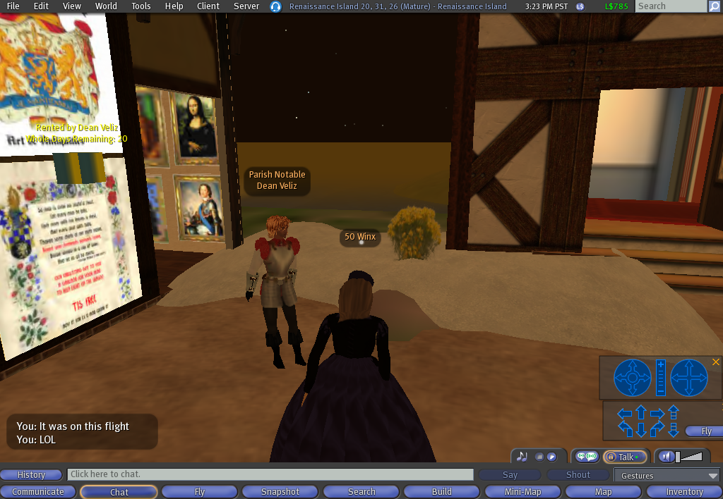

Areas within the virtual world are divided into islands aka SIMs. SIMs are the computer servers on which all the programming for an island is stored. A group of SIMs is a grid.

You can explore and participate in SL for free. If you want to build something in SL, you will have to purchase or rent real estate, which will require you to subscribe to SL for a monthly fee or pay a fee for a rental to a property owner.

LIBRARIANS IN SL

ALLIANCE LIBRARY SYSTEM AND OPAL

Supported by a grant from the Alliance Library System of Illinois (http://www.alliancelibrarysystem.com/ ) and in partnership with Open Programming for All (OPAL) (http://www.opal-online.org/ ), a group of educators and librarians have built an archipelago of islands on what is called the education grid.

WHO’S IN THE SL LIBRARY SYSTEM

Some of the countries represented by library volunteers working in SL include:

- Belgium
- Canada
- France
- Germany
- Netherlands
- United Kingdom
- United States

WHAT LIBRARIANS AND EDUCATORS ARE DOING IN SL

- Librarians and educators are building an educational environment and providing a range of library related services.

- There are public and academic libraries which have built a presence in SL.

- Librarians provide reference services and training.

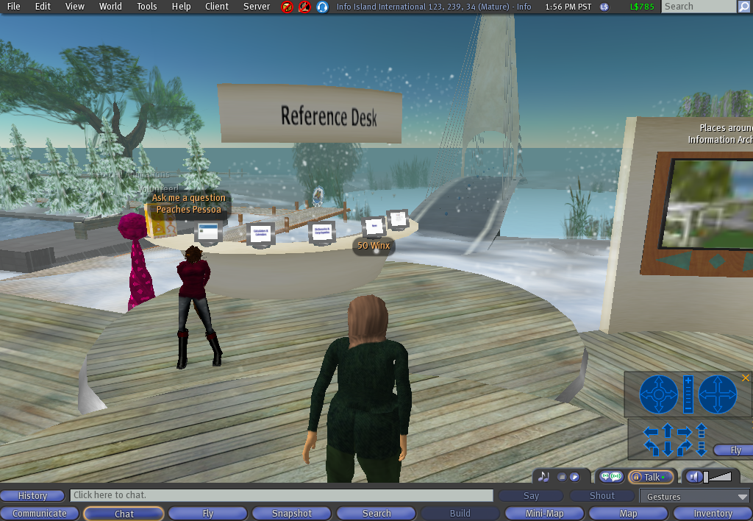

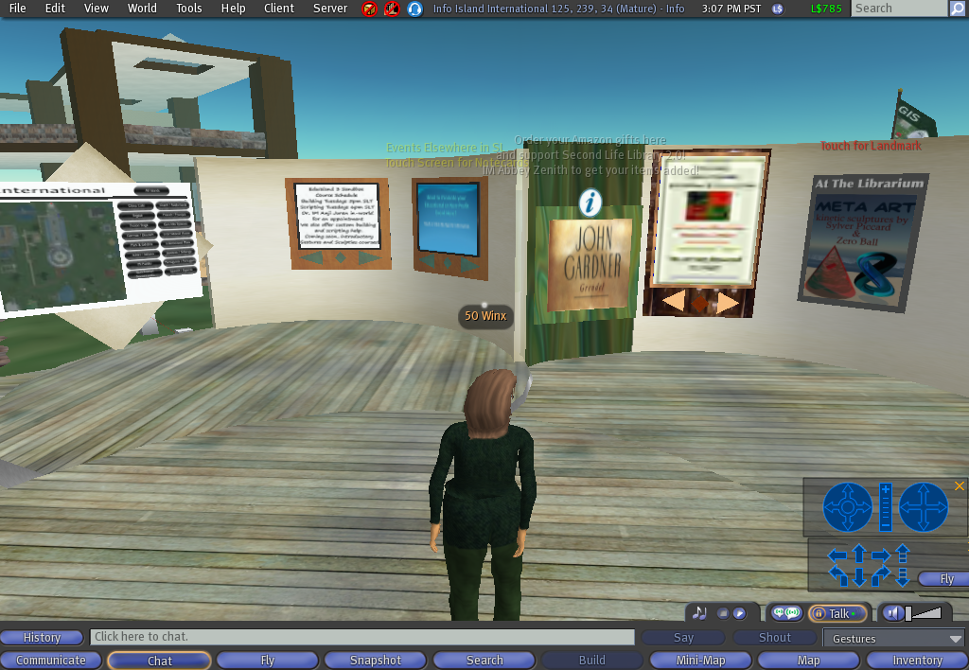

- Librarians have built period environments. Examples are the Victorian themed Caledon grid and the Elizabethan England themed Renaissance Island.

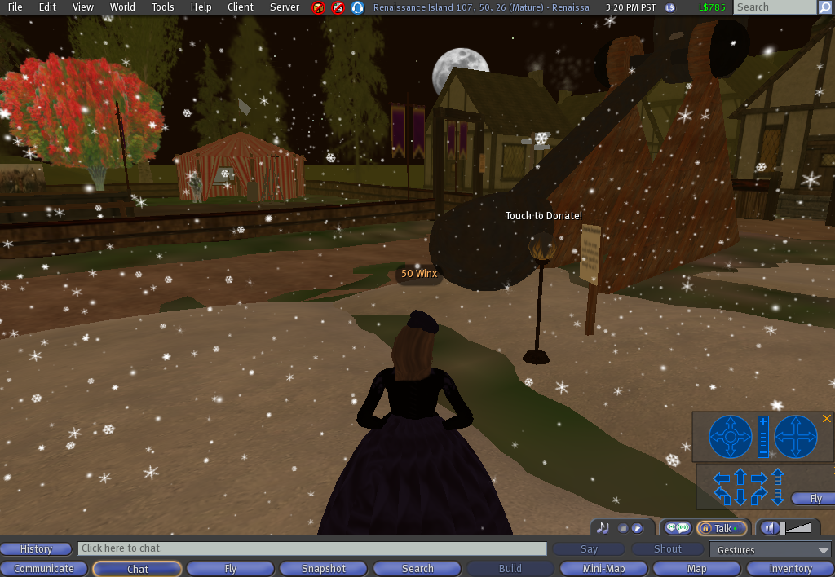

- Librarians and Educators provide access to technology resources adapted to SL. For example, educators and librarians have adapted the class management system Moodle for SL; it is known as Sloodle. Visit the Sloodle tutorial in SL to learn how to use it (243,222,33) http://slurl.com/secondlife/virtuALBA/243/222/33

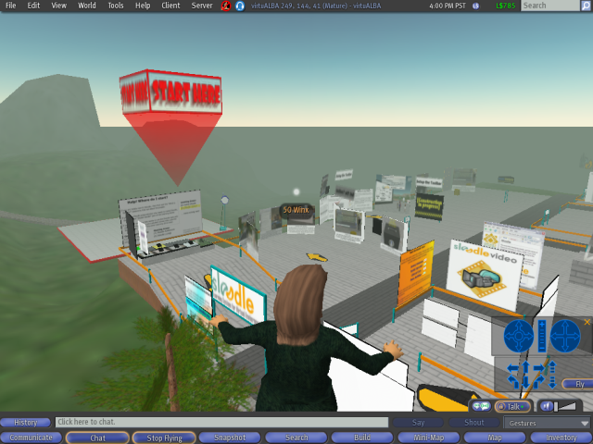

- There are entertainment venues which provide places for concerts and theatricals.

- Artists display virtual works in virtual galleries, museums, libraries, and other venues.

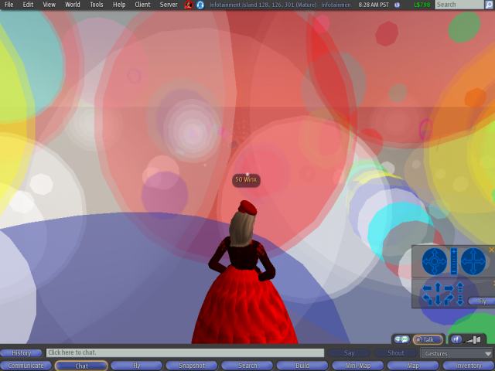

- Harvard Law School is teaching classes in SL.

- Universities have built virtual campuses in SL.

- Tufts University’s Tisch Library and the Wright Center for Science Education has its Climate Change Education Center in SL, funded by the Berger Family Technology Transfer Endowment (83,186,23).

- There is a French library, Bibliotheque Franco, built by a French university consultant. He has done an excellent job utilizing different tools in the library, and may be the only one in SL currently providing an RSS feed to mobile phone service. The link is on the upstairs level of the library. A branch of this library is located on Info International; the coordinates are for the main French library. (42,219,21)
http://slurl.com/secondlife/Ebeoplex/42/216/22

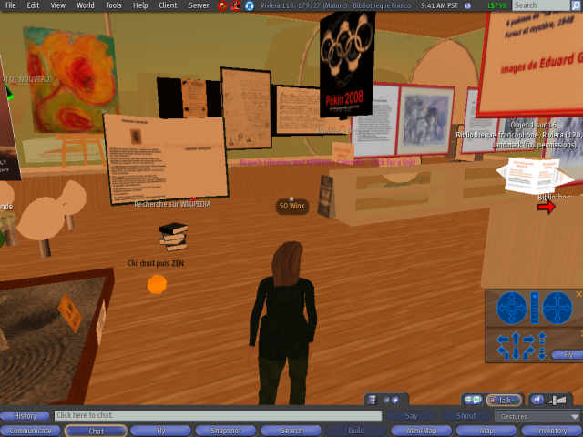

- SL Best Practices in Education. Like all good educators, they are developing standards: http://slbestpractices2007.wikispaces.com/SLCN.tv+Archives

NEW MEDIA CONSORTIUM (NMC)

The New Medium Consortium (NMC) is an international 501(c)3 not-for-profit consortium of nearly 250 learning-focused organizations dedicated to the exploration and use of new media and new technologies. Among the membership are some of the most highly regarded colleges and universities in the world (including UCLA), museums, research centers, foundations, and forward-thinking companies.

NMC Orientation: This grid offers useful technology information including how to stream audio and video in SL, how to create a slide show, how to use voice chat options, and more. The coordinates are for the orientation area of the grid. (108,123,39)
http://slurl.com/secondlife/NMC%20Orientation/108/123/39

NMC site: http://www.nmc.org/

NMC Campus Observor: http://sl.nmc.org/
This is the online zine for the latest news regarding NMC’s SL campus.

NMC VIRTUAL WORLDS

“2007 was a year in which campuses made their entries into Second Life in great numbers, and as a result there is a considerable critical mass of educational institutions now existent in Second Life — more than 1200 educational islands were created in 2007, and the number of educational projects launched last year in Second Life is many times that.”

“2008 also promises to see strong educational use of Second Life, but with a new focus. Projects in 2008 are much more likely to be about creating learning experiences than virtual campuses.”

New initiatives for 2008 include:

- The NMC Virtual Learning Prize. The NMC Virtual Worlds team will be soliciting ideas for the development of immersive content from educators around the globe. Twenty ideas will be selected in 2008 for development. Each Virtual Learning prize recipient will receive $5,000 US in cash incentives and virtual services that can be devoted to realizing the idea in Second Life. Recipients will have their idea funded with $4,500 US in premium development services from NMC and receive an honorarium of $500 US in cash. The copyright for prize winning ideas will of course remain with the inventor, but the products created as part of this program will go into open source and be distributed royalty free to the educational community. This program will be launched in March, 2008.

- The Educational Resource Repository. The NMC is devoting an entire sim for an educational resources repository that will be located on Learning, an island within the NMC Campus. To seed the content of this repository, and to encourage other developers to support education in Second Life, the NMC will release virtually all the content it produced in 2007 into open source — buildings, meeting facilities, educational tools, avatars, clothing, equipment, scripts, and much more. The amount of material that the NMC has licensed to release in this way numbers in the thousands of objects, and the NMC is committed to adding to it throughout the year. The repository, in which everything from shoes to amphitheaters will be available for a single Linden dollar (simply to enable tracking via counts), will also include resources donated by other developers. The first of these is Stephane Zugzwang’s renowned Virtual Reality Room, which is already available. The NMC’s Educational Resources Repository will open February 1, 2008

- Development of New Forms of Architecture. Among the interests of the NMC Virtual Worlds team for 2008 is to explore new concepts of architecture that may be especially suited for virtual spaces. The first of these, created by real-life architect and NMC Virtual Worlds developer CJ Holden, is an extremely flexible modular structure that works with the SL building grid to allow the construction of simple or complex structures organically in literally minutes.

- Live mentoring for new entrants into Second Life. High on the list of planned enhancements for the NMC’s Orientation Island experience is the implementation of a mentoring program. There is strong support for this in the Second Life educational community, and a presence-aware mentor notification system has already been piloted. The mentor community is expected to launch sometime in the first part of 2008.

Press Release:
http://virtualworlds.nmc.org/wp-content/uploads/2008/01/press-release-nmc-virtual-worlds-2008-plans.pdf

Seriously Engaging: http://www.youtube.com/watch?v=S9VZKTT6gZ8&feature=related

AWARDS

The Alliance Library System’s Technology Award was awarded in 2007 to Rhonda Trueman aka Abbey Zenith (SL).

The ALA awarded its Library of the Future Award for 2007 to the Second Life Library.

LIBRARIAN-HOSTED GRIDS

In addition to the Education Grid, there are at least two other grids hosted by librarians.

The Teen Grid is for teenagers. It is a closed grid. Librarians who work on the Teen Grid must undergo a security background check.

Caledon is a Victorian themed grid. One of the developers of this grid is a librarian whose avatar name is JJ Drinkwater. There are over 25 islands in this grid. Caledon VictoriaCity is the island on which The Whitehorn Memorial Library (48:202:23), a SL Branch Library, is located.

SOME PLACES ON THE EDUCATION GRID

- Commonwealth Island: This island is a location for non-profit activist organizations (169,69,22). http://slurl.com/secondlife/Commonwealth%20Island/169/69/22

- Health Info Island (130:140:23) http://slurl.com/secondlife/Healthinfo%20Island/130/140/23 : This island contains health related resources, including the Consumer Health Library (62:148:21) http://slurl.com/secondlife/Healthinfo%20Island/62/148/22 and a medical library.

- Info Island: This island is undergoing reconstruction; it was the former site of the SL Library Reference Desk and where the Second Life Library is located. Most librarian meetings take place in the amphitheatre on this island. Website: http://infoisland.org/

- Info Island International: This is where the SL Library Reference desk is located and where librarians offer reference services. It is also a popular place for librarians to just hang out (118:229:22).
http://slurl.com/secondlife/Info%20Island%20International/118/229/22

- Infotainment Island: This site has art installations and a jazz club (130:131:31): http://slurl.com/secondlife/Infotainment%20Island/130/131/31.

- The Machinima Institute Group: This is where you can learn how to make movies in SL. It is a bit complicated, so this institute offers classes. The person who built the institute and teaches classes is HVX Silverstone. If you run into her, tell her 50 Winx sent you. (63,21,23) http://slurl.com/secondlife/Eduisland%203/63/21/23

- The San Jose State University School of Library and Information Science campus (SJSU SLIS): This is the first library science school campus in SL (221:140:33) http://slurl.com/secondlife/SJSU%20SLIS/221/140/33

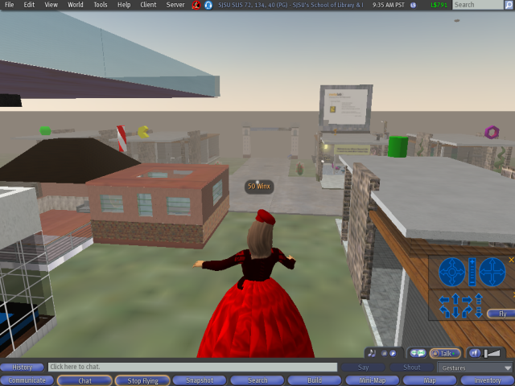

- Renaissance Island: This is a Tudor England themed island. This island hosted the first broadcast tie-in with the in-world broadcast of some episodes of the Showtime series, The Tudors http://slurl.com/secondlife/Renaissance%20Island/107/45/27)

- Stanford University: Stanford has an island in SL. There is a book history exhibit on the Stanford Island http://slurl.com/secondlife/Stanford%20University%20Libraries/85/216/33

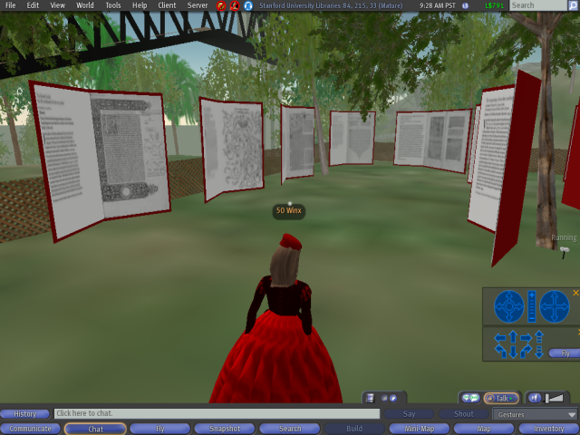

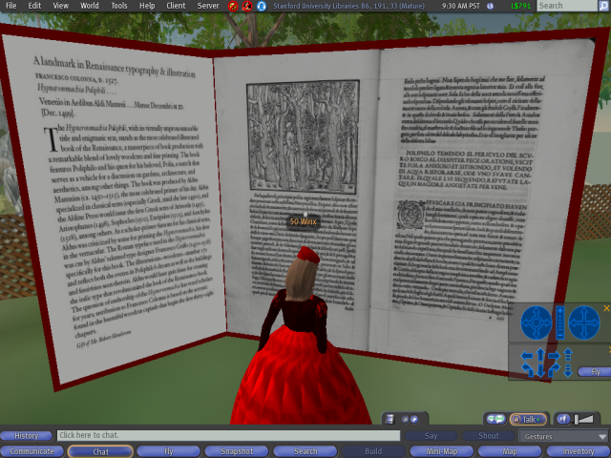

- UCLA Library: Yes, thanks to Esther Grassian (avatar name Alexandria Knight) UCLA has a presence in SL! (http://slurl.com/secondlife/Cybrary%20City/231/140/27)

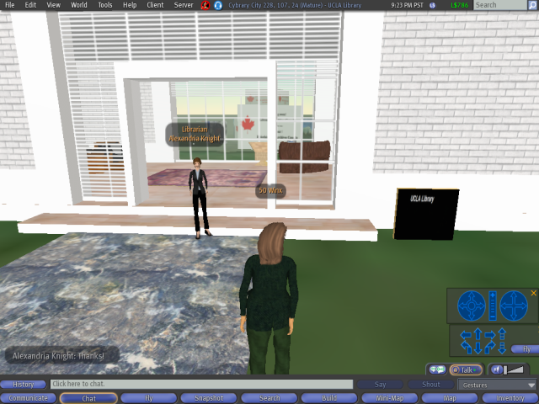

THE SALAMANDER PROJECT

An area of concern for librarians in SL is how to organize the educational material in SL. One approach, The Salamander Project, is a collaborative project coordinated by researchers and educators at The Center for Advanced Technology in Education at the University of Oregon.

The project mission is “to enlist people to collaborate to find, index, and discuss aspects of the 3D Virtual World ‘Second Life’ that has educational value and share in the research, development, and training opportunities associated with those factors.”

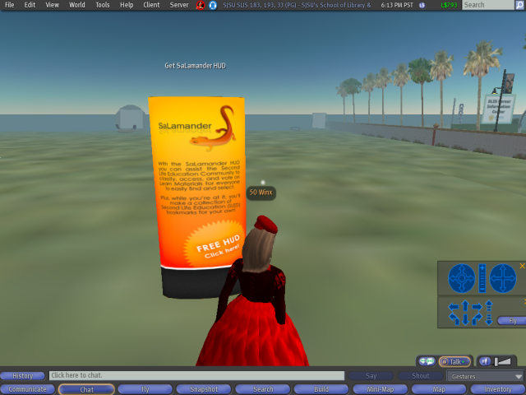

The Salamander Project has a "Proof of Concept" grant from the NorthWest Academic Computing Consortium for $10,000. With this startup money, the following objectives are intended to be accomplished:
- Create several tools for nominating Learning Objects within Second Life.

- Establish a working taxonomy for these Learning Objects within Second Life on the SaLamander wiki.

- Develop some initial capacity for Second Life Learning Objects to be found within MERLOT: http://www.merlot.org/merlot/index.htm.
MERLOT is a user-centered, searchable collection of peer reviewed, higher education, online learning materials created by registered members, and a set of faculty development support services.

Do check out the SaLamander wiki. There is much information regarding educational materials, tools, and management systems in development for SL on this wiki: http://www.eduisland.net/salamanderwiki/index.php?title=Main_Page#Participant_Registration_and_Contact_Information
A video overview of SaLamander is available: http://blip.tv/file/571587
Wainbrave Bernal (SL avatar name) gave a presentation on SaLamander. The presentation slides are available here: http://sl.nmc.org/wp-content/uploads/2008/01/nmc-salamander.pdf

GOVERNMENT IN SECOND LIFE

Government agencies are building a presence is SL.

- The USC Center on Public Diplomacy and the U.S. Department of State Bureau of International Information Programs jointly sponsored the Virtual Vibe Jazz Fest ’07 in SL.

- Center for Disease Control (CDC) http://www.cdc.gov/search.do?queryText=Second+Life&searchButton.x=18&searchButton.y=7&action=search have entered SL

- The Federal Consortium for Virtual Worlds http://www.ndu.edu/irmc/fedconsortium.html
Click on the Agenda tab to learn what was covered at this conference. The video presentation listed below by NOAA was featured at the conference.

- The National Oceanic and Atmospheric Agency (NOAA) video presentation given to government employees. (This is a movie. If the link does not work, copy it and paste it into your browser.): http://ndu.blackboard.com/bbcswebdav/institution/IRMC/FedConst/HACK101.mov
This presentation is about a half hour long. I strongly recommend it. The avatar giving the demonstration briefly touches on many subjects regarding SL, government involvement in SL, partnerships forming in SL, Moodle, etc. The demonstration also mentions how to register for SL using interfaces other than the SL home page.
NOAA: http://usasearch.gov/search?affiliate=noaa.gov&v%3Aproject=firstgov&query=Second+Life&x=0&y=0

- House of Representatives sub-committee video on SL: http://energycommerce.edgeboss.net/wmedia/energycommerce/040108.ti.hrg.virtual_worlds.wvx

OTHER PLACES OF INTEREST

- IBM: IBM has one of the most impressive grids in SL. Check it out to see how business is using this 3D environment. Look for the 3D navigational map to orient you. (161,56,22)

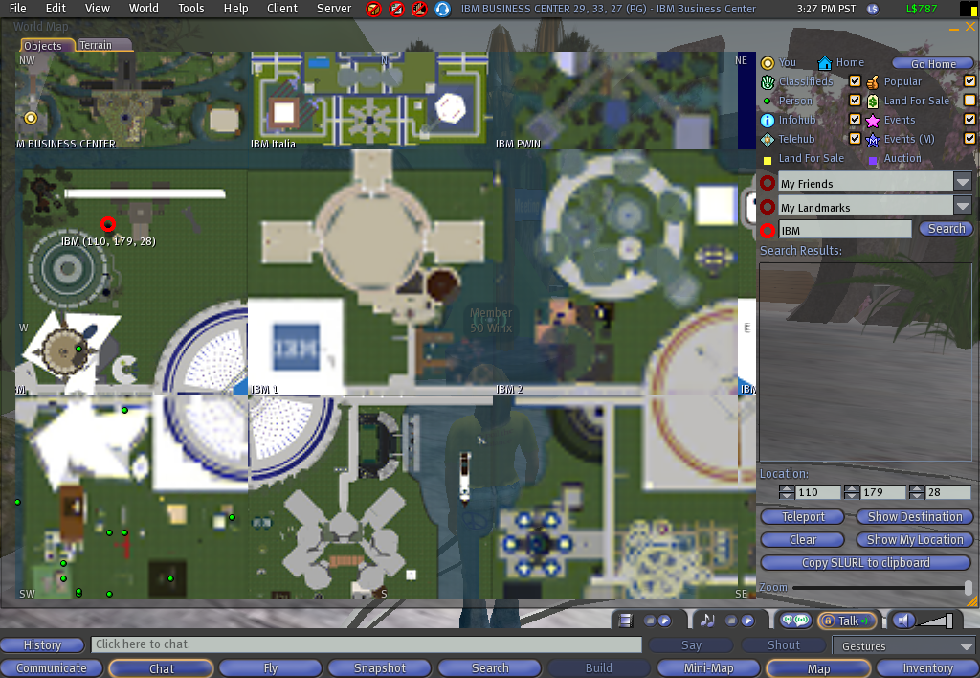

- IMB’s SL web page: http://www.ibm.com/Search/?q=Second+Life&v=16&en=utf&lang=en&cc=us&Search=Search
This page houses IBM’s SL blog. It is full of information for the technical geek, and has provides information regarding projects IBM is pursuing in SL.

- SciLand: http://www.scilands.org/
SciLands is a SL continent and user world dedicated to science and technology. Organizations involved with SciLands include include the National Physical Laboratory (NPL), NASA, San Francisco’s Exploratorium hands-on science and technology museum, Elon University, The University of Denver, The Tech Museum of San Jose, Imperial College London, National Library of Medicine (NIH), National Oceanic and Atmospheric Administration (NOAA), National Space Society, Space Studies Group, Space Frontier Foundation, NPR Science Friday, Loughborough University, Future Focus - BERR, Memorial Sloan-Kettering Cancer Center, Texas Wesleyan University, Northern Michigan University and the International Spaceflight Museum.

- SLCN.TV (Second Life Cable Network): http://www.slcn.tv/
SLCN.TV is a video network designed to expand the in-world audience and to deliver virtual entertainment to the real-world. They cover live events such as the SL Best Practices in Education conference held in May 2007 and stream live voice for conferences in SL.

- Svarga: This island has been programmed to be an evolving ecological system. Use the little white pod to take a tour, or just explore on your own. (6,122,22) http://slurl.com/secondlife/Svarga/115/42/30

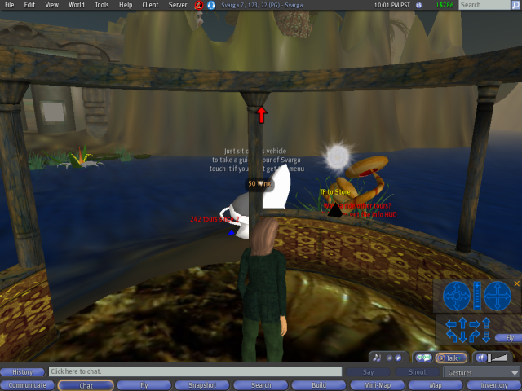

The Weather Channel: This is a fun site to visit. You can have your avatar try surfing or skiing from this site. (113:4:26) http://slurl.com/secondlife/Weather/116/14/26

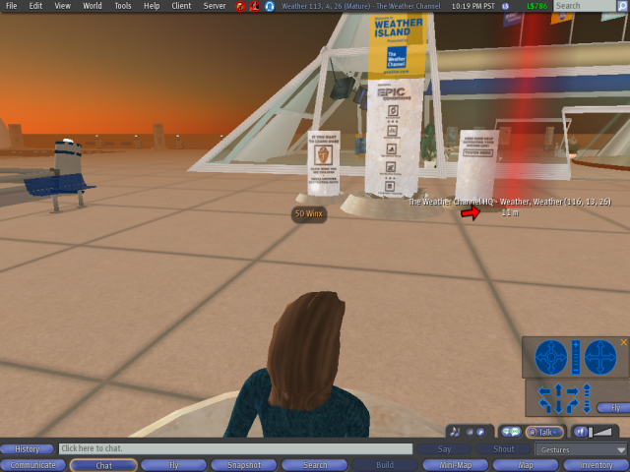

THiNC Book: http://thincsl.com/category/products/thinc-book/
Think book is a book publishing software program for use in SL. (132,105,71) http://slurl.com/secondlife/THINC/128/105/71

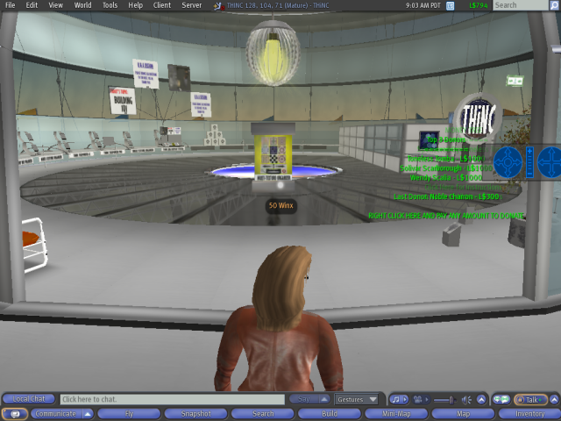

REGISTER

To register for Second Life, visit the SL website: http://secondlife.com/

You will have to choose a name in order to register. You will be provided with a list of last names from which you must choose a last name. You will also have to choose a first name of your choosing.

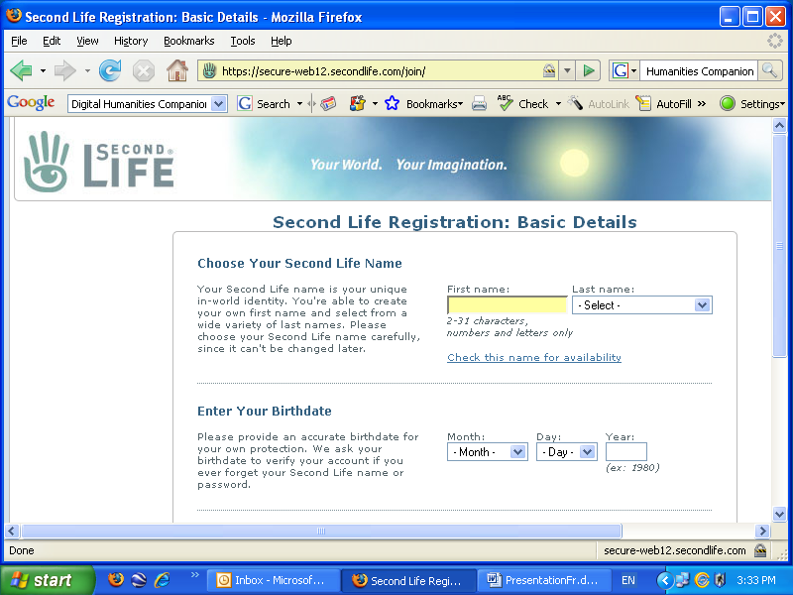

Download the SL software onto your computer.

ORIENTATION ISLAND

Once you have registered and logged onto SL, you will be given several avatar forms from which to choose. You may have to wait a few moments for your avatar to be “born.” Your name will appear above your avatar. You will find yourself at the entrance to Orientation Island.

Be careful when you begin. Once you leave Orientation Island, you may not go back to it.

Orientation Island has four modules which you can work your way through. They will teach you the basics of SL, including navigating around SL and editing your appearance.

MOVING YOUR AVATAR IN SL

To move your avatar, use the up, down, and side arrows. To fly up use the page up key; use the page down key to come down.

APPEARANCE

You are given a choice of several avatar types when you first register and log onto SL. Not all of them are human forms. Once you have chosen your basic type, you can make changes to your appearance.

You can change your hair, choose your eyes, and alter your size (both vertically and horizontally). You can also change the default set of clothing you are given.

Once you get familiar with navigating and making basic changes to your appearance, you can go shopping to buy attachments to alter your appearance. You can, for example, buy “prim” hair which is worn as an attachment. You can also buy skin with anatomical parts. Check out some videos on this before you buy, so you know how to choose well made attachments. You don’t what seams to show or have a George Hamilton sun tan.

Shopping is VERY big in SL, and you can find stores to buy your avatar all sorts of clothes, to suit ANY occasion, and probably any time period as well. You can often find freebies, (free clothes, accessories, houses, modes of transportation, plants, drinks, food, etc.) as well.

See the Second Life Tutorial on how to change your appearance below to get you started. How to change your appearance: http://www.youtube.com/watch?v=GqbuMi5N97c&feature=related

RIGHT CLICKING IS IMPORTANT

Right clicking your mouse allows your avatar to perform many common activities in SL. What those activities are depends upon on what you click. Right clicking opens up a pie divided into eight segments with the bottom segment giving you the option to display another pie. The labels representing the activities your avatar can perform which are displayed if you click on an object will be different than those displayed if you click on another avatar.

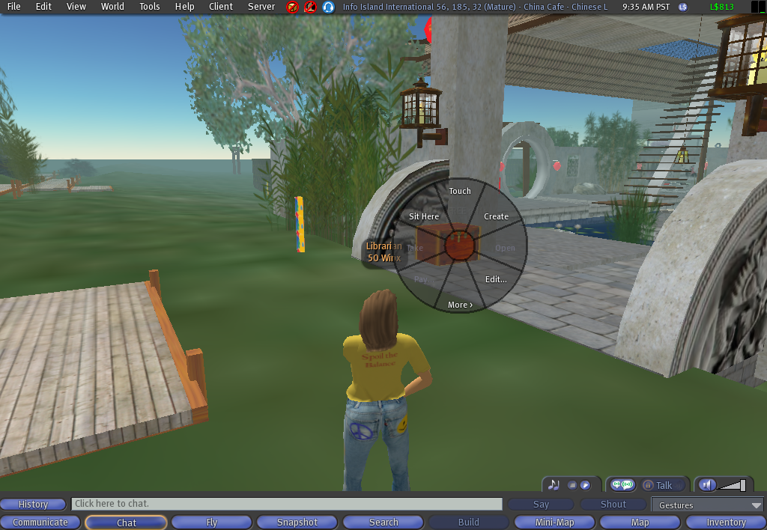

When you click on an object, the first set of options you will see is:

- Sit Here
- Touch
- Create
- Edit…
- More>

HOW TO SIT
Navigate your avatar so that it is in the vicinity in front of the object on which you want to sit.
- Right click on the object.

- Click on “Sit Here.”

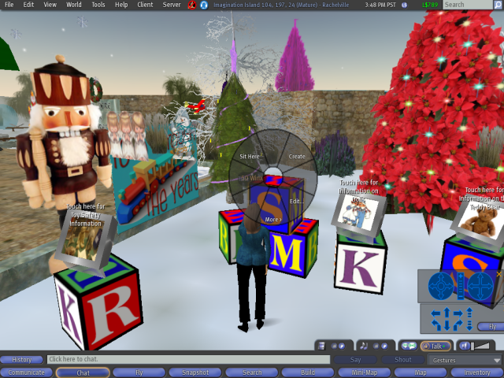

To stand up, click on the Stand Up tab at the bottom center of your screen.

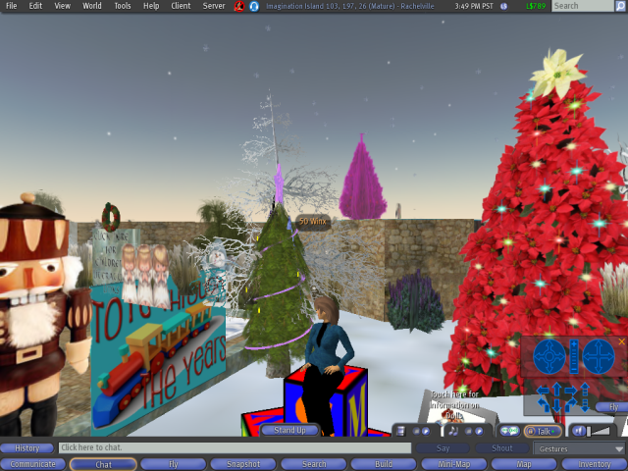

Be sure to position yourself in front of the object on which you want to sit, otherwise you may find yourself sitting in direction you do not want to face.

TOUCH

Touching an object may allow you to animate, teleport, access a notecard, or direct you to a website. To touch an object, right click your mouse, and left click touch.

MORE>
Clicking on more will give you additional options such as “Wear” to change your clothing.

Clicking on More> again will bring up options which will allow you to “Report Abuse” or to “Inspect” which provides you with information about an object, such as who created it.

CLICKING ON ANOTHER AVATAR

The labels of the pie segments are different when you click onto another avatar than when you click on an object. The pie segments you will see are:

- Go to
- Mute
- Profile
- Send IM…
- Pay
- Add Friend
- More>

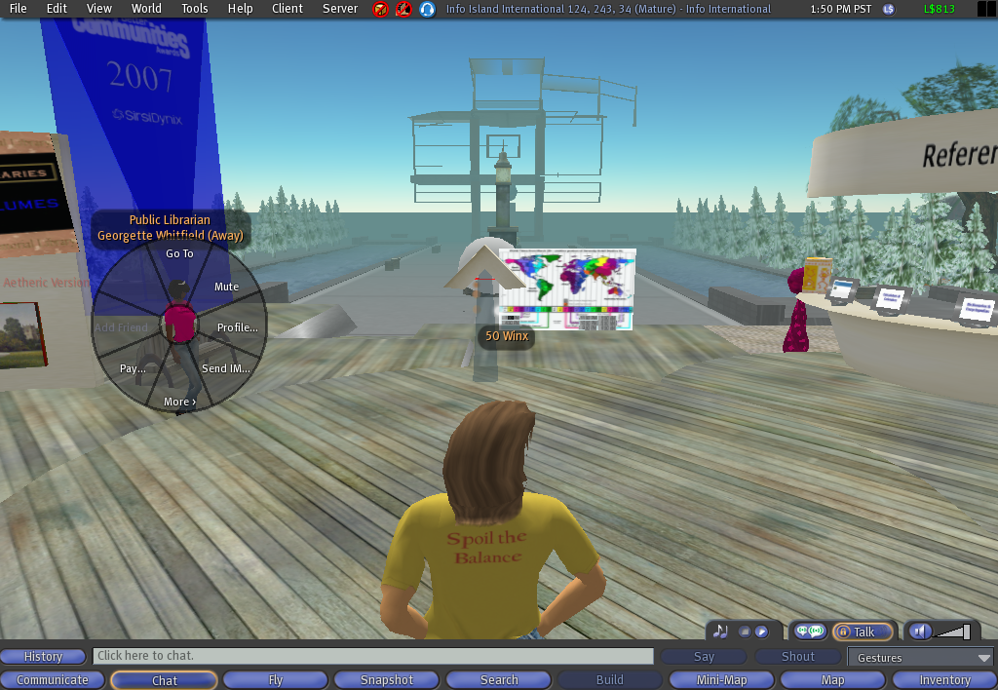

PROFILE

You can access information about another avatar by right clicking on the avatar and clicking on “Profile.” A window will appear that will tell you to what groups the avatar belongs, when the avatar was “born” (first logged onto SL), and additional information the person has provided. The tabs across the top allow you access additional information.

Second Life Tutorial - How to fill in your Profile: http://www.youtube.com/watch?v=ZCgQRrdtgQc&feature=related

SEND IM

Send IM allows you to send an Instant Message to another avatar. See more about instant messaging and communicating in SL under Communicating in SL.

Clicking on More> will bring up segments labeled Group Invite and Give Card.

PAY

Pay allows you to make purchases and payments in SL.

ADD A FRIEND

Clicking on Add A Friend allows you to extend an invitation to someone to be included in your friends list. When someone is on your friend list, you will be able to see if they are in-world when you are. You can highlight their name in your list and send an instant message to them whether they are in-world or not. You can highlight their name, click to show their profile, and drag items from your inventory onto their profile to transfer a copy of an item, landmark, note, etc. to them.

COMMUNICATING IN SL
There are three ways to communicate in SL.

CHAT

- Chatting is used to communicate to other avatars by using your computer keyboard to type in the chat field. This is the most common form of communication in SL.

  - To chat, click on the Chat tab located on the lower left side of your computer screen.

  - A chat field will open. Click inside the chat field and type your message. Then press Enter on your key board to send your chat.

  - The message you sent will pop up for several seconds on your screen above the chat field. When someone in your vicinity sends a chat message, you will see it pop up here.

There are times when you may be with a group where several people are chatting simultaneously and several conversational threads are happening at once. To ease following the threads, click on the History button to the left of chat field. A window will stay open until you close it which will contain all the messages sent by people in the vicinity. You will be able to scroll up and down this window and read the messages.

- Instant messaging is used when you want your communication to be private, when sending a message to a group, when communicating with someone in your Friends list who is online in a location different from that where you are, and when leaving a message for someone who is not online.

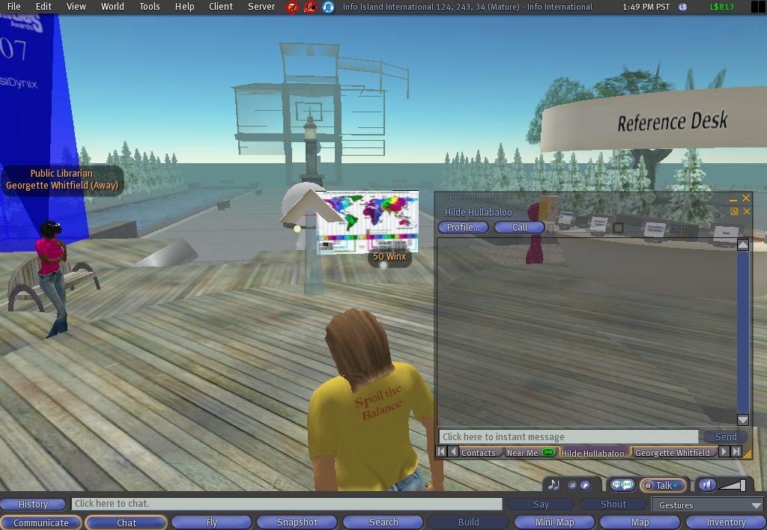

INSTANT MESSAGE

You may want to communicate privately with an avatar so that others around you cannot hear (or see) what you are saying. To do this, right click on the avatar with whom you wish to communicate, and left click on Send IM. A window will open and you can type your message in the chat field at the bottom of the window. Click on send to send the message to the other avatar. Your chat session will appear in the window about the chat field. When the avatar responds to you, you will see an indication in the window that the avatar is typing their response to you.

You can also leave an Instant Message for another avatar who is online, but in a different location from you or who is not online. You can do this by highlighting the name of the avatar if you have them in your friends list.

- Click on the Communicate tab.

- Click on Contacts.

- Click on the Friends tab.

- Click on the name of the avatar to whom you wish to send a message.

- Click on IM/Call and type your message. If the person is in SL they will respond. If not, your message will be delivered to them when they log onto SL.

VOICE

- Voice is used when you wish to talk to someone within voice distance. You will need to have a microphone and speakers or headsets to use this function. You will also have to set your voice preferences by clicking on Edit, then Preferences, then voice.

SETTING PREFERENCES

You will need to set preferences for how you want your computer to handle things such as sound and video streaming, voice, etc. To set preferences, click on Edit, then click on Preferences at the bottom of the popup menu. A window with a list of buttons on the left will open. Click on the button for the settings you want to adjust.

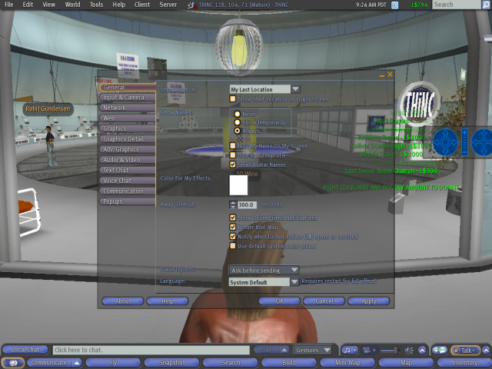

CURRENCY

You will want to register without signing up for a subscription. However, you may want to give credit card information. When I signed on, I was given L$250 for entering my credit card information.

You can participate in SL without using real money or a credit card. SL has its own currency, Linden dollars (L$). You may purchase L$s by buying them with real money, you can try and find a “job” in SL and earn some, or you can build things in SL and sell them for L$s in SL. I parked my avatar at a job which is called “camping” in SL.

Some stores and places in SL offer freebies of every variety, including clothes, houses, vehicles, plants, food, and drinks.

SEARCHING IN SL

To locate library-related groups in SL, click on the Search tab located at the bottom your computer screen. It is located in the middle of the screen. You can search for events, places, people, and groups. When searching for places, be sure you have the mature box checked.

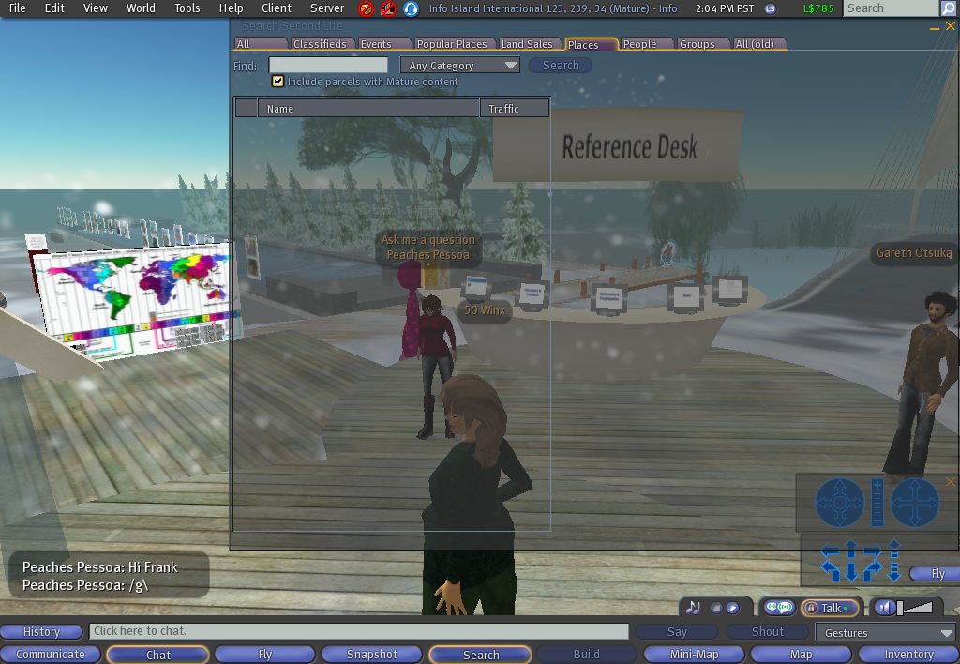

LOCATING LIBRARY GROUPS

To locate library-related groups in SL, click on the Search tab located at the bottom your computer screen. It is located in the middle of the screen. When the search screen opens, click on the Groups tab at the top of the screen. It is the last tab. Be sure the “Include Mature groups” box is checked. Type in “librarians” in the Find field and click on search. A list of librarian groups will appear.

In addition, there are numerous library committees which you may join once you are a member of the Librarians of Second Life group.

There are 797 members in the Librarians of Second Life group.
Check out their website, Second Life L!brary Staff Worksite: http://www.infoisland.org/drupal/

INVENTORY

Animations, scripts, notes, clothes, body parts, landmarks, objects, gestures, and folders are stored in your inventory. Your avatar will come with a Library in your inventory that has a basic set of some of these features. You access your inventory by clicking on the Inventory tab at the bottom right of your screen.

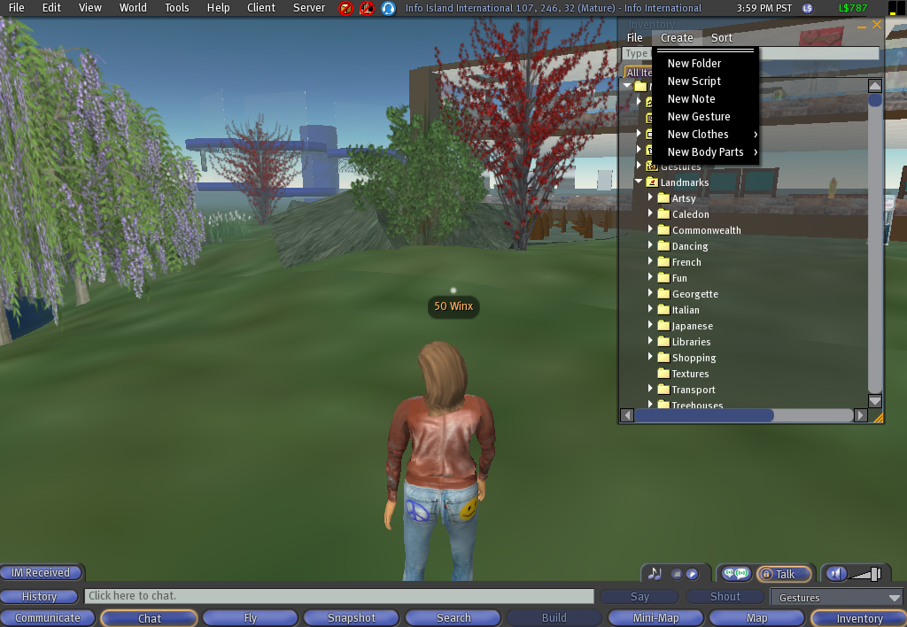

You can create new folders, notes, etc., by clicking on Create in the menu at the top of your Inventory.

You can share landmarks, notes, folders, etc. with other avatars by dragging an item from your Inventory to the avatar with whom you want to share the item.

You can send something to an avatar that is not online. If they are in your Friends List, highlight their name, and open up their profile. Then drag the item from your Inventory to their profile.

If they are not in your Friends List, access the Search function by clicking on the Search tab at the bottom of your screen. In the Search window, click on the People tab and enter the name of the avatar in the search field. Open the avatar’s profile and drag the item from your Inventory onto the avatar’s profile.

BUILDING IN SL

The basic building blocks in SL are called prims (short for primitives). Since storage capacity on servers has limitations, the size of the servers impacts the number of prims allowed on a server. Everything you see in SL is built using prims.

There are places in SL where you can get information to help you with building.

- The SJSU SLIS campus has building information. (55,86,33)

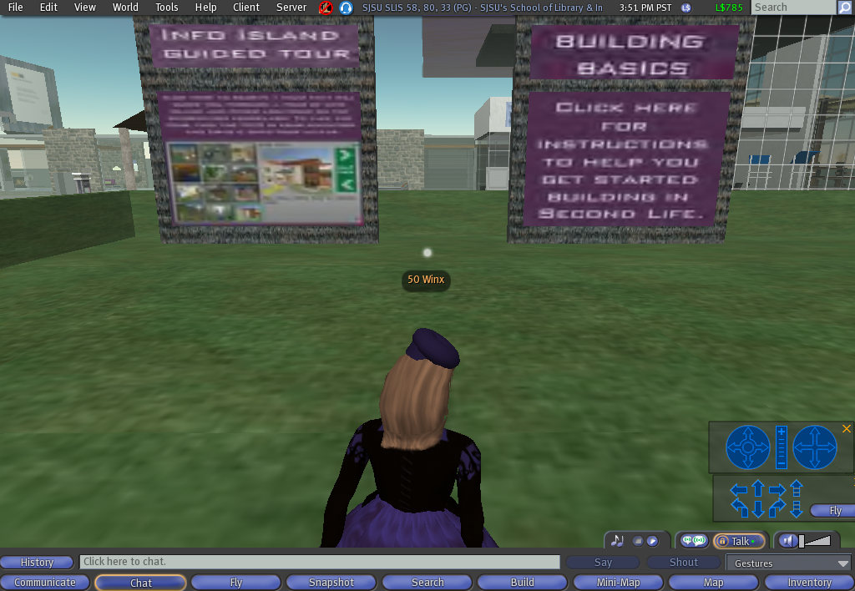

- SL’s in-world building tutorial is located in the Ivory Tower of Prims.

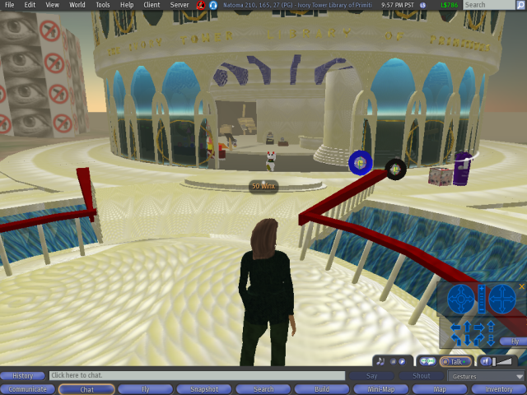

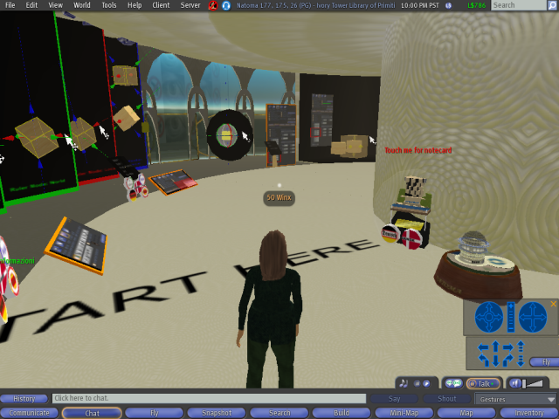

SYSTEM REQUIREMENTS

Windows | Minimum Requirements | Recommended Requirements
Internet Connection* | Cable or DSL | Cable or DSL
Operating System | 2000, XP, or Vista | XP or Vista
Computer Processor | 800 MHz Pentium III or Athlon, or better | 1.5 GHz (XP), 2-GHz (Vista) 32-bit (x86) or better
Computer Memory | 512 MB or more | 1 GB or more
Graphics Card for XP/2000** | - NVIDIA GeForce 2, GeForce 4 MX or better  - OR ATI Radeon 8500, 9250 or better  - OR Intel 945 chipset | NVIDIA Graphics cards  6000 Series:  - 6600, 6700, 6800  7000 Series:  - 7600, 7800, 7900  8000 Series:  - 8500, 8600, 8800  GeForce Go Series:  - 7600, 7800, 7900  ATI Graphics Cards  - X800, X900, X1600, X1700, X1800, X1900  - x2600, x2900  - x3650, x3850
Graphics Card for Vista (requires latest drivers)** | - NVIDIA GeForce 6600 or better  - OR ATI Radeon 9500 or better  - OR Intel 945 chipset | NVIDIA Graphics cards  7000 Series:  - 7600, 7800, 7900  8000 Series:  - 8500, 8600, 8800  GeForce Go Series:  - 7600, 7800, 7900  ATI Graphics Cards  - X1600, X1700, X1800, X1900  - x2600, x2900  - x3650, x3850
Mac OS | Minimum Requirements | Recommended Requirements
Internet Connection* | Cable or DSL | Cable or DSL
Operating System | Mac OS X 10.3.9 or better | Mac OS X 10.4.3 or better
Computer Processor | 1 GHz G4 or better | 1.25 GHz G4 or better
Computer Memory | 512 MB or more | 1 GB or more
Graphics Card** | - ATI Radeon 9200 and above  - OR ATI Radeon X Series  - OR NVIDIA GeForce 2, GeForce 4  - OR NVIDIA GeForce 5000 Series and above | - ATI: X1600, X1900, X2400, X2600  - OR NVIDIA: 6800, 7600, 7800, 8800
LINUX | Minimum Requirements | Recommended Requirements
Internet Connection* | Cable or DSL | Cable or DSL
Operating System | A reasonably modern 32-bit Linux environment is required. If you are running a 64-bit Linux distribution then you will need its 32-bit compatibility environment installed. | A reasonably modern 32-bit Linux environment is required. If you are running a 64-bit Linux distribution then you will need its 32-bit compatibility environment installed.
Computer Processor | 800 MHz Pentium III or Athlon, or better | 1.5 GHz or better
Computer Memory | 512MB or more | 1 GB or more
Graphics Card** | - NVIDIA GeForce 2, GeForce 4 MX, or better  - OR ATI Radeon 8500, 9250, or better | NVIDIA Graphics cards  6000 Series:  - 6600, 6700, 6800  7000 Series:  - 7600, 7800, 7900  8000 Series:  - 8500, 8600, 8800  GeForce Go Series:  - 7600, 7800, 7900
* Second Life is not compatible with dial-up internet, satellite internet, and some wireless internet services.
** Second Life may not run on graphics cards other than the ones listed above. The following cards are NOT compatible with Second Life:
- NVIDIA cards that report as a RIVA TNT or TNT2
- ATI cards that report as RAGE, RAGE PRO, or RADEON 320M, 340M, 345M, or similar model numbers
- Intel chipsets less than a 945 including Intel Extreme
- Cards with the following branding: 3DFX, RIVA, TNT, SiS, S3, S3TC, Savage, Twister, Rage, Kyro, MILENNIA, MATROX
The following cards have not been tested with Second Life, and compatibility is not certain:
- NVIDIA cards that report as Quadro
- ATI cards that report as RADEON IGP or RADEON XPRESS
- ATI cards that report as FireGL
- ATI cards that report as FireMV

RESOURCES

BOOKS ABOUT SECOND LIFE

Mansfield, R. (2007). How to Do Everything with Second Life (How to Do Everything). McGraw-Hill Osborne Media. ISSN: 0071497897. Amazon: http://www.amazon.com/How-Do-Everything-Second-Life%C2%AE/dp/0071497897/ref=pd_bbs_sr_5/104-7917105-7246334?ie=UTF8&s=books&qid=1194473603&sr=8-5

Rymaszweski, M., Au, W.J., Wallace, M., and Winters C. (2007). Second Life: The Offical Guide. Sybex. ISBN: 047009608X. Amazon: http://www.amazon.com/Second-Life-Official-Michael-Rymaszewski/dp/047009608X/ref=pd_bbs_sr_1/104-7917105-7246334?ie=UTF8&s=books&qid=1194473603&sr=8-1#sipbody

Terdiman, D. (2007). Entrepreneur's Guide to Second Life: Making Money in the Metaverse. Sybex. ISBN: 0470179147. Amazon: http://www.amazon.com/Entrepreneurs-Guide-Second-Life-Metaverse/dp/0470179147/ref=pd_bbs_sr_6/104-7917105-7246334?ie=UTF8&s=books&qid=1194473603&sr=8-6

Weber, A., Rufer-Bach, K., Platel, R. (2007). Creating Your World: The Official Guide to Advanced Content Creation for Second Life. Sybex. ISBN: 0470171146. Amazon: http://www.amazon.com/Creating-Your-World-Official-Advanced/dp/0470171146/ref=pd_bbs_sr_2/104-7917105-7246334?ie=UTF8&s=books&qid=1194473603&sr=8-2

GOVERNMENT IN SECOND LIFE:

House of Representatives sub-committee video on SL: http://energycommerce.edgeboss.net/wmedia/energycommerce/040108.ti.hrg.virtual_worlds.wvx

The National Oceanic and Atmospheric Agency (NOAA) video presentation given to government employees. (This is a movie. If the link does not work, copy it and paste it into your browser.): http://ndu.blackboard.com/bbcswebdav/institution/IRMC/FedConst/HACK101.mov
This presentation is about a half hour long. I strongly recommend it. The avatar giving the demonstration briefly touches on many subjects regarding SL, government involvement in SL, partnerships forming in SL, Moodle, etc. The demonstration also mentions how to register for SL using interfaces other than the SL home page.

MOODLE/SLOODLE

Some of you may be aware of Moodle, the open source class (or learning) management system. Sloodle is Moodle adapted to SL.

The Moodle website is: http://moodle.org/

Rice, W. (2006). Moodle E-Learning Course Development. Packt Publishing. ISBN: 1904811299. Amazon: http://www.amazon.com/Moodle-E-Learning-Course-Development-William/dp/1904811299/ref=pd_bbs_1/104-7917105-7246334?ie=UTF8&s=books&qid=1194475704&sr=1-1

Sloodle tutorial in SL: (243,222,33) http://slurl.com/secondlife/virtuALBA/243/222/33

The Sloodle website is: http://www.sloodle.com/

Rice. W. (2007). Moodle Teaching Techniques. Packt Publishing. ISBN: 184719284X. Amazon: http://www.amazon.com/Moodle-Teaching-Techniques-William-Rice/dp/184719284X/ref=pd_bbs_2/104-7917105-7246334?ie=UTF8&s=books&qid=1194475704&sr=1-2

PUBLISHING IN SL

THiNC Book: http://thincsl.com/category/products/thinc-book/
Think book is a book publishing software program for use in SL.

SALAMANDER

Salamander Google Group list: http://groups.google.com/group/salamanderproject

The SaLamander Wiki for information regarding the SaLamander HUD: http://www.eduisland.net/salamanderwiki/index.php?title=Main_Page#Participant_Registration_and_Contact_Information

A video overview of SaLamander is available: http://blip.tv/file/571587

Wainbrave Bernal’s (SL avatar name) SaLamander presentation slides: http://sl.nmc.org/wp-content/uploads/2008/01/nmc-salamander.pdf

TUTORIALS

NMC (New Media Consortium) Campus: Seriously Engaging: http://www.youtube.com/watch?v=S9VZKTT6gZ8&feature=related

Second Life Tutorial - How to change your appearance: http://www.youtube.com/watch?v=GqbuMi5N97c&feature=related

Second Life Tutorial - How to fill in your Profile: http://www.youtube.com/watch?v=ZCgQRrdtgQc&feature=related

Second Life Tutorial - How to manage your inventory: http://www.youtube.com/watch?v=AULw9Oa_1Bw&feature=related

Second Life Tutorial - How to send and create a notecard: http://www.youtube.com/watch?v=PwSIYGhZbT4&feature=related

Second Life Tutorial - How to use gestures: http://www.youtube.com/watch?v=6WKo4G8aQBc&feature=related

Second Life Tutorial - How to use HUDs: http://www.youtube.com/watch?v=D3rsGO2Wqho&feature=related

Second Life Tutorial - How to use the building grid: http://www.youtube.com/watch?v=8k-XoIPycm8&feature=related

WEB SITES

Cyber Slang Guide: http://www.nnwebs.com/services/cyberslang.html
This site will give you a directory of common keyboard slang shortcuts such as “afk” for away from keyboard.

The Institute for the Future of the Book: http://www.futureofthebook.org/
This is a think tank funded by the MacArthur Foundation and affiliated with the University of Southern California. Their purpose is “investigating the evolution of intellectual discourse as it shifts from printed pages to networked screens.”

Mashable: http://mashable.com/
This site is dedicated to social networking news.

MERLOT (Multimedia Educational Resource for Learning and Online Teaching): http://www.merlot.org/merlot/index.htm
MERLOT is a user-centered, searchable collection of peer reviewed, higher education, online learning materials created by registered members, and a set of faculty development support services.

NMC (New Media Consortium): http://www.nmc.org/

NMC Campus Observor: http://sl.nmc.org/
This is the online zine for the latest news regarding NMC’s SL campus.

NMC Virtual Worlds: http://virtualworlds.nmc.org
This is NMC’s program to help learning-focused organizations to explore the potential of virtual worlds. NMC Virtual Worlds provides custom services for education and training, and conducts an ongoing series of events, conferences, and programs.

NOAA video presentation given to government employees. (If the link does not work, copy it and paste it into your browser.): http://ndu.blackboard.com/bbcswebdav/institution/IRMC/FedConst/HACK101.mov
This presentation is about a half hour long. I strongly recommend it. The avatar giving the demonstration briefly touches on many subjects regarding SL, government involvement in SL, partnerships forming in SL, Moodle, etc. The demonstration also mentions how to register for SL using interfaces other than the SL home page.

SciLand: http://www.scilands.org/ SciLand is a SL continent and user world dedicated to science and technology. Members meet regularly and collaborate.

Second Life Grid: http://secondlifegrid.net/
This is the Linden Labs site that gives an overview of Second Life and provides information about the Second Life platform and how organizations and institutions are using Second Life.
To see how some educational institutions are using Second Life, check out this page on the site: http://secondlifegrid.net/how/education_and_training

Second Life L!brary Staff Worksite: http://www.infoisland.org/drupal/
Use this site to keep up with what is happening with the SL Library and it groups. Also access the SL Library calendars from this site. To add an event to the calendar, contact Abbey Zenith (SL name) in-world.

Second Life Locations for Support Information: https://secure-web16.secondlife.com/community/support.php
This site provides access to information about SL and to its knowledge base. (The knowledge base can be accessed directly when you are in-world via the F1 key.)

SL Best Practices in Education: http://slbestpractices2007.wikispaces.com/SLCN.tv+Archives

SLCN.TV (Second Life Cable Network) is a video network designed to expand the in-world audience and to deliver virtual entertainment to the real-world. They cover live events such as the SL Best Practices in Education conference held in May 2007 and are used to stream live voice for conferences in SL: http://www.slcn.tv/

SLurl: http://slurl.com/ This site allows you to create a teleport in a document that will take you directly to a site in SL.

WEB VIDEOS

Cecil Hirvi. EdTech Island on Second Life (Revised): http://www.youtube.com/watch?v=w07GtOvnIU0&feature=related

Education in Second Life: Explore the Possibilities: http://www.youtube.com/watch?v=TMGR9q43dag&feature=related

Introducing the Avatars of SJSU: http://www.youtube.com/watch?v=WyDa-Di35uc&feature=related

Introduction to Second Life: http://www.youtube.com/watch?v=b72CvvMuD6Q&feature=related

Knowville: http://www.youtube.com/watch?v=2NjMLip41so

Ohio University Second Life Campus: http://www.youtube.com/watch?v=aFuNFRie8wA&feature=related

(San Jose State University) SJSU SLIS Second Life Campus: http://www.youtube.com/watch?v=j-9zt3Sd7oc&feature=related

OTHER WORLDS

Entropia Universe: http://www.entropiauniverse.com/en/rich/5000.html

Kaneva: http://www.kaneva.com/

Metaplace: http://metaplace.com/

Sony Home: YouTube demo: http://www.youtube.com/watch?v=kyquAXKeEI0
Sony home is a Playstation 3 program available for free and accessed through the Playstation 3 media bar.

There.com: http://www.there.com/

Rhonda Super
Library Print Acquisitions Dept.
UCLA
rasuper1@library.ucla.edu
(310) 267-5854
Second Life: 50 Winx
Skype: Rhonda Super

