IR.17 Full record examples

In the cataloging records provided here, when changes have been made to the bibliographic record, they appear in boldface.

Figure 1: Online integrating resource 1—initial viewing (April 19, 2003)

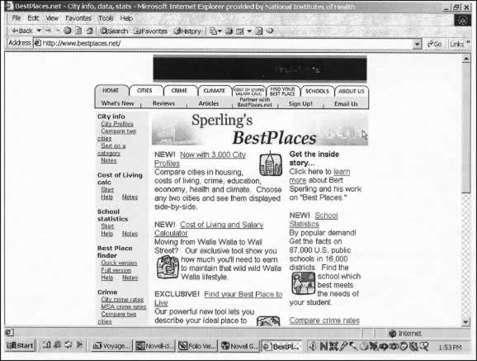

Bibliographic record created for Figure 1
Type: m ELvl: Srce: c Audn: Ctrl: Lang: eng
BLvl: i File: m GPub: MRec: Ctry: oru
Desc: a DtSt: m Dates:1998, 9999

006 Freq: u Regl: u ISSN: SrTp: d Orig: s
Form: s EntW: Cont: s GPub: Conf: Alph: S/L: 2
007 ## $a c $b r $d m $e n
010 ## $a 20091234567
040 ## $a XXX $c XXX
042 ## $a pcc
050 #4 $a HN60 $b .S64
245 00 $a Sperling’s bestplaces $h [electronic resource].
246 1# $a Sperling’s best places
246 1# $a BestPlaces
246 10 $a Best places
246 10 $i Title on title bar: $a BestPlaces.net
260 3# $a Portland, Or. : $b Fast Forward
362 1# $a Began in 1998?

588 ## $a Title from home page based on version modified Mar. 30, 2001(viewed Apr. 19, 2003).
500 ## $a Updated version of Places U.S.A. software developed by Bert Sterling.
650 #0 $a Cities and towns $x Ratings $z United States $v Databases.
651 #0 $a Quality of life $z United States $v Databases.
700 1# $a Sperling, Bert.
710 2# $a Fast Forward, Inc.
856 40 $u http://www.bestplaces.net

Comments:

Because there are specific data elements within this site that can be specified and searched, it appears that the content is primarily manipulable numeric data (Leader/06 value “m”). An 006 is added for the continuing aspects of the integrating resource. If the decision had been that the content is primarily textual, the Leader/06 value would have been “a;” in that case, two 006’s would have been needed, one for the electronic aspects and one for the integrating/continuing aspects. In case of doubt, use value “m.” In either case, the $v Databases can be used with the subject headings.

Sperling’s name is clearly associated with the site. However, when the “Inside story” page on the site is checked, he is described as the “driving force;” the site is said to be produced by a “small group of experts” (i.e., the staff of Fast Forward). Therefore, title main entry was selected, and added entries are made for Sperling and for Fast Forward, Inc. This site has only been viewed once, so no changes are yet needed on the record.

Figure 2: Online integrating resource 2-initial viewing (Feb. 2, 1999)
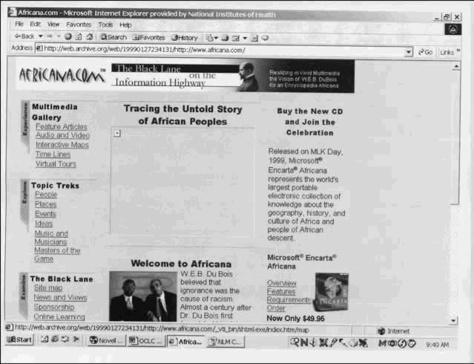

Bibliographic record created for Figure 2
Type: a ELvl: I Srce: d GPub: Ctrl: Lang: eng
BLvl: i Form: s Conf: ■ Freq: ■ MRec: Ctry: xxu
S/L: 2 Orig: EntW: Regl: ■ Alph:
Desc: a SrTp: d Cont: DtSt: c Dates: 1999,9999

006 Type: m Audn: File: d GPub:
007 ## $a c $b r $d m $e n
010 ## $a 20071234567
040 ## $a XXX $c XXX
042 ## $a pcc
050 #4 $a E185
245 00 $a Africana.com $h [electronic resource] : $b the Black lane on the information highway.
246 1# $a Black lane on the information highway
260 1# $a [United States] : $b Africana.com

588 ## $a Title from home page (viewed Feb. 2, 1999).
520 ## $a Electronic collection of knowledge about the geography, history, and culture of Africa and people of African descent.
650 #0 $a African Americans.
651 #0 $a United States $x Civilization $x African American influences.
710 2# $a Africana.com Inc.
856 40 $u http://www.africana.com

Comments:

Proper choice of Leader 06 (Record type) is a judgment issue. There are links to interactive maps, and audio and video material, but the primary content appears to be textual (language material). Thus the language material workform was selected, bibliographic level “i” and one 006 added to convey the electronic aspects.

Figure 3: Online integrating resource 2-- second viewing (Aug. 15, 2002)
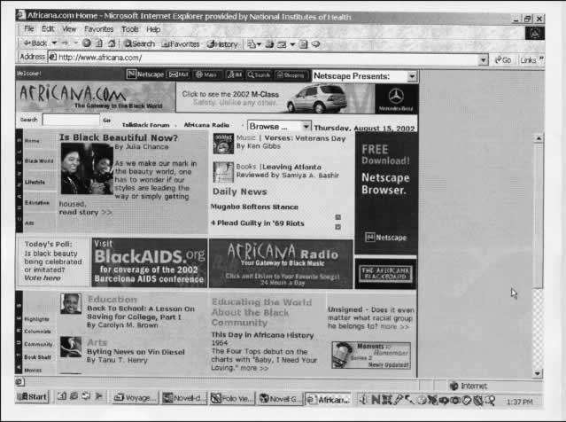

Bibliographic record updated to reflect Figure 3

Type: a ELvl: I Srce: d GPub: Ctrl: Lang: eng
BLvl: i Form: s Conf: ■ Freq: ■ MRec: Ctry: xxu
S/L: 2 Orig: EntW: Regl: ■ Alph:
Desc: a SrTp: d Cont: DtSt: c Dates: 1999,9999

006 Type: m Audn: File: d GPub:

007 ## $a c $b r $d m $e n
040 ## $a XXX $c XXX $d XXX
010 ## $a 20071234567
042 ##
050 #4 E185
245 00 Africana.com $h [electronic resource] : $b the gateway to the Black world.
246 1# $i Title on title bar: $a Africana.com home
246 1# $i Subtitled: $a Black lane on the information highway $f <Feb. 2, 1999>
260 3# $a [United States] : $b Africana.com
310 ## $a Updated daily $b <Aug. 15, 2002>
321 ## $a Frequency varies $b <Feb. 2, 1999>

588 ## $a Title from home page (viewed Aug. 15, 2002).
520 ## $a Electronic collection of knowledge about the geography, history, and culture of Africa and people of African descent.
650 #0 $a African Americans $x Social life and customs.
650 #0 $a African Americans $x Intellectual life.
651 #0 $a United States $x Civilization $x African American influences.
710 2# $a Africana.com Inc.
856 40 $u http://www.africana.com

Comments:

In viewing the site later, we see that the subtitle and title bar title of this site have changed, and the frequency has become more regular, with daily updates, so the existing record is updated to reflect these changes. Keeping the old subtitle as an access point is a cataloger judgment issue. Since the original record provided access to that portion of the title, it was felt worthwhile to keep it as an access point.

Figure 4: Online integrating resource 2--third viewing (April 21, 2003)

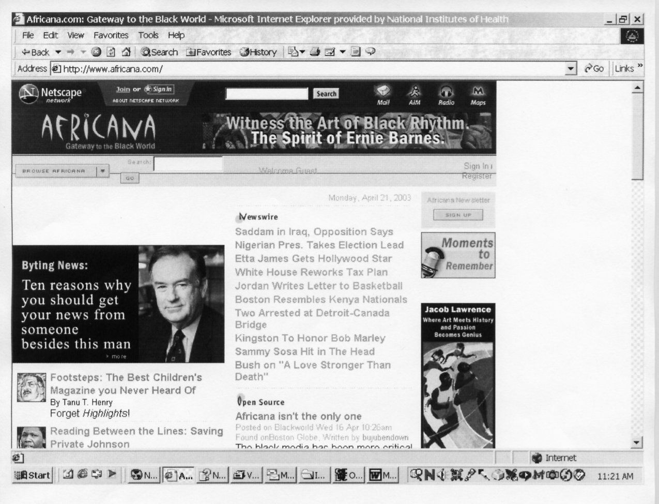

Bibliographic record updated to reflect Figure 4
Type: a ELvl: I Srce: d GPub: Ctrl: Lang: eng
BLvl: i Form: s Conf: ■ Freq: ■ MRec: Ctry: xxu
S/L: 2 Orig: EntW: Regl: ■ Alph:
Desc: a SrTp: d Cont: DtSt: c Dates: 1999,9999

006 Type: m Audn: File: d GPub:

007 ## $a c $b r $d m $e n
010 ## $a 20071234567
040 ## $a XXX $c XXX $d XXX
042 ## $a pcc
050 #4 $a E185
245 00 $a Africana $h [electronic resource] : $b gateway to the Black world.
246 1# $i Title on title bar: $a Africana.com
246 1# $i Subtitle: $a Black lane on the information highway $f <Feb. 2, 1999>
247 10 $a Africana.com $f <Aug. 15, 2002>
260 3# $a [United States] : $b Africana.com, $c 1999.
310 ## $a Updated daily $b <Aug. 15, 2002>
321 ## $a Frequency varies $b <Feb. 2, 1999>

588 ## $a Title from homepage (viewed Apr. 21, 2003).
650 #0 $a African Americans $x Social life and customs.
650 #0 $a African Americans $x Intellectual life.
651 #0 $a United States. $x Civilization $x African American influences.
710 2# $a Africana.com Inc.
856 40 $u http://www.africana.com

Comments:

When viewed again, this site has a new title on the homepage, so the previous title is moved to a 247 field, with the date it was viewed supplied in the 247 $f, and the current title is given in the 245. The source of title note is updated to reflect the most current viewing date. The subtitle was modified to show absence of initial “The” and the 246 was modified to reflect change in the title bar title.

Figure 5: Online integrating resource 3--initial viewing (Nov. 24, 2001)
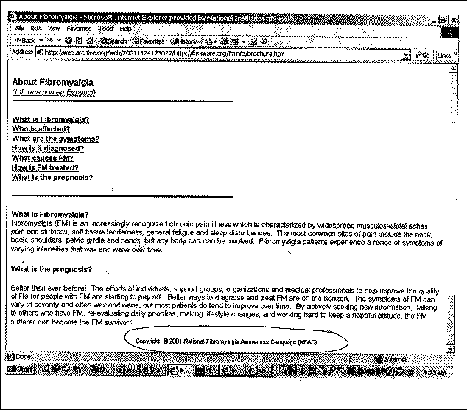

Bibliographic record for Figure 5

Type: a ELvl: I Srce: d GPub: Ctrl: Lang: eng
BLvl: i Form: s Conf: ■ Freq: ■ MRec: Ctry: cau
S/L: 2 Orig: EntW: Regl: ■ Alph:
Desc: a SrTp: d Cont: DtSt: c Dates: 200u,9999

006 Type: m Audn: File: d GPub:

007 ## $a c $b r $d m $e n
010 ## $a 2007123467
040 ## $a XXX $c XXX
041 0# $a eng $a spa
042 ## $a pcc
060 #4 $a WE 544
245 00 $a About fibromyalgia $h [electronic resource].
260 3# $a Orange, CA : $b National Fibromyalgia Awareness Campaign
546 ## $a Text in English and Spanish.

588 ## $a Title from caption (viewed Nov. 24, 2001).
650 #2 $a Fibromyalgia $v Popular Works.
710 2# $a National Fibromyalgia Awareness Campaign.
856 40 $u http://fmaware.org/fminfo/brochure.htm

Comments:

This updating Web site has no explicit publication date, so no 260 $c is given. The only date on the resource is a single copyright date which matches the current year of viewing, so at this point it cannot be determined if this is a date that is likely to change every year or actually reflects the true beginning date for the resource. A 546 note is made to indicate that the user can view the text in either English or Spanish and that information is also coded in the 041 field.

Figure 6: Online integrating resource 3--second viewing (Mar. 30, 2003)

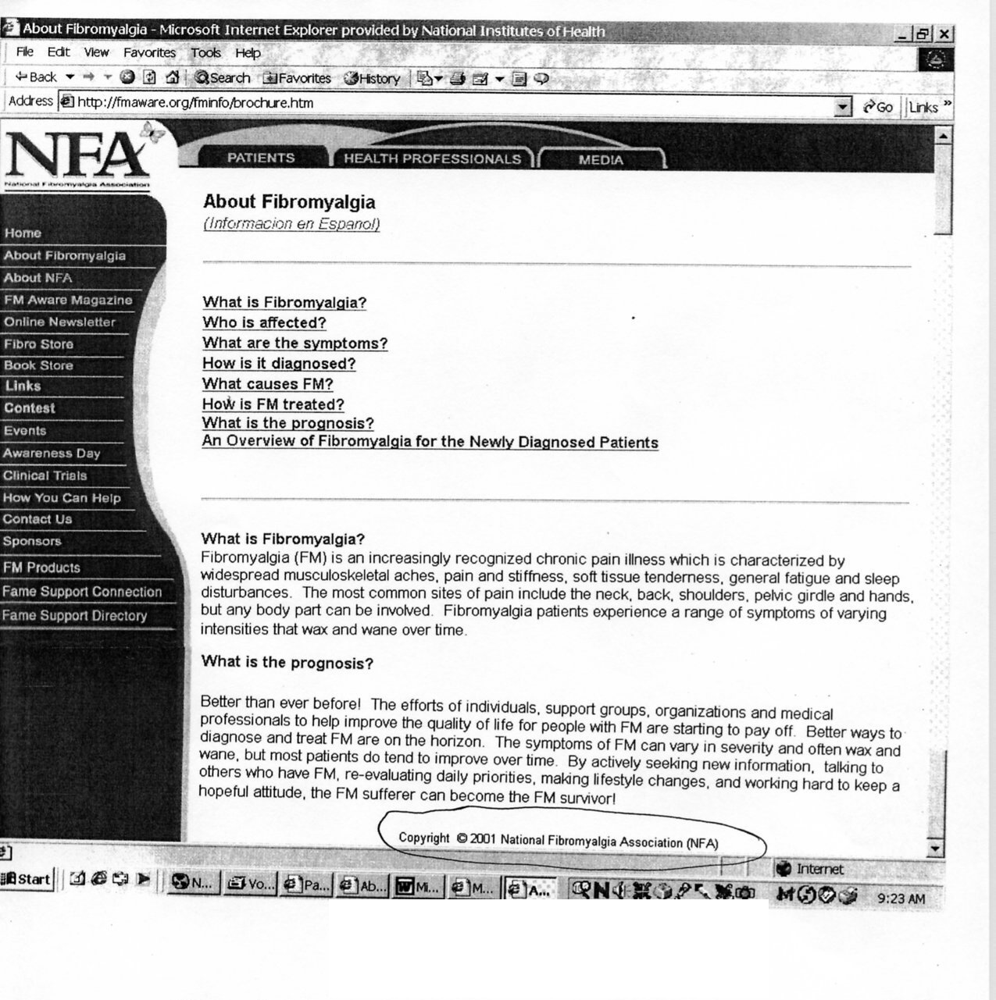

Bibliographic Record updated to reflect Figure 6

Type: a ELvl: I Srce: d GPub: Ctrl: Lang: eng
BLvl: i Form: s Conf: ■ Freq: ■ MRec: Ctry: cau
S/L: 2 Orig: EntW: Regl: ■ Alph:
Desc: a SrTp: d Cont: DtSt: c Dates: 2001,9999

006 Type: m Audn: File: d GPub:

007 ## $a c $b r $d m $e n
010 ## $a 20071234567
040 ## $a XXX $c XXX $d XXX
041 0# $a eng $a spa
042 ## $a pcc
060 #4 $a WE 544
245 00 About fibromyalgia $h [electronic resource].
260 3# $a Orange, CA : $b National Fibromyalgia Association
362 1# $a Began in 2001?
546 ## $a Text in English and Spanish.

588 ## $a Title from caption (viewed Mar. 30, 2003).
550 ## $a Issued by the National Fibromyalgia Awareness Campaign <Nov. 24, 2001>
650 #2 $a Fibromyalgia $v Popular Works.
710 2# $a National Fibromyalgia Association.
710 2# $a National Fibromyalgia Awareness Campaign.
856 40 $u http://fmaware.org/fminfo/brochure.htm

Comments:

When site is viewed again, the publisher has changed, so the 260 field must be updated to reflect the current publisher (also the issuing body), along with an access point (710) for the current publisher. If it is considered important to retain the former issuing body in the record, that information is moved to the 550 field as shown, and the earlier 710 may be retained in the record. Since at this point the cataloger can see that the copyright 2001 statement remains on the page, it is now reasonable to assume that actually may reflect the original date of publication, so a 362 note may be added to the record and the first date in the fixed field is made more specific.

Figure 7a: Online integrating resource 4, home page--initial viewing (Oct. 19, 1995)

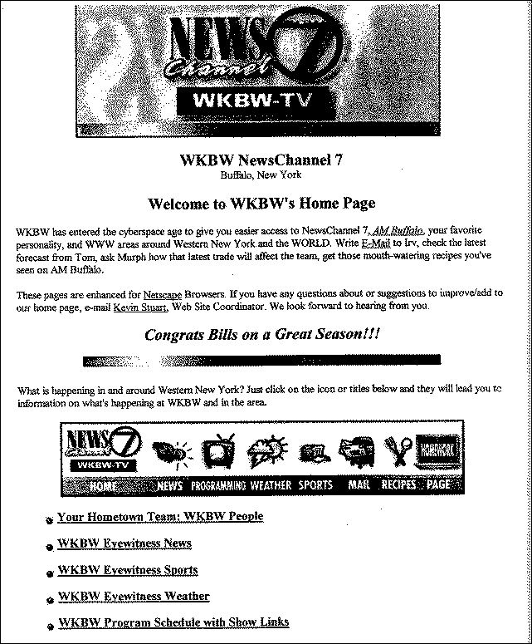

Figure 7b: Online integrating resource 4--initial viewing con’td (page source)

Bibliographic record for Figure 7 (a and b)

Type: m ELvl: Srce: c Audn: Ctrl: Lang: eng
BLvl: i File: m GPub: MRec: Ctry: nyu
Desc: a DtSt: m Dates:1995, 9999

006 Freq: k Regl: ■ ISSN: SrTp: w Orig: s
Form: s EntW: Cont: s GPub: Conf: Alph: S/L: 2

007 ## $a c $b r $d m $e n
010 ## $a 20071234567
040 ## $a XXX $c XXX
042 ## $a pcc
245 00 $a News channel 7, WKBW-TV $h [electronic resource].
246 1# $a WKBW NewsChannel 7
246 1# $a News channel seven, WKBW-TV
246 1# $i Title on source code: $a WKBW home page
260 3# $a Buffalo, N.Y. : $b WKBW-TV
310 ## $a Continuously updated
362 1# $a Began in 1995?

588 ## $a Title from home page banner graphic (viewed Oct. 19, 1995)
650 #0 $a Television stations $z New York (State) $z Buffalo.
710 2# $a WKBW (Television station : Buffalo, N.Y.)
856 40 $u http://www.wkbw.com

Comments:

Choice of title proper is somewhat problematic for this site as there are several reasonable choices a cataloger could make for the source of the title proper, all appearing on the home page. Since the banner title appears to be the most complete, it is selected as the 245, and all the other possibilities are recorded in 246 fields.

Once again, the choice of workform depends on cataloger judgment as to whether the site is primarily textual or more mixed or multimedia in nature. In this example, the cataloger has decided the various links reflected a combination of computer-oriented multimedia and selected the computer workform.

Because the Web site makes a reference to entering the cyberspace age, it may be reasonable to guess that it began publication near the time of viewing, thus the 362 field with questionable date is added.

The site is updated more frequently than daily, it is coded as “continuously updated” in the 008 and a corresponding 310 field for that frequency is added to the record. Note that when the 006 Frequency is coded “k,” MARC 21 does not allow value “x” in 006 Regularity.

Figure 8: Online integrating resource 4, second viewing (Apr. 9, 2001)

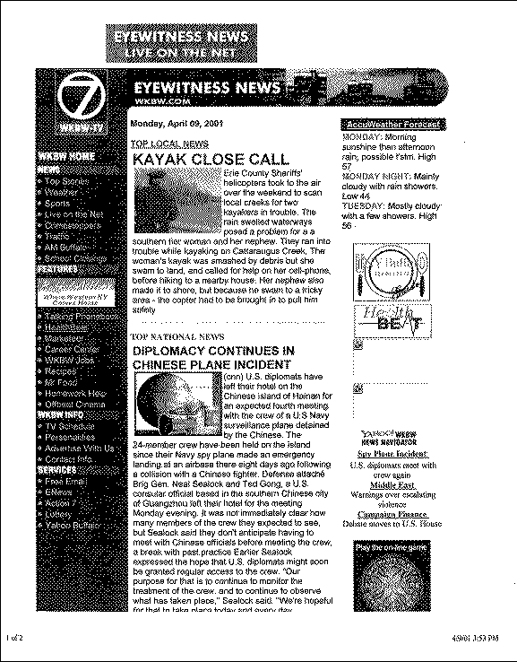
Bibliographic record updated to reflect Figure 8

Type: m ELvl: Srce: c Audn: Ctrl: Lang: eng
BLvl: i File: m GPub: MRec: Ctry: nyu
Desc: a DtSt: m Dates:1995, 9999

006 Freq: k Regl: r ISSN: SrTp: w Orig: s
Form: s EntW: Cont: s GPub: Conf: Alph: S/L: 2

007 ## $a c $b r $d m $e n
010 ## $a 2007123467
040 ## $a XXX $c XXX $d XXX
042 ## $a pcc
245 00 $a Eyewitness news, WKBW.com $h [electronic resource].
246 1# $i At head of title: $a Eyewitness news live on the net
246 1# $i Title on source code: $a WKBW-TV
246 1# $a WKBW NewsChannel 7 $f <Oct. 19, 1995>
246 1# $i Title on source code: $a WKBW home page $f <Oct. 19, 1995>
247 10 $a News channel 7, WKBW-TV $f <Oct. 19, 1995>
260 3# $a Buffalo, N.Y. : $b WKBW-TV
310 ## $a Continuously updated
362 1# $a Began in 1995?

588 ## $a Title from home page banner graphic (viewed Apr. 9, 2001)
650 #0 $a Television stations $z New York (State) $z Buffalo.
710 2# $a WKBW (Television station : Buffalo, N.Y.)
856 40 $u http://www.wkbw.com

Comments:

When this site is viewed again, the title on both the webpage which is displayed and the title in the source code have both changed. The banner graphic is still selected as the source of the title proper and the new title is put in the 245. The former 245 field is moved to a 247 field, and new 246 fields are added for the title in the source code and the information at head of title. The former variant titles were determined by the cataloger to be important enough to retain in the record, but dates are added in the 246 $f to show these titles no longer appear on the resource. The source of title note is updated to give the most current viewing date.

Figure 9: Online integrating resource—third viewing (June 16, 2003)

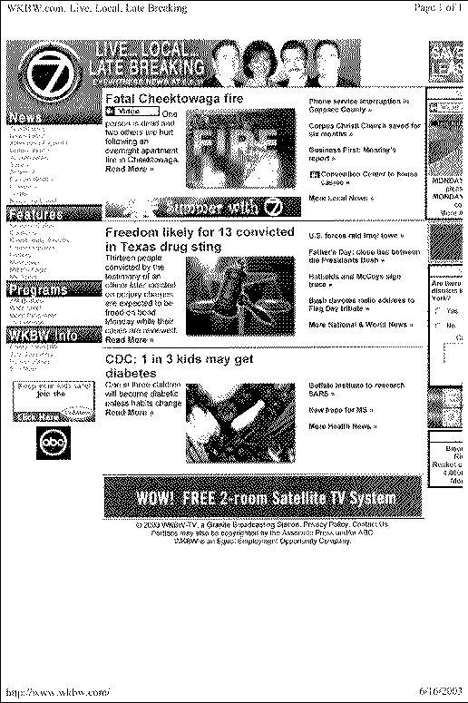

Bibliographic record updated to reflect Figure 9
Type: m ELvl: Srce: c Audn: Ctrl: Lang: eng
BLvl: i File: m GPub: MRec: Ctry: nyu
Desc: a DtSt: m Dates:1995, 9999

006 Freq: k Regl: r ISSN: SrTp: w Orig: s
Form: s EntW: Cont: s GPub: Conf: Alph: S/L: 2

007 ## $a c $b r $d m $e n
010 ## $a 20071234567
040 ## $a XXX $c XXX $d XXX
042 ## $a pcc
245 00 $a WKBW.com $h [electronic resource].
246 1# $i At head of title: $a Eyewitness news live on the net $f <Apr. 9, 2001>
246 1# $i Title on source code: $a WKBW-TV $f <Apr. 9, 2001>
246 33 $a WKBW NewsChannel 7 $f <Oct. 19, 1995>
246 1# $i Title on source code: $a WKBW home page $f <Oct. 19, 1995>
247 10 $a Eyewitness news, WKBW.com $f <Apr. 9, 2001>
247 10 $a News channel 7, WKBW-TV $f <Oct. 19, 1995>
260 3# $a Buffalo, N.Y. : $b WKBW-TV
310 ## $a Continuously updated
362 1# $a Began in 1995?

588 ## $a Title from source code (viewed June 16, 2003)
650 #0 $a Television stations $z New York (State) $z Buffalo.
710 2# $a WKBW (Television station : Buffalo, N.Y.)
856 40 $u http://www.wkbw.com

Comments:

Another viewing of the site reveals that the title has changed yet again. The banner graphic no longer contains information that could be regarded as a title, so the title is taken from the source code (which is the same as the information seen on the title bar). The former 245 is moved to a 247 field, with the date it had been viewed added as a $f in angle brackets. The current title is put in the 245 field and the source of title note and date viewed is updated to reflect the current iteration. The other title information provided in the source code (i.e. live, local, late breaking) is not considered important enough to transcribe or note in the record.

Figure 10: Online integrating resource 5-- initial viewing (June 15, 2002)

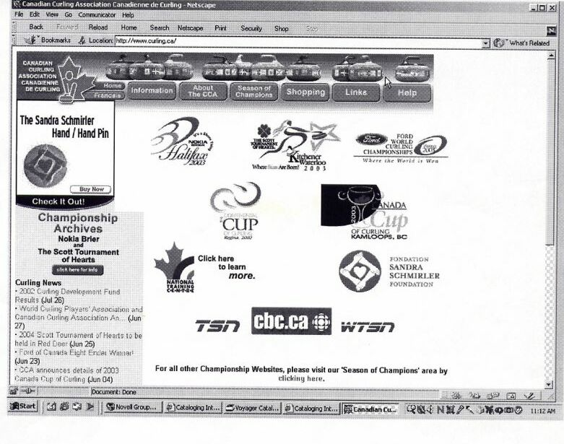

Bibliographic record created for Figure 10

Type: a ELvl: I Srce: d GPub: Ctrl: Lang: eng
BLvl: i Form: s Conf: ■ Freq: ■ MRec: Ctry: onc
S/L: 2 Orig: EntW: Regl: ■ Alph:
Desc: a SrTp: d Cont: DtSt: c Dates: 1999,9999

006 Audn: File: d GPub:

007 ## $a c $b r $d m $e n
010 ## $a 2007123467
040 ## $a XXX $c XXX
041 0# $a eng $a fre
042 ## $a pcc
050 #4 $a GV845
245 00 $a Canadian Curling Association $h [electronic resource] = $b Association Canadienne de curling.
246 31 $a Association Canadienne de curling
260 3# $a Cumberland, Ont. : $b Canadian Curling Association
362 1# $a Began in 1999?

546 ## $a May be viewed in English or French.
588 ## $a Title from home page (viewed June 15, 2002).
650 #0 $a Curling $z Canada.
710 #2 $a Canadian Curling Association.
856 40 $u http://www.curling.ca

Comments:

This updating Web site is an example of the use of a parallel title in an integrating resource record. Per Rule 1.1B5, even though the word “Association” only appears once on the homepage and title bar, it is clearly meant to be read in both the English and French forms and thus is repeated without brackets in the 245 field.

Because the site includes much more than administrative details of the Association, title main entry was selected for this resource. Beginning date is estimated from a range of copyright dates given at the bottom of the screen (not viewable in this printout).

If the Web site had been cataloged after the 2002 Revision of AACR2, other title information “[Web site]” in subfield $b would have been required; prior to that revision, decision was cataloger’s judgment (rule 12.1E1b refers to 1.1E; rule 1.1E6 could have been applied).

Figure 11: Online integrating resource5--second viewing (Apr. 19, 2003)
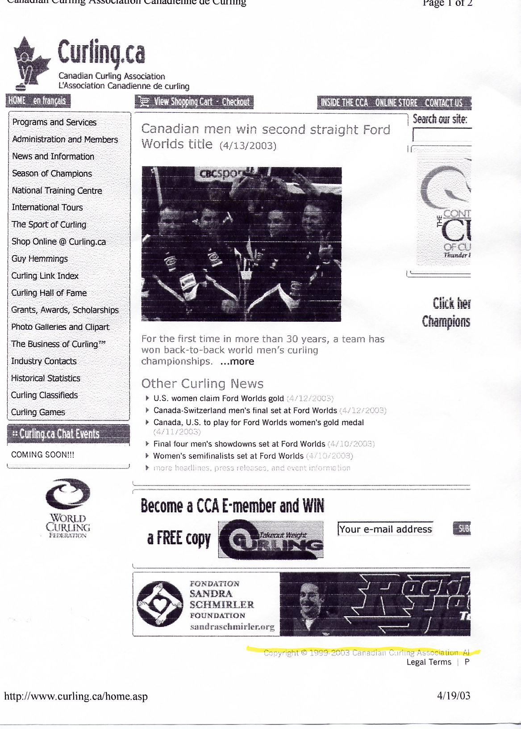

Bibliographic record updated to reflect Figure 11

\
Type: a ELvl: I Srce: d GPub: Ctrl: Lang: eng
BLvl: i Form: s Conf: ■ Freq: ■ MRec: Ctry: onc
S/L: 2 Orig: EntW: Regl: ■ Alph:
Desc: a SrTp: d Cont: DtSt: c Dates: 1999,9999

006 Audn: File: d GPub:

007 ## $a c $b r $d m $e n
010 ## $a 2007123467
040 ## $a XXX $c XXX $d XXX
041 0# $a eng $a fre
042 ## $a pcc
050 #4 $a GV845
245 00 $a Curling.ca $h [electronic resource] / $c Canadian Curling Association.
246 11 $a Association Canadienne de curling $f <June 15, 2002>
247 10 Canadian Curling Association $f <June 15, 2002>
260 3# $a Cumberland, Ont. : $b Canadian Curling Association
362 1# $a Began in 1999?

546 ## $a May be viewed in English or French.
588 ## $a Title from home page (viewed Apr. 19, 2003).
650 #0 $a Curling $z Canada.
710 2# $a Canadian Curling Association.
856 40 $u http://www.curling.ca

Comments:

When the site is viewed again, the title has changed, so the earlier title is moved to a 247 field, and the existing 246 field for the parallel title is adjusted to reflect the fact that the parallel title is associated with an earlier iteration*. The first indicator in the 246 field is changed from “3” to “1” so that a note reflecting the date associated with this earlier parallel title will be generated, as well as an added entry. The date viewed in the source of title note is updated. Note that in the 245 subfield $c, the parallel statement of responsibility is not given per LCRI 1.1F11.

The 246 field with subfield $i could also be used to give information about the parallel title on an earlier iteration:
246 1# $i Former parallel title: $a Association Canadienne de curling $f <June 15, 2002>

Figure 12a: Updating loose-leaf 1--with accompanying material

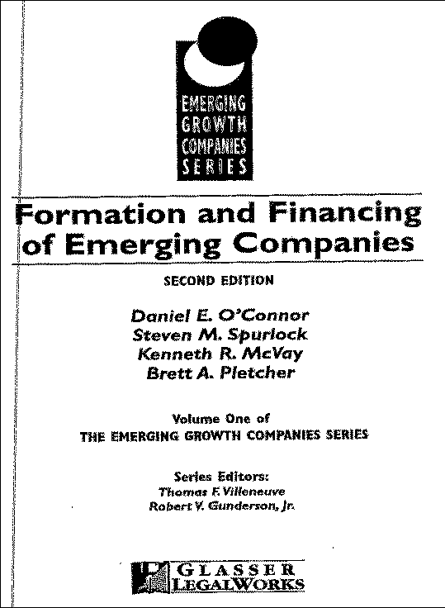
Figure 12b: Updating loose-leaf 1--with accompanying material cont’d

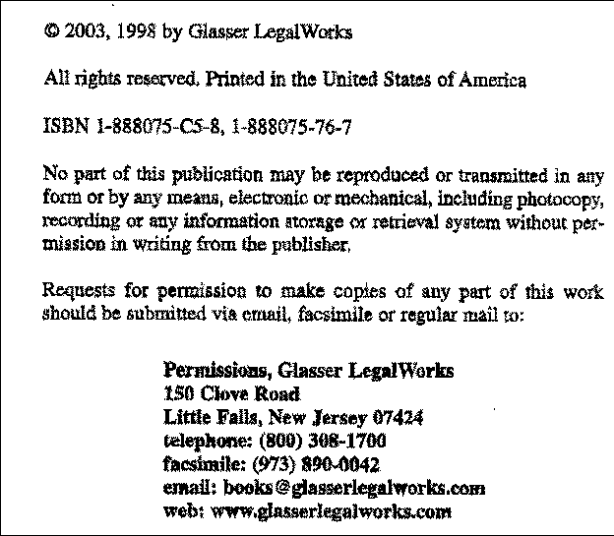

Figure 12c: Updating loose-leaf 1--with accompanying material cont’d

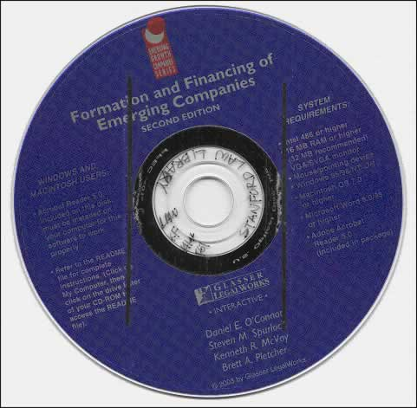

Bibliographic record created for Figure 12 (a, b, and c)

Type: a ELvl: I Srce: d GPub: Ctrl: Lang: eng
BLvl: i Form: Conf: ■ Freq: ■ MRec: Ctry: nju
S/L: 2 Orig: EntW: Regl: ■ Alph:
Desc: a SrTp: l Cont: DtSt: c Dates: 2003,9999

020 188075767
020 |z1888075C58
043 n-us---
050 4 KF1414 |b.F67
245 00 Formation and financing of emerging companies / |cDaniel E. O'Connor ... [et al.].
250 2nd ed.
260 3 Little Falls, N.J. : $b Glasser LegalWorks, $c 2003-
300 v. (loose-leaf) : |bforms ; $c 26 cm. + $e CD-ROM (4 3/4 in.).
490 1# Emerging growth companies series ; $v v. 1
538 System requirements for accompanying CD-ROM: Intel 486 or higher; 16 M
B RAM or higher (32 MB recommended); Windows 95/98/NT or Macintosh OS 7.0 or higher; Microsoft Word 6.0/95 or higher, Adobe Acrobat reader 5.0(included).
500 Includes index.
650 0 New business enterprises $x Law and legislation $z United States.
650 0 New business enterprises $x Finance $x Law and legislation $z United States.
700 1 O'Connor, Daniel E., $d 1961-
780 00 O'Connor, Daniel E., $d 1943- $t Formation and financing of emerging companies. $b 1st ed. $z 1888075767
830 #0 Emerging growth companies series ; $v v. 1

Comments:

This record illustrates an updating loose-leaf with accompanying material.

Figure 13a: Updating loose-leaf—with transfer binder

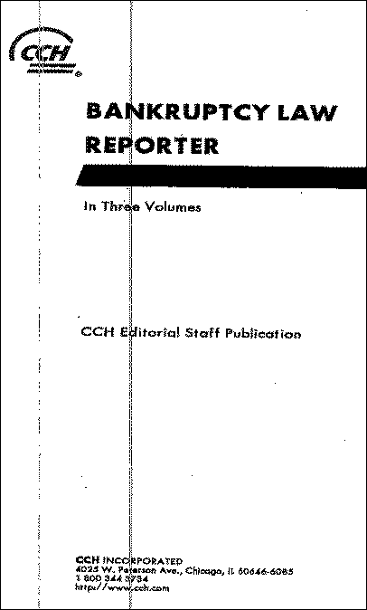

Figure 13b: Updating loose-leaf—with transfer binder cont’d

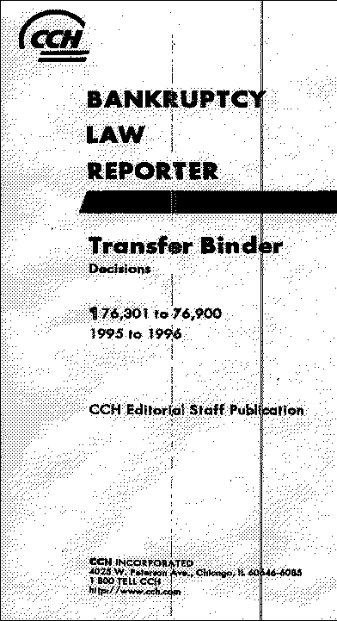

Bibliographic record created for Figure 13 (a and b)

Type: a ELvl: I Srce: d GPub: Ctrl: Lang: eng
BLvl: i Form: Conf: ■ Freq: s MRec: Ctry: ilu
S/L: 2 Orig: EntW: Regl: r Alph:
Desc: a SrTp: l Cont: DtSt: c Dates: 1979,9999

010 2007123467
042 pcc
043 n-us---
245 00 Bankruptcy law reporter.
260 3 Chicago, Ill. : $b Commerce Clearing House, $c c1979-
300 v. (loose-leaf), v. (transfer) ; $c 25 cm.
310 Updated semimonthly
490 1 Topical law reports
500 "CCH editorial staff publication."
500 Includes indexes.
500 Kept up to date by current reports.
500 Material of a permanent nature is removed from main set and filed in
transfer binders with title: Decisions.
650 0 Bankruptcy $z United States.
710 2 Commerce Clearing House.
830 0 Topical law reports (Commerce Clearing House)

Comments:

This record illustrates the use of the 300 field for indicating that there are transfer binders associated with the resource.

The 310 on this record is also coded in the fixed field. An alternate wording for the 310 would be “Semimonthly updates”.

Figure 14a: Updating loose-leaf

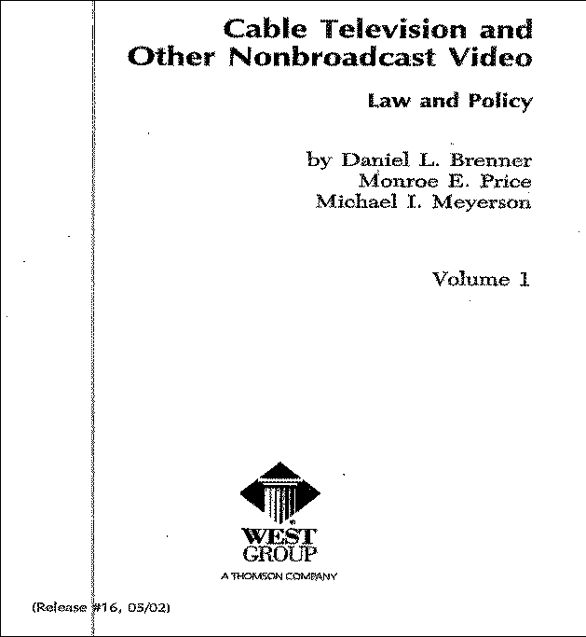

Figure 14b: Updating loose-leaf cont’d

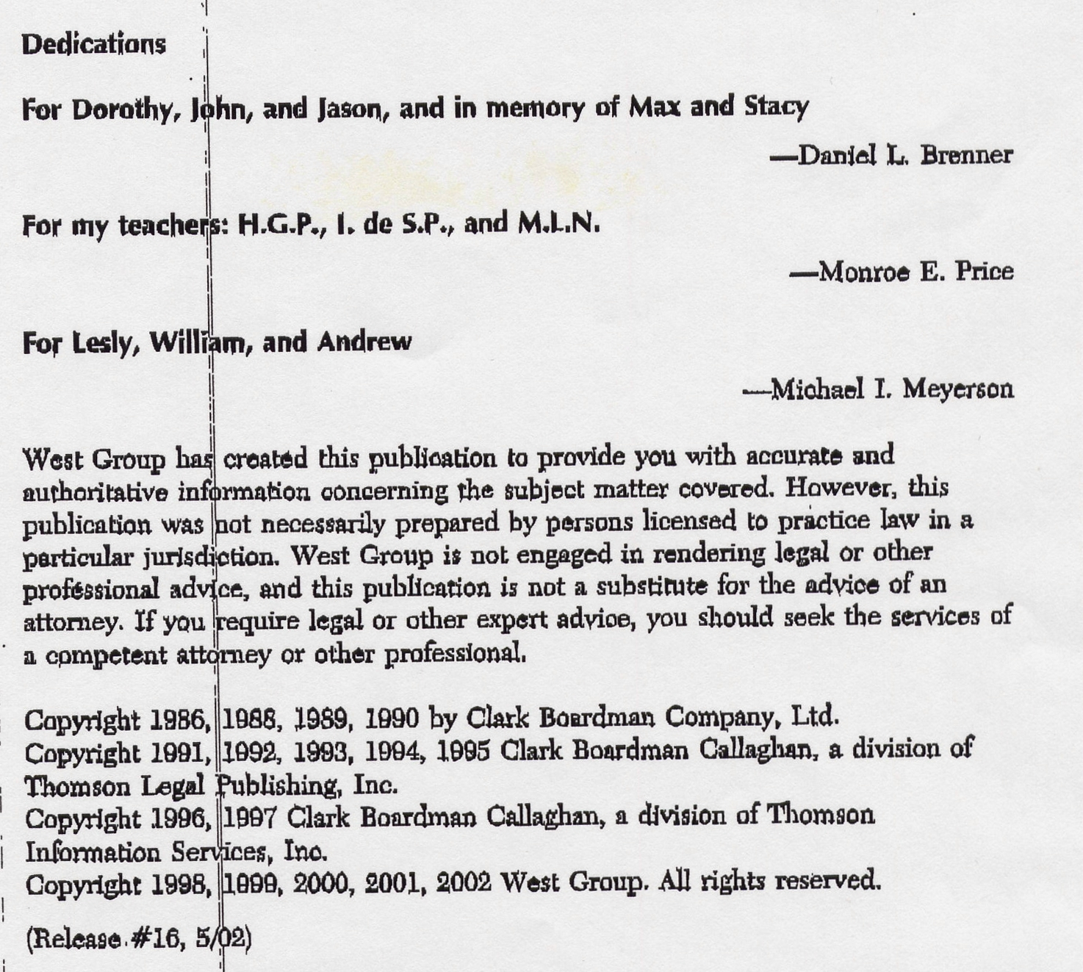

Bibliographic record created for Figure 14 (a and b)
Type: a ELvl: Srce: d GPub: Ctrl: Lang: eng
BLvl: i Form: Conf: ■ Freq: ■ MRec: Ctry: mnu
S/L: 2 Orig: EntW: Regl: ■ Alph:
Desc: a SrTp: l Cont: DtSt: d Dates: 1986,2002

010 8530946
020 0876324898 (loose-leaf)
040 DLC |cDLC |dDLC |dCStRLIN
043 n-us---
050 00 KF2844 |b.B74 1986
082 00 343.73/09946 |a347.3039946 |219
100 1 Brenner, Daniel L., |d1951-
245 10 Cable television and other nonbroadcast video : |blaw and policy / |cby Daniel L. Brenner, Monroe E. Price, Michael I. Meyerson.
260 3 St. Paul, Minn. : |bWest Group, |c1986-2002.
300 2 v. (loose-leaf) ; |c26 cm.
490 1 Entertainment & communications law library
500 Authors: Daniel L. Brenner and Monroe E. Price (1986- ).
500 Published: New York : C. Boardman, 1986-1990 ; Deerfield, IL : Clark Boardman Callaghan, 1991-1997 ; St. Paul, Minn. : West Group, 1998-2002.
500 Series title: Clark Boardman Callaghan entertainment & communications law library, <1986-1998>
500 Includes index.
500 Description based on: v. 1, t.p., rel. #16, 05/02.
650 0 Cable television |xLaw and legislation |zUnited States.
650 0 Direct broadcast satellite television |xLaw and legislation |zUnited States.
700 1 Price, Monroe Edwin, |d1938-
700 1 Meyerson, Michael.
785 00 Brenner, Daniel L., |d1951- |t Cable television and other nonbroadcast video. |b 2003 ed.
830 0 Entertainment & communications law library.
830 0 Clark Boardman Callaghan entertainment & communications law library.

Comments:

This record is the original edition of an updating loose-leaf title updated to reflect release #16 (Figure 14a); it lacks any edition statement. The next example shows the new edition of this title; the 785 field in record above provides a link to the new record.

Note that the basic cataloging reflects previous punctuation practice and need not be changed to reflect new rules. This record contains examples of notes for changes in author, title and series, as well as a note indicating the release on which the description is based.

Figure 15a: Updating loose-leaf —new base volume

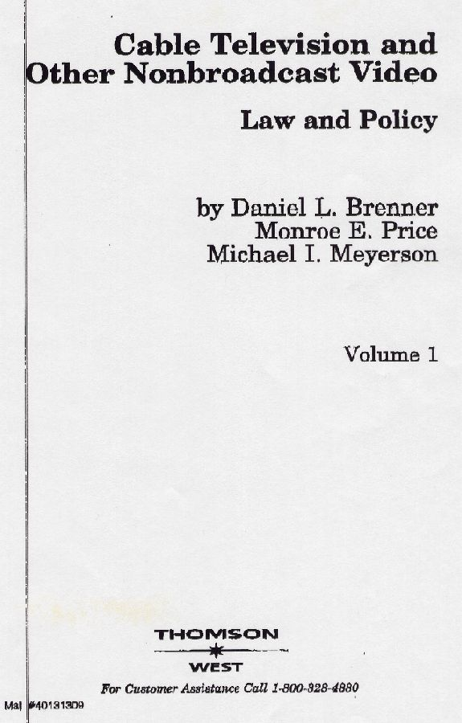

Figure 15b: Updating loose-leaf 2—new base volume cont’d

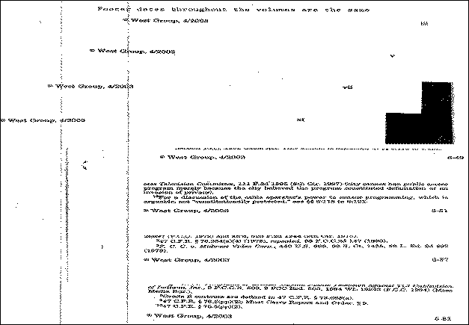

Figure 15c: Updating loose-leaf 2—new base volume cont’d

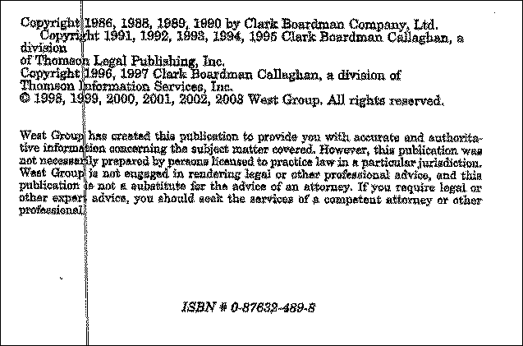

Figure 15d: Updating loose-leaf 1—new base volume cont’d

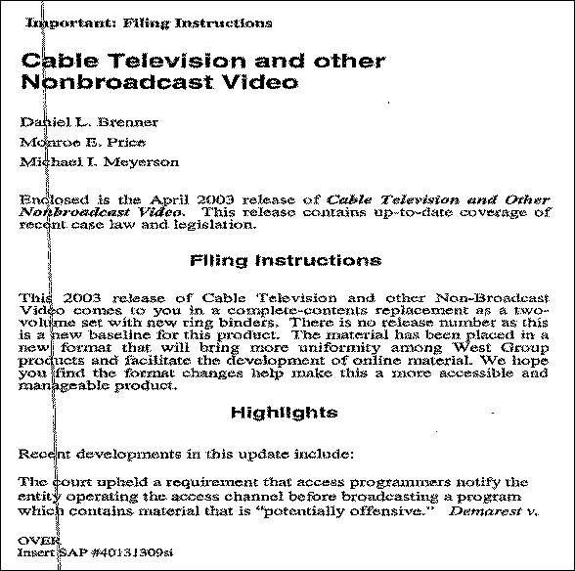

Bibliographic record created for Figure 15 (a, b, c and d)

Type: a ELvl: I Srce: d GPub: Ctrl: Lang: eng
BLvl: i Form: s Conf: ■ Freq: ■ MRec: Ctry: mnu
S/L: 2 Orig: EntW: Regl: ■ Alph:
Desc: a SrTp: d Cont: DtSt: c Dates: 2003,9999

020 |z 0876324898
040 MBS |cMBS
043 n-us---
050 4 KF2844.Z9 |bB74 2003
100 1 Brenner, Daniel L., |d1951-
245 10 Cable television and other nonbroadcast video : |blaw and policy / |cby Daniel L. Brenner, Monroe E. Price, Michael I. Meyerson.
250 [2003 ed.].
260 3 [St. Paul, Minn.] : |bThomson West, |cc2003-
300 v. (loose-leaf) ; |c25 cm.
504 Includes bibliographical references and index.
- 0 Cable television |xLaw and legislation |zUnited States.
650 0 Direct broadcast satellite television |xLaw and legislation |zUnited States.
700 1 Price, Monroe Edwin, |d1938-
700 1 Meyerson, Michael.
780 00 Brenner, Daniel L., |d1951- |t Cable television and other nonbroadcast video |w (DLC) 8530946 |z 0876324898

Comments:

This record is an example of a title that was released with a new base volume, having a new date in the header/footer, etc., that is consistent throughout the base volume, but that does not have a new edition statement. According to LCRI 21.3B, this new iteration should be treated as a new resource and a new bibliographic record is required. Because both the earlier iteration and this current one lack edition statements and the main entry/title proper is the same, an edition statement is supplied in brackets on the bibliographic record for the new iteration, using the beginning year of publication, distribution, etc.

The ISBN is the same as the resource in Figure 14, it is coded as 020 subfield $z on the new bibliographic record. (The publisher considers the release to be an update, rather than a new edition, and continues to use the same ISBN.)

The 780 field provides a link to the previous edition of the resource.

