Converting PowerPoint and Word Documents to Adobe Acrobat 7 Standard
1/16/2008

Purpose: To create a trainee manual

- Before beginning, decide whether you will (eventually) also want to index the final package.
  - If the answer is yes, or if you think you may want to change one or more of the segments, then the strategy to use is to build small Adobe Acrobat files and then combine them into larger “Binders.”
  - If the answer is no, it might be more convenient to simply create a PDF document from multiple Word, Powerpoint, etc. files.
  - Decision: I used the first strategy. Reasons: First, I wanted to control the Powerpoint conversion by forcing it to go through “handout” rather than “slide presentation.” Second, my computer kept giving me an error message when I tried to use the conversion within Word (but it worked when I created PDF through Adobe). Since I did not have time to troubleshoot the problem, I decided to create multiple Adobe files & then combine them.
- Powerpoint file
  - Pull up a Powerpoint file. Delete the slides showing the answers to any exercises & re-save the file with a slightly different name. Re-open
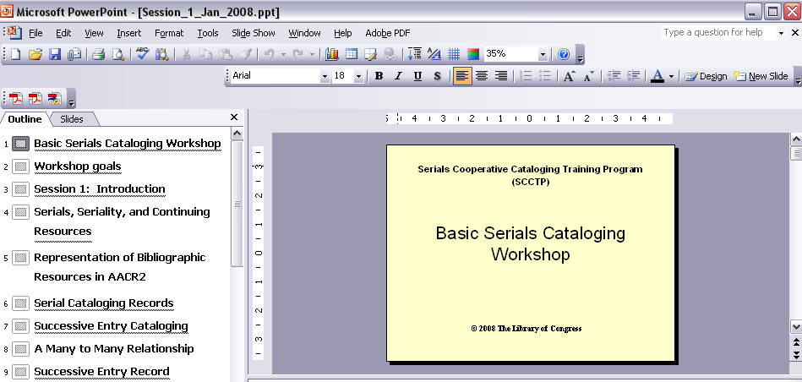

  - Choose menu item “File” then “print”and select handout / black & white / 2 slides per page
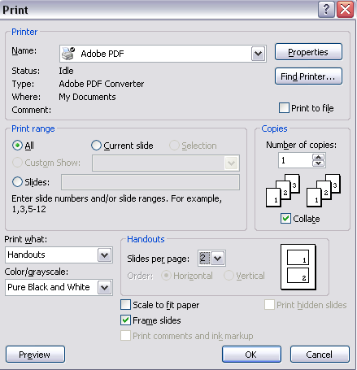

  - Scan through the file to make sure it looks ok. Do not include headers or footers; especially, do not include pagination.
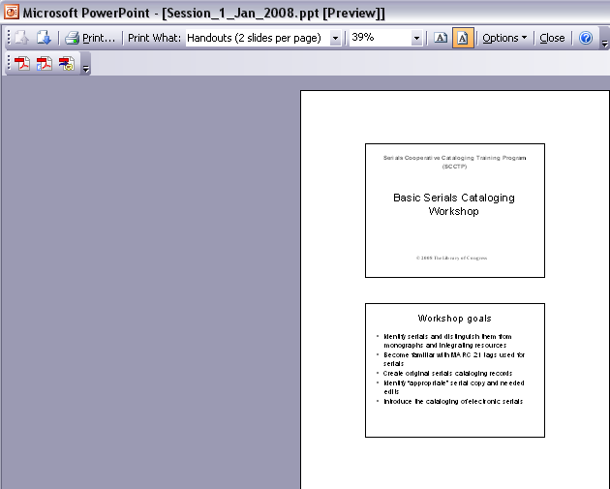

  - Click the icon “convert to Adobe PDF” in PowerPoint. If the program asks if you want to save the PowerPoint file, say yes (after all, it is just a copy). Adobe will do the rest.
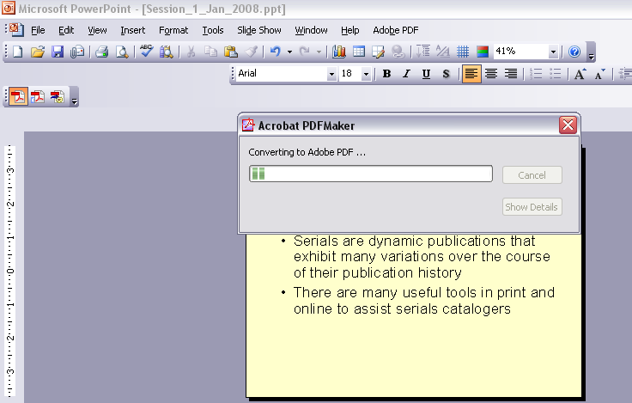
  - After converting the file, Adobe Acrobat will display & you will see the Acrobat file. Add the name of the session and pagination through the menu option: Document // Headers and footers. In my case, I decided to add a footer. You may choose to alternate the position of the session name and page numbers, so that the printed manual is more book-like. (I did not do that for the sample file) Note that <<1>> creates pagination as 1, 2, 3, etc.
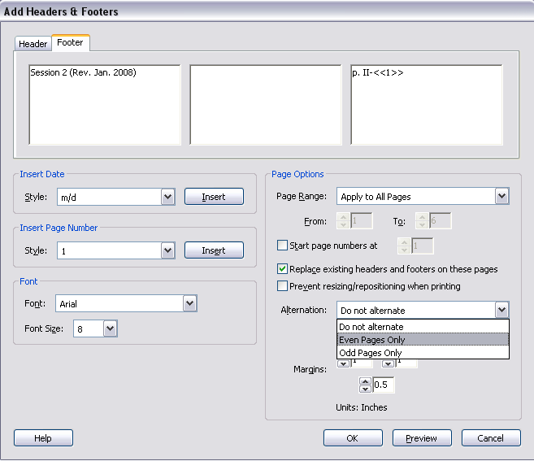
  - View the result and see if it is ok.
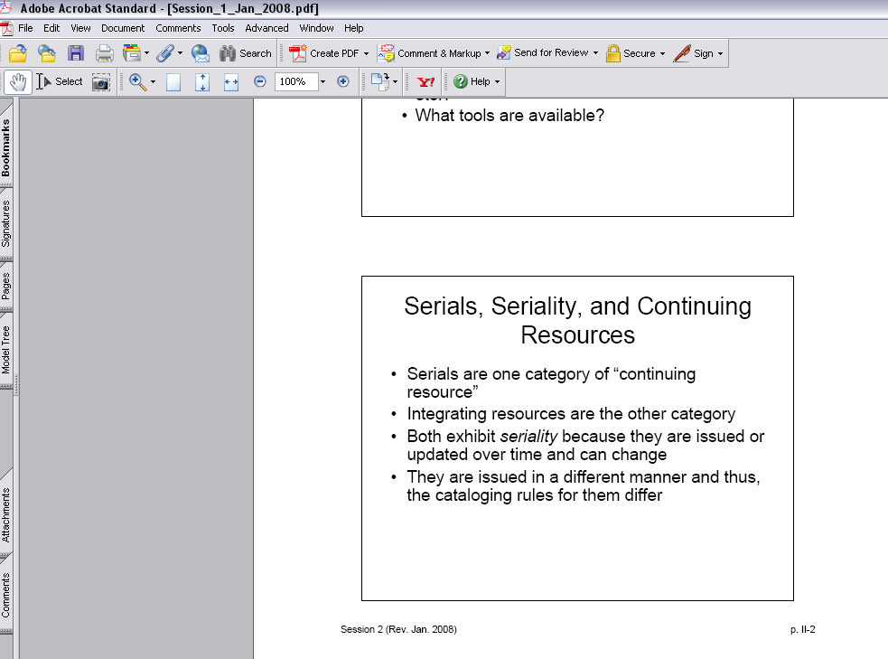
  - Save the file.

- Word, as I mentioned, was acting out. So I had to create the Word file through Adobe rather than through Word. If you run into the same problem, here is the method used:
  - From top menu, choose “Create PDF” and “Single file.” Browse to find the file to convert
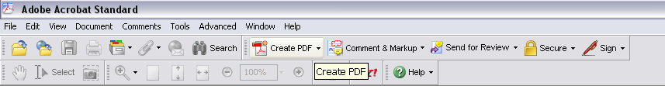
  - Click OK to start the process
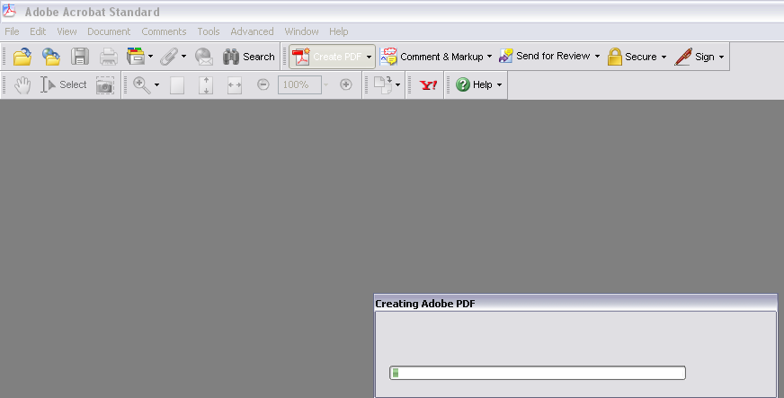

- To create binders of multiple files, Use Create PDF-Multiple files. Add as many fields as you wish. You may re-arrange the files. You may also combine new files into an existing “Binder.” Then click “ok.”
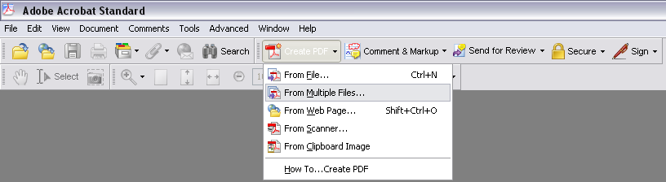

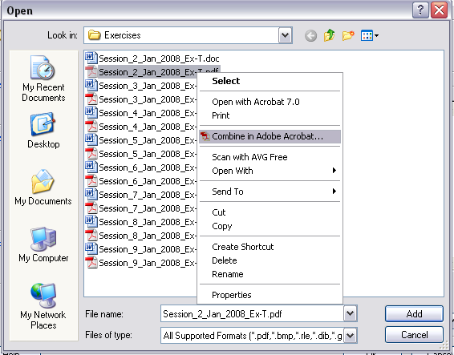

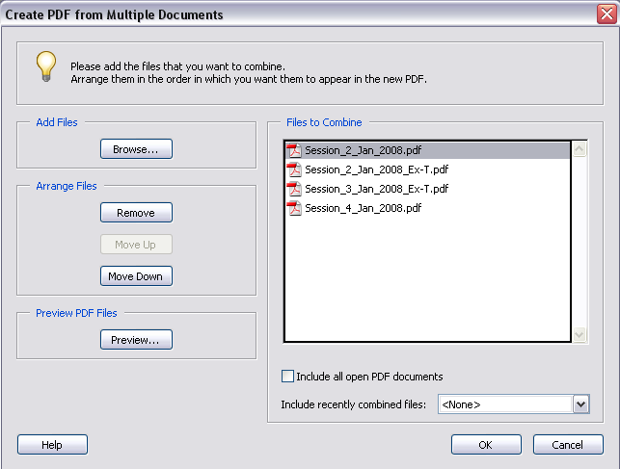

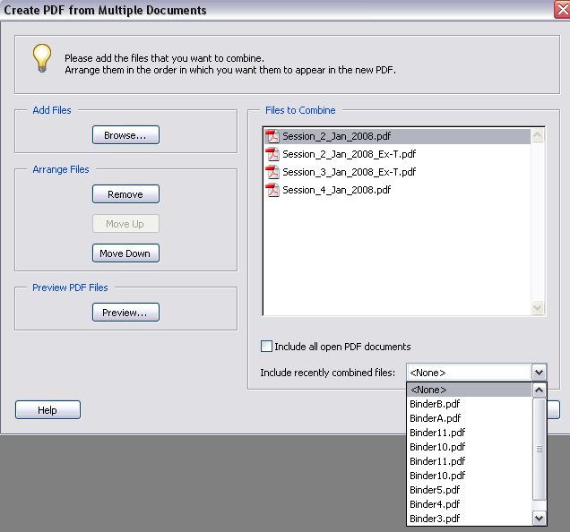

- Choose a name for the “binder” or accept the default; save the file
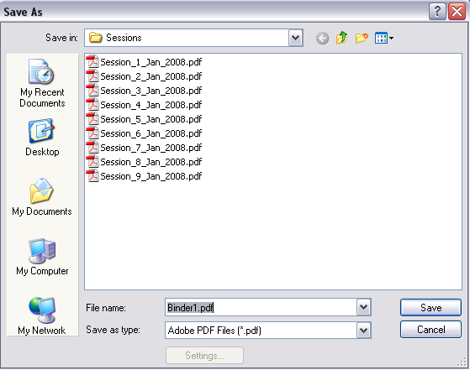

Note: If you create pdfs incrementally, then you will have better control over the file size for the Binder.

That’s all!

