Building a Trainee Manual (using Adobe Acrobat 8)
2/20/2008; rev. 2/22/2008

Strategy: The core files are the Trainer’s files; all other files are derived. That way, the Trainer slides and the Trainee manual will remain in sync.

Result: Because it’s helpful to know this ahead of time, here are specific details about the way the final Trainee Manual should look:
- Contents: The Manual consists of
  - Preliminaries: t.p., t.p. verso (in file w/t.p.), forward, preface, contents page. The forward, preface, and contents page should each be on a separate page (when printed out). Use intentionally-blank-pages to ensure this.
  - Session Powerpoint presentations (2 slides per page; exclude answer slides). If not an even number of pages, add intentionally-blank-pages
  - Session exercises. If not an even number of pages, add intentionally-blank-pages
  - Appendices. Each appendix should begin on a separate page
- Headers/footers:
  - All pages after the preliminaries should have a footer for the workshop plus revision date: SCCTP Basic Serials Cataloging Workshop – February 2008.
  - Odd-numbered pages should have a header for the Trainee Manual, the session/appendix, and the page:
Trainee Manual [at left edge] Session 3 – Exercises
p. 1
  - Even-numbered pages should have the same header, but with left & right elements reversed
Session 3 – Exercises Trainee Manual
p. 2
Have at hand
- Have available a print copy of the immediate previous ed. for the Trainee manual. This is essential in order to correctly derive the trainee exercise files from the instructor’s exercise files. In some cases, the trainee files will contain additional material (e.g., empty form) that cannot be intuited by looking at the instructor’s files.
- Have available all Word files for the preliminary pages (t.p., etc.). Be sure these have been reviewed by the CONSER Coordinator & Specialist for correct copyright data, ISBNs, etc., before producing the Trainee Manual
- Keep notes of which slides should be omitted from the trainee Powerpoint slides. It is easy to chop of the exercise slides at the end of each instructor’s Powerpoint file. But if some interactive exercises during the presentation require omission of certain slides from the trainee handouts, those slides will be more difficult to find & delete.
- Exercises: Beware! The exercises & answers appear in THREE places. Any change must be reflected in all three places.
  - Instructor’s slides: At the end of each presentation (except Session 1)
  - Instructor’s exercise documents
  - Appendix F
- File names are important! For the Basic Serials Cataloging Workshop, the following conventions were used: Session_#_Month_Year_Instructor/Trainee.extension
  - PowerPoint slides:
    - Session_3_Feb_2008_Instructor.ppt
    - Session_3_Feb_2008_Trainee.ppt
  - Exercises: (Note: Would be better in future to name as: …_Trainee_Ex.ppt, because Adobe tends to list files alphabetically as the default, for “combine files” function)
    - Session_3_Feb_2008_Ex_Instructor.doc
    - Session_3_Feb_2008_Ex_Trainee.doc
  - Appendices:
    - Appendix_A_Feb_2008.doc
  - Preliminaries
    - TitlePage_Feb_2008.doc
    - Foreword_Feb_2008.doc
    - Preface_Feb_2008.doc
    - TableOfContents_Feb_2008.doc

Preliminary Step
- Instructor’s slides: In order to produce the Trainee manual, these should have slide pagination only; do not include handout footers or headers. Check the following views during content development:
  - Preview view: What do the slides look like when full-sized? Do any slide graphics or text segments run off the slide?
  - Notes view: What will the notes look like? Editing in the notes view will allow you to re-size the font, correct tabbing errors, and view the page as it will print. While notes can also be viewed through the “normal” view, the result is unclear.
  - Settings: Please DO NOT hard-code slide numbers when editing slides.
    - Check “slide number” under Insert/Slide number (on main menu)
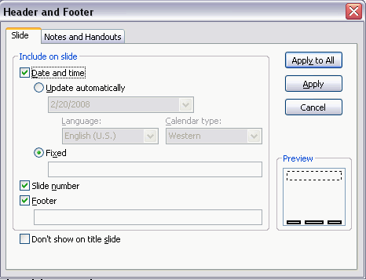
    - Remove check from “notes and handouts”
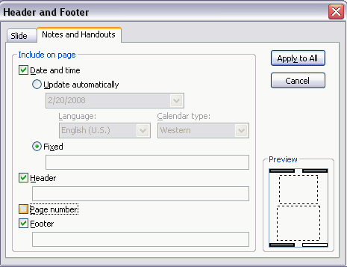

- Word documents: Instructor’s exercises, Appendices, preliminaries: Headers & footers on instructors Word documents make sense, but keep track of where it is added & whether the developer has mischievously added headers or footers within a document. (I discovered that someone had added pagination to just the last page of one of the Appendices! While it is possible to remove this in Adobe, it is a nuisance.)
Derivation step
- Prefatory material: The order of files should be: title page, foreword, preface, contents page. No change to these is needed during the derivation step
- Slide files → Trainee files → Trainee Acrobat files
  - Remove exercise answers at end of sessions 2-9.
  - Menu: Format/background: Turn off any background graphics. Change background color to white.
  - Re-check Header & Footer settings to make sure that slide numbering is ON but handouts numbering is OFF.
  - If you run into any errors in compiling the Acrobat files, you may need to remove animation (e.g., in Session 3).
  - Save files under a new file name.
  - Print the slide file using the Adobe PDF printer option in order to fit multiple slides on one page. (Note: There is an option to create a PDF file through Acrobat, but the result is one slide per page)
    - Go to menu option File—Print
    - Select: Handout, Pure black & white, Slides per page=2
    - Printer: At top of dialog box, under printer Name, choose Adobe PDF
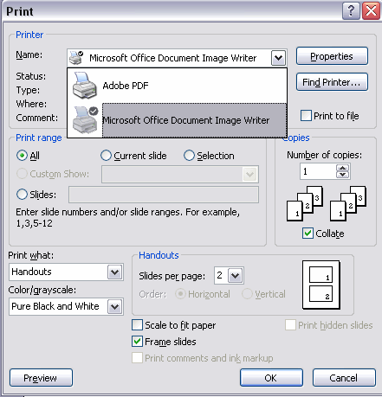

- Instructor’s Exercises (Word Documents)→ Trainee Exercises
  - Re-save files as trainee files.
  - Comparing a previous version of the Trainee Manual to the current Instructor Files, remove answers or comments. Edit Bib records to remove instructor answers.
  - Add any forms needed by the student to complete the exercise.
  - Check for any headers & footers; delete.

- Appendices → Adobe Acrobat file: It is easier to string together the Appendices ahead of time rather than bringing them into the mega-build of the Trainee Manual all at once.
  - Start an Adobe Acrobat session. Choose Create PDF
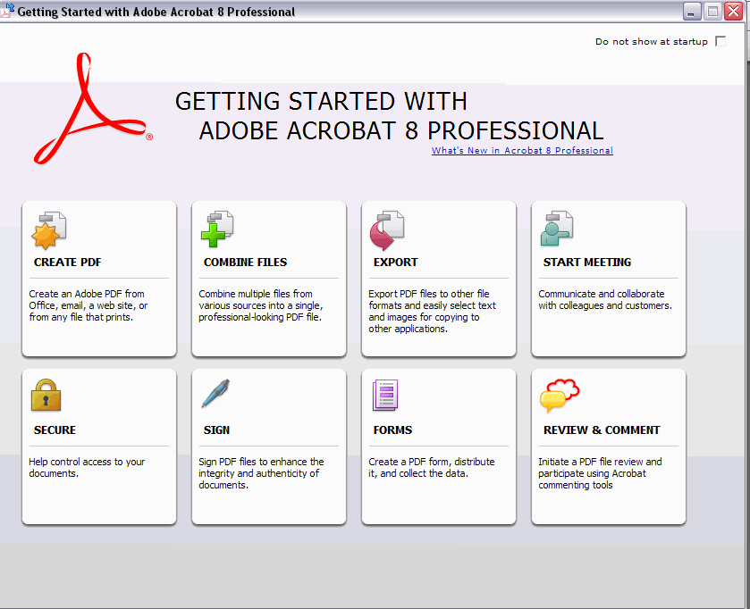
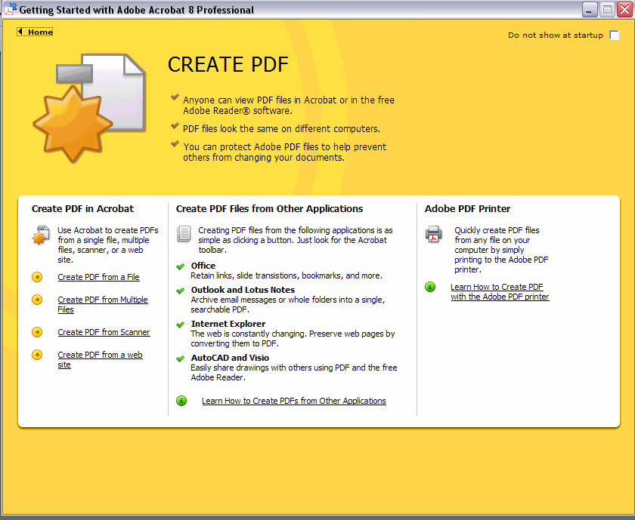
  - Either bring in a folder that has the files or identify them one by one.
Initial sort order is alphabetic, but you can re-arrange the files.
NOTE: You may choose to add “intentionally blank page” files here, if you know that the number of pages will be uneven. Or, you can insert such pages after the PDF file has been created
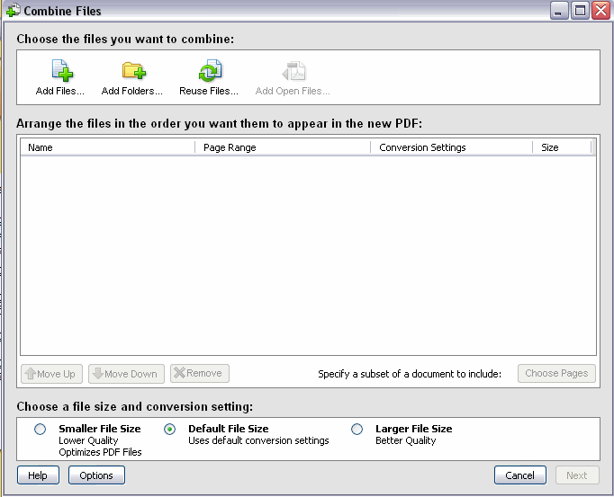
  - Create the Acrobat file. Pay close attention! Some segments may fail to convert. If that happens, create an Acrobat file from the segment & then re-run the build using the Acrobat file rather than the corresponding Word file.
  - Save the Appendices file.
  - If you need to insert pages at this point, use Document—Insert. The dialog box will walk you through the choice of file to add and where to insert it among the PDF pages.
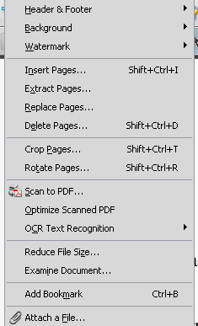 | 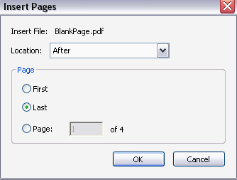

  - Some minor editing is also possible through the Advanced Actions Toolbar (View--Toolbars—Advanced). Within this Toolbar, a “text edit” function allows one to select text & delete it (for example). It’s primitive, though—you would not want to write a document in Acrobat.
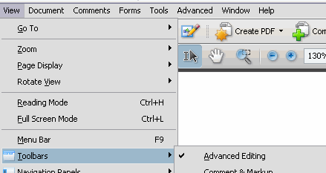
  - Add a universal footer. Use Document—Header & Footer—Add
For this manual, the universal footer was:
Center: SCCTP Basic Serials Cataloging Workshop – February 2008
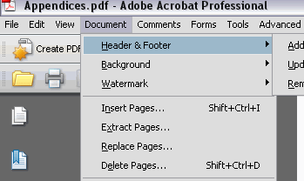

  - Add specific header information for each segment. Use Document—Header & Footer—Update.
Note that the universal footer information is automatically displayed; you only need to fill in one of the empty boxes with new text. One odd thing about header lines in Acrobat: They push up rather than down. So “Trainee manual” displays at the bottom of the header; while “Session 3//p. 3” displays higher. Remember to add a carriage return to even up the headers. Otherwise, the result will be slightly tilted, for example:
Session 3 - Exercises
Trainee Manual p. 2
Be sure to save each segment. The program entices one to try to batch the changes, but that tends to fail.
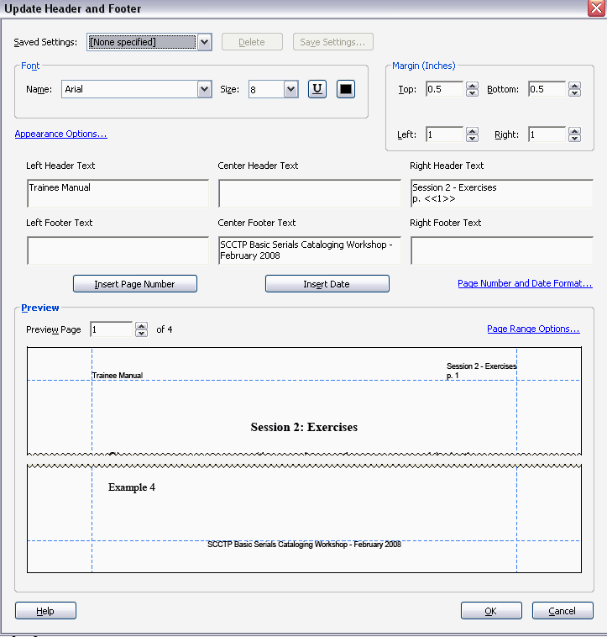

For the odd-number page header, use:
Left header: Trainee Manual
NOTE: To get this to print even with “Session 3”
there must be one blank line below “Trainee Manual”
Right header: Session 3 – Exercises
p. <<1>> NOTE: the <<1>> will increment the page no. by 1

Fill in the beginning/end pages (references the Adobe page numbers). Under Subset, choose “odd number pages” or “even number pages”
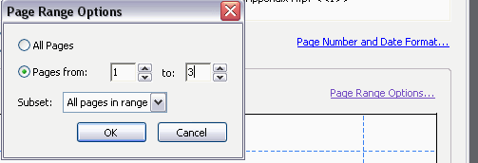
Preview the results before saving.

Compiling a manual
- From the Adobe “Getting Started” menu, choose “Combine Files.”
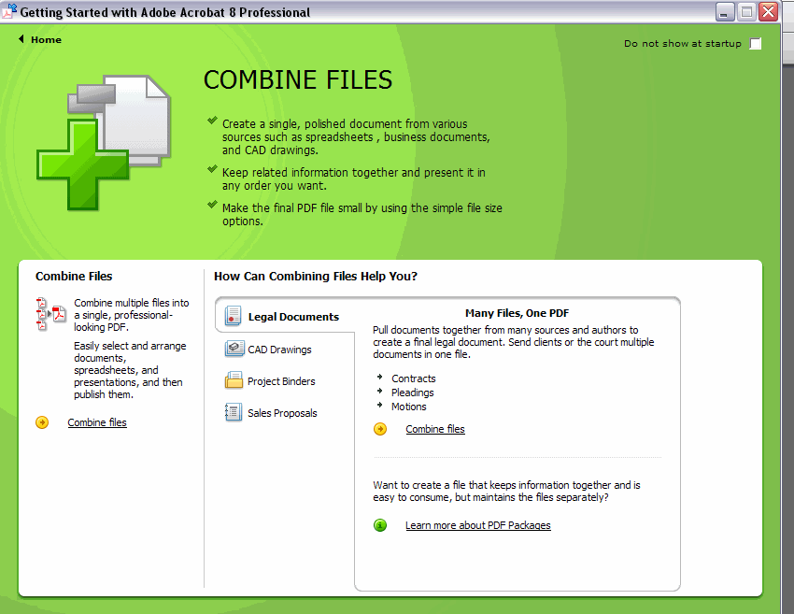
- Choose the folders & files to combine. Adobe will allow you to combine many types of files: PDF, Word, etc. (Note: It is better to create PDFs of Powerpoint files separately, in order to get 2 slides per page)
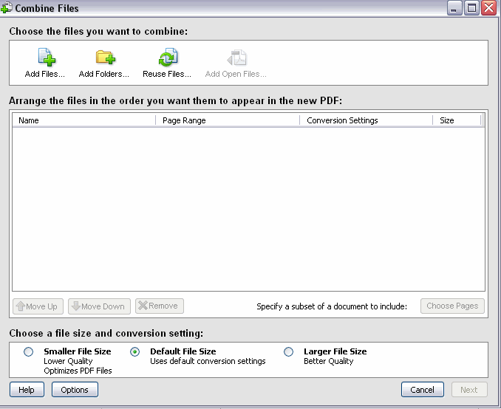
- Re-order the files by moving them up or down in the list.
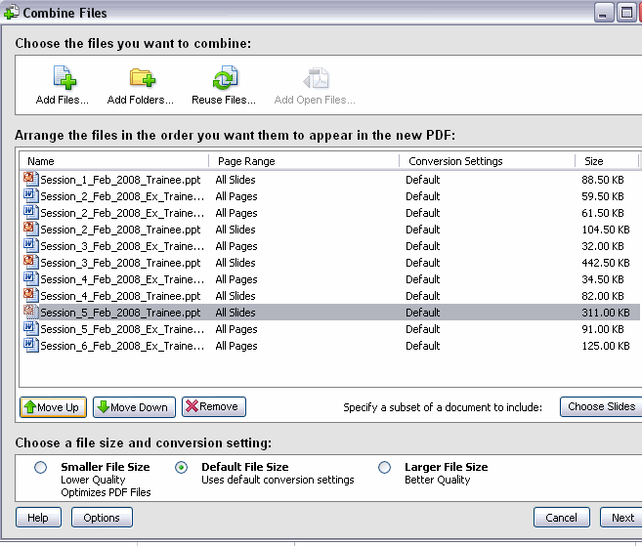
- Choose whether to create one mega-file or a package with separate parts. Then press Create.
Note: A single mega-file is smaller than a package. But it is easier to maintain parts of a package, and navigation within a package is clearer.

