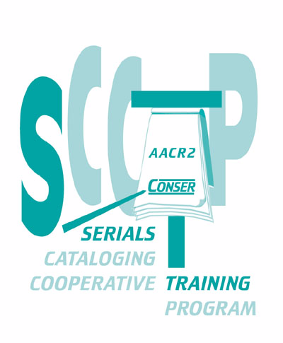

Basic Serials Cataloging Workshop

Trainee Manual

Prepared by
Cameron J. Campbell
University of Chicago

For the

Serials Cataloging Cooperative Training Program

Under the auspices of the

Cooperative Online Serials Program (CONSER)

Library of Congress, Cataloging Distribution Service

January 2008 revision

(1) Instructor manual – (2) Trainee Manual

ISBN 0-8444-1077-2 (Instructor Manual)
ISBN 0 -8444-1078-0 (Trainee Manual)

© 2008 The Library of Congress except within the United States

Distributed by the Library of Congress
Cataloging Distribution Service
101 Independence Avenue, S.E.
Washington, D.C. 20541-4912

