Elluminate through Telephony (Elluminate 9.0 at UCLA)
8/18/2009

Single User
Explanation: If a presenter's head set dies, then telephony for a single user may get you through the session.

- Go to Tools > Telephony > Configure Telephone Connection.
- Enter the user's telephone number into the Elluminate Session information box. This is the local telephone number of the person who will be calling into the session.
- Click & Save. Connect to call immediately.
Note: You can also click "save" and then later go to Tools>Telephony>Connect Session to Teleconference, if person is not yet on Elluminate
- The Elluminate session will then call the phone number, so someone needs to be ready to pick up the phone. That person will then be able to communicate with the other participants.

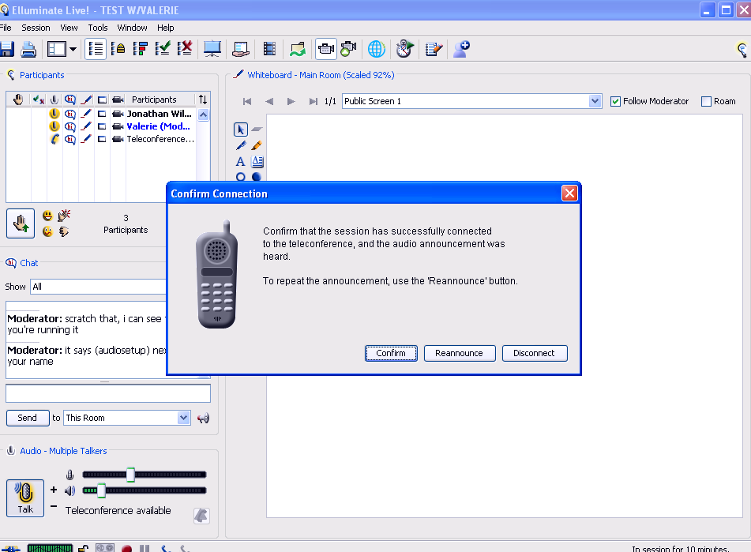

Ask all presenters & participants to run the audio test (Tools: Audio) and to set up their profile to disable the normal audio output.

Conference calls (multiple people)

From Jonathan Wilson: (message dated Feb 4, 2009)

We just tested the teleconferencing capability successfully with 3 people calling in. I requested a number from CTS by calling x53333 and inputted the number they gave me into the Elluminate Session field in the full 10-digit format.
Next I called the number using my office phone, and then connected with Elluminate. Once others had connected I hung up my phone, and they could all hear me while I talked on my headset. They complained that my voice was a little "static-y" but I was definitely understandable.
One downside is that you can't tell how many people are in the teleconference, but there are audio cues telling you when someone joins or hangs up.
Let me know if you have any questions or want to try testing again, Jonathan

From Terence Young: (message dated Feb 5, 2009)

Below are the two types of conference services that CTS offers. I included some features for each type that will answer your original questions.

Meet Me:
Minimum of 1 hr advance notice but it is first come, first serve.
30 People Max per conference call
310 dial-in number only
Free to local users (but check for cost for out-of-area-code participants)
Contact/Setup: 53333 or mmconf@cts.ucla.edu

On Demand Plus:
CTS will setup an account for you with Copper Conferencing.
Once setup, you have a permanent, toll-free number so you can create a conference call at any time 24/7.
3 cents /person/minute.
48 hr notice for original setup
125 max people
Security code required to enter conference; secure line.
Contact/Setup: 53333 or mmconf@cts.ucla.edu

