Sharing an Application through Elluminate 9.5
8/18/2009

- To start application sharing, use the sharing icon or: Tools/Application Sharing/Host Application. Result: For both the moderator and participants, the Elluminate panels will display to the left of the screen; the whiteboard will be replaced by the application being shared.
- At this point, the moderator can walk through an application, but the participants can only watch.
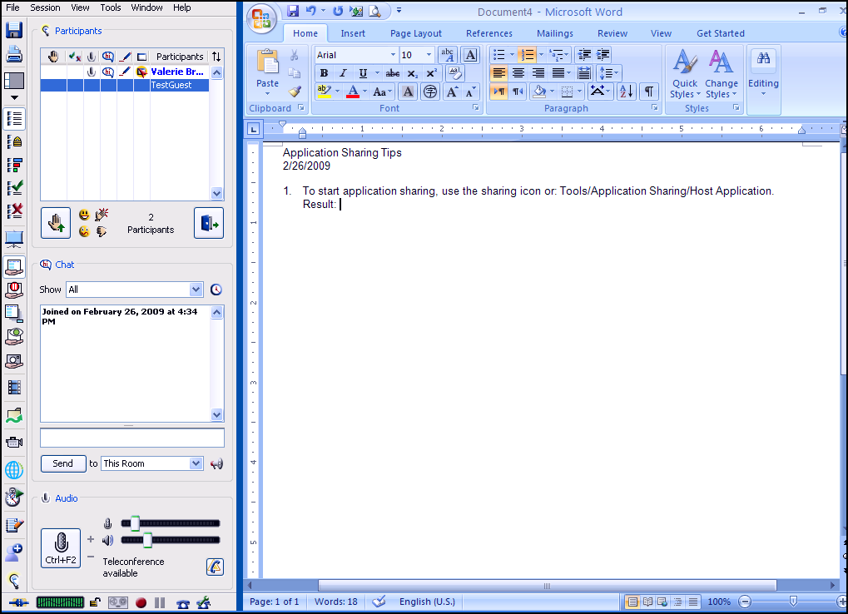

- To turn over control to a participant, either go to Tools/Application Sharing/Give Control of Application or highlight a participant & give control of the application. The participant's version of the shared application will be ringed in a color (e.g., pink).
Note that control can be given by a moderator to any participant. One does not need to first raise a participant to moderator status.
- To re-gain control from the participant, press Ctrl+Space. [Implication: I think that only one person has control of the application at a time.]

