Default Setup Options for Elluminate 9.5
8/18/2009

Purpose: To make sure that when creating a session, the session has certain defaults by globally editing the settings.

- Go to "Utilities"
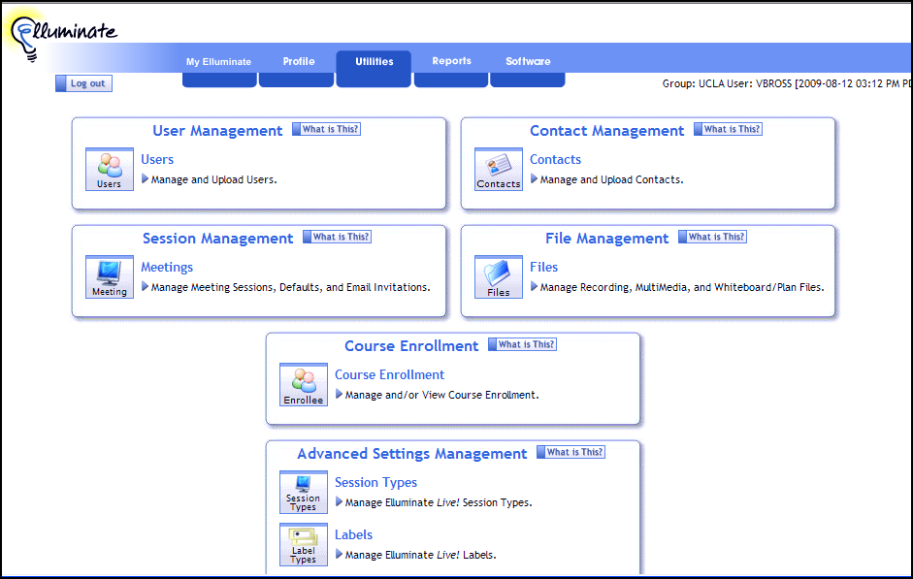

- Go to "Session Management"; click on "Meeting Defaults" and then "Edit"
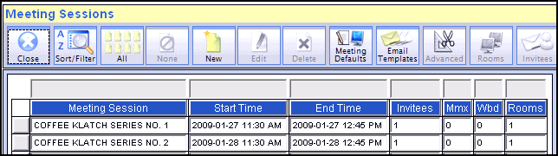

- Make the following changes and then click "SAVE"
  - Under Version: Use drop-down box to find "9.5"
  - Under Session options: UNCHECK "permissions granted on enter."
  - Under Session options: UNCHECK "all participants are chair."
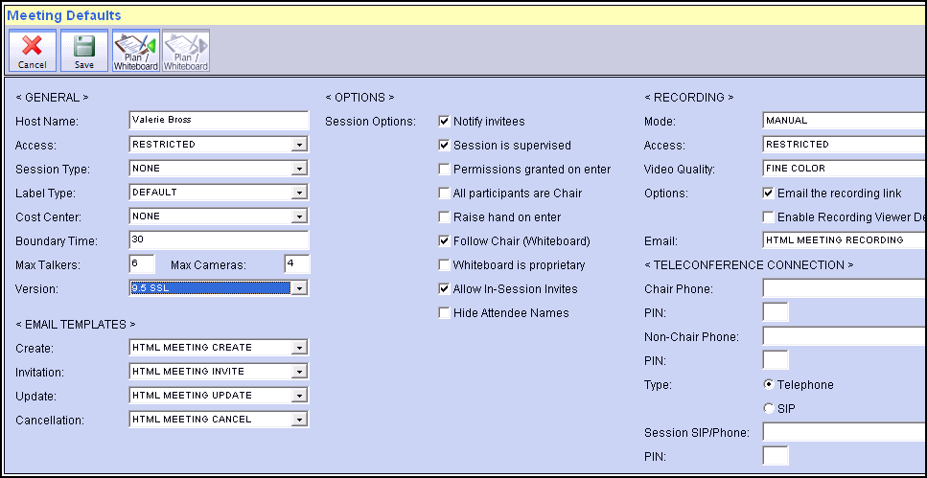

- Return to the main screen. The next time you use "schedule a meeting," the desired defaults should display.
