Title: Insect Science
12/19/2005

Background:
Ulrich’s record: According to this and to the page for the online version, Insect science continues Entomologia Sinica (ISSN: 1005-295X)

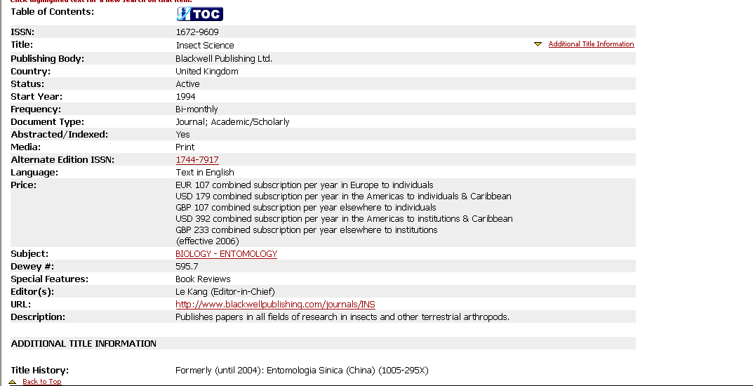
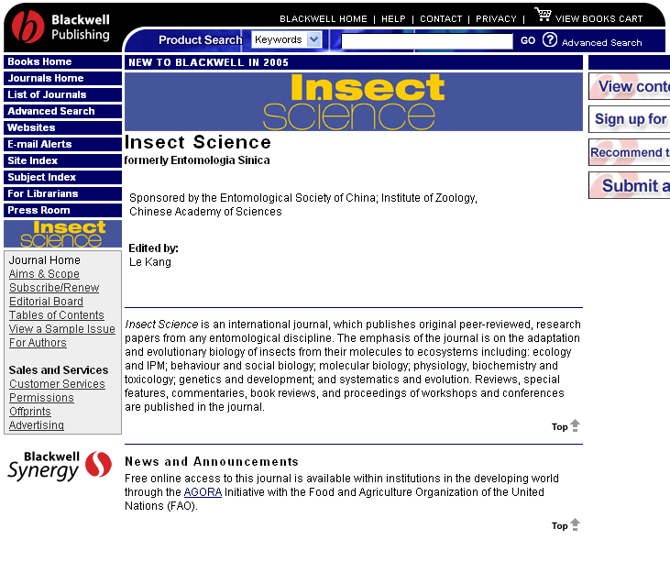
Scanned pages:
Insect science | v.12:no.1(2005:Feb.): cover
Insect science | v.12:no.1(2005:Feb.): p. 2 of cover
Insect science | v.12:no.1(2005:Feb.): p.1 (Editorial)
Insect science | v.12:no.1(2005:Feb.): p. 3 of cover

