Trouble-Shooting Microphone Problems
1/27/2009 Renee Chin

- Before you begin your audio configuration in Elluminate Live!, go to START, Settings, Control Panel. Choose icon that indicates: 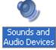

- Click on the Voice tab, then click on Volume for the Voice recording:

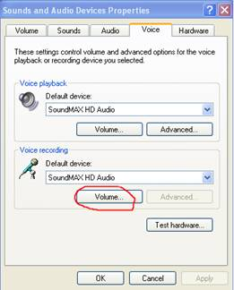

- Put a checkmark in the Select box under Microphone:
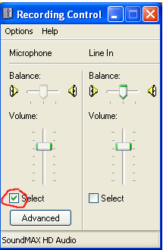

- Close the box, click NO if prompted with a dialog box.

- To configure your audio and microphone in advance, go to http://www.elluminate.com/support/index.jsp. Click on Join the Configuration Room. When the dialog box pops up, hit OK to open session:
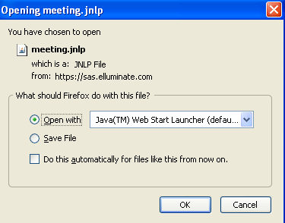

- For the audio setup, follow the instructions on the whiteboard before you.

- For the microphone set up, choose microphone as your audio input device, click OK
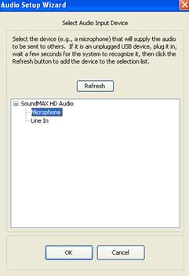

- If you find that your microphone does not record, go to Tools, Preferences, under Audio, highlight Microphone Boost. Make sure the box for “Boost microphone signal” is checked off. Click Apply, close. Repeat the audio configuration:
