Felix Hu, Patrick Wu, Joe Xu, Henry Zhang

admin@yinruihu.com

Abstract

This specification gives an overview of the CSSA miniapp. This includes brief view to each page and the functions on each page. This does not include specific appl-ication to each function.

FUnction Specification For cssa miniapp

1. Table of Contents

1. Main Page 3

1.1 Weather and Date 3

1.1.1 Default Time Zone 3

1.1.2 Default City 3

1.1.3 Weather Description 3

1.1.4 Interact with user 3

1.2 News 4

1.2.1 Content 4

1.2.2 Interact with user 4

1.3 Personal Timetable // todo what if the user didn’t login via ucl 4

1.3.1 Block(For each Lecture) 4

1.3.2 Full timetable button 4

1.3.3 User interaction 4

1.4 Library seats 4

1.4.1 Progress bar(for each library) 4

1.4.2 Library Displayed 5

1.4.3 Interact with user 5

1.4.4 Press progress bar 5

2. My-UCL Page 6

2.1 Wechat Login 6

2.2 UCLAPI Login 6

2.3 API BOX 7

2.3.1 Personal Timetable (UCLAPI Login) 7

2.4 My CSSA 7

3. Post Page 8

3.1 Post Scroll Bar 8

3.1.1 Interact with user 8

3.2 Post Block 9

3.2.1 Time 9

3.2.2 Title 9

3.2.3 Brief content 9

3.2.4 Photo 9

3.2.5 User Information 9

3,3 Post Button(Wechat Login Only) 9

4. Restaurant Page 10

4.1 CSSA CARD(Wechat Login) 10

4.2 Restaurant Block 10

4.3 Restaurant Search 11

4.4 Restaurant Filter 11

# Main Page

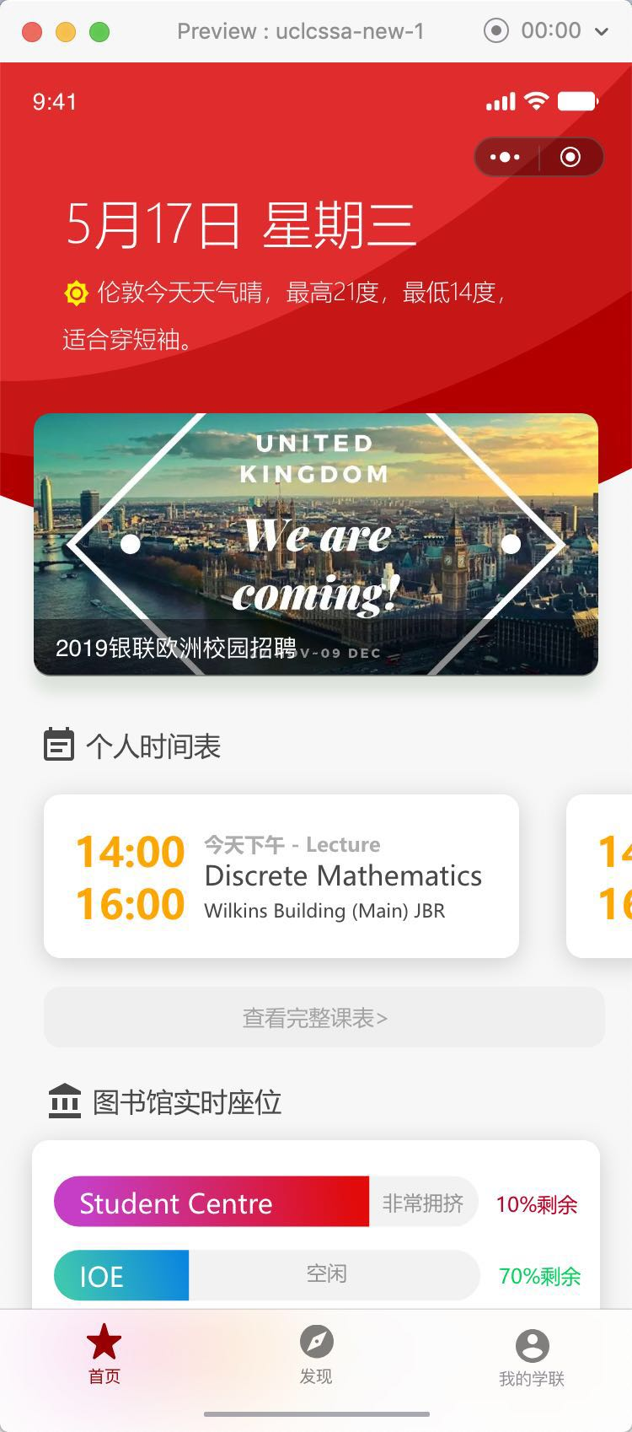

1.4 Library Seats

1.1 Weather and Date

1.2 News[Scroll bar]

1.3 Personal Timetable[Scroll bar]

## Weather and Date

This part should contain two parts Date and the Weather. User should able to choose the time zone and preferred city.

### Default Time Zone

Time zone use should be GMT0.

### Default City

London

### Weather Description

Format : Weather + Highest Degree(Celsius) + Lowest(Celsius)+ Suggest dressing

### Interact with user

Nil

## News

News are displayed inside a scroll bar with speed 2s/time (Every two seconds scroll to the left once)

### Content

This must contain CSSA activities. Can contain other information if required.

### Interact with user

When user press the picture, article should displayed.(Design will include later todo)

## Personal Timetable // todo what if the user didn’t login via ucl

Scroll bar that displays today’s lectures. And a button in the bottom to get full time table of the week. Each lecture is displayed inside a block. The scroll bar can only be moved when user scroll it.

### Block(For each Lecture)

This should include the following information(English):

* Start and End time
* Lecture Room
* Lecture Name
* Lecture Format (Lecture, Problem base learning, tutoring)

### Full timetable button

Design will include later.

### User interaction

User should able to scroll the bar, able to press each lecture block and the button.

## Library seats

A block that displays popular library seats situation. The information for each library should be displayed inside a progress bar.

### Progress bar(for each library)

This is used to tell user the number of empty seats. When it is full means there is no empty seats vice versa. The color of the bar represents the library congestion. The actual number should be displayed next to the bar.

#### Color

* When the total amount of empty seats is over 70%, fill the bar with green.
* When the total amount of empty seats is less than 50%, fill the bar with yellow.
* When the total amount of empty seats is less than 30%, fill the bar with orange.
* When the total amount of empty seats is less than 15% , fill the bar with red.

#### Number Display

The number displayed should be an integer. The display should ignore the decimal places.

### Library Displayed

* Main library
* Science library
* Student Centre(new)
* IOE library
* User may choose the library they want to display

### Interact with user

User should able to press the progress bar.

### Press progress bar

Jump to library seats page(Design will include later)

# My-UCL Page

Wechat Login

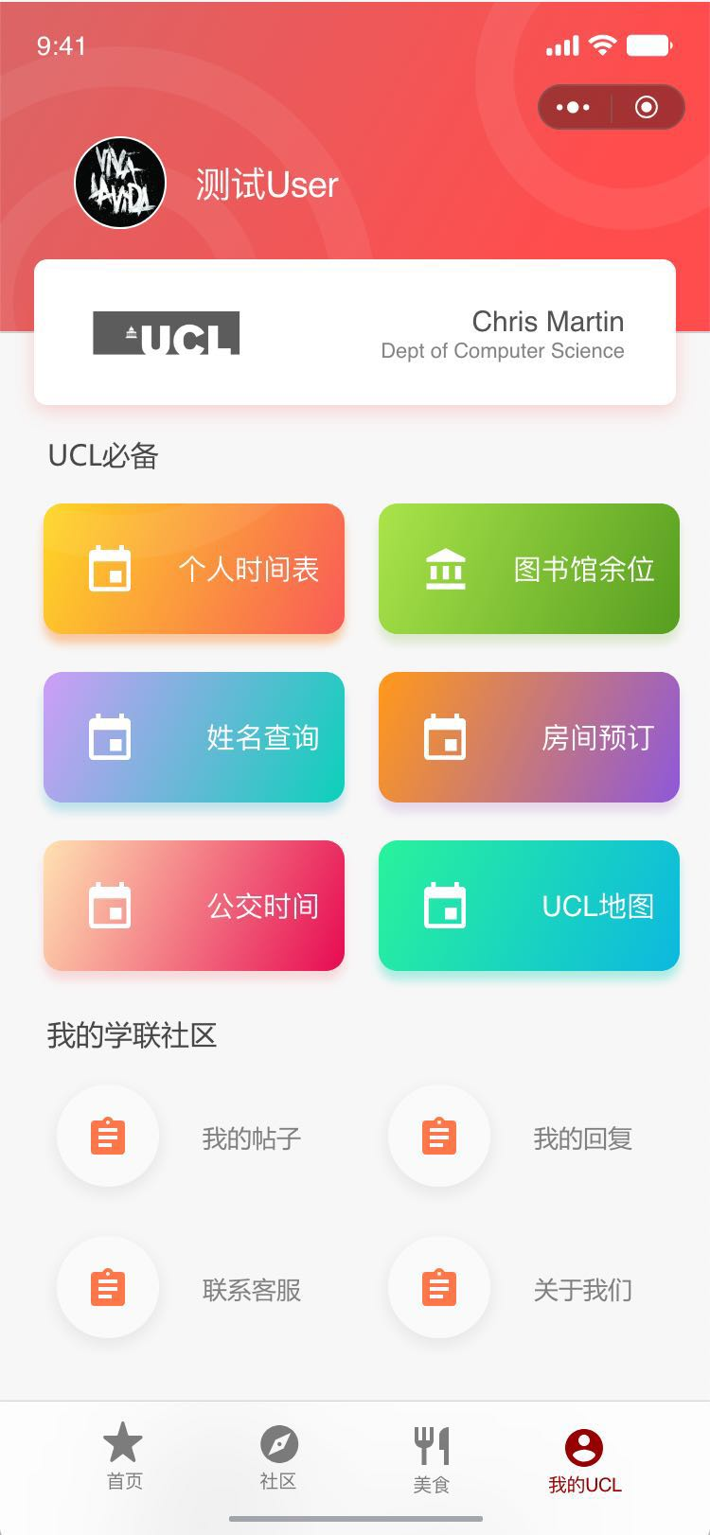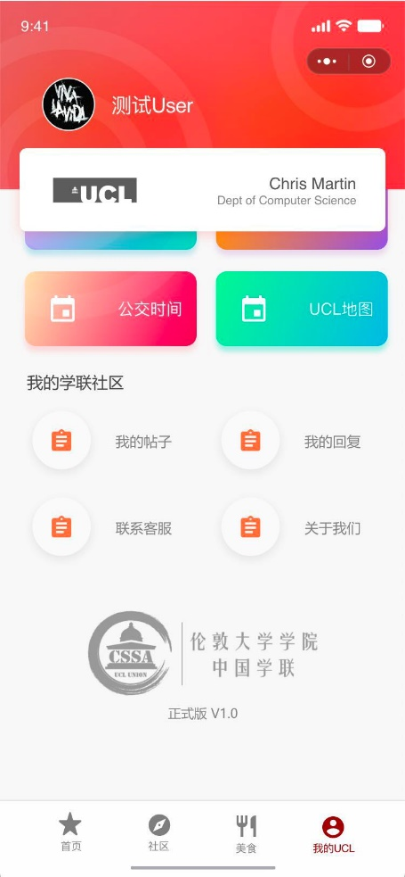

UCLAPI Login

My CSSA

API BOX

**In this section we need to define two phrases, wechat login and uclapi login.**

## 2.1 Wechat Login

Login in via wechat, Can be done via wechat api. This login get users’ to provide their profile photo, gender, and wechat name.

## 2.2 UCLAPI Login

Login in via UCL. Can be done by connecting to UCLAPI. This login will get users’ UPI number, department, student number and real name.

## 2.3 API BOX

### 2.3.1 Personal Timetable (UCLAPI Login)

Design should include later

## 2.4 My CSSA

# Post Page

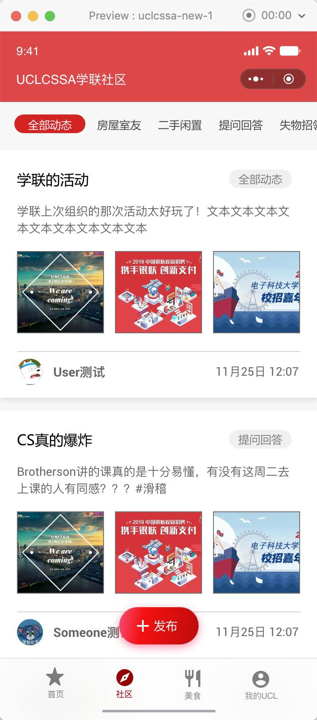

Post Scroll Bar

Post Block

Post Button

## Post Scroll Bar

User can post to different aspects of posts.

This include

* 房屋室友
* 二手闲置
* 提问回答
* 失物招领

### Interact with user

* Scroll bar should be scrollable and should be static when user doesn’t scroll it.
* When user press specific section, that section should be highlighted as shown in the design and the posts displayed should be filtered.

## Post Block

Each Post inside post page will be displayed as a post block. A post block should include following elements.

* Time
* Title
* Brief content
* User Information
* Photo

### Time

GMT 0.

### Title

Title of the post no more than 1 line(todo).

### Brief content

No more than 2 line(tpdo)

### Photo

No more than 3 photos.

### User Information

User Profile and id.

## 3,3 Post Button(Wechat Login Only)

Design will included shortly todo.

# Restaurant Page

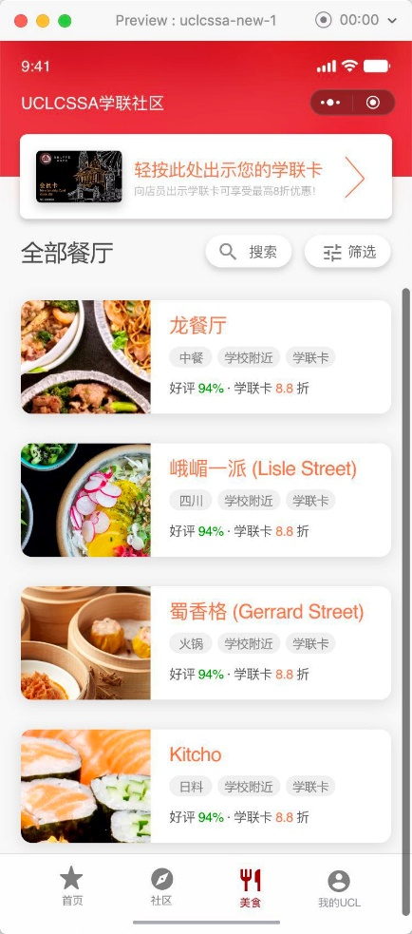

CSSA Card

Restaurant Block

Restaurant Filter

Restaurant Search

## CSSA CARD(Wechat Login)

When pressed, display the CSSA card.

## Restaurant Block

Restaurant Block should include following elements

* Name of restaurant
* Photo of restaurant

## Restaurant Search

## 4.4 Restaurant Filter